

Planning

Delegated Officer Report
The application is classified as a Schedule 1 application as defined by the Town and Country Planning (Discharge of Local Planning Functions) (England) Regulations 2026 and as such must be determined utilising delegated powers.

Summary of application details
Application reference: | PLA-2026-001228
Application type: | Full planning permission
Proposal: | Conversion of the existing apartment at first and second floor level into two self-contained apartments.
Site address: | 26 Lansdowne Road Manchester M8 5SH
Ward(s): | Crumpsall
Date application valid: | 08 September 2026
Applicant name: | Bilal Saddique
Agent (if any): | Mr Sam Golding
Case officer: | Carl Glennon
Recommendation: | Approve
Date of recommendation: | 2 November 2026

Description of site, building and/or area
The application property is in a retail/commercial area and situated at the junction of Lansdowne Road and Eadington Street (which is residential).The application property presents two storeys to Lansdowne Road and three storeys to the rear. The elevations comprise red / orange brick with tiled pitched roof. The rear elevation is rendered and incorporates a flat roof single storey extension. The ground floor and basement area use in connection with a learning centre / childcare facility. The building frontage incorporates a projecting bay with roller shutter to windows in the front and side elevations. There is a separate doorway in the ground floor front elevation providing access to the upper floors. The rear yard is walled. The adjacent alleyway is gated.

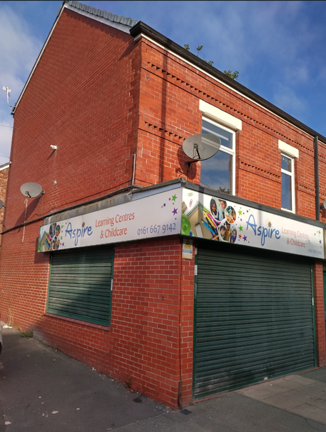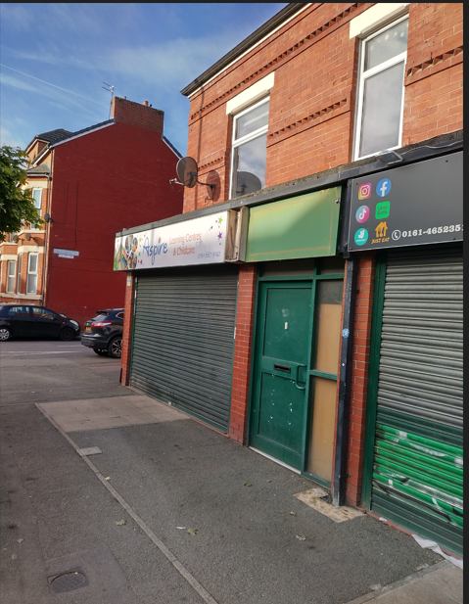
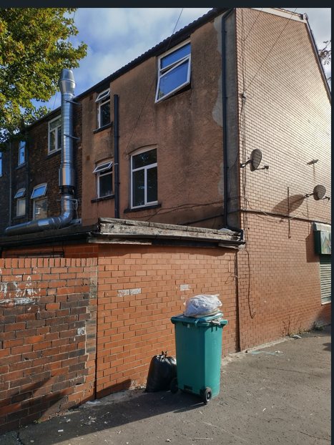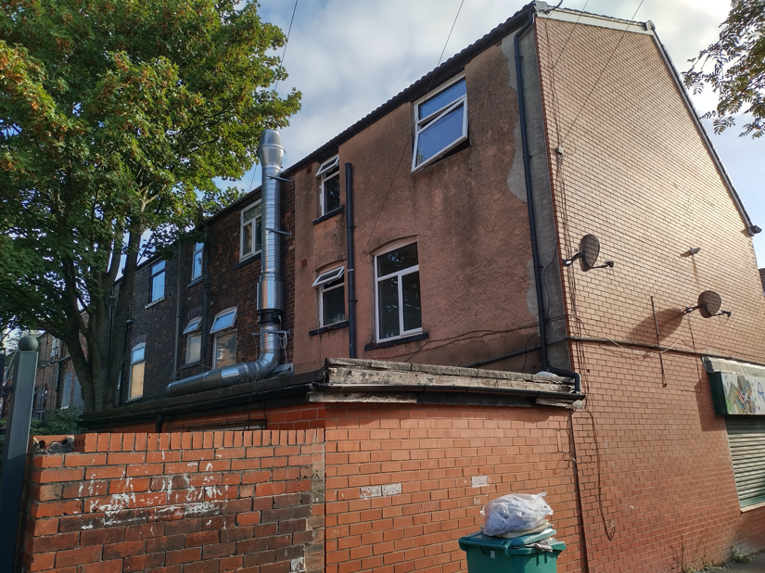

Fiug.1 – Views of the application site (24 September 2026)

Description of development
The ground floor educational use would not be affected by the development due to the maintenance of a separate entrance within the front elevation. The existing apartment would be sub-divided to provide one bedroom, one person apartment on the first and second floor. Each apartment would have floorspace of 38 sq. metres and 37 sq. metres respectively. Related bins would be stored in the rear yard. External alterations are not proposed as part of the development.
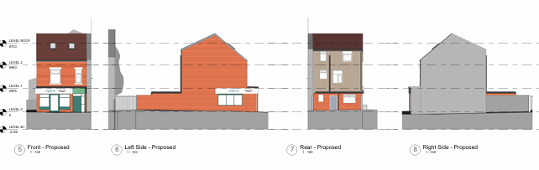
Fig. 2 – Proposed elevations
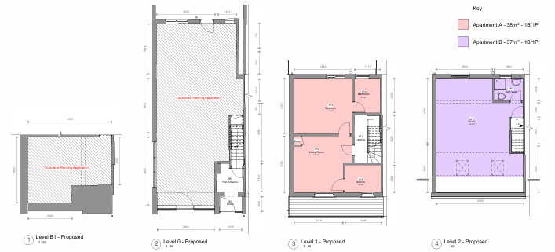
Fig.3 – Proposed layout

Relevant planning history

Consultation, notification and publicity responses

Consultations

Local residents and businesses – No comments received.

Environmental Health – Request a condition requiring the submission and implementation of a waste and recycling storage scheme.
Highways – The following comments have been received:

i. The level of trips generated by the development would not be significant.
ii. The site is in a sustainable location with regard to the access to public transport.
iii. The provision of bollards to prevent adjacent on-pavement parking should be considered.
iv. The provision of secure cycle storage is recommended.
v. External doors should open inwards.
vi. Bin storage arrangements are acceptable subject to return of bins to the storage areas following collection.
vii. Consideration should be given to the impact of construction work on the highway.
viii. The applicant should agree the following arrangements with the Council as local highways authority:
- Licensing, hoarding / scaffolding, and skips positioning.
- Requirements for temporary pedestrian and traffic management.

Notifications and publicity

A site and press notice was not required in this case.

Relevant policies
National Planning Policy Framework (NPPF- August 2026)

The NPPF sets out the government’s policies for plan making and for making decisions on development proposals in England. It is a material consideration of critical importance in both contexts. This version replaces the previous NPPF published in December 2024.

Paragraph 17 States that . Achieving sustainable development means that the planning system has three overarching objectives in providing for the homes, commercial development, facilities and infrastructure which society needs. These objectives are:
a. An economic objective
b. A social objective
c. An environmental objective.

The proposal would deliver a sustainable development and would accord with the above objectives.

Chapter 3. Decision-making policies

Policy DM3: Determining development proposals – Sets out the considerations of the LPA when determining development proposals. The assessment of the development accords with these requirements.

Chapter 4. Achieving sustainable development
Policy S3: Presumption in favour of sustainable development

The development would be appropriately related to the following chapters and policies.

Chapter 17. Pollution, public protection and security
Policy P3: Living conditions and pollution

Chapter 18. Managing flood risk and coastal change
Policy F4: Assessing flood risk for decision-making

Sustainable Development Joint Development Plan Document - Places for Everyone (2022-2039)

Policy JP-P6 (Health) – Has been related to the assessment of harm associated with the development. The principle of residential uses above commercial uses. Appropriate noise attenuation and waste management is capable of being delivered. The development would thereby accord with policy JP-P6.

Planning Practice Guidance

i. Consultation and pre-decision matters;
ii. Health and well-being;
iii. Noise.

It is considered that the development would be appropriately related to the above objectives for the reasons set out in the report.

The Places for Everyone Plan

The following policy is relevant.
JPS1 - Sustainable development

Manchester's Local Development Framework: Core Strategy

Policy SP 1 - Relevant principles relate to the extent to which the development:
a. Makes a positive contribution to neighbourhoods of choice;
b. Minimise emissions, ensure efficient use of natural resources and reuse previously developed land wherever possible;
c. Improve access to jobs, services, education and open space by being located to reduce the need to travel and provide good access to sustainable transport provision.

The proposed flats would also contribute to the quality of residential provision in the area. Local amenity would be maintained. Policy SP1 would thereby be accorded with.

Policy EN19 Waste - Requires consideration of the submitted details relating to waste and recycling management. Bin storage arrangements can be provided in the rear yard. On this basis, policy EN19 would be accorded with.

Policy T1 (Sustainable transport) - In this case, the development would not generate significant traffic, and the site is in a sustainable transport location. The constraints of the site would prevent cycle storage. Policy T1 would be appropriately responded to.

Policy DM1 (Development Management) – States, amongst other things, that development should have regard to the following:

- Impact on the surrounding areas;
- Effects on amenity;
- Accessibility;
- Community safety and crime prevention;
- Design for health;
- Refuse storage and collection.

The development not unduly harm the amenities of the area and provision can be made to deliver appropriate security measures throughout the site. The development site has the capacity to be supported with waste and recycling storage. The development would not unduly impact upon existing levels of amenity. Policy DM1 would thereby be accorded with.

Unitary Development Plan (UDP) saved policies

DC 5 Flat conversions – The proposed additional apartment would be acceptable. Inclusive access cannot be achieved due to the configuration of the application property.

Policy DC26 (Development and noise) - Has been related to the proposals contribution to the local noise environment. There would be no change on the existing circumstances regarding the relationship between non-residential and residential uses. A noise attention condition has not therefore been included.

Manchester Residential Quality Guidance

This guidance is relevant to new build development, but its space criteria have been referenced in the assessment of the quality of the internal space achieved as part of this proposal. In this case the proposed flats would meet the required space criteria for a one bedroom, one person units. This would be acceptable given the constraints of the application property.

Assessment
Delegated Officer Scheme of Delegation - Schedule 1
The application is classified as a Schedule 1 application as defined by the Town and Country Planning (Discharge of Local Planning Functions) (England) Regulations 2026 and as such must be determined utilising delegated powers.

Principle of the development – Residential use to the upper floor of the application property has been historically established. The continue residential used would be consistent with residential uses above premises in a retail / commercial parade. The development would contribute to local housing supply and would thereby deliver positive benefits. The proposed layout would meet required standards for residential conversion.

Ground floor use – Historically, ground floor uses were consistent with Class E with residential occupation above. This mix of uses would be maintained and would be appropriate in a commercial parade. However, the existing educational use falls with Class F1 (a) and there is no record of planning permission being granted for this use. The proposed development can be undertaken without affecting the ground floor use. Issues relating to resolving this unauthorised uses are capable of being addressed separately.

Residential amenity – The development would achieve an appropriate layout for one person, one bedroom occupation. The proposed layout would be of sufficient quality to encourage sustained occupation. The development would not significantly affect levels of activity around the site and the existing relationship to neighbouring housing would be maintained .

Use – A condition has been included relating the occupation of the development to two separate one bedroom, one person flats (Class C3). This condition is necessary to aid the future management of the development.

Internal layout and space – The respective flats would achieve an internal space of 38 sq. metres and 37 sq. metres. The internal layout would be acceptable given the constraints of the application property. Appropriate communal staircases and corridor would be provided. The internal layout would be appropriate.

Residential amenity – The development would secure a satisfactory quality of internal space with the configuration of the building envelope. The level of amenity would be commensurate with the characteristics of residential accommodation above retail and commercial premises in the locality.

Noise – The development would maintain the existing relationship between the ground and first floor. A condition requiring additional noise insulation is not considered necessary in these circumstances.

Crime and security – The development would provide a separate residents’ access from Lansdowne Road thereby maximising natural surveillance. An informative has been included that recommends that any new security fittings meet secured by design standards thereby reducing any increased risk of crime.

Inclusive access – As there would be no change in the existing circumstances regarding access to the first floor apartments.

Waste management –Waste collection would take place via the adjacent alleyway, which would be consistent with the existing arrangements. The residential bins would be accessed via the rear alleyway. The distance travelled by residents when accessing bins would exceed usual requirements. However, the configuration the application property would not facilitate direct access to the rear yard. Details indicating the storage of bins within the rear yard are acceptable and conditioned.

Highways issues – The development would not be supported with off-street car parking. The site is in a sustainable location regarding access to public transport thereby reducing reliance on private car usage. The proposed level of residential occupation the development would not result in significant traffic generation or otherwise unduly impact on the operation of the highway.

Cycle storage – Given the constraints of the rear yard and the need to accommodation waste and recycling bins there would be insufficient space for the provision of cycle storage.

Flood Risk – The site is in Flood Zone 1 with a low risk of surface water flooding.

Other Legislative Requirements

Equality Act 2010
Section 149 (Public Sector Equality Duty) of the Equality Act 2010 requires due regard to the need to: Eliminate unlawful discrimination, harassment and victimisation and other conduct prohibited by the Act and; Advance equality of opportunity between persons who share a protected characteristic and persons who do not share it. The Equality Duty does not impose a legal requirement to conduct an Equality Impact Assessment. Compliance with the Equality Duty involves consciously thinking about the aims of the Equality Duty as part of the process of decision-making.

Human Rights Act 1998 considerations
This application needs to be considered against the provisions of the Human Rights Act 1998. Under Article 6, the applicants (and those third parties, including local residents, who have made representations) have a right to a fair hearing and to this end the local planning authority must give full consideration to their comments.

Protocol 1 Article 1, and Article 8 where appropriate, confer(s) a right of respect for a person’s home, other land and business assets. In taking account of all material considerations, including Council policy as set out in the Core Strategy and saved polices of the Unitary Development Plan, the Director of Planning, Building Control & Licensing has concluded that some rights conferred by these articles on the applicant(s)/objector(s)/resident(s) and other occupiers and owners of nearby land that might be affected may be interfered with but that that interference is in accordance with the law and justified by being in the public interest and on the basis of the planning merits of the development proposal. She believes that any restriction on these rights posed by the recommendation given is proportionate to the wider benefits of and that such a decision falls within the margin of discretion afforded to the Council under the Town and Country Planning Acts.

Conclusion
It is considered that the development would deliver a proportionate amount of residential accommodation. The development be appropriately related to its context. The develop would be appropriate subject to the attached conditions.

Recommendation: Approve

1) The development must be begun not later than the expiration of three years beginning with the date of this permission.

Reason - Required to be imposed pursuant to Section 91 of the Town and Country Planning Act 1990.

2) The development hereby approved shall be carried out in accordance with the following drawings and documents received by the City Council as local planning authority on the specified dates:

Proposed plans and elevations Ref: GSS26120.1/OP1
Existing and proposed site plan (bin storage) Ref: GSS26120.1/S02 Rev 1 received 8 September 2026

Reason - To ensure that the development is carried out in accordance with the approved plans. Pursuant to policies SP1 and DM1 of the Core Strategy for the City of Manchester.

3) The development hereby approved shall only be occupied as a two self-contained one bedroom, one person flats (Class C3) as shown on drawings referenced Proposed plans and elevations Ref: GSS26120.1/OP1 and for no other purposes.

Reason – In the interests of residential amenity pursuant to policies SP1 and DM1 of the Cire Strategy for the City of Manchester.

4) The development shall be implemented in accordance with the following details relating to the storage of waste and recycling bins as received by the Council as local planning authority on 8 September 2026:

Existing and proposed site plan (bin storage) Ref: GSS26120.1 S02 Rev 1
Waste management proforma.

The approved arrangements shall be implemented before the occupation of the development and maintained in situ thereafter.

Reason - In the interests of residential amenity and to secure appropriate arrangements for the storage and collection of segregated waste and recycling, pursuant to policies SP1, EN19 and DM1 of the Core Strategy for the City of Manchester.
Informatives

1) Guidance for developers can accessed via the following link:
http://www.manchester.gov.uk/info/500207/planning_and_regeneration/1962/additional_planning_guidance/3

2) Security and crime reduction measures – It is recommended that all new locks, fixtures, fitting, doors, windows, frames and glazing meets Secured by Design standards.

3) It is recommended that the applicant agrees any requirements for licensing, hoarding / scaffolding, and skips with the Council Highways Licensing Team via email:
highwaylicences@manchester.gov.uk.

4) It is recommended that the applicant agrees any requirements for temporary
pedestrian and traffic management with MCC's Event and Traffic Management Team via
email: highwaynetworkmanagement@manchester.gov.uk.

