

Planning

Delegated Officer Report

The application is classified as a Schedule 1 application as defined by the Town and Country Planning (Discharge of Local Planning Functions) (England) Regulations 2026 and as such must be determined utilising delegated powers.

Summary of application details
Application reference: | PLA-2026-001855
Application type: | Removal/variation of conditions
Proposal: | Variation of condition 2 (specified plans) of planning permission ref: 143433/FH/2025 for the erection of a single storey rear extension following demolition of outbuilding to allow amendments comprising relocation of the rear patio doors by approximately 500mm, insertion of a side window and removal of the side entrance door at 43 Parkville Road.
Site address: | 43 Parkville Road Manchester M20 4TX
Ward(s): | Didsbury East
Date application valid: | 05 October 2026
Applicant name: | Mrs Renee Lavorini
Agent (if any): | Miss Helen Ainsworth
Case officer: | Joshua Lee
Recommendation: | Approve
Date of recommendation: | 02 Nov 2026

Description of site, building and/or area
The proposal relates to a two storey semi detached dwellinghouse on Parkville Road. The property features an existing two storey rear extension, detached outbuilding, gardens to the rear and hardstanding to the front and side for off street vehicle parking.
The property is in a mostly residential part of the Didsbury East ward of Manchester. The Christie Surface Car Park D sits to the rear boundary. The site is within a high-risk surface water area (More than 3.3% chance of a flood each year) and sits within the HS2 Phase 2B safeguarding zone.

Description of development
Variation of condition 2 (specified plans) of planning permission ref: 143433/FH/2025 for the erection of a single storey rear extension following demolition of outbuilding to allow amendments comprising relocation of the rear patio doors by approximately 500mm, insertion of a side window and removal of the side entrance door at 43 Parkville Road.
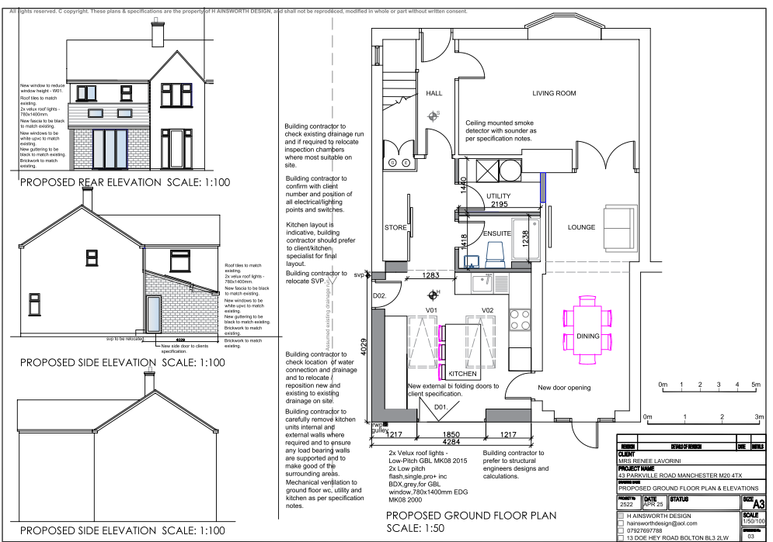
Figure 1. Approved plans
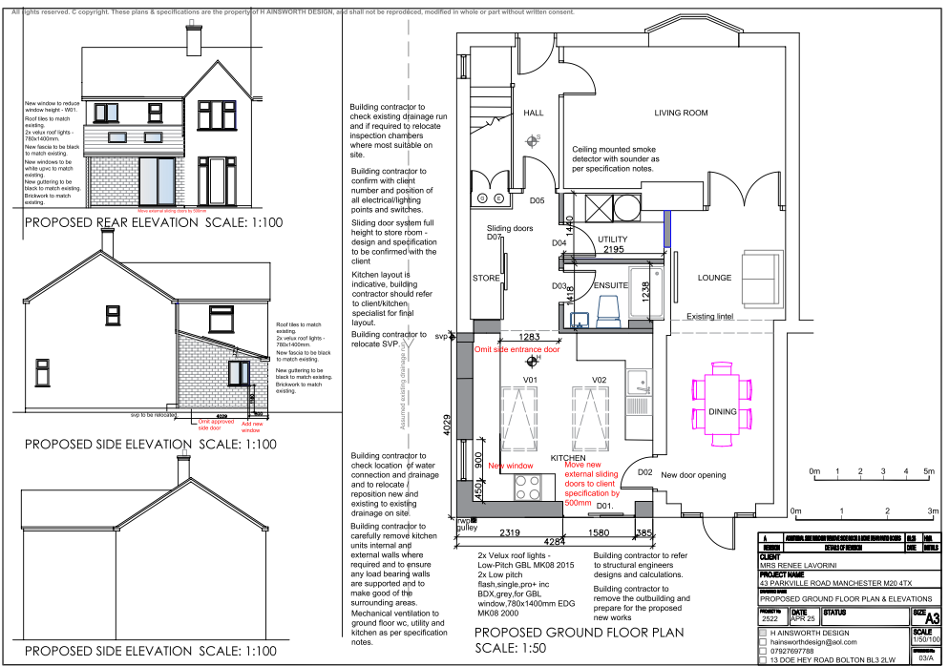
Figure 2. Proposed variation

Relevant planning history

143433/FH/2025
Erection of single storey rear extension following demolition of outbuilding
Approve
2025-09-02

052932/FH/SOUTH1/97
Description: Formation of porch and WC extension to front of dwelling
Decision: Approved 02/12/1997
NB: This was never implemented

033839
Description: 2nd storey extension to form bedroom
Decision: Approved 16/05/1989

Consultation, notification and publicity responses

Notifications and publicity

Neighbour letters
No responses received.

Relevant policies
In accordance with Section 38(6) of the Planning and Compulsory Purchase Act 2004, planning applications must be determined in accordance with the statutory development plan unless material considerations indicate otherwise.
For Manchester, the development plan comprises:
- The Manchester Core Strategy (2012 to 2027);
- Saved policies of the Manchester Unitary Development Plan (UDP); and
- The Places for Everyone Joint Development Plan Document (2022 to 2039).
These documents are considered up to date and are afforded significant weight in the determination of planning applications. Relevant Supplementary Planning Documents (SPDs) and other adopted guidance may also be material considerations.
The National Planning Policy Framework sets out the government’s policies for plan-making and for making decisions on development proposals in England. It is a material consideration of critical importance in both contexts.
Where relevant, the Council is required to give special regard to the desirability of preserving listed buildings and their settings, and special attention to the desirability of preserving or enhancing the character or appearance of conservation areas, in accordance with the Planning (Listed Buildings and Conservation Areas) Act 1990.
The policies and guidance referred to below are considered the most relevant to the scale, nature and location of the proposed development.
- The Manchester Core Strategy Development Plan Document 2012-2027
  - Development Management and Planning Obligations
    - DM 1 - Development Management
  - Objective 1 - Spatial Principles
    - SP 1 - Spatial Principles (Partially replaced by PfE Policy JP-S 1)
  - Objective 6 Environment
    - EN 1 - Design Principles and Strategic Character Areas
    - EN 14 – Flood Risk (partially replaced by PfE Policy JP-S 4)
    - EN 19 – Waste
- Guide to development in Manchester - supplementary planning document and planning guidance, April 2007
- Extant Unitary Development Plan (UDP) –
  - Citywide Development Control Policies
    - DC1 - Residential extensions
    - DC26 - Development and Noise
- Places for Everyone Plan Joint Development Plan Document 2022-2039-
  - Strategy
    - JP-Strat9: Southern Areas
  - Sustainable and Resilient Places
    - JP-S1: Sustainable Development
    - JP-S4: Flood Risk and the Water Environment
  - Places for People
    - JP-P1 Sustainable Places
- National Planning Policy Framework – August 2026 - National Development Management Policies (NDMPs)
  - Procedural Policies
    - Chapter 3 – Decision-making policies
      - DM1: Preparing development proposals
      - DM2: Information requirements
      - DM3: Determining development proposals
      - DM6: Use of planning conditions and obligations
      - DM7: Relationship with other regulatory regimes
      - DM10: Removal of national permitted development rights
  - Sustainable Development
    - Chapter 4 - Achieving sustainable development
      - S3: Presumption in favour of sustainable development
      - S4: Principle of development within settlements
  - Creating high quality, sustainable places
    - Chapter 12 - Making effective use of land
      - L2: Making effective use of land
      - L3: Achieving appropriate densities
    - Chapter 14 - Achieving well-designed places
      - DP3: Key principles for well-designed places
      - DP4: The design process
  - Conserving and enhancing the environment
    - Chapter 18 - Managing flood risk and coastal change
      - F4: Assessing flood risk for decision-making
      - F6: Development in areas at risk of flooding from rivers or the sea
      - F7: Ensuring development is safe from flooding

Assessment

Principle of Development
A section 73 application allows for the variation of conditions attached to an existing planning permission. In this case, permission is sought to vary condition 2 (specified plans) of planning permission 143433/FH/2025 to allow the repositioning of the approved rear patio doors by approximately 500mm, the removal of the approved side entrance door and the insertion of a side facing window.
The principle of the single storey rear extension has already been established through the original planning permission and remains unchanged. The assessment therefore relates only to the acceptability of the proposed amendments and whether they would result in any material planning harm.

Appropriate siting, layout, scale, form, massing, materials, and detail
The proposed amendments do not alter the footprint, height, scale, roof form or overall massing of the approved extension. The changes are limited to the arrangement of openings within the approved elevations. The repositioned patio doors would remain within the rear elevation and the introduction of a side window in place of the approved side entrance door would represent only a minor alteration to the fenestration pattern. As such, the development would continue to appear subordinate to the host dwelling and would remain consistent with the design approved under permission 143433/FH/2025. The proposal is therefore considered acceptable in design terms.

Impact on the surrounding areas in terms of the design, scale and appearance of the proposed development. Development should have regard to the character of the surrounding area.
The proposed changes are modest and would be largely screened from public views. The repositioning of the rear patio doors would not materially alter the external appearance of the extension, whilst the replacement of the side entrance door with a window would maintain an active side elevation. Given the limited nature of the amendments, the proposal would not adversely affect the character or appearance of the dwelling or wider street scene and would remain in keeping with the surrounding residential area.

Effects on amenity

Privacy
The positioning of the new side-facing window further along the rear projection would alter the outlook from the extended accommodation and would result in a different relationship with the neighbouring property when compared to the approved scheme.
Whilst this change is a material consideration, the proposed window would remain at ground floor level. Existing boundary treatments along the shared boundary provide effective screening between neighbouring properties and their gardens, thereby limiting opportunities for direct overlooking. The side-facing window would principally overlook the side access passage and boundary treatment rather than neighbouring habitable room windows or the main areas of private amenity space. Given the established boundary enclosures and the domestic nature of the opening, the amended arrangement would be no more harmful to neighbouring residential amenity than the approved scheme and would not result in an unacceptable loss of privacy. Accordingly, the proposal is considered acceptable in respect of residential amenity.

Light
As the amendments would not alter the size, projection, height or position of the approved extension, there would be no additional impact on daylight or sunlight received by neighbouring properties beyond that previously assessed and accepted under the extant consent.

Noise
The proposal relates solely to minor amendments to openings and would not introduce any noise generating uses or features. No adverse noise impacts are therefore anticipated.

Accessibility: buildings and neighbourhoods fully accessible to disabled people, access to new development by sustainable transport modes.
The variation would not materially alter access arrangements to or within the dwelling. The development would therefore remain accessible and would not give rise to any accessibility concerns.

Adequacy of internal accommodation and external amenity space.

The proposal would not reduce the size of the dwelling or the approved garden area. Adequate internal accommodation and external amenity space would therefore be retained

Refuse storage and collection.
The amendments would not affect refuse storage or collection arrangements at the property. Existing arrangements would continue to serve the dwelling.

Vehicular access and car parking
The proposal would not alter existing parking provision or vehicular access arrangements and is therefore acceptable in this regard

Green Infrastructure including open space, both public and private
The proposal would not affect existing green infrastructure and would retain the approved level of private garden space.

Flood risk and drainage
The site lies within an area of high surface water risk. However, the proposal relates only to minor changes to openings within an approved extension and would not increase the building footprint or alter drainage arrangements. Accordingly, the amendments would not materially affect flood risk or drainage matters when compared to the approved scheme.

Other Legislative Requirements

Equality Act 2010
Section 149 (Public Sector Equality Duty) of the Equality Act 2010 requires due regard to the need to: Eliminate unlawful discrimination, harassment and victimisation and other conduct prohibited by the Act and; Advance equality of opportunity between persons who share a protected characteristic and persons who do not share it. The Equality Duty does not impose a legal requirement to conduct an Equality Impact Assessment. Compliance with the Equality Duty involves consciously thinking about the aims of the Equality Duty as part of the process of decision-making.

Human Rights Act 1998 considerations
This application needs to be considered against the provisions of the Human Rights Act 1998. Under Article 6, the applicants (and those third parties, including local residents, who have made representations) have a right to a fair hearing and to this end the local planning authority must give full consideration to their comments.
Protocol 1 Article 1, and Article 8 where appropriate, confer(s) a right of respect for a person’s home, other land and business assets. In taking account of all material considerations, including Council policy as set out in the Core Strategy and saved polices of the Unitary Development Plan, the Director of Planning, Building Control & Licensing has concluded that some rights conferred by these articles on the applicant(s)/objector(s)/resident(s) and other occupiers and owners of nearby land that might be affected may be interfered with but that that interference is in accordance with the law and justified by being in the public interest and on the basis of the planning merits of the development proposal. She believes that any restriction on these rights posed by the recommendation given is proportionate to the wider benefits of and that such a decision falls within the margin of discretion afforded to the Council under the Town and Country Planning Acts.

Planning balance & Conclusion
The proposed variation seeks only minor amendments to the arrangement of openings within an extension that has already been approved. The footprint, scale, height and overall form of the extension would remain unchanged, and no additional impacts would arise in respect of visual amenity, neighbouring amenity, highways, flood risk or other material planning considerations. It is also relevant that alterations to openings of a dwellinghouse can generally be undertaken under Schedule 2, Part 1, Class A of the General Permitted Development Order, subject to the applicable limitations and conditions, which demonstrates the limited planning significance of the proposed changes. The amended development therefore remains compliant with the development plan and the variation of condition 2 is recommended for approval.

Recommendation: Approve

Article 35 Declaration
Officers have worked with the applicant in a positive and proactive manner based on seeking solutions to problems arising in relation to dealing with the planning application. The proposal is considered to be acceptable and therefore determined within a timely manner.

Conditions to be attached to decision for approval

Variation time limit
The development must be begun not later than the expiration of three years beginning with the date of planning permission 143433/FH/2025, that date being 2nd September 2025.
Reason - Required to be imposed pursuant to Section 91 of the Town and Country Planning Act 1990.

Specified plans
The development hereby approved shall be carried out in accordance with the following drawings and documents:
  - Location Plan - 14 Jul 2025
  - 2522 43 parkville wa rev a.pdf - Proposed Ground Floor Plan & Elevations - 5 Oct 2026
Reason - To ensure that the development is carried out in accordance with the approved plans, pursuant to policies DM 1, SP 1 and EN 1 of the Core Strategy and JP-P1 & of Places for Everyone.

Materials to match
The materials used in the external surfaces of the development hereby approved shall be similar in appearance to the existing building in terms of type, size, colour and texture.
Reason - In order to ensure a satisfactory appearance in the interests of visual amenity in accordance with policies SP1 and DM1 of the Core Strategy and the requirements of the National Planning Policy Framework.

