

Planning

Delegated Officer Report

The application is classified as a Schedule 1 application as defined by the Town and Country Planning (Discharge of Local Planning Functions) (England) Regulations 2026 and as such must be determined utilising delegated powers.

Summary of application details
Application reference: | PLA-2026-001841
Application type: | Removal/variation of conditions
Proposal: | Variation of Condition 2 (Specified Plans) attached to Planning Permission PLA-2026-000297 for the erection of a single-storey rear extension, to allow part of the extension to have an increased rearward projection from approximately 4.35 metres to 6.00 metres.
Site address: | 13 Alford Avenue Manchester M20 1AQ
Ward(s): | Old Moat
Date application valid: | 29 September 2026
Applicant name: | Mr Muhammad Qasim
Agent (if any): | Mr Mahboob Alam
Case officer: | Joshua Lee
Recommendation: | Approve
Date of recommendation: | 02 Nov 2026

Description of site, building and/or area
The proposal relates to a two-storey end-terrace dwellinghouse on Alford Avenue.
The property is in a mostly residential part of the Old Moat ward of Manchester. Part of the site sits in Flood Zone 2 and at medium risk for surface water flooding.

Description of development
Variation of Condition 2 (Specified Plans) attached to Planning Permission PLA-2026-000297 for the erection of a single-storey rear extension, to allow part of the extension to have an increased rearward projection from approximately 4.35 metres to 6.00 metres.
The proposed variation introduces a further 1.65m projection spanning 3.1m across the rear of the approved extension retaining a 3.5m gap to the shared boundary. The proposed further extension is finished in matching brick with a flat roof.
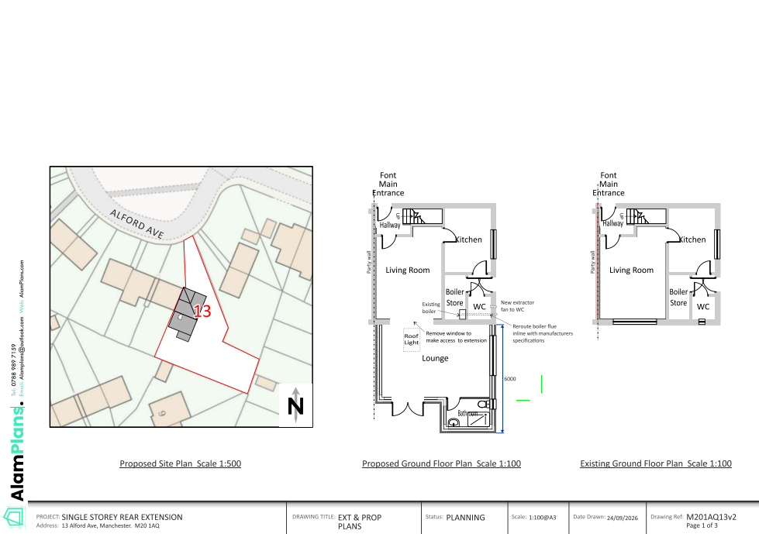
Figure 1. Proposed variation

Relevant planning history

PLA-2026-000297
Erection of a single-storey rear extension.
Approve
2026-08-21

Consultation, notification and publicity responses

Consultations

Flood Risk Management
No response received.

Notifications and publicity

Neighbour letters
No responses received.

Relevant policies
In accordance with Section 38(6) of the Planning and Compulsory Purchase Act 2004, decisions on planning applications must be made in line with the statutory development plan, unless material considerations indicate otherwise.

For Manchester, the development plan comprises:

- The Core Strategy (2012–2027)
- Saved policies of the Unitary Development Plan (UDP)
- The Places for Everyone Joint Development Plan Document (2022–2039)

These documents are considered up to date and carry substantial weight in decision-making. Supplementary Planning Documents (SPDs) and other local guidance may also be relevant.

National planning policy, including the National Planning Policy Framework (NPPF), is a material consideration and provides overarching guidance.

Where applicable, the Council must give special regard to preserving the character of conservation areas and the setting of listed buildings, in line with statutory duties under the Planning (Listed Buildings and Conservation Areas) Act 1990.

The policies referenced in this report are those considered most relevant to the nature, scale and location of the proposed development as follows:

- The Manchester Core Strategy Development Plan Document 2012-2027
  - Development Management and Planning Obligations
    - DM 1 - Development Management
  - Objective 1 - Spatial Principles
    - SP 1 - Spatial Principles (Partially replaced by PfE Policy JP-S 1)
  - Objective 6 Environment
    - EN 1 - Design Principles and Strategic Character Areas
    - EN 14 – Flood Risk (partially replaced by PfE Policy JP-S 4)
    - EN 19 – Waste
- Guide to development in Manchester - supplementary planning document and planning guidance, April 2007
- Extant Unitary Development Plan (UDP) –
  - Citywide Development Control Policies
    - DC1 - Residential extensions
    - DC26 - Development and Noise
- Places for Everyone Plan Joint Development Plan Document 2022-2039-
  - Strategy
    - JP-Strat9: Southern Areas
  - Sustainable and Resilient Places
    - JP-S1: Sustainable Development
    - JP-S4: Flood Risk and the Water Environment
  - Places for People
    - JP-P1 Sustainable Places
- National Planning Policy Framework – August 2026 - National Development Management Policies (NDMPs)
  - Procedural Policies
    - Chapter 3 – Decision-making policies
      - DM1: Preparing development proposals
      - DM2: Information requirements
      - DM3: Determining development proposals
      - DM6: Use of planning conditions and obligations
      - DM7: Relationship with other regulatory regimes
  - Sustainable Development
    - Chapter 4 - Achieving sustainable development
      - S3: Presumption in favour of sustainable development
      - S4: Principle of development within settlements
    - Chapter 5 - Meeting the challenge of climate change
      - CC2: Mitigation of climate change
      - CC3: Adaptation to climate change
  - Creating high quality, sustainable places
    - Chapter 12 - Making effective use of land
      - L2: Making effective use of land
    - Chapter 14 - Achieving well-designed places
      - DP3: Key principles for well-designed places
      - DP4: The design process
  - Conserving and enhancing the environment
    - Chapter 18 - Managing flood risk and coastal change
      - F4: Assessing flood risk for decision-making
      - F6: Development in areas at risk of flooding from rivers or the sea
      - F7: Ensuring development is safe from flooding
      - F8: Sustainable drainage systems and watercourses
- Town and Country Planning Act 1990
  - Part 3 - Control over development
    - Determination of applications
      - Section 73 - Determination of applications to develop land without compliance with conditions previously attached.

Assessment

Principle of Development
Planning permission PLA-2026-000297 was granted on 21 August 2026 for the erection of a single-storey rear extension at the property. The current application seeks to vary Condition 2 of that permission to allow part of the approved extension to project approximately 6.0m from the original rear elevation, rather than approximately 4.35m. The additional projection would therefore be approximately 1.65m in depth and would extend across only approximately 3.1m of the rear elevation, retaining a separation of approximately 3.5m from the shared boundary.
The principle of extending the dwelling has already been established through the extant planning permission. The key consideration is therefore whether the proposed increase in projection would result in any materially different or unacceptable planning impacts when compared with the approved scheme.
It is also a material consideration that a single-storey rear extension projecting up to 6m from the original rear wall may, subject to the relevant limitations, conditions and prior approval requirements, be capable of being undertaken under permitted development rights through the larger home extension process. The proposed maximum projection of 6m therefore provides a relevant fallback consideration. This does not determine the application, which must be considered on its own merits, but weighs in favour of the acceptability of the additional projection where no unacceptable impacts arise.
The principle of the proposed variation is therefore acceptable, subject to consideration of its design, neighbouring amenity and other relevant matters.

Appropriate siting, layout, scale, form, massing, materials, and detail
The approved development comprises a single-storey rear extension projecting approximately 4.35 metres. The variation would increase part of the extension by a further approximately 1.65 metres, resulting in a maximum projection of 6 metres. The additional section would be limited to approximately 3.1 metres in width and would remain approximately 3.5 metres from the shared boundary. It would be finished in matching brickwork and have a flat roof.
While the variation would increase the footprint of the approved extension, the additional element would remain single storey, would occupy only part of the width of the extension and would be wholly positioned to the rear of the dwelling. The part of the extension closest to the shared boundary would retain the lesser projection already approved.
The principal amenity consideration is whether the additional 1.65 metre projection would materially alter the relationship between the approved extension and neighbouring residential properties. The additional section would be limited to approximately 3.1 metres in width and, importantly, would remain approximately 3.5 metres from the shared boundary.
The section closest to the adjoining property would therefore remain as previously approved, substantially limiting the additional effect of the variation on neighbouring living conditions.
Having regard to its single-storey scale, limited width and relationship with the original dwelling, the additional element would not appear disproportionate or unduly dominant. The amended development would remain subordinate to the host dwelling and acceptable in its siting, scale, form, massing, materials and detailing.

Impact on the surrounding areas in terms of the design, scale and appearance of the proposed development. Development should have regard to the character of the surrounding area.
The proposed variation would be positioned wholly to the rear of the dwelling and would have limited visibility from the surrounding public realm. The additional projection would consequently have little influence on the appearance of Alford Avenue or the wider street scene.
The increased depth would not materially alter the character of the approved development, and the continuation of matching materials would ensure that the addition relates appropriately to the host dwelling.
The variation would therefore have no unacceptable impact upon the character or appearance of the dwelling or surrounding area.

Effects on amenity

Privacy
The proposal would remain entirely at ground-floor level. The rear-facing glazing would principally overlook the applicant's own rear garden in a manner typical of residential development.
The variation does introduce a new side facing window however this has similar outlook to previously approved side windows and would not result in any unacceptable additional overlooking or loss of privacy to neighbouring occupiers.

Light
Although the extension would have a greater maximum projection than previously approved, the additional 1.65 metre section would be approximately 3.5 metres from the shared boundary. The part of the extension closest to the adjoining dwelling would retain the depth previously found acceptable.
Given the separation of the additional built form from the neighbouring property, together with its single-storey scale, the variation would not result in a material loss of daylight or sunlight to neighbouring occupiers.
The proposal would therefore have an acceptable impact in respect of light.

Noise
The variation would provide additional floorspace associated with the existing dwellinghouse and would not introduce a different or more intensive use. No material increase in noise or disturbance beyond that reasonably associated with normal residential occupation is anticipated.

Accessibility: buildings and neighbourhoods fully accessible to disabled people, access to new development by sustainable transport modes.
The variation would not alter the existing access arrangements to the dwelling and would not materially change the accessibility considerations associated with the approved development.

Adequacy of internal accommodation and external amenity space.
The variation would increase the internal floorspace of the dwelling while resulting in a further modest reduction in the rear garden. Notwithstanding the increased projection, a usable area of private external amenity space would remain beyond the extension.
The development would therefore continue to provide an appropriate balance between internal accommodation and private external amenity space.

Refuse storage and collection.
The proposed variation would not affect the existing arrangements for domestic refuse storage or collection and would not increase the number of residential units at the property.

Vehicular access and car parking
The proposal would not alter the existing vehicular access or parking arrangements at the property. No additional dwelling would be created, and the variation would not generate a material additional parking demand.

Green Infrastructure including open space, both public and private
The additional projection would occupy a further limited area of the existing rear garden. However, adequate private garden space would remain beyond the development, and the proposal would not affect public open space or wider green infrastructure.

Flood risk and drainage
The application site is located within Flood Zone 2 and the proposal therefore requires careful consideration in relation to flood risk and drainage. The proposed development seeks to vary an extant planning permission for a single-storey rear extension by increasing the depth of part of the approved extension from approximately 4.35m to 6m.
The flood risk implications of extending the dwelling have already been considered under planning permission PLA-2026-000297, where the principle of a single-storey rear extension at the site was accepted. The current proposal would result in a modest increase in the footprint of the approved extension; however, the amendment is limited in scale and does not materially alter the conclusions previously reached regarding flood risk. The development remains ancillary to the existing residential use and would not introduce any highly vulnerable uses or increase occupancy at the site.
Whilst the proposal would result in a small increase in built form within the flood zone, the additional footprint is relatively modest and is not considered to significantly increase flood risk on the site or elsewhere. The submitted Flood Risk Statement remains applicable to the amended scheme and no substantive changes to drainage arrangements are proposed.
It is also a material consideration that the extension, as approved under PLA-2026-000297, has already established the principle of development in this location. Furthermore, a single-storey rear extension of comparable depth could potentially be constructed under permitted development rights, subject to compliance with the relevant provisions of the General Permitted Development Order. This fallback position attracts some weight in the assessment.
Taking these factors into account, it is considered that the limited increase in depth proposed through this application would not materially worsen the flood risk impacts associated with the approved development. On balance, the proposal is considered acceptable having regard to the aims of Policy EN18 of the Core Strategy and the flood risk guidance contained within Chapter 14 of the National Planning Policy Framework.

Other Legislative Requirements

Equality Act 2010
Section 149 (Public Sector Equality Duty) of the Equality Act 2010 requires due regard to the need to: Eliminate unlawful discrimination, harassment and victimisation and other conduct prohibited by the Act and; Advance equality of opportunity between persons who share a protected characteristic and persons who do not share it. The Equality Duty does not impose a legal requirement to conduct an Equality Impact Assessment. Compliance with the Equality Duty involves consciously thinking about the aims of the Equality Duty as part of the process of decision-making.

Human Rights Act 1998 considerations
This application needs to be considered against the provisions of the Human Rights Act 1998. Under Article 6, the applicants (and those third parties, including local residents, who have made representations) have a right to a fair hearing and to this end the local planning authority must give full consideration to their comments.
Protocol 1 Article 1, and Article 8 where appropriate, confer(s) a right of respect for a person’s home, other land and business assets. In taking account of all material considerations, including Council policy as set out in the Core Strategy and saved polices of the Unitary Development Plan, the Director of Planning, Building Control & Licensing has concluded that some rights conferred by these articles on the applicant(s)/objector(s)/resident(s) and other occupiers and owners of nearby land that might be affected may be interfered with but that that interference is in accordance with the law and justified by being in the public interest and on the basis of the planning merits of the development proposal. She believes that any restriction on these rights posed by the recommendation given is proportionate to the wider benefits of and that such a decision falls within the margin of discretion afforded to the Council under the Town and Country Planning Acts.

Planning balance & Conclusion
The proposed variation would increase part of the approved single-storey rear extension from approximately 4.35 metres to a maximum projection of 6 metres. The additional 1.65 metre projection would be limited to approximately 3.1 metres in width and, importantly, would retain approximately 3.5 metres separation from the shared boundary. The section of the extension closest to the adjoining property would therefore remain as previously approved.
The additional built form would remain subordinate to the host dwelling and would not result in unacceptable harm to its character or the appearance of the surrounding area. Having regard to its single-storey scale and separation from the shared boundary, the variation would not result in an unacceptable loss of light, privacy or outlook, or an overbearing impact upon neighbouring occupiers. The variation would not materially alter the conclusions reached in respect of flood risk, access, parking, biodiversity or other relevant planning matters. The potential permitted development fallback for a 6 metre rear extension is also a material consideration which weighs in favour of the proposal. Overall, the amended development remains acceptable and approval is recommended.

Recommendation: Approve

Article 35 Declaration
Officers have worked with the applicant in a positive and proactive manner based on seeking solutions to problems arising in relation to dealing with the planning application. The proposal is considered to be acceptable and therefore determined within a timely manner.

Conditions to be attached to decision for approval

Time - variation
The development must be begun not later than the expiration of three years beginning with the date of planning permission PLA-2026-000297, that date being 21st August 2026
Reason - Required to be imposed pursuant to Section 91 of the Town and Country Planning Act 1990.

Specified plans
The development hereby approved shall be carried out in accordance with the following drawings and documents:
- Location Plan received 12 May 2026;
- Planning DRW ALFOv2, Proposed Drawings received 29 Sept 2026
- d. Flood Risk Statement received 12 May 2026
- Flood Risk Map received 12 May 2026.
Reason - To ensure that the development is carried out in accordance with the approved plans, pursuant to policies DM 1, SP 1 and EN 1 of the Core Strategy and JP-P1 & of Places for Everyone.

Materials to match
The materials used in the external surfaces of the development hereby approved shall be similar in appearance to the existing building in terms of type, size, colour and texture.
Reason - In order to ensure a satisfactory appearance in the interests of visual amenity in accordance with policies SP1 and DM1 of the Core Strategy and the requirements of the National Planning Policy Framework.

Informative(s)

Property Flood Resilience Measures
The applicant is advised to incorporate Property Flood Resilience (PFR) measures to a minimum of 150mm above the surface water flood level or a minimum of 600mm above the fluvial flood level.

