

Planning

Delegated Officer Report

Summary of application details
Application reference: | PLA-2026-001516
Application type: | Full planning permission
Proposal: | Installation of a ground floor fire escape door and canopy, a ground floor link bridge, fire safety alterations including replacement fire-rated windows, installation of external condenser units, and a plant room housing mechanical and electrical equipment, including a chiller, chilled water plate heat exchanger, chilled water pumps, BMS panel and electrical switchgear.
Site address: | Wolfson Molecular Imaging Centre Christie Hospital Manchester M20 3LJ
Ward(s): | Withington
Date application valid: | 02 September 2026
Applicant name: | The Christie NHS Foundation Trust
Agent (if any): | Charlotte Maynard
Case officer: | David Lawless
Recommendation: | Approve
Date of recommendation: | 29 October 2026

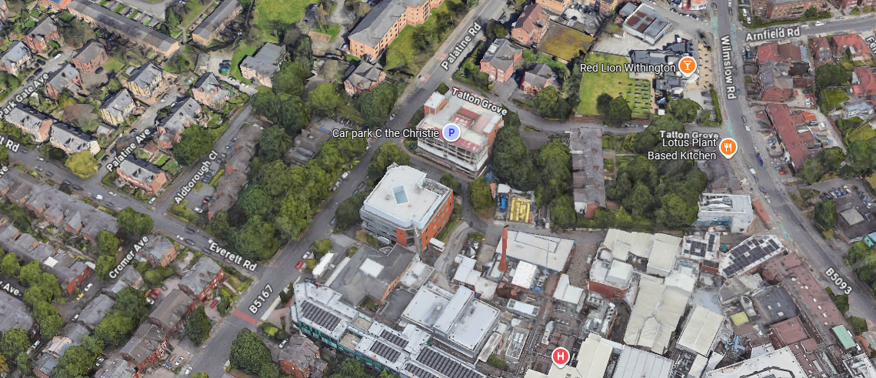

Description of site, building and/or area

This application relates to the Wolfson Molecular Imaging Centre, a facility located within the Christie Hospital estate. This particular building is located on the western half of the hospital estate and fronts Palatine Road.

Hospital buildings are located to the north, east and south of the application site, while to the west, on the opposite side of Palatine Road there is a multi-use building, offering office space.

Description of development

The applicant is proposing the following:

- Installation of a ground floor fire escape door and canopy, a ground floor link bridge, fire safety alterations including replacement fire-rated windows.
- Installation of external condenser units and a plant room housing mechanical and electrical equipment, including a chiller, chilled water plate heat exchanger, chilled water pumps, BMS panel and electrical switchgear.

CGIs of the proposed development are below:

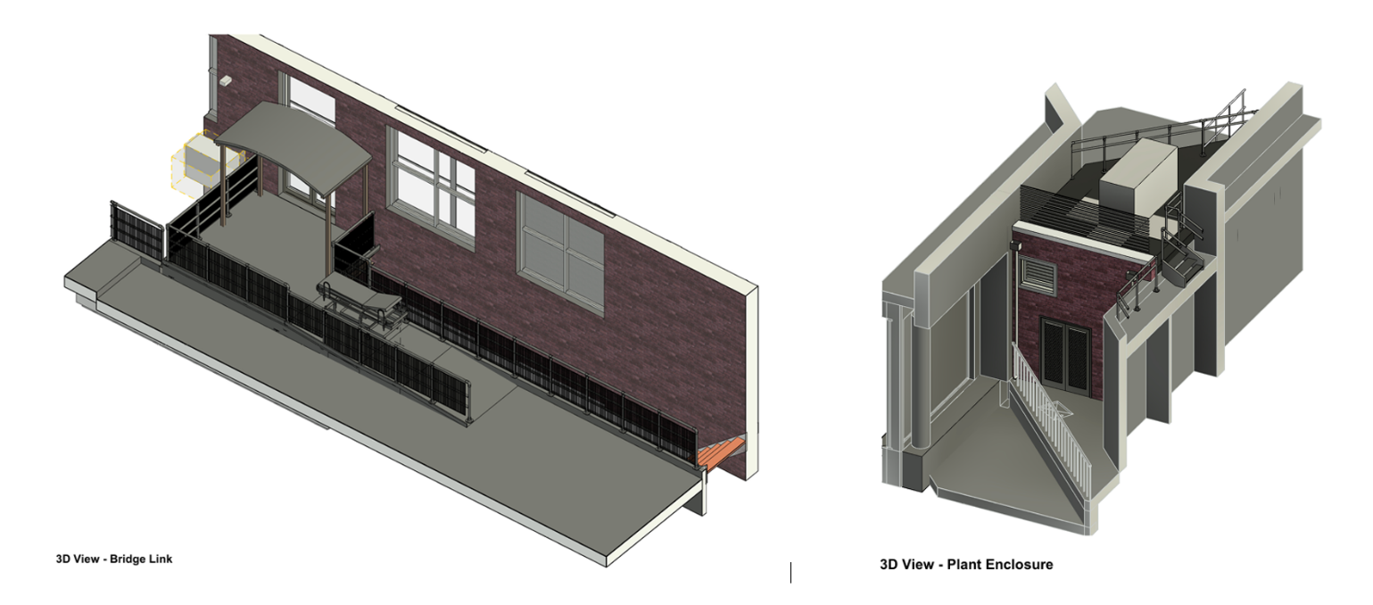

The bridge link would be located on the northern side of the building (red star) while the plant enclosure would be located on the southern side (yellow star)

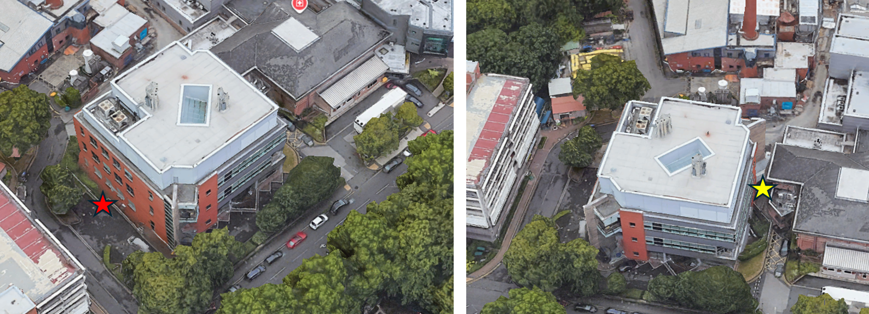

Relevant planning history

144079/FO/2025 - Erection of a single storey plant room extension with an upper plant deck and a canopy located on the south-eastern elevation of the Wolfson building, and bin store to the rear. Relocation of an existing gas bottle store. Replacing a glazed curtain wall panel with an aluminium panel. Construction of a bin enclosure to the north-eastern elevation of the building. Relocation of existing cycle stands and external light bollards. APPROVED 6 January 2026
Consultations

Local Residents/Businesses – No comments received.

Environmental Health – Have suggested the imposition of an acoustic insulation condition.

Flood Risk Management – No objections and requested several informatives be attached to any permission granted.

Highways Services – It is understood that the proposals will be contained within the private boundary of the site and will not have an impact on the existing pedestrian and vehicular access points, circulation, approved car parking, external highway network or the adopted highway. It is anticipated that the proposals are unlikely to generate a significant increase in the level of vehicular trips therefore they do not raise any network capacity concerns.

Relevant policies

National Planning Policy Framework (August 2026)

- Policy DM3 (Determining development proposals)

The Places for Everyone Plan

- Policy JP-Strat9 (Southern Areas)
- Policy JP-P6 (Health)

Core Strategy Development Plan Document

- Policy DM1 (Development Management)
- Policy EN 1 (Design Principles and Strategic Character Areas)
- Policy EN16 (Air Quality)
- Policy SP1 (Spatial Principles)

Saved UDP Policies

- DC26 (Development and Noise)

The following documents are also regarded as material considerations in the assessment of this application.

- The Guide to Development in Manchester (SPD) (2007)
- Manchester Residential Quality Guidance (2016)
- Manchester’s Green and Blue Infrastructure Strategy (2022)
- Manchester City Council Climate Change Action Plan (2020-2025)
- National Design Guide

Assessment

Principle of the Proposal – The principle of the proposed development is considered acceptable. Comparable proposals have previously been approved within the wider hospital complex, including planning permission 144079/FO/2025 on the same building, approved in January 2026.

Notwithstanding the acceptability of the proposal in principle, careful consideration must be given to its potential impact on residential amenity, particularly in relation to noise generated by the proposed plant and equipment.

Residential Amenity – The proposed plant enclosure would be located within the hospital complex and at a sufficient distance (circa 80 metres) from the nearest residential properties such that significant adverse noise impacts are not anticipated. Furthermore, the surrounding context is characterised by existing hospital-related activity and plant infrastructure, which contributes to the prevailing background noise environment. As such, the proposal is not considered likely to give rise to unacceptable harm to the amenity of nearby residents.

Nevertheless, Environmental Health has advised that, in the interests of safeguarding residential amenity and to ensure that noise from the development remains within acceptable limits, it is prudent to impose a condition requiring the implementation of appropriate acoustic insulation and noise attenuation measures. Subject to compliance with this condition, it is considered that the proposal would not have an unacceptable impact on the living conditions of neighbouring occupiers.

Visual Amenity – The proposed fire escape and bridge link on the northern side of the building (circled red below) would be of a simple metal construction and, as such, would not result in any undue harm to the visual amenity of the area.

The condenser units located to the side and rear of the building (circled yellow on the elevation below) would be screened by the proposed balustrading and would not be readily visible from the public realm. Accordingly, their siting in this location would not have a detrimental impact upon visual amenity.

The application of privacy window film (circled green) and the installation of new basement windows (circled blue) would similarly not result in any undue harm to the visual amenity of the building or the surrounding area.

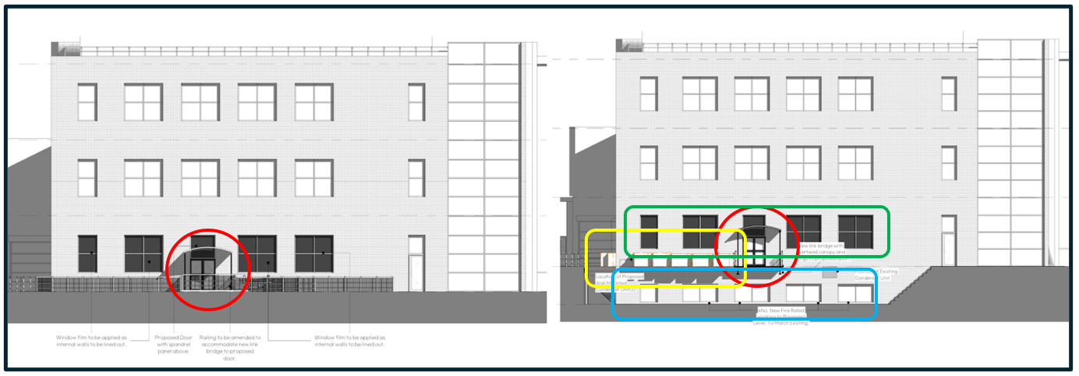

The proposed plant room would be located between two existing hospital buildings and would present only a limited elevation to Palatine Road. Given that the proposed masonry materials would match those of the existing building, together with the restricted visibility of the development from the public realm, it is considered that the proposal would not result in any undue harm to the level of visual amenity enjoyed along this stretch of Palatine Road.

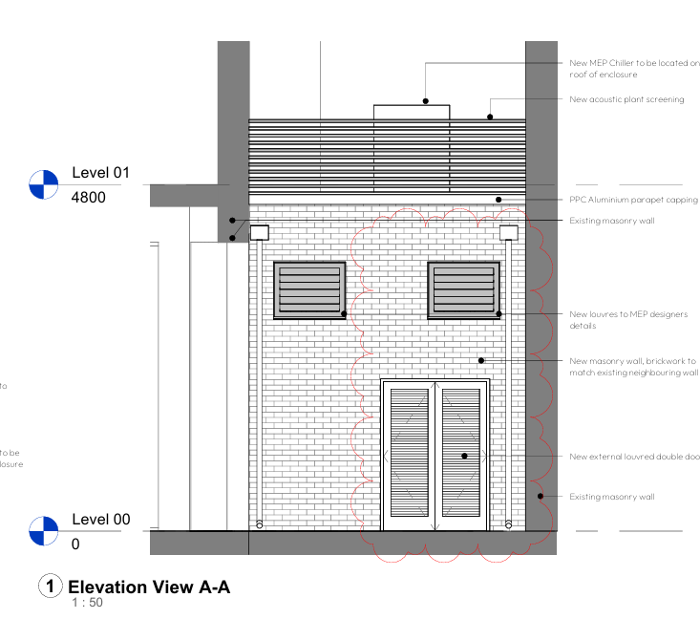

Drainage/Flood Risk – The Informatives suggested by the Flood Risk Management Team would be attached to any approval granted.

Pedestrian/Highway Safety – The proposal does not raise any pedestrian or highway safety concerns.

Other Legislative Requirements

Equality Act 2010 – Section 149 (Public Sector Equality Duty) of the Equality Act 2010 requires due regard to the need to: Eliminate unlawful discrimination, harassment and victimisation and other conduct prohibited by the Act and; Advance equality of opportunity between persons who share a protected characteristic and persons who do not share it. The Equality Duty does not impose a legal requirement to conduct an Equality Impact Assessment. Compliance with the Equality Duty involves consciously thinking about the aims of the Equality Duty as part of the process of decision-making.

Human Rights Act 1998 considerations – This application needs to be considered against the provisions of the Human Rights Act 1998. Under Article 6, the applicants (and those third parties, including local residents, who have made representations) have a right to a fair hearing and to this end the local planning authority must give full consideration to their comments.

Protocol 1 Article 1, and Article 8 where appropriate, confer(s) a right of respect for a person’s home, other land and business assets. In taking account of all material considerations, including Council policy as set out in the Core Strategy and saved polices of the Unitary Development Plan, the Director of Planning, Building Control & Licensing has concluded that some rights conferred by these articles on the applicant(s)/objector(s)/resident(s) and other occupiers and owners of nearby land that might be affected may be interfered with but that that interference is in accordance with the law and justified by being in the public interest and on the basis of the planning merits of the development proposal. She believes that any restriction on these rights posed by the recommendation given is proportionate to the wider benefits of and that such a decision falls within the margin of discretion afforded to the Council under the Town and Country Planning Acts.

Conclusion

The proposed development is considered acceptable in principle and would not result in any undue harm to either residential or visual amenity. Subject to the imposition of a condition requiring appropriate acoustic insulation and noise attenuation measures, the proposal is not considered likely to cause unacceptable impacts on nearby residents. Furthermore, the proposed alterations, plant equipment and plant room enclosure would be appropriately screened or of a design and appearance that would not have an unduly detrimental impact upon the visual amenity of the area.

Article 35 Declaration

Officers have worked with the applicant in a positive and proactive manner based on seeking solutions to issues arising from the consideration of this application.

Recommendation: Approve

Conditions attached to this decision

1) The development must be begun not later than three years beginning with the date of this permission.

Reason - Required to be imposed by Section 91 of the Town and Country Planning Act 1990 (as amended).

2) The development hereby approved shall be carried out in accordance with the following drawings received on 2 September 2026:

a) Location Plan – drawing no. 251001-CRI8-XX-XX-D-A-020001 REV B
b) Existing and Proposed Elevations – drawing no. 251001-CRI8-XX-XX-DR-A-070001 REV C
c) Proposed General Arrangement Plan – drawing no. 251001-CRI8-XX-00-D-A-070002 REV B
d) Proposed External Bridge Plans and Elevations – drawing no. 251001-CRI8-XX-XX-D-A-070004 REV A

and the following drawing received on 27 October 2026:

e) Proposed Plant Enclosure Plans and Elevations – drawing no. 251001-CRI8-XX-XX-D-A-070005 REV B

Reason - To ensure that the development is carried out in accordance with the approved plans. Pursuant to Policies SP1 and DM1 of the Manchester Core Strategy.

3) The materials used in the external surfaces of the development (brickwork and ironmongery) hereby approved shall be similar in appearance to the existing building in terms of type, size, colour and texture.

Reason - In order to ensure a satisfactory appearance in the interests of visual amenity in accordance with Policies SP1 and DM1 of the Manchester Core Strategy and the requirements of the National Planning Policy Framework.

4) a) Externally mounted ancillary plant, equipment and servicing, including that within the plant room, shall be selected and/or acoustically treated in accordance with a scheme designed so as to achieve a rating level of 5dB (LAeq) below the typical background (LA90) level at the nearest noise sensitive location. Prior to commencement of the use hereby approved the scheme shall be submitted to and approved in writing by the City Council as Local Planning Authority in order to secure a reduction in the level of noise emanating from the site. The scheme shall be implemented in full before the use commences or as otherwise agreed in writing by the City Council as Local Planning Authority

b) Prior to the operation of the scheme a verification report shall be submitted to and approved in writing by the City Council as Local Planning Authority to validate that the work undertaken throughout the development conforms to the recommendations and requirements in the approved acoustic report. The report shall also undertake post completion testing to confirm that the noise criteria have been met. Any instances of non-conformity with the recommendations in the verification report shall be detailed along with any measures required to be undertaken prior to operation of the scheme to ensure compliance with the agreed noise criteria.

Reason - To minimise the impact of the development and to prevent a general increase in pre-existing background noise levels around the site, pursuant to Policy DM1 in the Manchester Core Strategy and Saved UDP Policy DC26.

Informatives

1) Flood Risk Management Informative - a) The applicant is advised to incorporate Property Flood Resilience (PFR) measures to a minimum of 150mm above the surface water flood level or a minimum of 600mm above the fluvial flood level.

b) MCC records highlight that the underground Shaw Brook is located within close proximity to the site (approximately 88 m to the Southeast of the site), while our records are frequently updated to ensure the highest level of accuracy, the records cannot guarantee 100% accuracy for all culverted assets. Therefore, we would request that the applicant informs the onsite contractor to remain observant and to take the appropriate safety precautions during excavation works. If any major unknown drainage assets are found beneath the site, then further investigation works should take place to identify the asset and MCC Lead Local Flood Authority (LLFA) should be contacted immediately. Any alterations to an ordinary watercourse will require consent from MCC LLFA under Land Drainage Act 1991. The developer can apply for land drainage consent (if required) via the following link:

https://manchester.portal.uk.empro.verintcloudservices.com/site/myaccount/request/pr_watercourse_land.

2) Highway Services Informative - a) The Applicant is required to discuss and agree any requirements for licensing, hoarding / scaffolding, and skips with MCC's Highways Licensing Team via Email to: highwaylicences@manchester.gov.uk

b) The Applicant is required to discuss and agree any requirements for temporary pedestrian and traffic management with MCC’s Event and Traffic Management Team via Email to highwaynetworkmanagement@manchester.gov.uk

3) Environmental Health Informative - To safeguard the amenities of nearby residents, construction and demolition works shall be confined to the following hours unless otherwise agreed in writing by the City Council:

• Monday - Friday: 7.30am - 6pm
• Saturday: 8.30am - 2pm
• Sunday / Bank holidays: No work

