

Planning

Delegated Officer Report

Summary of application details
Application reference: | PLA-2026-001180
Application type: | Removal/variation of conditions
Proposal: | Variation of Condition 2 (Specified plans) and 4 (noise) attached to Planning Permission 141742/VO/2024 for City Council Development for installation of floor mounted air sourced heat pumps and enclosure to the rear and the installation of solar PV panels to rear pitched roof slope, to increase height and quantities of access doors to acoustic enclosure.
Site address: | Woodville Resource Centre Shirley Road Manchester M8 0NE
Ward(s): | Cheetham
Date application valid: | 04 September 2026
Applicant name: | Mr Robert Renshaw
Agent (if any): | Chloe Reed
Case officer: | Katie Raw
Recommendation: | Approve
Date of recommendation: | 29 October 2026

Description of site, building and/or area
The application site relates to Woodville Resource Centre located within the north Manchester ward of Cheetham. The application site is home to the Sure Start Centre, as well as the Acorn Grove Nursery. The property consist of a L shaped two storey, red brick building with red roof tiles with single storey extensions to the east, south and west. The building is accessible from Shirley Road and the site benefits from a car park to the north of the site, which includes Sheffield cycle loop provision, and areas of soft landscaping surround the building.

The works to be implemented specifically as part of the 141742/VO/2024 application involved the area to the east of the site in between the existing building and the eastern boundary of the site, and the rear /southern pitched roof slope of the main building.

The area subject to the current variation application relates to the area to the east of the site, where the ASHP enclosure has been installed (installation completed 9 February 2025).

Description of development
The current application seeks variation of Condition 2 (Specified plans) and 4 (noise) attached to Planning Permission 141742/VO/2024 for City Council Development for installation of floor mounted air sourced heat pumps and enclosure to the rear and the installation of solar PV panels to rear pitched roof slope, to increase height and quantities of access doors to acoustic enclosure.

The parent application of 141742/VO/2024 approved planning permission for City Council Development for installation of floor mounted air sourced heat pumps and enclosure to the rear and the installation of solar PV panels to rear pitched roof slope.

During the course of the current application, plans were amended to overcome discrepancies, plans were provided to reflect the changes beyond the host permission, as could be seen on site, information was provided in respect to the relocation of an existing shed on the site, and the description of development updated accordingly.

Further relevant planning history
OTH-2026-000381- Non-material amendment to planning approval reference 141742/VO/2024 to amend the size of air source heat pump enclosure
Withdrawn 10 June 2026. The works were not considered non material.

CDN/25/0643- Discharge of Condition 5(b) (bat surveys) attached to planning permission 141742/VO/2024.
Approved 21 August 2025.

142984/JO/2025- Variation of condition 5 (bat surveys) attached to planning permission referenced 141742/VO/2024 to allow the installation of Air Source Heat Pumps to amend the wording to refer to Bat Survey being required prior to works commencing for the installation of the PV array.
Withdrawn 10 July 2025.

095010/FO/2010/N1- Installation of 1 no. wall mounted canopy to south elevation and 1 no. freestanding canopy to centre of play area.
Approved 09.02.2011

083960/FO/2007/N1- Erection of 2.4m high weld mesh perimeter fencing and elevational alterations including entrance canopy.
Approved 22.08.2007

069245/FO/2003/N1- Erection of single storey extensions to existing community centre (Class D2) and change of use to nursery (Class D1). Relocation of existing boundary fence. Approved 14.01.2004.

Further planning history exists for the previous use of the site as an elderly people’s home.

Consultation, notification and publicity responses

Consultations

Highway Services

No objections were raised with the proposed alterations.

Further comments dated 27 October 2026:
Highways had no concerns with the repositioning of the existing shed on a parking space.

Environmental Health

Colleagues raised concerns with the methodology of the submitted plant verification report.
Despite the limitations however, bearing in mind the commentary that it was subjectively inaudible at the boundary of the property, also that all 8 units were in full operation during the measurements when under normal circumstances only 6 would be in use and that the results of the measurements show noise level fluctuated throughout the measurement period, which suggests the plant was not audible above the background Environmental Health can look to accept the assessment.
Colleagues requested confirmation the larger plant enclosures applied for within this application were installed during the measurements as the report suggests the enclosure was the same as originally used in the initial assessment rather than the new larger enclosure.

Further comments dated 28 September 2026:
Accept that the surveys were undertaken with the enlarged acoustic enclosure and can recommend discharge of the condition.

Arboricultural Team

Colleagues requested an AIA /AMA to assess the impact the proposal will have on the trees within the area before making comment from an arboricultural perspective.

Greater Manchester Ecology Unit

No objections were raised with the proposed alterations.

Manchester Airport Safeguarding Officer

No objections were raised with the proposed alterations.

Notifications and publicity

No responses were received from local representatives.

Relevant policies
The National Planning Policy Framework (NPPF) (August 2026)

The document sets out the Government's Planning Policies for England and how these are
expected to be applied.

The purpose of the planning system is to contribute to the achievement of sustainable development, by managing the use and development of land in the long-term public interest.

Achieving sustainable development means that the planning system has three overarching objectives in providing for the homes, commercial development, facilities and infrastructure which society needs. These objectives are interdependent and need to be pursued in mutually supportive ways (so that opportunities can be taken to secure net gains across all three):
a) an economic objective
b) a social objective and
c) an environmental objective.

The following specific chapters and policies are considered to be particularly relevant to the proposed development:
Chapter 3- Decision-making policies- The objective of the policies in this chapter is to ensure that development proposals are informed by appropriate information and decided in a way which is proportionate, timely and effective. This chapter provides a set of general decision-making policies which should be read with the rest of the thematic policies in the other chapters.
>Policy DM3: Determining development proposals
>Policy DM6: Use of planning conditions and obligations

Chapter 4- Achieving sustainable development- The objective of the policies in this chapter is to meet development needs through sustainable patterns of development, including by maximising the potential for growth on suitable land within settlements, enabling development which will support the rural economy, rural communities and the provision of infrastructure, and limiting development away from settlements to help safeguard the intrinsic character and beauty of the countryside.
>Policy S3: Presumption in favour of sustainable development

Chapter 7- Building a strong, effective economy- The objective of the policies in this chapter is to enable businesses to invest, expand and adapt in a way that reflects the opportunities, challenges and characteristics of different areas, and supports long-term economic growth both locally and nationally.
>Policy E2: Meeting the need for business land and premises

Chapter 14 - Achieving well-designed places- The objective of the policies in this chapter is to promote high quality, healthy, inclusive and sustainable places, through setting clear expectations about design outcomes and the use of relevant tools and processes.
>Policy DP1: Achieving Well-Designed Places
>Policy DP2: Designing in Context
>Policy DP3: Key principles for well-designed places
>Policy DP4: The design process

The Manchester Core Strategy Development Plan Document 2012-2027 ("the Core Strategy")
was adopted by the City Council on 11th July 2012. Updated March 2024 following adoption of
Places for Everyone Joint Development Plan

The Core Strategy is the key document in Manchester's Local Development Framework. It
replaces significant elements of the Unitary Development Plan (UDP) as the document that sets
out the long term strategic planning policies for Manchester's future development. Of relevance
are:
Policy DM1 (Development Management
Policy SP1 (Spatial Principles
Policy EN4 (Reducing CO2 Emissions by Enabling Low and Zero Carbon Development);
Policy EN5 (Strategic Areas for low and zero carbon decentralised energy infrastructure);
Policy EN7 (Energy Infrastructure opportunities low and zero carbon decentralised energy
schemes);
Policy EN8 (Adaptation to Climate Change);
Policy T1 (Sustainable Transport);

Unitary Development Plan Saved Policies (1995)

Large elements of the UDP have been superseded by the Core Strategy. The following saved
policies are of relevance in the consideration of this application:
DC26.1 The council intends to use the development control process to reduce the impact of
noise on people living and working in, or visiting, the city. In giving effect to this intention, the
council will consider both
(a) the effect of the new development proposals which are likely to be generators of noise and
(b) the implications of new development being exposed to exiting noise sources which are
effectively outside planning control.
Places for Everyone (2022-2039)

Places for Everyone is a long-term plan of nine Greater Manchester districts for jobs, new
homes, and sustainable growth. It has been published by the GMCA on behalf of the nine
districts and took effect and became part of the statutory development plan on March 21, 2024.
The Plan and its policies are now a material planning consideration in the determination of
planning applications. The Plan and its policies must therefore be given full weight in the
planning balance.

The policies of relevance are:
i.JP- S1- Sustainable development
ii.JP- S2 – Carbon and energy.

Assessment
Principle of Development

The current application seeks variation of Condition 2 (Specified plans) and 4 (noise) attached to Planning Permission 141742/VO/2024 for City Council Development for installation of floor mounted air sourced heat pumps and enclosure to the rear and the installation of solar PV panels to rear pitched roof slope, to increase height and quantities of access doors to acoustic enclosure. The application has been submitted as the works on site vary from those approved under 141742/VO/2024. Such works have impacted the specified plans attached to the host permission decision notice and impacted supporting documentation previously relating to noise output from the acoustic enclosure.

The principle of development has already been approved under host permission
141742/VO/2024 and so this assessment considers only the proposed amendments to the
scheme. Such amendments will now be discussed.

Residential Amenity

The height of the acoustic enclosure would increase by 600mm from 2600mm approved to 3200mm, and the enclosure now has 1 rather than 2 access doors.

The enlarged enclosure would sit close to the windows within the eastern elevation of the host building, however in comparison to the relationship with the windows already approved, any further harm in respect of loss of light from the enclosure would be minimal.

The main amenity concern from the proposed ASHP is the potential noise output, given the
number of ASHPs (8) proposed in one location. To overcome this concern, the proposal
includes the installation of a reinforced concrete plinth acoustic enclosure, which has been increased in height to allow appropriate air and ventilation flows. Colleagues in Environmental Health were satisfied with the results within the submitted verification report, on the basis the surveys were undertaken with the enlarged enclosure in place, which the agent confirmed they were. On this basis, it is not considered the proposal would give rise to adverse noise implications to the detriment of surrounding neighbours/ users of the centre.

Visual Amenity

Whilst the enclosure would have a height larger than that previously approved, it is considered that the ASHPs have been sited in a location to minimise the impact to users of the Centre. As they are located at the rear of the Centre, an area primarily used for bin storage and a few parking spaces, for much of the visitors they would be unaware of the development to
the rear, and the current alteration would not alter any visual harm from the proposal.

Siting, Scale, Design and Appearance

The height of the acoustic enclosure would increase by 600mm from 2600mm approved to 3200mm. Whilst the LPA acknowledge the structure is impressionable, the increase is minimal and the height of the structure is required for the ASHPs and enclosure to work effectively. As such, the siting and scale of the enlargement is considered acceptable.

In addition, 2no. access doors were proposed within the front elevation of the enclosure, however being on site, only 1no. door had been installed. No concern is raised in respect of the design and appearance of the proposal.

Noise

As discussed previously in the report, colleagues in Environmental Health raised no concerns in respect of noise from the enlarged enclosure and the current application is considered acceptable in this regard.

Trees

Colleagues in MCC Arboriculture requested an AIA /AMA to assess the impact the proposal will have on the trees within the area before making comment from an arboricultural perspective. However, the agent confirmed during the course of the application that no additional works were required for the amended proposal and that all works were in line with the original Arboricultural Impact Assessment. As such, it would be considered inappropriate to request further information and conditions relating to the tree works would remain on the decision notice as previously approved.

Changes to Parking Provision following Relocation of Existing Shed

As part of the proposals, the applicant has moved an existing shed from the south of the ASHP enclosure to one of the parking spaces in front of the enclosure (see plans below).

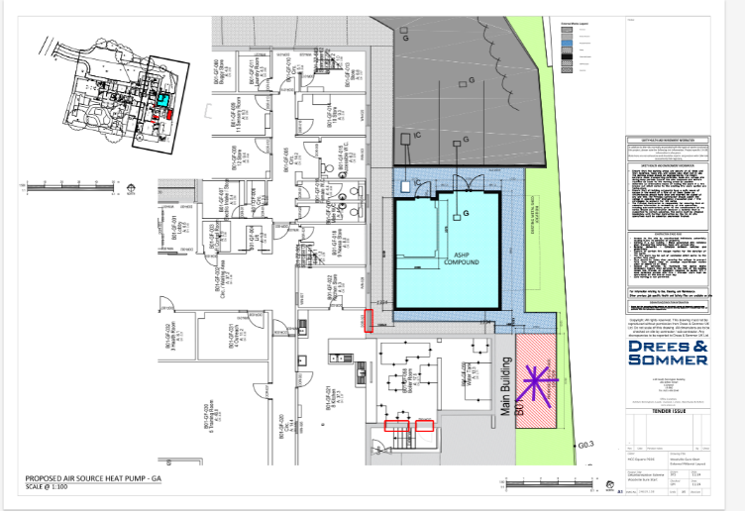
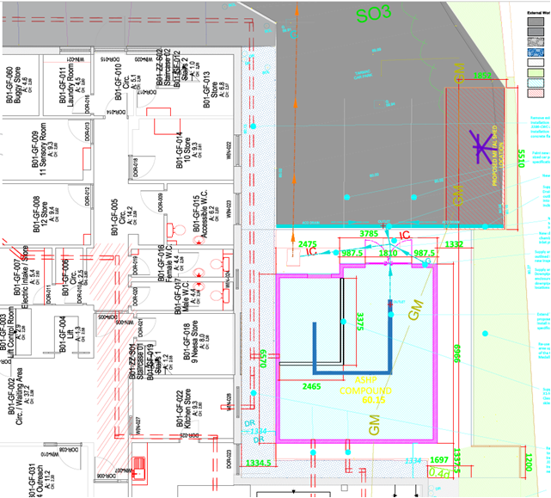

Figure 1. Left hand image: shed location within host permission. Right hand image: shed position as seen on site

The agent has justified such alteration by explaining the shed is an existing shed that was going to be re-located as per the original application. However the location would have hindered the fire escape route so the existing shed was pushed along slightly away from the new ASHP. The slight move has not affected any parking spaces, as the area does not have dedicated or line marked parking spaces.

Colleagues in Highway Services reviewed the alteration and raised no concerns, and as such the current application is considered acceptable.

Other Legislative Requirements

Equality Act 2010
Section 149 (Public Sector Equality Duty) of the Equality Act 2010 requires due regard to the need to: Eliminate unlawful discrimination, harassment and victimisation and other conduct prohibited by the Act and; Advance equality of opportunity between persons who share a protected characteristic and persons who do not share it. The Equality Duty does not impose a legal requirement to conduct an Equality Impact Assessment. Compliance with the Equality Duty involves consciously thinking about the aims of the Equality Duty as part of the process of decision-making.

Human Rights Act 1998 considerations
This application needs to be considered against the provisions of the Human Rights Act 1998. Under Article 6, the applicants (and those third parties, including local residents, who have made representations) have a right to a fair hearing and to this end the local planning authority must give full consideration to their comments.

Protocol 1 Article 1, and Article 8 where appropriate, confer(s) a right of respect for a person’s home, other land and business assets. In taking account of all material considerations, including Council policy as set out in the Core Strategy and saved polices of the Unitary Development Plan, the Director of Planning, Building Control & Licensing has concluded that some rights conferred by these articles on the applicant(s)/objector(s)/resident(s) and other occupiers and owners of nearby land that might be affected may be interfered with but that that interference is in accordance with the law and justified by being in the public interest and on the basis of the planning merits of the development proposal. She believes that any restriction on these rights posed by the recommendation given is proportionate to the wider benefits of and that such a decision falls within the margin of discretion afforded to the Council under the Town and Country Planning Acts.

Article 35 Declaration

The proposal was assessed with regards to policies outlined in the National Planning Policy Framework, Unitary Development Plan Saved Policies, Local Development Framework Core Strategy Development Plan and other material considerations. Officers have worked with the applicant/agent in a positive and proactive manner, further information has been requested in relation to the scheme and appropriate conditions have been placed on the approval granted.

Recommendation: Approve

