

Planning

Delegated Officer Report

Summary of application details
Application reference: | PLA-2026-001600
Application type: | Full planning permission
Proposal: | Erection of single-storey ground floor extension to provide additional SEND teaching space and sensory room.
Site address: | Heald Place Primary School Heald Place Manchester M14 7PN
Ward(s): | Moss Side
Date application valid: | 09 September 2026
Applicant name: | The Board of Governors
Agent (if any): | Mr Liam Kelly
Case officer: | Holly Wright
Recommendation: | Approve
Date of recommendation: | 28 October 2026

Description of site, building and/or area
The application site forms part of Heald Place Primary School in the Rusholme ward of Manchester. The school occupies a split site, with the main teaching accommodation located west of Heald Place and additional school facilities to the east. The site is situated within an established urban area and is surrounded predominantly by residential properties, bounded by Claremont Road to the north, Heald Place to the east, Parkfield Street to the west, and residential properties to the south.

The proposed extension is located within the western part of the school site and will be attached to the existing single storey detached building. The wider school campus includes a mix of historic and modern teaching buildings, areas of hardstanding and play space, and is enclosed by security fencing. The site benefits from established pedestrian links and accessible entrances, including level access and ramps.

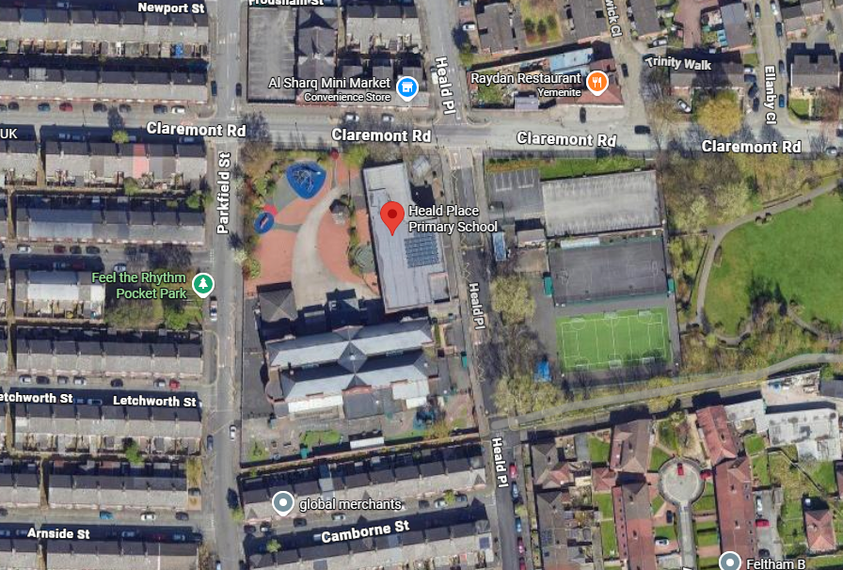
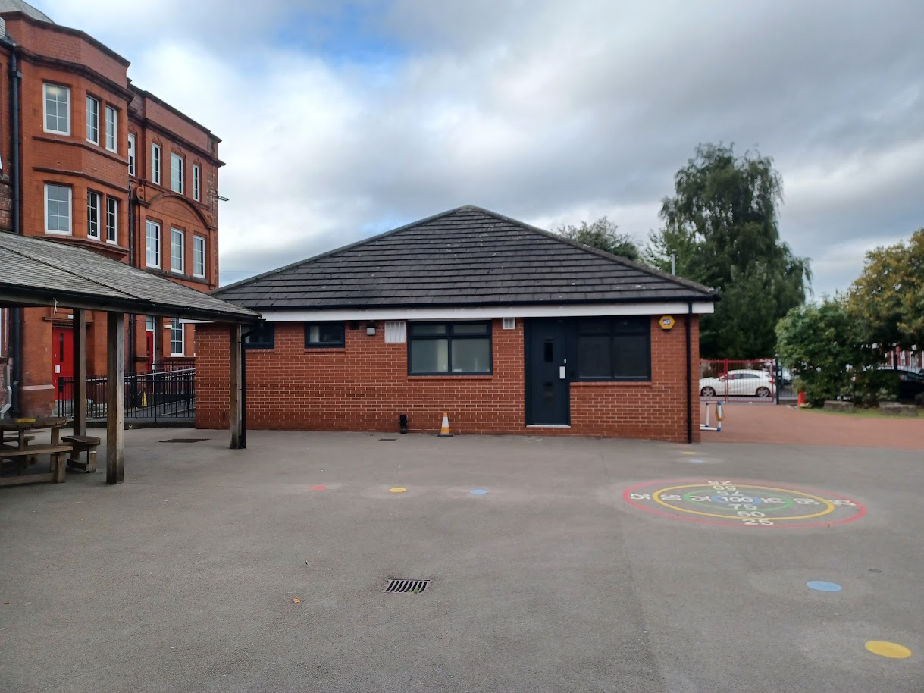
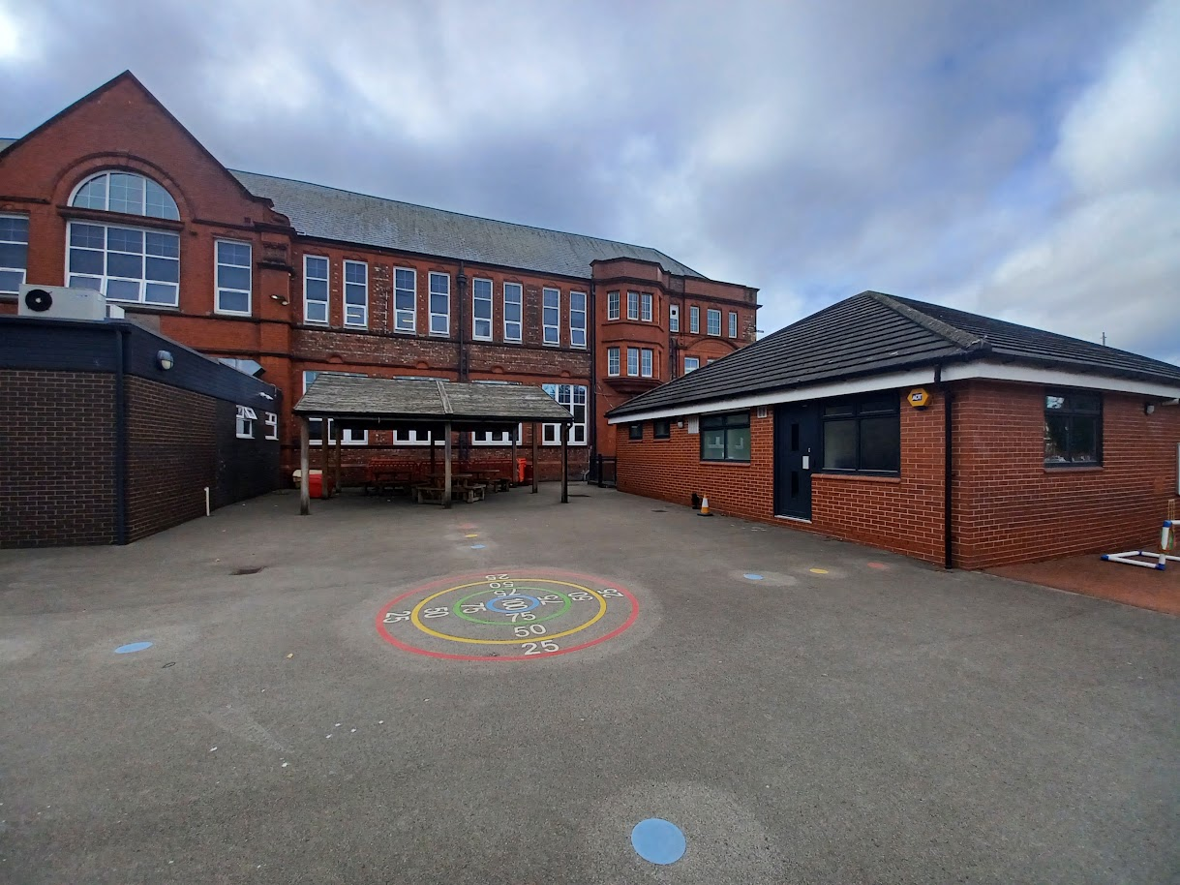

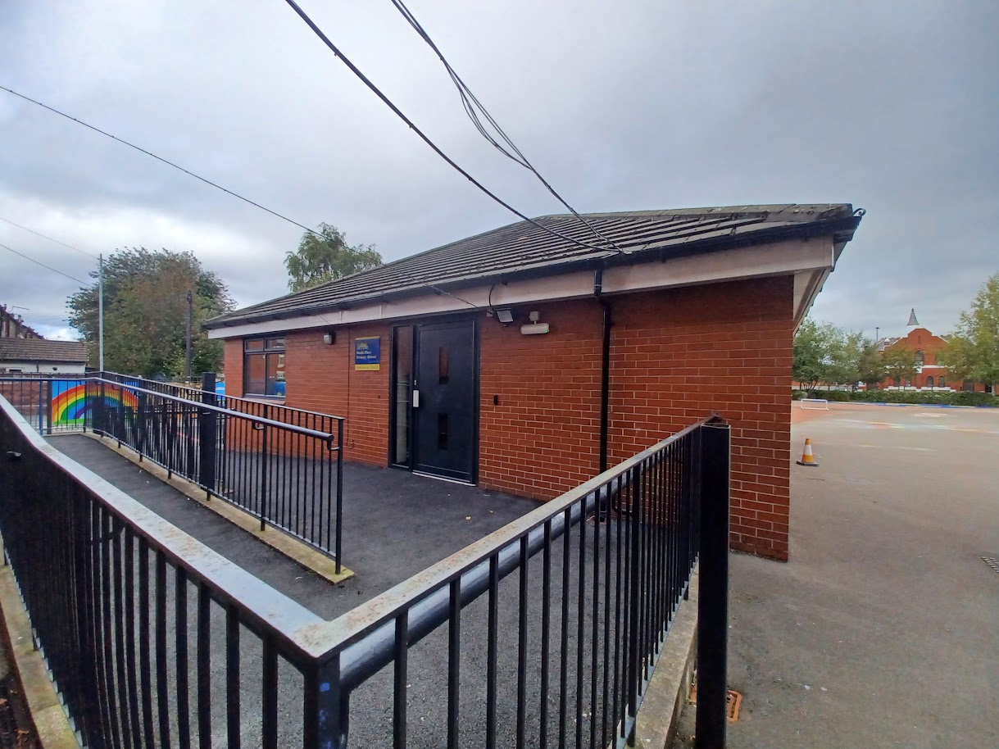

Description of development
The applicant is seeking planning permission for the erection of a single storey ground floor extension to provide additional SEND teaching space and sensory room.

Consultation, notification and publicity responses
Local residents – no responses received.

Highways made the following comments in response to the application:

- *Clarification is sought on whether there will be an increase in pupils and staff numbers associated with the school.
- Existing vehicular and pedestrian access to the site is provided from Heald Place.
- D&A Statement confirms that the proposed development does not require any alterations to the existing vehicular and pedestrian access arrangements.
- *D&A Statement confirms that the existing parking arrangement will remain unaffected – Although further information is required on current parking provision.
- It would be useful to understand the existing number of cycle parking spaces at the site and whether they are secured and covered.
- *It is assumed that refuse storage and delivery/servicing will remain as existing – Confirmation required.
- A Construction Management Plan is required prior to any works taking place and should be conditioned.
Environmental Health recommended a condition relating to the control of construction hours be attached in the event of an approval.

Flood Risk Management advised the proposal can be approved with no recommendation required.

Relevant policies
Unitary Development Plan (UDP) – The UDP has been superseded by the Core Strategy
Development Plan, but certain policies are still considered of relevance:
- Policy DC26 – Development and Noise

The Manchester Core Strategy – Development Plan Document 2012-2027 (“the Core
Strategy”) was adopted by the City Council on the 11th of July 2012:
- Policy DM1 – Development Management
- Policy SP1 – Spatial Principles

Places for Everyone - is a long-term plan of nine Greater Manchester districts for jobs, new
homes, and sustainable growth. It has been published by the GMCA on behalf of the nine
districts and took effect and became part of the statutory development plan on March 21, 2024.
- Policy JP-P1: Sustainable Places

National Planning Policy Framework (NPPF, 2026)
- Chapter 14 – Achieving Well-Designed Places
- Policy DP3: Key principles for well-designed places

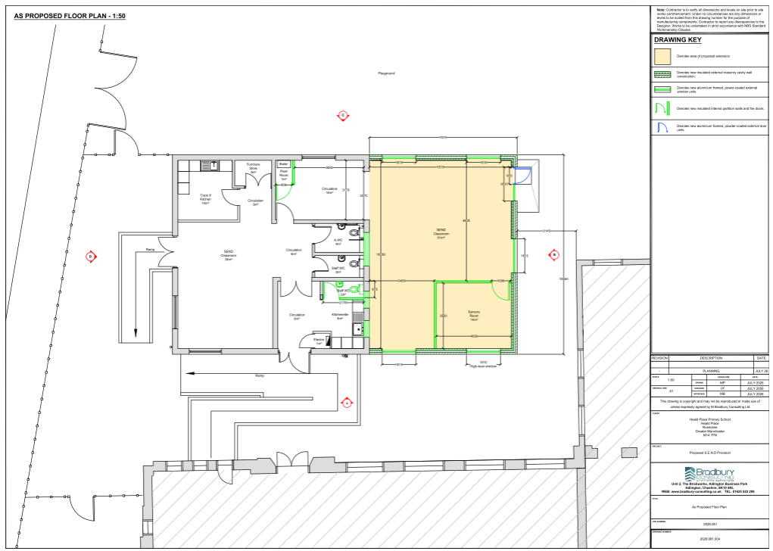
Submitted proposed plan

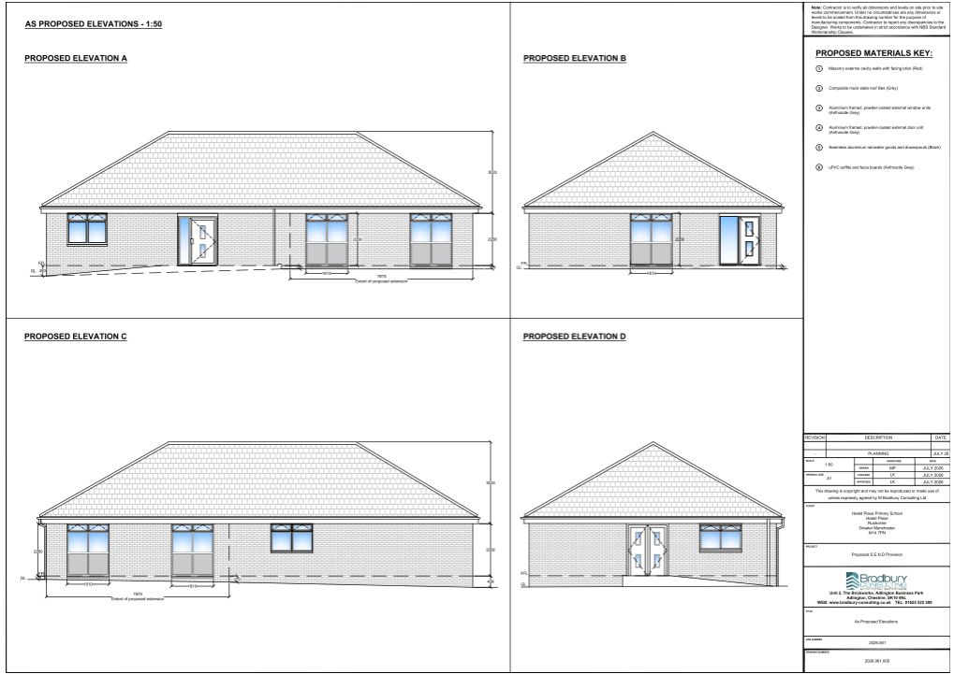
Submitted proposed elevations

Assessment
Principle – the principle of the proposal, to erect a single storey ground-floor extension to provide additional SEND teaching space and sensory room for a school, is acceptable. Notwithstanding this, consideration must be given to the proposal’s siting, scale, and massing, appearance, impact upon visual and residential amenity, waste storage, and parking, amongst other matters

Siting, scale, and massing – the proposed extension would be attached to an existing single storey building within the school grounds and would replace an existing canopy structure located within the playground area. The extension would project approximately 7.8m eastwards from the existing building and measure to 10.6m in length. It would have a hipped roof with a maximum height of 5.9m and an eaves height of 2.26m, matching those of the existing building.

Overall, the siting, scale and massing of the proposal is considered acceptable. Owing to its single storey form and appropriate dimensions, the extension would remain visually subservient within the school grounds and would not appear as an excessively large or bulky addition to the site. Further to this, by virtue of its siting approximately 30m from the nearest residential properties, the proposal would not introduce an overbearing presence within the surrounding area. The proposal would also deliver significant public benefits, including enhanced teaching facilities and improved educational provision at the school.

The proposal therefore accords with policies DM1 and SP1 of the Manchester Core Strategy.

Appearance and visual amenity – the submitted application form states that the extension would be constructed using red engineering facing brickwork to match the existing building. The extension would be served by a pitched, hipped roof finished in artificial slate tiles, including matching hip and ridge tiles. The proposed works would also include the re-roofing of the existing building, resulting in a consistent appearance across the overall development.

The proposed windows and doors would comprise double-glazed units with anthracite-grey powder-coated aluminium frames, matching those already present on the building. Anthracite-grey uPVC fascia and soffit boards would be installed throughout, replacing the existing fascia and soffits, whilst existing rainwater goods would be replaced with black powder-coated seamless aluminium gutters and downpipes.

The northern and southern elevations of the extension would each contain two windows, whilst the eastern elevation would contain two windows and a single door.

The proposal is considered acceptable in terms of its appearance and visual impact. The scale, form, design and palette of external materials would reflect those of the existing building, ensuring that the extension integrates successfully with its surroundings and remains in-keeping with the established character and educational function of the school. Further to this, the replacement roofing, windows, fascia boards and rainwater goods would provide a cohesive and visually consistent appearance across the building.

Given its location within the school grounds, set well back from the public highway and surrounding footpaths, the extension would have limited visibility within the surrounding street scene and public realm. As such, the proposal would not give rise to detrimental impacts upon the visual amenity of the area, nor would it appear as an unduly prominent or dominant feature within the locality.

In addition, any limited visual impacts associated with the proposal would be outweighed by the substantial public benefits arising from the scheme, including the provision of enhanced teaching facilities and improved educational accommodation for the school and its users.

The proposal is therefore considered to accord with policies DM1 and SP1 of the Manchester Core Strategy and the relevant provisions of the National Planning Policy Framework (2026).

Residential amenity – the proposal is considered acceptable in respect of residential amenity. The proposed extension would be located within the school grounds and positioned approximately 30m from the nearest residential properties. Given this distance, together with the single storey scale of the extension, the proposal would not give rise to unacceptable impacts in terms of overshadowing, loss of daylight, loss of outlook, or an overbearing sense of enclosure for neighbouring occupiers.

It should also be noted that any perceived harm caused to the residential amenity of the area as
a result of the proposal would be outweighed by the significant public benefits that the scheme
would produce, including improved teaching facilities for the school and its users.

The proposal therefore accords with policies DM1 and SP1 of the Manchester Core Strategy.

Waste storage – the proposal would not affect the existing waste storage or management arrangements serving the school. This has been confirmed by the agent in email correspondence dated 20 October 2026. Accordingly, no waste management concerns are raised, and the proposal is considered acceptable in this regard.

The proposal therefore accords with policies DM1 and SP1 of the Manchester Core Strategy.

Parking and highways implications – the proposal would not affect the existing parking or cycle storage arrangements serving the school. The agent has confirmed that parking is provided within a dedicated car park located opposite the main school building on Heald Place, comprising 37 standard parking spaces and 2 accessible spaces (39 spaces in total). The school also benefits from a secure covered cycle store within the site, providing parking for up to 10 bicycles.

As the proposal would not result in any changes to existing parking provision, access arrangements or cycle storage facilities, no highway or parking concerns are raised. The proposal is therefore considered acceptable in this regard and accords with policies DM1 and SP1 of the Manchester Core Strategy.

Use – the agent has confirmed that the proposal would not result in an increase in pupil or staff numbers at the school. The extension is intended to provide dedicated accommodation for pupils with Special Educational Needs and Disabilities (SEND) who are already enrolled at the school, together with the staff who support them. The proposal would address an identified shortfall in on-site facilities and enhance the school's ability to meet the needs of its existing pupil cohort, particularly those with complex needs. Accordingly, the proposal would not generate additional demand for parking, servicing, or other infrastructure, and no concerns are raised in respect of the proposed use.

Other matters – Highways requested a Construction Management Plan (CMP) be secured by condition. However, given the limited scale and nature of the proposed extension within an existing school site, it is considered that such a requirement would be disproportionate and unnecessary. The development is unlikely to result in significant construction-related impacts on the highway network or neighbouring amenity and, therefore, a CMP condition is not considered justified in this instance.

Conclusion – given the above issues, it is considered that the proposal is acceptable in terms of its principle, siting, scale and massing, appearance, impact upon visual and residential amenity, waste storage and parking. The proposal complies with saved policy DC1 of the Unitary Development Plan for the City of Manchester, policies DM1 and SP1 of the Manchester Core Strategy and chapter 14 of the National Planning Policy Framework (2026).

Other Legislative Requirements

Equality Act 2010
Section 149 (Public Sector Equality Duty) of the Equality Act 2010 requires due regard to the need to: Eliminate unlawful discrimination, harassment and victimisation and other conduct prohibited by the Act and; Advance equality of opportunity between persons who share a protected characteristic and persons who do not share it. The Equality Duty does not impose a legal requirement to conduct an Equality Impact Assessment. Compliance with the Equality Duty involves consciously thinking about the aims of the Equality Duty as part of the process of decision-making.

Human Rights Act 1998 considerations
This application needs to be considered against the provisions of the Human Rights Act 1998. Under Article 6, the applicants (and those third parties, including local residents, who have made representations) have a right to a fair hearing and to this end the local planning authority must give full consideration to their comments.

Protocol 1 Article 1, and Article 8 where appropriate, confer(s) a right of respect for a person’s home, other land and business assets. In taking account of all material considerations, including Council policy as set out in the Core Strategy and saved polices of the Unitary Development Plan, the Director of Planning, Building Control & Licensing has concluded that some rights conferred by these articles on the applicant(s)/objector(s)/resident(s) and other occupiers and owners of nearby land that might be affected may be interfered with but that that interference is in accordance with the law and justified by being in the public interest and on the basis of the planning merits of the development proposal. She believes that any restriction on these rights posed by the recommendation given is proportionate to the wider benefits of and that such a decision falls within the margin of discretion afforded to the Council under the Town and Country Planning Acts.

Recommendation: Approve

Article 35 Declaration

Officers have worked with the applicant in a positive and proactive manner based on seeking
solutions to problems arising in relation to dealing with the planning application. Minor issues have arisen during the consideration of this application and the officer negotiated with the agent to reach a satisfactory resolution.

Condition(s) to be attached to decision for approval OR Reasons for recommendation to
refuse:

1) 3-year time limit:

The development must be begun not later than the expiration of three years beginning with the
date of permission.

Reason – Required to be imposed pursuant to Section 91 of the Town and Country Act Planning
Act 1990.

2) Specified plans:

The development hereby approved shall be carried out in accordance with the following
documents and drawings:

- ‘As Proposed Floor Plan’, numbered ‘2026.061.004’, received by the City Council as Local Planning Authority on 9 September 2026.
- ‘As Proposed Elevations’, numbered ‘2026.061.005’, received by the City Council as Local Planning Authority on 9 September 2026.
- ‘Design and Access Statement’, received by the City Council as Local Planning Authority on 9 September 2026.

Reason - To ensure that the development is carried out in accordance with the approved plans,
pursuant to policies SP1 and DM1 of the Manchester Core Strategy.

3) Materials:

The materials used in the external surfaces of the development hereby approved shall be similar in appearance to the existing building in terms of type, size, colour and texture.

Reason - In order to ensure a satisfactory appearance in the interests of visual amenity in accordance with policies SP1 and DM1 of the Manchester Core Strategy and the requirements of the National Planning Policy Framework.

Informatives:

1) The applicant is required to discuss and agree any requirements for licensing, hoarding / scaffolding, skips and temporary points of access (Section 50) with MCC's Highways Licensing Team via Email to: highwaylicences@manchester.gov.uk

2) The applicant is required to discuss and agree any requirements for temporary pedestrian and traffic management with MCC’s Event and Traffic Management Team via Email to highwaynetworkmanagement@manchester.gov.uk.

