

Planning

Delegated Officer Report

Summary of application details
Application reference: | PLA-2026-000962
Application type: | Full planning permission
Proposal: | Change of Use from Class C3 to Class C2 (supported housing).
Site address: | 12 Chisholm Street Manchester M11 2LE
Ward(s): | Clayton & Openshaw
Date application valid: | 07 September 2026
Applicant name: | Mrs Reginah Chidemo
Agent (if any): | Mr Sylvester Rukani
Case officer: | Katie Raw
Recommendation: | Refuse
Date of recommendation: | 28 October 2026

Description of site, building and/or area
The application site relates to 12 Chisholm Street within the east Manchester ward of Clayton & Openshaw. The applicant site sits within a Radburn style estate whereby the primary elevation of the property faces into an alleyway to the north as opposed to facing the street of Chisholm Sreet, with the gable elevation of the dwelling sited against Weaver Walk.

The application site relates to a two storey, gable roof dwellinghouse constructed of red brick with an outhouse/ outrigger attached to both the front and rear elevations. The site is bounded by railings upon of low brick walls to the front and a high brick wall to the rear. The property currently comprises of living areas on the ground floor, and 3 bedrooms and a bathroom on the first floor.

The immediate context is residential in nature, with the arterial road of Ashton Old Road sited further to the north of the site. The immediate context has a range of property types, including Radburn style estates, terraced properties and newer age properties to the west.

Description of development
The current application seeks planning permission for Change of Use from Class C3 to Class C2 (supported housing).

Relevant planning history
No planning history can be found for this site.

Consultation, notification and publicity responses

Consultations

Environmental Health

Environmental Health confirmed they had no comments to make on the application.

Highway Services

The proposed change of use from a single dwelling (C3) to (C2) supported housing is not anticipated to result in a material increase in vehicle trip generation.

The site is considered to be in a sustainable and accessible location, with a range of transport options available. Frequent bus services are available within walking distance of the site.

No vehicle access for the property. Sufficient opportunities for on-street parking are available in the vicinity of the site, as the surrounding roads are not subject to waiting restrictions.
Provision should be made for secure and sheltered cycle parking. As a minimum, cycle parking should be provided for staff and residents, proportional to the scale of the proposed use. Details of the location, layout, and security of cycle storage should be secured by condition.
There is no bin storage location shown on the submitted plans, therefore details of the proposed refuse and recycling storage and collection point should be submitted and shown on an updated dimensioned plan.

Informatives on Construction Management were provided for the applicant’s review.

MCC Supported Housing (Children's Homes)

The Children's Commissioning Team do not support this application. The position is informed by Manchester City Council's current assessment of sufficiency and market capacity, which identifies an existing oversupply of children's residential provision within Manchester and a need to ensure that any new provision is strategically aligned to evidenced local need.
In particular, the Team has concerns regarding the concentration of children's homes within the immediate M11 locality. There are already four registered children's homes operating within this area, located at:
• M11 1HN
• M11 1HZ
• M11 1NT
• M11 1HL
The proposed development would further increase the clustering of children's residential provision within a relatively small geographical area. Children's Commissioning does not consider this proposal to address an identified gap in local provision and therefore does not support the establishment of an additional children's home in this locality.

Notifications and publicity
No responses were received from local representatives.

Relevant policies
The National Planning Policy Framework (NPPF) (August 2026)

The document sets out the Government's Planning Policies for England and how these are
expected to be applied.

The purpose of the planning system is to contribute to the achievement of sustainable development, by managing the use and development of land in the long-term public interest.
Achieving sustainable development means that the planning system has three overarching objectives in providing for the homes, commercial development, facilities and infrastructure which society needs. These objectives are interdependent and need to be pursued in mutually supportive ways (so that opportunities can be taken to secure net gains across all three):
a) an economic objective
b) a social objective and
c) an environmental objective.

The following specific chapters and policies are considered to be particularly relevant to the proposed development:
Chapter 3- Decision-making policies- The objective of the policies in this chapter is to ensure that development proposals are informed by appropriate information and decided in a way which is proportionate, timely and effective. This chapter provides a set of general decision-making policies which should be read with the rest of the thematic policies in the other chapters.
>Policy DM3: Determining development proposals
>Policy DM6: Use of planning conditions and obligations

Chapter 4- Achieving sustainable development- The objective of the policies in this chapter is to meet development needs through sustainable patterns of development, including by maximising the potential for growth on suitable land within settlements, enabling development which will support the rural economy, rural communities and the provision of infrastructure, and limiting development away from settlements to help safeguard the intrinsic character and beauty of the countryside.
>Policy S3: Presumption in favour of sustainable development

Chapter 6- Delivering a sufficient supply of homes- The objective of the policies in this chapter is to support the delivery of a substantial increase in the supply of homes and traveller sites, by ensuring that a sufficient amount and variety of land can come forward where needed. This includes planning for an appropriate mix of accommodation for the local community and ensuring that land with permission is developed without unnecessary delay.
>Policy HO7: Meeting the need for homes

Chapter 12- Making effective use of land- The objective of the policies in this chapter is to promote the effective use of land in meeting the need for homes and other uses, while safeguarding and improving the environment and ensuring safe and healthy living conditions.
>Policy L2: Making effective use of land

Chapter 14 - Achieving well-designed places- The objective of the policies in this chapter is to promote high quality, healthy, inclusive and sustainable places, through setting clear expectations about design outcomes and the use of relevant tools and processes.
>Policy DP3: Key principles for well-designed places
>Policy DP4: The design process

Places for Everyone (2022-2039)

Places for Everyone is a long-term plan of nine Greater Manchester districts for jobs, new homes, and sustainable growth. It has been published by the GMCA on behalf of the nine districts and took effect and became part of the statutory development plan on March 21, 2024.

The Plan and its policies are now a material planning consideration in the determination of planning applications. The Plan and its policies must therefore be given significant weight in the planning balance.

No policies are considered directly applicable in this instance.

The Manchester Core Strategy Development Plan Document 2012-2027 ("the Core Strategy")
was adopted by the City Council on 11th July 2012. Updated March 2024 following the adoption
of the Places for Everyone Joint Development Plan.

The Core Strategy is the key document in Manchester's Local Development Framework. It
replaces significant elements of the Unitary Development Plan (UDP) as the document that sets
out the long term strategic planning policies for Manchester's future development.

Of relevance are:
Policy SP1 (Spatial Principles) (last bullet point of the policy removed following the adoption of
the Places for Everyone Joint Development Plan),
Policy EN1 (Design Principles and Strategic Character Areas),
Policy DM1 (Development Management),
Policy H1 (Overall Housing Provision (partially replaced by PfE Policy JP-H1),
Policy H4 (East Manchester),
Policy H10 (Housing for people with additional support needs),
Policy EN19 (Waste).

Extant Unitary Development Plan (UDP) (1995)

Saved policies from the City Councils UDP.
Policy DC2 (Rest Homes and Nursing Homes)- Relates to planning applications for rest homes, nursing homes and other uses within Class C2 of the Use Classes Order. The Council will have regard to the provision of rest homes and nursing homes where the proposed building is suitable in terms of its size and layout, and where the use can operate without causing unacceptable harm to neighbouring residents. In assessing proposals, the Council considers issues such as noise and disturbance, traffic generation, parking, servicing arrangements, access, and the impact on the character and amenity of the surrounding residential area. The policy seeks to balance the need for specialist care accommodation with the protection of established residential neighbourhoods, ensuring that care home developments are appropriately located and integrated into their surroundings.

Policy DC26 (Development and Noise)- Aims to reduce the harmful effects of noise through the planning process by carefully managing how different land uses are located in relation to each other. The policy resists new noise‑sensitive development, such as housing, schools or hospitals, in locations where they would be exposed to unacceptably high existing noise levels, unless effective mitigation can realistically be achieved. Equally, it seeks to prevent new noisy development from harming established residential areas or other quiet, sensitive locations. Where noise impacts are likely, applicants may be required to submit a noise assessment and incorporate appropriate mitigation measures, such as layout changes, sound insulation, screening or limits on operating hours, to ensure a satisfactory standard of amenity is provided.

The Special Needs and Supported Housing Policy (1998) and Supplementary Planning Guidance

The Guidance states that the City Council wishes to ensure that the City's various communities remain, or become more, sustainable in economic and social terms. In this respect, whilst generally welcoming housing developments which will provide accommodation for people with special needs in appropriate locations, the Council will seek to avoid an over-concentration of such provision in any one area.

Assessment
Principle of Development

Section 38(6) Planning and Compulsory Purchase Act 2004 requires that decisions are to be made in accordance with the development plan, unless material considerations indicate otherwise. This is reinforced by paragraph 3 of the National Planning Policy Framework.

In this case, the principle of the proposed development is considered unacceptable and contrary to the aforementioned development plan policies and supporting guidance.

The proposed conversion of the property to supported accommodation (Use Class C2) would result in the loss of a family sized dwelling within an area where the retention of such housing is important to support the Council's housing objectives. The surrounding area is predominantly characterised by family homes, and the proposal would further reduce the stock of such accommodation whilst increasing the concentration of supported housing within the locality.

Further, the proposal would contribute to an overconcentration of this type of accommodation (Use Class C2) in this part of the city. The continued clustering of supported housing would undermine the balance of uses necessary to create and maintain sustainable neighbourhoods and would be detrimental to the character and function of the immediate area.

In addition, the site plans within the submitted plans are inaccurate (although the submitted location plan with site edged red is correct).

On this basis, the proposal is considered to conflict with saved policy DC2 of the Unitary Development Plan for the City of Manchester, policies H4, H10, DM1 and SP1 of the Manchester Core Strategy, and the National Planning Policy Framework (NPPF). There are no material considerations to indicate otherwise.

The principal issues of concern are outlined further below.

Residential Amenity (and Comings and Goings)

The immediate context is residential in nature. The immediate context has a range of property types, including Radburn style estates, terraced properties and newer age properties to the west.

The proposed C2 use would comprise a single-occupancy children's home operating within Use Class C2, providing care and accommodation for one child. The home will be staffed on a 24-hour basis by suitably qualified and trained residential care staff. At any one time, there will typically be a maximum of two residential care workers present on site, depending on the
assessed needs and risk profile of the child resident. Staffing levels will be maintained in accordance with the child's placement plan, safeguarding requirements, and relevant regulatory standards. Staff will operate on a rotational shift pattern, typically comprising: Day Shift: 08:00 to 20:00, Night Shift: 20:00 to 08:00.

Given the property as existing has 3 bedrooms, the number of comings and goings associated with the C2 use would not be considered to be significantly beyond what could be expected for a family dwellinghouse. However, this assumption is made on the basis there is only 1 child, as use class C2 does not restrict the number of children (as use class C3b does). On the basis of the application as submitted, any harm in relation to existing residential amenity of the surrounding properties including harm from comings and goings is not considered to be significant.

Housing Balance and the Loss of Family Accommodation

As a result of the proposal, 12 Chisholm Street would no longer be available for rent/sale for single family purposes. Policy H4 of the Core Strategy sets out requirements for new housing development in East Manchester. East Manchester, over the lifetime of the Core Strategy, will accommodate around 30% of new residential development. Priority will be given to family housing and other high value, high quality development where this can be sustained.

The Housing Need and Demand Assessment 2010 (Arc4) shows there is a need for 3-4 bed family housing, which the applicant property offers. There is huge demand across the city for larger homes, demonstrated by the waiting list for social housing, highlighting that demand significantly outstrips supply.

The Manchester Move website provides advice on available properties in Manchester and is used by the City Council’s Housing and Residential Growth service as a data source, reflecting the Manchester Housing Register. The latest figures extracted from the website shows an extremely high demand for social housing in Manchester with over 15,000 live applications on the Manchester Housing Register. The table below highlights the number of households on the Manchester Housing Register, by their band and the size of property applicants need. The applicant site has 3 bedrooms unmodified. Figure 1 shows that for a 3 bedroom property 2,771 applicants were waiting for a 3 bedroom property as per the information dated August 2026.

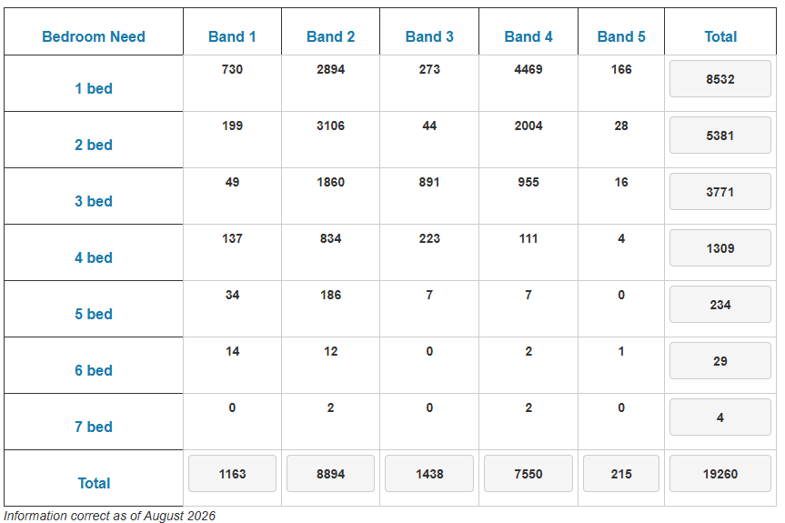

Figure 1. Number of households on Manchester Housing Register, by band and size of property

The application property is therefore a dwellinghouse suitable for a larger family and the proposal in this case would see the loss of such. Whilst these figures are based on the supply of social housing, there is inevitably an intrinsic relationship between the availability of family homes for sale or rent in the private sector, and the demand for housing.

An important policy objective of the City Council is to improve the quality of housing stock in the city and to deliver a more sustainable housing market. This can be achieved by increasing the amount of family housing stock on offer and by providing for choice through a range of accommodation. This would allow for more balanced and cohesive neighbourhoods that provide for stronger and safer communities. The loss of a family house in this area would conflict with this aspiration, undermine the policy objectives for the area and increase the threat of existing families being driven out of the area, or from being attracted to the area, due to a shortage of appropriate accommodation. Whilst the effect of the loss of a single home on the overall mix and balance of housing in the area would be limited, it would nevertheless contribute to the shortfall.

Whilst the applicant considers that the proposal would provide a valuable care facility and operate in a manner similar to a dwellinghouse, this does not overcome the concerns identified by the Council. The proposal would result in the permanent loss of a family sized dwelling within the housing stock and insufficient evidence has been provided to demonstrate that there is no reasonable prospect of the property continuing to serve its lawful residential use. The social benefits associated with the provision of specialist children's and adult care accommodation are acknowledged but these benefits do not outweigh the harm arising from the loss of a dwellinghouse where a continuing demand for family housing exists.

Although the proposal would continue to provide accommodation, it would no longer be available for occupation as a dwellinghouse within the general housing market. The proposal would therefore result in the loss of a Class C3 dwelling irrespective of whether residential accommodation remains on site. The suggestion that the loss of a single property is insignificant overlooks the fact that the same argument could be advanced in respect of every individual dwelling converted to an alternative use. The cumulative effect of such losses is therefore a legitimate planning consideration as whilst both uses are residential in nature and may outwardly appear similar in operation, they are distinct planning use classes serving different functions and meeting different forms of accommodation need. The proposal would therefore remove a family dwelling from the city's housing stock and replace it with specialist residential accommodation

In addition, the proposal would introduce a specialist institutional use into an established residential area. By virtue of its nature and operational characteristics, the use would not be fully comparable to a conventional dwelling and would alter the established residential function of the property. The applicant has not demonstrated that the proposal would preserve the character of the area or avoid contributing to an overconcentration of such facilities where this has been identified as a concern.

The Council is therefore of the view the proposed change of use would result in the loss of a family sized dwellinghouse which would reduce the standard and availability of such housing in the area, undermining the provisions of policies H4, DM1 and SP1 of the Manchester Core Strategy, which seek to provide an appropriate mix and balance of housing provision in the locality, in order to maintain a sustainable, viable neighbourhood and cohesive housing market. On this basis, the proposed change of use is considered unacceptable.

Oversupply

Overarching policy and guidance relating to supported living provision is contained within saved policy DC2.1 of the Unitary Development Plan, policy H10 of the Manchester Core Strategy and Supplementary Planning Guidance contained within The Special Needs and Supported Housing Policy (1998).

A principal thread running through these documents is the need to seek to avoid an over-concentration of such provision in any one area and to ensure an evener spread of ‘special need’ accommodation within local areas and across the city as a whole.

In this case, the proposed development would result in an over concentration of this particular type of care within this area of the city. The MCC Supported Housing (Children's Homes) Team raised concerns regarding the concentration of children's homes within the immediate M11 locality. The Team identified four registered children's homes operating within this area, located at: M11 1HN, M11 1HZ, M11 1NT and M11 1HL, noting that the applicant site has a postal address of M11 2LE. The identified alternative provisions are located approximately between a 6 to 16 minute walk from the applicant site.

It is considered that further provision for the care of children would lead to the clustering and accumulation of such accommodation in the immediate area which would be harmful to the character of this immediate area and the local balance of uses, as part of creating sustainable, cohesive neighbourhoods.

As outlined previously Manchester currently has an oversupply of children's residential provision and, following a review of local sufficiency and market capacity, the Council does not currently support the development of additional children's homes unless they can clearly demonstrate that they meet a specific and evidenced gap in provision. The assessment of sufficiency is undertaken on a city-wide basis rather than by individual neighbourhoods or postcode areas.

In relation to this particular proposal, there is already four existing children's homes operating in very close proximity to the proposed site. Whilst the primary position is based on the overall sufficiency picture across Manchester, as a City we would also seek to avoid further clustering of children's homes within the same immediate area wherever possible. It is considered that a concentration of children's homes in such close proximity to be inconsistent with our strategic approach to service development and placement sufficiency.

On the basis of the lack of support provided by SNMG and the information on the nature and location of similar accommodation situated locally, it is considered that the introduction of the proposed use would lead to an over concentration of such uses in the immediate area, which in turn would adversely affect the character of the area, upsetting the balance of uses within a key residential neighbourhood.

Whilst it is accepted that the process of registering and operating a children's or adult care home is separate from the planning process, the planning system is nevertheless entitled to consider evidence relating to need, demand and the suitability of a proposal in the context of wider service provision, as identified within Policy H10 of the Core Strategy. In this respect, Children's Commissioning has advised that there is an oversupply of this type of accommodation within Manchester and the proposal does not consider the proposal to address an identified gap in local provision.

As the specialist body responsible for assessing accommodation requirements for looked-after children and adults across the city, significant weight can reasonably be afforded to its professional advice.

The Council's concern is not solely the numerical proportion of children's homes within the city, but whether additional provision is required in light of existing capacity and whether there is a balanced distribution of such facilities across Manchester. The concentration of children's homes within a particular area remains a material consideration, particularly where specialist officers within the Council have identified concerns regarding oversupply and clustering.

The Council acknowledges that future demand for children's home and adult provision can fluctuate and that sufficient accommodation must be available to meet emerging needs.

As such, the proposal has not demonstrated that the loss of a family dwellinghouse is justified by an identified need for additional children's home provision in this location. The professional advice of the MCC Children's Commissioning Team indicates that sufficient capacity already exists and that further provision within the M11 area is neither necessary nor strategically supported at this time.

Inaccurate Information

The Town and Country Planning (Development Management Procedure) (England) Order 2015 (as amended) provides general requirements for the submission of planning applications and states that “an application for planning must….be accompanied by…. 7(1c)(ii) any other plans, drawings and information necessary to describe the development which is the subject of the application”. In addition, national decision making policy DP4 states “The local planning authority should… b. Ensure that relevant planning conditions refer to clear and accurate plans and drawings which provide visual clarity about the design of the development”.

With this in mind, it is considered that the information submitted under this application fails to meet the requirements set out in this Order and the NPPF, as the existing and proposed site plan does not reflect the correct location of the applicant site. Whilst the submitted location plan identifies the correct property (see Figure 2), the existing and proposed site plan within drawings outlines a property that is not the applicant property (see Figure 3). Whilst the agent was given the opportunity to amend the plans, the error was not addressed within the revised proposed drawings received 21 October 2026.
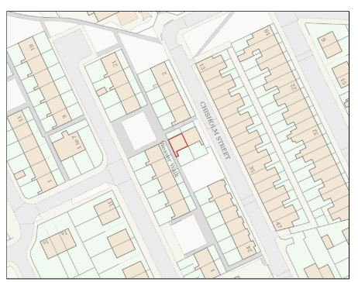

Figure 2, Submitted Location Plan

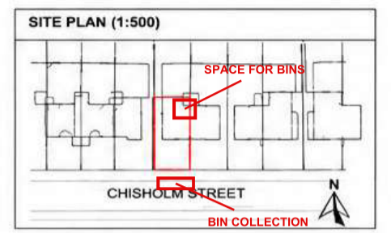
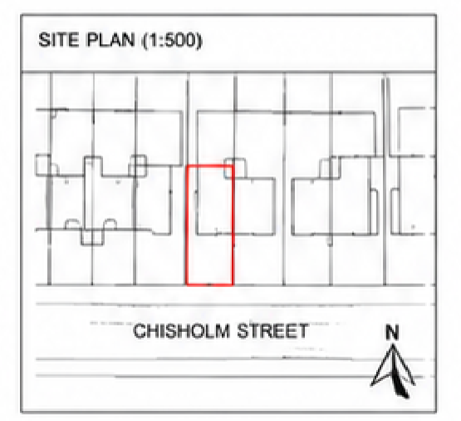

Figure 3, Left hand image: site plan shown within existing drawings. Right hand image: site plan shown within proposed drawings

Therefore, given the quality and accuracy of the submitted information, the City Council is unable to support this application, as it conflicts with the principles set out under the Town and Country Planning (Development Management Procedure) (England) Order 2015 (as amended), and provisions within the NPPF.

Other Legislative Requirements

Equality Act 2010
Section 149 (Public Sector Equality Duty) of the Equality Act 2010 requires due regard to the need to: Eliminate unlawful discrimination, harassment and victimisation and other conduct prohibited by the Act and; Advance equality of opportunity between persons who share a protected characteristic and persons who do not share it. The Equality Duty does not impose a legal requirement to conduct an Equality Impact Assessment. Compliance with the Equality Duty involves consciously thinking about the aims of the Equality Duty as part of the process of decision-making.

Human Rights Act 1998 considerations
This application needs to be considered against the provisions of the Human Rights Act 1998. Under Article 6, the applicants (and those third parties, including local residents, who have made representations) have a right to a fair hearing and to this end the local planning authority must give full consideration to their comments.

Protocol 1 Article 1, and Article 8 where appropriate, confer(s) a right of respect for a person’s home, other land and business assets. In taking account of all material considerations, including Council policy as set out in the Core Strategy and saved polices of the Unitary Development Plan, the Director of Planning, Building Control & Licensing has concluded that some rights conferred by these articles on the applicant(s)/objector(s)/resident(s) and other occupiers and owners of nearby land that might be affected may be interfered with but that that interference is in accordance with the law and justified by being in the public interest and on the basis of the planning merits of the development proposal. She believes that any restriction on these rights posed by the recommendation given is proportionate to the wider benefits of and that such a decision falls within the margin of discretion afforded to the Council under the Town and Country Planning Acts.

Conclusion
Given the above reasons, the local planning authority recommends the application is refused in a timely manner.

Article 35 Declaration
Officers have informed the agent that the proposal is fundamentally unacceptable, and therefore no negotiations in this instance would resolve the problems arising in relation to dealing with the planning application. The proposal is considered to be contrary to the development plan and therefore refused in a timely manner.

Recommendation: Refuse

