

Planning

Delegated Officer Report

Summary of application details
Application reference: | PLA-2026-001423
Application type: | Householder planning permission
Proposal: | Elevational alterations to side and rear elevations to form new doors and windows, with new boundary fence to side elevation, following demolition of single-storey elements to side and external ramps.
Site address: | 645 Wilmslow Road Manchester M20 6BA
Ward(s): | Didsbury East
Date application valid: | 08 September 2026
Applicant name: | Mr Usman Butt & Mrs Samira Butt
Agent (if any): | Mr Simon Miles
Case officer: | Holly Wright
Recommendation: | Approve
Date of recommendation: | 28 October 2026

Description of site, building and/or area
The application relates to a part-two / part-three storey detached property of redbrick with a red tile dual pitch roof with gable end features and hanging tile to the front, side, and rear.
The property features white timber-framed windows and doors, including a three-storey angular
bay, a two-storey squared bay, and an angular loft level bay to the front, a decorative front
porch canopy, an access ramp and stairs to the front, side and rear, a converted basement /
lower-ground floor, a single storey side and rear extension, and a spacious tarmacadam parking
area to the rear with the site itself also featuring mature trees and landscaping.

The property is situated within the Didsbury East ward, close to Didsbury Village, Fog Lane Park, and Barlow Moor Road. The property is not listed, nor is it site within a Conservation Area. The character of the surrounding area is predominantly residential, with semi-detached and detached dwellinghouses located to the north, east, south, and west of the application site.

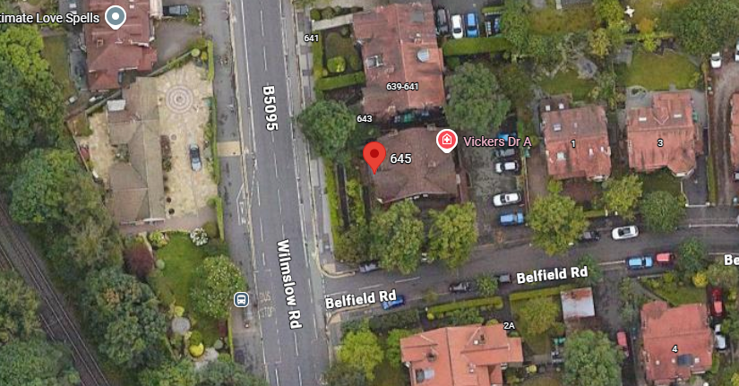

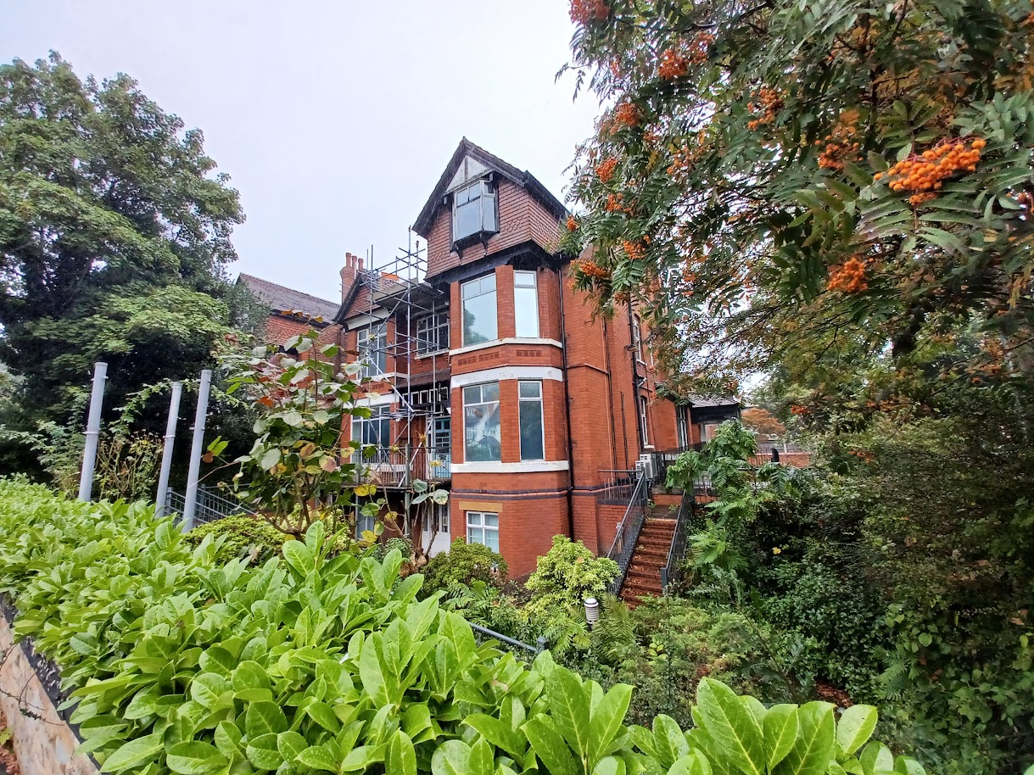

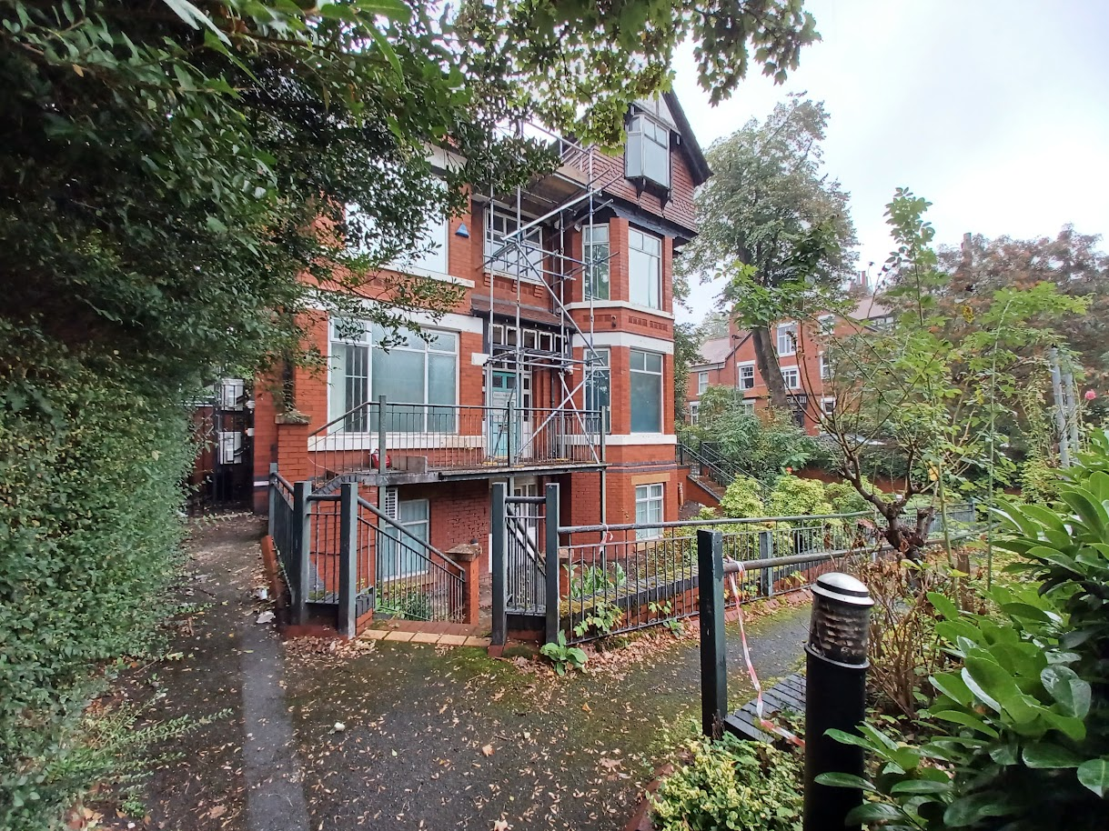

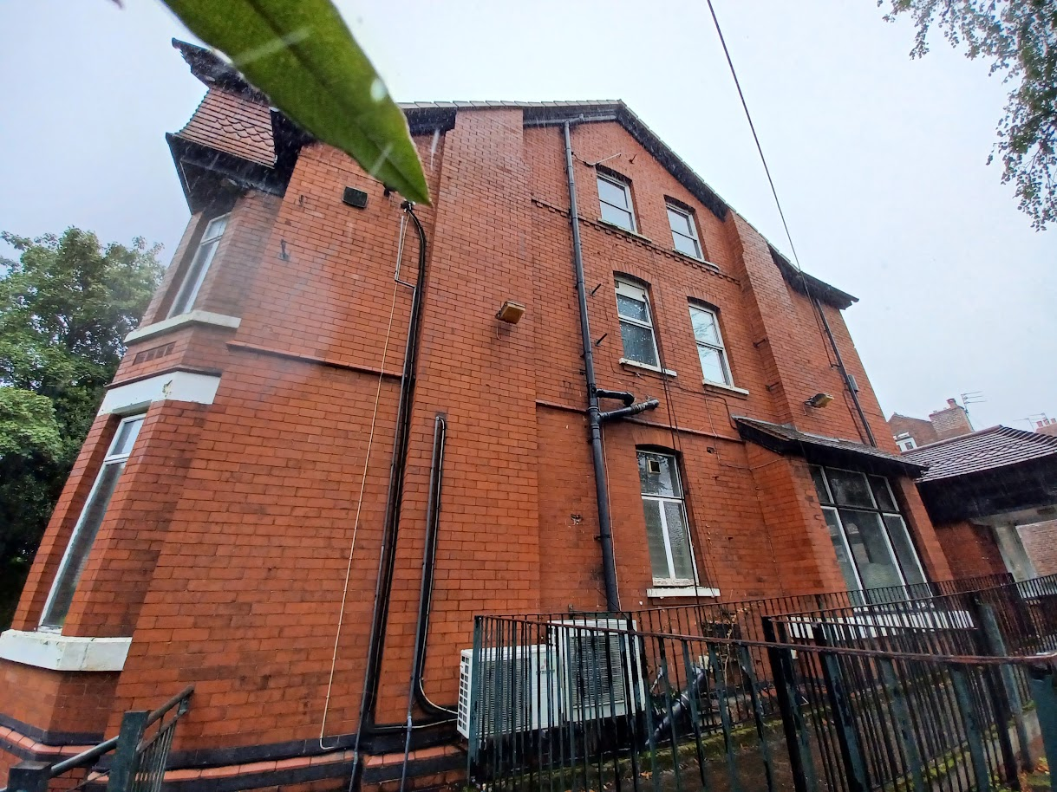

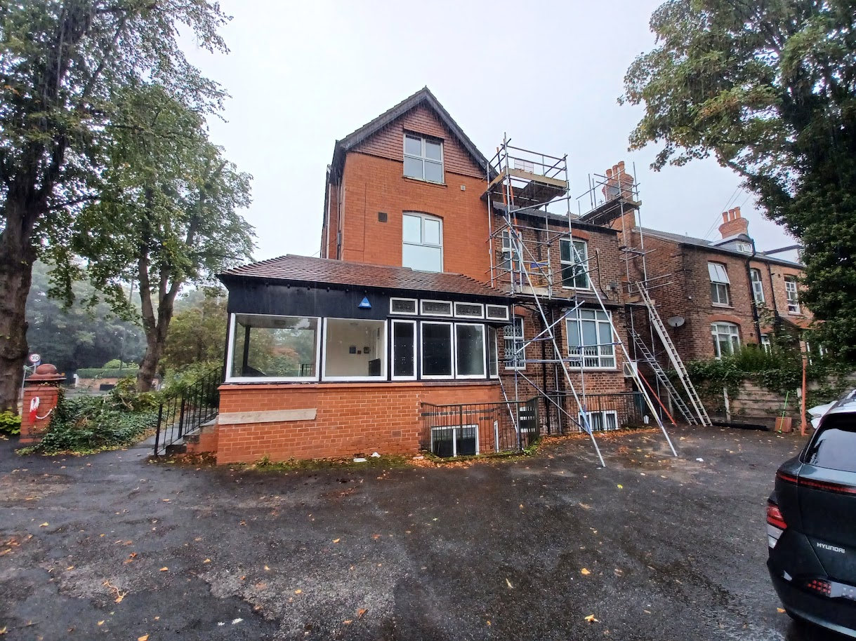

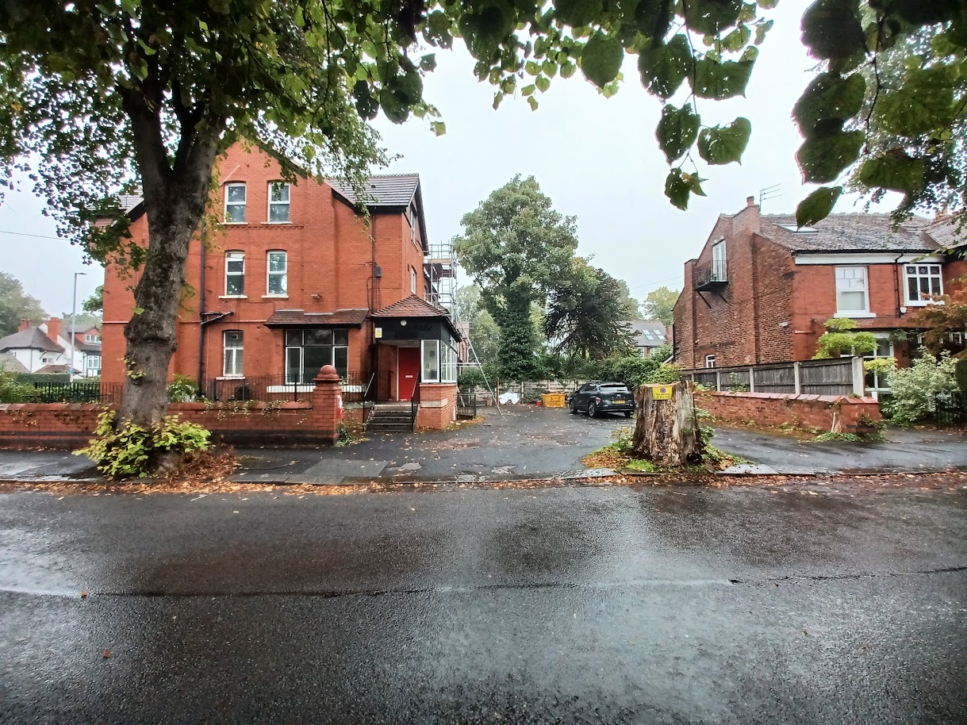

Description of development
The applicant is seeking planning permission for elevational alterations to the side and rear elevations to form new doors and windows, with a new boundary fence to the side elevation, following the demolition of single-storey elements to side and external ramps.

Relevant planning history
Planning Application - 121978/FO/2018 - Change of use from medical centre (Class D1) to four apartments (1 x 2 bed, 3 x 3 bed) with associated elevational alterations, landscaping and car parking – Approved (2019).

Planning Application - 143299/P3MAP/2025 - Prior Approval for conversion of existing medical centre in to a 6 bedroom dwellinghouse – Approved (2025).

Consultation, notification and publicity responses
Local residents – no responses received.

Highways made the following comments on the application:

- Proposed works appears to be within the site boundary.
- The level of trips generated is not anticipated to be significant and as such no highways capacity concerns are expected.
- Existing plans indicate that vehicular access to the site is currently provided via Belfield Road, serving an on-site car park accommodating 7no. parking spaces.
- Proposed Plans indicate 2no. car parking spaces via Belfield Road which appears to be within the site boundary.
- *It should be noted that all individual driveway parking spaces should be a minimum of 3.0m x 6.0m to ensure that vehicles / pedestrians do not impact on the adopted highway.
- *A pedestrian visibility splay should be undertaken for the proposed parking spaces.
- Pedestrian access is to be from Wilmslow Road.
- It is recommended that provision of an Electrical Vehicle charging point (minimum 7kW) is made available.
- Secure and sheltered cycle parking provision should be made, within the curtilage of the site, at a provision of one-per-unit.
- It is recommended that all fencing / railings adjacent to the adopted highway are visually permeable from a distance of 600mm upwards to ensure adequate visual permeability for child pedestrians.
- The applicant should be advised that all gated accesses (except fire exits) will need to provide inward opening gates to ensure they do not impact on the adopted footway or highway.
- Refuse bins are stored within the site boundary – Acceptable in principle.
- Noted that collection will form part of the existing kerbside collection at neighbouring residential properties.
- A Construction Management Plan is required prior to the start of any works.

Relevant policies
The following policies are considered relevant in the consideration of this application.

Unitary Development Plan (UDP) – The UDP has been superseded by the Core Strategy
Development Plan, but certain policies are still considered of relevance:
- Policy DC1 – Residential Extensions

The Manchester Core Strategy – Development Plan Document 2012-2027 (“the Core
Strategy”) was adopted by the City Council on the 11th of July 2012:
- Policy DM1 – Development Management
- Policy SP1 – Spatial Principles

Places for Everyone - is a long-term plan of nine Greater Manchester districts for jobs, new
homes, and sustainable growth. It has been published by the GMCA on behalf of the nine
districts and took effect and became part of the statutory development plan on March 21, 2024.
- Policy JP-P1 – Sustainable Places

National Planning Policy Framework (NPPF, 2026)
- Chapter 14 – Achieving Well-Designed Places
- Policy DP3: Key principles for well-designed places

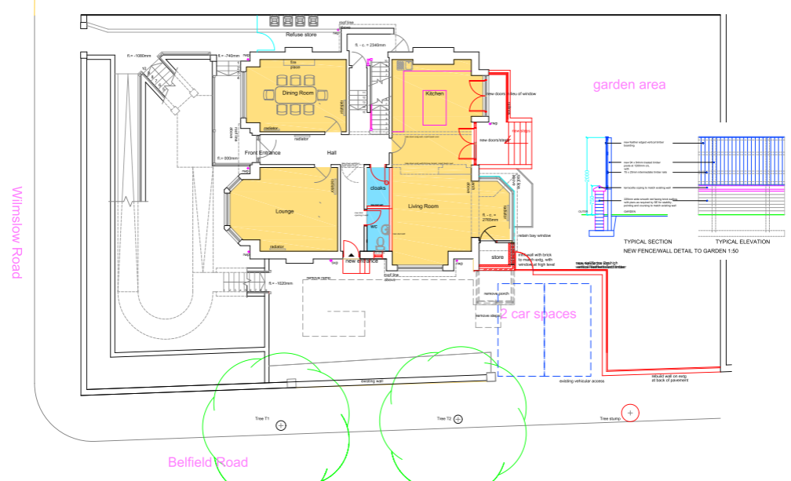
Submitted proposed site plan
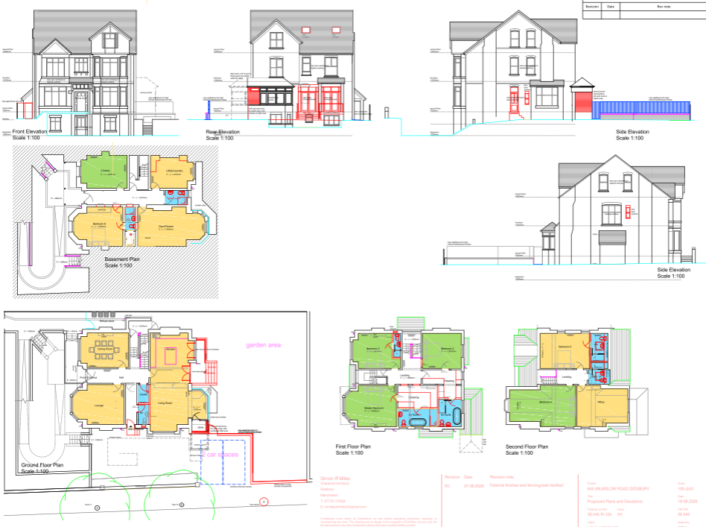
Submitted proposed plans and elevations

Assessment
Principle – the principle of the proposal, to undertake elevational alterations and erect a new boundary fence following the demolition of existing ramps and single storey additions, to provide improved living accommodation for a dwellinghouse, is acceptable. Notwithstanding this, consideration must be given to the proposal’s appearance, impact upon visual and residential amenity, waste storage, and parking, amongst other matters.

Scope of works – the application proposes a series of external alterations and associated works to the existing property, comprising the following:

Front elevation (Wilmslow Road):
- Replacement of the existing lower ground-floor door with a composite door.
- Replacement of existing windows with uPVC-framed windows.

South side elevation (Belfield Road):
- Removal of the existing access ramp.
- Replacement of an existing ground-floor window with a new composite door and associated steps.
- Installation of a new ground-floor uPVC-framed window.
- Replacement of existing windows with uPVC-framed windows.

Rear elevation:
- Partial demolition of the existing rear porch/single-storey addition, including making good the resulting walls, gable and roof using materials to match the existing building. The works also include the installation of a high-level window and reinstatement of the adjoining bay window.
- Installation of two rooflights within the rear roof slope.
- Replacement of existing windows with uPVC-framed windows.
- Replacement of a ground-floor window with a new uPVC-framed doorset and associated steps.
- Replacement of a ground-floor window within the rectangular bay projection with a new uPVC-framed doorset.
- Replacement of the existing ground-floor door with a composite door.

North side elevation:
- Replacement of existing windows with uPVC-framed windows.
- Installation of a new first-floor uPVC-framed window. The proposed window is recommended to be conditioned to be obscurely glazed to safeguard the residential amenity of the occupants of No.643 Wilmslow Road.

External works:
- Installation of a new 2m-high gate and fence between the application property and the plot’s northern shared boundary.
- Conversion of the existing rear parking area into private garden space.
- Retention of two off-street parking spaces served by the existing vehicular access from Belfield Road.
- Installation of a new 2m-high wall and vertical featherboard timber fence to separate the retained parking area from the proposed garden space.

This proposal would result in alterations to all elevations of the property, together with associated boundary treatments, landscaping changes and reconfiguration of the site's external areas.

Appearance and visual amenity – the proposal consists of a range of external alterations, including replacement windows and doors, amendments to existing openings, the removal of a rear addition, installation of rooflights, erection of new boundary treatments and alterations to the site's external areas. Overall, the works would improve the appearance of the property and reinforce its residential character.

The replacement uPVC windows and composite doors would update the building's appearance without significantly changing its overall character. The proposed openings largely follow the existing fenestration pattern, ensuring the scale and proportions of the elevations remain consistent. On the front elevation, the changes are limited to replacement windows and a new entrance door and would not adversely affect the street scene.

On the south elevation, the removal of the existing access ramp and its replacement with a door and steps would result in a more conventional residential appearance. To the rear, the partial demolition of the existing porch/addition and reinstatement of the bay window would improve the appearance of the property by restoring an original feature and reducing built form. The proposed rooflights would be modest in scale and located on the rear roof slope, where they would have limited visibility from public viewpoints.

The proposed first-floor window in the north elevation would be appropriately sized and, subject to a condition requiring obscure glazing, would sit comfortably within the elevation. The proposed fencing, wall and gate are typical residential boundary treatments and would be in-keeping with the character of the area.

The conversion of part of the rear parking area to private garden space would create a more attractive setting by increasing landscaped amenity space and reducing the amount of hardstanding, whilst retaining sufficient off-street parking provision.

Overall, the proposed alterations are considered sympathetic to the host property and would provide some visual enhancements, particularly through the removal of the rear addition and improvements to the external amenity space. The development would not harm the appearance of the property or the visual amenity of the surrounding area and is therefore considered acceptable.

Residential amenity – the proposal is not considered to give rise to unacceptable impacts upon the residential amenity of neighbouring occupiers. The majority of the works relate to the replacement of existing windows and doors, alterations to existing openings, and changes to boundary treatments, all of which are domestic in nature and would not result in harmful levels of overlooking, overshadowing or loss of outlook.

The partial demolition of the existing rear porch/single-storey addition would reduce built form at the rear of the property and would not have a detrimental impact upon residential amenity. The proposed rooflights would be located within the rear roof slope and, given their position and design, would not give rise to overlooking. The proposed ground-floor doors and windows would serve areas where openings already exist and would not introduce materially different relationships with neighbouring properties.

A new first-floor window is proposed within the north elevation facing No.643 Wilmslow Road. Whilst this has the potential to create overlooking, it is considered that this can be satisfactorily addressed through a planning condition requiring the window to be fitted with obscured glazing and retained as such thereafter. Subject to this condition, the proposal would not result in an unacceptable loss of privacy.
The proposed fencing, wall and gate would provide appropriate boundary definition and screening, whilst the conversion of part of the rear parking area to private garden space would improve the quality of the site's external amenity provision.

As such, overall, the proposal is not considered to result in significant harm to the living conditions of neighbouring occupiers and is considered acceptable in residential amenity terms.

Waste storage – the submitted site plan indicates that the property’s refuse bins would be housed within a designated refuse store located to the north of the dwellinghouse behind the proposed fence/gate. These arrangements are considered acceptable.

Parking and highways implications – MCC’s Highways Services have reviewed the application and raise no objection. As the proposal relates to alterations to an existing dwelling rather than a change of use or intensification of the site, it is not expected to generate a significant increase in vehicle movements or create any highway capacity issues.

The site is accessed from Belfield Road and currently benefits from a parking area to the rear. The proposal would retain two off-street parking spaces served by the existing access arrangement. Whilst additional information was requested in relation to pedestrian visibility splays, the visibility available to vehicles using the access would remain broadly comparable to the existing situation, given the established boundary treatment alongside No. 1 Belfield Road and the long-standing use of the access.

Highways officers also recommended the provision of electric vehicle charging facilities and secure cycle parking. However, given that the proposal does not create any additional dwellings and involves only external alterations to the existing property, it is not considered reasonable or necessary to require these measures in this case.

Provision for refuse and recycling storage is available within the site, and collections would continue through the existing kerbside arrangements. Given the limited scale and nature of the works, a Construction Management Plan is not considered necessary.

Overall, the proposal would not give rise to any unacceptable highway safety, access or parking concerns and is therefore acceptable in highway terms

Conclusion – given the above issues, it is considered that the proposal is acceptable in terms
of its principle, siting, scale and massing, appearance, impact upon visual and residential
amenity, waste storage and parking. The proposal complies with saved policy DC1 of the
Unitary Development Plan for the City of Manchester, policies DM1 and SP1 of the Manchester
Core Strategy and the requirements of the National Planning Policy Framework (2026).

Other Legislative Requirements

Equality Act 2010
Section 149 (Public Sector Equality Duty) of the Equality Act 2010 requires due regard to the need to: Eliminate unlawful discrimination, harassment and victimisation and other conduct prohibited by the Act and; Advance equality of opportunity between persons who share a protected characteristic and persons who do not share it. The Equality Duty does not impose a legal requirement to conduct an Equality Impact Assessment. Compliance with the Equality Duty involves consciously thinking about the aims of the Equality Duty as part of the process of decision-making.

Human Rights Act 1998 considerations
This application needs to be considered against the provisions of the Human Rights Act 1998. Under Article 6, the applicants (and those third parties, including local residents, who have made representations) have a right to a fair hearing and to this end the local planning authority must give full consideration to their comments.

Protocol 1 Article 1, and Article 8 where appropriate, confer(s) a right of respect for a person’s home, other land and business assets. In taking account of all material considerations, including Council policy as set out in the Core Strategy and saved polices of the Unitary Development Plan, the Director of Planning, Building Control & Licensing has concluded that some rights conferred by these articles on the applicant(s)/objector(s)/resident(s) and other occupiers and owners of nearby land that might be affected may be interfered with but that that interference is in accordance with the law and justified by being in the public interest and on the basis of the planning merits of the development proposal. She believes that any restriction on these rights posed by the recommendation given is proportionate to the wider benefits of and that such a decision falls within the margin of discretion afforded to the Council under the Town and Country Planning Acts.

Recommendation: Approve

Article 35 Declaration:

Officers have worked with the applicant in a positive and proactive manner based on seeking
solutions to problems arising in relation to dealing with the planning application. Minor issues
have arisen during the consideration of this application and the officer negotiated with the agent
to reach a satisfactory resolution.

Condition(s) to be attached to decision for approval OR Reasons for recommendation to
refuse

1) 3-year time limit:

The development must be begun not later than the expiration of three years beginning with
the date of permission.

Reason - Required to be imposed pursuant to Section 91 of the Town and Country Act Planning
Act 1990.

2) Specified plans:

The development hereby approved shall be carried out in accordance with the following
documents:

- ‘Proposed Site Plan’, numbered ’26 545 PL101 P2’, received by the City Council as Local Planning Authority on 8 September 2026.
- ‘Proposed Plans and Elevations’, numbered ’26 545 PL100 P2’, received by the City Council as Local Planning Authority on 8 September 2026.

Reason - To ensure that the development is carried out in accordance with the approved plans,
pursuant to saved policy DC1 of the Unitary Development Plan for the City of Manchester and
policies SP1 and DM1 of the Manchester Core Strategy.

3) Materials:

The materials used in the external surfaces of the development hereby approved shall be those as specified on approved plans titled:

- ‘Proposed Site Plan’, numbered ’26 545 PL101 P2’, received by the City Council as Local Planning Authority on 8 September 2026.
- ‘Proposed Plans and Elevations’, numbered ’26 545 PL100 P2’, received by the City Council as Local Planning Authority on 8 September 2026.

Reason - In order to ensure a satisfactory appearance in the interests of visual amenity in accordance with policies SP1 and DM1 of the Core Strategy and the requirements of the National Planning Policy Framework

4) Obscure glazing:

The proposed window in the first-floor of the northern elevation of the host dwellinghouse shall be obscure glazed to a specification of no less than level 5 of the Pilkington Glass Scale or such other alternative equivalent and shall be retained as such thereafter. Any parts of the window that can be opened must be more than 1.7 metres above the floor of the room in which the window is installed.

Reason - In order to protect the amenity of neighbouring residents and in accordance with policies SP1 and DM1 of the Manchester Core Strategy.

