

Planning

Delegated Officer Report

Summary of application details
Application reference: | OTH-2026-001925
Application type: | Non-Material Amendment
Proposal: | Non-Material Amendment to planning permission 144600/VO/2025 to vary the wording of Condition 2 (Approved Drawings) to allow for the omission of a window and the relocation of a proposed door to replace a previously proposed window.
Site address: | Pavilion House, Manchester University Sports Ground Willenhall Road Manchester M23 0BD
Ward(s): | Northenden
Date application valid: | 09 October 2026
Applicant name: | Manchester City Council
Agent (if any): | Paul Butler Associates
Case officer: | David Lawless
Recommendation: | Approve
Date of recommendation: | 28 October 2026

Description of site, building and/or area

This application relates to the pavilion building which forms part of the Wythenshawe Sports Ground. The sports ground consists of approximately 36 hectares of playing fields and associated car parking. The sports ground is located to the north of the M60. Vehicular and pedestrian access (blue arrow) is via Willenhall Road, while pedestrian only access can also be gained via a foot bridge over the M60 from Fellpark Road (yellow arrow). The sports ground and the area adjoining it to the north of the M60 is allocated as Green Belt.

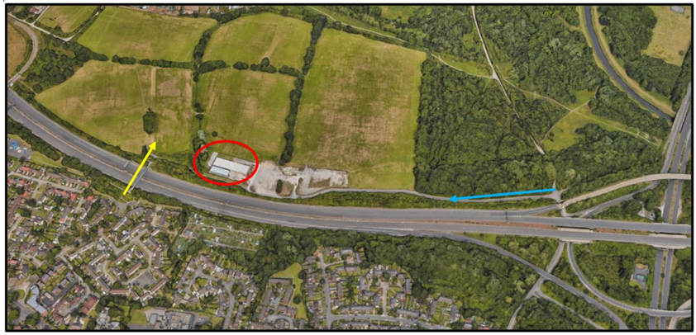

Description of development

The applicant obtained planning permission for the following in January 2026, under reference 144600/VO/2025:

Refurbishment of existing sports pavilion (Class F2) involving a partial change of use to provide: a weightlifting gym (Class E), ancillary cafe and community room, external alterations, CCTV and lighting, reconfiguration to the existing hard landscaping to enable a widened pedestrian footpath, installation of external plant and enclosure and other associated works.

They are now applying for a non-material amendment to allow for the omission of a window and the relocation of a proposed door to replace a previously proposed window, as well as the installation of additional roof cowls.

Consultations

n/a

Relevant policies

National Planning Policy Framework (August 2026) – A revised National Planning Policy Framework (NPPF) was published on 17 August 2026 following a period of public consultation and has superseded the previous version. Given the timing of its publication, the application has been assessed against both the former and revised frameworks. Having undertaken this review, it is considered that the changes introduced by the revised NPPF do not materially affect the assessment or conclusions reached in relation to the proposed development.

The revised version fundamentally restructures national planning policy with a more rules based, pro-growth approach, replacing the previous paragraph based framework and the traditional tilted balance with a new presumption in favour of sustainable development. Key reforms include stronger support for housing delivery, particularly higher-density development near major public transport hubs, greater policy support for economic growth, infrastructure and rural productivity, stronger protection for pubs and other community facilities and continued robust protection of designated landscapes. The reforms are intended to make planning decisions faster, clearer and more predictable whilst accelerating housing and economic growth.

In this instance, the relevant sections are outlined below:

Policy DM3 (Determining development proposals) – When considering development proposals, local planning authorities should:

- Work with the applicant in a positive and proactive manner, where necessary seeking solutions to problems arising from initial proposals, to enable a timely decision;
- Take a proportionate approach to the consideration of the planning matters raised by the proposals, in a way that reflects their scale, complexity and potential impact;
- Take account of planning matters raised during any pre-application engagement, including any positive responses to this engagement, as well as representations on the proposals;
- Consult statutory or internal consultees only where it is necessary to do so. Decisions on development proposals should not be delayed in order to secure advice from a statutory or internal consultee beyond their statutory deadlines unless there is insufficient information to make the decision or more detailed advice may enable an approval rather than a refusal;
- Consider whether otherwise unacceptable development proposals could be made acceptable through the use of planning conditions or planning obligations; and
- Not refuse applications for development which should clearly be approved, having regard to its accordance with the development plan, the policies in this Framework and any other material considerations.

Policy HO7 (Meeting the need for homes) – In applying the policies in this Framework, substantial weight should be given to the benefits of providing homes which will contribute towards meeting the evidenced accommodation needs of the community, as identified through needs assessments prepared for the area of the local planning authority and other relevant evidence. This includes, but is not limited to, homes needed for different groups assessed under policy HO1 (Assessing the need for homes).

The Places for Everyone Plan – This plan was adopted on 21 March 2024, as such the Plan and its policies are now a material planning consideration in the determination of planning applications. The Plan and its policies must therefore be given significant weight in the planning balance. The relevant policy is set out below:

Policy JP-Strat9 (Southern Areas) – This policy states that the economic competitiveness, distinctive local neighbourhood character and environmental attractiveness of the southern areas will be protected and enhanced. There will be a strong emphasis on making as much use as possible of suitable previously developed (brownfield) land and promoting the roles of the areas’ town centres and its other key assets.

Policy JP-P7: Sport and Recreation – This policy states that a network of high quality and accessible sports and recreation facilities will be protected and enhanced, supporting greater levels of activity for all ages, including by encouraging the incorporation of a sports facilities mix in all education settings, that meet both curriculum and local community sport needs as identified by an up to date Local Authority Sports Needs Assessment, and made available for community use where possible.

Core Strategy Development Plan Document – The Core Strategy Development Plan Document 2012 -2027 ("the Core Strategy") was adopted by the City Council on 11th July 2012. It is the key document in Manchester's Local Development Framework. The Core Strategy replaces significant elements of the Unitary Development Plan (UDP) as the document that sets out the long term strategic planning policies for Manchester's future development.

A number of UDP policies have been saved until replaced by further development plan documents to accompany the Core Strategy. Planning applications in Manchester must be decided in accordance with the Core Strategy, saved UDP policies and other Local Development Documents. Relevant policies in the Core Strategy are detailed below.

Policy SP1, Spatial Principles, - Development in all parts of the City should make a positive contribution to neighbourhoods of choice including creating well designed places that enhance or create character and protect and enhance the built and natural environment.

Policy DM1, Development Management – This policy states that all development should have regard to a number of specific issues, of which the following are of most relevance:-

- Appropriate siting, layout, scale, form, massing, materials and detail.
- Impact on the surrounding areas in terms of the design, scale and appearance of the proposed development. Development should have regard to the character of the surrounding area.
- Effects on amenity, including privacy, light, noise, vibration, air quality, odours, litter, vermin, birds, road safety and traffic generation. This could also include proposals which would be sensitive to existing environmental conditions, such as noise.
- Community safety and crime prevention.
- Design for health.
- Vehicular access and car parking.
- Effects relating to biodiversity, landscape, archaeological or built heritage.
- Flood risk and drainage.

Policy EN10, Safeguarding Open Space, Sport and Recreation Facilities – This policy states that the Council will seek to retain and improve existing open spaces, sport and recreation facilities and provide a network of diverse, multi-functional open spaces. Proposals will be supported that:

- improve the quality and quantity of accessible open space, sport and recreation in the local area
- provide innovative solutions to improving the network of existing open spaces, increase accessibility to green corridors, and enhance biodiversity
- improve access to open space for disabled people

It states further that proposals on existing open spaces and sport and recreation facilities will only be permitted where:

- Equivalent or better replacement open space, sport or recreation facilities will be provided in the local area; or
- The site has been demonstrated to be surplus for its current open space, sport or recreation function; or
- The development will be ancillary to the open space, sport or recreation facility and complement the use or character.

Policy EN12, Area priorities for Open Space, Sport and Recreation – The priorities for open space, sport and recreation in the City set out in Manchester's Strategic Open Space, Sport and Recreation Study and within the regeneration areas include the following:

  - Wythenshawe: improve existing facilities and sites.

Saved UDP Policy DC26 (Development and Noise) – Policy DC26.1 states that the Council intends to use the development control process to reduce the impact of noise on people living and working in, or visiting, the City. In giving effect to this intention, the Council will consider both:

- the effect of new development proposals which are likely to be generators of noise; and
- the implications of new development being exposed to existing noise sources which are effectively outside planning control.

Policy DC26.2 states that new noise-sensitive developments (including large-scale changes of use of existing land or buildings), such as housing, schools, hospitals or similar activities, will be permitted subject to their not being in locations which would expose them to high noise levels from existing uses or operations, unless the effects of the noise can realistically be reduced. In giving effect to this policy, the Council will take account both of noise exposure at the time of receiving a planning application and of any increase that may reasonably be expected in the foreseeable future.

Assessment

Principle of the Proposal – This proposal forms part of a Council-led initiative being delivered in partnership with Trafford and Stockport Councils, with funding secured through the Football Foundation. The proposed improvements to the sporting facilities would enhance the recreational offer at the site, delivering clear benefits to the local community and supporting the long-term, sustainable use of the facilities.

The proposed amendments comprise the following elevational changes, as illustrated on the submitted plans:

a) The removal of a window on the north elevation and its replacement with a door; and
b) The removal of a door and window on the east elevation.
c) The installation of additional roof cowls.

Given the minor nature of the proposed amendments, there is no objection in principle to these alterations. The changes are considered limited in scale and would not adversely affect the appearance or character of the development.

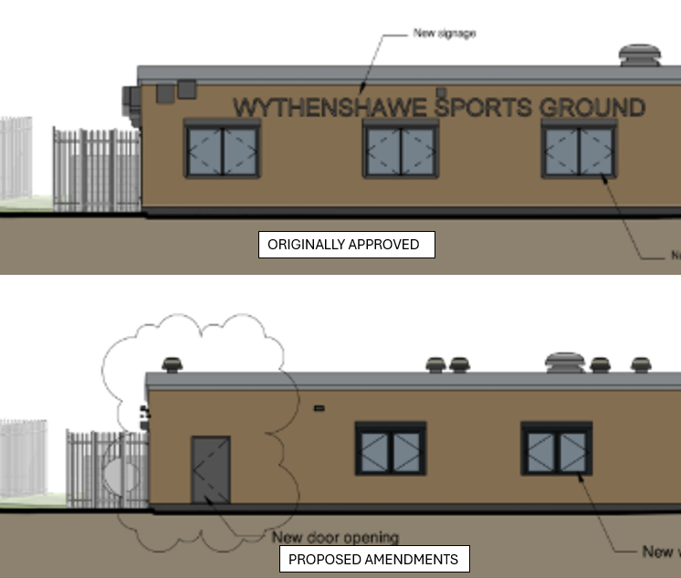
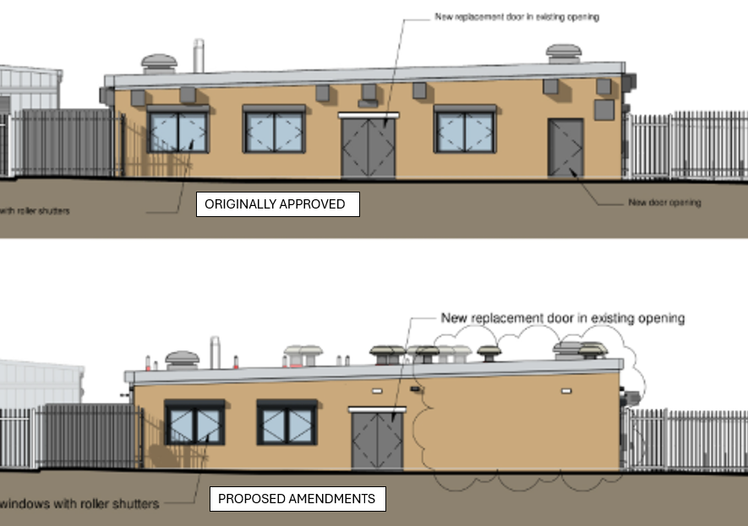

Residential and Visual Amenity – The proposed amendments are minor in nature and are limited to the repositioning and removal of a small number of openings within the building elevations, as well as the addition of roof cowls to the roof.

The replacement of a window with a door on the north elevation, together with the omission of a door and window on the east elevation, would not result in any material change to the scale, massing, height, or overall appearance of the development. Furthermore, the amendments would not introduce any additional overlooking, loss of privacy, overshadowing, or overbearing impacts upon neighbouring properties.

A total of 24 additional roof cowls are proposed to be installed on the roof of the building, as illustrated below. The roof-mounted units shown in orange represent the existing extraction equipment. The proposed roof cowls are required to provide fresh air intake and exhaust air discharge routes for the heat recovery ventilation units serving the building. The ventilation strategy was developed during the early RIBA design stages to optimise energy efficiency and operational performance, whilst ensuring compliance with the relevant ventilation standards for the development. The number of roof penetrations has been carefully rationalised, with intake/exhaust routes combined where practicable, in order to minimise the overall number of roof cowls required.

In visual terms, the additional roof cowls would not result in any material harm to visual amenity and would not detract from the overall appearance or architectural character of the building. Furthermore, any acoustic impact arising from the proposed roof-mounted ventilation terminals is expected to be negligible, given the substantial separation distance between the site and the nearest residential properties, together with the presence of the M60 motorway, which forms a significant physical and acoustic barrier between them.
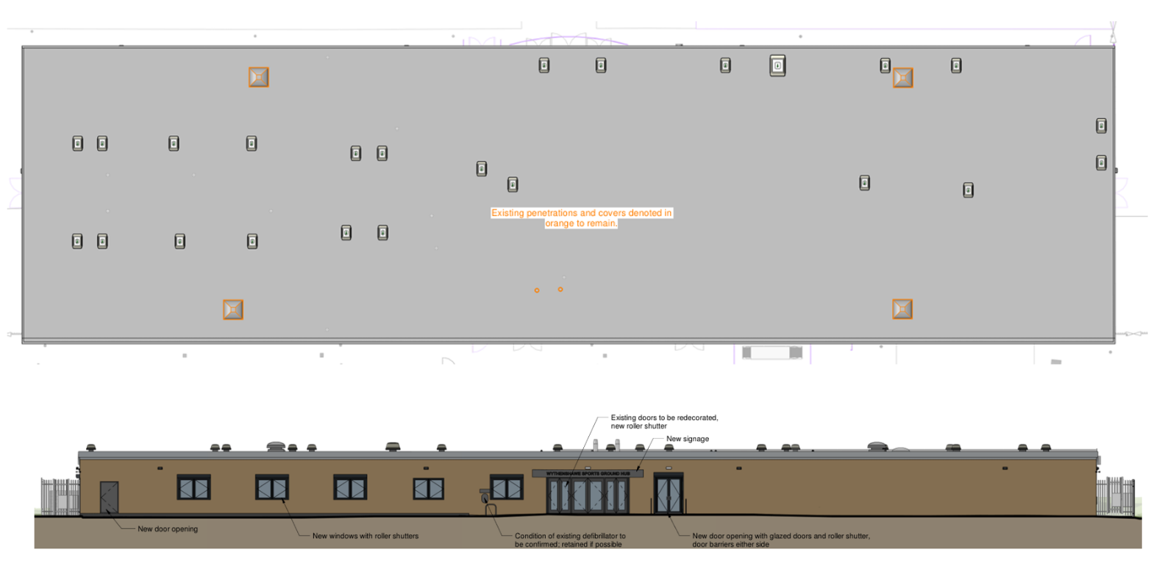
Given the limited extent of the alterations, it is considered that the proposals would have no detrimental impact on the visual amenity of the surrounding area or on the residential amenity currently enjoyed by nearby occupiers.

Pedestrian and Highway Safety – The proposed amendments are confined to minor alterations to the arrangement of openings within the building elevations and would not affect the established access arrangements, internal road layout or parking provision associated with the development.

The replacement of a window with a door on the north elevation and the omission of a door and window on the east elevation would not generate any additional vehicular movements, alter pedestrian routes, or result in increased conflict between pedestrians and vehicles.

As such, the amendments would have no material implications for the safe and efficient operation of the local highway network, nor would they compromise pedestrian safety within or around the site. The proposals are therefore considered acceptable in highway and transportation terms.

Other Legislative Requirements

Equality Act 2010 – Section 149 (Public Sector Equality Duty) of the Equality Act 2010 requires due regard to the need to: Eliminate unlawful discrimination, harassment and victimisation and other conduct prohibited by the Act and; Advance equality of opportunity between persons who share a protected characteristic and persons who do not share it. The Equality Duty does not impose a legal requirement to conduct an Equality Impact Assessment. Compliance with the Equality Duty involves consciously thinking about the aims of the Equality Duty as part of the process of decision-making.

Human Rights Act 1998 considerations – This application needs to be considered against the provisions of the Human Rights Act 1998. Under Article 6, the applicants (and those third parties, including local residents, who have made representations) have a right to a fair hearing and to this end the local planning authority must give full consideration to their comments.

Protocol 1 Article 1, and Article 8 where appropriate, confer(s) a right of respect for a person’s home, other land and business assets. In taking account of all material considerations, including Council policy as set out in the Core Strategy and saved polices of the Unitary Development Plan, the Director of Planning, Building Control & Licensing has concluded that some rights conferred by these articles on the applicant(s)/objector(s)/resident(s) and other occupiers and owners of nearby land that might be affected may be interfered with but that that interference is in accordance with the law and justified by being in the public interest and on the basis of the planning merits of the development proposal. She believes that any restriction on these rights posed by the recommendation given is proportionate to the wider benefits of and that such a decision falls within the margin of discretion afforded to the Council under the Town and Country Planning Acts.
Conclusion

Recommendation: Approve

Reasons for approval

1) The details of the proposed amendments are:

a) Omission of a window and the relocation of a proposed door to replace a previously proposed window
b) Installation of additional roof cowls

2) Following an assessment of the details submitted, the proposed amendments are considered to be of a non-material nature and acceptable to the City Council as the Local Planning Authority. The City Council is satisfied that the proposed changes will not result in any significant or material alteration to the host planning permission.

Conditions attached to this decision

1) Condition 2) The development hereby approved shall be carried out in accordance with the following drawings and documents received on 21 November 2025:

- NPS-ZZ-00-D-A-0802 P03 - LOCATION PLAN
- 118404-NPS-ZZ-00-D-A-0801 P01 - EXISTING SITE BLOCK PLAN
- 118404-NPS-ZZ-00-D-A-0803 P01 - PROPOSED SITE BLOCK PLAN
- 15152-CGP-00-00-DR-E-6801 P01 - GF ELECTRICAL SERVICES PLAN
- 15152-CGP-00-00-DR-E-6802 P01- ADDITIONAL PLANS
- P197-222-A - DENVER ID LIGHTING PLAN
- P24-00827 01 - TOPOGRAPHICAL SURVEY DRAWING

and the following drawings received on 9 October 2026:

- 118404-NPS-ZZ-00-D-A-0300 C04 - Proposed GA Level 00 Floor Plan

and the followings drawings received on 27 October 2026:

- 118404-NPS-ZZ-01-D-A-0305-C02 - Proposed Roof Plan
- 118404-NPS-ZZ-XX-D-A-0600-C03 - Proposed Building Elevations

Reason - To ensure that the development is carried out in accordance with the approved plans. Pursuant to Policies SP1 and DM1 of the Manchester Core Strategy.

