

Planning

Delegated Officer Report

Summary of application details
Application reference: | PLA-2026-001173
Application type: | Householder planning permission
Proposal: | Two-storey and single-storey side extension.
Site address: | 59 Meltham Avenue Manchester M20 1FE
Ward(s): | Old Moat
Date application valid: | 18 August 2026
Applicant name: | Mr Oliver Skipper
Agent (if any): | Mr Ahmed Choudhry
Case officer: | Tracie Simpson
Recommendation: | Refuse
Date of recommendation: | 27th October 2026

Description of site, building and/or area

The site relates to a two-storey semi-detached dwellinghouse within the Old Moat Ward of Manchester. The property is of a traditional design and is characterised by projecting bay windows to the principal elevation, together with a front porch. The front curtilage comprises a combination of hardstanding and gravel surfacing, providing off-street parking on the driveway. The dwelling benefits from an existing single storey wrap around extension extending across part of the side and rear elevations. The property is served by a gabled roof form, typical of the prevailing character and appearance of surrounding residential development within the area. An enclosed private garden is located to the rear of the site.

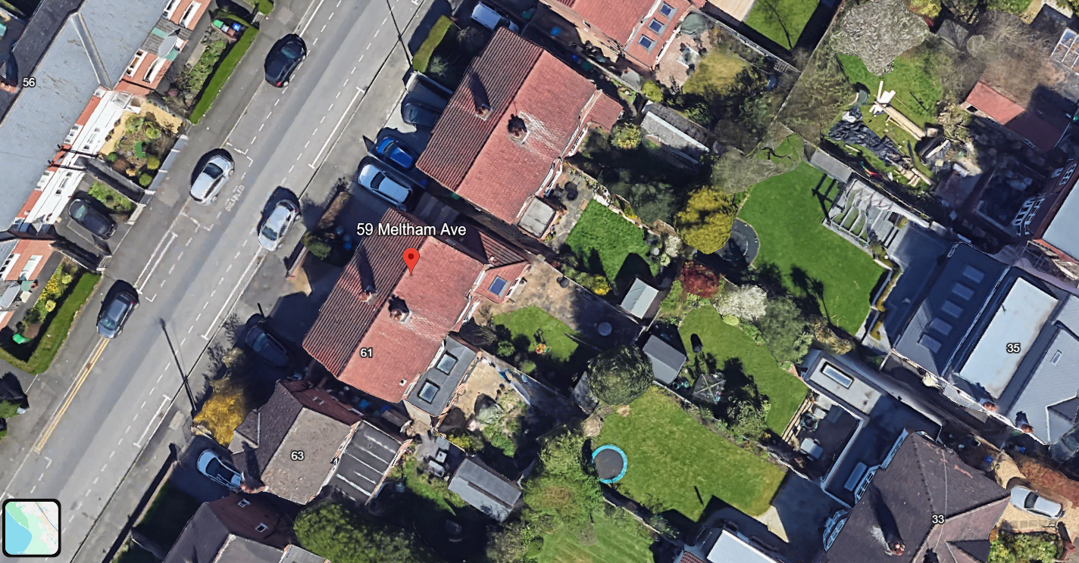Description of development
The applicant is seeking planning permission for the erection of a two-storey and single-storey side extension

Relevant planning history
No previous applications relating to this site

Consultation, notification and publicity responses

Consultations

N/A

Notifications and publicity

No response received as a result of this proposal.

Relevant policies
In accordance with Section 38(6) of the Planning and Compulsory Purchase Act 2004, planning applications must be determined in accordance with the statutory development plan unless material considerations indicate otherwise.
For Manchester, the development plan comprises:
- The Manchester Core Strategy (2012 to 2027);
- Saved policies of the Manchester Unitary Development Plan (UDP); and
- The Places for Everyone Joint Development Plan Document (2022 to 2039).
These documents are considered up to date and are afforded significant weight in the determination of planning applications. Relevant Supplementary Planning Documents (SPDs) and other adopted guidance may also be material considerations.
The National Planning Policy Framework sets out the government’s policies for plan-making and for making decisions on development proposals in England. It is a material consideration of critical importance in both contexts.
Where relevant, the Council is required to give special regard to the desirability of preserving listed buildings and their settings, and special attention to the desirability of preserving or enhancing the character or appearance of conservation areas, in accordance with the Planning (Listed Buildings and Conservation Areas) Act 1990.
The policies and guidance referred to below are considered the most relevant to the scale, nature and location of the proposed development.

- The Manchester Core Strategy Development Plan Document 2012-2027
  - Development Management and Planning Obligations
    - DM 1 - Development Management
  - Objective 1 - Spatial Principles
    - SP 1 - Spatial Principles (Partially replaced by PfE Policy JP-S 1)
  - Objective 6 Environment
    - EN 1 - Design Principles and Strategic Character Areas
    - EN 19 – Waste
- Guide to development in Manchester - supplementary planning document and planning guidance, April 2007
- Extant Unitary Development Plan (UDP) –
  - Citywide Development Control Policies
    - DC1 - Residential extensions
    - DC26 - Development and Noise
- Places for Everyone Plan Joint Development Plan Document 2022-2039-
  - Strategy
    - JP-Strat9: Southern Areas
  - Sustainable and Resilient Places
    - JP-S1: Sustainable Development
  - Places for People
    - JP-P1 Sustainable Places
- National Planning Policy Framework – August 2026 - National Development Management Policies (NDMPs)
  - Procedural Policies
    - Chapter 3 – Decision-making policies
      - DM1: Preparing development proposals
      - DM2: Information requirements
      - DM3: Determining development proposals
      - DM6: Use of planning conditions and obligations
      - DM7: Relationship with other regulatory regimes
      - DM9: Use of development orders
      - DM10: Removal of national permitted development rights
  - Sustainable Development
    - Chapter 4 - Achieving sustainable development
      - S3: Presumption in favour of sustainable development
      - S4: Principle of development within settlements
  - Creating high quality, sustainable places
    - Chapter 12 - Making effective use of land
      - L2: Making effective use of land
    - Chapter 14 - Achieving well-designed places
      - DP3: Key principles for well-designed places
      - DP4: The design process

Assessment

Principle of the Proposal

Policies SP1 and DM1 of the Manchester Core Strategy 2012 (Core Strategy) seek to ensure that new development enhances or creates character, protects and enhances the built environment; and that the design, scale and appearance of the proposed development is appropriate to its context. Policies DC1.1, DC1.2, DC1.3 and DC1.4 of The Unitary Development Plan for the City of Manchester 1995 (UDP) relate specifically to residential extensions and set out a number of criteria against which proposals for extensions will be assessed. Although these latter policies are now of some age, they are consistent with the guidance in the National Planning Policy Framework (NPPF) which seeks a high standard of design in new developments which provides a good standard of amenity of all existing and future occupiers.
The principle of allowing residents to extend their homes to provide enlarged or improved accommodation is generally acceptable provided that there is no overriding, undue impact upon either the character of the property or upon the residential and visual amenity of nearby residential occupiers.

In this instance the principle of the proposal is considered acceptable and it is not believed that there are any factors of sufficient weight in amenity terms that would warrant refusal of the application.

On balance, the proposed extension is deemed to accord with saved policy DC1 of the UDP and policies DM1 and SP1 of the Manchester Core Strategy

Residential Amenity

The applicant seeks planning permission for the erection of a two-storey and single-storey side extension. During the assessment of the application, concerns were raised regarding the limited first-floor setback from the principal elevation and the potential for the development to create a terracing effect within the street scene. Whilst amended plans were subsequently submitted, these amendments do not overcome the concerns identified.

Ground Floor

At ground-floor level, the extension would project from the side elevation and would align with the front wall of the existing dwelling, extending up to the shared boundary with No. 57 Meltham Avenue. The extension would continue rearwards along the side of the property, adjoining the existing side extension. The proposal would be finished with a mono-pitched roof, and a window would be provided within the front elevation.

First Floor

At first-floor level, the extension would be set back approximately 1.5m from the front elevation of the dwelling and would extend rearwards for approximately 5.0m, with a width of approximately 2.3m up to the shared boundary with No. 57 Meltham Avenue. A window would be provided within the front elevation and no side-facing windows are proposed. The roof would be set down approximately 1.5m below the main ridge and would incorporate a gable design to reflect the form of the host dwelling and surrounding development.

Whilst the applicant has amended the scheme to increase the setback at first-floor level, the Council considers that the proposed 1.5m setback remains insufficient to satisfactorily reduce the perception of terracing. The dwelling occupies a position where the space between buildings contributes positively to the rhythm, spacing and visual character of the streetscene. In circumstances where a minimum separation of 1.52m to the side boundary cannot be achieved, a more substantial setback is normally sought to ensure that a two-storey side extension appears subordinate to the host property and retains a clear visual break between dwellings.

Although examples of similar extensions exist within the wider area, these developments are not directly comparable as they benefit from materially greater spacing between neighbouring properties. The proposal would substantially reduce the visual gap between the application property and No. 57 Meltham Avenue, resulting in the erosion of the established spacious character of the street and creating the impression of a continuous built form. Furthermore, should a similar extension be constructed at the neighbouring property, the cumulative effect would significantly reinforce the appearance of terracing, to the detriment of the character and appearance of the area.

The proposal therefore fails to appear as a subordinate addition to the original dwelling and has not been designed in a manner which appropriately respects the character of the host property, the prevailing pattern of development, or the amenities of neighbouring occupiers. As such, the development is considered to represent an over dominant and visually intrusive addition within the street scene.

For these reasons, the proposal is considered contrary to the design and amenity objectives of the National Planning Policy Framework (2026), Core Strategy Policies SP1, DM1 and EN1, and Saved Policy DC1 of the Manchester Unitary Development Plan.

Scale and Mass

The size and footprint of the proposal is believed to provide an overbearing impact upon the residential amenities of surrounding properties. It is therefore considered that the design, scale and appearance of the proposed changes are unsatisfactory and are considered not to accord with the principles for residential extensions set out in saved UDP policy DC1, DM1 and EN1 of the Core Strategy.

Design

The proposed development, by reason of its siting, scale, and design, would not appear as a an acceptable addition to the host dwelling and would result in a form of development that is visually intrusive and out of keeping with the character and appearance of the existing property and surrounding area. Whilst the application indicates that materials would be chosen to match the existing dwelling, the use of matching materials alone is insufficient to overcome the concerns arising from the overall design and proportions of the proposal.

The proposal would fail to reflect the established pattern of development within the locality and would result in a development that appears incongruous within the street scene. Furthermore, owing to its scale and relationship with neighbouring properties, the development would have an unacceptable impact on residential amenity and the character of the area.

On balance, the design and appearance of the proposed development is considered unacceptable and contrary to Policies DM1 and EN1 of the Manchester Core Strategy.

Bins

The proposed refuse bin storage area would be located to the front of the property within a dedicated storage area positioned in front of the proposed extension. This is considered an acceptable and accessible location for waste storage and would comply with Policy EN19 of the Manchester Core Strategy.

Car Parking

The proposal would not alter the existing car parking arrangements at the property. As such, the development would not give rise to any concerns in relation to parking provision.

Other Legislative Requirements

Equality Act 2010
Section 149 (Public Sector Equality Duty) of the Equality Act 2010 requires due regard to the need to: Eliminate unlawful discrimination, harassment and victimisation and other conduct prohibited by the Act and; Advance equality of opportunity between persons who share a protected characteristic and persons who do not share it. The Equality Duty does not impose a legal requirement to conduct an Equality Impact Assessment. Compliance with the Equality Duty involves consciously thinking about the aims of the Equality Duty as part of the process of decision-making.

Human Rights Act 1998 considerations
This application needs to be considered against the provisions of the Human Rights Act 1998. Under Article 6, the applicants (and those third parties, including local residents, who have made representations) have a right to a fair hearing and to this end the local planning authority must give full consideration to their comments.

Protocol 1 Article 1, and Article 8 where appropriate, confer(s) a right of respect for a person’s home, other land and business assets. In taking account of all material considerations, including Council policy as set out in the Core Strategy and saved polices of the Unitary Development Plan, the Director of Planning, Building Control & Licensing has concluded that some rights conferred by these articles on the applicant(s)/objector(s)/resident(s) and other occupiers and owners of nearby land that might be affected may be interfered with but that that interference is in accordance with the law and justified by being in the public interest and on the basis of the planning merits of the development proposal. She believes that any restriction on these rights posed by the recommendation given is proportionate to the wider benefits of and that such a decision falls within the margin of discretion afforded to the Council under the Town and Country Planning Acts.

Conclusion
On balance, it is believed that the proposal would interfere with the character of the area and in terms of residential amenity it is considered that there will be a significant impact. The proposed development therefore does not accord with Core Strategy Policy DM1 and saved policy DC1 of the UDP.

Recommendation: Refuse
Article 35 Declaration

Positive and proactive working - Officers have worked with the applicant in a positive and proactive manner based on seeking solutions to problems arising in relation to dealing with the planning application. Issues have arisen during the consideration of this application and a satisfactory resolution has not been reached.

Reason for refusal

The proposed first floor side extension, by virtue of its insufficient setback from the principal elevation and its proximity to the side boundary, would create a terracing effect that would be harmful to the established character of the street scene. The proposal would therefore result in an unsympathetic form of development contrary to Policies DM1, SP1 and EN1 of the Manchester Core Strategy, saved policy DC1 of the UDP, PfE and NPPF

