

Planning

Delegated Officer Report

Summary of application details
Application reference: | PLA-2026-001089
Application type: | Consent to display an advertisement
Proposal: | Installation of 1no. internally Illuminated fascia sign and 1no. internally illuminated hanging sign.
Site address: | 50 King Street Manchester M2 4LY
Ward(s): | Deansgate
Date application valid: | 02 September 2026
Applicant name: | Dr Harvey Moscot
Agent (if any): | Mr Robert Mumby
Case officer: | Ciara Gettinby
Recommendation: | REFUSE
Date of recommendation: | 26 October 2026

Description of site, building and/or area
King Street is characterised by its Listed Buildings and the preservation of its heritage assets; the area is commercial in nature with the surrounding ground-floor units being occupied by shops, café’s or restaurants. Located in St Ann’s Conservation Area, it is known for its historically significant Georgian Buildings and Grade I Listed Building, St Ann’s Church that dates back to the year 1712. 50 King Street is a terraced building abutting a Grade II Listed Building, no. 48 King Street. The applicant building is three storeys tall with decorative detailing at the cornice of the shopfront. The first and second floor are considered to hold more heritage significance than the shopfront, with more detailing and architectural features along the front elevation.

Also, within the vicinity of the site is, Grade II Listed Building 54 & 56 King Street, Grade II Listed Building 41 South King Street, Grade II Listed Building, 35 and 37 King Street, Grade II Listed Building, 33 King Street, and Grade II Listed Building 29 and 31 King Street.

Map of surrounding Listed Buildings
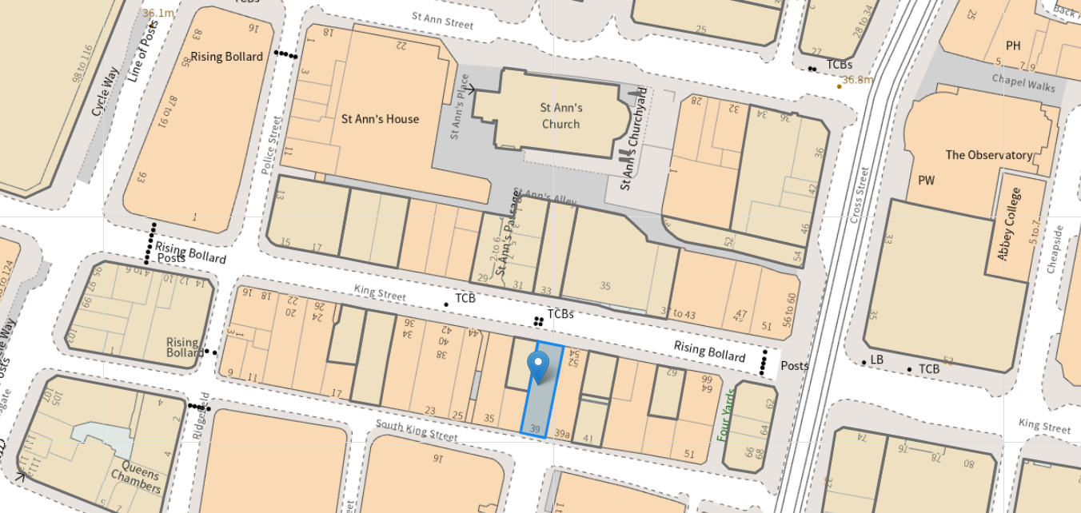

Map of St Ann’s Conservation Area
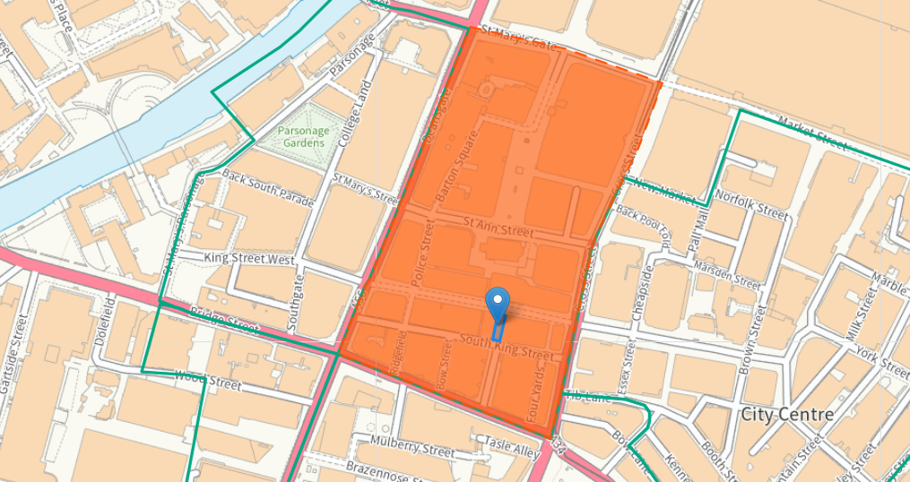

Description of development
Advertisement consent is sought for the installation of a fascia board and a projecting sign. The fascia board would be internally illuminated at 300cd/m2 with a yellow background and black lettering. The board would be fixed onto the original fascia board of the shopfront and have a depth of 0.5 resulting in the fascia board projecting forwards of the shopfront. The projecting sign would also be internally illuminated, sit adjacent to the fascia board and have a depth of 120mm.

Proposed Plans

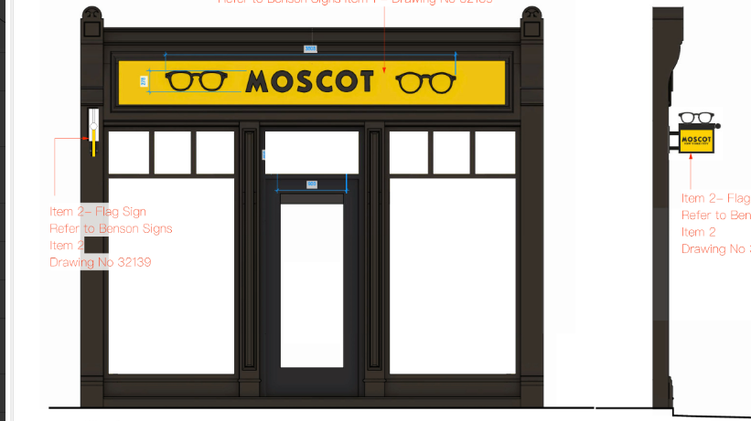

Site Photos
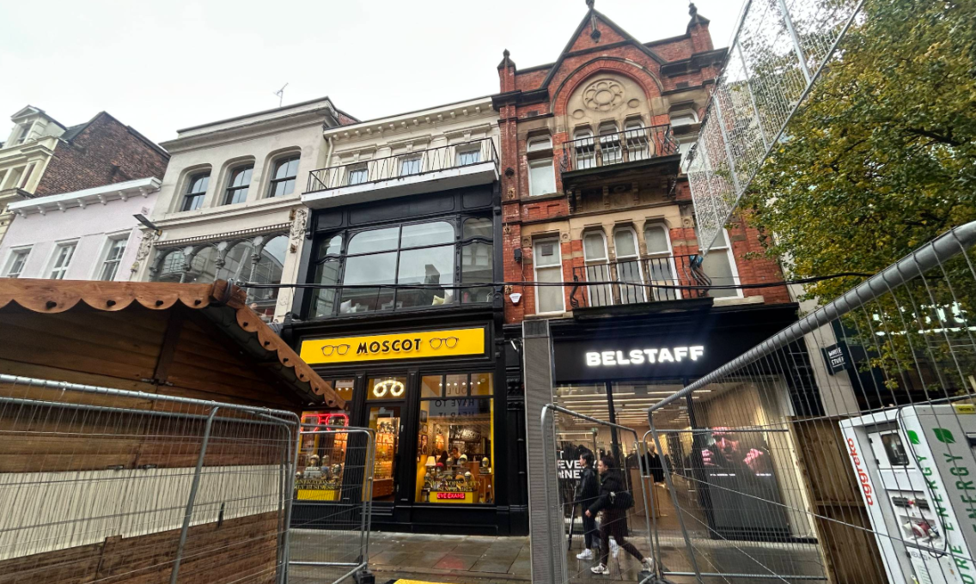

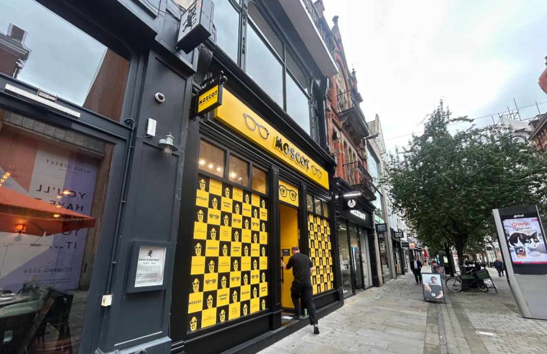

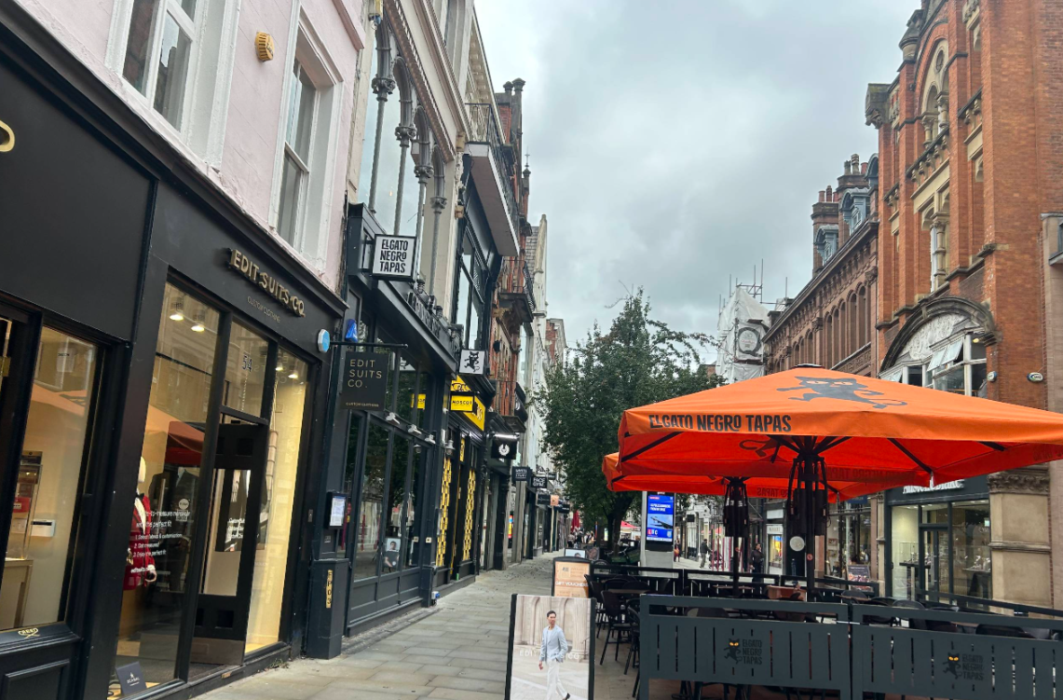

Previously approved shopfront design
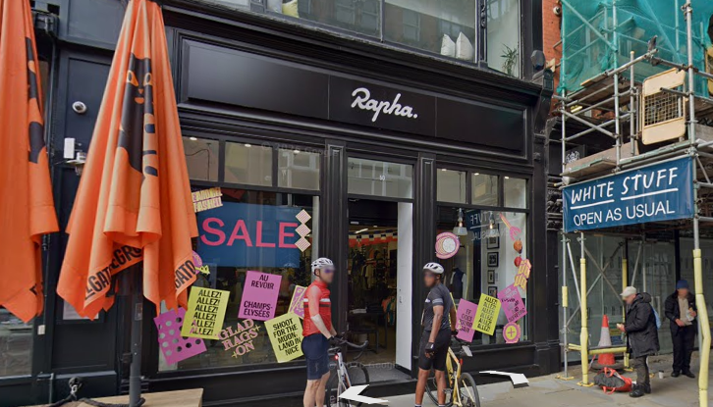

Consultation, notification and publicity responses
Environmental Health- no objections, recommended conditions to be attached should the application be approved.

Highway Services- no objections, recommended an informative to be attached should the application be approved.

Neighbouring properties were notified of the development via letter; no representations have been received.

Relevant policies
The Town and County Planning (Control of Advertisements) Regulations 2007
The Local Planning Authority shall exercise its powers under these Regulations in the interests of amenity and public safety, taking into account-

- The provisions of the development plan, so far they are material; and
- Any other relevant factors

2.

- Factors relevant to amenity include the general characteristics of the locality, including the presence of any feature of historic, architectural, cultural or similar interest;
- Factors relevant to the public safety include-

- The safety of persons using any highway, railway, waterway, etc..
- Whether the display of an advertisement in question is likely to obscure or hinder the ready interpretation of, any traffic sign, railway signal or aid
- Whether the display of an advertisement in question is likely to hinder the operation of any device used for the purpose of security or surveillance or for measuring the speed of any vehicle

3. In taking account of factors relevant to amenity, the local planning authority may, if it thinks fit, disregard any advertisement that is being displayed.

4. Unless it appears to the Local Planning Authority to be required in the interests of amenity or public safety, an express consent for the display of advertisements shall not contain any limitation or restriction relating to the subject matter, content or design of what is to be displayed.

The following policies are considered relevant in the consideration of this application:

Places for Everyone- A long term plan of nine Greater Manchester districts for jobs, new homes and sustainable growth, it has been published by the GMCA on behalf of the nine districts (Bolton, Bury, Rochdale, Oldham, Tameside, Stockport, Manchester, Trafford, Salford, Wigan) and took into effect and become part of the statutory development plan on March 21, 2024.

-Policy JP-P1: Sustainable Places
-Policy JP-P2: Heritage
-Policy JP-Strat2: City Centre

The Manchester Core Strategy- Development Plan Document 2012- 2027 (The Core Strategy) was adopted by the City Council on the 11th of July 2012, it is a key document for the local plan which provides a framework that planning applications are assessed against.

Policy DM1- Development Management
Policy SP1- Spatial Principles
Policy EN3- Heritage
Policy CC9: Design and Heritage

Unitary Development Plan (UDP)- The UDP has been superseded by the Core Strategy Development Plan, but certain policies are still considered relevance:

-Policy DC.14 – Shopfronts and Related Signs
-Policy DC.15- Advertisements, Hoardings and Posters
-Policy DC19- Listed Buildings
-Policy DC18- Conservation Areas

The National Planning Policy Framework (August 2026)- The Government’s new national planning policies and how they are to be implemented through local authorities.

Policy DP3- Key principles for well-designed places
Policy S3: Presumption in favour of sustainable development
Policy HE9: Conservation Areas
Policy HE6: Proposals affecting designated heritage assets
Policy HE5: Assessing effects on heritage assets

Other Material Considerations:

Manchester City Council Shopfront and Design Guide (2024)

Other Legislative Requirements Planning (Listed Buildings and Conservation Areas) Act 1990

Section 72- Special attention shall be paid to the desirability of preserving or enhancing the character of appearance of that area.

Assessment
In the case of this application, the principle of the proposal is considered unacceptable and cannot be supported as it conflicts with the development plan policies and associated guidance listed in the preceding section. It is considered that the insertion of the proposed fascia sign and projecting sign would have an unduly harmful impact on the visual amenity of the St Ann’s Conservation Area and nearby heritage assets.

The existing shopfront is considered to have a matte finish and be neutral in colour therefore, responding well to the context of the building and surrounding area in line with Policy DM1. The development proposal would introduce an obtrusive structure that would detract from the heritage assets and conservation area due to its bright colour and glossy appearance. This would result in an overall diminished appearance of the building. The shopfront and Design Guidance (2024) states ‘overtly reflective acrylic boards and aluminium panels, gloss vinyl, PVC cladding or similar would not be considered acceptable for new fascia signage.’ Therefore, the proposal does not align with the current guidance, and the glossy vinyl design is considered unacceptable. The proposed yellow background is not considered to be cohesive with the street scene, blend with the existing shopfronts and would harm the setting of the nearby Listed Buildings. The current design does not reflect well on the local context of the building and neighbouring units and would have a detrimental impact on the visual amenity of the area.

The Manchester City Council’s Shopfront and Design Guide (2024) also states ‘a fascia [sign] should not unduly project from the face of a shopfront, which can have a negative impact on … [the] appearance of [the] shopfront.’ The current proposal would go against the design guidance as the fascia board creates a bulky and over-dominating appearance to the building and would project forwards of the original fascia. Policy DM1 of the Core Strategy states that ‘development should have regard to the character of the surrounding area’ in which this proposal is not considered to, it is also considered to lack an appropriate design, or appearance and would result in an overall negative effect on the conservation area and setting of nearby Listed Buildings.

Also stated in the Shopfront and Design Guide is, ‘new signage should … have a max depth of 30mm’ the proposed projecting sign would have a depth of 120mm and would not align with the design guide and other projecting signs along King Street. The depth of 120mm would result in a bulky projecting sign that would be out of character to the surrounding shopfronts. Other units along King Street have demonstrated compliance with the guidance through a maximum 30mm depth of a projecting sign. Policy JP-P1 of the Places for Everyone document states that development should ‘respect and acknowledge’ the character of a setting. In this case, a slimline projecting sign would be more appropriate as it would carry less weight and would lessen any harm to the conservation area. The images below demonstrate the advertisement precedent set along King Street, with individually lettered signs placed onto original shopfronts and projecting signs that are of a 30mm depth. The 30mm maximum depth is standard all over the City Centre as per the design guide.

Furthermore, The Town and Country Planning (Control of Advertisements) Regulations encourage proposals to respond well to the ‘historic, [and] architectural’ detailing in relation to the building. In this case, the fascia board nor the projecting sign is considered to respond well to the surrounding historic environment and detailing of the building. The depth of the projecting sign constitutes an unsympathetic proposal that fails to consider the sense of place and existing character of the St Ann’s Conservation Area. It is therefore considered to be harmful to the visual amenity of King Street and nearby designated heritage assets.

Similar decisions have been reached in recent appeals, (references- APP/B4215/H/25/3370701 and 6008236) appended at the end of this report. Both appeals demonstrate the harm such signs can have on the visual amenity of an area and nearby heritage assets.

Overall, the proposed signage does not align with multiple guidance set out in the Manchester Shopfront and Design Guide (2024) and therefore is contrary to Policy DM1, SP1, and EN3 of the Core Strategy. The proposed advertisements would go against Policy HE9 of the NPPF which states ‘development proposals should … consider the area’s special architectural or historic interest in the design of development.’ The development design is considered to be inappropriate to the setting of the building and would detract from the Conservation Area and nearby heritage assets. Therefore, is contrary to JP-P1, JP-P2 and JP-Strat2 of the Places for Everyone Joint Development Document, Policy DC19, 18, 14 and 15 of the UDP.

Precedent images of signage along King Street:

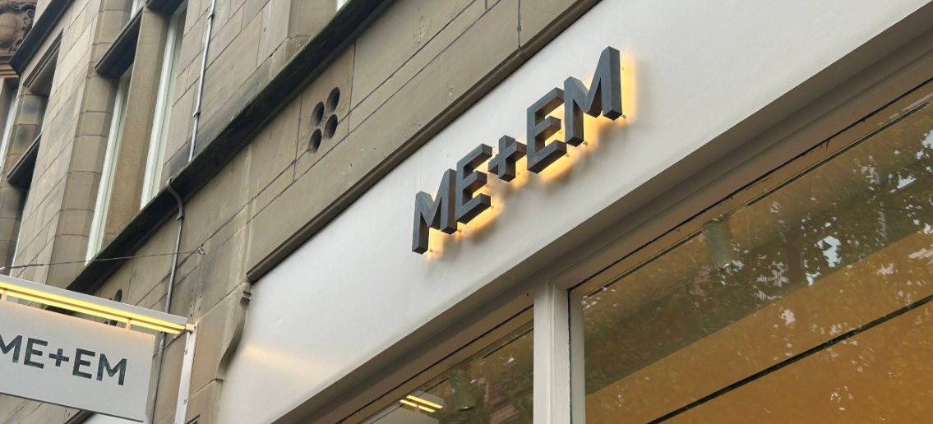

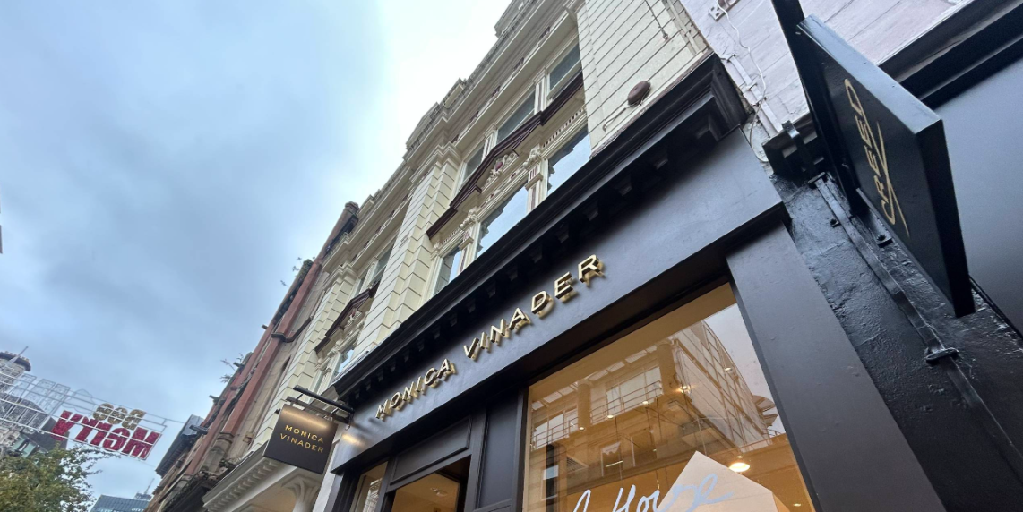

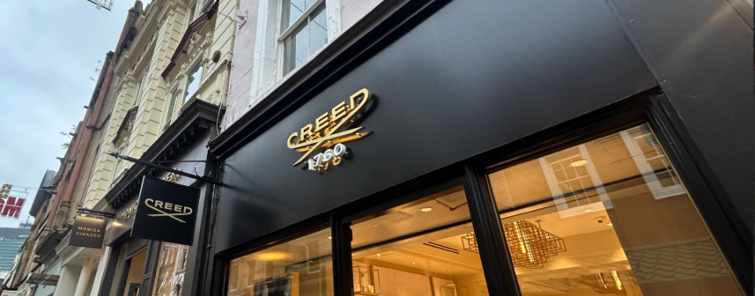

Public Safety
The proposed signage would have sufficient headroom clearance and is not considered to pose any safety concerns. It is not considered that there is evidence of a public safety impact for pedestrians in order to warrant a reason for refusal on these grounds.

Other Legislative Requirements

Equality Act 2010
Section 149 (Public Sector Equality Duty) of the Equality Act 2010 requires due regard to the need to: Eliminate unlawful discrimination, harassment and victimisation and other conduct prohibited by the Act and; Advance equality of opportunity between persons who share a protected characteristic and persons who do not share it. The Equality Duty does not impose a legal requirement to conduct an Equality Impact Assessment. Compliance with the Equality Duty involves consciously thinking about the aims of the Equality Duty as part of the process of decision-making.

Human Rights Act 1998 considerations
This application needs to be considered against the provisions of the Human Rights Act 1998. Under Article 6, the applicants (and those third parties, including local residents, who have made representations) have a right to a fair hearing and to this end the local planning authority must give full consideration to their comments.

Protocol 1 Article 1, and Article 8 where appropriate, confer(s) a right of respect for a person’s home, other land and business assets. In taking account of all material considerations, including Council policy as set out in the Core Strategy and saved polices of the Unitary Development Plan, the Director of Planning, Building Control & Licensing has concluded that some rights conferred by these articles on the applicant(s)/objector(s)/resident(s) and other occupiers and owners of nearby land that might be affected may be interfered with but that that interference is in accordance with the law and justified by being in the public interest and on the basis of the planning merits of the development proposal. She believes that any restriction on these rights posed by the recommendation given is proportionate to the wider benefits of and that such a decision falls within the margin of discretion afforded to the Council under the Town and Country Planning Acts.

Conclusion
Due to a combination of its depth, materials and visual appearance, the proposed projecting sign and fascia board would result in a visually obtrusive feature that would detract from the nearby heritage assets and conservation area. Therefore the advertisements are refused on visual amenity grounds, as the proposal is contrary to the Town and Country Planning (Control of Advertisement) (England) Regulations 2007, Policies JP-P1 of the Places for Everyone Plan, Policies SP1 and DM1 of the Manchester Core Strategy (2012), saved Policies DC15.1, DC15.2 and of the Unitary Development Plan for the City of Manchester (1995) and Policy DP3 and S3 of the National Planning Policy Framework.

Recommendation: REFUSE
Reason for refusal:
The proposal would result in an unduly harmful impact on the visual amenity of the St Ann’s Conservation Area and nearby heritage assets due to its siting, design, appearance and would form an obtrusive feature within the street scene. The proposal therefore is contrary to the provisions of Town and Country Planning (Control of Advertisement) (England) Regulations 2007, Policies JP-P1, JP-P2, JP-Strat2 of the Places for Everyone Plan, Policies SP1, EN1, EN3, CC9 and DM1 of the Manchester Core Strategy (2012), saved Policies DC14, DC15, DC18 and DC19 of the Unitary Development Plan for the City of Manchester (1995) and Policy DP3, S3, HE5, HE6 and HE9 of the National Planning Policy Framework.

Appendix 1

Appeal Ref: APP/B4215/H/25/3370701
340 Deansgate, Manchester M3 4LY
• The appeal is made under Regulation 17 of the Town and Country Planning (Control of
Advertisements) (England) Regulations 2007 (as amended) against a refusal to grant express
consent.
• The appeal is made by Sainsbury's Supermarkets Ltd against the decision of Manchester City
Council.
• The application Ref is 142853/AO/2025.
• The advertisement proposed is the installation of 1no. internally illuminated fascia sign, no.3 vinyl
signs and 1no. internally illuminated projecting sign.

Decision
1. The appeal is dismissed insofar only as it relates to the 1no. internally illuminated
projecting sign.

Preliminary Matters
2. The application form described the proposal as ‘one fascia sign and one projecting
sign’. I have used the decision notice description, as it provides better clarity.

3. The Council’s decision granted the installation of 1 internally illuminated fascia sign
and 3 external vinyl signs, but refused permission for 1 internally illuminated
projecting sign. The appellant has submitted the appeal for express consent for
this projecting sign only, and I have made my determination on the same basis.

4. Since the submission of evidence for this appeal, my site visit identified that the
Sainsbury’s store is now in operation. A projecting sign of the same dimensions
and location sought has been erected, but its precise lettering/logo is slightly
different. For the avoidance of doubt, my determination is therefore based on the
submitted plans.

Main Issue

5. Powers under the Advertisement Regulations shall be exercised only in the
interests of amenity and public safety. The Council has not highlighted any
potential harmful impact to public safety, and I make the same conclusion.

6. The main issue is therefore the effect of the proposed advertisement on the visual
amenity of the area, with particular regard to the preservation or enhancement of
the character or appearance of the Castlefield CA, and the setting of nearby listed
buildings.
Appeal Decision APP/B4215/H/25/3370701
https://www.gov.uk/planning-inspectorate 2
Reasons

7. The site is a Sainsbury’s Local convenience store, occupying the ground floor of a
part six and part four storey office building. It lies within central Manchester on
Deansgate, a very busy and commercial street. The proposed internally
illuminated projecting sign would be sited in line with the fascia approximately
2.3m above ground, fixed directly to the building’s brick façade. It would comprise
orange aluminium with white fret cut lettering on both sides, at 875mm wide,
500mm high, and 100mm deep, and illuminated to 144 Canelas/m².

8. The site lies within the Castlefield Conservation Area (CA), with the CA boundary
running along Deansgate. For an advertisement in a CA, the test from s72(1) of
the Planning (Listed Buildings and Conservation Areas) Act 1990 is that “special
attention shall be paid to the desirability of preserving or enhancing the character
or appearance of a Conservation Area”. This statutory duty applies in
advertisement appeals insofar as it relates to the consideration of amenity. The
statutory duty to have special regard to preserving a listed building or its setting
does not apply to applications for advertisement consent, but the Advertising
Regulations identify that factors relevant to amenity include the presence of any
feature of historic or architectural interest.

9. The CA derives significance from its incorporation of some of Manchester's richest
heritage. It can be understood as a microcosm of the city’s history, from multiple
major roman roads and Fort Mamucium (Scheduled Monument) as the first definite
record of human settlement in Manchester, through to mass-industrialisation and
beyond, such as Britian's first canal in 1761, the railway, and the Great Northern
Warehouse from 1899. The CA contains numerous listed buildings and designated
heritage assets, which clearly play a key positive contribution to the visual
character and amenity of the area. They hold significance in that respect,
architecturally, and in contributing towards the understanding of the historic
development of the city.

10. That closest to the appeal site is the Grade II Castlefield Information Centre,
occupied by Instituto Cervantes and attached to the Former Market Hall (Grade II).
There is also direct inter-visibility with the Grade II listed buildings of Nos. 235-291
Deansgate, the K6 telephone kiosk beside No. 330 Deansgate, Nos. 29-41
Liverpool Road, and the Castlefield Viaduct.

11. The streetscene is busy and commercial, containing multiple items of street
furniture, fascias and signage, and different building types, sizes, and materials.
This includes a modern hotel directly opposite, and the modern design of the host
building itself. However, the area retains a clearly historic character and visual
amenity. Within multiple vistas, these listed buildings and structures would form a
direct backdrop to the sign.

12. The sign would be somewhat obtrusive within this context, exacerbated by its
bulky width and illumination. Notwithstanding its relatively small size in isolation, I
have to be mindful of a cumulative impact. Section 6.3 of the Shopfront and
Signage Design Guide (‘the Guide’) (2024) identifies those new advertisements
must be sensitively designed and well-integrated into an elevation and the wider
streetscene in design, proportion, and position. Signage should relate well to the
character, scale, and architectural features, and should, amongst other matters,
have a maximum depth of 30mm and not be in the form of internally illuminated
lightbox signage. Appeal Decision APP/B4215/H/25/3370701
https://www.gov.uk/planning-inspectorate 3

13. The Guide also specifies that organisations should show particular flexibility and
special consideration to CAs (page 10). Although it is only guidance, and is
inevitably general in its approach, I find no compelling reason not to abide by it,
especially in this historic context. The proposed sign constitutes a generalised
approach, which has not been designed to relate to this context. The images
provided, and my site visit observations, indicate that various types of slimmer
signage are not commercially untenable.

14. In precedent the appellant refers to a very similar Sainsbury’s sign further along
Deansgate, also sited opposite listed buildings (116194/AO/2017). However, its
approval was prior to the adoption of the Guide, on a substantially different
building façade, and my site visit identified that it is no longer present. It therefore
provides no direct support. Also referenced is an identical projecting sign allowed
on appeal at an Oldham Street store, also attached to a modern building within a
CA. That Inspector acknowledged that it does not appear dominant or discordant
and its contemporary appearance reflects the character of the building, although
did note its 100mm depth as not insubstantial. However, again I find that site has a
different streetscene character, including a different relationship with listed
buildings, such that it does not direct me to conclude similarly.

15. Both parties have also provided images of other illuminated signs. Again, I have
not found them to be individually determinative because their specific streetscene
context is different to that for the appeal proposal.

16. Overall, the proposed projecting sign would harm the visual amenity of the area,
and in this context would not preserve or enhance the character and appearance
of the CA or the settings of adjacent listed buildings. In accordance with the
Advertisement Regulations, I have taken into account the provisions of the
development plan so far as relevant to visual amenity. The sign would conflict with
the Manchester Core Strategy Development Plan Document Policies SP1 and
DM1, the Places for Everyone Joint Development Plan Document 2022 to 2039
Policy JP-P2, and the Unitary Development Plan Saved Policy DC14. Together
and amongst other matters, these require development to have regard to and
protect the character of the surrounding area and heritage assets, through
appropriate scale, form, and massing. Shop signs should be in keeping with the
character of the building and adjoining buildings, and the wider area.

Conclusion
17. With no other material considerations indicating otherwise, for the reasons given
above I conclude that the appeal is dismissed insofar as it relates to the internally
illuminated projecting sign.

Appeal Ref: 6008236
1 Goods Yard Street, Manchester M3 3BG
• The appeal is made under Regulation 17 of the Town and Country Planning (Control of
Advertisements) (England) Regulations 2007 (as amended) against a refusal to grant express
consent.
• The appeal is made by Permanently Unique against the decision of Manchester City Council.
• The application reference is 145010/AO/2026.
• The advertisement proposed is proposed single fascia sign and projecting signs x 2.

Decision

1. The appeal is dismissed.

Preliminary Matters

2. The Government published a revised National Planning Policy Framework (the
Framework) on 17 August 2026. It does not change the planning policy context in
respect of the main issues, and I have determined the appeal accordingly.

3. Regulation 3 of the Town and Country Planning (Control of Advertisements)
(England) Regulations 2007 (as amended) requires that local planning authorities
control the display of advertisements in the interests of amenity and public safety,
taking into account the provisions of the development plan, in so far as they are
material, and any other relevant factors.

4. The Council’s reason for refusal relates specifically to matters of amenity. There
was no objection raised on the grounds of public safety, and I find no reason to take
a different view on this matter.

Main Issue

5. The main issue is the effect of the proposed advertisements on the visual amenity of
the host building and the surrounding area.

Reasons

6. The appeal site forms part of Manchester Goods Yard; a recently completed mixeduse development delivered as part of the wider Enterprise City regeneration project
at a key gateway location to Manchester City Centre. The surrounding area
comprises a mix of commercial, leisure, hospitality, office, residential and cultural
uses within a contemporary urban setting. The appeal premises occupy a ground
floor commercial unit within a multi-storey building, with office accommodation at the
upper levels. The building exhibits a coherent architectural design, characterised by
high-quality materials and carefully considered elevations. The site lies within the
Castlefield Conservation Area (CCA). An approved signage strategy has been
established for the wider Enterprise City development which seeks to maintain the
Appeal Decision 6008236
https://www.gov.uk/planning-inspectorate 2
architectural quality and cohesive appearance of the buildings through a restrained
and coordinated approach to signage and wayfinding.

7. The proposed advertisements comprise an internally illuminated fascia sign
positioned on the corner feature of the building together with two internally
illuminated projecting signs. At my site visit it was apparent that the corner feature
canopy forms a prominent architectural feature of the host building, contributing to
its modern design and appearance within the wider development. It is also a
recurring feature which is repeated at other corners on the development, helping to
establish a consistent architectural language across the site. As such, the feature
plays an important role in the overall appearance of the building and the wider
development.

8. The proposed fascia sign would be positioned on this architectural feature and, by
reason of its siting, scale and illumination, would appear unduly prominent within the
street scene. Rather than complementing the architectural composition of the host
building, it would draw attention away from the design of the corner canopy feature
and diminish the clarity of the building's architectural form. Furthermore, the
proposed projecting signs, whilst acceptable in principle, would appear overly bulky
and conspicuous as a consequence of their depth and method of construction. The
proposed materials would not reflect the high quality detailing of the host building
and would appear as visually intrusive additions to the façade. As a result, they
would not reflect the restrained and coordinated approach to signage promoted by
the approved signage strategy and would appear at odds with the building’s design.
Taken together, the proposed advertisements would fail to integrate successfully
with the host building and would detract from its appearance and that of the wider
development, causing harm to visual amenity.

9. As part of my assessment, I have considered the Manchester Shopfront and
Signage Design Guide (2024). Whilst the document is supplementary guidance
rather than development plan policy, it provides a relevant framework for assessing
the impact of advertisements on visual amenity. Amongst other things, the guidance
seeks to ensure that signage responds appropriately to the architectural character of
its host building and avoids overly prominent, bulky or visually intrusive forms of
advertisement. In this case, I find that the proposed fascia sign and projecting signs
would not accord with the principles of the guidance.

10. In reaching my decision, I have had regard to the appeal site's location within the
CCA and to the statutory duty under Section 72(1) of the Planning (Listed Buildings
and Conservation Areas) Act 1990, which requires special attention to be paid to the
desirability of preserving or enhancing the character or appearance of conservation
areas. I note that the Council raised no heritage objection to the proposal and
concluded that the advertisements would have a neutral effect on the CCA. I have
no reason to disagree with that assessment and therefore find that the proposal
would preserve the character and appearance of the CCA.

11. For the reasons given above, I conclude that the proposed advertisements would
have an unduly harmful effect on the visual amenity of the building, its high-quality
façade and the wider development. The advertisements would undermine the strong
architectural form of the host building and conflict with the approved signage
strategy. Consequently, the proposal conflicts with Policies SP1, EN1 and DM1 of
the Manchester Core Strategy (2012) which among other things seek to ensure that
development in Manchester is located in the right places, is well designed, and is
Appeal Decision 6008236 https://www.gov.uk/planning-inspectorate 3
managed in a way that supports sustainable growth while protecting the character
and amenity of the surrounding area and saved Policy DC14 of the Manchester
Unitary Development Plan (1995) which seeks to ensure that shopfronts and
associated signage are of an appropriate scale, design and appearance, which
preserve or enhance the character of the building and surrounding streetscene.

Other Matters

12. The appellant has drawn my attention to the approved signage at Mollie’s, 2
Atherton Street. I have carefully considered this comparison. However, I do not
consider that this approval demonstrates that the appeal proposal would be
acceptable. Whilst the premises are located in close proximity to one another, the
circumstances of the two sites differ. In particular, the façade at the Mollie’s is set
back behind boundary treatments which obscure the ground floor elevation. By
contrast, the appeal premises occupies a prominent position within a building whose
ground floor façade is highly visible in the street scene. As a result, the
circumstances of the two sites are materially different and the approval at Mollie's
carries little weight in my assessment of the appeal proposal.

13. The appellant also argues that the presence of informal advertisements and
promotional material elsewhere within the wider development demonstrates that
occupiers require greater visibility than provided by the approved signage strategy
and is a consequence of the Council's approach to signage control. However,
regardless of the reasons for their presence, other signage displays within the area
do not justify the appeal proposal and do not alter my assessment of its effect on
visual amenity.

14. I acknowledge the appellant's submissions that the proposed illuminated signage is
necessary to attract passing trade and contribute to the commercial success and
viability of the restaurant. However, the advertisement control regime limits the
assessment of proposals to considerations of amenity and public safety. Whilst
some degree of signage is clearly necessary to identify and advertise the premises,
commercial competition, business requirements and the desire to maximise visibility
are not determinative considerations. In this case, I have not been provided with
convincing evidence that the scale, siting and design of the proposed
advertisements are necessary to achieve effective identification of the unit, nor that
alternative signage solutions more closely aligned with the approved signage
strategy and design guidance would be incapable of providing an appropriate level
of visibility. Consequently, the commercial benefits identified by the appellant do not
outweigh the harm to visual amenity arising from the proposed advertisements.

15. The appellant further argues that non-illuminated versions of the projecting signs
may benefit from deemed consent. However, the appeal before me relates to the
specific advertisements as proposed. The acceptability or otherwise of a different
scheme is not a matter that falls to be determined in this decision.

Conclusion
16. For the reasons given above the appeal should be dismissed.

