

Planning

Delegated Officer Report

Summary of application details
Application reference: | PLA-2026-000947
Application type: | Full planning permission
Proposal: | Replacement of existing external platform lift at main entrance with new platform lift.
Site address: | Crown Courts Minshull Street Manchester M1 3FS
Ward(s): | Piccadilly
Date application valid: | 07 September 2026
Applicant name: | The Secretary of State for Justice
Agent (if any): | Mr Rob Firman
Case officer: | Ciara Gettinby
Recommendation: | Approve
Date of recommendation: | 16 October 2026

Description of site, building and/or area
The applicant site that relates to this Listed Building Consent, is Grade II Listed Building, Minshull House occupied by the Crown Courts. The building features five storeys with a basement and consists of sandstone ashlar and redbrick with sandstone dressings. The south-east side of the building is considered to hold the most heritage value. The application relates specifically to eastern entrance of the site which is deemed to be of a more modern appearance and features modern interventions. The entrance features two staircases and their associated handrails and an existing platform lift. Running adjacent to the entrance are the Metrolink Tram tracks.

The surrounding area is characterised by the nearby office blocks and hotels. Tram tracks bound the site on the north-east. Located within the vicinity of the site are, Grade II Listed Building, Minshull House, Grade II Listed Building 11 Bloom Street, Grade II Listed Building 42 Bloom Street & 9 Minshull Street and Grade II Listed Lock, 86 Rochdale Canal.

Description of development
Listed Building Consent is sought for the replacement of existing external platform lift at the main entrance. This application has been submitted alongside other applications to update and improve the functions of the crown courts, references: PLA-2026-001226 and PLA-2026-001504.

The total works include, removal of existing lift, insertion of drainage hole within the recess of the staircase, insertion of hydraulic hose on the underground car park level and the associated holes (2) that will be needed to facilitate it, insertion of electrical cables into existing cables run, proposed cabinet to store the electrical wires and insertion of hole beneath the cabinet and the insertion of the replacement lift.

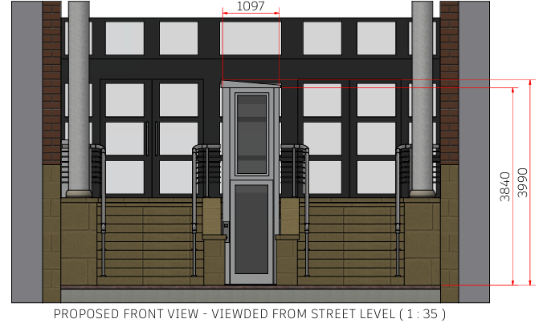
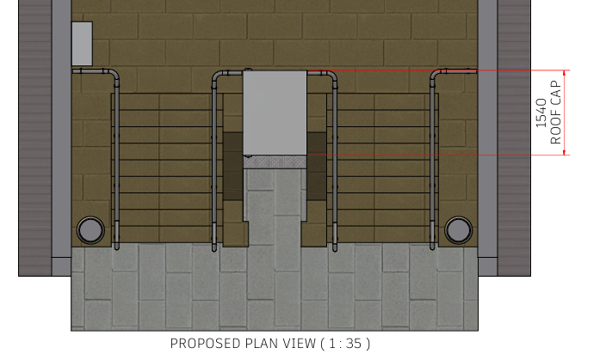
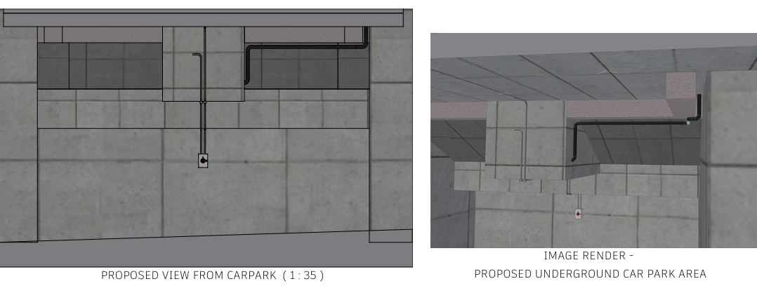
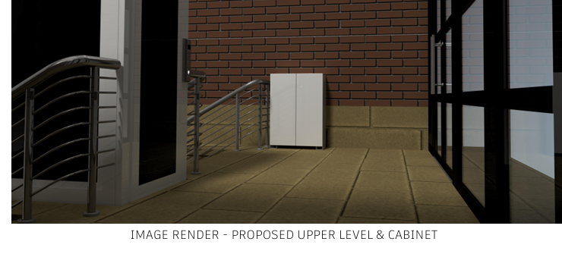

Consultation, notification and publicity responses
Highway Services- no objections to the proposal but have recommended informatises to be attached.

Historic England- no objections or comments.

A site notices was displayed adjacent to the site; no representations have been received.

Relevant policies
The following policies are considered relevant in the consideration of this application:

Places for Everyone- A long term plan of nine Greater Manchester districts for jobs, new homes and sustainable growth, it has been published by the GMCA on behalf of the nine districts (Bolton, Bury, Rochdale, Oldham, Tameside, Stockport, Manchester, Trafford, Salford, Wigan) and took into effect and become part of the statutory development plan on March 21, 2024.

-Policy JP-P1: Sustainable Places
-Policy JP-P2: Heritage
-Policy JP-Strat2: City Centre

Unitary Development Plan (UDP)- The UDP has been superseded by the Core Strategy Development Plan, but certain policies are still considered of relevance:

-Policy DC19- Listed Buildings

The Manchester Core Strategy- Development Plan Document 2012- 2027 (The Core Strategy) was adopted by the City Council on the 11th of July 2012, it is a key document for the local plan which provides a framework that planning applications are assessed against.

Policy DM1- Development Management
Policy SP1- Spatial Principles
Policy EN1- Design Principles and Strategic Character Areas
Policy EN3- Heritage
Policy CC9: Design and Heritage

The National Planning Policy Framework (August 2026)- The Government’s new national planning policies and how they are to be implemented through local authorities.

Policy DP3- Key principles for well-designed places
Policy HE5: Assessing effects on heritage assets
Policy HE6- Proposals affecting designated heritage assets

Other Legislative Requirements Planning (Listed Buildings and Conservation Areas) Act 1990

Section 66 – For development which affects a listed building or its setting, the local planning authority shall have special regard to the desirability of preserving the building or its setting.

Assessment
In determining whether proposed works are acceptable, the main issue to consider is the impact the proposed works will have on the historic character and fabric of the listed building itself and to establish whether the public benefits, including heritage benefits of the proposal that would outweigh any harm to the significance of the heritage asset. These matters are set out below.

Principle
The proposed works would facilitate the continued provision of disabled access to the Crown Courts. This entrance is the only entrance that would provide level access to the building and therefore the insertion of a new platform lift is of importance. It is not expected that the proposed development would create an unacceptable impact on the visual amenity of the Grade II Listed Building, or nearby heritage assets, these matters are set out below.

Impact on the Listed Building and Public Benefits
As set out in Policy HE5 of the National Planning Policy Framework (August 2026) development proposals affecting heritage assets should be accompanied by their assessment of the significance of assets affected, the level of detail should be proportionate to the asset’s importance. Upon assessment, this entrance to the building is considered to hold low heritage significance as it is the newer extension and therefore, a modern intervention to the building.

Overall, the insertion of the holes and cabinet would result in harm to the building, as the holes would damage the existing fabric and the cabinet would contribute to clutter on the upper-level platform. The removal and insertion of the new lift would not result in any harm to the building considering the dimensions and overall appearance of the lift would be similar to that of existing.

However, the cabinet would be located on the upper level and would be set back and shielded by the existing column from the public view. Additionally, the insertion of the holes would not be visible as they would be located underneath the proposed lift and cabinet and the associated wires would not be visible to the public view. As this particular part of the building is considered to be of low heritage significance, the works are not considered to harm the overall heritage significance of the building.

Although the proposal would result in harm, these works would be significantly outweighed by the public benefits it would bring, as it would facilitate disabled access to the Crown Courts.
Considering the works would affect the newer extension of the building, where there is little heritage significance and would result in important public benefits through facilitating disabled access, the proposal is considered acceptable. Whilst it is necessary to have special regard to the desirability of preserving the building, there are sufficient benefits for this in this particular case.

Therefore, the proposal aligns with Policy DP3, HE5, and HE6 of the NPPF, Policy DC19 of the UDP, Policy JP-P1, JP-P2 and JP-Strat2 of the Places for Everyone Joint Development Plan and Policy DM1, SP1, EN1, EN3 and CC9 of the Core Strategy.

Other Legislative Requirements

Equality Act 2010
Section 149 (Public Sector Equality Duty) of the Equality Act 2010 requires due regard to the need to: Eliminate unlawful discrimination, harassment and victimisation and other conduct prohibited by the Act and; Advance equality of opportunity between persons who share a protected characteristic and persons who do not share it. The Equality Duty does not impose a legal requirement to conduct an Equality Impact Assessment. Compliance with the Equality Duty involves consciously thinking about the aims of the Equality Duty as part of the process of decision-making.

Human Rights Act 1998 considerations
This application needs to be considered against the provisions of the Human Rights Act 1998. Under Article 6, the applicants (and those third parties, including local residents, who have made representations) have a right to a fair hearing and to this end the local planning authority must give full consideration to their comments.

Protocol 1 Article 1, and Article 8 where appropriate, confer(s) a right of respect for a person’s home, other land and business assets. In taking account of all material considerations, including Council policy as set out in the Core Strategy and saved polices of the Unitary Development Plan, the Director of Planning, Building Control & Licensing has concluded that some rights conferred by these articles on the applicant(s)/objector(s)/resident(s) and other occupiers and owners of nearby land that might be affected may be interfered with but that that interference is in accordance with the law and justified by being in the public interest and on the basis of the planning merits of the development proposal. She believes that any restriction on these rights posed by the recommendation given is proportionate to the wider benefits of and that such a decision falls within the margin of discretion afforded to the Council under the Town and Country Planning Acts.

Conclusion
Given the above issues, it is considered that the proposal is acceptable in terms of its principle, and impact on the listed building through providing its public benefits. The proposal broadly complies with Policy DP3, HE5, and HE6 of the NPPF, Policy DC19 of the UDP, Policy JP-P1, JP-P2 and JP-Strat2 of the Places for Everyone Joint Development Plan and Policy DM1, SP1, EN1, EN3 and CC9 of the Core Strategy.

Article 35 Declaration
Officers have worked with the applicant in a positive and proactive manner based on seeking solutions to problems arising in relation to dealing with the planning application. No significant problems have arisen during the consideration of this application, and the applicant has been determined in a timely manner, in accordance with the policies in the development plan.

Recommendation: Approve

Conditions attached to this decision

- Time
The development must have begun no later than the expiration of three years beginning with the date of permission. Required to be imposed pursuant to Section 91 of the Town and Country Planning Act of 1990.

Reason - Required to be imposed pursuant to Section 91 of the Town and Country Planning Act of 1990.

- Specified Plans

The development hereby approved shall be carried out in accordance with the following documents:

Lift Area Details, ref- CL2459_REF_0001_02 REV A
Ground Floor Layout, ref- 326944-0000-MoJ-NEW-GF-DR-A-0001-CR-01-0D100 REV 01
Lift Area Details, ref- CL2459_REF_0001_04 REV A
The Location Plan, ref- 2606-03-01-01 REV 01
Lift Area Details, ref- CL2459_REF_0001_03 REV A

All received by the City Council as the LPA on the 7 July 2026.

Reason- to ensure that the development is carried out in accordance with the approved plans, pursuant to saved policy DC1 of the Unitary Development Plan for the City of Manchester and policies SP1 and DM1 of the Manchester Core Strategy.

Informative

The applicant should be advised of the details of working safely near Metrolink which can be found on the Metrolink Website at; https://www.tfgm.com/public-transport/tram/working-safely. This document provides contact details for the Metrolink Operator in order that the proposed method of erection can be discussed and relevant permits obtained.

The applicant is required to discuss and agree any requirements for licensing, hoarding / scaffolding, and skips with MCC's Highways Licensing Team via Email to: highwaylicences@manchester.gov.uk

The applicant is required to discuss and agree any requirements for temporary pedestrian and traffic management with MCC’s Event and Traffic Management Team via Email to highwaynetworkmanagement@manchester.gov.uk

