
TBT-073 TOOLBOX TALK
Bird Hazard Management

WHAT?

This Toolbox Talk is provided to ensure that all personnel working on the project understand the requirements of the approved Bird Hazard Management Plan and their individual responsibilities in preventing the construction site from becoming an attractant to birds.

The project is located within the safeguarded area associated with Manchester Airport. Bird activity associated with construction sites can contribute to aviation bird-strike risk, particularly where food, waste, water, exposed ground or other attractants encourage birds to congregate.

WHY? - LARGE CONGREGATION OF BIRDS

Birds congregating around the construction site may subsequently move between the site and the airport/aircraft flight paths. This can increase the potential for bird strikes involving aircraft.

Birds must not be dispersed when in large congregations in fear of entering into the aviation flight path. If the site management see or are informed of large congregations of birds on site, dispersal can only take place in co-ordination with informing MAN airport WCU is informed.

A clean construction site is therefore an aviation safety requirement, not simply a housekeeping requirement.

Manchester Airport states that wildlife management is part of aerodrome safeguarding and that developments which have the potential to increase bird numbers or bird movements can result in a net increase in bird-strike risk.

Dos  - Food must only be consumed in the designated site welfare/eating areas.  - Food packaging must be disposed of immediately in the designated waste receptacles.  - Any spilled food or food waste must be cleaned up immediately and reported to the relevant supervisor where necessary.  - Report immediately to the Site Manager/Environmental Manager if large numbers of birds begin congregating on or around the site.  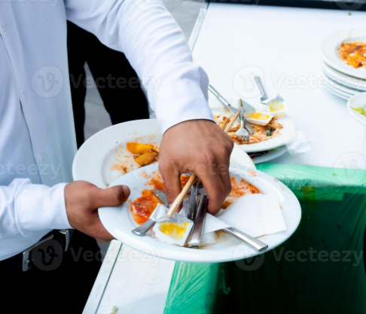 | DON’Ts  - Do not eat food in work areas, compounds, plant areas, roof areas, excavations or other parts of the site unless specifically authorised by the Site Manager.  - Food must not be left unattended or stored in locations accessible to birds.  - Food scraps must never be thrown onto the ground.  - Do not feed birds or other wildlife under any circumstances.  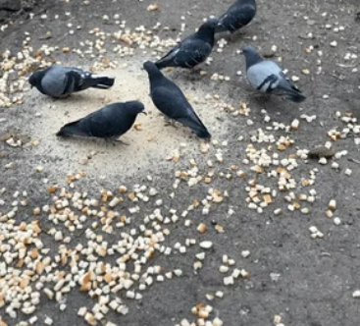

LARGE CONGREGATION OF BIRDS
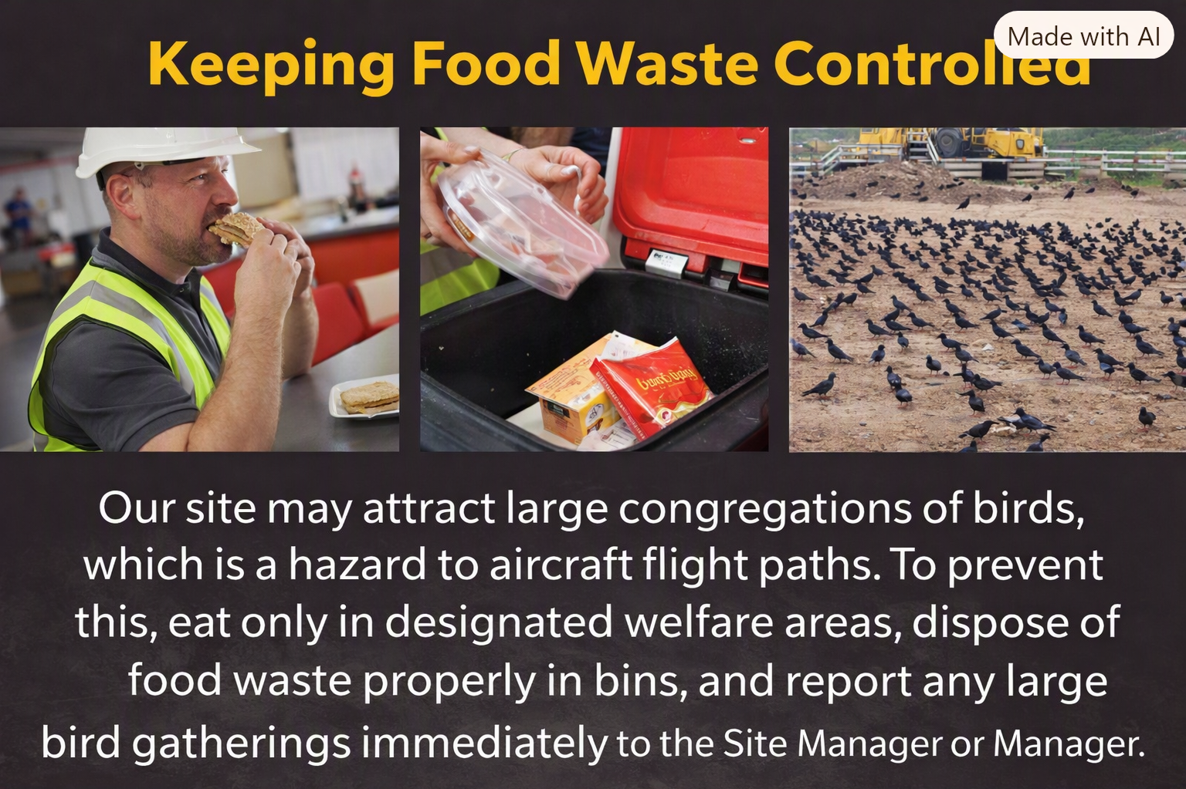

Birds congregating around the construction site may subsequently move between the site and the airport/aircraft flight paths. This can increase the potential for bird strikes involving aircraft.

A clean construction site is therefore an aviation safety requirement, not simply a housekeeping requirement.

Manchester Airport states that wildlife management is part of aerodrome safeguarding and that developments which have the potential to increase bird numbers or bird movements can result in a net increase in bird-strike risk.

Large congregations of birds on or near the construction site must be reported immediately to the Site Manager or Environmental Manager. Do not attempt to disperse birds yourself, as this can drive them directly into aircraft flight paths and create a serious aviation safety hazard. Stop work in the affected area if instructed, maintain good housekeeping to avoid attracting birds, and await direction from Manchester Airport’s Wildlife Control Unit (WCU) before any action is taken.

