

Planning

Delegated Officer Report

Summary of application details
Application reference: | NOT-2026-001924
Application type: | Prior notification: Building (agricultural/forestry)
Proposal: | Prior approval for agricultural storage building.
Site address: | Land Opposite Bollin View Off Mill Lane Manchester
Ward(s): | Woodhouse Park
Date application valid: | 09 October 2026
Applicant name: | Mr James Pownall
Agent (if any): | Mr Ian Pleasant
Case officer: | Joshua Lee
Recommendation: | Refuse
Date of recommendation: | 15 Oct 2026

Description of site, building and/or area
The application site lies to the south of Mill Lane on the southeastern edge of the village of Ashley and to the south of Altrincham. The site is surrounded by the River Bollin.
The site is within a rural part of the Woodhouse Park ward of Manchester City Council where it is designated as being within an area of Green Belt and close to the Manchester Airport Aerodrome.
The Trafford LPA is immediately to the south with the River Bollin acting as the border.

Description of development
The proposals under this application are to construct a new agricultural building on the site to house the agricultural equipment and machinery associated with working the agricultural land under the applicant’s ownership. The proposed building is a steel portal frame building constructed of plastic-coated steel roofing and cladding.
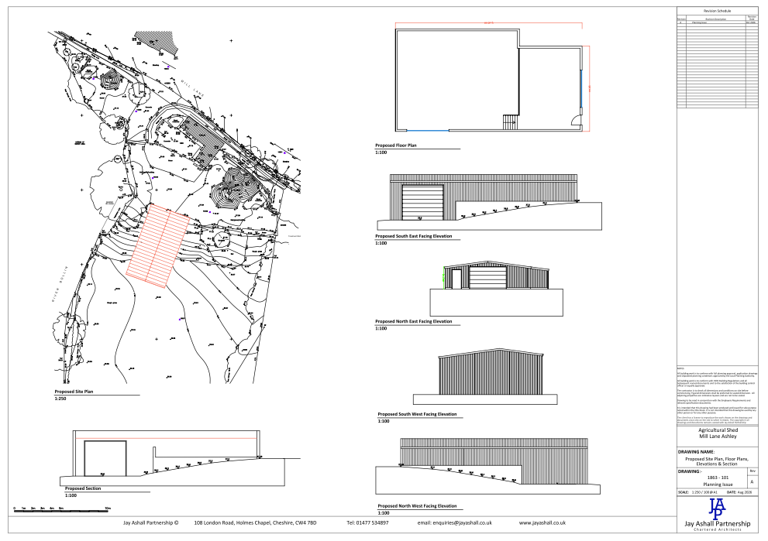
Figure 1. Proposed plan and elevations

Relevant planning history
- 052975/FH/SOUTH3/97 - Erection of loose boxes and store - Approved - 18/11/1997
- 102170/FH/2013/S2 - Erection of 4 no. stables - Approved - 31/05/2013

Consultation, notification and publicity responses
Not required.

Relevant policies
The proposal falls to be considered against the requirements of Schedule 2, Part 6, Class A of the Town and Country Planning (General Permitted Development) (England) Order 2015 (as amended), which grants planning permission for certain agricultural developments subject to specified limitations, conditions and prior approval requirements.
In determining the application, the Council is required to have regard to the National Planning Policy Framework and has also had regard to the statutory Development Plan as material considerations. However, these considerations do not expand the scope of assessment beyond the matters specified within Part 6, Class A of the GPDO.
The legislation, policies and guidance considered relevant to the assessment are:

Legislation
- The Town and Country Planning (General Permitted Development) (England) Order 2015 (as amended)
  - Schedule 2
    - Part 6 – Agricultural and forestry
      - Class A – Agricultural development on units of 5 hectares or more

National Policy
- National Planning Policy Framework (August 2026), including relevant National Development Management Policies

Local Policy
- Places for Everyone Joint Development Plan Document 2024-2039
- Manchester Core Strategy Development Plan Document 2012-2027
- Saved policies of the Manchester Unitary Development Plan

The Town and Country Planning (General Permitted Development) (England) Order 2015

Part 6, Class A - agricultural development on units of 5 hectares or more

Permitted development
A. The carrying out on agricultural land comprised in an agricultural unit of 5 hectares or more in area of—
(a)works for the erection, extension or alteration of a building; or
(b)any excavation or engineering operations,
which are reasonably necessary for the purposes of agriculture within that unit.
A.1 Development not permitted | Comments
- the development would be carried out on a separate parcel of land forming part of the unit which is less than 1 hectare in area; | The application site itself measures 1.01 hectares.
- it would consist of the erection or extension of any agricultural building on an established agricultural unit (as defined in paragraph X of Part 3 of this Schedule) where development under Class Q or S of Part 3 (changes of use) of this Schedule has been carried out within a period of 10 years ending with the date on which development under Class A(a) begins; | No Part Q or Part S development has ever occurred on the site.
- it would consist of, or include, the erection, extension or alteration of a dwelling; | The proposals are not to erect, extend or alter a dwelling.
- it would involve the provision of a building, structure or works not designed for agricultural purposes; | The building is for the purposes of agricultural storage.
- the ground area which would be covered by—  - any works or structure (other than a fence) for accommodating livestock or any plant or machinery arising from engineering operations would exceed 1,000 square metres; or  - any building erected or extended or altered by virtue of Class A F2would exceed 1,500 square metres  calculated as described in paragraph D.1(2)(a) of this Part; | The proposed building measures 210sqm
- the height of any part of any building, structure or works within 3 kilometres of the perimeter of an aerodrome would exceed 3 metres; | The proposed building would be located within 3 kilometres of the perimeter of an aerodrome (Manchester Airport). Due to the sloping nature of the site, the ridge height would reach approximately 5 metres above adjacent ground level at the south-west elevation. Accordingly, part of the building would exceed the 3-metre height limitation.
- the height of any part of any building, structure or works not within 3 kilometres of the perimeter of an aerodrome would exceed 12 metres; | n/a
- any part of the development would be within 25 metres of a metalled part of a trunk road or classified road; | The site is not within 25m of a metalled part of a trunk road or classified road.
- it would consist of, or include, the erection or construction of, or the carrying out of any works to, a building, structure or an excavation used or to be used for the accommodation of livestock or for the storage of slurry or sewage sludge where the building, structure or excavation is, or would be, within 400 metres of the curtilage of a protected building; | The building is not for the accommodation of livestock or storage or slurry or sewage sludge.
- it would involve excavations or engineering operations on or over article 2(4) land which are connected with fish farming; | N/A
- any building for storing fuel for or waste from a biomass boiler or an anaerobic digestion system—  - would be used for storing waste not produced by that boiler or system or for storing fuel not produced on land within the unit; or  - is or would be within 400 metres of the curtilage of a protected building [F5; or | N/A
- the erection or extension of a building would be carried out on land or a building that is, or is within the curtilage of, a scheduled monument | The building is not within the curtilage of a scheduled monument.

The proposal seeks prior approval for the erection of an agricultural storage building under Schedule 2, Part 6, Class A of the Town and Country Planning (General Permitted Development) (England) Order 2015 (as amended).
The application site lies within 3 kilometres of the perimeter of an aerodrome. Limitation A.1(f) of Class A states that development is not permitted where the height of any part of any building, structure or works within 3 kilometres of the perimeter of an aerodrome would exceed 3 metres.
The applicant states that the building has been designed to be 3 metres in height when measured from the adjacent access road. However, limitation A.1(f) requires consideration of the height of any part of the building and is not based on a single reference point. In this regard, the site is characterised by a change in levels, and the proposed building would be positioned on sloping ground. Whilst part of the structure would measure approximately 3 metres in height when taken from the access road, the submitted plans demonstrate that other parts of the building would exceed 3 metres in height when measured relative to the adjoining ground level.
As part of the proposed building would exceed 3 metres in height within 3 kilometres of the perimeter of an aerodrome, the proposal fails to comply with limitation A.1(f) of Schedule 2, Part 6, Class A of the GPDO. Whilst the proposal may comply with other limitations and criteria within Class A, the development must satisfy all of the relevant limitations in order to benefit from permitted development rights. As the proposal fails to comply with limitation A.1(f), it does not constitute permitted development and cannot proceed through the prior approval process.

Other Legislative Requirements

Equality Act 2010
Section 149 (Public Sector Equality Duty) of the Equality Act 2010 requires due regard to the need to: Eliminate unlawful discrimination, harassment and victimisation and other conduct prohibited by the Act and; Advance equality of opportunity between persons who share a protected characteristic and persons who do not share it. The Equality Duty does not impose a legal requirement to conduct an Equality Impact Assessment. Compliance with the Equality Duty involves consciously thinking about the aims of the Equality Duty as part of the process of decision-making.

Human Rights Act 1998 considerations
This application needs to be considered against the provisions of the Human Rights Act 1998. Under Article 6, the applicants (and those third parties, including local residents, who have made representations) have a right to a fair hearing and to this end the local planning authority must give full consideration to their comments.
Protocol 1 Article 1, and Article 8 where appropriate, confer(s) a right of respect for a person’s home, other land and business assets. In taking account of all material considerations, including Council policy as set out in the Core Strategy and saved polices of the Unitary Development Plan, the Director of Planning, Building Control & Licensing has concluded that some rights conferred by these articles on the applicant(s)/objector(s)/resident(s) and other occupiers and owners of nearby land that might be affected may be interfered with but that that interference is in accordance with the law and justified by being in the public interest and on the basis of the planning merits of the development proposal. She believes that any restriction on these rights posed by the recommendation given is proportionate to the wider benefits of and that such a decision falls within the margin of discretion afforded to the Council under the Town and Country Planning Acts.

Planning Balance and Conclusion
The proposal fails to comply with limitation A.1(f) of Schedule 2, Part 6, Class A of the Town and Country Planning (General Permitted Development) (England) Order 2015 (as amended). As part of the proposed building would exceed 3 metres in height above adjacent ground level within 3 kilometres of the perimeter of an aerodrome, the development is not permitted development. The proposal cannot therefore proceed through the prior approval process, and prior approval is recommended for refusal.

Reasons for refusal

Development not permitted - A.1(f)
The proposed development does not constitute permitted development under Schedule 2, Part 6, Class A of the Town and Country Planning (General Permitted Development) (England) Order 2015 (as amended). The site lies within 3 kilometres of the perimeter of an aerodrome, and part of the proposed building would exceed 3 metres in height above the adjacent ground level. The proposal therefore fails to comply with limitation A.1(f) of Class A and is not permitted development. The prior approval procedure is not available, and prior approval is therefore refused.

