PICCADILLLY GARDENS : SITE HOARDING
BRIEFING NOTE (Planning Application ref 144971/VO/2026, Condition 12)
Purpose of this briefing note is to respond to the planning condition as set out below :
Prior to the installation of the Phase Two hoarding line, as indicated on drawing PGD-AHR-XX-ZZ-D-A-9007 P02 and Transport statement received by the City Council, as Local Planning Authority, on the 17 February 2026, final details of the siting, scale and appearance of the hoarding line shall be submitted for approval in writing by the City Council, as Local Planning Authority. This shall include the following:
* Consultation with local businesses;
* Details of the final design of the hoarding including height and position.
* Details of temporary lighting and CCTV coverage of this area.
- Siting :
The Phase 2 hoarding location has been reviewed and developed with input from GMP Inspector K Hare from the City Centre Neighbourhood Policing Team (06 October 2026), TfGM Safety Review Committee (09 October 2026) and MCC Highways (10 September 2026). Some adjustments were requested including mesh hoarding in specific locations, incorporation of chamfer at corner, widening of hoarding line to support temporary HVM and incorporation of white bulkhead light fittings. The proposed hoarding location has been marked up as set out below to identify the above adjustments are proposed.
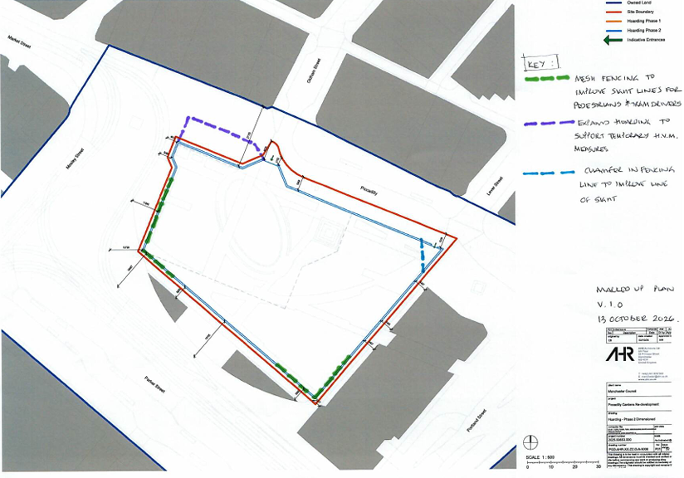
- Scale :
The Phase 2 hoarding is an extension of the existing hoarding in height and construction except where TfGM and GMP have requested mesh panels be used. The height is circa 2.4m and the hoarding is described as a PVC on ground hoarding system secured in place by counterweight concrete blocks, and paladin mesh panel system where mesh has been requested. Images below of the 2 systems prior to branding install.
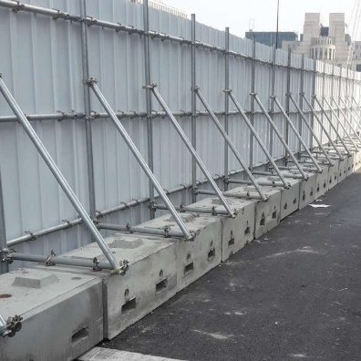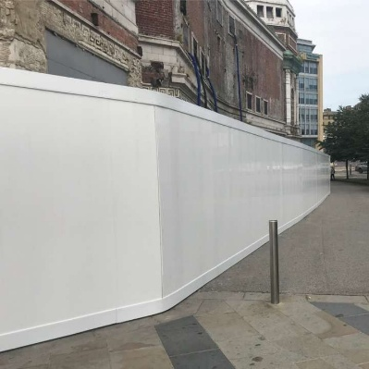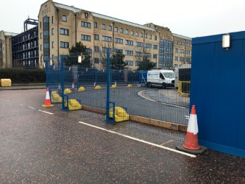
- Appearance :
The solid hoarding will have the project branding installed along its whole perimeter. The project branding includes historic references for the site, positive quotes from stakeholders and design statements. The expanded hoarding will also include directional signage for the local businesses.
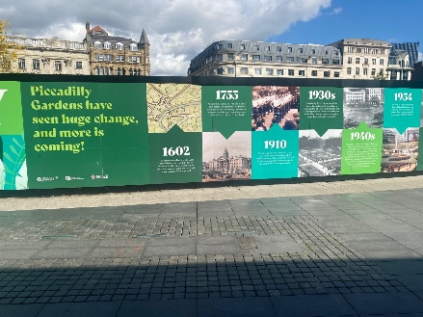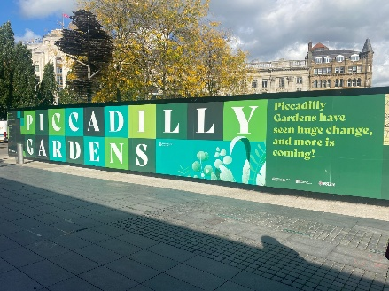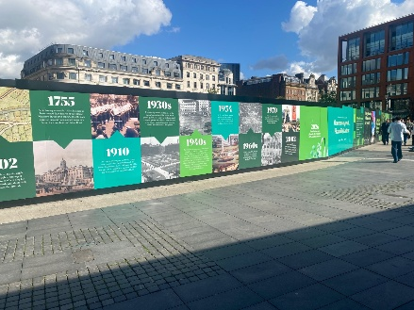

- Consultation :
There have been various discussions with Legal and General, the landlord of No 01 Piccadilly and the existing adjacent Pavillion. In turn they have shared these proposals with their tenants whom we are in contact with to agree directional signage and ‘business open as usual’ signage that can be secured to the hoarding.
- Lighting and CCTV :
Temporary lighting will be installed to the perimeter of the hoarding facing the existing Pavillion and No 01 Piccadilly.
Whilst reviewing the hoarding line with GMP on 06 October locations and coverage of existing CCTV cameras were discussed and agreed as suitable.
THE END

