

Planning

Delegated Officer Report

Summary of application details
Application reference: | PLA-2026-001523
Application type: | Householder planning permission
Proposal: | Erection of two-storey side and rear extension and single-storey front extension.
Site address: | 1 Tamar Drive Manchester M23 2QB
Ward(s): | Baguley
Date application valid: | 03 September 2026
Applicant name: | Mr Ishtiaq Bibi
Agent (if any): | Mr Mohammed Yaseen
Case officer: | Joshua Lee
Recommendation: | Approve
Date of recommendation: | 15 Oct 2026

Description of site, building and/or area
The proposal relates to a two storey semi detached dwellinghouse in Tamar Road. The property features an existing single storey side extension. The property is finished in render and pebbledash.
The property sits on an angled curtilage perpendicular to properties on Netley Road within a mostly residential part of the Baguley ward of Manchester.

Description of development
Erection of two-storey side and rear extension and single-storey front extension.

Two-storey side extension
The proposed two storey side extension would project 4000mm from the existing side elevation and run the full 6840mm of the elevation to sit in line with the existing rear elevation. The rear of the extension turns inwards to follow the angled boundary.

Two storey rear extension
The proposed two storey rear extension projects 3000mm from the existing rear elevation and, at ground floor, spans 5300mm across the rear of the property. At first floor the rear extension spans 4700mm leaving a 770mm gap to the shared boundary.

Single-storey front extension
The proposed front extension projects 1500mm from the existing principal elevation and runs 6500mm across the full front of the original dwellinghouse.
The extensions are finished in render to match and roof tile to match with gable ends.
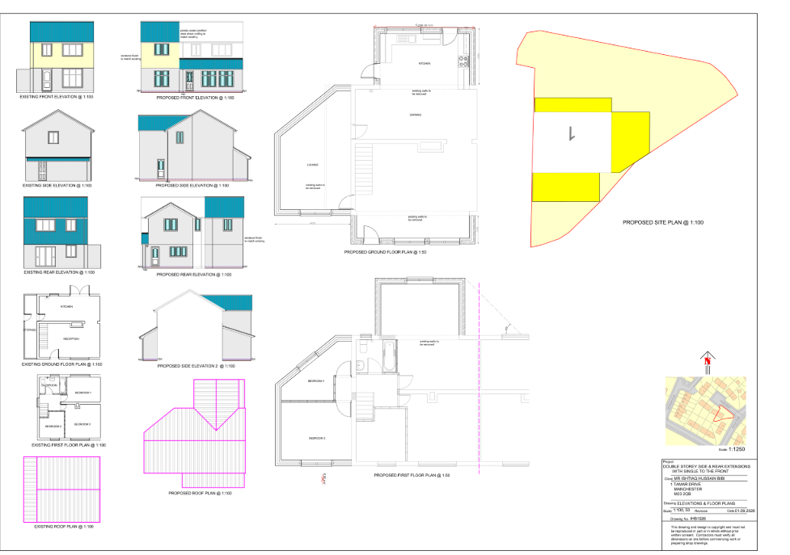
Figure 1. Existing and proposed plans

Relevant planning history
There is no planning history at the address.

Consultation, notification and publicity responses

Notifications and publicity

Neighbour letters
1 no. representation has been received objecting to the proposal on the following grounds:
- Existing parking shortages and highway safety concerns within Tamar Drive.
- Tamar Drive is a small cul-de-sac with limited parking availability and a narrow access road where vehicles can have difficulty passing one another.
- Parking spaces are already heavily utilised, with vehicles sometimes parking partly on the kerb due to limited capacity.
- Concern that the proposal may reduce on-site parking provision at No. 1 Tamar Drive, resulting in additional demand for on-street parking.
- Concern that vehicles associated with the property, including existing household vehicles, would be displaced onto the highway.
- Concern regarding cumulative parking impacts when considered alongside the conversion of No. 2 Tamar Drive to a three-bedroom dwelling.
- Existing overspill parking from nearby Netley Road is said to contribute to parking pressures in the area.
- Concern that parked vehicles, including work vans, can obstruct visibility and access at the entrance to the cul-de-sac, which is located on a bend.
- Reference is made to previous vehicle incidents within the cul-de-sac and the presence of young children in the area.
- Concern that construction traffic, delivery vehicles and contractors' parking would further restrict parking availability and access during building works.
- Concern that future occupancy levels at the property could generate additional vehicle ownership and parking demand.
- It is considered that the proposal would exacerbate existing parking and highway safety issues and should therefore be refused.
Relevant planning concerns will be taken into consideration when assessing the proposal

Negotiations
During the course of the application, concerns were identified regarding the scale, massing and design of the proposed two-storey side extension, its relationship with neighbouring properties, the potential for overlooking from first-floor windows, and the absence of bin storage details.
Following a site visit, the applicant was advised that the proposal required amendments to ensure the extension appeared subordinate to the host dwelling and to reduce its impact on neighbouring occupiers. Specifically, officers requested that the first-floor element be set back from the principal elevation, that the first-floor side element adjacent to the boundary with No. 6 Netley Road be reduced and positioned further from the boundary, that the first-floor rear projection be set back further to lessen its visual impact, that first-floor window positions be reconsidered to avoid overlooking, and that suitable refuse and recycling storage be shown on the plans.
The applicant subsequently submitted amended plans on two occasions. Revisions included the introduction of a setback to the first-floor element from the principal elevation. Whilst officers acknowledged this as a positive amendment that improved the subservient appearance of the extension, further concerns remained in relation to the scale and massing of the two-storey side extension adjacent to the boundary with No. 6 Netley Road, the proposed first-floor side-facing window, the adequacy of the setback from neighbouring properties, and the absence of clearly identified bin storage. These matters were raised with the applicant and further amendments were requested.
The final amended plans were received on 13 October 2026 and have been assessed as part of the determination of the application. Officer negotiations resulted in revisions to the scheme that reduced its visual prominence and improved its relationship with the host dwelling and surrounding properties when compared with the original submission.
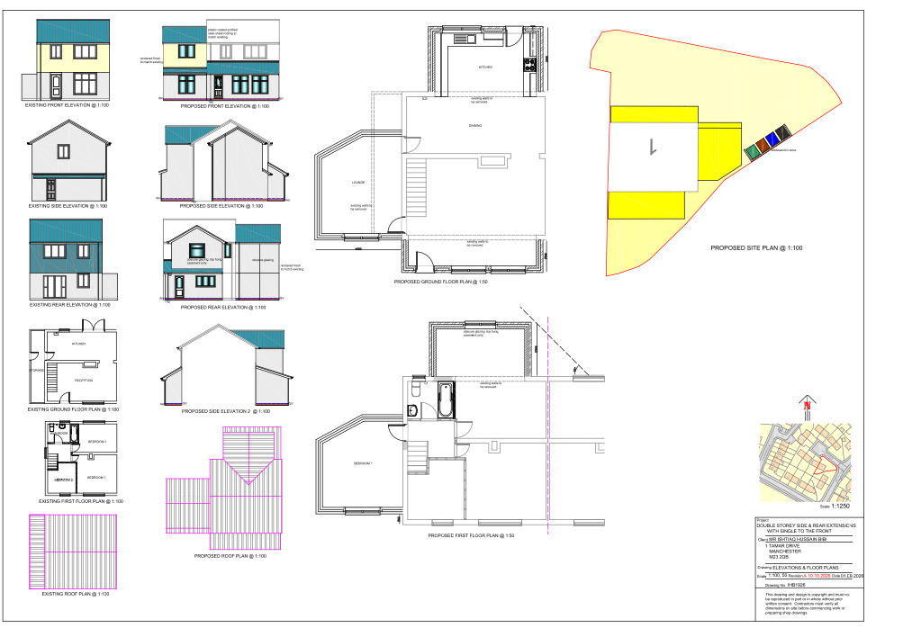
Figure 2. Updated plans and elevations

Relevant policies
In accordance with Section 38(6) of the Planning and Compulsory Purchase Act 2004, planning applications must be determined in accordance with the statutory development plan unless material considerations indicate otherwise.
For Manchester, the development plan comprises:
- The Manchester Core Strategy (2012 to 2027);
- Saved policies of the Manchester Unitary Development Plan (UDP); and
- The Places for Everyone Joint Development Plan Document (2022 to 2039).
These documents are considered up to date and are afforded significant weight in the determination of planning applications. Relevant Supplementary Planning Documents (SPDs) and other adopted guidance may also be material considerations.
The National Planning Policy Framework sets out the government’s policies for plan-making and for making decisions on development proposals in England. It is a material consideration of critical importance in both contexts.
Where relevant, the Council is required to give special regard to the desirability of preserving listed buildings and their settings, and special attention to the desirability of preserving or enhancing the character or appearance of conservation areas, in accordance with the Planning (Listed Buildings and Conservation Areas) Act 1990.
The policies and guidance referred to below are considered the most relevant to the scale, nature and location of the proposed development.
- The Manchester Core Strategy Development Plan Document 2012-2027
  - Development Management and Planning Obligations
    - DM 1 - Development Management
  - Objective 1 - Spatial Principles
    - SP 1 - Spatial Principles (Partially replaced by PfE Policy JP-S 1)
  - Objective 6 Environment
    - EN 1 - Design Principles and Strategic Character Areas
    - EN 19 – Waste
- Guide to development in Manchester - supplementary planning document and planning guidance, April 2007
- Extant Unitary Development Plan (UDP) –
  - Citywide Development Control Policies
    - DC1 - Residential extensions
    - DC26 - Development and Noise
- Places for Everyone Plan Joint Development Plan Document 2022-2039-
  - Strategy
    - JP-Strat9: Southern Areas
  - Sustainable and Resilient Places
    - JP-S1: Sustainable Development
  - Places for People
    - JP-P1 Sustainable Places
- National Planning Policy Framework – August 2026 - National Development Management Policies (NDMPs)
  - Procedural Policies
    - Chapter 3 – Decision-making policies
      - DM1: Preparing development proposals
      - DM2: Information requirements
      - DM3: Determining development proposals
      - DM6: Use of planning conditions and obligations
      - DM7: Relationship with other regulatory regimes
      - DM10: Removal of national permitted development rights
  - Sustainable Development
    - Chapter 4 - Achieving sustainable development
      - S3: Presumption in favour of sustainable development
      - S4: Principle of development within settlements
    - Chapter 5 - Meeting the challenge of climate change
      - CC2: Mitigation of climate change
      - CC3: Adaptation to climate change
  - Creating high quality, sustainable places
    - Chapter 12 - Making effective use of land
      - L2: Making effective use of land
      - L3: Achieving appropriate densities
    - Chapter 14 - Achieving well-designed places
      - DP3: Key principles for well-designed places
      - DP4: The design process

Assessment

Principle of Development
The proposal seeks to extend and alter an existing dwellinghouse within an established residential area. Whilst the Council acknowledges the need for additional living accommodation, development must not result in harm to the character of the area or the amenity of neighbouring occupiers.
The application site is located within a settlement where the National Planning Policy Framework states that development proposals should generally be approved unless their adverse effects would substantially outweigh the benefits. Policy DM1 of the Manchester Core Strategy similarly supports development where it responds appropriately to its context and does not result in unacceptable impacts.
The principle of extending the dwellinghouse is considered acceptable in this established residential location. It is also relevant that householders benefit from a range of permitted development rights for domestic extensions, indicating that residential enlargement is generally acceptable in principle, subject to compliance with detailed planning considerations relating to design, character and residential amenity.
Accordingly, the principle of the development is considered acceptable, subject to the detailed assessment set out below.

Appropriate siting, layout, scale, form, massing, materials, and detail
The proposed extensions have been designed to complement the appearance of the existing dwelling through the use of matching render and roof tiles. The submitted plans indicate that the extensions would reflect the architectural character of the host property and maintain a consistent appearance with the existing fenestration and roof form.
The two-storey side extension has been amended during the course of the application to incorporate a setback from the principal elevation and a lower ridge line than the existing dwelling. These measures assist in ensuring that the extension appears subordinate to the original dwellinghouse and reduce the potential for a terracing effect within the street scene. The rear element of the extension has also been amended in response to officer concerns regarding its scale and relationship with neighbouring properties.
In respect of No. 6 Netley Road, the impact of the development is moderated by the separation maintained from the shared boundary and by the stepped arrangement of the rear elevation, which is recessed from the main rear building line. These design measures help to break up the overall massing of the extension and reduce its visual impact when viewed from the neighbouring property.
The relationship with No. 3 Tamar Drive is more constrained and the proposal would result in a greater degree of visual presence. However, the rear extension projects 3m at ground floor level, reducing to approximately 2.5m at first-floor level, and incorporates a 750mm setback from the shared boundary. These amendments reduce the perceived bulk of the extension when viewed from the neighbouring property and help to mitigate potential overbearing effects.
The front extension projects approximately 1.5m from the principal elevation at ground floor level only. Given its limited projection and single-storey scale, it would have a similar presence to a modest front porch and would not appear unduly prominent within the street scene. In addition, the nearest front-facing windows at No. 3 Tamar Drive are offset from the proposed extension, which further assists in reducing the visual impact and perceived massing when viewed from that property.
Whilst the proposal represents a substantial addition to the dwelling, the extensions would remain proportionate to the host property and would read as a coherent addition rather than appearing as a separate or dominant structure. Taking account of the amendments secured during the application process, the siting, layout, scale, form, massing, materials and detailing of the proposal are considered acceptable and compliant with Policies EN1 and DM1 of the Core Strategy and Policy DC1 of the UDP.

Impact on the surrounding areas in terms of the design, scale and appearance of the proposed development. Development should have regard to the character of the surrounding area.
The site is located within an established residential area characterised by a variety of house types, many of which have been extended and altered over time. The proposed extensions would be largely viewed within the context of the existing dwelling and the surrounding pattern of residential development.
Although the development would increase the overall scale of the property, the amendments secured during the application process ensure that the side extension remains visually subordinate to the original dwelling. The extensions are set behind the established building line at first-floor level and use materials that match the host dwelling, which would assist in integrating the development into the wider streetscene.
Views from the public realm would principally comprise the front extension and the front section of the side extension. Given their scale, design and relationship with the existing dwelling, these additions would not appear incongruous or unduly prominent within the street scene. The proposal would therefore preserve the character and appearance of the surrounding area and accords with Policies EN1 and DM1 of the Core Strategy and Policy DC1 of the UDP.

Effects on amenity

Privacy
The proposal includes new glazing within the front and rear elevations. However, these windows would largely replace existing openings or serve a similar function to those currently present, maintaining established outlooks towards the street and rear garden. Consequently, the development would not result in a material increase in overlooking or an unacceptable loss of privacy to neighbouring occupiers.
Furthermore, following negotiations during the application process, side-facing windows have been removed from the proposed extensions. This amendment significantly reduces the potential for direct overlooking of adjacent properties, particularly No. 6 Netley Road.
Particular regard has been given to the first-floor rear windows, which would be repositioned closer to the boundary with No. 6 Netley Road. To safeguard neighbouring amenity, a condition is recommended requiring these windows to be obscure-glazed and retained as top-opening only. This will prevent opportunities for overlooking towards the neighbouring property.
A further condition is recommended removing permitted development rights for the insertion of additional windows or openings within the elevations of the extensions in order to protect the privacy of neighbouring occupiers. Subject to these conditions, the proposal is considered to have an acceptable impact on residential amenity.

Light
The proposed extensions have been assessed in relation to neighbouring properties, particularly the dwellings on Netley Road and adjoining residential properties on Tamar Drive.
Whilst the development would increase the built form adjacent to neighbouring boundaries, the final amended plans have reduced the massing of the first-floor elements and increased separation distances from neighbouring properties. Given the orientation of the site, the scale of the extensions and their relationship to surrounding dwellings, it is not considered that the proposal would result in unacceptable losses of daylight or sunlight to neighbouring windows or private amenity areas.
The proposal would not therefore have an unacceptable overbearing impact or lead to material losses of light to neighbouring occupiers.

Noise
The proposed extension is not expected to generate any noise beyond what would be reasonably expected of a residential dwelling.

Road Safety and Traffic Generation
One representation has been received raising concerns regarding existing parking pressures and the potential for the proposal to increase demand for on-street parking.
The application relates to the extension of an existing family dwelling and does not create a new residential unit. Whilst the proposal would provide additional residential accommodation, it is not considered likely to result in a level of traffic generation that would materially affect the operation or safety of the local highway network.
The submitted plans indicate that off-street parking would remain available within the curtilage of the property following completion of the development. Given the scale and nature of the proposal, the Highway Authority has not raised any objection. The development is therefore not considered to result in an unacceptable impact on highway safety or parking provision.

Accessibility: buildings and neighbourhoods fully accessible to disabled people, access to new development by sustainable transport modes.
The proposal relates to alterations and extensions to an existing dwellinghouse and would not prejudice accessibility to or within the property. The additional accommodation would be provided at both ground and first-floor level and would not alter existing means of access to the site.
The property remains located within an established residential area with access to local services, walking routes and public transport. The proposal is therefore considered acceptable with regard to accessibility and sustainable transport.

Adequacy of internal accommodation and external amenity space.
The proposed extensions would provide additional internal living accommodation and improve the functionality of the dwelling for its occupants. Despite the increase in built form, a substantial rear garden would remain available following construction.
The remaining external amenity space is considered sufficient to meet the needs of future occupiers and is comparable to that enjoyed by neighbouring properties. Accordingly, the proposal would maintain an acceptable level of residential amenity.

Refuse storage and collection.
The proposal would result in the enclosure of the existing side access. The submitted plans identify a garage/bin store area within the site, and the applicant has confirmed that domestic refuse and recycling bins would be stored within this area. This has been conditioned.
The development would therefore maintain suitable waste storage facilities and would not prejudice existing refuse collection arrangements. The proposal is considered compliant with Policy EN19 of the Core Strategy.

Vehicular access and car parking
Concerns have been raised regarding existing parking pressures within Tamar Drive. However, the proposal does not involve the subdivision of the dwelling or the creation of additional residential units.
Although the development would alter the layout of the site, off-street parking provision would remain available within the curtilage of the property. Given the scale of the proposal and its continued use as a single dwellinghouse, it is not considered that the proposal would give rise to unacceptable parking demand or highway safety concerns.
The proposal is therefore considered acceptable in relation to vehicular access and parking.

Green Infrastructure including open space, both public and private
The dwelling benefits from a garden beyond the siting of the proposed development and maintains a good amount of private green space post development.

Flood risk and drainage
The site is not located in a flood risk area and therefore does not require a flood statement or assessment.
The proposal has a negligible impact on drainage using the existing drainage on site.

Other Legislative Requirements

Equality Act 2010
Section 149 (Public Sector Equality Duty) of the Equality Act 2010 requires due regard to the need to: Eliminate unlawful discrimination, harassment and victimisation and other conduct prohibited by the Act and; Advance equality of opportunity between persons who share a protected characteristic and persons who do not share it. The Equality Duty does not impose a legal requirement to conduct an Equality Impact Assessment. Compliance with the Equality Duty involves consciously thinking about the aims of the Equality Duty as part of the process of decision-making.

Human Rights Act 1998 considerations
This application needs to be considered against the provisions of the Human Rights Act 1998. Under Article 6, the applicants (and those third parties, including local residents, who have made representations) have a right to a fair hearing and to this end the local planning authority must give full consideration to their comments.

Protocol 1 Article 1, and Article 8 where appropriate, confer(s) a right of respect for a person’s home, other land and business assets. In taking account of all material considerations, including Council policy as set out in the Core Strategy and saved polices of the Unitary Development Plan, the Director of Planning, Building Control & Licensing has concluded that some rights conferred by these articles on the applicant(s)/objector(s)/resident(s) and other occupiers and owners of nearby land that might be affected may be interfered with but that that interference is in accordance with the law and justified by being in the public interest and on the basis of the planning merits of the development proposal. She believes that any restriction on these rights posed by the recommendation given is proportionate to the wider benefits of and that such a decision falls within the margin of discretion afforded to the Council under the Town and Country Planning Acts.

Planning balance & Conclusion
The proposal would provide improved and enlarged family accommodation within an established residential area through the extension of an existing dwellinghouse. Following amendments secured through the application process, the development has been designed to appear subordinate to the host property, utilise materials that reflect the existing dwelling, and maintain the character and appearance of the surrounding residential area. Whilst the proposal would increase the scale and massing of the dwelling and result in some additional visual presence when viewed from neighbouring properties, the revised design, including setbacks from the principal elevation, reduced first-floor projections and the omission of side-facing windows, ensures that impacts upon neighbouring amenity are not considered unacceptable. The proposal would retain adequate outdoor amenity space, refuse storage and off-street parking provision, and would not give rise to significant highway safety concerns. Taking all material considerations into account, the benefits of providing enhanced living accommodation outweigh the limited impacts identified and the proposal is considered to accord with Policies DM1, EN1 and EN19 of the Manchester Core Strategy, Policy DC1 of the UDP and relevant policies of the National Planning Policy Framework. Planning permission should therefore be approved, subject to the attached conditions.

Recommendation: Approve

Article 35 Declaration
Officers have worked with the applicant in a positive and proactive manner based on seeking solutions to problems arising in relation to dealing with the planning application. There were minor changes required to meet the requirements for approval and the officer and applicant worked together to find an amicable solution.

Conditions to be attached to decision for approval

3-year time limit
The development must be begun not later than three years beginning with the date of this permission.
Reason - Required to be imposed by Section 91 of the Town and Country Planning Act 1990 (as amended).

Specified plans
The development hereby approved shall be carried out in accordance with the following drawings and documents:
  - TAMAR DRIVR 1 MCR.pdf - Location Plan, Site Plan, Elevations and Floor Plans - IH81926 REV A – received by the LPA 15 Oct 2026
Reason - To ensure that the development is carried out in accordance with the approved plans, pursuant to policies DM 1, SP 1 and EN 1 of the Core Strategy and JP-P1 & of Places for Everyone.

Materials to match
The materials used in the external surfaces of the development hereby approved shall be similar in appearance to the existing building in terms of type, size, colour and texture.
Reason - In order to ensure a satisfactory appearance in the interests of visual amenity in accordance with policies SP1 and DM1 of the Core Strategy and the requirements of the National Planning Policy Framework.

Bin store
The secure and ventilated bin store for the storage of waste containers, including segregated and recyclable waste, as listed with the drawings above, shall be implemented prior to the first use of the extension hereby approved and thereafter retained and maintained, in perpetuity.
Reason - In the interests of residential and visual amenity pursuant to saved policy DC1 of the Unitary Development Plan for Manchester and policies SP1 and DM1 of the Core Strategy for Manchester.

OBSCURE GLAZING AND TOP OPENING WINDOW – NEW DWELLING/EXTENSION TO DWELLING
The bathroom window in the first floor of the main rear elevation and the rear window in the first floor rear extension of the development hereby approved shall be obscure glazed to a specification of no less than level 5 of the Pilkington Glass Scale or such other alternative equivalent and shall be retained as such thereafter. Any parts of the window that can be opened must be more than 1.7 metres above the floor of the room in which the window is installed.
Reason - In order to protect the amenity of neighbouring residents and in accordance with policies SP1 and DM1 of the Core Strategy.

EXTENSIONS – PD RIGHTS REMOVED FOR NEW OPENINGS
Notwithstanding the provisions of Schedule 2, Part 1 of the Town and Country Planning (General Permitted Development) Order 2015 (as amended) (or any order revoking and re-enacting that Order with or without modification), no additional windows, doors or other openings shall be inserted in the development hereby approved, without planning permission being granted by the Local Planning Authority.
Reason - In the interests of residential amenity, pursuant to policies DM1 and SP1 of the Manchester Core Strategy.

