

Planning

Delegated Officer Report

Summary of application details
Application reference: | PLA-2026-001013
Application type: | Householder planning permission
Proposal: | Erection of single-storey rear extension, installation of side dormer extension and basement conversion (including enlargement of basement) with associated light well and solar panels and roof lights.
Site address: | 2 Clifton Road Manchester M21 8UX
Ward(s): | Chorlton Park
Date application valid: | 03 August 2026
Applicant name: | Mr and Mrs David and Kathryn Gray
Agent (if any): | Mr Matthew McNulty
Case officer: | Ellie Knowles
Recommendation: | Approve
Date of recommendation: | 14 October 2026
Description of site/building/area

The application relates to a three-storey semi-detached Victorian dwellinghouse of red brick construction and with grey tiled gable roofs. The property features white painted timber windows, double storey bay windows and lean-to canopy to the front and original single storey lean-to outrigger and bay window at ground floor to the rear.

The application property is situated within a corner plot at the junction with Corkland Road, affording garden areas to the front, southwestern side and rear. There is a driveway to the front/side. Boundary treatment around the curtilage consists of an original brickwork boundary wall (>1m in height) with stone copings. Additional timber fencing and trellising is existing atop of walling around the rear garden. There are large conifers along the rear boundary.

The surrounding area is predominantly residential in character, featuring semi-detached Victorian properties of a similar character, scale and form.

At the time of the site visit, September 2026, construction had commenced on site.

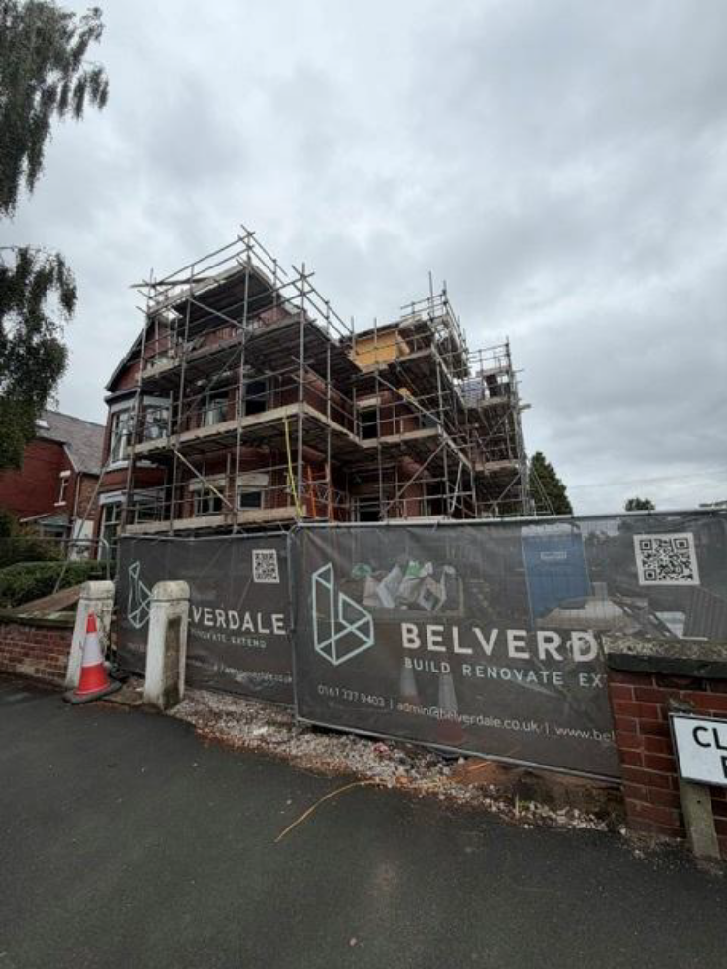

Listed building: Not applicable

Conservation area: Not applicable

Tree Preservation Order: Not applicable

Description of development

The applicant is seeking permission for the erection of single-storey rear extension, installation of side dormer extension and basement conversion (including enlargement of basement) with associated light well and solar panels and roof lights.

This application forms a resubmission of the original permission 143216/FH/2025.

Consultations & Notification Responses

Local responses

Three letters of representation were received from one local resident raising the following concerns:
- Building work has begun on site
- Cladding is out of character
- Additional rear extension height has a substantial and domineering impact
- Boundary fence would cause significant impact
- No details regarding the configuration of the basement conversion
- There is no mention of the significant reconstruction that has taken place with regard the underpinning between the two houses and all the external walls, nor the removal of all internal walls to be replaced by steels

Consultee responses
None

Relevant Planning History

At the application site –

143216/FH/2025 – Erection of single storey rear extension, installation of side dormer extension and basement conversion (including enlargement of basement) with associated light well. Approved 25/09/2025.

History of negotiations

No negotiations were entered into with the agent, given that the scheme was considered policy compliant.

Policy

Places for Everyone (2022-2039) – Places for Everyone is a long-term plan of nine Greater Manchester districts for jobs, new homes, and sustainable growth. It has been published by the GMCA on behalf of the nine districts and took effect and became part of the statutory development plan on March 21, 2024.

The PfE Plan and its policies are now a material planning consideration in the determination of planning applications. The PfE Plan and its policies must therefore be given full weight in the planning balance.

Manchester Core Strategy Development Plan Document (2012-2027) - The Core Strategy was adopted on the 11 July 2012 and replaces a large number of policies in Manchester’s Unitary Development Plan. Parts of the policies have been superseded by the Places for Everyone Plan.

The Unitary Development Plan (UDP) for the City of Manchester (1995) - The Unitary Development Plan for the City of Manchester was adopted in 1995 and has largely been replaced with the policies contained within the Core Strategy. However, there are a number of policies that are extant.

The relevant Places for Everyone policies for this application are as follows:

JP-Strat5 – Inner Areas
JP-S1 – Sustainable Development
JP-P1 – Sustainable Places

The relevant Core Strategy policies for this application are as follows:

DM 1 – Development Management
SP 1 – Spatial Principles (partially superseded by PfE)
EN 1 – Design Principles and Strategic Character Areas
EN 19 – Waste

The relevant saved UDP policies for this application are:

DC1 – Residential Extensions
DC26 – Development and Noise

A relevant material consideration is also:
- Manchester Residential Quality Guidance March 2017 (Manchester’s Emerging Space Standards)

National Planning Policy Framework

The National Planning Policy Framework (August 2026) - The National Planning Policy Framework (NPPF) sets out the Government’s planning policies for England and how these should be applied.

Planning law requires that applications for planning permission be determined in accordance with the development plan, unless material considerations indicate otherwise. The national decision-making policies in this Framework are a material consideration in making these decisions and should be read alongside the policies in the development plan.

The Local Planning Authority consider the following NPPF policies relevant to this proposal.

DM3: Determining development proposals
S3: Presumption in favour of sustainable development
L4: Residential extensions
DP3: Key principles for well-designed places

Issues

Principle of development:

The principle of the development has been established through the original permission, 143216/FH/2025. However, consideration must be given to the revised elements of the proposal, with regards to their siting, scale and massing, appearance and impact upon visual amenity, residential amenity, waste storage, and parking.

Impact on visual amenity and the street scene:

The proposed amendments to the previous approval are:
- 1.no additional window to side dormer extension
- 1.no additional fixed glazed panel to the single storey extension
- PV solar panels to the roof
- The addition of 4.no velux roof lights to the second-floor bedrooms and landing, and first-floor master bedroom
- Enlargement in height of the single storey rear extension by approx. 300mm

The proposed single storey rear extension would project approx. 2-3.3m from the original rear
elevation and span the full width of the host dwellinghouse. The extension would accommodate
a flat roof, 4.3m in total height. The proposed rear extension would feature black timber cladding (specification: ThermoChar – Noir Brosse’) with black aluminium coping and granite tile rear terrace (2.75m in depth by 3.25m width) with glass side balustrade. The submitted plans indicate that its northeastern side elevation would be blank, its southwestern side elevation would feature 1.no fixed glazed panel and its southeastern facing rear elevation would feature significant glazing in the form of a black aluminium door and fixed glazed side panel. The scale, design and projection of the rear extension complies with the advice stipulated within saved policy DC1.3 of the Unitary Development Plan for the City of Manchester.

The proposed dormer extension would be sited within the southwestern side roof plane of the
main gable roof, measuring approx. 3.6m in width, set down from the ridge and up from the
eaves. The side dormer extension would be finished in vertically hanging (natural slate) roof
tiles to match the main roof and accommodate a gable roof that mirrors the pitch of the existing
side gable element. It would feature a single front rooflight and 1.no window in the front elevation. It is acknowledged that side dormers are evident within the street scene at no.s 8, 10 and 12 Clifton Road, therefore, it is considered that these examples set a precedent within the immediate locality for extensions of this nature (side dormers) on this specific house type.

As such, the overall siting, scale, and massing of the proposal is considered to be acceptable as
the developments are understood as being subservient to the host dwellinghouse in terms of
their dimensions, would avoid resulting in ‘excessively large or bulky’ additions to the property,
and would not cause undue harm to the residential amenity of neighbouring occupiers in terms
of introducing overbearing features into the area. The proposal would be in-keeping with the
existing precedent of residential extensions in this locale.

Sited at the side and rear of the property, the proposal would be highly visible within the street
scene or public realm. The proposed use of natural slate hanging tiles to the dormer cheeks
should provide a blended appearance with the host dwellinghouse, ensuring that the dormer
extension does not form a prominent visual feature within the street scene. The design and
choice of materials for the single storey rear element would constitute black timber cladding and
a flat roof to the single storey rear extension, adding a contemporary design to the existing
property. This is considered acceptable on balance, in this specific scale and location and is not considered to be detrimental to the character of the property and wider street scene.

The proposed basement conversion with enlargement and associated lightwell, would not be
readily visible from the street scene and therefore raises limited impact upon the character of
the host property and wider street scene.

PV panels are now proposed to the southwestern side and southeastern rear roof scapes, as shown on plan refs: 2428-201 G and 2428-202 F. The proposed PV array would comprise Aiko Neostar A490-MCE54Mw panels, which would constitute an in-roof flush system. Whilst the PVs would be partially visible from the highway given the corner plot orientation of the application site, it is considered that their visual impact would be limited due to their flush arrangement, which can be supported on balance.

The proposal therefore accords with saved policy DC1 of the Unitary Development Plan for the City of Manchester and policies DM1 and SP1 of the Manchester Core Strategy.

Impact on residential amenity:

No.4 Clifton Road is the adjoining semi-detached residential property due north-east. This property affords a matching existing lean-to rear outrigger.

The proposed single storey rear extension would project approx.2m from the existing outrigger of no.4 and the proposed rear terrace would project a further approx. 2.75m rearwards (including the stepped access down into the applicant’s garden), both sited along the shared boundary with this neighbouring property.

Given the scale of the proposed single storey flat roofed rear extension, which has been amended to accommodate a maximum roof height of approx. 4.3m, the same ‘ridge’ height as the former outrigger (it will replace), it is not considered that this amended element would give rise to issues associated with overshadowing, loss of light, or loss of outlook, nor should it introduce an overbearing presence into the area. Moreover, proposed glazing would afford sole outlook over the applicant’s own rear garden areas to the southwestern side and rear, therefore these are not considered to give rise to any indue overlooking and loss of privacy of neighbouring occupiers. To further mitigate any overlooking impacts upon this adjoining neighbour, additional boundary screening in the form of a timber fencing sited atop the existing boundary wall is proposed, at a height of 1.8m above the rear terrace.

The proposed gable dormer extension would be sited within the southwestern side roof plane of the main roof. This element would feature a 1.no front roof light and 1.no window to the front elevation, which would afford outlook over the highway. Given the proposed scale, orientation and siting of this dormer extension, it is not considered that this element would cause any overdominance, overlooking or overshadowing impacts upon neighbouring properties.

The proposed additional 4no. rooflights, basement conversion with enlargement and associated rear lightwell does not raise any issues associated with overshadowing, loss of light, or loss of outlook, nor should it introduce an overbearing presence into the area.

The proposal therefore accords with saved policy DC1 of the Unitary Development Plan for the City of Manchester and policies DM1 and SP1 of the Manchester Core Strategy.

Impact on Highway Safety:

The proposed development would not interfere with the existing parking provision off street on the front driveway, as such is considered acceptable in this regard.

Waste:

The current waste storage arrangements would be unaffected by the proposal.

Other matters:

Concern has been raised through representations regarding structural matters relating to the basement conversion. This is a Building Control matter, with the responsibility for checking
that building regulations have been met falling to building control bodies either from the local authority or the private sector as a registered building control approver.

Conclusion:
Given the above issues, it is considered that the proposal is acceptable in terms of its principle, siting, scale and massing, appearance, impact upon visual and residential amenity, waste storage and parking as it broadly complies with saved policies DC1 of the UDP, policies DM1 and SP1 of the Core Strategy, policy JP-P1 and JP-P2 of the Places for Everyone joint development plan document and guidance contained within the NPPF.

Other Legislative Requirements

Equality Act 2010
Section 149 (Public Sector Equality Duty) of the Equality Act 2010 requires due regard to the need to: Eliminate unlawful discrimination, harassment and victimisation and other conduct prohibited by the Act and; Advance equality of opportunity between persons who share a protected characteristic and persons who do not share it. The Equality Duty does not impose a legal requirement to conduct an Equality Impact Assessment. Compliance with the Equality Duty involves consciously thinking about the aims of the Equality Duty as part of the process of decision-making.

Human Rights Act 1998 considerations
This application needs to be considered against the provisions of the Human Rights Act 1998. Under Article 6, the applicants (and those third parties, including local residents, who have made representations) have a right to a fair hearing and to this end the local planning authority must give full consideration to their comments.

Protocol 1 Article 1, and Article 8 where appropriate, confer(s) a right of respect for a person’s home, other land and business assets. In taking account of all material considerations, including Council policy as set out in the Core Strategy and saved polices of the Unitary Development Plan, the Director of Planning, Building Control & Licensing has concluded that some rights conferred by these articles on the applicant(s)/objector(s)/resident(s) and other occupiers and owners of nearby land that might be affected may be interfered with but that that interference is in accordance with the law and justified by being in the public interest and on the basis of the planning merits of the development proposal. She believes that any restriction on these rights posed by the recommendation given is proportionate to the wider benefits of and that such a decision falls within the margin of discretion afforded to the Council under the Town and Country Planning Acts.

Recommendation: Approve

Article 35 Declaration

Officers have worked with the applicant/agent in a positive and proactive manner based on seeking solutions to problems arising in relation to dealing with the planning application. In this instance, no negotiations were necessary but appropriate conditions have been attached to the end of this report. The scheme is considered to be in accordance with the guidance contained within saved policy DC1 of the Manchester Unitary Development Plan and to policies SP1 and DM1 of the Core Strategy.

Condition(s) to be attached to decision for approval

- The development must be begun not later than the expiration of three years beginning with the date of this permission.

Reason - Required to be imposed pursuant to Section 91 of the Town and Country Planning Act 1990.

- The development hereby approved shall be carried out in accordance with the documents labelled:
- 'Proposed Ground Floor Plan', numbered '2428-101 D', stamped as received by the City Council as Local Planning Authority on the 13/07/2026.
- 'Proposed First Floor Plan', numbered '2428-102 A', stamped as received by the City Council as Local Planning Authority on the 13/07/2026.
- 'Proposed Second Floor Plan', numbered '2428-103 C', stamped as received by the City Council as Local Planning Authority on the 13/07/2026.
- 'Proposed Basement Plan', numbered '2428-110 B', stamped as received by the City Council as Local Planning Authority on the 13/07/2026.
- 'Proposed Elevations’, numbered '2428-201 G', stamped as received by the City Council as Local Planning Authority on the 13/07/2026.
- ‘Proposed Elevations’, numbered ‘2428-202 F’, stamped as received by the City Council as Local Planning Authority on the 13/07/2026.
- ‘Proposed Elevations’, numbered ‘2428-203 C', stamped as received by the City Council as Local Planning Authority on the 13/07/2026.
- 'Proposed Site Plan, numbered '2428-1003', stamped as received by the City Council as Local Planning Authority on the 13/07/2026.
- Email received from agent 15:49pm 14/10/2026 – specifying external cladding material and PV specification

Reason - To ensure the development is carried out in accordance with the approved plans, pursuant to Policies SP1 and DM1 of the Core Strategy.

- The materials to be used on the external surfaces of the development hereby permitted shall be implemented in accordance with the approved details set out in the documents and drawings as specified in Condition 2 of this approval.

Reason- To ensure the appearance of the building to be extended is not adversely affected by the materials to be used in the construction of the extension, pursuant to saved policies DC1.1, DC1.2 and DC1.4 of the Unitary Development Plan for the City of Manchester and policy DM1 of the Manchester Core Strategy.

- Notwithstanding the provisions of the Town and Country Planning (General Permitted Development) Order 2015 or any legislation amending or replacing the same, no windows or doors shall be inserted in the development hereby approved, other than those expressly authorised by the granting of this planning permission.

Reason - In the interests of residential and visual amenity since any additions to the approved dwelling may adversely impact upon the neighbouring occupiers, pursuant to saved policy DC1 of the Unitary Development for the City of Manchester Policies DM1 and SP1 of the Manchester Core Strategy.

- Prior to first use of the development hereby approved, the boundary screen (along the northeastern shared side boundary) as shown on plan ref: 2428-203 C, shall be erected and retained in situ for the lifetime of the development.

Reason - In the interests of residential and visual amenity, pursuant to saved policy DC1 of the Unitary Development for the City of Manchester Policies DM1 and SP1 of the Manchester Core Strategy.

