

Planning

Delegated Officer Report

Summary of application details
Application reference: | PLA-2026-001283
Application type: | Full planning permission
Proposal: | Creation of bar use (Sui Generis).
Site address: | 80 Port Street Manchester M1 2FH
Ward(s): | Piccadilly
Date application valid: | 20 August 2026
Applicant name: | Mr Ben Grainger
Agent (if any): | Miss Ellie Philcox
Case officer: | Ciara Gettinby
Recommendation: | Approve
Date of recommendation: | 13 October 2026

Description of site, building and/or area
The building associated with this full planning permission is One Port Street, a nine-storey building compromising of 481 dwellings, residential amenity space and ground floor commercial space. The property sits just on the outside of the core City Centre with the Northern Quarter Neighbourhood and Ancoats within walking distance. The surrounding area is characterised by its active character, with many bars, restaurants and live music venues within the vicinity. The application specifically relates to unit 3, a ground floor corner unit which fronts onto Great Ancoats Street. The southern elevation sits adjacent to and looks out upon a small area of public realm and walkway.

North-east of the site is Ancoats Conservation Area, and south of the site is Brownfield Mill a Grade II* Listed Building. Also, within close proximity to the site is Grade II Listed Canal Lock No. 82, Grade II Listed Building, 72-76 Newton Street and Grade II* Listed Building, Jacksons Warehouse.

In relation with this application, an advert consent was submitted, ref- PLA-2026-001260, for the installation of a projecting sign. This was approved in September 2026.
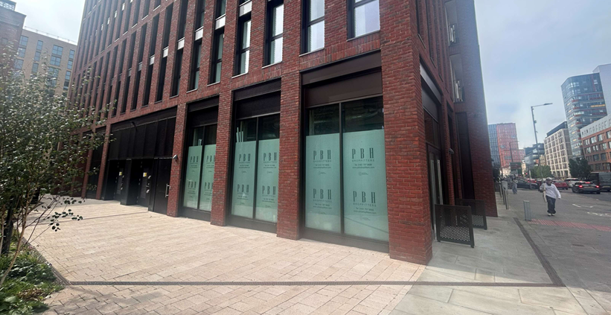

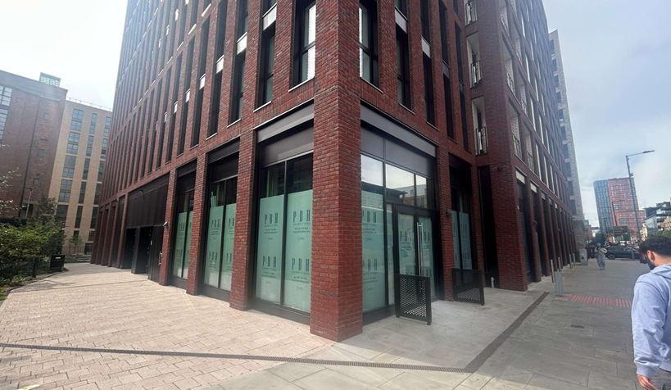
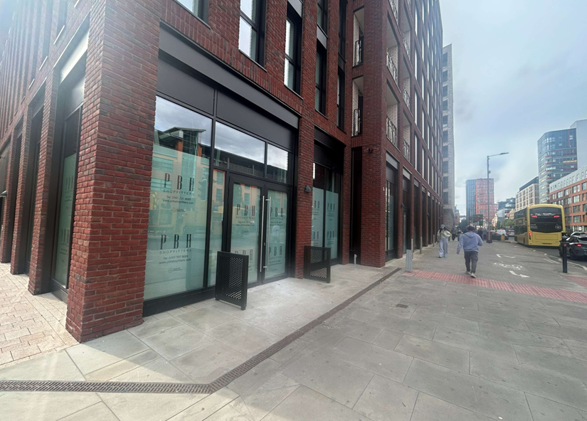

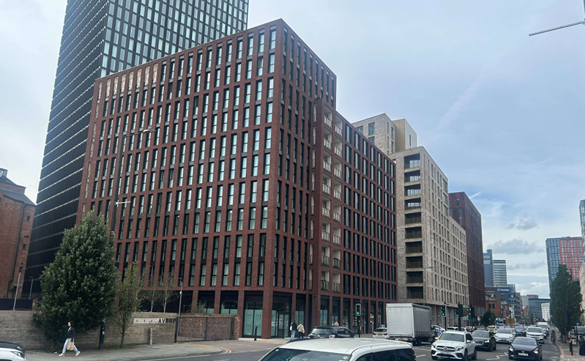

Description of development
Planning permission is sought for the creation of a bar use (Sui Generis), as existing the unit is currently empty and unoccupied. The unit is proposed to be solely a bar with no cooking or sale of food. The proposal would result in 6 no. full-time employees and 3 no. part-time employees. No external alterations are proposed as part of this application.

The hours of operation proposed are:

9:00am- 23:30pm Sunday to Wednesday
9:00am- 00:30pm Thursday
9:00am- 01:30pm Friday to Saturday

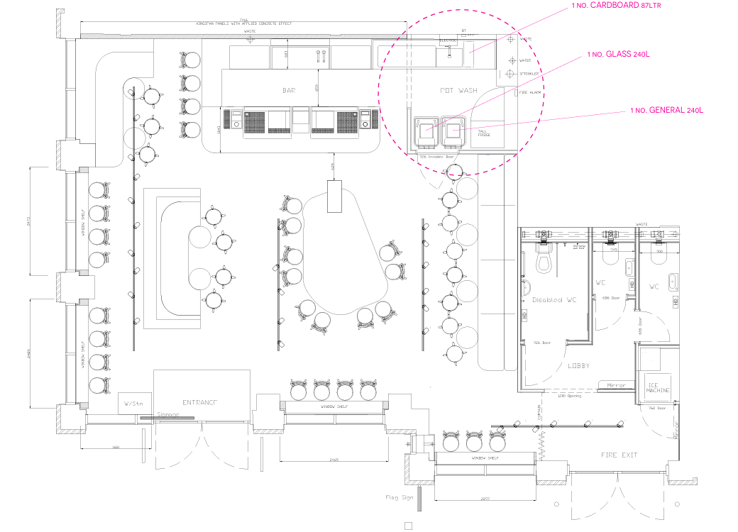

Consultation, notification and publicity responses

Consultations

Environmental Health- no objections subject to the attachment of condition 3 (Noise insulation) to control noise outbreak onto the surrounding residential properties.
Highway Services- no objections
Greater Manchester Police- no comments.

Notifications and publicity
Neighbouring properties were notified of the development via letter. Two objections and one representation was received, outlined below:

-Concerns around noise late into the night
-The development would result in increased litter
-The proposals effect on security and increased levels in anti-social behaviour
-Customer activity outside the premises, including queuing, smoking and coming and goings
-Waste/glass disposal and the effect on noise
-Impact on residential amenity and wellbeing
-Increased footfall
-Increased road traffic and noise from taxis

All representations have been taken into account over the course of the application. The application has been assessed by colleagues in environmental health who has recommended conditions to be attached to ensure that appropriate measures have taken place to reduce any effect on nearby residents and to verify and monitor the noise levels. All material considerations have been taken into account and addressed in the report below.

Relevant policies
The following policies are considered relevant in the consideration of this application:

Places for Everyone- A long term plan of nine Greater Manchester districts for jobs, new homes and sustainable growth, it has been published by the GMCA on behalf of the nine districts (Bolton, Bury, Rochdale, Oldham, Tameside, Stockport, Manchester, Trafford, Salford, Wigan) and took into effect and become part of the statutory development plan on March 21, 2024.

-Policy JP-P1: Sustainable Places
-Policy JP-Strat2: City Centre

Unitary Development Plan (UDP)- The UDP has been superseded by the Core Strategy Development Plan, but certain policies are still considered of relevance:

- Policy DC10 Food and Drink Uses
- Policy DC 26.1 Development and Noise

The Manchester Core Strategy- Development Plan Document 2012- 2027 (The Core Strategy) was adopted by the City Council on the 11th of July 2012, it is a key document for the local plan which provides a framework that planning applications are assessed against.

Policy DM1- Development Management
Policy SP1- Spatial Principles
Policy EN1- Design Principles and Strategic Character Areas
Policy EN19- Waste

The National Planning Policy Framework (August 2026)- The Government’s new national planning policies and how they are to be implemented through local authorities.

Achieving sustainable development

Policy S3- Presumption in favour of sustainable development

Achieving well-designed places

Policy DP3- Key principles for well-designed places
Policy DP4- The design process

Assessment
Principle of the Development
The regeneration of this area has created a high-quality mixed-use area, and this proposal would positively contribute to this process. It would support the City Centre’s economy and improve street level engagement and help to further establish this area. Other drinking establishments including, bars and pubs have created an active character along Great Ancoats Street and therefore there is a strong precedent for works.

In view of the above, it is considered that the proposal would contribute to the mixed-use neighbourhood. The proposal is therefore conditioned to be in accordance with PfE Policies, JP-P1, and JP-Strat2, Core Strategy Policies DM1, SP1 and EN3, and saved Policies from the UDP, DC10 and DC26 and Policies S3, DP3 and DP4 of the NPPF (August 2026).

Residential Amenity
As set out in Policy DC26 of the Unitary Development Plan, impacts of a proposed development on residential amenity must be assessed as part of the application. In this instance, no new external plant equipment is proposed, and no extraction equipment is required for the proposed use. The unit would not include a kitchen and there would be no food operations. Therefore, fumes and odour are not considered to impact the residential amenity of the area.

Noise was also assessed over the course of the application, and a formal acoustic assessment was submitted. Environmental health officers have requested further information surrounding noise for the neighbouring occupiers and have recommended a condition to be attached. The condition would be required to be discharged prior to the use of the unit and would provide, noise insulation for entertainment levels and a verification report that would validate the work undertaken conforms to the requirements of the noise impact assessment.

Details undertaken by the applicant can be found in the operational management strategy on the security and management of the facility. CCTV systems and door supervisors will be implemented and would help manage noise control outside of the establishment. The operational strategy addresses ways to manage: crime and disorder, public nuisance, noise, door management, customer dispersal and the external area. The management strategy will be conditioned to that these measures are implemented in accordance with the permission.

The proposed is not considered to impact on the current parking provision of residents due to its key transport connections, with multiple bus stops nearby and Picadilly train station within walking distance. The proposed is within the busy City Centre location, in which food and beverage use are expected and encouraged. Further details on waste are discussed further in the report.

Although it is acknowledged that the site is not located in the central City Centre area of the City, this area is still characterised by its vibrant nightlife and the bars along Great Ancoats Street have set a precedent for this area, therefore the introduction of a (sui generis) bar use in this area is not considered out of character for the area. Given the above reasons, with the attached appropriate conditions, the scheme is not considered to give rise to any residential amenity implications and would therefore comply with Policy DM1 and SP1 of the Manchester Core Strategy.

Waste
As per Policy DM1, development proposals should have regard to refuse storage and collection. The proposal includes a waste management strategy, that sets out the location of the bins internally and the process for waste collection. All bins will be contained internally in the ‘pot wash’ area of the unit and would be wheeled through the unit to the public highway for collection. The proposed waste arrangement is considered acceptable, and will be conditioned accordingly, pursuant to Policies DM1 and EN19 of the Manchester Core Strategy.

Accessibility
Policy CC10 of the Manchester Core Strategy requires consideration of access. The applicant site is considered to be accessible with level surface and appropriate range of movement for wheelchair users and others. The ground floor proposed plan demonstrates adequate room for movement and access to a disabled bathroom.

The accessibility arrangement is therefore considered acceptable, pursuant to the requirements of Policies DC10.1 of the UDP and Policy CC9 of the Core Strategy.

Highway Impacts
Policies JP-Strat4, and JP-C5 requires development encourages sustainable transport use and promotes walking and cycling. Secure cycle parking is provided in the basement of the site for employees. Although there is not cycle parking specifically at the site, there is a variety of provisions in the surrounding area. Aforementioned, the site is located centrally and is within walking distance of sustainable transport networks including, Picadilly Railway Station, Metrolink Stops and bus routes along Great Ancoats Street.

Thus, the development is not expected to have an undue impact on the highway. The proposal is therefore acceptable pursuant to Policies DC10, of the UDP, T1 of the Core Strategy and Policy JP-C5 and JP-Strat4 of the Places for Everyone Joint Development Plan Document.

Other Legislative Requirements

Equality Act 2010
Section 149 (Public Sector Equality Duty) of the Equality Act 2010 requires due regard to the need to: Eliminate unlawful discrimination, harassment and victimisation and other conduct prohibited by the Act and; Advance equality of opportunity between persons who share a protected characteristic and persons who do not share it. The Equality Duty does not impose a legal requirement to conduct an Equality Impact Assessment. Compliance with the Equality Duty involves consciously thinking about the aims of the Equality Duty as part of the process of decision-making.

Human Rights Act 1998 considerations
This application needs to be considered against the provisions of the Human Rights Act 1998. Under Article 6, the applicants (and those third parties, including local residents, who have made representations) have a right to a fair hearing and to this end the local planning authority must give full consideration to their comments.

Protocol 1 Article 1, and Article 8 where appropriate, confer(s) a right of respect for a person’s home, other land and business assets. In taking account of all material considerations, including Council policy as set out in the Core Strategy and saved polices of the Unitary Development Plan, the Director of Planning, Building Control & Licensing has concluded that some rights conferred by these articles on the applicant(s)/objector(s)/resident(s) and other occupiers and owners of nearby land that might be affected may be interfered with but that that interference is in accordance with the law and justified by being in the public interest and on the basis of the planning merits of the development proposal. She believes that any restriction on these rights posed by the recommendation given is proportionate to the wider benefits of and that such a decision falls within the margin of discretion afforded to the Council under the Town and Country Planning Acts.

Conclusion
Given the above reasons, the proposed use is considered to be acceptable. The appearance and visual amenity of the are is not considered to be affected and the development would in within the character of the surrounding area. The noise levels are conditioned to protect the neighbouring residential units and no odour or fumes would result from the proposal. Given this, the proposal is considered to be acceptable pursuant to JP-P2 and JP-Strat2 of the Places for Everyone Joint Development Plan Document, Policy DM1, SP1, EN1 and EN19 of the Core Strategy and Policies DC10 and DC26 of the UDP.

Article 35
In assessing the merits of a planning application, officers will seek to work with the applicant in a positive and proactive manner to seek solutions to problems arising in relation to dealing with the planning application. All such issues have been resolved due to the discussions within the applicant and the conditions.

Recommendation: Approve

Conditions attached to this decision

- Time
The development must have begun no later than the expiration of three years beginning with the date of permission. Required to be imposed pursuant to Section 91 of the Town and Country Planning Act of 1990.

Reason - Required to be imposed pursuant to Section 91 of the Town and Country Planning Act of 1990.

- Specified Plans
The development hereby approved shall be carried out in accordance with the following documents:

Proposed GF Plan/ Detailed Bin Store Plan, ref- 3853 4/1, received by the City Council as the LPA on the 7 August 2026.
Proposed Waste Strategy Layout, received by the City Council as the LPA on the 7 August 2026.

Reason- to ensure that the development is carried out in accordance with the approved plans, pursuant to saved policy DC1 of the Unitary Development Plan for the City of Manchester and policies SP1 and DM1 of the Manchester Core Strategy.

- Noise Insulation

3a) Prior to the first use of the development, a noise impact assessment of the premises and a scheme of acoustic treatment shall be submitted to for approval by the City Council as Local Planning Authority. Where entertainment noise is proposed the LAeq (entertainment noise) shall be controlled to 5dB below the LA90 (without entertainment noise) in all octave bands at the facade of the nearest noise sensitive locations, and internal noise levels at structurally adjoined residential properties in the 63HZ and 125Hz octave frequency bands shall be controlled so as not to exceed (in habitable rooms) 47dB and 41dB (Leq,5min), respectively.

The premises shall be acoustically insulated and treated to limit the breakout of noise in accordance with a noise impact assessment, and the measures shall remain in-situ for the duration of the development.

3b) Prior to the first use/occupation of the development, a Completion/Verification Report shall be submitted to for approval by the Local Planning Authority to validate that the work undertaken conforms to the recommendations and requirements of the approved noise impact assessment.

In the event of any non-conformity with the approved noise insulation, then any further measures that are required to achieve the required noise criteria shall be carried out. Any required measures and validation shall continue until conformity has been achieved and agreed in writing by the Local Planning Authority, prior to first use/occupation of the development.

The approved details shall be implemented and remain in place for as long as the unit is in use (and any subsequent permitted changes of use under Use Class Sui Generis)

Reason - To minimise the impact of the development and to prevent a general increase in pre-existing background noise levels around the site. Pursuant to policies SP1 and DM1 of the Core Strategy and saved policy DC26 of the UDP.

- Opening Hours
The premises shall not be open outside the following hours:

9:00am- 23:30pm Sunday to Wednesday
9:00am- 00:30pm Thursday
9:00am- 01:30pm Friday to Saturday

Reason - In interests of residential amenity in order to reduce noise and general disturbance in accordance with saved policy DC26 of the Unitary Development Plan for the City of Manchester and policies SP1 and DM1 of the Core Strategy.

- Waste Management
The details of the approved Waste Management scheme ‘WASTE MANAGEMT STRATEGY Rev A’ and ‘Waste Strategy Layout Plan’ submitted to the City Council as the Local Planning Authority on the 7 August 2026 shall be implemented as part of the development and shall remain in situ whilst the use or development is in operation.

Reason - In order to ensure that adequate provision is made within the development for the storage and recycling of waste in accordance with policies DM1 and EN19 of the Core Strategy for the City of Manchester.

- Delivery and Servicing Hours
Deliveries, servicing and collections, including waste collections shall not take place outside the following hours:

Monday to Friday: 10:00-16:00 and 18:00-08:00.
Saturday and Sunday: No restriction.

Reason - In order to protect the amenity of local residents and in accordance with policies SP1 and DM1 of the Core Strategy.

- Level Access
The development hereby approved shall retain full level access throughout the ground floor of the unit.

Reason - To ensure that satisfactory disabled access is provided by reference to the provisions Core Strategy policy DM1.

- Use Class
The development hereby approved shall be occupied as Sui Generis and for no other purpose of The Town and Country Planning (Use Classes) Order 1987 (or any order revoking and re-enacting that Order with or without modification) and for no other purpose of The Town and Country Planning (Use Classes) Order 1987 (or any order revoking and re-enacting that Order with or without modification).

Reason - For the avoidance of doubt and in order to secure a satisfactory form of development as the application has only been assessed on the basis of being used as a Sui Generis unit ensuring the vitality of the unit and in the interest of residential amenity, pursuant to policies SP1, DM1, and EN19 of the Core Strategy for Manchester (2012) and Saved Unitary Development Plan policy DC26.1.

- Clear Glazing
The window(s) at ground level, fronting onto Great Ancoats Street shall be retained as a clear glazed window opening at all times and views into the premises shall not be screened or obscured in any way, with the exception of that required for building control regulations.

Reason - The clear glazed window(s) is an integral and important element in design of the ground level elevations and are important in maintaining a visually interesting street-scene consistent with the use of such areas by members of the public, and so as to be consistent with saved policy DC14 of the Unitary Development Plan for the City of Manchester and policies SP1 and DM1 of the Core Strategy.

- Operational Management Plan
The details of the approved Operational Management Strategy ‘Operational Management Strategy’ Rev A, received by the City Council as the LPA on the 7th August 2026 shall be implemented as part of the development and shall remain in situ whilst the use or development is in operation.

Reason - Reason - To safeguard the amenities of nearby residential occupiers as the site is located in a residential area, pursuant to policies SP1, DM1 and C10 of the Manchester Core Strategy and to saved policy DC26 of the Unitary Development Plan for Manchester.

Informatives

The applicant is advised that any requirements for licensing, hoarding / scaffolding and any associated temporary traffic management arrangements will need discussion and agreement with the Council's Highways Applications and Network Resilience teams via Contact Manchester (Tel. 0161 234 5004) Email -highwaylicences@manchester.gov.uk.

- The applicant is required to discuss and agree any requirements for temporary pedestrian and traffic management with the Council's Event and Traffic Management Team via Email to highwaynetworkmanagement@manchester.gov.uk

