

Planning

Delegated Officer Report

Summary of application details
Application reference: | 145620/FO/2026
Application type: | Full planning permission
Proposal: | Erection of single-storey outbuilding in rear garden to provide cycle, bin and ancillary storage
Site address: | 29 Stanley Road Manchester M16 8HS
Ward(s): | Whalley Range
Date application valid: | 07 April 2026
Applicant name: | Mr Bahaaddin Ali
Agent (if any): | Mr. Niamat Ali
Case officer: | Joshua Lee
Recommendation: | Approve
Date of recommendation: | 12 October 2026

Description of site, building and/or area
The proposal is related to a three-storey semidetached building on Stanley Road currently in use as six self-contained flats. The property features hardstanding to the front , side and rear for off street parking with some grassed area to the rear with trees.
The property is in a mostly residential part of Whalley Range ward and within the Whalley Range Conservation Area. The property site borders a Flood Zone 2 area to the front however this does not cover the development area at the rear of the site.

Description of development
Erection of single-storey outbuilding in rear garden.
The proposed outbuilding sits at the rear boundary of the site and measures 6500mm x 4500mm with an eave’s height of 2440mm and a ridge height of 3300mm. The outbuilding is finished in grey composite cladding over a timber frame and a dual pitched gable roof with roof tiles to match the main dwelling. Doors are featured to the front and windows to the side and rear.
The proposed outbuilding is denoted as being for bicycle, garden, and other general storage associated with the residential flats.
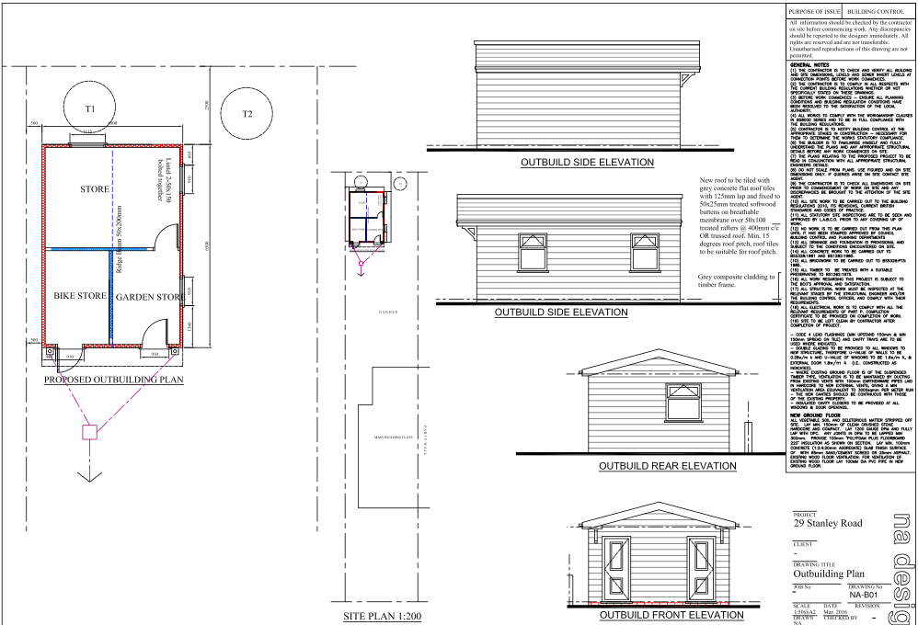
Figure 1. Proposed plan and elevations

Relevant planning history
Application | Proposal | Decision | Decision Date
036688 | Conversion of house from 3 self-contained flats to 6 self-contained flats | Approved | 01/08/1990
097284/FO/2011/S1 | Erection of a second floor extension to the existing rear outrigger to provide additional living accommodation | Approved | 01/11/2011
116623/FO/2017 | Installation of a rear dormer to create an enlarged flat | Approved | 03/11/2017

Consultation, notification and publicity responses

Consultations

Greater Manchester Ecology Unit
The Greater Manchester Ecology Unit initially advised that no habitats would be impacted by the proposed development and that the application would be exempt from statutory Biodiversity Net Gain (BNG) requirements under the de minimis exemption. An informative relating to protected species and biodiversity enhancements was recommended. Following a subsequent review of site photographs, concerns were raised that the presence of brash piles could indicate previous vegetation clearance, in which case habitat degradation may need to be considered and the de minimis exemption may not apply. Further clarification was sought regarding whether any trees or vegetation had been removed from the site. Following confirmation that no trees or vegetation had been removed, GMEU confirmed that a BNG assessment is not required for the application and raised no objection to the proposal.

Neighbourhood Team Leader (Arboriculture)
The Arboricultural Officer initially requested an Arboricultural Impact Assessment and Arboricultural Method Statement to assess the impact of the proposal on adjoining trees. Following submission and review of the required information, it was concluded that the proposed outbuilding could be installed without negatively affecting existing trees. The Arboricultural Officer therefore raises no objection to the proposal.

Notifications and publicity

Neighbour letters, site notice and press advertisement
No representations received.

Relevant policies
In accordance with Section 38(6) of the Planning and Compulsory Purchase Act 2004, planning applications must be determined in accordance with the statutory development plan unless material considerations indicate otherwise.
For Manchester, the development plan comprises:
- The Manchester Core Strategy (2012 to 2027);
- Saved policies of the Manchester Unitary Development Plan (UDP); and
- The Places for Everyone Joint Development Plan Document (2022 to 2039).
These documents are considered up to date and are afforded significant weight in the determination of planning applications. Relevant Supplementary Planning Documents (SPDs) and other adopted guidance may also be material considerations.
The National Planning Policy Framework sets out the government’s policies for plan-making and for making decisions on development proposals in England. It is a material consideration of critical importance in both contexts.
Where relevant, the Council is required to give special regard to the desirability of preserving listed buildings and their settings, and special attention to the desirability of preserving or enhancing the character or appearance of conservation areas, in accordance with the Planning (Listed Buildings and Conservation Areas) Act 1990.
The policies and guidance referred to below are considered the most relevant to the scale, nature and location of the proposed development.
- The Manchester Core Strategy Development Plan Document 2012-2027
  - Development Management and Planning Obligations
    - DM 1 - Development Management
  - Objective 1 - Spatial Principles
    - SP 1 - Spatial Principles (Partially replaced by PfE Policy JP-S 1)
  - Objective 6 Environment
    - EN 1 - Design Principles and Strategic Character Areas
    - EN 3 – Heritage (Deletions replaced with PfE Policy JP-P2)
    - EN 9 – Green Infrastructure
    - EN15 - Biodiversity and Geological Conservation (partially replaced by PfE Policy JP-G 8)
    - EN 19 – Waste
- Guide to development in Manchester - supplementary planning document and planning guidance, April 2007
- Extant Unitary Development Plan (UDP) –
  - Citywide Development Control Policies
    - DC1 - Residential extensions
    - DC18 - Conservation Areas
    - DC26 - Development and Noise
- Places for Everyone Plan Joint Development Plan Document 2022-2039-
  - Strategy
    - JP-Strat9: Southern Areas
  - Sustainable and Resilient Places
    - JP-S1: Sustainable Development
  - Greener Places
    - JP-G7: Trees and Woodland
    - JP-G8: A Net Enhancement of Biodiversity and Geodiversity
  - Places for People
    - JP-P1 Sustainable Places
    - JP-P2: Heritage
- National Planning Policy Framework – August 2026 - National Development Management Policies (NDMPs)
  - Procedural Policies
    - Chapter 3 – Decision-making policies
      - DM1: Preparing development proposals
      - DM2: Information requirements
      - DM3: Determining development proposals
      - DM6: Use of planning conditions and obligations
      - DM7: Relationship with other regulatory regimes
      - DM10: Removal of national permitted development rights
  - Sustainable Development
    - Chapter 4 - Achieving sustainable development
      - S3: Presumption in favour of sustainable development
      - S4: Principle of development within settlements
    - Chapter 5 - Meeting the challenge of climate change
      - CC2: Mitigation of climate change
      - CC3: Adaptation to climate change
  - Creating high quality, sustainable places
    - Chapter 12 - Making effective use of land
      - L2: Making effective use of land
    - Chapter 14 - Achieving well-designed places
      - DP3: Key principles for well-designed places
      - DP4: The design process
  - Conserving and enhancing the environment
    - Chapter 18 - Managing flood risk and coastal change
      - F4: Assessing flood risk for decision-making
      - F6: Development in areas at risk of flooding from rivers or the sea
      - F7: Ensuring development is safe from flooding
    - Chapter 19 - Conserving and enhancing the natural environment
      - N2: Improving the natural environment
      - N3: Trees in new development
    - Chapter 20 - Conserving and enhancing the historic environment
      - HE4: Securing the conservation of heritage assets
      - HE5: Assessing effects on heritage assets
      - HE9: Conservation areas

Assessment

Principle of Development
The proposal seeks permission for a single-storey outbuilding within the rear garden of an existing residential building containing six self-contained flats. The outbuilding would be used for bicycle, garden and general storage purposes ancillary to the lawful residential use of the site.
The site is in an established residential area within the Whalley Range Conservation Area, where residential development and associated ancillary structures are acceptable in principle. The proposal would not introduce a new or intensified use, and the outbuilding would remain clearly incidental to the main residential use. To safeguard this relationship, a condition is recommended to ensure that the outbuilding is used only for purposes incidental to the flats and not as a separate unit of accommodation.
Whilst permitted development rights for domestic outbuildings do not apply in this instance due to the nature of the property, outbuildings of a comparable scale and incidental function are commonly erected within residential curtilages under permitted development rights for dwellinghouses. This provides context for the limited scale and domestic nature of the proposal, although the application must be assessed on its own planning merits.
Local and national planning policy support the effective use of land within settlements and the provision of development that meets the needs of existing residents, provided there are no unacceptable impacts. The proposed development is modest in scale, located to the rear of the site, and compatible with the surrounding residential character.
The proposed development is therefore considered acceptable in principle, subject to detailed assessment of design, amenity and heritage considerations.

Appropriate siting, layout, scale, form, massing, materials, and detail
The proposed outbuilding would be located to the rear of the property and would be of a modest single-storey scale. The building would be finished in grey composite cladding with associated glazing and has been designed as a contemporary ancillary structure that remains clearly subordinate to the main building.
By reason of its limited scale, height and siting within the rear garden, the outbuilding would not appear overly prominent or incongruous within the site. Whilst the proposed materials differ from those of the host building, the structure would be viewed primarily within the context of the enclosed rear garden and would read as a ancillary addition. As such, it would not detract from the character or appearance of the existing building or the wider area.
Given its single-storey form, modest footprint and position within the rear garden, the proposed outbuilding would not result in unacceptable overbearing impacts, loss of outlook, overshadowing or loss of privacy to neighbouring occupiers. Due to its size, position and relationship with surrounding properties, the development would not create an unduly dominant feature when viewed from neighbouring sites.

Impact on the surrounding areas in terms of the design, scale and appearance of the proposed development. Development should have regard to the character of the surrounding area.
The proposed outbuilding would be located within the rear garden of the property and would be of a modest, single-storey scale. The structure would be finished in grey composite cladding, providing a contemporary appearance that is clearly distinguishable from, yet subordinate to, the main building.
In assessing the proposal, regard has been given to the character of the surrounding area. The outbuilding would be positioned to the rear of the site where it would have limited visibility from the public realm. By reason of its modest footprint, low height and ancillary nature, it would not appear as an unduly prominent feature within the site or the wider streetscene. The proposal would therefore respect the character of the surrounding area and would not result in harm to the visual amenity of the locality.
Accordingly, the development is considered to represent an appropriate form of development in terms of its siting, scale, massing, design and appearance, in compliance with Policy DM1 of the Manchester Core Strategy.

Effects on amenity

Privacy
The proposed outbuilding includes windows within the side and rear elevations. Given their ground floor position, existing boundary treatments and separation from neighbouring properties, no unacceptable overlooking or loss of privacy would arise.

Light
Given the proposal is entirely at ground floor level with limited massing and large separation distances the impact to light from the added massing is acceptable.

Noise
The proposed extension is not expected to generate any noise beyond what would be reasonably expected of an incidental use for a residential dwelling.

Accessibility: buildings and neighbourhoods fully accessible to disabled people, access to new development by sustainable transport modes.
The proposal does not change how people can get in and out of the building.

Adequacy of internal accommodation and external amenity space.
The proposal relates solely to ancillary storage accommodation and would not alter the standard of internal accommodation within the existing flats.

Refuse storage and collection.
The outbuilding would provide dedicated storage for bins and cycles associated with the six flats, helping to maintain the tidiness and functionality of the site whilst retaining suitable access for collection.

Vehicular access and car parking
The proposal doesn't change how vehicles access and park at the property.

Effects relating to biodiversity, landscape, archaeological or built heritage

Biodiversity
The application was reviewed by the Greater Manchester Ecology Unit. Following clarification from the applicant that no trees or vegetation had been removed from the site prior to the submission of the application, GMEU confirmed that the proposal is exempt from the statutory Biodiversity Net Gain requirements and that no Biodiversity Net Gain assessment is required. No objection has therefore been raised on ecological grounds. GMEU advised that protected species legislation remains applicable and recommended the inclusion of an informative relating to protected species and biodiversity enhancement measures.
The proposal relates to the erection of a modest outbuilding within an existing residential curtilage and would not result in the loss of any identified ecological features of significance. Having regard to the consultation response and the nature of the development, the proposal is considered acceptable in respect of biodiversity and complies with Policies EN15 of the Core Strategy and JP-G8 of Places for Everyone.

Built heritage
The proposed outbuilding would be modest in scale and positioned to the rear of the property, where it would have very limited visibility from the public realm. As such, it would not compete with the host building or interrupt views that contribute to the character and appearance of the conservation area.
Whilst grey composite cladding is not a traditional material associated with the conservation area, the outbuilding would be a modest ancillary structure located to the rear of the site, with limited public visibility. As a result, any effect on the character and appearance of the conservation area would be neutral and the proposal would preserve its significance. Its limited scale, low height and restricted public visibility reduce the significance of the material choice in heritage terms.
Furthermore, outbuildings of a comparable domestic scale are a common feature of residential rear gardens and, in many circumstances, can be erected under permitted development rights without the need for planning permission. Although each proposal must be assessed on its own merits, this provides context for the modest nature of the development. The proposal would preserve the character and appearance of the Whalley Range Conservation Area and would accord with Policy JP-P2 of Places for Everyone, Policy EN3 of the Core Strategy and the relevant heritage provisions of the National Planning Policy Framework.

Green Infrastructure including open space, both public and private
The proposal would be located within an existing private residential garden and would not result in the loss of any designated public open space or Green Infrastructure assets. The submitted arboricultural information demonstrates that the development can be accommodated without negatively impacting existing trees, and the Council's Arboricultural Officer has raised no objection to the proposal. The development would therefore preserve the site's existing contribution to urban greening and is considered acceptable in respect of Policies EN9 and EN15 of the Core Strategy.

Flood risk and drainage.
The property site borders a Flood Zone 2 area to the front however this does not cover the development area at the rear of the site.and therefore does not require a flood statement or assessment.

The proposal has a negligible impact on drainage using the existing drainage on site.

Other Legislative Requirements

Equality Act 2010
Section 149 (Public Sector Equality Duty) of the Equality Act 2010 requires due regard to the need to: Eliminate unlawful discrimination, harassment and victimisation and other conduct prohibited by the Act and; Advance equality of opportunity between persons who share a protected characteristic and persons who do not share it. The Equality Duty does not impose a legal requirement to conduct an Equality Impact Assessment. Compliance with the Equality Duty involves consciously thinking about the aims of the Equality Duty as part of the process of decision-making.

Human Rights Act 1998 considerations
This application needs to be considered against the provisions of the Human Rights Act 1998. Under Article 6, the applicants (and those third parties, including local residents, who have made representations) have a right to a fair hearing and to this end the local planning authority must give full consideration to their comments.
Protocol 1 Article 1, and Article 8 where appropriate, confer(s) a right of respect for a person’s home, other land and business assets. In taking account of all material considerations, including Council policy as set out in the Core Strategy and saved polices of the Unitary Development Plan, the Director of Planning, Building Control & Licensing has concluded that some rights conferred by these articles on the applicant(s)/objector(s)/resident(s) and other occupiers and owners of nearby land that might be affected may be interfered with but that that interference is in accordance with the law and justified by being in the public interest and on the basis of the planning merits of the development proposal. She believes that any restriction on these rights posed by the recommendation given is proportionate to the wider benefits of and that such a decision falls within the margin of discretion afforded to the Council under the Town and Country Planning Acts.

Planning balance & Conclusion
Section 38(6) of the Planning and Compulsory Purchase Act 2004 requires that planning applications be determined in accordance with the development plan unless material considerations indicate otherwise. The proposal seeks the erection of a modest outbuilding to provide cycle, bin and ancillary storage serving the existing six flats. The development is acceptable in principle and would provide practical storage facilities that support the ongoing use of the residential property.
The development would be of an appropriate scale, form and design, would not result in unacceptable impacts on the amenities of neighbouring occupiers, would preserve the character and appearance of the Whalley Range Conservation Area, would not adversely affect existing trees and would not give rise to any unacceptable biodiversity impacts. Consultees, including the Council's Arboricultural Officer and GMEU, raise no objection to the proposal subject to appropriate conditions. No representations have been received from neighbouring occupiers.
Taking all material considerations into account, the proposal accords with the relevant policies of the development plan and there are no material considerations that indicate a decision other than in accordance with that plan. The application is therefore recommended for approval, subject to the conditions set out in this report.

Recommendation: Approve

Article 35 Declaration
Officers have worked with the applicant in a positive and proactive manner based on seeking solutions to problems arising in relation to dealing with the planning application. There were minor changes required to meet the requirements for approval and the officer and applicant worked together to find an amicable solution.

Conditions to be attached to decision for approval

3-year time limit
The development must be begun not later than three years beginning with the date of this permission.
Reason - Required to be imposed by Section 91 of the Town and Country Planning Act 1990 (as amended).

Specified plans
The development hereby approved shall be carried out in accordance with the following drawings and documents:
  - NA-B01 Rev. A – Proposed Outbuilding Plan (received 31 July 2026)
  - The Location Plan (received 7 April 2026)
Reason - To ensure that the development is carried out in accordance with the approved plans, pursuant to policies DM 1, SP 1 and EN 1 of the Core Strategy and JP-P1 & of Places for Everyone.

Materials as approved on plan
The materials used in the external surfaces of the development hereby approved shall be those as specified on approved plan/drawing ref.
  - NA-B01 Rev. A – Proposed Outbuilding Plan (received 31 July 2026)

Reason - In order to ensure a satisfactory appearance in the interests of visual amenity in accordance with policies SP1 and DM1 of the Core Strategy and the requirements of the National Planning Policy Framework.

Use
The outbuilding hereby approved shall be used solely for purposes incidental to the use of the property at 29 Stanley Road and shall not be used as independent living accommodation, a separate dwellinghouse, or for any commercial purpose.
Reason: To ensure that the outbuilding remains ancillary to the lawful residential use of the site and to safeguard the living conditions of nearby occupiers, in accordance with Policies DM1 and SP1 of the Manchester Core Strategy and Policy JP-P1 of Places for Everyone.

Arboricultural Protection
The development hereby approved shall be carried out in full accordance with the arboricultural protection and construction recommendations contained within the submitted Arboricultural Impact Assessment (Ref: TCP AIA 002, dated August 2026), Tree Protection Plan (Ref: TCP 001) and Site Tree Appraisal (dated 16 June 2026).
All tree protection fencing and ground protection measures identified within the approved documents shall be erected prior to the commencement of development and retained for the duration of the construction works.
Reason: To ensure the protection and long-term retention of retained trees during construction, in accordance with Policies EN9 of the Manchester Core Strategy and Policy JP-G7 of Places for Everyone.

Informative(s)

Biodiversity Enhancement
The applicant is encouraged to incorporate biodiversity enhancements within the development where practicable. Such measures may include native planting, pollinator-friendly planting, bird boxes or bat roosting features. These measures would assist in supporting local biodiversity in accordance with national and local planning policy objectives.

