

Planning

Delegated Officer Report

Summary of application details
Application reference: | OTH-2026-001712
Application type: | Non-Material Amendment
Proposal: | Non-Material Amendment to Planning Permission 145489/JO/2026 to allow a small section of pitched roof to replace a flat roof at first floor level.
Site address: | 255 Brooklands Road Manchester M23 9HF
Ward(s): | Brooklands
Date application valid: | 21 September 2026
Applicant name: | Dr Hamid Sheikh
Agent (if any): | Mr Thomas Bedford
Case officer: | David Lawless
Recommendation: | Approve
Date of recommendation: | 12 October 2026

Description of site, building and/or area

255 Brooklands Road is a large two storey detached dwellinghouse, with hardsurfaced area and raised planters to the front and a large garden and outbuilding to the rear. The property is contemporary in design. It is finished in render, with timber panels in the front elevation and it is topped with a flat roof. The area is predominantly residential in nature.

Description of development

The applicant obtained planning permission in October 2022 (134465/FH/2022) to erect the following:

Erection of a 2 storey front extension and a single storey rear extension; erection of a single storey rear extension to existing outbuilding; erection of pitched roof to dwelling; creation of enlarged hardsurfaced area to the front and associated elevational alterations

They then applied for two variations, both of which were approved:

140127/JO/2024 – Variation of condition number 2 (specified plans) from planning approval reference 134465/FH/2022 to allow an amendment to the approved roof pitch and an increase in its height together with the installation of roof mounted solar panels

145489/JO/2026 – Variation of Conditions 2 attached to Planning Permission 140127/JO/2024 to alter the roof design.
The applicant is now applying for a non-material amendment, specifically the addition of a pitch roof element to the rear two storey element. Please see below:

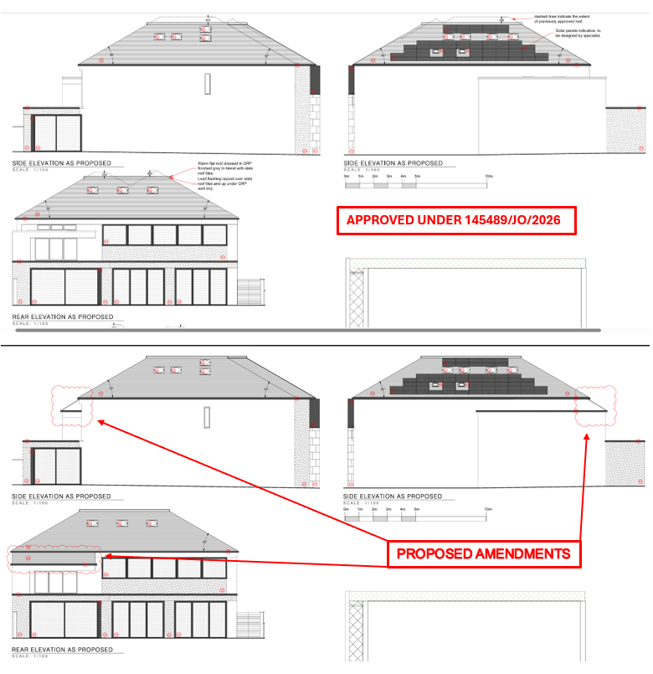

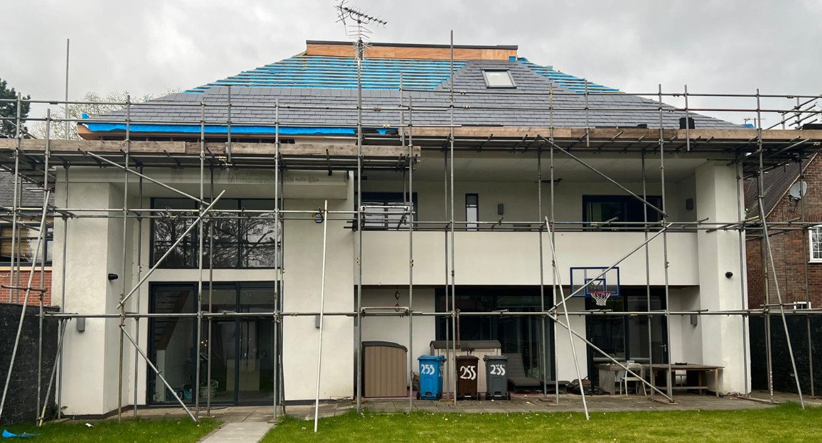

Consultations

n/a

Relevant Policies

National Planning Policy Framework (August 2026) – A revised National Planning Policy Framework (NPPF) was published on 17 August 2026 following a period of public consultation and has superseded the previous version. Given the timing of its publication, the application has been assessed against both the former and revised frameworks. Having undertaken this review, it is considered that the changes introduced by the revised NPPF do not materially affect the assessment or conclusions reached in relation to the proposed development.

The revised version fundamentally restructures national planning policy with a more rules based, pro-growth approach, replacing the previous paragraph based framework and the traditional tilted balance with a new presumption in favour of sustainable development. Key reforms include stronger support for housing delivery, particularly higher-density development near major public transport hubs, greater policy support for economic growth, infrastructure and rural productivity, stronger protection for pubs and other community facilities and continued robust protection of designated landscapes. The reforms are intended to make planning decisions faster, clearer and more predictable whilst accelerating housing and economic growth.

In this instance, the relevant sections are outlined below:

Policy DM3 (Determining development proposals) – When considering development proposals, local planning authorities should:

- Work with the applicant in a positive and proactive manner, where necessary seeking solutions to problems arising from initial proposals, to enable a timely decision;
- Take a proportionate approach to the consideration of the planning matters raised by the proposals, in a way that reflects their scale, complexity and potential impact;
- Take account of planning matters raised during any pre-application engagement, including any positive responses to this engagement, as well as representations on the proposals;
- Consult statutory or internal consultees only where it is necessary to do so. Decisions on development proposals should not be delayed in order to secure advice from a statutory or internal consultee beyond their statutory deadlines unless there is insufficient information to make the decision or more detailed advice may enable an approval rather than a refusal;
- Consider whether otherwise unacceptable development proposals could be made acceptable through the use of planning conditions or planning obligations; and
- Not refuse applications for development which should clearly be approved, having regard to its accordance with the development plan, the policies in this Framework and any other material considerations.

Core Strategy Development Plan Document – The Core Strategy Development Plan Document 2012 -2027 ("the Core Strategy") was adopted by the City Council on 11th July 2012. It is the key document in Manchester's Local Development Framework. The Core Strategy replaces significant elements of the Unitary Development Plan (UDP) as the document that sets out the long term strategic planning policies for Manchester's future development.

A number of UDP policies have been saved until replaced by further development plan documents to accompany the Core Strategy. Planning applications in Manchester must be decided in accordance with the Core Strategy, saved UDP policies and other Local Development Documents. Relevant policies in the Core Strategy are detailed below

Policy SP1, Spatial Principles, - Development in all parts of the City should make a positive contribution to neighbourhoods of choice including creating well designed places that enhance or create character and protect and enhance the built and natural environment.

Policy DM1, Development Management – This policy states that all development should have regard to a number of specific issues, of which the following are of most relevance:-

- Appropriate siting, layout, scale, form, massing, materials and detail.
- Impact on the surrounding areas in terms of the design, scale and appearance of the proposed development. Development should have regard to the character of the surrounding area.
- Effects on amenity, including privacy, light, noise, vibration, air quality, odours, litter, vermin, birds, road safety and traffic generation. This could also include proposals which would be sensitive to existing environmental conditions, such as noise.
- Community safety and crime prevention.
- Design for health.
- Vehicular access and car parking.
- Effects relating to biodiversity, landscape, archaeological or built heritage.
- Flood risk and drainage.

Saved UDP Policies – Policy DC1, Residential Extensions. – Policy DC1.1 states that in determining planning applications for extensions to residential properties, the Council will have regard to:

- the general character of the property;
- the effect upon the amenity of neighbouring occupiers;
- the desirability of enabling people to adapt their houses in appropriate ways to meet changing household needs;
- the overall appearance of the proposal in the street-scene;
- the effect of the loss of any on-site carparking.

Policy DC1.2 states that extensions to residential properties will be allowed subject to compliance with other relevant policies of the Plan and the following criteria:

- they are not excessively large or bulky (for example, resulting in structures which are not subservient to original houses or project out too far in front of the original buildings);
- they do not create an undue loss of sunlight, daylight or privacy;
- they are not out of character with the style of development in the area or the surrounding street scene by virtue of design, use of materials or constructional details;
- they would not result in the loss of off-street car-parking, in a situation where there is so severe an existing on-street parking problem that unacceptable additional pressures would be created.

Policy DC1.3 states that notwithstanding the generality of the above policies, the Council will not normally approve:

- rearward extensions greater than 3.65m (12 ft) in length;
- 2-storey extensions with a flat roof, particularly those which would be visible from the public highway;
- 2-storey extensions to terraced properties which occupy the full width of the house;
- flat roofed extensions to bungalows;
- extensions which conflict with the Council's guidelines on privacy distances (which are published as supplementary guidance).

Policy DC1.4 states that in considering proposals for 2-storey side extensions, the Council will have regard to the general guidance above and also to supplementary guidance to be issued. In particular, the Council will seek to ensure that:

- the development potential of the gap between detached and semi-detached houses is capable of being shared equally by the owners or occupiers of the two properties concerned;
- the actual or potential result of building the extension will not be the creation of a terracing effect, where this would be unsympathetic to the character of the street as a whole;
- the actual or potential result of building the extension will not be the creation of a very narrow gap between the properties, or any other unsatisfactory visual relationships between elements of the buildings involved.

As a guide, and without prejudice to the generality of this policy, the Council will normally permit 2-storey house extensions which, when built, would leave a minimum of 1.52m (5 ft) between the side wall and the common boundary, and which meet the other requirements of this policy. Proposals which cannot meet these requirements will be judged on their merits, but with weight being given to (a) and (c) above.

Assessment

Principle of the Proposal – Given the previous planning approvals granted for the site, the principle of the proposed amendment remains acceptable. Notwithstanding this, the potential impacts on residential amenity and visual amenity must be carefully assessed.

Design and Siting – The proposal seeks to replace the existing flat roof over the modest two-storey rear outrigger with a pitched roof that reflects the pitch and form of the main dwellinghouse roof. The design, scale and siting of the proposed non-material amendment are considered acceptable and would remain in keeping with the character and appearance of the host property.

Residential Amenity – The proposed amendment to the rear elevation would not result in any material increase in overlooking, loss of privacy, overshadowing, or loss of light to neighbouring properties. Accordingly, it is considered that the proposal would not have a detrimental impact on the level of residential amenity currently enjoyed by adjoining occupiers.

Visual Amenity – By reason of its design, scale and siting, the proposed amendment would integrate satisfactorily with the existing dwelling and would not appear incongruous within the street scene. It is therefore considered that the proposal would not have an unduly detrimental impact on visual amenity within the surrounding area, including views from Brooklands Road.

Pedestrian and Highway Safety – The proposed amendment relates solely to alterations to the roof form and would not affect access arrangements, parking provision or vehicle movements. As such, no adverse impacts on pedestrian or highway safety are anticipated.

Drainage – The proposed changes to the roof design do not raise any drainage concerns and are not considered likely to result in any adverse impacts in this regard.

Trees – The protected trees located along the front boundary of the site would be retained and remain unaffected by the proposed amendment.

Other Legislative Requirements

Equality Act 2010 – Section 149 (Public Sector Equality Duty) of the Equality Act 2010 requires due regard to the need to: Eliminate unlawful discrimination, harassment and victimisation and other conduct prohibited by the Act and; Advance equality of opportunity between persons who share a protected characteristic and persons who do not share it. The Equality Duty does not impose a legal requirement to conduct an Equality Impact Assessment. Compliance with the Equality Duty involves consciously thinking about the aims of the Equality Duty as part of the process of decision-making.

Human Rights Act 1998 considerations – This application needs to be considered against the provisions of the Human Rights Act 1998. Under Article 6, the applicants (and those third parties, including local residents, who have made representations) have a right to a fair hearing and to this end the local planning authority must give full consideration to their comments.

Protocol 1 Article 1, and Article 8 where appropriate, confer(s) a right of respect for a person’s home, other land and business assets. In taking account of all material considerations, including Council policy as set out in the Core Strategy and saved polices of the Unitary Development Plan, the Director of Planning, Building Control & Licensing has concluded that some rights conferred by these articles on the applicant(s)/objector(s)/resident(s) and other occupiers and owners of nearby land that might be affected may be interfered with but that that interference is in accordance with the law and justified by being in the public interest and on the basis of the planning merits of the development proposal. She believes that any restriction on these rights posed by the recommendation given is proportionate to the wider benefits of and that such a decision falls within the margin of discretion afforded to the Council under the Town and Country Planning Acts.

Recommendation: Approve

Reasons for approval

1) The details of the proposed amendments are:

- replacement of flat roof over 2 storey rear outrigger with pitched roof

2) Following an assessment of the details submitted, the proposed amendments are considered to be of a non-material nature and acceptable to the City Council as the Local Planning Authority. The City Council is satisfied that the proposed changes will not result in any significant or material alteration to the host planning permission or have a detrimental impact upon the levels of visual and residential amenity enjoyed within the vicinity of the site.

Conditions attached to this decision

3) Condition no. 3 – The development hereby approved shall be carried out in accordance with the following drawings:

a) PL-101, PL-102, PL-105 and PL107 received on 25 July 2022
b) PL04-106, received on 21 September 2026

Reason - To ensure that the development is carried out in accordance with the approved plans, pursuant to Policies SP1 and DM1 of the Manchester Core Strategy.

