

Planning

Delegated Officer Report

Summary of application details
Application reference: | PLA-2026-001544
Application type: | Full planning permission
Proposal: | Erection of single-storey rear extension and installation of dormer.
Site address: | 161 Acomb Street Manchester M14 4DY
Ward(s): | Moss Side
Date application valid: | 25 August 2026
Applicant name: | Mr David Hall
Agent (if any): | Mr Benjamin Maguire
Case officer: | Joshua Lee
Recommendation: | Refuse
Date of recommendation: | 12 Oct 2026

Description of site, building and/or area
The application property is a two-storey mid-terrace dwellinghouse of traditional red brick construction, forming part of a row of late Edwardian terraced properties. The dwelling features a ground-floor bay window, a pitched roof concealed behind a parapet, and a small enclosed front forecourt bounded by a low brick wall. To the rear the property features an original two storey outrigger and further single storey rear extension (noted as ‘storage’ on existing plans) within a small rear yard.
The property is currently occupied as a House in Multiple Occupation (HMO). The applicant has stated that the property has been in a HMO use for more than 10 years; however, there is no formal planning decision or Certificate of Lawfulness confirming the lawful planning use of the property as an HMO.
The property is within a within a dense row of traditional late Edwardian terraced housing in a mostly residential part of the Moss Side ward of Manchester. The area has a high density of House of Multiple Occupation dwellings.

Description of development
The proposal comprises the erection of a single-storey rear extension and a rear dormer roof extension to the existing two-storey mid-terraced dwellinghouse. The development would be accompanied by internal alterations and reconfiguration of the existing accommodation across the ground, first and second floor levels.
The single-storey rear extension would project approximately 5.1m beyond the existing rear elevation and extend across the majority of the width of the property. The extension would have an approximate eaves height of 2.4m and a maximum height of 2.9m. It would replace an existing rear extension.
A rear dormer extension is proposed within the rear roof slope. The dormer would occupy much of the rear roof plane and would provide additional accommodation within the roofspace, including a rear-facing dormer window.
The front elevation would remain largely unaltered, with the existing fenestration retained. New windows and doors are proposed within the rear elevation to serve the extension and roofspace accommodation. The submitted plans indicate that new windows and external doors would comprise uPVC double-glazed units.
The application form confirms that the external materials would be selected to match the existing dwellinghouse. Private rear amenity space would be retained following completion of the development.
The proposal would allow the increase from 5 to 6 bedrooms.
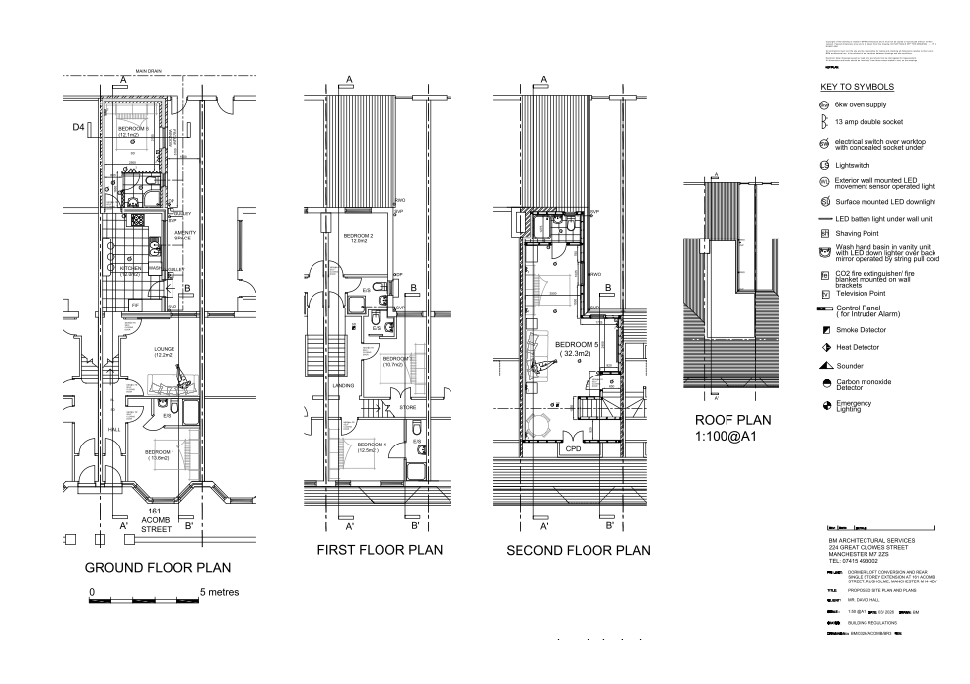
Figure 1. Proposed floor plans

Relevant planning history

Lawful development: Proposed - 145379/LP/2026
Single-storey extension and dormer roof extension both to the rear.
Refuse - 2026-04-17
- Rear Extension A.1(f)(i) - The proposed single storey rear extension as shown on the submitted drawings does not constitute permitted development. It fails to meet the requirements of Part 1, Schedule 2, A.1(f)(i) of the Town and Country Planning (General Permitted Development) (England) Order 2015 (as amended). The proposed extension would have a rearward projection of 5.1 metres and exceeds the 3 metre rearward projection permitted by A.1(f)(i).
- Refuse Dormer B.2(c) (i) and (ii) - The proposed rear dormer as shown on the submitted drawings does not constitute permitted development. It fails to meet the requirements of Part 1, Schedule 2, B.2(c)(i) and (ii) of the Town and Country Planning (General Permitted Development) (England) Order 2015 (as amended). There is no indication as to whether the proposed window would be obscurely glazed and the opening part of the window is less than 1.7 metres above the floor of the room in which it would be installed.

Consultation, notification and publicity responses

Consultations

Environmental Health
No response received.

Highway Services
Highway Services reviewed the proposal and raised no objection. They advised that the development is unlikely to result in a significant increase in vehicular trips or raise capacity concerns on the local highway network. The site is located in a sustainable location with access to public transport. Highway Services recommended the provision of secure and sheltered cycle parking and suggested a planning condition requiring details of cycle parking facilities to be submitted and approved.

Notifications and publicity

Neighbour letters

Relevant policies
In accordance with Section 38(6) of the Planning and Compulsory Purchase Act 2004, planning applications must be determined in accordance with the statutory development plan unless material considerations indicate otherwise.
For Manchester, the development plan comprises:
- The Manchester Core Strategy (2012 to 2027);
- Saved policies of the Manchester Unitary Development Plan (UDP); and
- The Places for Everyone Joint Development Plan Document (2022 to 2039).
These documents are considered up to date and are afforded significant weight in the determination of planning applications. Relevant Supplementary Planning Documents (SPDs) and other adopted guidance may also be material considerations.
The National Planning Policy Framework sets out the government’s policies for plan-making and for making decisions on development proposals in England. It is a material consideration of critical importance in both contexts.
Where relevant, the Council is required to give special regard to the desirability of preserving listed buildings and their settings, and special attention to the desirability of preserving or enhancing the character or appearance of conservation areas, in accordance with the Planning (Listed Buildings and Conservation Areas) Act 1990.
The policies and guidance referred to below are considered the most relevant to the scale, nature and location of the proposed development.
- The Manchester Core Strategy Development Plan Document 2012-2027
  - Development Management and Planning Obligations
    - DM 1 - Development Management
  - Objective 1 - Spatial Principles
    - SP 1 - Spatial Principles (Partially replaced by PfE Policy JP-S 1)
  - Objective 3 - Housing
    - H 1 – Overall Housing Provision (Partially replaced by PfE Policy JP-H 1)
    - H 5 – Central Manchester
    - H 11 – Houses in Multiple Occupation
  - Objective 6 Environment
    - EN 1 - Design Principles and Strategic Character Areas
    - EN 19 – Waste
- Guide to development in Manchester - supplementary planning document and planning guidance, April 2007
- Extant Unitary Development Plan (UDP) –
  - Citywide Development Control Policies
    - DC1 - Residential extensions
    - DC26 - Development and Noise

- Places for Everyone Plan Joint Development Plan Document 2022-2039-
  - Strategy
    - JP-Strat5: Inner Areas
  - Sustainable and Resilient Places
    - JP-S1: Sustainable Development
  - Places for People
    - JP-P1 Sustainable Places
- National Planning Policy Framework – August 2026 - National Development Management Policies (NDMPs)
  - Procedural Policies
    - Chapter 3 – Decision-making policies
      - DM1: Preparing development proposals
      - DM2: Information requirements
      - DM3: Determining development proposals
      - DM6: Use of planning conditions and obligations
      - DM7: Relationship with other regulatory regimes
      - DM10: Removal of national permitted development rights
  - Sustainable Development
    - Chapter 4 - Achieving sustainable development
      - S3: Presumption in favour of sustainable development
      - S4: Principle of development within settlements
  - Delivering homes and supporting growth
    - Chapter 6 - Delivering a sufficient supply of homes
      - HO7: Meeting the need for homes
  - Creating high quality, sustainable places
    - Chapter 12 - Making effective use of land
      - L2: Making effective use of land
      - L3: Achieving appropriate densities
    - Chapter 14 - Achieving well-designed places
      - DP3: Key principles for well-designed places
      - DP4: The design process

Assessment

Principle of Development
The application property is currently occupied as a House in Multiple Occupation (HMO). The applicant has stated that the property has been used as an HMO for more than 10 years. However, there is no formal planning permission or Certificate of Lawfulness confirming the lawful planning use of the property as an HMO.
The current application does not seek to regularise or formally establish the lawfulness of the existing HMO use. Accordingly, no determination is made through this application as to whether the existing HMO use is lawful for planning purposes. For the purposes of assessing the development now proposed, however, regard is had to the factual circumstances described by the applicant, namely that the property is presently occupied as an HMO accommodating five residents and that the proposed extensions and internal alterations would facilitate an increase to six bedrooms/residents.
The assessment has proceeded on the basis of the applicant's description of the existing use. The determination of this application does not confirm the lawful planning status of the existing HMO use, which would fall to be considered separately through an application for a Certificate of Lawfulness or other appropriate process.
The proposal therefore falls to be assessed against Policy H11 of the Manchester Core Strategy and all other relevant development plan policies. Particular regard must be had to Policy H11 given the existing HMO occupation of the property and its location within an area characterised by a high concentration of HMOs.
Policy H11 of the Manchester Core Strategy seeks to ensure that HMOs make a positive contribution to Manchester's housing offer whilst protecting the character, function and amenity of residential neighbourhoods. In relation to areas of high HMO concentration, the policy states that:
“In areas of high concentration, extensions to HMOs (as defined in the Housing Act 2004) would not be permitted where this could reasonably be expected to lead to an increase in the level of occupation.”
Council records demonstrate that the application site lies within a notable cluster of licensed HMOs. The Council's HMO licensing register identifies 15 licensed HMOs on Acomb Street, 23 on Ruskin Avenue and 10 on Haydn Avenue. Collectively, these three streets contain 48 licensed HMOs. By comparison, there are 181 licensed HMOs within the whole of the Moss Side ward. As such, over a quarter (approximately 26.5%) of the ward's licensed HMOs are concentrated on these three adjoining streets alone. The same area also accommodates approximately 290 licensed occupants, representing around 26.5% of the ward-wide licensed HMO capacity. This demonstrates a particularly high local concentration of HMOs around the application site and supports the conclusion that the property is located within an area of high HMO concentration for the purposes of Policy H11.
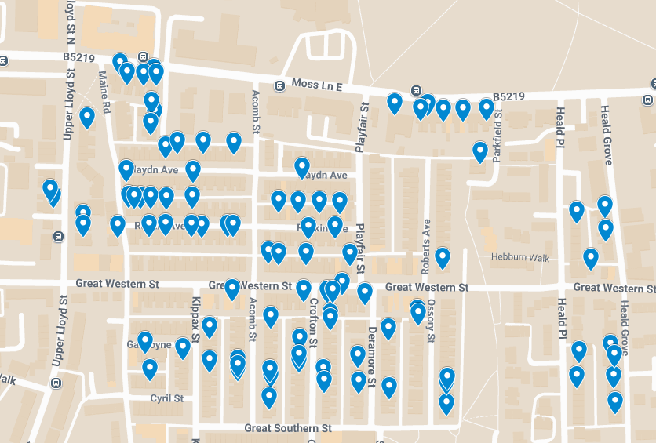
Figure 1. HMO Map of local area.
The submitted plans show the creation of an additional bedroom within the property. Whilst the proposal would not alter the use class of the property, which would remain an HMO, the key consideration under Policy H11 is whether the extension could reasonably be expected to increase the level of occupation. In this case, the proposal would increase the number of bedrooms from five to six and facilitate occupation by an additional resident. The proposal would therefore increase the level of occupation from five to six residents.
The proposal would consequently intensify the occupation of an HMO within an area already characterised by a high concentration of HMOs. As the extension would reasonably be expected to increase the level of occupation, the proposal directly conflicts with Policy H11 of the Manchester Core Strategy, which states that extensions to HMOs in areas of high concentration will not be permitted where they could reasonably be expected to lead to an increase in occupation.
Significant weight is attached to this conflict with the development plan. Accordingly, the principle of the development is unacceptable, and the proposal is contrary to Policy H11 of the Manchester Core Strategy.

Appropriate siting, layout, scale, form, massing, materials, and detail
Notwithstanding the conflict identified with Core Strategy Policy H11, the design merits of the proposal have been assessed.
The proposed single-storey rear extension would project approximately 5.1m beyond the existing rear elevation and extend across most of the width of the property. Given its modest height, with an eave’s height of approximately 2.4m and a maximum height of approximately 2.9m, the extension would appear subordinate to the host property and would not appear unduly bulky or dominant.
The proposed rear dormer would be positioned on the rear roof slope where it would have very limited visibility from the public realm. Rear dormers are a common feature on terraced properties throughout the locality, and the proposal would not appear incongruous within the prevailing roofscape. The development would not materially alter the appearance of the principal elevation or undermine the established character of the terrace.
The application confirms that materials would be selected to match those of the existing property. Subject to the use of matching materials, the proposal would integrate satisfactorily with the host dwelling and would preserve the visual character of the surrounding area.
Accordingly, the proposal is considered to accord with Core Strategy Policies DM1 and EN1 and saved UDP Policy DC1 in respect of design, scale, appearance and visual impact.
Impact on the surrounding areas in terms of the design, scale and appearance of the proposed development. Development should have regard to the character of the surrounding area.
The principal works would be located to the rear of the property and would have limited visibility from the public highway. Given the siting, scale and design of the extension and dormer, together with the proposed use of matching materials, the development would not adversely affect the character or appearance of the street scene. The proposal is therefore considered to comply with Core Strategy Policies DM1 and EN1 and saved UDP Policy DC1.

Effects on amenity

Privacy
The proposed single-storey rear extension would contain glazing serving habitable accommodation. These openings would maintain typical facing relationships found throughout the surrounding terraced environment and would not result in unacceptable overlooking beyond that which already exists.
The proposed dormer includes a side-facing window. In the absence of controls, this opening could give rise to overlooking of neighbouring properties. However, a condition could reasonably require the window to be obscurely glazed and fixed shut except for a top-hung opening section with any opening element positioned at least 1.7m above the finished floor level. Subject to such a condition, no unacceptable loss of privacy would arise.
The proposal would therefore have an acceptable impact on neighbouring privacy.

Light
The rear extension would project beyond the existing rear building line but would remain single storey in height. Such extensions are commonplace within terraced residential areas and, having regard to its scale and height, the proposal would not result in a significant loss of daylight, sunlight or outlook to adjoining occupiers.
The rear dormer would be contained within the roof slope and would not result in any overbearing relationship with neighbouring properties. Given its position and scale, it would not materially affect light reaching adjacent buildings.
Overall, the proposal would not give rise to any unacceptable overshadowing, loss of outlook or overbearing impact and is considered acceptable in residential amenity terms.

Noise
The construction works associated with the extension and dormer would be temporary in nature and would not result in ongoing noise impacts.
However, the proposal would facilitate the creation of an additional bedroom and thereby increase the occupancy of the existing HMO from five to six residents. Whilst the addition of a single occupant would not be expected to give rise to significant amenity harm in isolation, it would nevertheless intensify the existing use and generate additional day-to-day domestic activity associated with occupation of the property.
The site lies within an area already characterised by a high concentration of HMOs. In this context, incremental increases in occupancy contribute to the cumulative impacts associated with intensive shared housing accommodation, including increased comings and goings, activity within communal spaces and additional domestic noise generation.
Whilst the resulting impacts are not considered severe in their own right, they reinforce the concerns identified under Policy H11 regarding further intensification of HMO occupation within an area of high concentration. Moderate weight is therefore given to this consideration.

Road Safety and Traffic Generation
The proposal would not result in any alteration to the existing vehicular or pedestrian access arrangements serving the property.
Highway Services were consulted and raised no objection to the proposal. They advised that the development would be unlikely to generate a significant increase in vehicular trips and would not give rise to network capacity concerns. The site benefits from good accessibility by sustainable transport modes and is located within walking distance of regular bus services.
The proposal is therefore acceptable in highway safety and traffic generation terms.

Accessibility: buildings and neighbourhoods fully accessible to disabled people, access to new development by sustainable transport modes.
The proposal relates to extensions and alterations to an existing residential property and would not materially alter access arrangements to or from the site.
The property occupies a sustainable urban location with convenient access to public transport services, local shops, services and community facilities. The development would therefore continue to provide accessible accommodation within a sustainable location.
Accordingly, the proposal raises no accessibility concerns and accords with the objectives of inclusive and sustainable development.

Adequacy of internal accommodation and external amenity space.
The proposal would provide additional internal floorspace and facilitate the creation of a sixth bedroom within the existing HMO. The internal layout would remain capable of providing an acceptable standard of accommodation for future occupiers.
However, the proposed single-storey rear extension would substantially reduce the size of the existing rear yard, leaving only a limited area of shared external amenity space available to residents. The plans indicate that a relatively small area of outdoor space would remain following the extension.
The development would also increase the occupancy of the property from five to six residents. Consequently, a greater number of occupants would be reliant upon a reduced amount of outdoor amenity space. Whilst the remaining yard would continue to provide some external amenity provision, the level of amenity space available per resident would be diminished and would be limited for a six-person HMO.
Although the reduction in external amenity space would not, in isolation, justify refusal of the application, it reinforces the intensification of use arising from the proposal. The combination of increased occupancy and reduced shared outdoor space adds further weight to the conflict with Policy H11 of the Manchester Core Strategy, which seeks to resist extensions to HMOs in areas of high concentration where they could reasonably be expected to increase the level of occupation.

Refuse storage and collection.
A refuse storage area is shown within the site. Highway Services confirmed that this arrangement would ensure refuse is stored off the highway and considered it acceptable for refuse to be serviced in line with existing operations. The proposal is therefore acceptable in terms of refuse storage and collection.

Vehicular access and car parking
The proposal would not alter existing access arrangements or result in the loss of any off-street parking provision.
Given the sustainable location of the site and the modest increase in occupancy proposed, it is not considered that the development would create unacceptable parking pressures or highway impacts.
The proposal is therefore acceptable in parking and access terms.

Green Infrastructure including open space, both public and private
The proposal has no impact on green infrastructure.

Flood risk and drainage
The site is located within an existing residential area and the proposal comprises a relatively small-scale extension to an existing property.
The development would utilise existing drainage infrastructure and, having regard to its scale and nature, would not materially increase flood risk either on-site or elsewhere.
The proposal is therefore acceptable in terms of flood risk and drainage.

Other Legislative Requirements

Equality Act 2010
Section 149 (Public Sector Equality Duty) of the Equality Act 2010 requires due regard to the need to: Eliminate unlawful discrimination, harassment and victimisation and other conduct prohibited by the Act and; Advance equality of opportunity between persons who share a protected characteristic and persons who do not share it. The Equality Duty does not impose a legal requirement to conduct an Equality Impact Assessment. Compliance with the Equality Duty involves consciously thinking about the aims of the Equality Duty as part of the process of decision-making.

Human Rights Act 1998 considerations
This application needs to be considered against the provisions of the Human Rights Act 1998. Under Article 6, the applicants (and those third parties, including local residents, who have made representations) have a right to a fair hearing and to this end the local planning authority must give full consideration to their comments.
Protocol 1 Article 1, and Article 8 where appropriate, confer(s) a right of respect for a person’s home, other land and business assets. In taking account of all material considerations, including Council policy as set out in the Core Strategy and saved polices of the Unitary Development Plan, the Director of Planning, Building Control & Licensing has concluded that some rights conferred by these articles on the applicant(s)/objector(s)/resident(s) and other occupiers and owners of nearby land that might be affected may be interfered with but that that interference is in accordance with the law and justified by being in the public interest and on the basis of the planning merits of the development proposal. She believes that any restriction on these rights posed by the recommendation given is proportionate to the wider benefits of and that such a decision falls within the margin of discretion afforded to the Council under the Town and Country Planning Acts.

Planning balance & Conclusion
The proposed single-storey rear extension and rear dormer roof extension would be acceptable in design terms and would not result in unacceptable impacts on the character or appearance of the property, the surrounding area, neighbouring amenity, highway safety, accessibility or drainage. These considerations attract limited positive weight in favour of the proposal.
However, the application site is an existing House in Multiple Occupation located within an area of high HMO concentration. The proposed development would facilitate the creation of an additional bedroom and would increase the occupancy of the property from five to six residents. Core Strategy Policy H11 states that, in areas of high concentration, extensions to HMOs will not be permitted where they could reasonably be expected to lead to an increase in the level of occupation.
The proposal would directly increase the occupancy of the HMO and therefore falls squarely within the circumstances identified by Policy H11 where planning permission should not be granted. Significant weight is attached to this conflict with the development plan.
As the proposal would directly facilitate an increase in occupancy within an existing HMO located in an area of high HMO concentration, it conflicts with the clear wording of Policy H11. Significant weight is attached to this conflict. The limited benefits associated with additional residential accommodation and the otherwise acceptable physical alterations do not outweigh that identified conflict with the development plan.
Accordingly, the application is recommended for refusal.

Recommendation: REFUSE

Article 35 Declaration
The application has been determined within the statutory timescale. In this instance the principle of the application proposal is contrary to the adopted development plan and are not considered to improve the economic, social or environmental conditions of the area. It is not considered, in this instance, that amendments could be made that would make them acceptable. The applicant's agent was informed of these concerns prior to the determination of the application.

Reasons for recommendation to refuse

Intensification of use (Policy H11)
The proposed development would facilitate the creation of an additional bedroom within an existing House in Multiple Occupation and would increase the level of occupation of the property from five to six residents. The site is located within an area of high concentration of Houses in Multiple Occupation. As the proposal would reasonably be expected to result in an increase in the level of occupation, it is contrary to Policy H11 of the Manchester Core Strategy, which states that in areas of high concentration extensions to HMOs will not be permitted where they could reasonably be expected to lead to an increase in the level of occupation. The proposal is therefore contrary to Policy H11 of the Manchester Core Strategy 2012-2027.

