Landscaping Proposal

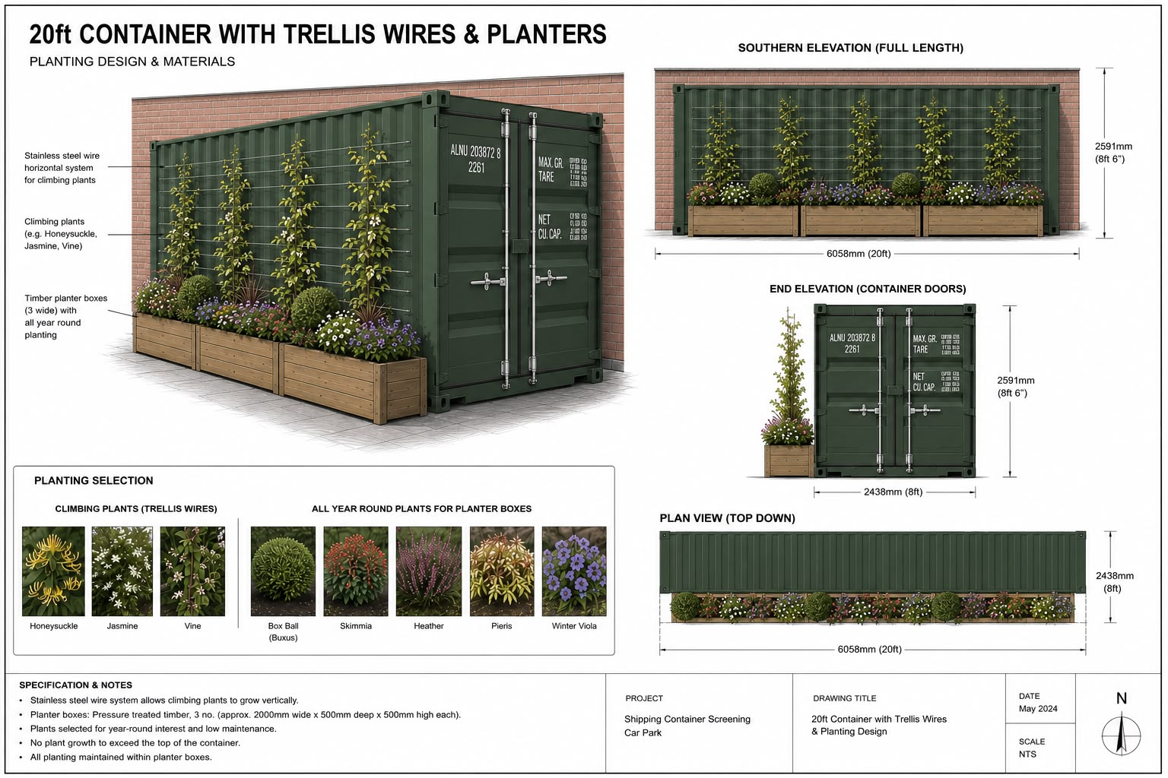

The image above sets out the proposed landscaping and screening arrangements.
The proposed scheme has been specifically designed to provide landscaped screening across the full southern elevation of the 20ft container.
The screening arrangement comprises:
- Three pressure-treated timber planter boxes, each approximately 2,000mm wide x 500mm deep x 500mm high, positioned along the full length of the southern elevation;
- Stainless-steel horizontal trellis wires fixed to the container to provide a suitable support system for climbing plants;
- Climbing planting, including species such as honeysuckle, jasmine and other suitable climbing vines, to provide vertical green screening to the container elevation;
- A range of year-round planting within the planter boxes, including box balls, Skimmia, heather, Pieris and winter violas, providing additional low-level screening and visual interest throughout the year.
The planting arrangement is intended to soften the appearance of the container and provide an appropriate landscaped treatment to its southern elevation. The planting will be contained within the proposed planter boxes and maintained to ensure that it remains healthy and effective as a screening measure. The maintenance of the plants will be undertaken primarily by the St Nicholas Church gardener, and members of the Burnage Foodbank Volunteer team will assist.
We will arrange for the landscaping scheme to be in place within the first week of the implementation of the container. The planting and associated trellis system will thereafter be retained and maintained, with failed or damaged planting replaced as necessary to ensure the continued effectiveness of the screening.

