

Planning

Delegated Officer Report

Summary of application details
Application reference: | PLA-2026-001308
Application type: | Lawful development: Proposed use
Proposal: | Proposed single-storey rear extension to existing semi detached property with flat roof and parapet wall.
Site address: | 4 College Drive Manchester M16 0AE
Ward(s): | Whalley Range
Date application valid: | 10 August 2026
Applicant name: | Ms Katherine O'Neill
Agent (if any): | Mr Ben Hall
Case officer: | Robert Tyrer

Recommendation:
Date of recommendation: | 01 October 2026

Description of site, building and/or area

Application site relates to a two-storey semi-detached dwellinghouse, located within a predominantly residential area.

Description of development

The applicant is seeking a certificate of proposed lawful development for a single-storey rear extension.

Relevant planning history
No previous planning applications

Consultation, notification and publicity responses
None Required - There is no statutory requirement to consult third parties including neighbours; views expressed by third parties on the planning merits of the case, or on whether the applicant has any private rights to carry out the operation, use or activity in question, are irrelevant when determining the application.

Legislative Issues

Sections 191 and 192 of the Town and Country Planning Act 1990 provide for anyone (not just a person with a legal interest in the land) to apply to the local planning authority (LPA) for a lawful development certificate (LDC). A certificate is a statutory document certifying:

(1) in the case of an application under section 191, the lawfulness, for planning purposes, of existing operations on, or use of land, or some activity being carried out in breach of a planning condition; or

(2) in the case of an application under section 192, the lawfulness of proposed operations on, or use of land.

The onus of proof in regard to (1) is firmly on the applicant and the issue of a certificate will depend on the on factual evidence provided about the history and planning status of the building or other land and the interpretation of any relevant planning law or judicial authority. The relevant test of the evidence in this matter is “the balance of probability” and the applicants own evidence does not need to be corroborated by independent evidence. If the LPA have no evidence to contradict the applicants version of events or make them less then probable, there is no good reason to refuse the issue of a certificate.

In regard to (2), this provides that, if the LPA are supplied with information satisfying them that the use or operations described in the application would be lawful, if instituted or begun at the time of the application, they shall issue a certificate to that effect; and, in any other case, they shall refuse the application.

In short, the purpose section 192 is to enable any person who wishes to find out whether any proposed use or operations would be lawful to apply to the LPA for that purpose

The application needs to describe the proposal with sufficient clarity and precision to enable the LPA to understand (from a written description and plans) exactly what is involved in the proposal; and to submit whatever supporting information or legal submission that are to be relied upon in order to satisfy the LPA that a certificate should be granted for the proposal.

In making their decision on an application under section 192, the LPA ask themselves the hypothetical question - "If this proposed change of use had already occurred, or if this proposed operation had commenced, on the application date, would it have been lawful for planning purposes?" In doing so, the LPA will not only consider whether the proposal would involve "development" requiring an application for planning permission, but whether it would involve a breach of any existing condition or limitation imposed on a grant of planning permission which has been acted upon, and which therefore constrains what can be done on the land. The LPA will not make a proposal fit a scenario; the only question is whether the proposal made by the applicant is lawful at the time of submission.

Assessment

This application is pursued under subsection (1) of section 192, which provides for an application to determine whether any proposed use of buildings or other land (s192(1)(a) or operations proposed to be carried out in, on, over or under land, (s192(1)(b) would be lawful for planning purposes.

The applicant states that the existing use falls under: “C3 – Dwellinghouses” and in response to the question “Why do you consider that a Lawful Development Certificate should be granted for this proposal?”, the applicant has responded with;

“Proposed single storey rear extension has been designed to meet all permitted development guidelines”

Legal Framework

The proposal will be considered under Schedule 2, Part 1, Class A of the Town and Country (General Permitted Development) Order 2015 (as amended), which is the relevant legislation for determining the enlargement, improvement, or other alterations to dwellinghouses.
Under Class A, "the enlargement, improvement, or other alterations of a dwellinghouse," the status of the original house needs to be taken into account, as this establishes the base from which all measurements should be taken. According to the Order, the term "original" means:
- In relation to a building existing on 1st July 1948, as existing on that date.
- In relation to a building built on or after 1st July 1948, as so built.

The Assessment
The following table outlines the compliance of the proposed development with the relevant paragraphs of Class A:
Paragraph | Development Not Permitted by Class A if: | Complies
A.1 (a) | Permission to use the dwellinghouse as a dwellinghouse has been granted only by virtue of Class G, M, MA, N, P, PA, or Q of Part 3 of this Schedule (changes of use). | N/A
A.1 (b) | As a result of the works, the total area of ground covered by buildings within the curtilage of the dwellinghouse (other than the original dwellinghouse) would exceed 50% of the total area of the curtilage (excluding the ground area of the original dwellinghouse). | Yes
A.1 (c) | The height of the part of the dwellinghouse enlarged, improved, or altered would exceed the height of the highest part of the roof of the existing dwellinghouse. | Yes
A.1 (d) | The height of the eaves of the part of the dwellinghouse enlarged, improved, or altered would exceed the height of the eaves of the existing dwellinghouse. | Yes
A.1 (e) | The enlarged part of the dwellinghouse would extend beyond a wall which:  - forms the principal elevation of the original dwellinghouse; or  - fronts a highway and forms a side elevation of the original dwellinghouse. | Yes
A.1 (f) | Subject to paragraph (g), the enlarged part of the dwellinghouse would have a single storey and:  - extend beyond the rear wall of the original dwellinghouse by more than 4 metres in the case of a detached dwellinghouse, or 3 metres in the case of any other dwellinghouse; or  - exceed 4 metres in height. | Yes
A.1 (g) | For a dwellinghouse not on article 2(3) land nor on a site of special scientific interest, the enlarged part of the dwellinghouse would have a single storey and:  - extend beyond the rear wall of the original dwellinghouse by more than 8 metres in the case of a detached dwellinghouse, or 6 metres in the case of any other dwellinghouse; or  - exceed 4 metres in height. | N/A
A.1 (h) | The enlarged part of the dwellinghouse would have more than a single storey and:  - extend beyond the rear wall of the original dwellinghouse by more than 3 metres; or  - be within 7 metres of any boundary of the curtilage of the dwellinghouse opposite the rear wall of the dwellinghouse. | N/A
A.1 (i) | The enlarged part of the dwellinghouse would be within 2 metres of the boundary of the curtilage of the dwellinghouse, and the height of the eaves of the enlarged part would exceed 3 metres. | Yes
A.1 (j) | The enlarged part of the dwellinghouse would extend beyond a wall forming a side elevation of the original dwellinghouse, and would:  - exceed 4 metres in height;  - have more than a single storey; or  - have a width greater than half the width of the original dwellinghouse. | No (iii)
A.1 (ja) | Any total enlargement (being the enlarged part together with any existing enlargement of the original dwellinghouse to which it will be joined) exceeds or would exceed the limits set out in sub-paragraphs (e) to (j). | N/A
A.1 (k) | It would consist of or include:  - the construction or provision of a verandah, balcony, or raised platform;  - the installation, alteration, or replacement of a microwave antenna;  - the installation, alteration, or replacement of a chimney, flue, or soil and vent pipe; or  - an alteration to any part of the roof of the dwellinghouse. | Yes
A.1 (l) | The dwellinghouse is built under Part 20 of this Schedule (construction of new dwellinghouses). | N/A
Additional Conditions for Article 2(3) Land
A.2(a) | It would consist of or include the cladding of any part of the exterior of the dwellinghouse with stone, artificial stone, pebble dash, render, timber, plastic, or tiles. | N/A
A.2 (b) | The enlarged part of the dwellinghouse would extend beyond a wall forming a side elevation of the original dwellinghouse | N/A
A.2 (c) | The enlarged part of the dwellinghouse would have more than a single storey and extend beyond the rear wall of the original dwellinghouse. | N/A
Conditions for Permitted Development
A.3(a) | The materials used in any exterior work (other than materials used in the construction of a conservatory) must be of a similar appearance to those used in the construction of the exterior of the existing dwellinghouse. | Yes
A.3(b) | Any upper-floor window located in a wall or roof slope forming a side elevation of the dwellinghouse must be:  - Obscure-glazed, and  - Non-opening unless the parts of the window which can be opened are more than 1.7 metres above the floor of the room in which the window is installed. | N/A
A.3(c) | Where the enlarged part of the dwellinghouse has more than a single storey, or forms an upper storey on an existing enlargement of the original dwellinghouse, the roof pitch of the enlarged part must, so far as practicable, be the same as the roof pitch of the original dwellinghouse. | N/A

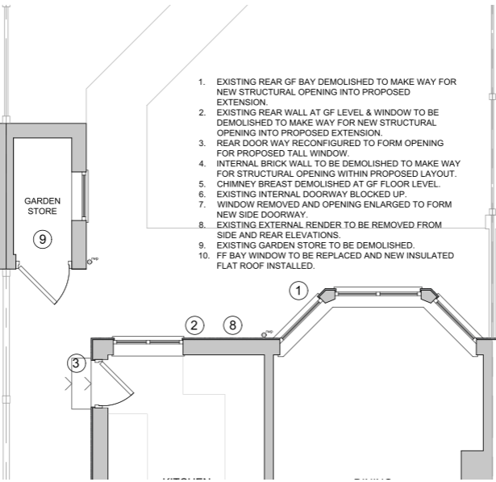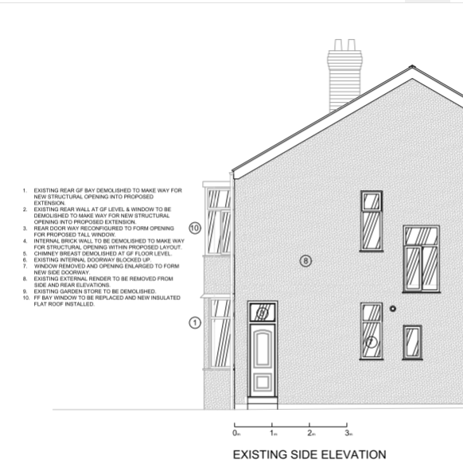
Image 1 Existing rear elevation of the property, illustrating the existing rear bay window.

Sub paragraph A.1 (j)(iii) states that development is not permitted if the enlarged part of the dwellinghouse would extend beyond a wall forming a side elevation of the original dwellinghouse and would have a width greater than half the width of the original dwellinghouse.

In this case, the applicant proposes a single-storey rear extension. The rear elevation, like the front elevation, incorporates a two-storey bay window. The submitted plans confirm that the ground-floor element of the rear bay window would be demolished to allow the construction of the extension, as indicated by the annotation accompanying point 1 on the existing floor plan and side elevation drawings.

The term “side elevation” is not defined in the Order, but it is stated within the Technical Guidance (“Permitted development rights for householders” September 2019) that a wall forming a side elevation is any wall that cannot be identified as being a front wall or a rear wall. It advises that ‘houses will often have more than two side elevation walls’. The Technical Guidance also provides an illustrative example of walls forming a side elevation, although this does not show the arrangement found at the application site. Nevertheless, this demonstrates that fairly narrow sections of wall can be regarded as a wall forming a side elevation for the purposes of A.2.(b).

In this instance, the angled elevation of the bay window cannot be said to be a rear wall even
though it is not entirely side facing.
Image 1 includes two orange lines and box added by the case officer to identify the walls that form side elevations of the original dwellinghouse. As the proposed extension would project beyond these side elevations and, at its widest point, would have a width exceeding half the width of the original dwellinghouse, the proposal fails to comply with the requirements of sub-paragraph A.1(j)(iii).

Other Legislative Requirements

Equality Act 2010
Section 149 (Public Sector Equality Duty) of the Equality Act 2010 requires due regard to the need to: Eliminate unlawful discrimination, harassment and victimisation and other conduct prohibited by the Act and; Advance equality of opportunity between persons who share a protected characteristic and persons who do not share it. The Equality Duty does not impose a legal requirement to conduct an Equality Impact Assessment. Compliance with the Equality Duty involves consciously thinking about the aims of the Equality Duty as part of the process of decision-making.

Human Rights Act 1998 considerations

This application needs to be considered against the provisions of the Human Rights Act 1998. Under Article 6, the applicants (and those third parties, including local residents, who have made representations) have a right to a fair hearing and to this end the local planning authority must give full consideration to their comments.

Protocol 1 Article 1, and Article 8 where appropriate, confer(s) a right of respect for a person’s home, other land and business assets. In taking account of all material considerations, including Council policy as set out in the Core Strategy and saved polices of the Unitary Development Plan, the Director of Planning, Building Control & Licensing has concluded that some rights conferred by these articles on the applicant(s)/objector(s)/resident(s) and other occupiers and owners of nearby land that might be affected may be interfered with but that that interference is in accordance with the law and justified by being in the public interest and on the basis of the planning merits of the development proposal. She believes that any restriction on these rights posed by the recommendation given is proportionate to the wider benefits of and that such a decision falls within the margin of discretion afforded to the Council under the Town and Country Planning Acts.

Conclusion

The proposed single storey rear extension does not meet the requirements of Schedule 2, Part 1, Class A the Town and Country (General Permitted Development) Order 2015 (as amended), specifically sub-paragraph A.1(j)(iii) because it would extend beyond a side elevation wall of the original dwellinghouse and have a width greater than half the width of the dwellinghouse. The certificate is therefore recommended for refusal.

Recommendation: Refuse

The proposed single-storey rear extension, as detailed on drawings PRP_1, PRP_2, PRP_3, PRP_4 and PRP_5, does not constitute permitted development because it would extend beyond a wall forming a side elevation of the original dwellinghouse and would have a width greater than half the width of the dwellinghouse, and therefore fails to comply with Schedule 2, Part 1, Class A, sub-paragraph (j) of the Town and Country (General Permitted Development) Order 2015 (as amended).

