

Planning

Delegated Officer Report

Summary of application details
Application reference: | PLA-2026-001362
Application type: | Householder planning permission
Proposal: | Retrospective consent sought for replacement single-storey side garage.
Site address: | 3 Slaithwaite Drive Manchester M11 4BA
Ward(s): | Clayton & Openshaw
Date application valid: | 17 August 2026
Applicant name: | Iyashi Housing Limited
Agent (if any): | Mr Sam Iqbal
Case officer: | Katie Raw
Recommendation: | Approve
Date of recommendation: | 8 October 2026

Description of site, building and/or area
The application site relates to 3 Slaithwaite Drive within the east Manchester ward of Clayton & Openshaw. The application property comprises a two storey house with a pitched roof set between gable elevations. The elevations predominantly comprise red/orange brickwork with white render above. The southern elevation is adjoined by a single storey garage subject to this application and a conservatory extends from the rear extension adjacent to the northern site boundary. The rear garden is substantially larger than neighbouring gardens. The front garden is hard surfaced and provides off street car parking accessed from Slaithwaite Drive.

As confirmed during the course of the application, the established use of the property is a C3b use. Such use does not require the benefit of change of use planning consent given it remains within the C3 dwellinghouses use class.

The applicant site sits within the cul-de-sac of Slaithwaite Drive comprising of similar dwellinghouses and open space to the north subject to previous planning applications (see planning history for further details). The immediate context is residential in nature.

Description of development
The current application seeks retrospective consent for replacement single-storey side garage (see Figure 1).

During the course of the application, the agent confirmed the proposed garage outbuilding conversion is ancillary to the residential use: it holds residents' records and supplies and provides a workspace for the service manager and for staff during the shift. It is not used for
any wider business purpose.

Discrepancies within the submitted drawings were amended during the course of the application.

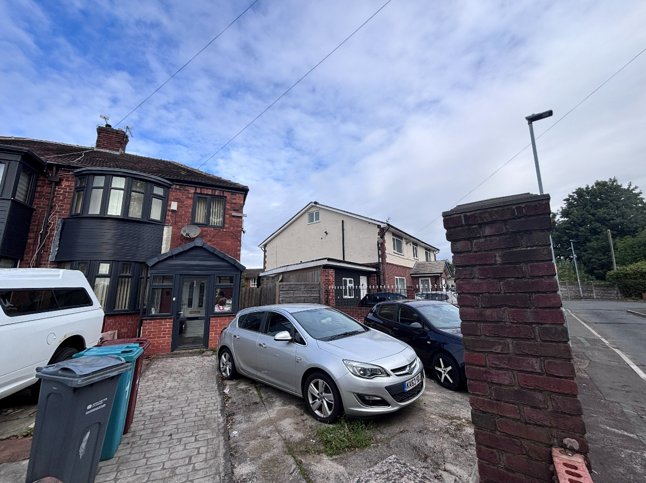
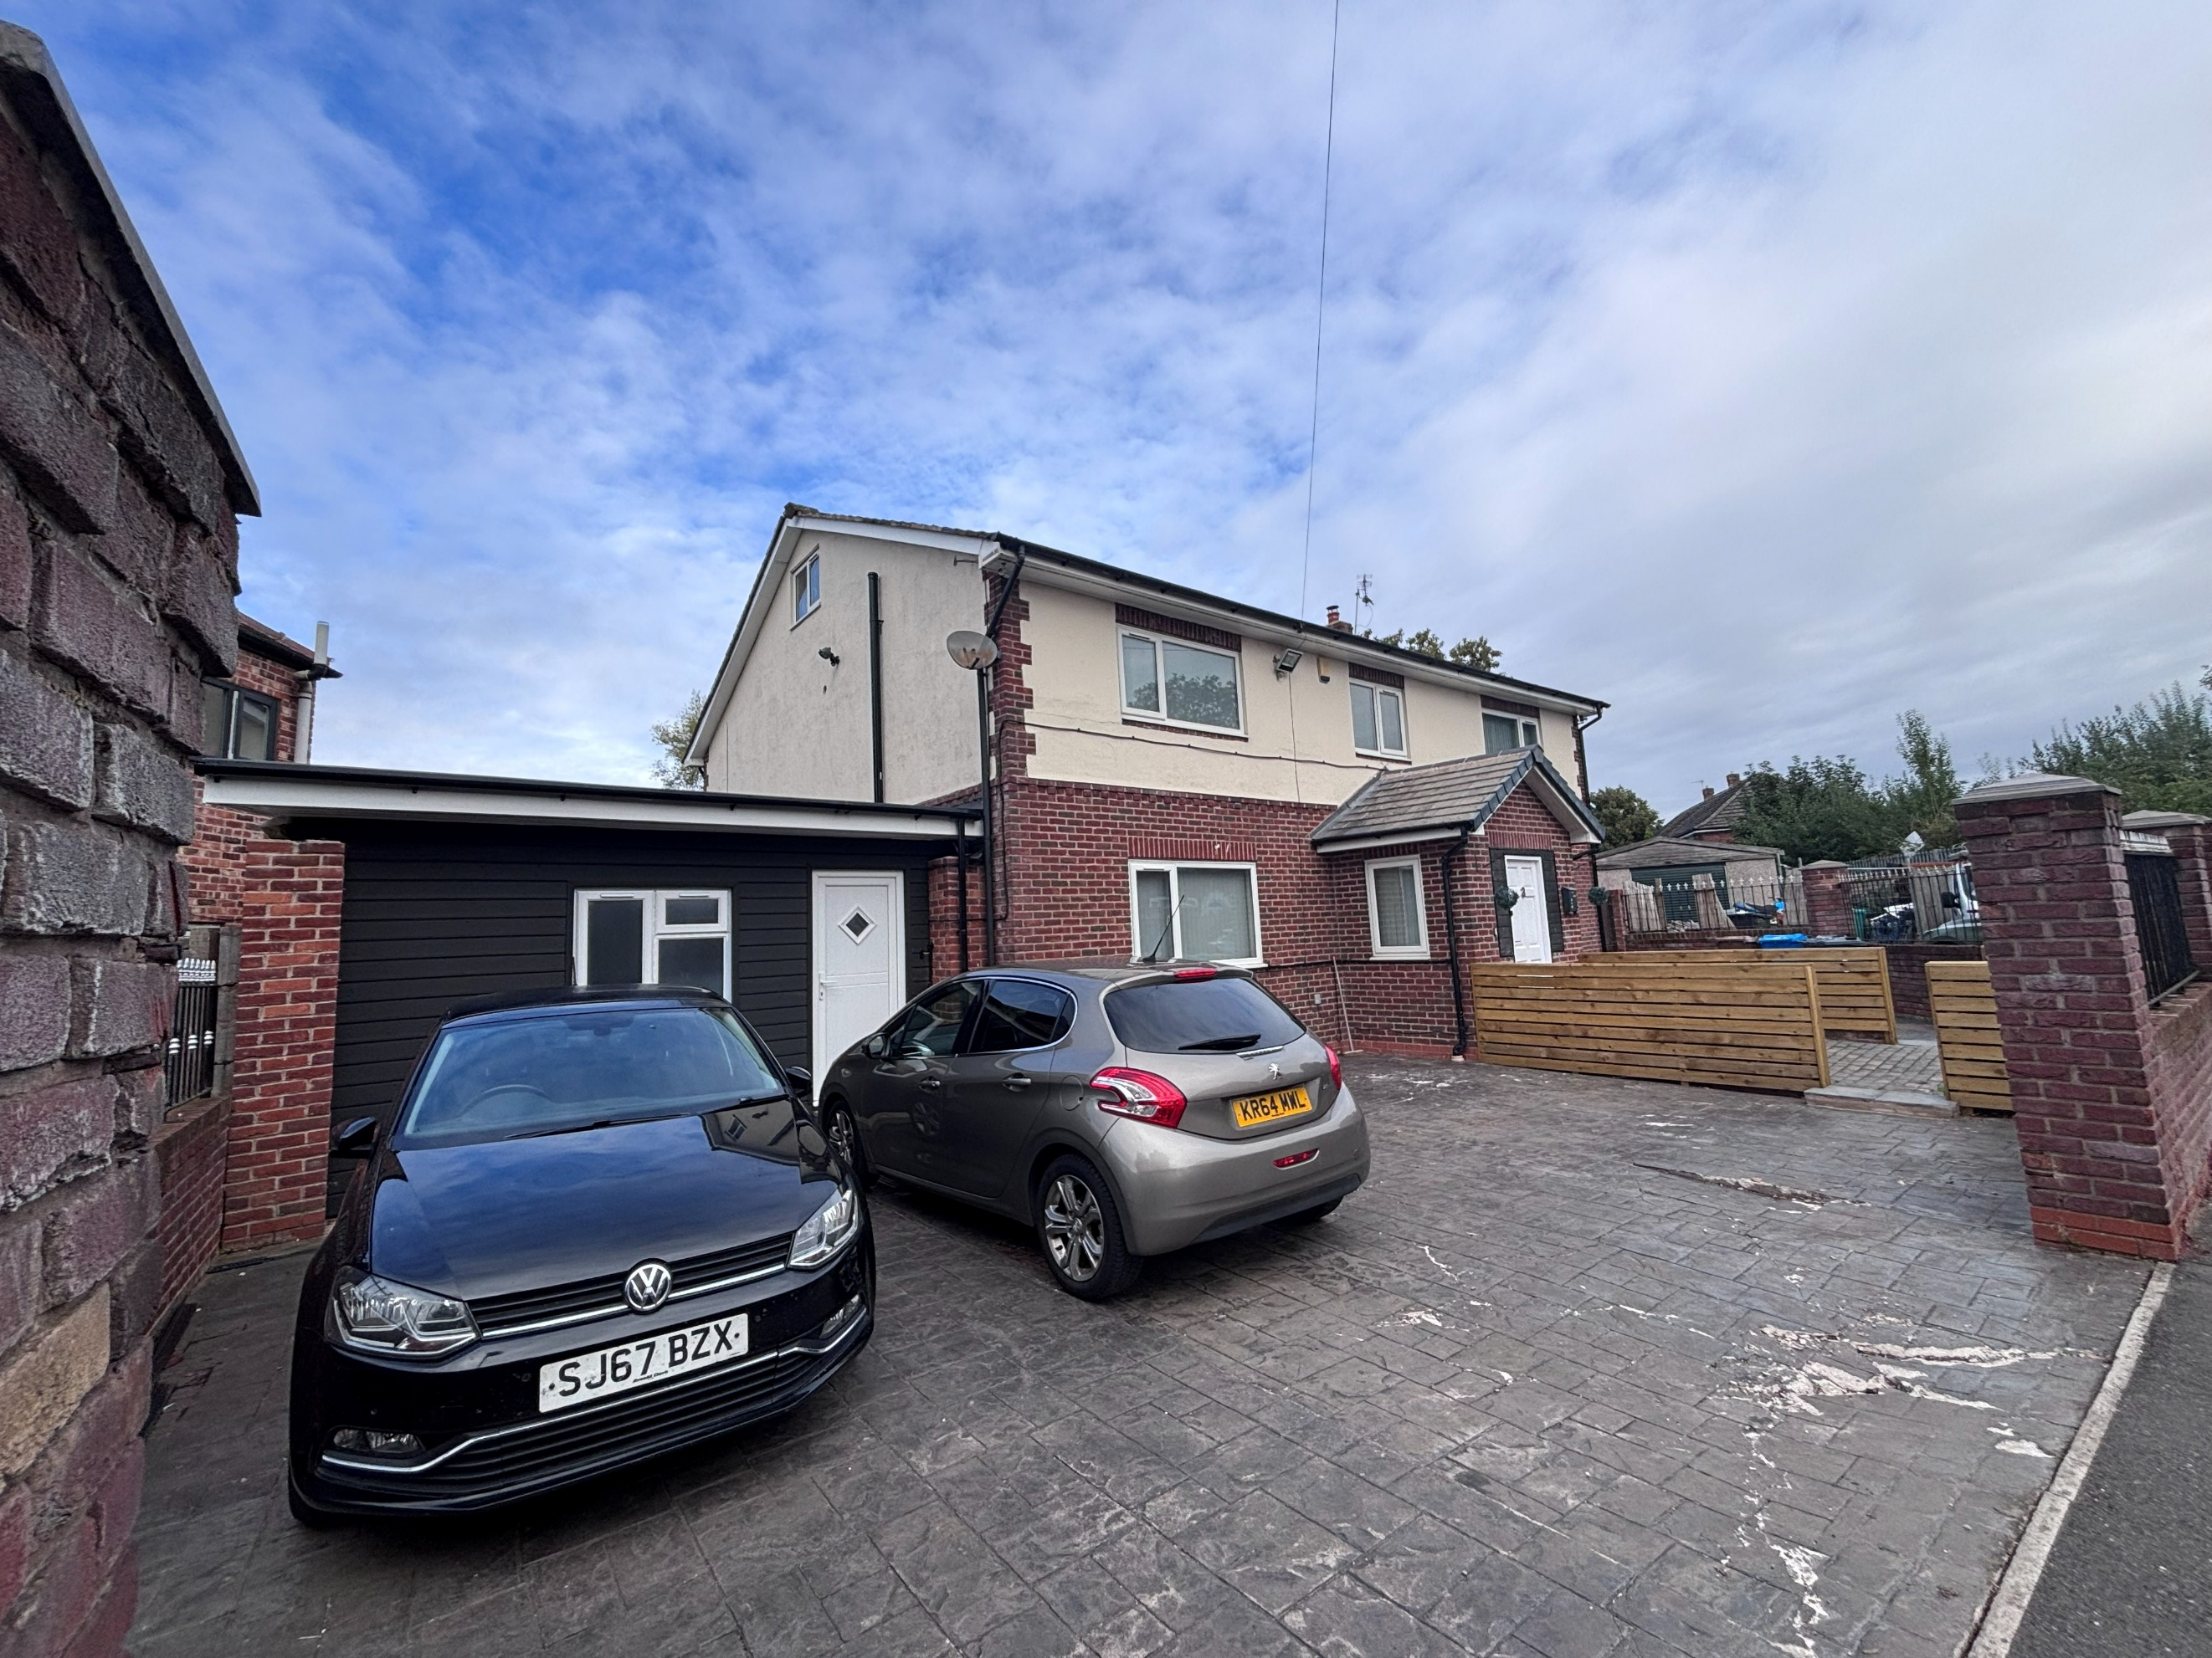

Figure 1. Garage structure to be retained as seen on site

Relevant planning history
Applicant site:
141840/FO/2025- Conversion of property to form 2 semi detached dwellinghouses (Class C3) together with associated elevational alterations and parking.
Approved 19 March 2025.
*It appears as though such permission has not been implemented.

Adjacent to applicant site:
136702/FO/2023- Land Adjacent To 3 Slaithwaite Drive, Manchester, M11 4BA- Erection of pair of two storey, semi-detached dwellinghouses (Class C3).
Approved 2 February 2024.

Consultation, notification and publicity responses

Consultations
No consultees were required for this application.

Notifications and publicity
No responses were received from the neighbour notification process.

Relevant policies
The National Planning Policy Framework (August 2026)

The document sets out the Government's Planning Policies for England and how these are
expected to be applied.

The purpose of the planning system is to contribute to the achievement of sustainable development, by managing the use and development of land in the long-term public interest.

Achieving sustainable development means that the planning system has three overarching objectives in providing for the homes, commercial development, facilities and infrastructure which society needs. These objectives are interdependent and need to be pursued in mutually supportive ways (so that opportunities can be taken to secure net gains across all three):
a) an economic objective
b) a social objective and
c) an environmental objective.

The following specific policies are considered to be particularly relevant to the proposed
development:
Chapter 3- Decision-making policies- The objective of the policies in this chapter is to ensure that development proposals are informed by appropriate information and decided in a way which is proportionate, timely and effective. This chapter provides a set of general decision-making policies which should be read with the rest of the thematic policies in the other chapters.
>Policy DM3: Determining development proposals
>Policy DM6: Use of planning conditions and obligations

Chapter 4- Achieving sustainable development- The objective of the policies in this chapter is to meet development needs through sustainable patterns of development, including by maximising the potential for growth on suitable land within settlements, enabling development which will support the rural economy, rural communities and the provision of infrastructure, and limiting development away from settlements to help safeguard the intrinsic character and beauty of the countryside.
>Policy S3: Presumption in favour of sustainable development

Chapter 14 - Achieving well-designed places- The objective of the policies in this chapter is to promote high quality, healthy, inclusive and sustainable places, through setting clear expectations about design outcomes and the use of relevant tools and processes.
>Policy DP1: Achieving Well-Designed Places
>Policy DP2: Designing in Context
>Policy DP3: Key principles for well-designed places
>Policy DP4: The design process

The Manchester Core Strategy Development Plan Document 2012-2027 ("the Core Strategy")
was adopted by the City Council on 11th July 2012, updated March 2024 following adoption of Places for Everyone Joint Development Plan

The Core Strategy is the key document in Manchester's Local Development Framework. It
replaces significant elements of the Unitary Development Plan (UDP) as the document that sets
out the long term strategic planning policies for Manchester's future development. Of relevance
are:
Policy DM1 (Development Management);
Policy SP1 (Spatial Principles) (partially superseded by PfE);
Policy EN1 (Design Principles and Strategic Character Areas).

Unitary Development Plan Saved Policies

Large elements of the UDP have been superseded by the Core Strategy. The following saved
policies are of relevance in the consideration of this application:

DC1. Residential Extensions
DC1.1 states that in determining planning applications for extensions to residential properties,
the Council will have regard to:
a. The general character of the property;
b. The effect upon the amenity of the neighbouring occupiers;
c. The desirability of enabling people to adapt their houses in appropriate ways to meet
changing household needs;
d. The overall appearance of the proposal in the a street scene;
e. The effect of the loss of any on-site car parking.

DC1.2 states that extensions to residential properties will be allowed subject to compliance with
other relevant policies of the Plan and the following criteria:
a. They are not excessively large or bulky (for example resulting in structures which are not
subservient to original houses or project out too far in front of original buildings);
b. They do not create undue loss of sunlight, daylight or privacy;
c. They are not out of character with the style of development in the area or the surrounding
scene by virtue of design, use of materials or construction details.
d. they would not result in the loss of off-street car-parking, in a situation where there is so
severe an existing on-street parking problem that unacceptable additional pressures would be
created.

DC1.3 Notwithstanding the generality of the above policies, the Council will not normally
approve:
a. rearward extensions greater than 3.65m (12 ft) in length;
b. 2-storey extensions with a flat roof, particularly those which would be visible from the public
highway;
c. 2-storey extensions to terraced properties which occupy the full width of the house;
d. flat roofed extensions to bungalows;
e. extensions which conflict with the Council's guidelines on privacy distances (which are
published as supplementary guidance).

DC1.6 For the avoidance of doubt, policies DC1.1 to DC1.4 apply to domestic houses, flats,
houses in multiple occupation, nursing homes, rest homes and hotels.

Guide to Development in Manchester Supplementary Planning Document and Planning
Guidance, Adopted April 2007.

The Guide aims to help to develop and enhance a unique and positive sense of place within
Manchester and its neighbourhoods. The guidance is grouped under seven key principles
recognised by CABE as being those urban design characteristics which create successful
places. These are: character and context, continuity and enclosure, ease of movement, quality
of the public realm, diversity, legibility, and adaptability. It advises that high quality design is a
vital attribute of successful neighbourhoods.

Manchester Residential Quality Guidance (2017)

This guidance provides clear direction on what is required to deliver sustainable neighbourhoods of choice where people will want to live and also raise the quality of life across Manchester.

Places for Everyone (2022-2039)

Places for Everyone is a long-term plan of nine Greater Manchester districts for jobs, new
homes, and sustainable growth. It has been published by the GMCA on behalf of the nine
districts and took effect and became part of the statutory development plan on March 21, 2024.
The Plan and its policies are now a material planning consideration in the determination of
planning applications. The Plan and its policies must therefore be given full weight in the
planning balance.

The following policies are relevant:
JP- S1- Sustainable development.

Assessment
Principle of Development

The submitted application seeks retrospective consent for replacement single-storey side garage. During the course of the application, the agent confirmed the existing use of the property was a C3b use and so does not require a change of use application for the house to operate where care is provided for the residents. The side garage subject to this application consists of an office to support the use of the main dwelling. The office holds residents' records and supplies and provides a workspace for the service manager and for staff during the shift. It is not used for any wider business purpose. On the basis the use C3b is considered to sit within C3 dwellinghouses, it is considered the application can still be dealt with as a householder application. On the basis the use is established (by not requiring planning permission), the principle of development to retain the supporting office space is considered acceptable. Discrepancies across the drawings were identified and amended with the supply of revised drawings. However, consideration must be given to the proposal's appearance, impact on the visual amenity of the area and impact on the neighbouring properties' residential amenity.

Residential Amenity

A garage structure has been a character of the applicant site as far back as at least July 2008. The garage structure seen on site was constructed/ altered some time after May 2025.

The garage sits against the shared boundary and side amenity space connected with no.1 Slaithwaite Drive. Given the positioning of such structure and the height of the garage of 3 metres at the largest point, the structure would not give rise to any adverse overbearing implications or loss of light implications.

A window is inserted in the primary elevation of the proposal facing in the direction of the streetscene. Given the window would come no closer than the primary building line of the main dwellinghouse, no implications would be caused in respect of overlooking to the surrounding properties.

The garage is used as an office space to support the class C3B use. To ensure it is only used in a manner consistent to the C3 use, a condition to this effect would be attached to any approval granted to mitigate any adverse residential amenity implications.

The proposal is considered pursuant to the City Council’s Planning Policies SP1 and DM1 of the Manchester Core Strategy (2012), saved policy DC1 of the Unitary Development Plan for the City of Manchester (1995), the Guide to Development in Manchester SPD and the National Planning Policy Framework, on the grounds of residential amenity.

Visual Amenity

The structure is constructed of black composite cladding to the front and rear, with supporting red brick piers, and a mix of materials to the side. Whilst the introduction of black composite panels would be out of keeping with the materiality of the main dwelling, the previous garage consisted of a black garage door and so the contrasting colouration has been established within the streetscene. Given this, the use of the materials seen on site would not be so harmful to warrant a refusal on the scheme.

On balance, the proposal is pursuant to the City Council’s Planning Policies SP1 and DM1 of
the Manchester Core Strategy (2012), saved policy DC1 of the Unitary Development Plan for
the City of Manchester (1995), the Guide to Development in Manchester SPD and the National
Planning Policy Framework, in relation to visual amenity.

Siting, Scale, Massing, Design and Appearance

The side extension replaces the existing on the site and has a height at the largest point of 3 metres, a varying width and a length shorter than the length of the main dwelling (7.4 metres). As such, it is considered to represent a subservient feature to the dwellinghouse and so considered acceptable in respect of siting and scale.

As such, the proposed design and scale of the proposal is considered pursuant in regard to the resultant appearance and so would be considered pursuant to Policy DC1 of the UDP and Core Strategy policies SP1 and EN1.

Off Street Parking

The alterations to the previous garage has resulted in the loss of enclosed off street parking. However, the site still benefits from two off street parking spaces as a minimum and so no concern is raised in respect of the built up of on street parking.

Bin Storage

No change to bin storage provisions would occur as a result of the proposal.

Other Legislative Requirements

Equality Act 2010
Section 149 (Public Sector Equality Duty) of the Equality Act 2010 requires due regard to the need to: Eliminate unlawful discrimination, harassment and victimisation and other conduct prohibited by the Act and; Advance equality of opportunity between persons who share a protected characteristic and persons who do not share it. The Equality Duty does not impose a legal requirement to conduct an Equality Impact Assessment. Compliance with the Equality Duty involves consciously thinking about the aims of the Equality Duty as part of the process of decision-making.

Human Rights Act 1998 considerations
This application needs to be considered against the provisions of the Human Rights Act 1998. Under Article 6, the applicants (and those third parties, including local residents, who have made representations) have a right to a fair hearing and to this end the local planning authority must give full consideration to their comments.

Protocol 1 Article 1, and Article 8 where appropriate, confer(s) a right of respect for a person’s home, other land and business assets. In taking account of all material considerations, including Council policy as set out in the Core Strategy and saved polices of the Unitary Development Plan, the Director of Planning, Building Control & Licensing has concluded that some rights conferred by these articles on the applicant(s)/objector(s)/resident(s) and other occupiers and owners of nearby land that might be affected may be interfered with but that that interference is in accordance with the law and justified by being in the public interest and on the basis of the planning merits of the development proposal. She believes that any restriction on these rights posed by the recommendation given is proportionate to the wider benefits of and that such a decision falls within the margin of discretion afforded to the Council under the Town and Country Planning Acts.

Article 35 Declaration
The proposal was assessed with regards to policies outlined in the National Planning Policy Framework, Unitary Development Plan Saved Policies, Local Development Framework Core Strategy Development Plan and other material considerations. In this instance officers have worked with the applicant in a positive and proactive manner, guided the applicant through issues arising with the application and appropriate conditions have been attached to the approval granted.

Recommendation: Approve

