

Planning

Delegated Officer Report

Summary of application details
Application reference: | PLA-2026-001402
Application type: | Full planning permission
Proposal: | Change of use of the existing 5-bedroom dwellinghouse (Use Class C3) to a 4-bedroom House in Multiple Occupation (HMO) (Use Class C4).
Site address: | 12 Billing Avenue Manchester M12 6EZ
Ward(s): | Ardwick
Date application valid: | 20 August 2026
Applicant name: | Mr Hanjiang Lin
Agent (if any): | Mr Lawrence Lui
Case officer: | Carl Glennon
Recommendation: | Refuse
Date of recommendation: | 6 October 2026

Description of site, building and/or area

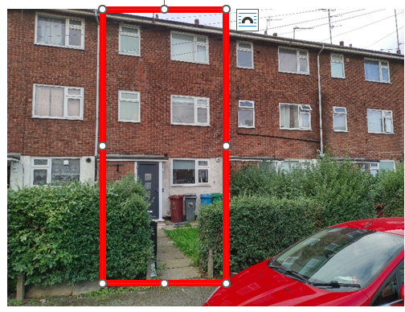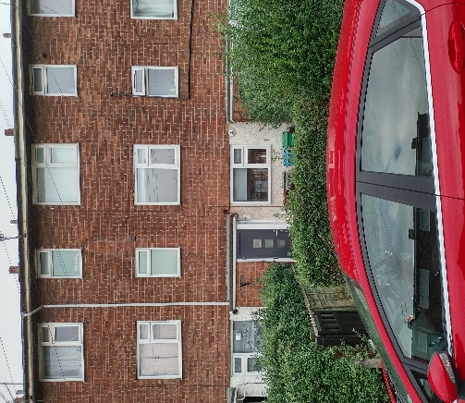
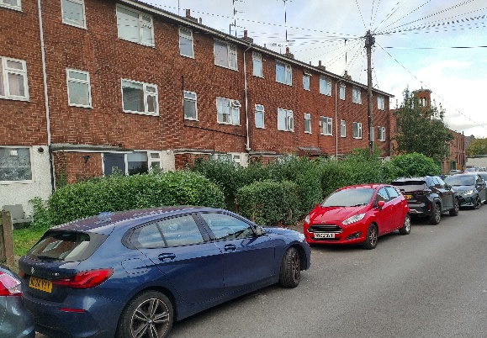

Fig.1 – Views of the application property (outlined in red)

The application property is in a residential location and centrally positioned in a three storey terrace of houses. The property is located on the southside of Billing Avenue. The property has a front and rear garden but does not benefit from in curtilage car parking. The property comprises of brown brickwork with a grey tiled roof and windows with white uPVC frames. A porch a flat roof canopy projects from the principal elevation. There is notable on-street car parking on the adjacent street.

Description of development
The proposed development would involve the reconfiguration of the internal layout to allow the formation of:

i. Ground floor – Communal kitchen and dining area.
ii. First and second floor – Two bedrooms with en-suite bathroom to each floor.

The existing arrangement of external doors and windows would be maintained. Arrangements for waste and recycling bin storage have not been identified.

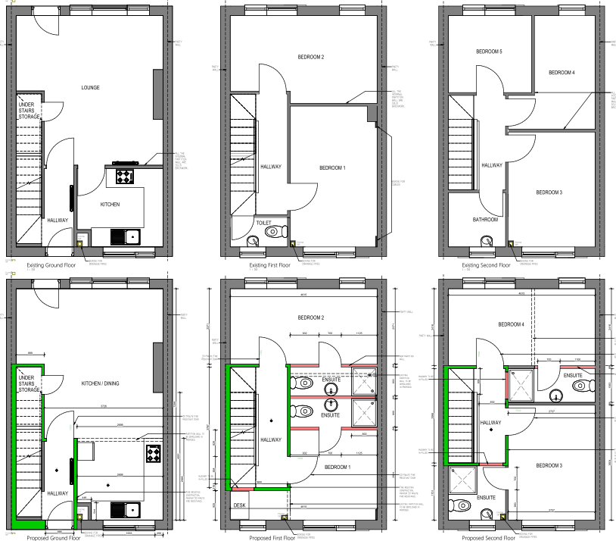

Fig.2 – Existing & proposed layout

Relevant planning history
No history of previous applications.

Consultation, notification and publicity responses

Consultations

Local residents - No comments received.

Environmental Heath - If planning permission is granted, a condition is recommended requiring approval and implementation of waste and recycling management scheme.

Notifications and publicity

Local and other required consultation was undertaken. A press and site notice was not required.

Relevant policies
National Planning Policy Framework (NPPF- August 2026)

The NPPF sets out the government’s policies for plan making and for making decisions on development proposals in England. It is a material consideration of critical importance in both contexts. This version replaces the previous NPPF published in December 2024.

Paragraph 17 States that . Achieving sustainable development means that the planning system has three overarching objectives in providing for the homes, commercial development, facilities and infrastructure which society needs. These objectives are:
a. An economic objective
b. A social objective
c. An environmental objective.

The proposal would deliver a sustainable development and would accord with the above objectives.

Chapter 3. Decision-making policies

Policy DM3: Determining development proposals – Sets out the considerations of the LPA when determining development proposals. The assessment of the development accords with these requirements.

Chapter 4. Achieving sustainable development

Policy S3: Presumption in favour of sustainable development – The development would result in the loss of accommodation and its contribution towards the maintenance of a sustainable community. The development also has the potential to harm residential amenity and the character of the area (for the reason outlined in this report).

Chapter 14. Achieving well-designed places

Policy DP3: Key principles for well-designed places - States that development should respond to its context and create well-designed places. The development would relate satisfactorily to the application. Matching materials would be used. Policy DP3 would thereby be accorded with.

Chapter 17. Pollution, public protection and security

Policy P2: Ground Conditions – No historic ground conditions, that may affect the development, have been identified. Ground works are not proposed.

Policy P3: Living conditions and pollution – The development would produce an intensity of occupation that would adversely affect the character and amenities of the area. The site has the capacity to accommodate bin storage.

Chapter 18. Managing flood risk and coastal change

Policy F4: Assessing flood risk for decision-making - The application site is in Flood Zone1and is not affected by surface water flooding.

Planning Practice Guidance - On 6 March 2014 the Department for Communities and Local Government (DCLG) launched this planning practice guidance web-based resource. The PPG seeks to both simplify and clarify planning guidance easier and simpler. It is intended to be read in conjunction with the National Planning Policy Framework (NPPF) and is relevant to key planning issues of significance to applicants and local authorities. In considering this application consideration has been given to the following aspects of the PPG:

i. Consultation and pre-decision matters;
ii. Health and well-being;
iii. Noise.

It is not considered that the development would accord with points (ii) and (iii) for the reasons set out in this report.

Sustainable Development Joint Development Plan Document - Places for Everyone (2022-2039)

Policy JP-C6: Walking and Cycling - Discusses measures required to deliver a higher proportion of journeys made by walking and cycling. The site has the capacity for the provision of limited cycle storage, which would potentially encourage the adoption of a sustainable transport mode.

Policy JP-P6 - Health - States that development should maximise its positive contribution to health and wellbeing, whilst avoiding any potential negative impacts of new development. It is considered that the development would result in an overly intensive use of the site. It would thereby generate levels of activity, noise and disturbance that would be harmful to the character and amenities of the area. Policy JP-P6 would not thereby be accorded with.

Policy JP-S1 - Sustainable development - States that, to address climate change, development should aim to maximise its economic, social and environmental benefits simultaneously, minimise its adverse impacts, utilise sustainable construction techniques and actively seek opportunities to secure net gains across each of the different objectives. Whilst some improvements would be made to the quality of the accommodation, the harm caused by the proposed intensity of occupation would not encourage sustained future occupation. Policy JP-S1 would not, therefore, be accorded with.

Manchester's Local Development Framework: Core Strategy

Policy SP 1 (Spatial Principles) - Specifies the Core Development Principles for parts of the City. In this case the relevant principles relate to the extent to which the development:

a. Makes a positive contribution to neighbourhoods of choice through: the creation of well designed places that enhance or create character; making a positive contribution to the health, safety and well-being of residents and responding to the diverse needs of all members of the community and the protection and enhancement of the built and natural environment;
b. Minimises emissions, ensures efficient use of natural resources and reuses previously developed land wherever possible;
c. Improves access to jobs, services, education and open space whilst reducing the need to travel and securing good access to sustainable transport provision.

For the reasons, set out in this report it is not considered that the development would accord with policy SP1, particularly regarding the impact of the intensified use of the application property. It is also considered that the related excessive noise and activity would be harmful to residential amenity and discourage the sustained occupation of the application property.

Policy EN19 Waste - Relates to waste management and requires that consideration is given to consideration of the submitted details relating to the applicant's proposals for the provision of a waste management plan to demonstrate how:

i. Both construction and demolition waste will be minimised and recycled on site wherever possible;
ii. How the sustainable waste management needs of the end user will be met.

Although not identified as part of the proposal, it is considered that site has the capacity to achieve satisfactory waste and recycling storage and collection in accordance with policy EN19.

Policy H1 (Overall Housing Provision) - Discusses the need to manage the supply and availability of housing in the city. It also the need to ensure that housing supply contributes to creating mixed communities by providing house types to meet the needs of a diverse and growing Manchester population. The development would conflict with policy H1 by reducing the supply of much needed family housing in the city.

Policy H5 (Central Manchester) - States, amongst other things, that over the lifetime of the Core Strategy, the area will accommodate around 14% of new residential development. Priority will be given to family housing and other high value, high quality development where this can be sustained. The development would undermine these objectives.

Policy H11 Houses in Multiple Occupation - In addition to Manchester's Article 4 Direction that prevents change of use from Class C3 (Dwelling houses) to C4 (small-scale HMOs) and requires that such proposals rear considered through the submission of a planning application.

The application property does not appear to be in a location with a significant number of HMO uses. However, policy H11 requires consideration of harm potentially caused by the loss of accommodation suitable for family occupation. This harm includes the undermining of the sustainability of the neighbouring community. Furthermore, policy H11 states that change of use from Class C3 to HMO uses would only be permitted where there is no reasonable demand for the existing use. Such justification has not been provided in this case and its appears that the application property has the capacity to continue to operate for Class C3 purposes. The development would thereby be contrary to policy H11.

Policy T1 Sustainable Transport - Relates to the delivery of sustainable, high quality, integrated transport system, which encourages a modal shift away from car travel to public transport, cycling and walking and prepare for carbon free modes of transport.

The application site is in an area with notable on-street car parking attributable to neighbouring residential uses and visitors to the district centre. The proposal has not identified the provision of secure cycle storage. The site is accessible via public transport, and the site is within walking distance of the city centre. However, given the intensity of occupation, the development has the potential to introduce higher levels of the car ownership compared to occupation by a single household. The objective of reducing the negative impacts of traffic generation required by policy T1 would not, therefore, be delivered.

Policy DM1 Development Management - Discusses a range of issues that all development should have regard to. The development fails to accord with policy DM1 as it would:

i. Adversely impact upon on the residential character of the area;
ii. Harm to the amenities of future and neighbouring residents. This harm would be attributable to additional noise, disturbance and activity associated with the development.
iv. Have the potential increase demand for on street car parking. This would be particularly harmful to the amenity of the area, as there is a noticeable incidence of on-street car parking and traffic congestion.

Unitary Development Plan saved policies - The following policy are relevant:

DC26 - Development and Noise

Policy DC26.1 - The Council intends to use the development control process to reduce the impact of noise. In this case the increased intensity of occupation has the potential to produce additional noise, disturbance and activity in and around the application property due to. The resulting harm to residential amenity would be contrary to saved policy DC26.

Assessment
Principle of the development – The City Council recognises the valuable contribution that well managed HMOs can make to the provision of affordable housing but stresses the importance of careful siting to avoid negative impacts on residential amenity. It is acknowledged that the intensity of use associated with unrelated households living together, different lifestyles and different patterns of behaviour can cause frequent comings and goings with associated noise and disturbance. It is considered that HMOs tend to attract people who will live in the property for a comparatively short period of time and consequently they do not have the same interest in the well-being of an area as those who are less transient. It is believed that this cyclical change in occupiers has a negative impact on the character and appearance of the area

The applicant has not been provided evidence that the application property has been previously actively and unsuccessfully marketed for Class C3 occupation at a price Class C4 rather than Class C3 properties in the area, i.e., a price that would not deter potential purchasers seeking a family home. The property appears to be in a reasonable condition. The applicant has not provided any evidence to indicate that the condition of the property would be an obstacle to its continued Class C3 occupation.

In these circumstances, it is not considered that the applicant has demonstrated that the use of the property for Class C3 purposes is no longer viable. The development would, however, reduce the supply of family housing suitable for family occupation. The principle of the development is therefore unacceptable.

Demand for Class C3 dwellinghouses – The LPA has made referenced social housing allocations information provided by Manchester Move, which is an organisation that advertises ready to rent homes provided by approximately 18 not-for-profit landlords via its website: The allocation of housing is related to need and categorised into the following bands:

Band 1 – Highest priority
Band 2 – High priority
Band 3 – Medium priority
Band 4 and Band 5 – Lower priority.

Reference has been made to [Manchester Move] data from August 2026. It is acknowledged that 730 and 2894 people are seeking 1 bedroom accommodation. However, data for August 2026 also indicates that:

i. 137 and 834 households are seeking 4 bed accommodation in Band 1 and Band 2.
ii. 34 and 186 household are seeking 5 bed accommodation in Band 1 and Band 2.

It is likely that there is a limited supply of rental homes for larger families in the city and, in these circumstances, the identified need is significant. There is concern that the conversion of large properties would reduce the supply of accommodation, for which, there is a specific need. Consequently, the retention of the application property for Class C3 occupation would be appropriate. As stated, the application has not been supported with evidence to demonstrate that there is no reasonable demand for the existing use. It therefore appears that the application property has the capacity to continue to operate for Class C3 purposes. Consequently, the retention of the application property for Class C3 occupation would be appropriate and beneficial to the character and amenities of the area.

Residential amenity – The development has the potential to intensify the occupation of the application property. It would thereby produce levels of activity, noise and disturbance that would depart from the characteristic occupation of houses in Billing Avenue and be harmful to the residential amenities of the area. The development would thereby be unacceptable.

Traffic generation and car parking – Billing Avenue is affected by significant on-street car parking generated by residential uses and potentially commuters. The shared occupation of the application property has the potential to generate higher levels of car ownership than would be usually associated with a single households. The existing adverse impacts of congestion and excessive vehicular movement would be exacerbated by the proposed increase in occupation of the application property (and related car ownership) to the detriment of residential amenity.

Waste management – The application property has the capacity to accommodate bin storage in the rear garden area.

Cycle storage - The applicant has not provided details of cycle storage within the rear garden. However, given the available space within the garden, some secure cycle storage could be potentially provided.

Other Legislative Requirements

Equality Act 2010
Section 149 (Public Sector Equality Duty) of the Equality Act 2010 requires due regard to the need to: Eliminate unlawful discrimination, harassment and victimisation and other conduct prohibited by the Act and; Advance equality of opportunity between persons who share a protected characteristic and persons who do not share it. The Equality Duty does not impose a legal requirement to conduct an Equality Impact Assessment. Compliance with the Equality Duty involves consciously thinking about the aims of the Equality Duty as part of the process of decision-making.

Human Rights Act 1998 considerations
This application needs to be considered against the provisions of the Human Rights Act 1998. Under Article 6, the applicants (and those third parties, including local residents, who have made representations) have a right to a fair hearing and to this end the local planning authority must give full consideration to their comments.

Protocol 1 Article 1, and Article 8 where appropriate, confer(s) a right of respect for a person’s home, other land and business assets. In taking account of all material considerations, including Council policy as set out in the Core Strategy and saved polices of the Unitary Development Plan, the Director of Planning, Building Control & Licensing has concluded that some rights conferred by these articles on the applicant(s)/objector(s)/resident(s) and other occupiers and owners of nearby land that might be affected may be interfered with but that that interference is in accordance with the law and justified by being in the public interest and on the basis of the planning merits of the development proposal. She believes that any restriction on these rights posed by the recommendation given is proportionate to the wider benefits of and that such a decision falls within the margin of discretion afforded to the Council under the Town and Country Planning Acts.

Conclusion
The Council maintains that the development would remove an opportunity to provide a much needed contribution to the supply of family accommodation in the city. The potential increase in the intensity of occupation of the property would result in additional levels of noise and activity in and around the site. The development would thereby be harmful to residential amenity. The potential levels of disturbance would also adversely affect the characters of the area and lead to an increase in cyclical changes to occupation. Such circumstances would the detrimental to the formation of a sustainable community. The proposed level of occupation would also potentially lead to increased traffic generation and demand for on-street car parking. The development would thereby be unacceptable.

Recommendation: Refuse

1) The proposed development would result in the loss of quality residential accommodation, which would reduce the supply and availability of family housing. The development would thereby fail to positively respond to an identified housing need and undermine the formation of cohesive and sustainable neighbourhoods where people would choose to live. The development would thereby be contrary to policies SP1, H1, H5 and DM1 of the Core Strategy for the City of Manchester.

2) The proposed development would result in an over intensive use of the application dwellinghouse and result in a consequential increase in the levels of noise and disturbance, activity and traffic generation through its occupation as a house in multiple occupation (HMO) with limited usable amenity space. Occupation as an HMO would undermine the formation of sustainable communities, have a detrimental impact upon the amenity of neighbouring residents and thereby be contrary to policies H11, DM1 and SP1 of the Core Strategy for the City of Manchester.

