William Kay House –University of Manchester
Methodology
1.Existing RH side stone wall sections
The existing curved top stone wall sections acting as the boundary between the adjoining Diocese property are to be retained and reset .They have historically acted as the railing base section with posts fixed into drilled holes and secured with lead .The old post and lead plugs still being visible .
The stones will be carefully lifted with aid of mechanical digger and suction lifting equipment and carefully stacked adjacent to the work area whilst ground levels are reset and the main structures formed.
They will be replaced and levelled in the same sequence they were removed utilizing the same equipment.
The joints will be re-pointed in a suitable mortar. Lime mortar has previously been approved for use in this scheme and in keeping with the heritage of the building.
These stones have been used as the template for the same size and style of stone to be used to form a new front elevation shallow wall and to take new railings.
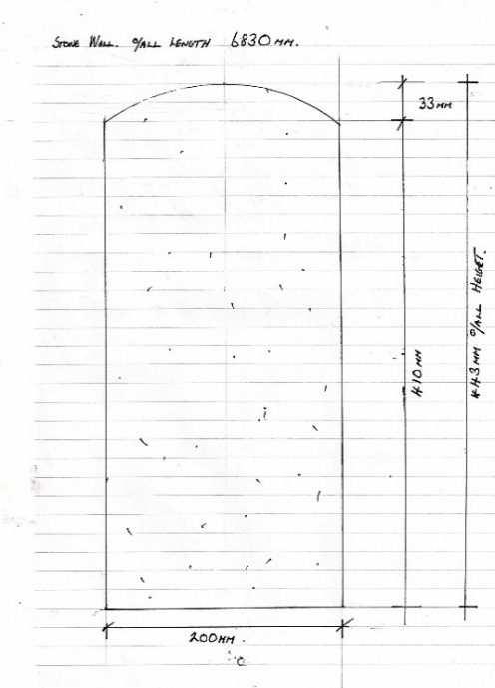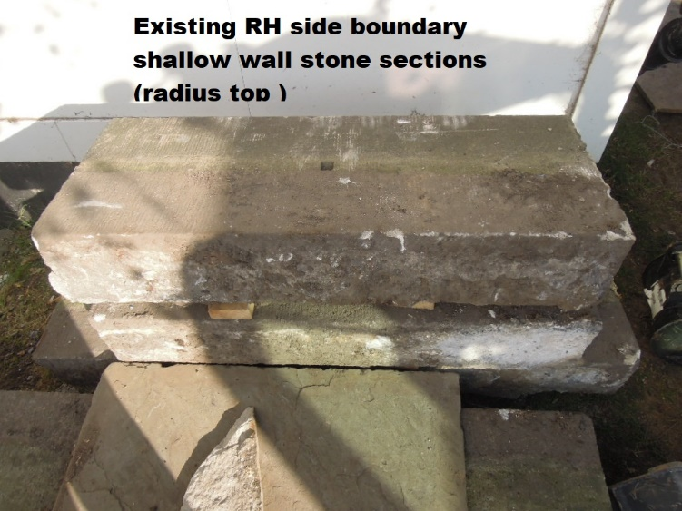

2.Existing Paving
The existing paving slabs are formed in a random pattern and have overtime become uneven.
They are a mix of thicknesses ,ranging from approximately 30mm /50mm to 70mm .
They have been historically repointed with various types of mortar.
The scheme requires the existing flags to be carefully lifted ( use of suction equipment and small machine excavators ).The flags will be carefully stacked whilst the new structures are formed and levels re-set ).
The existing flags will be re-laid in the same random pattern on to a new base with adjusted levels (Eg to afford DDA compliant access ). With a repeat of the same protective lifting/placing methods /machinery .Cuts and adjustments to be kept to a minimum with no new stone intended to be laid alongside existing flags .
An existing concrete pin kerb that formed a perimeter to a shrub area is to be replaced with a new natural stone edging kerb as required by MCC Planning.
Flags to be re-pointed with a suitable lime mortar.
