William Kay House –University of Manchester
Stair Protection Methodology
1.RH Side Front entrance steps
Prior to works commencing photos of the existing condition of the front step is documented. Please see appended to this document
The Existing stone steps to this Entrance are understood to be the original stone steps. Over time they appear to have had significant wear and have historically been covered with a protective coating of asphalt. This is still existing and overs a significant layer of protection.
The planned works to the front entrance incorporate the addition of a cantilevered beam and block support structure to cover /conceal this step area and create a new stone step access with an integrated Disabled Platform lift. The cantilevered element ensures minimal load bearing on the original stone steps.
The beam and block arrangement has been designed to impose minimal loadings on the existing stone steps and to leave the current step structure at the entrance uninterrupted with no fixings or alterations, to the extent that if the new structures were removed the current existing steps would be retained as found.
The addition of a hi-load DPM covering of the entire steps overlaid on the existing asphalt using a Hi-load visqueen DP membrane. This is a second layer of protection on the steps and allows for a straightforward removal back to original steps if/when the platform is removed.
The new blockwork wall structure with cantilevered concrete beams will be formed and beams will pass over the step structure to form a base for the new entrance arrangements .

Existing Condition.
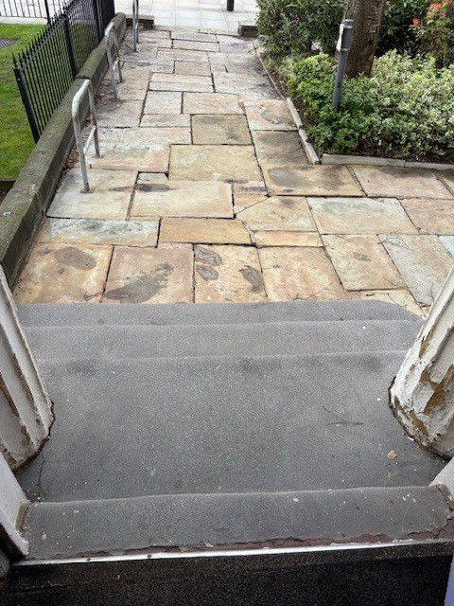
Figure 1 – View from Oxford Road Figure 2 – View from above
The right hand side of William Kay house features the staircase which will provide the new accessible platform entrance.
This has historically been overlaid with a protective asphalt coating which is unsightly and sagging.
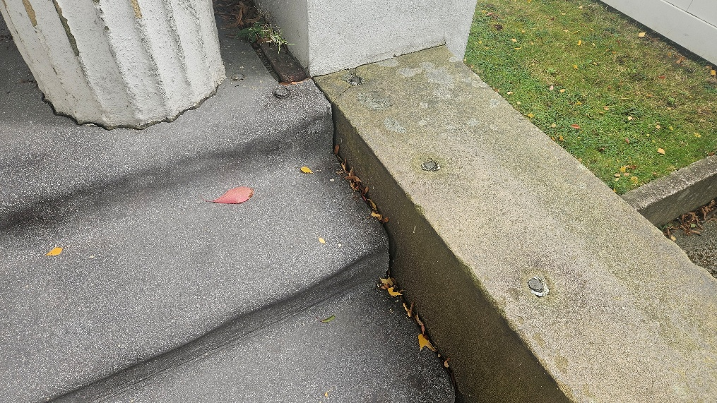
Figure 3 – Existing condition abutment with stone wall.

