

Planning

Delegated Officer Report

Summary of application details
Application reference: | PLA-2026-001346
Application type: | Full planning permission
Proposal: | City Council Development for installation of 5 security cameras.
Site address: | 1 Piccadilly Gardens Manchester M1 1RG
Ward(s): | Piccadilly
Date application valid: | 19 August 2026
Applicant name: | Ms Samantha Stabler
Case officer: | Ciara Gettinby
Recommendation: | Approve
Date of recommendation: | 7 October 2026

Description of site, building and/or area
The applicant site that relates to this development is One Picadilly Gardens, an eight-storey building that sits south-east of Picadilly Gardens. The building features underground car parking, the ground-floor units are occupied as restaurants and the upper storeys operate as offices. The building itself is of a contemporary design with large glazed windows and brick columns.

Northeast of the site is Smithfield Conservation Area and Stevenson Square Conservation Area. To the west of the site is George Street Conservation Area. In the close vicinity of the applicant building is Grade II Listed Structure, Queen Victoria Monument and Grade II Listed Structure, Wellington Statue. Other Listed Buildings within proximity are, Grade II Listed Thistle Hotel, 3-9 Portland Street, Grade II Listed Building, 49 Piccadilly and Grade II Listed Building, 47 Picadilly.
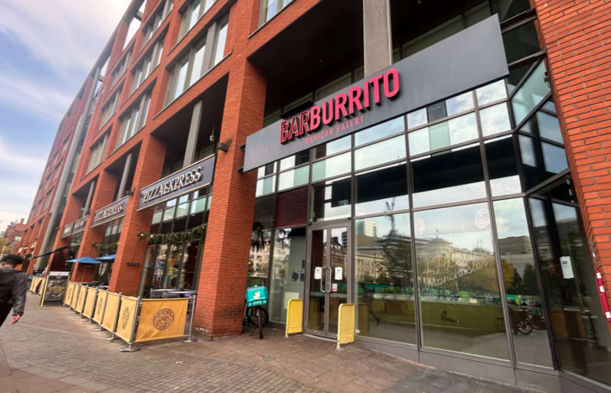

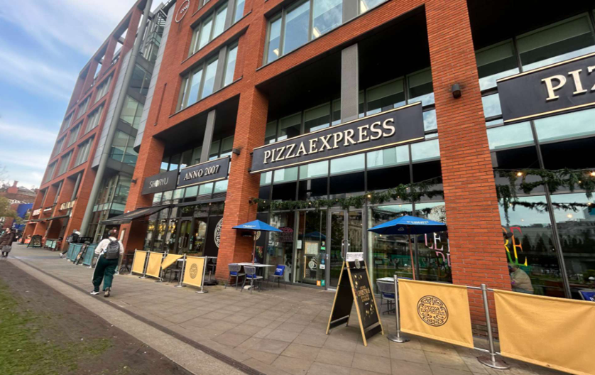

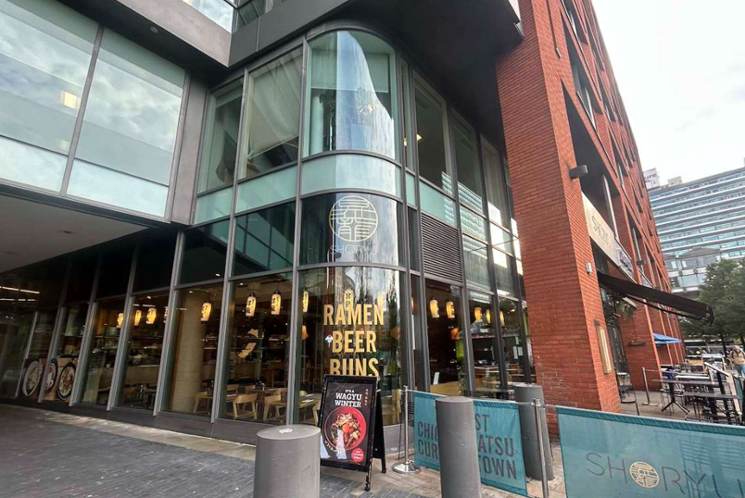

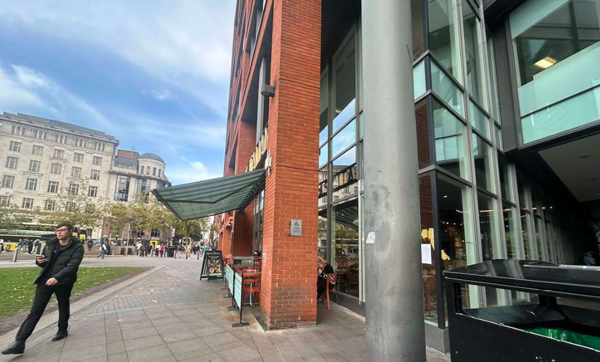

Description of development
This full planning permission relates to the installation of five cameras to One Picadilly Gardens along with five radio transmitters for a temporary period of five years. The cameras would be located along the north and west elevation of the building, most of them facing towards Picadilly Gardens. They would be located at fascia height, and the radio transmitters would be located behind the pillars of the building to be hidden from public view.

This application has been submitted following approval of planning application PLA-2026-001348 for the redevelopment and reconfiguration of Picadilly Gardens compromising works to the public realm.
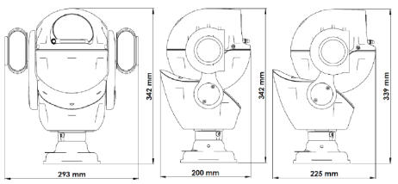



Proposed CCTV Cameras

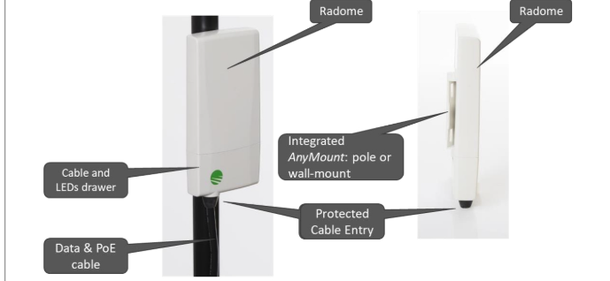
Proposed radio transmitter

Consultation, notification and publicity responses

Consultations
Counter Terrorism Policing- no objections.

Greater Manchester Police- no objections.

Notifications and publicity
A site notice was displayed adjacent to the site; no representations have been received.

Owners of neighbouring properties were notified of the works via a letter. No representations have been received.

Relevant policies
The following policies are considered relevant in the consideration of this application:

Places for Everyone- A long term plan of nine Greater Manchester districts for jobs, new homes and sustainable growth, it has been published by the GMCA on behalf of the nine districts (Bolton, Bury, Rochdale, Oldham, Tameside, Stockport, Manchester, Trafford, Salford, Wigan) and took into effect and become part of the statutory development plan on March 21, 2024.

-Policy JP-P1: Sustainable Places- a scheme should be consistent with a clear identity, socially inclusive, resource-efficient, safe, functional and convenient.

-Policy JP-Strat2: City Centre- The role of the City Centre as the most significant economic location in the country outside London will be strengthened considerably. The City Centre will continue to provide the primary focus for business, retail, leisure, culture and tourism activity in Greater Manchester, but the increasingly important residential role of the City Centre will be expanded.

The Manchester Core Strategy- Development Plan Document 2012- 2027 (The Core Strategy) was adopted by the City Council on the 11th of July 2012, it is a key document for the local plan which provides a framework that planning applications are assessed against.

Policy DM1: Appropriate siting, layout, scale form, massing, materials, and detail. Impact on the surrounding areas in terms of the design, scale and appearance of the proposed development. Development should have regard to the character of the surrounding area. Effects on amenity, including privacy, light, noise, vibration and air quality.

Policy SP1: Providing high quality and diverse housing around district centres which meet local needs, all in a distinct environment. The majority of new residential development in these neighbourhoods will be in the inner areas defined by North Manchester, East Manchester and Central Manchester Regeneration Areas.

Policy EN1: All development in Manchester will be expected to follow the seven principles of urban design, as identified in national planning guidance. Opportunities for good design to enhance the overall image of the City should be fully realised.

The National Planning Policy Framework (August 2026)- The Government’s new national planning policies and how they are to be implemented through local authorities.

Policy S3- Decisions on development proposals should apply a presumption in favour of sustainable development and development proposals that accord with an up-to-date development plan and the decision-making policies in the NPPF should be approved without delay.

Policy DP3- Development proposals should respond to their context, so that they integrate with and enhance their surroundings. To create well designed places development proposals should reflect aspects of the following principles, liveability, climate, nature, movement, built form, public space and identity.

Policy P5: Development proposals should identify potential safety risks and proportionate mitigation opportunities which can be addressed through the design of the scheme. This applies especially where particular groups may be vulnerable to crime, or to the fear of crime such as women or girls.

Assessment
Principle
The insertion of CCTV cameras and their radio transmitters are supported in principle as they would contribute to overall safety and crime prevention around Picadilly Gardens. They would contribute to mitigating crime opportunities and would decrease the fear of crime to the visitors and vulnerable groups in Picadilly Gardens, in line with Policy P5 of the NPPF (August 2026). However, consideration must be given to the impact on the visual amenity of the building and area.

Visual Amenity
The five CCTV cameras would be located along the columns of One Picadilly Gardens and the associated radio transmitters would be located behind the columns, to be hidden from public view. Four cameras and their associated transmitters would be located along the north elevation, facing out onto Picadilly Gardens and one would be located on the west elevation corner. The cameras and their mounts would be black in colour to maintain a neutral appearance and would be located above fascia level so would not be at eye level to any passers-by. As existing, there are CCTV cameras attached to One Picadilly Gardens that are concealed behind the pillars (pictured below).

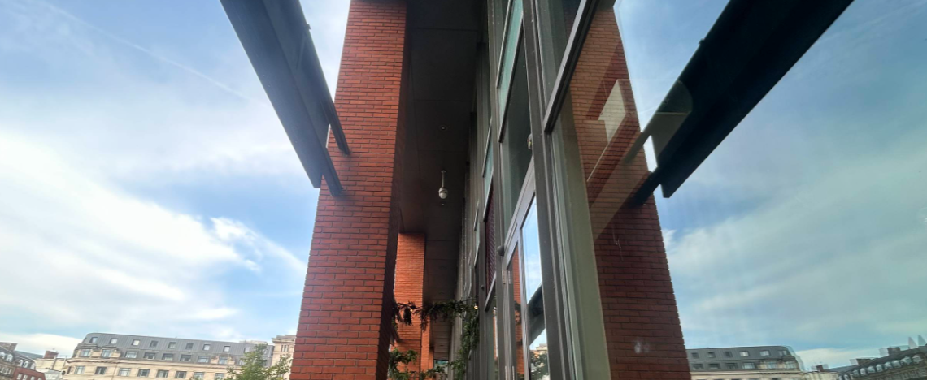

The design of the CCTV cameras are naturally large and have prominent lights attached to either side of each camera. This would result in the cameras being noticeable on the building, however this design is acceptable as the obvious presence of the CCTV is considered to deter criminals and decrease the fear of crime for visitors. The positioning of the CCTV cameras would allow for an unobstructed view across Picadilly Gardens and therefore would improve the public realm by means of safety.

Overall, the scheme is not considered to significantly impact the visual amenity of the building and surrounding area considering they would be a small addition, and the radio transmitters would be hidden behind the pillars. The principle and benefit of the CCTV cameras would contribute to a safer public realm and would encourage visitors at the same time as deterring criminal activity. The development is therefore considered to comply with Policy DM1, SP1 and EN1 of the Core Strategy, Policy S3, DP3 and P5 of the NPPF (August 2026) and Policy JP-P1 and Policy JP-Strat2 of the Places for Everyone Joint Development Plan Document.

Other Legislative Requirements

Equality Act 2010
Section 149 (Public Sector Equality Duty) of the Equality Act 2010 requires due regard to the need to: Eliminate unlawful discrimination, harassment and victimisation and other conduct prohibited by the Act and; Advance equality of opportunity between persons who share a protected characteristic and persons who do not share it. The Equality Duty does not impose a legal requirement to conduct an Equality Impact Assessment. Compliance with the Equality Duty involves consciously thinking about the aims of the Equality Duty as part of the process of decision-making.

Human Rights Act 1998 considerations
This application needs to be considered against the provisions of the Human Rights Act 1998. Under Article 6, the applicants (and those third parties, including local residents, who have made representations) have a right to a fair hearing and to this end the local planning authority must give full consideration to their comments.

Protocol 1 Article 1, and Article 8 where appropriate, confer(s) a right of respect for a person’s home, other land and business assets. In taking account of all material considerations, including Council policy as set out in the Core Strategy and saved polices of the Unitary Development Plan, the Director of Planning, Building Control & Licensing has concluded that some rights conferred by these articles on the applicant(s)/objector(s)/resident(s) and other occupiers and owners of nearby land that might be affected may be interfered with but that that interference is in accordance with the law and justified by being in the public interest and on the basis of the planning merits of the development proposal. She believes that any restriction on these rights posed by the recommendation given is proportionate to the wider benefits of and that such a decision falls within the margin of discretion afforded to the Council under the Town and Country Planning Acts.

Conclusion
Given the above issues it is considered that the proposal is acceptable in terms of its principle and visual amenity as it broadly complies with the Policy DM1, SP1 and EN1 of the Core Strategy, Policy S3, DP3 and P5 of the NPPF (August 2026) and Policy JP-P1 and Policy JP-Strat2 of the Places for Everyone Joint Development Plan Document.

Article 35 Declaration
Officers have worked with the applicant in a positive and proactive manner based on seeking solutions to problems arising in relation to dealing with the planning application. No significant problems have arisen during the consideration of this application, and the application has been determined in a timely manner, in accordance with the policies with the development plan.

Recommendation: Approve

Conditions attached to this decision
- Time
The development must have begun no later than the expiration of three years beginning with the date of permission. Required to be imposed pursuant to Section 91 of the Town and Country Planning Act of 1990.

Reason - Required to be imposed pursuant to Section 91 of the Town and Country Planning Act of 1990.

2) Specified Plans

The development hereby approved shall be carried out in accordance with the following documents

Supporting information, radio specification, Siklu, received by the City Council as LPA on the 13 August 2026.
Supporting information, CCTV Camera specification, Redvision, received by the City Council as the LPA on the 13 August 2026
Supporting Information- CCTV Location Proposals, received by the City Council as the LPA on the 13 August 2026.
Location plan, ref- GM929798, received by the City Council as the LPA on the 18 August 2026.

Reason- to ensure that the development is carried out in accordance with the approved plans, pursuant to saved policy DC1 of the Unitary Development Plan for the City of Manchester and policies SP1 and DM1 of the Manchester Core Strategy.

