

Planning

Delegated Officer Report

Summary of application details
Application reference: | PLA-2026-000465
Application type: | Full planning permission
Proposal: | Erection of outbuilding (incorporating seating, dining, kitchen, spa, changing room, WC and plant room) with sunken swim spa and associated landscaping.
Site address: | 21A Didsbury Park Manchester M20 5LH
Ward(s): | Didsbury East
Date application valid: | 10 July 2026
Applicant name: | Mr Mark Flanagan
Agent (if any): | Mr Andrew Edmunds
Case officer: | Joshua Lee
Recommendation: | Approve
Date of recommendation: | 06/10/2026

Description of site, building and/or area
The proposal is related to a newly constructed semidetached dwellinghouse on Didsbury Park. The property features hardstanding to the front for off street vehicle parking.
The property is located in a predominantly residential part of the Didsbury East ward of Manchester. The site sits within the Didsbury St James Conservation Area. There are a number of listed heritage assets in the vicinity of the site.

Description of development
The applicant is proposing the Erection of outbuilding (incorporating seating, dining, kitchen, spa, changing room, WC and plant room) with sunken swim spa and associated landscaping.
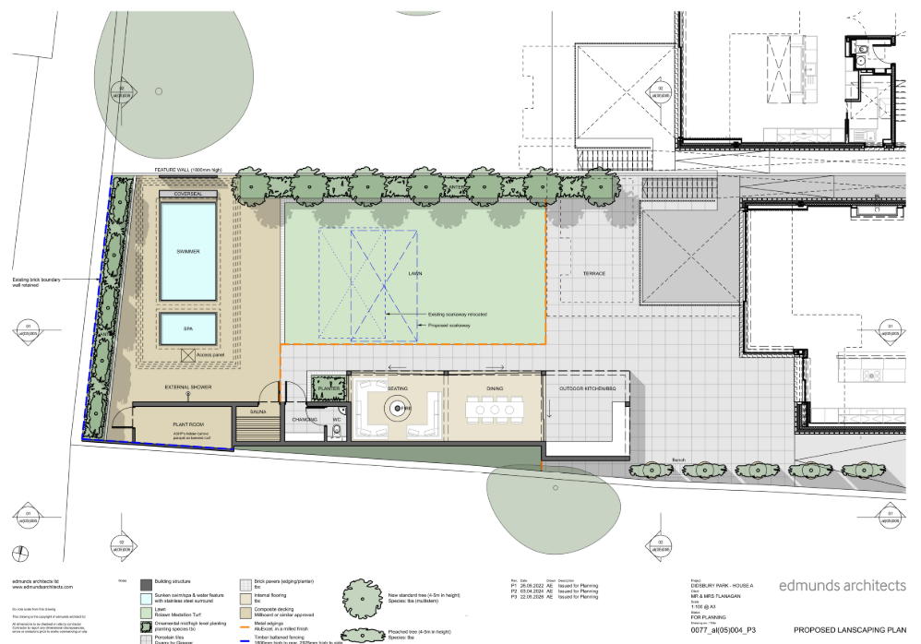
Figure 1. Proposed site plan
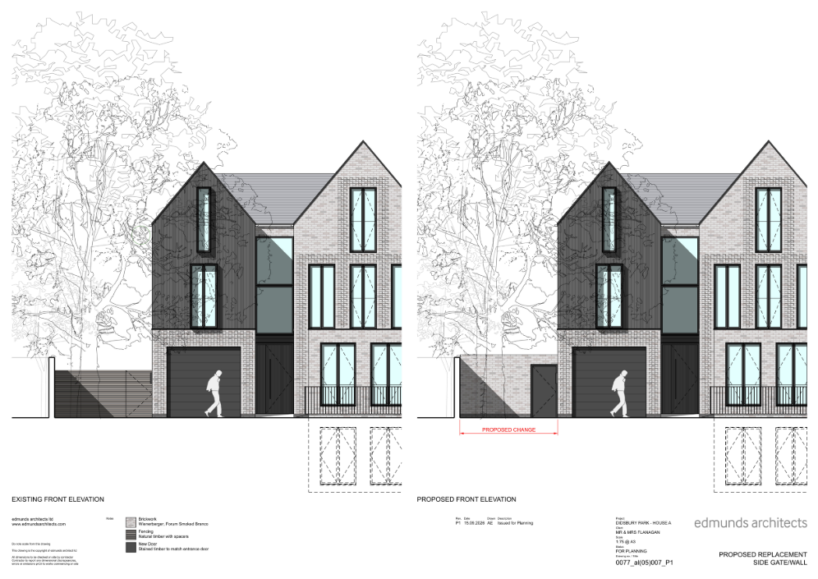
Figure 2. Proposed replacement wall

Relevant planning history
139707/FH/2024 – Approved 29.05.2024 – Erection of 3 no. outbuildings to form a snug, outdoor kitchen and store/WC, together with a sunken swim spa and associated landscaping.
135037/FO/2022 – Approved 12.01.2023 – Erection of 3 no. outbuildings together with installation of a sunken spa/pool and associated landscaping.
133444/JO/2022 – Approved 16.06.2022 – Variation of Condition 1 (Specified Plans) attached to planning permission 131214/JO/2021 to allow the omission of the pergola, amendments to the sunken courtyard, alterations to windows and access hatch changes.
CDN/21/0932 – Refused 04.02.2022 – Discharge of Condition 8 (Contaminated Land) attached to planning permission 131214/JO/2021.
131214/JO/2021 – Approved 23.09.2021 – Variation of Condition 2 (Specified Plans) attached to planning permission 129428/JO/2021 to allow alterations to sunken courtyards.
129428/JO/2021 – Approved 30.04.2021 – Variation of Condition 2 (Specified Plans) attached to planning permission 123880/FO/2019 to allow alterations including a new window, alterations to window positions, basement footprint reduction, amendments to sunken courtyards and a new pergola.
CDN/21/0173 – Approved 16.04.2021 – Discharge of Conditions relating to materials, landscaping, construction management, waste storage, electric vehicle charging, privacy screening and sustainability attached to planning permission 123880/FO/2019.
123880/FO/2019 – Approved 27.08.2019 – Erection of two three-storey detached dwellinghouses with associated landscaping and car parking following demolition of the existing building.

Consultation, notification and publicity responses

Consultations

Environmental Health
No objection subject to conditions. Environmental Health has recommended a condition requiring the plant room and any associated external plant, equipment or servicing to be designed and/or acoustically treated to achieve noise levels at least 5dB below existing background noise levels at the nearest noise-sensitive receptor. A scheme of mitigation is to be submitted for approval prior to the commencement of the approved use, together with a post-installation verification report demonstrating compliance with the agreed noise criteria

Arboricultural Team
The Council's Arboricultural Officer advises that, whilst a number of trees are proposed for removal to facilitate the development, the majority are located within the rear garden and have limited public amenity value due to their position adjoining the private Owens Park estate. Tree T3, an ash tree on the frontage, is identified as being in decline and no objection is raised to its removal. It was confirmed that the trees are not protected by a Tree Preservation Order, although T3 appears within the approved landscaping scheme secured under the previous variation permission. On this basis, the Arboricultural Officer raises no objection to the proposed tree removals subject to a condition requiring replacement tree planting to be submitted and approved, ensuring that the landscaping objectives secured under the earlier permission are maintained.

Notifications and publicity

Neighbour letters, site notice and press advert
No responses received.

Didsbury Civic Society
No responses received.

Negotiations
Issues were identified during the consultation process regarding the proposed brick wall to the side of the property. Concerns were raised that its height and solid appearance would result in an overly enclosed form of development that would detract from the character and appearance of the conservation area.
In response, discussions were undertaken with the applicant in a positive and proactive manner. The applicant was advised that the visual impact of the wall could be reduced either by lowering it to the height of the existing boundary fence or by incorporating measures to soften its appearance.
Following these discussions, amended plans were submitted which introduced a green/living wall to the proposed side gate wall. The revised design helps soften the appearance of the structure and reduces its visual impact within the street scene and conservation area.
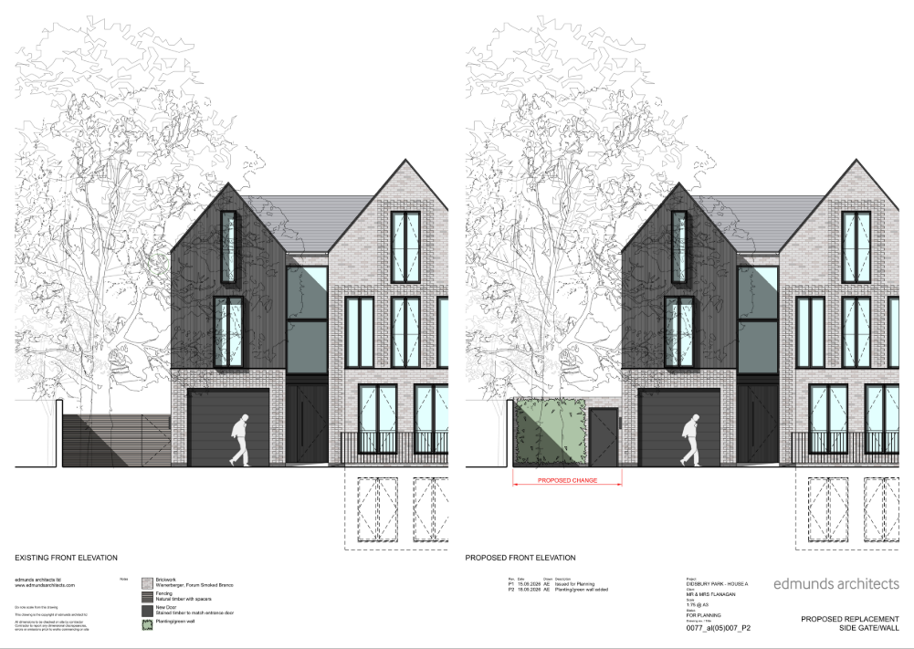

Consultation, notification & publicity responses to Changes

Notifications and publicity

Neighbour letters
No responses received.

Relevant policies
In accordance with Section 38(6) of the Planning and Compulsory Purchase Act 2004, decisions on planning applications must be made in line with the statutory development plan, unless material considerations indicate otherwise.

For Manchester, the development plan comprises:

- The Core Strategy (2012–2027)
- Saved policies of the Unitary Development Plan (UDP)
- The Places for Everyone Joint Development Plan Document (2022–2039)

These documents are considered up to date and carry substantial weight in decision-making. Supplementary Planning Documents (SPDs) and other local guidance may also be relevant.

National planning policy, including the National Planning Policy Framework (NPPF), is a material consideration and provides overarching guidance.

Where applicable, the Council must give special regard to preserving the character of conservation areas and the setting of listed buildings, in line with statutory duties under the Planning (Listed Buildings and Conservation Areas) Act 1990.

The policies referenced in this report are those considered most relevant to the nature, scale and location of the proposed development as follows:

- The Manchester Core Strategy Development Plan Document 2012-2027
  - Development Management and Planning Obligations
    - DM 1 - Development Management
  - Objective 1 - Spatial Principles
    - SP 1 - Spatial Principles (Partially replaced by PfE Policy JP-S 1)
  - Objective 6 Environment
    - EN 1 - Design Principles and Strategic Character Areas
    - EN 3 – Heritage (Deletions replaced with PfE Policy JP-P2)
    - EN 9 – Green Infrastructure
    - EN 18 - Contaminated Land and Ground Stability
    - EN 19 – Waste
- Guide to development in Manchester - supplementary planning document and planning guidance, April 2007
- Extant Unitary Development Plan (UDP) –
  - Citywide Development Control Policies
    - DC1 - Residential extensions
    - DC18 - Conservation Areas
    - DC19 - Listed Buildings
    - DC26 - Development and Noise
- Places for Everyone Plan Joint Development Plan Document 2022-2039-
  - Strategy
    - JP-Strat9: Southern Areas
  - Sustainable and Resilient Places
    - JP-S1: Sustainable Development
  - Greener Places
    - JP-G6: Urban Green Space
    - JP-G7: Trees and Woodland
  - Places for People
    - JP-P1 Sustainable Places
    - JP-P2: Heritage
- National Planning Policy Framework (NPPF) December 2024–
  - Section 2 - Achieving sustainable development
  - Section 4 – Decision-making
  - Section 11 – Making effective use of land
  - Section 12 – Achieving well-designed places
  - Section 16 - Conserving and enhancing the historic environment
- National Planning Policy Framework – August 2026 - National Development Management Policies (NDMPs)
  - Procedural Policies
    - Chapter 3 – Decision-making policies
      - DM1: Preparing development proposals
      - DM2: Information requirements
      - DM3: Determining development proposals
      - DM6: Use of planning conditions and obligations
      - DM7: Relationship with other regulatory regimes
      - DM10: Removal of national permitted development rights
  - Sustainable Development
    - Chapter 4 - Achieving sustainable development
      - S3: Presumption in favour of sustainable development
      - S4: Principle of development within settlements
    - Chapter 5 - Meeting the challenge of climate change
      - CC2: Mitigation of climate change
      - CC3: Adaptation to climate change
  - Creating high quality, sustainable places
    - Chapter 14 - Achieving well-designed places
      - DP3: Key principles for well-designed places
      - DP4: The design process
  - Conserving and enhancing the environment
    - Chapter 19 - Conserving and enhancing the natural environment
      - N2: Improving the natural environment
      - N3: Trees in new development
    - Chapter 20 - Conserving and enhancing the historic environment
      - HE4: Securing the conservation of heritage assets
      - HE5: Assessing effects on heritage assets
      - HE9: Conservation areas

Assessment

Principle of development
The application seeks planning permission for the erection of an outbuilding, sunken swim spa and associated landscaping within the residential curtilage of an existing dwellinghouse. The proposed outbuilding would remain incidental to the enjoyment of the dwellinghouse and would not create a separate residential unit or independent planning use.
Domestic outbuildings are generally acceptable in principle within residential curtilages where they are of an appropriate scale and do not result in unacceptable impacts on visual amenity, neighbouring amenity or heritage assets. The site is of sufficient size to accommodate the development without resulting in overdevelopment of the plot or compromising its residential function.
It is noted that certain forms of domestic outbuilding may be erected under permitted development rights (with the approved houses retaining these rights). Whilst the current proposal requires planning permission due to its scale and/or design, the fallback position is afforded limited weight in favour of the proposal.
The site lies within the Didsbury St James Conservation Area and near a number of listed buildings. The acceptability of the proposal therefore depends on its detailed design and its effect on the character and appearance of the conservation area and the setting of nearby heritage assets, which are considered elsewhere in this report.
Subject to those considerations, there is no objection in principle to the proposed development, which is considered to accord with Core Strategy policies DM1, EN1 and EN3, UDP policies DC1, DC18 and DC19, Places for Everyone policies JP-S1, JP-P1 and JP-P2, and the relevant policies of the NPPF.

Appropriate siting, layout, scale, form, massing, materials, and detail
The proposed outbuilding would be positioned within the rear garden of the property, well screened from the public realm and contained within a substantial residential curtilage. Its siting, scale and footprint are proportionate to the size of the plot and would not result in overdevelopment. The building would remain clearly subordinate to the host dwelling.
The design adopts a contemporary approach that reflects the architectural character of the recently constructed dwelling. The proposed materials, including matching brickwork, glazing and roofing materials, would complement the host property and provide a cohesive appearance. Whilst relatively large in footprint, the outbuilding would be single storey in height and its visual presence would be moderated by existing and proposed landscaping.
The structures would be located a considerable distance from neighbouring dwellings and garden areas. Given its height, scale and separation distances, the development would not appear overbearing, create an unacceptable sense of enclosure or materially harm outlook from neighbouring habitable room windows or private amenity spaces.
The proposed side wall would be slightly taller than existing and with a green wall, help mask the added massing.
Having regard to its siting, design, scale, massing and materials, the proposal would integrate successfully within the site, preserve the character and appearance of the surrounding area, and provide an acceptable relationship with neighbouring occupiers. The development therefore accords with Core Strategy Policies DM1 and EN1, UDP Policy DC1, Places for Everyone Policy JP-P1 and the design objectives of the NPPF
Impact on the surrounding areas in terms of the design, scale and appearance of the proposed development. Development should have regard to the character of the surrounding area.
The proposed development would have a limited visual presence within the wider streetscene due to its location to the rear of the dwelling and the screening provided by existing boundary treatments and landscaping. As such, views from public vantage points would be restricted. The scale and appearance of the building are considered compatible with the established residential character of the area and would not detract from the quality of the surrounding townscape. Furthermore, for the reasons set out in the heritage section of this report, the proposal would preserve the character and appearance of the Didsbury St James Conservation Area and the setting of nearby listed buildings.
Accordingly, the proposal is considered to have an acceptable impact on the surrounding area in terms of its design, scale and appearance.

Effects on amenity

Privacy
The proposed building would contain glazing and doors facing into the applicant's own garden area. Given the separation distances to neighbouring properties, boundary treatments and the single-storey nature of the development, the proposal would not result in unacceptable overlooking or loss of privacy to neighbouring occupiers.

Light
The outbuilding would be single storey and positioned a significant distance from neighbouring dwellings. As such, it would not give rise to any material loss of daylight or sunlight to nearby residential properties.

Noise
The proposed outbuilding, swim spa and associated facilities would be used ancillary to the enjoyment of the dwellinghouse. Whilst some increase in domestic activity may occur, this would be consistent with the lawful residential use of the site and, given the scale of the proposal and separation from neighbouring dwellings, is not considered likely to result in unacceptable disturbance to nearby occupiers.
The proposal includes a plant room and is understood to incorporate plant equipment associated with the swim spa and air source heat pump. The Council's Environmental Health Officer has reviewed the proposal and raises no objection subject to a planning condition requiring any external plant and equipment to achieve noise levels at least 5dB below the existing background noise level at the nearest noise-sensitive receptor. A post-installation verification report is also required to demonstrate compliance with the approved noise criteria.
Subject to the recommended condition, it is considered that the development would not result in unacceptable noise impacts on neighbouring residential amenity and would comply with Core Strategy Policy DM1 and saved UDP Policy DC26.

Accessibility: buildings and neighbourhoods fully accessible to disabled people, access to new development by sustainable transport modes.
The proposal relates to ancillary domestic accommodation within an existing residential curtilage and would not alter access arrangements to the site. The development raises no significant accessibility concerns.

Refuse storage and collection.
The development would not materially alter existing refuse storage or collection arrangements. Adequate provision for waste storage would remain available within the site.

Vehicular access and car parking
The proposal would not alter access arrangements or on-site parking provision. Sufficient off-street parking would remain available to serve the dwellinghouse

Effects relating to biodiversity, landscape, archaeological or built heritage

Built heritage
The site lies within the Didsbury St James Conservation Area and in the vicinity of a number of listed buildings. Particular regard has been given to the statutory duties under Sections 66 and 72 of the Planning (Listed Buildings and Conservation Areas) Act 1990.
The proposed outbuilding would be positioned within the rear garden of the property, where it would be largely screened from public views by existing and proposed landscaping and viewed in the context of the recently constructed dwelling.
By virtue of its single-storey form, subordinate scale, sympathetic material palette and limited visibility from the public realm, the development would not detract from the spacious residential character, mature landscape setting or significance of the conservation area.
The green wall to the new gate wall helps mask the added massing and helps maintain the verdant nature of the conservation area.
Furthermore, the proposal would not adversely affect the setting, significance or appreciation of nearby listed buildings.
The development would therefore preserve the character and appearance of the Didsbury St James Conservation Area and preserve the setting of nearby listed buildings, resulting in no harm to designated heritage assets and complying with Core Strategy Policy EN3, UDP Policies DC18, Places for Everyone Policy JP-P2 and the heritage provisions of the NPPF

Green Infrastructure including open space, both public and private
The proposal would result in the removal of a number of trees within the site, including Tree T3 on the frontage and several trees within the rear garden. The Council's Arboricultural Officer has reviewed the proposals and raises no objection, advising that the affected trees are not protected and make a limited contribution to public amenity, whilst Tree T3 is an ash tree in decline that would not ordinarily warrant long-term retention. Although the loss of existing trees carries some limited weight against the proposal, significant weight is attributed to the Arboricultural Officer's assessment regarding their condition and amenity value. Furthermore, replacement tree planting can be secured through condition to maintain the landscaping objectives established under previous permissions and to ensure the continued provision of green infrastructure benefits on the site. Taking these matters into account, it is considered that the limited harm arising from the loss of trees would be adequately mitigated through replacement planting and would not result in unacceptable harm to the site's landscape character, biodiversity value or green infrastructure function. The proposal therefore complies with Core Strategy Policies EN9 and DM1, Places for Everyone Policies JP-G6 and JP-G7 and NDMP Policies N2 and N3.

Flood risk and drainage.
The proposal relates to development within an existing residential curtilage and would utilise altered drainage arrangements. Given its scale and nature, no significant flood risk or drainage concerns are raised.

Other Legislative Requirements

Equality Act 2010
Section 149 (Public Sector Equality Duty) of the Equality Act 2010 requires due regard to the need to: Eliminate unlawful discrimination, harassment and victimisation and other conduct prohibited by the Act and; Advance equality of opportunity between persons who share a protected characteristic and persons who do not share it. The Equality Duty does not impose a legal requirement to conduct an Equality Impact Assessment. Compliance with the Equality Duty involves consciously thinking about the aims of the Equality Duty as part of the process of decision-making.

Human Rights Act 1998 considerations
This application needs to be considered against the provisions of the Human Rights Act 1998. Under Article 6, the applicants (and those third parties, including local residents, who have made representations) have a right to a fair hearing and to this end the local planning authority must give full consideration to their comments.
Protocol 1 Article 1, and Article 8 where appropriate, confer(s) a right of respect for a person’s home, other land and business assets. In taking account of all material considerations, including Council policy as set out in the Core Strategy and saved polices of the Unitary Development Plan, the Director of Planning, Building Control & Licensing has concluded that some rights conferred by these articles on the applicant(s)/objector(s)/resident(s) and other occupiers and owners of nearby land that might be affected may be interfered with but that that interference is in accordance with the law and justified by being in the public interest and on the basis of the planning merits of the development proposal. She believes that any restriction on these rights posed by the recommendation given is proportionate to the wider benefits of and that such a decision falls within the margin of discretion afforded to the Council under the Town and Country Planning Acts.

Conclusion
The proposed outbuilding, sunken swim spa and associated landscaping are considered acceptable in principle and would provide ancillary facilities associated with the enjoyment of the existing dwellinghouse. By virtue of its siting, scale, design and materials, the development would remain subordinate to the host property and would not result in unacceptable impacts on the character of the area, neighbouring residential amenity, highway safety, drainage or other material planning considerations. Furthermore, having had special regard to the desirability of preserving the setting of nearby listed buildings and paying special attention to preserving the character and appearance of the Didsbury St James Conservation Area, it is considered that the proposal would preserve the significance of these heritage assets. Whilst the development would result in the loss of a number of trees, the Council's Arboricultural Officer raises no objection and replacement planting can be secured through condition to maintain the site's green infrastructure value. Taking all material considerations into account, the proposal accords with the Development Plan and relevant provisions of the National Planning Policy Framework and National Development Management Policies and is therefore recommended for approval subject to the attached conditions.

Recommendation: Approve

Article 35 Declaration
Officers have worked with the applicant in a positive and proactive manner based on seeking solutions to problems arising in relation to dealing with the planning application. The proposal is considered to be acceptable and therefore determined within a timely manner.

Conditions to be attached to decision for approval

3-year time limit
The development must be begun not later than three years beginning with the date of this permission.
Reason - Required to be imposed by Section 91 of the Town and Country Planning Act 1990 (as amended).

Specified plans
The development hereby approved shall be carried out in accordance with the following drawings and documents:
- 0077 al(05)001 Rev P4 – Location Plan, received 25 May 2026.
- 0077 al(05)003 Rev P3 – Proposed Landscaping Plan, received 25 May 2026.
- 0077 al(05)004 Rev P3 – Proposed Landscaping Plan, received 25 May 2026.
- 0077 al(05)005 Rev P3 – Proposed Elevations (North & East), received 25 May 2026.
- 0077 al(05)006 Rev P1 – Proposed Elevations (East & West), received 25 May 2026.
- 0077 al(05)007 Rev P2 - Proposed replacement side gate/wall, received 18 Sept 2026
Reason - To ensure that the development is carried out in accordance with the approved plans, pursuant to policies DM 1, SP 1 and EN 1 of the Core Strategy and JP-P1 & of Places for Everyone.

Materials as approved on plan
The materials used in the external surfaces of the development hereby approved shall be those as specified on approved plan/drawing ref.
- 0077 al(05)003 Rev P3 – Proposed Landscaping Plan, received 25 May 2026.
- 0077 al(05)004 Rev P3 – Proposed Landscaping Plan, received 25 May 2026.
- 0077 al(05)005 Rev P3 – Proposed Elevations (North & East), received 25 May 2026.
- 0077 al(05)006 Rev P1 – Proposed Elevations (East & West), received 25 May 2026.
- 0077 al(05)007 Rev P2 - Proposed replacement side gate/wall, received 18 Sept 2026

Reason - In order to ensure a satisfactory appearance in the interests of visual amenity in accordance with policies SP1 and DM1 of the Core Strategy and the requirements of the National Planning Policy Framework.

Arboriculture
The development shall be carried out in full accordance with the Arboricultural Impact Assessment (11551 Rev P09) received by the Local Planning Authority on 6 July 2026, including all tree protection measures, working methods and recommendations contained therein. The approved tree protection measures shall be erected before any works commence on site and shall remain in place for the duration of construction works.
Reason: To protect existing trees during the construction period in the interests of the visual amenity and environmental quality of the area and to comply with Policies EN9 and DM1 of the Manchester Core Strategy.

Tree Replacement
No above ground works shall take place until details of replacement tree planting have been submitted to and approved in writing by the Local Planning Authority. The details shall include the species, size, number, location and timing of planting. The approved replacement tree planting shall be carried out in the first planting season following the completion of the development or within such other timescale as may first be agreed in writing by the Local Planning Authority. Any tree planted in accordance with this condition that is removed, dies, becomes seriously damaged or diseased within a period of five years from the date of planting shall be replaced in the next planting season with a tree of similar size and species, unless otherwise agreed in writing by the Local Planning Authority.
Reason: To secure appropriate mitigation for the loss of existing trees and to ensure the continued provision of green infrastructure and landscaping benefits in accordance with Policies EN9 and DM1 of the Manchester Core Strategy.

APPROVED PLANT EQUIPMENT NOISE – PRE-INSTALLATION
  - Prior to the installation of the external plant equipment hereby approved, either a scheme that demonstrates that the external plant equipment will achieve a rating level of 5dB (LAeq) below the typical background (LA90) level in each octave band at the nearest noise sensitive location, or a scheme showing a method to acoustically treat/insulate the external plant equipment so as to achieve a rating level of 5dB (LAeq) below the typical background (LA90) level in each octave band at the nearest noise sensitive location, shall be submitted to and approved in writing by the Local Planning Authority.
  - Prior to the first operation of the external plant equipment, a verification report, which will include post-completion testing, shall be submitted to and approved in writing by the Local Planning Authority to validate that the external plant equipment achieve a rating level of 5dB (LAeq) below the typical background (LA90) level at the nearest noise sensitive location.
  - In the event of non-conformity with a rating level of 5dB (LAeq) below the typical background (LA90) level in each octave band, then any measures/changes required to achieve conformity shall be carried out. Any required measures/changes and verification shall continue until conformity has been achieved and agreed in writing by the Local Planning Authority, before operation of the external plant equipment can commence.

Reason - To minimise the impact of the development and to prevent a general increase in pre-existing background noise levels around the site. Pursuant to policies SP1 and DM1 of the Core Strategy and saved policy DC26 of the UDP.

