

Planning

Delegated Officer Report

Summary of application details
Application reference: | PLA-2026-000972
Application type: | Householder planning permission
Proposal: | Erection of a single-storey front extension, together with a single-storey side and rear extension.
Site address: | 15 Newcliffe Road Manchester M9 6LY
Ward(s): | Charlestown
Date application valid: | 31 July 2026
Applicant name: | Mr Ehimen Akhimien
Agent (if any): | Mr M Mohammed
Case officer: | Joshua Lee
Recommendation: | Approve
Date of recommendation: | 08/10/2026

Description of site, building and/or area
The property which is subject to this householder application is a two-storey, C3 dwellinghouse. The property features white uPVC window frames, red brickwork and grey slate roof tiles. To the side of the property is a hardstanding driveway which as existing has the parking provision for two vehicles. To the rear of the property is a large garden.
Newcliffe Road is a residential street located in the Charlestown ward of Manchester. The surrounding area is mainly residential in nature, with many other family properties of a similar age and design. The property is located within Medium and Low Surface Water Risk areas.

Description of development
The application seeks planning permission for the erection of single-storey front, side and rear extensions to the existing dwelling. The proposed rear extension would project approximately 4.5 metres beyond the existing rear elevation and, together with the 4.5m projecting side extension, would create an enlarged kitchen/dining area, master bedroom suite, and gym at ground-floor level. The proposed front extension would form an enclosed entrance porch projecting approximately 1.25 mmm from the principal elevation. The extensions would be constructed using facing brickwork and roof tiles to match the existing dwelling, with new uPVC double-glazed windows and doors.
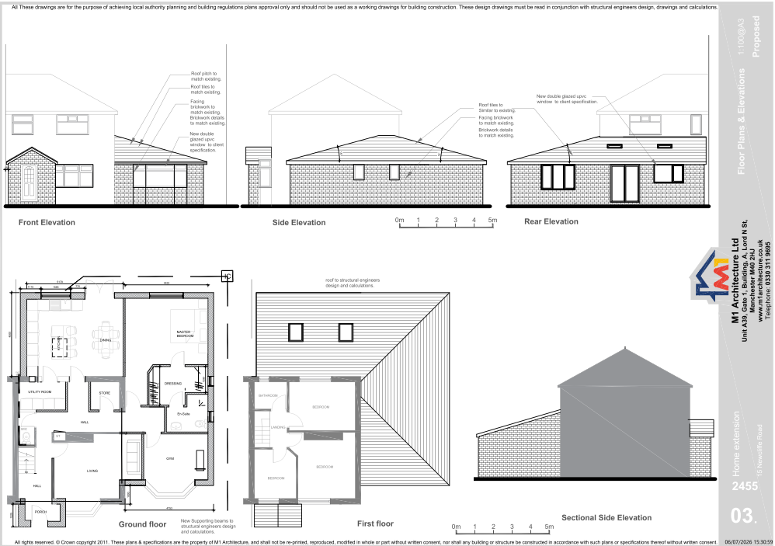
Figure 1. Proposed plans and elevations

Relevant planning history

Planning Application - 144935/FH/2026
Erection of a single-storey front, side and rear extension.
Refuse - 2026-03-09
The application sought planning permission for a substantial single-storey front, side and rear extension at 15 Newcliffe Road, Manchester. The proposal was recommended for refusal because its scale, massing and design would have more than doubled the footprint of the original dwelling, resulting in an overly dominant and visually incongruous form of development that was considered out of character with both the host property and the surrounding area. The rear extension was considered excessively large and too close to the boundary with No. 13 Newcliffe Road, creating an overbearing impact and harming neighbouring residential amenity through increased enclosure and loss of outlook. In addition, the side extension would have removed the existing off-street parking provision, leading to concerns regarding increased on-street parking demand and potential impacts on residential amenity and highway safety. Consequently, the proposal was found to conflict with saved UDP Policy DC1 and Core Strategy Policies SP1 and DM1, and planning permission was recommended for refusal.

Consultation, notification and publicity responses

Consultations

Manchester City Council Flood Risk Management
Flood Risk Management has reviewed the application and raises no objection. Records indicate a United Utilities public sewer crosses the site and the Local Planning Authority is advised to ensure United Utilities are consulted prior to determination. An informative is recommended advising the applicant to incorporate Property Flood Resilience measures. No planning conditions are requested, and the proposal can be approved from a flood risk perspective.

United Utilities
No response received.

Notifications and publicity

Neighbour letters
No responses received.

Negotiations
Issues arose during the consultation process which required positive and proactive discussions with the applicant.
A query was raised regarding the submitted red line boundary plan, as a review of the Council's land ownership records identified a parcel of land within the application site that did not appear to be within the applicant's ownership. The application had been submitted with Certificate A, certifying that the applicant was the sole owner of all land to which the application relates.
Following discussions with the applicant, further information and evidence were provided demonstrating that the land in question had recently been acquired by the applicant. Officers were satisfied that the ownership issue had been resolved and that Certificate A had been correctly completed. No further amendments to the application were required as a result of these discussions.

Relevant policies
In accordance with Section 38(6) of the Planning and Compulsory Purchase Act 2004, planning applications must be determined in accordance with the statutory development plan unless material considerations indicate otherwise.
For Manchester, the development plan comprises:
- The Manchester Core Strategy (2012 to 2027);
- Saved policies of the Manchester Unitary Development Plan (UDP); and
- The Places for Everyone Joint Development Plan Document (2022 to 2039).
These documents are considered up to date and are afforded significant weight in the determination of planning applications. Relevant Supplementary Planning Documents (SPDs) and other adopted guidance may also be material considerations.
The National Planning Policy Framework sets out the government’s policies for plan-making and for making decisions on development proposals in England. It is a material consideration of critical importance in both contexts.
Where relevant, the Council is required to give special regard to the desirability of preserving listed buildings and their settings, and special attention to the desirability of preserving or enhancing the character or appearance of conservation areas, in accordance with the Planning (Listed Buildings and Conservation Areas) Act 1990.
The policies and guidance referred to below are considered the most relevant to the scale, nature and location of the proposed development.
- The Manchester Core Strategy Development Plan Document 2012-2027
  - Development Management and Planning Obligations
    - DM 1 - Development Management
  - Objective 1 - Spatial Principles
    - SP 1 - Spatial Principles (Partially replaced by PfE Policy JP-S 1)
  - Objective 6 Environment
    - EN 1 - Design Principles and Strategic Character Areas
    - EN 8 – Adaptation to Climate Change (partially replaced by PfE Policies JP-S 2, JP-S 4 and JP-G 8)
    - EN 14 – Flood Risk (partially replaced by PfE Policy JP-S 4)
    - EN 19 – Waste
- Guide to development in Manchester - supplementary planning document and planning guidance, April 2007
- Extant Unitary Development Plan (UDP) –
  - Citywide Development Control Policies
    - DC1 - Residential extensions
    - DC26 - Development and Noise
- Places for Everyone Plan Joint Development Plan Document 2022-2039-
  - Strategy
    - JP-Strat9: Southern Areas
  - Sustainable and Resilient Places
    - JP-S1: Sustainable Development
    - JP-S4: Flood Risk and the Water Environment
  - Places for People
    - JP-P1 Sustainable Places
- National Planning Policy Framework – August 2026 - National Development Management Policies (NDMPs)
  - Procedural Policies
    - Chapter 3 – Decision-making policies
      - DM1: Preparing development proposals
      - DM2: Information requirements
      - DM3: Determining development proposals
      - DM6: Use of planning conditions and obligations
      - DM7: Relationship with other regulatory regimes
      - DM8: Unauthorised development and enforcement
  - Sustainable Development
    - Chapter 4 - Achieving sustainable development
      - S3: Presumption in favour of sustainable development
      - S4: Principle of development within settlements
    - Chapter 5 - Meeting the challenge of climate change
      - CC2: Mitigation of climate change
      - CC3: Adaptation to climate change
  - Creating high quality, sustainable places
    - Chapter 12 - Making effective use of land
      - L2: Making effective use of land
    - Chapter 14 - Achieving well-designed places
      - DP3: Key principles for well-designed places
      - DP4: The design process
  - Conserving and enhancing the environment
    - Chapter 18 - Managing flood risk and coastal change
      - F4: Assessing flood risk for decision-making
      - F6: Development in areas at risk of flooding from rivers or the sea
      - F7: Ensuring development is safe from flooding
      - F8: Sustainable drainage systems and watercourses

Assessment

Principle of development
Many people prefer to extend their existing homes rather than move, and the planning system needs to accommodate this demand for more living space, while at the same time ensuring that the amenities of neighbours are protected, and that the overall character of the surrounding area is not harmed. The Council is not generally in favour of dealing with this issue by laying down firm rules about home extensions with each case looked at on its individual merits, having regard to a range of criteria.
In this case the principle of the development is acceptable.
As stated in Policy DM 1 of the Manchester Core Strategy, all development should have regard to the following specific issues:

Appropriate siting, layout, scale, form, massing, materials, and detail
The proposed extensions would be constructed using facing brickwork and roof tiles to match the existing dwelling, together with matching uPVC windows and doors. The development would therefore integrate satisfactorily with the established appearance of the host property.
The front extension would form a modest entrance porch projecting approximately 1.25 metres beyond the principal elevation. Owing to its limited scale and domestic appearance, it would not appear visually intrusive or unduly prominent within the street scene.
The side and rear extensions would remain entirely single storey with a modest roof height. Whilst the development would increase the overall footprint of the dwelling, the amended scheme is significantly reduced in scale compared to the previously refused proposal. In particular, the rear projection and overall built form have been reduced such that the proposal is no longer considered excessive or disproportionate in relation to the host dwelling.
The previous application was refused in part because the scale, massing and proximity of the extensions to the boundary with No. 13 Newcliffe Road were considered to create an overbearing feature and harmful sense of enclosure. The current proposal has been amended and reduced in footprint from the refused scheme.
Whilst the proposed extensions would be visible from No. 13 and would alter the existing outlook to some extent, the development would remain single storey and would not project to such an extent that it would appear dominant or oppressive when viewed from neighbouring windows or garden areas. On balance, the proposal is not considered to result in an unacceptable overbearing impact or loss of outlook to occupiers of No. 13 Newcliffe Road.
Due to the reduced scale, single-storey design and use of matching materials, the development would appear as a sympathetic addition to the dwelling and would not result in an overly dominant or visually incongruous form of development.
Impact on the surrounding areas in terms of the design, scale and appearance of the proposed development. Development should have regard to the character of the surrounding area.
Newcliffe Road is characterised by semi-detached dwellings set within relatively spacious plots. A number of properties within the area have been extended and altered over time, reflecting the evolving residential character of the street.
The proposed extensions would remain single storey in scale and would utilise materials to match the existing dwelling. Whilst the proposal would increase the footprint of the property, the amended scheme has been significantly reduced from the previously refused development and would no longer appear excessively bulky or dominant.
The front porch extension would be modest in scale and the side and rear extensions would be largely screened from public views. As such, the development would sit comfortably within the plot and would not appear out of keeping with the established character and appearance of the surrounding area.

Effects on amenity

Privacy
The proposal includes new windows and glazed doors at ground-floor level. These openings would primarily serve the applicant's private rear garden and would not result in overlooking beyond that typically associated with a residential dwelling.
No side-facing windows serving habitable rooms are proposed and therefore the development would not give rise to unacceptable overlooking or loss of privacy for neighbouring occupiers.

Light
The extensions would remain single storey and have relatively modest roof heights. Whilst positioned close to the boundary with No. 13 Newcliffe Road, the scale and projection of the amended scheme are substantially reduced when compared with the previously refused proposal.
Given the height, siting and design of the development, it is not considered that the proposal would result in an unacceptable loss of daylight or sunlight to neighbouring properties.

Noise
The proposed extension would facilitate additional living accommodation associated with the continued occupation of the property as a single dwellinghouse. The proposal is not expected to generate noise levels beyond those normally associated with residential use

Accessibility: buildings and neighbourhoods fully accessible to disabled people, access to new development by sustainable transport modes.
The proposal would not adversely affect accessibility to the property and would retain safe access arrangements. The development is located within an established residential area which benefits from access to local services and public transport options.

Adequacy of internal accommodation and external amenity space.
The proposal would significantly improve the quality and quantity of accommodation available to occupants of the dwelling by providing additional living space and improved internal layouts.
Despite the increase in built footprint, a substantial rear garden would remain available for private outdoor amenity purposes. The proposal therefore provides adequate internal accommodation and retains sufficient external amenity space.

Refuse storage and collection.
The proposal would not adversely affect refuse collection arrangements. Adequate space remains available within the curtilage of the property for the storage and presentation of bins for collection.

Vehicular access and car parking
The submitted site plan demonstrates that adequate off-street parking would be retained within the site following completion of the development. Unlike the previously refused proposal, the amended scheme incorporates parking provision within the curtilage of the property, including within land recently acquired by the applicant. The proposed parking area would be finished in a permeable surface, allowing surface water to drain within the site and reducing the potential for increased surface water run-off and would therefore be permitted development in its own right. As such, the development is not considered likely to result in unacceptable pressure on on-street parking provision within the surrounding area.
The proposal would not alter the existing vehicular access arrangements serving the site, and no highway safety concerns are identified. Whilst the parking area would extend into the recently acquired land, no new vehicular access is proposed. The existing means of access would continue to be used and, accordingly, planning permission is not required for the continuation of the existing access arrangements. The applicant has confirmed that new parking and boundary treatments will utilise permitted development rights. The proposal is therefore considered acceptable in highway and parking terms.

Green Infrastructure including open space, both public and private
Whilst a portion of the existing garden would be occupied by the extensions, a sizeable area of private outdoor space would remain available following development. The proposal would not affect any public open space or strategic green infrastructure assets.

Flood risk and drainage.
The site is located within areas identified as having medium and low risk of surface water flooding. The Council's Flood Risk Management team reviewed the proposal and raised no objection to the development. It was noted that a public sewer crosses the site and that United Utilities should be consulted but no response was received. Flood Risk Management also recommended an informative relating to property flood resilience measures.
Given the domestic scale of the proposal and the absence of any objection from the Council's Flood Risk Management team, the development is considered acceptable in flood risk and drainage terms.

Other Legislative Requirements

Equality Act 2010
Section 149 (Public Sector Equality Duty) of the Equality Act 2010 requires due regard to the need to: Eliminate unlawful discrimination, harassment and victimisation and other conduct prohibited by the Act and; Advance equality of opportunity between persons who share a protected characteristic and persons who do not share it. The Equality Duty does not impose a legal requirement to conduct an Equality Impact Assessment. Compliance with the Equality Duty involves consciously thinking about the aims of the Equality Duty as part of the process of decision-making.

Human Rights Act 1998 considerations
This application needs to be considered against the provisions of the Human Rights Act 1998. Under Article 6, the applicants (and those third parties, including local residents, who have made representations) have a right to a fair hearing and to this end the local planning authority must give full consideration to their comments.
Protocol 1 Article 1, and Article 8 where appropriate, confer(s) a right of respect for a person’s home, other land and business assets. In taking account of all material considerations, including Council policy as set out in the Core Strategy and saved polices of the Unitary Development Plan, the Director of Planning, Building Control & Licensing has concluded that some rights conferred by these articles on the applicant(s)/objector(s)/resident(s) and other occupiers and owners of nearby land that might be affected may be interfered with but that that interference is in accordance with the law and justified by being in the public interest and on the basis of the planning merits of the development proposal. She believes that any restriction on these rights posed by the recommendation given is proportionate to the wider benefits of and that such a decision falls within the margin of discretion afforded to the Council under the Town and Country Planning Acts.

Recommendation: Approve

Article 35 Declaration
Officers have worked with the applicant in a positive and proactive manner based on seeking solutions to problems arising in relation to dealing with the planning application. The proposal is considered to be acceptable and therefore determined within a timely manner.

Conclusion
The proposed single-storey front, side and rear extensions have been significantly reduced in scale compared with the previously refused scheme and are considered to represent a sympathetic addition to the host dwelling. The development would be of an appropriate design, scale and appearance, would not result in unacceptable harm to the character of the area or the amenity of neighbouring occupiers, would retain adequate parking provision and private amenity space, and raises no concerns in relation to flood risk or drainage. Accordingly, the proposal is considered to accord with the relevant policies of the Manchester Core Strategy, saved UDP policies, the Places for Everyone Joint Development Plan and the National Planning Policy Framework, and planning permission is therefore recommended for approval subject to the conditions set out in this report.

Conditions to be attached to decision for approval

3-year time limit
The development must be begun not later than three years beginning with the date of this permission.
Reason - Required to be imposed by Section 91 of the Town and Country Planning Act 1990 (as amended).

Specified plans
The development hereby approved shall be carried out in accordance with the following drawings and documents:
  - Location Plan - 9 July 2026.
  - 2455-15 Newcliffe Road.pdf - Existing and Proposed Site Plan, Existing Floor Plans and Elevations, Proposed Floor Plans and Elevation - 9 Jul 2026
  - 2455-15 Newcliffe Road.pdf - Site Plan (parking detail) - 2445-01B - 7 Oct 2026
Reason - To ensure that the development is carried out in accordance with the approved plans, pursuant to policies DM 1, SP 1 and EN 1 of the Core Strategy and JP-P1 & of Places for Everyone.

Materials to match
The materials used in the external surfaces of the development hereby approved shall be similar in appearance to the existing building in terms of type, size, colour and texture.
Reason - In order to ensure a satisfactory appearance in the interests of visual amenity in accordance with policies SP1 and DM1 of the Core Strategy and the requirements of the National Planning Policy Framework.

Informative(s)

Property Flood Resilience (PFR) measures
The applicant is advised to incorporate Property Flood Resilience (PFR) measures to a minimum of 150mm above the surface water flood level or a minimum of 600mm above the fluvial flood level.

Boundary Treatment
The applicant is advised that any new or altered walls, fences, gates or other means of enclosure should comply with the relevant permitted development limitations. Where a proposed boundary treatment does not benefit from permitted development rights, a separate application for planning permission may be required. This permission does not grant approval for any boundary treatment that requires separate planning permission.

