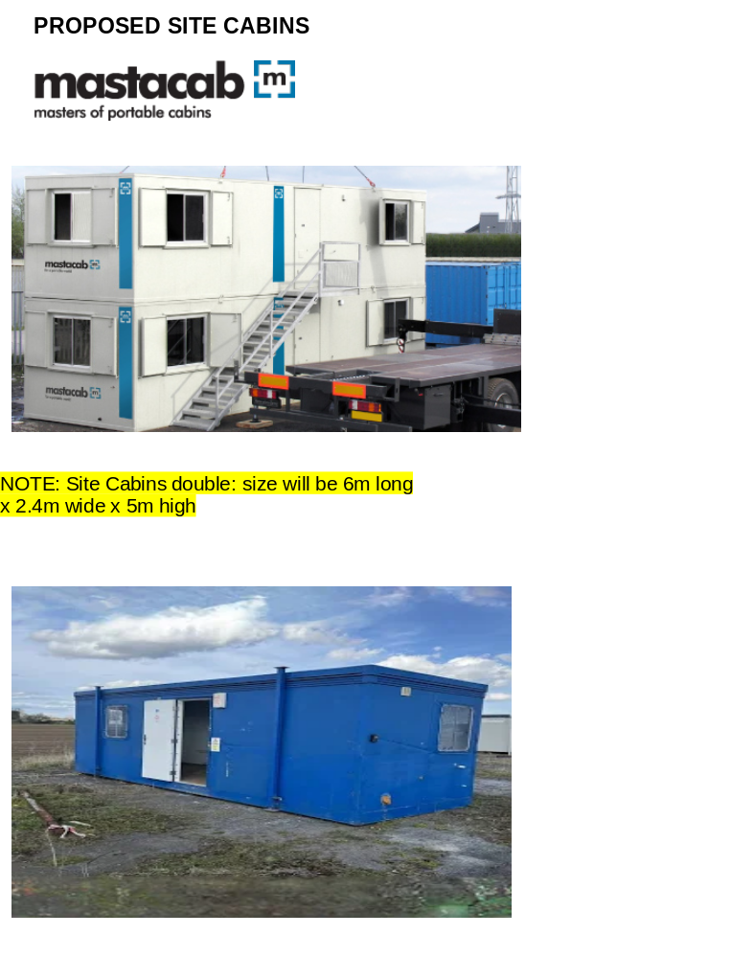

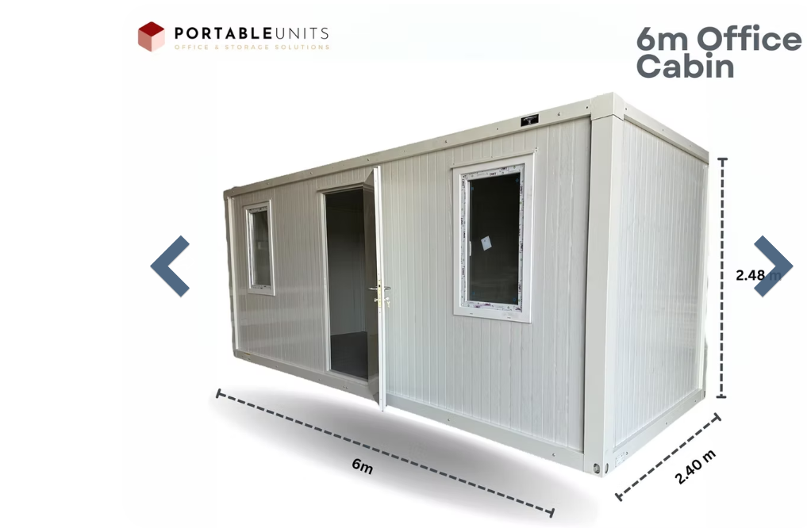

Accommodation
From offices to canteen and welfare units our range of portable cabins provide a flexible, safe and comfortable environment.

Elite anti-vandal portable cabins
- New, modern cabins
- Clean white interior and exterior finish
- Electric heating/lighting
- Supplied with high quality furniture
- Available in a variety of sizes
- Electric handwash facilities

Also available as an
ECO cabin

Standard anti-vandal portable cabins
- Ideal for use as site offices and canteens
- Supplied with furniture
- Available in a variety of sizes
- Gas or electric heating/lighting/cooking
- Gas or electric handwash facilities

Also available as an
ECO cabin

Mastacab ECO anti-vandal range
All of our portable cabins are available as an ECO option. The Mastacab Eco range uses environmentally friendly designs that can help you achieve an excellent BREEAM rating while saving energy and reducing your operating costs. Our sustainable designs can also help you become Considerate Constructors Scheme certified.
The Mastacab ECO range includes:
- Timers and thermostats on heaters
- Low energy T5 lighting
- Passive infrared motion detectors on lights
- Low volume dual flush WC
- Push button taps to prevent taps being left on

