

Planning

Delegated Officer Report

Summary of application details
Application reference: | PLA-2026-000703
Application type: | Listed building consent (Alt/Ext)
Proposal: | Listed Building Consent for internal fitout, 3 ATMs, air inlet and outlet points to the windows, and roof plant.
Site address: | Ground Floor Alliance House 30 Cross Street Manchester M2 7AQ
Ward(s): | Deansgate
Date application valid: | 12 August 2026
Applicant name: | Mr Miguel Perez Tallon
Agent (if any): | Mr Simon Bird
Case officer: | Ciara Gettinby
Recommendation: | Approve
Date of recommendation: | 30 September 2026

Description of site, building and/or area
This application for Listed Building Consent relates to The Ground Floor Unit of 30 Cross Street, Alliance House, a Grade II listed building. The property and therefore site is located in the St Anns Square Conservation Area (1970). The building itself is four storeys and currently operates on the ground floor as a Santander Bank and the upper floors are in use as offices or unused spaces. Also located in the vicinity are, 25 St Ann Street (Grade II* Listed Building), 17-23 St Anns Square (Grade II Listed Building), 34-36 St Ann Street (Grade II Listed Building), and Former Lloyds Bank, 53 King Street (Grade II Listed Building).

The surrounding area is commercial in nature, with many different uses such as, café’s, restaurants, commercial shops and drinking establishments up and down Cross Street. St Ann’s Street is quieter in nature and leads onto St Ann’s Square where there are more commercial establishments. The area is characterised by its retention of historic buildings and features and is popular visitor destination because of this.

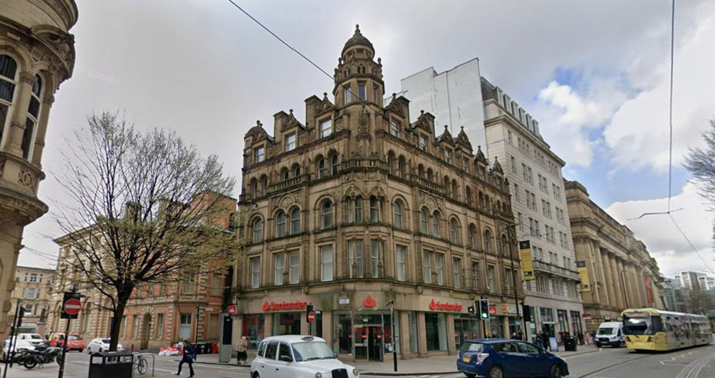

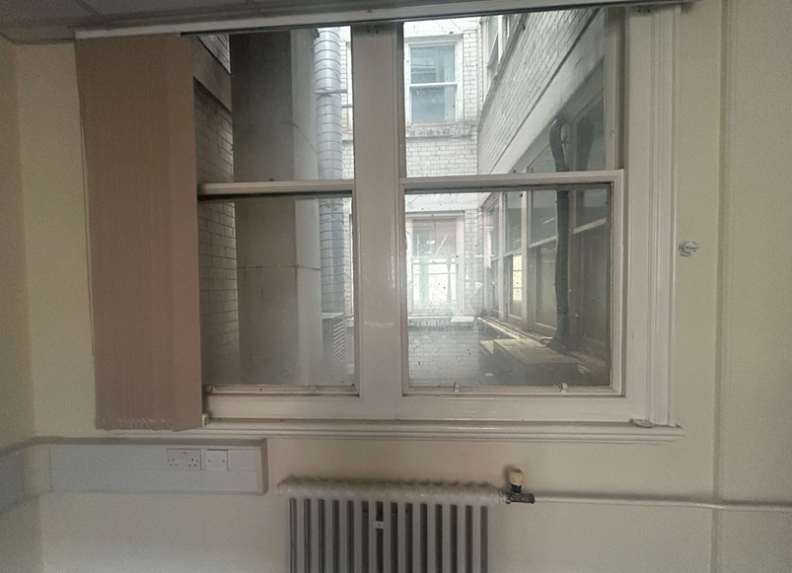

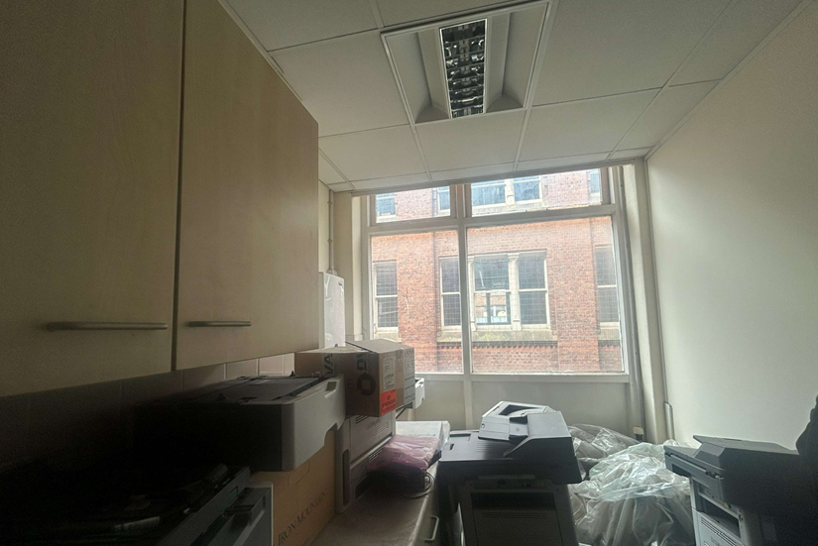

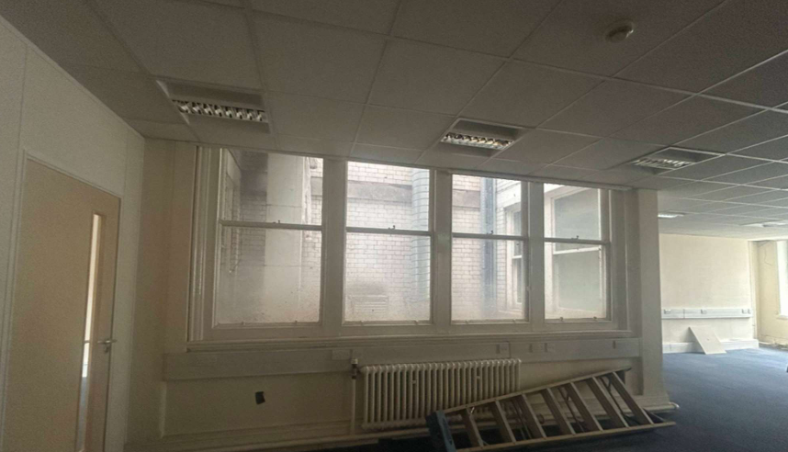

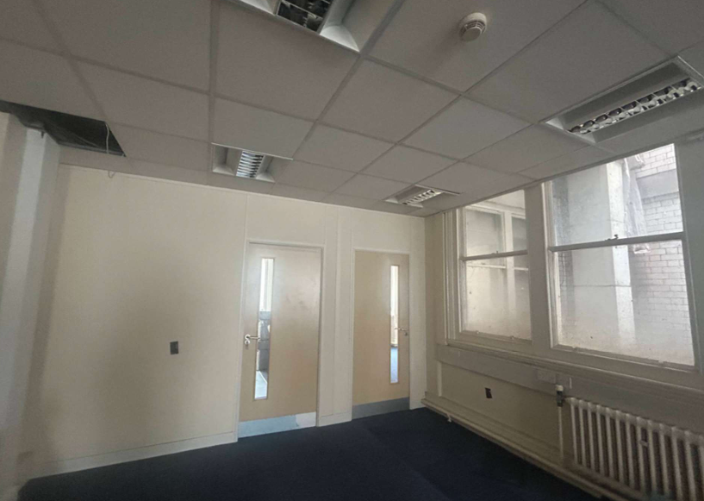

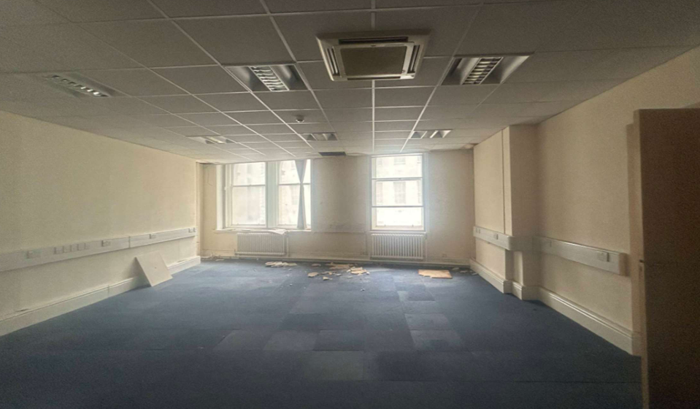

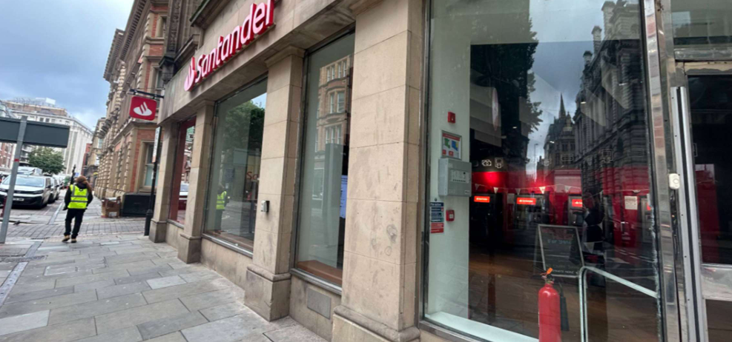

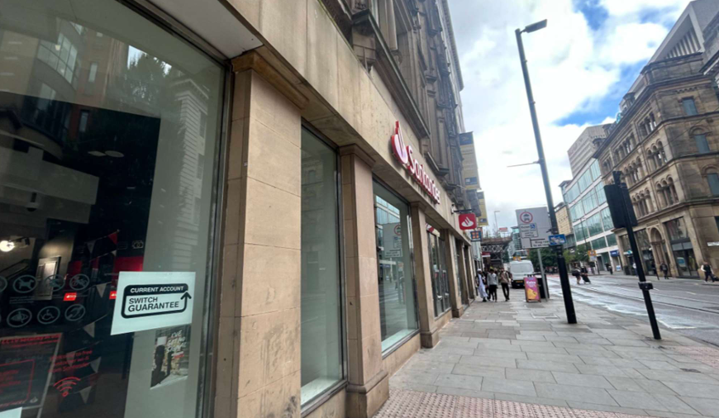

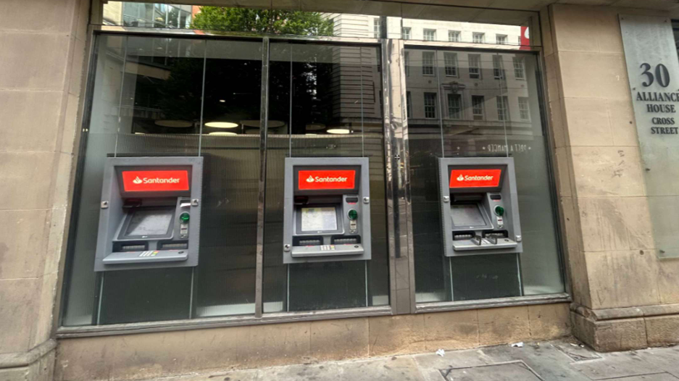

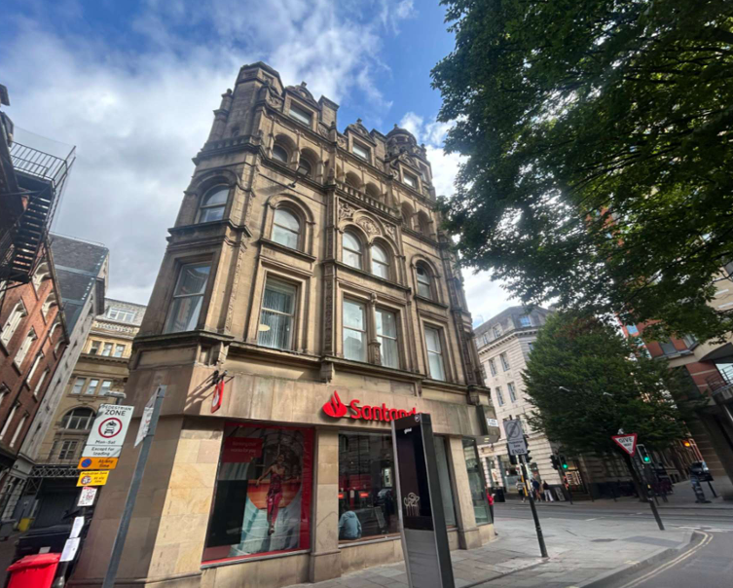

Description of development
Listed Building Consent is sought for the following works:

Ground floor: the replacement of internal and external ATMs, replacement of projecting signs, instillation of vinyl, instillation of internal display, removal of two internal walls to allow access to the stairwell, installation of two air extract vents to the ceiling and replacement of existing fan.

First floor: removal of existing bathrooms and walls, creation of new storerooms, insertion of new bathrooms, insertion of louvres in the internal lightwell, replacement of heaters and ventilation systems.

Second floor: removal of two internal walls and existing staff room, insertion of walls to create a meeting room, staff room, admin room and semi-private meeting rooms, insertion of louvres into internal lightwell, removal of air conditioning systems and addition of new air conditioning systems.

Roof: installation of three new plants to the roof.

This application has been submitted in relation to a Full Planning Application, ref- PLA-2026-001033 and an Advertisement Consent, ref- PLA-2026-000710, approved in September 2026.

The cumulative works are to support a shared working space on the first and second floor and to improve/ relocate facilities such as the staff rooms, bathrooms and office meeting rooms.

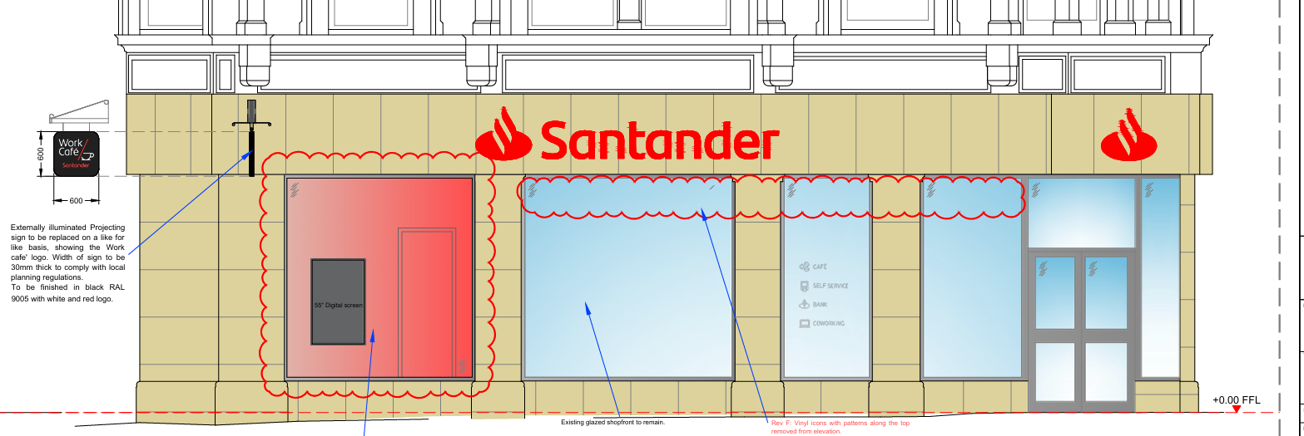
Ground Floor Elevation

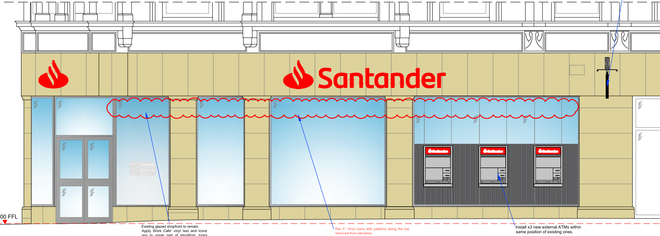
Ground Floor Elevation
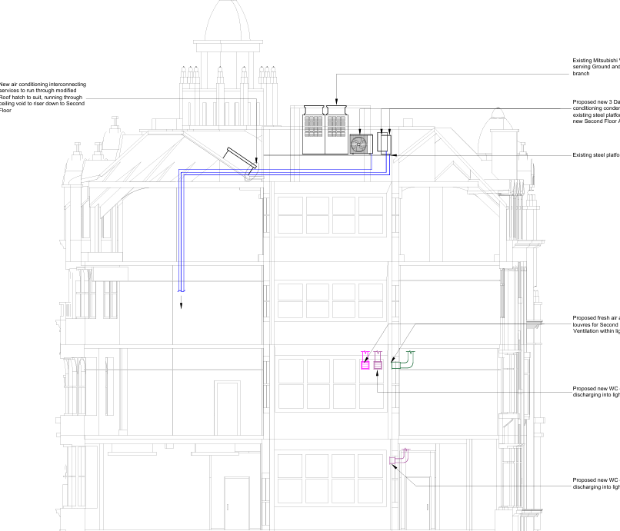
Side Elevation (Adjoining)
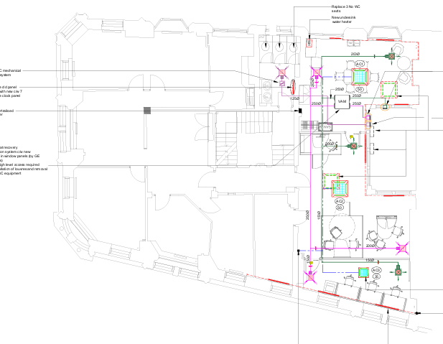
Proposed second floor plan
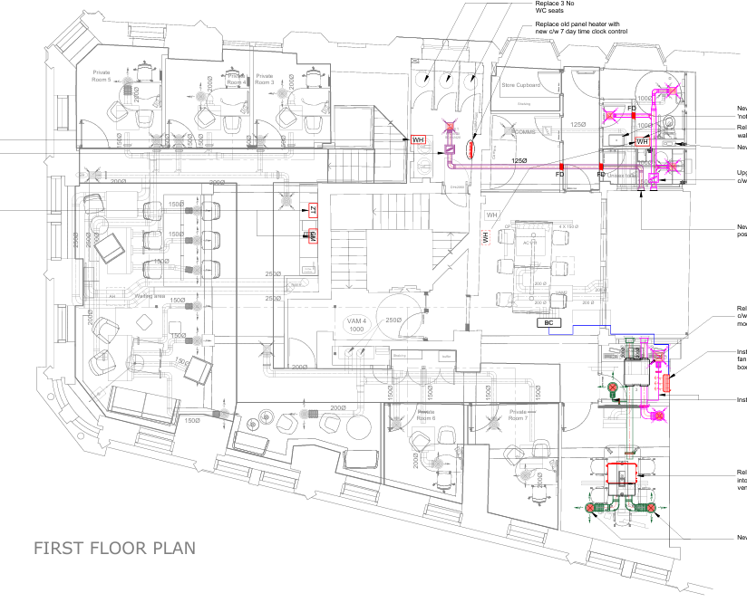
Proposed first floor plan
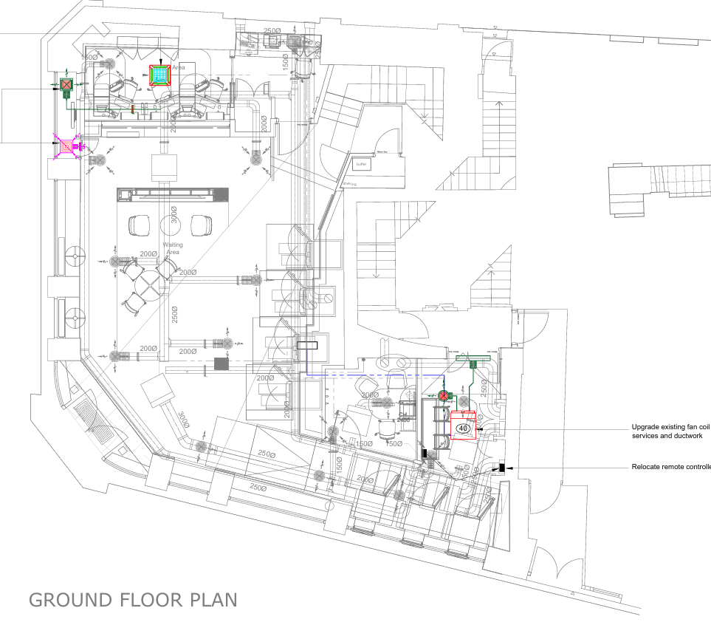
Proposed ground floor plan

Consultation, notification and publicity responses

Consultations

None.

Notifications and publicity
Occupiers of neighbouring buildings were notified of the proposal via notification letters. No representations have been received.

Relevant policies
The following policies are considered relevant in the consideration of this application:

Places for Everyone- A long term plan of nine Greater Manchester districts for jobs, new homes and sustainable growth, it has been published by the GMCA on behalf of the nine districts (Bolton, Bury, Rochdale, Oldham, Tameside, Stockport, Manchester, Trafford, Salford, Wigan) and took into effect and become part of the statutory development plan on March 21, 2024.

-Policy JP-P1: Sustainable Places
-Policy JP-P2: Heritage
-Policy JP-Strat2: City Centre

Unitary Development Plan (UDP)- The UDP has been superseded by the Core Strategy Development Plan, but certain policies are still considered of relevance:

-Policy DC19- Listed Buildings
-Policy DC18- Conservation Areas

The Manchester Core Strategy- Development Plan Document 2012- 2027 (The Core Strategy) was adopted by the City Council on the 11th of July 2012, it is a key document for the local plan which provides a framework that planning applications are assessed against.

Policy DM1- Development Management
Policy SP1- Spatial Principles
Policy EN1- Design Principles and Strategic Character Areas
Policy EN3- Heritage
Policy CC9: Design and Heritage

The National Planning Policy Framework (August 2026)- The Government’s new national planning policies and how they are to be implemented through local authorities.

Policy DP3- Key principles for well-designed places
Policy HE5: Assessing effects on heritage assets
Policy HE6- Proposals affecting designated heritage assets
Policy HE9: Conservation Areas

Other Legislative Requirements Planning (Listed Buildings and Conservation Areas) Act 1990

Section 66 – For development which affects a listed building or its setting, the local planning authority shall have special regard to the desirability of preserving the building or its setting.

Section 72- Special attention shall be paid to the desirability of preserving or enhancing the character of appearance of that area.

Assessment
In determining whether proposed works are acceptable, the main issue to consider is the impact the proposed works will have on the historic character and fabric of the listed building itself and to establish whether the public benefits, including heritage benefits of the proposal that would outweigh any harm to the significance of the heritage asset.

Principle
The proposed works would facilitate the continued use on the ground floor and first floor of the building and re-introduce occupation and use of the second floor. It is not expected that the proposed development would create an unacceptable impact on the visual amenity of the Grade II Listed Building or nearby heritage assets, these matters are set out below.

Impact on The Listed Building and Public Benefits
As set out in Policy HE5 of the National Planning Policy Framework (August 2026) development proposals affecting heritage assets should be accompanied by their assessment of the significance of assets affected, the level of detail should be proportionate to the asset’s importance. Upon assessment, the outside of the building is considered to have great heritage significance, due to its architectural detailing. However, the internal layout of the building has undergone modern alterations and as a result, holds low heritage value.

The removal of the internal walls throughout the scheme is considered acceptable given that all of them are of modern interventions and hold low heritage significance. The replacement of the internal and external ATMs is considered to result in harm, given that it would be introducing modern equipment, however, the shop front is clearly a modern addition, and ATMs have been a feature of the ground floor unit since the occupation of the bank. The replacement of the ATMs would retain the existing panelling along the glazing, and although this would reduce the visibility in the building, is considered to be acceptable in this instance so as to reduce the risk of crime and provide privacy for the users of the ATM.

The development includes the replacement and relocation of air conditioning units in the first and second floor, including vents attached to the ceiling across the first, second and ground floor. These works would be fixed to modern walls and would not be visible from the street scene or public view. The works therefore are not considered to have an adverse effect on its historic character and would therefore be in line with Policy DC19 of the UDP.

The roof plants would not be visible from the public view as the roof form would conceal the proposed. The units would not affect the building line or view of the roof form for the Listed Building and surrounding heritage assets. Furthermore, the insertion of the louvres to the first floor and second floor would be located in the windows of the internal lightwell, therefore, they would only be seen internally and would not be visible to the public view. Although these works would result in harm, the works would be concealed from the street scene and public view.

The proposal would also include internal vinyls and an internal display. The proposed vinyls would be applied internally and would offer essential information and new information on the proposed facilities on the ground, first and second floor. The vinyls would be minimal in scale and would still provide a certain degree of visibility into the shopfront. The internal display would have a neutral image, so not to detract from the heritage significance of the building. Although this would reduce the visibility along the shopfront, is required due to security in relation to the nature of the bank and is therefore considered acceptable. This would result in harm to the building, however in this instance the public benefits of the use of the ground floor as a bank, outweigh this harm.

The proposed works would continue to facilitate the use of the building at ground floor and first floor level. The proposed works would restore the second floor and re-instate occupation at this level, therefore benefiting the heritage asset through continuing its occupation and use. As discussed in Policy HE6 of the National Planning Policy Framework, ‘important public benefits can include securing the long-term reuse of a vacant or underused listed building’ the harm caused by the works is outweighed by the public benefits it would bring in re-using the vacant second floor and supporting the use of the ground and first floor. Whilst it is necessary to have special regard to the desirability of preserving the building, there are sufficient benefits for this in this particular case.

Recommendation: APPROVE

Other Legislative Requirements

Equality Act 2010
Section 149 (Public Sector Equality Duty) of the Equality Act 2010 requires due regard to the need to: Eliminate unlawful discrimination, harassment and victimisation and other conduct prohibited by the Act and; Advance equality of opportunity between persons who share a protected characteristic and persons who do not share it. The Equality Duty does not impose a legal requirement to conduct an Equality Impact Assessment. Compliance with the Equality Duty involves consciously thinking about the aims of the Equality Duty as part of the process of decision-making.

Human Rights Act 1998 considerations
This application needs to be considered against the provisions of the Human Rights Act 1998. Under Article 6, the applicants (and those third parties, including local residents, who have made representations) have a right to a fair hearing and to this end the local planning authority must give full consideration to their comments.

Protocol 1 Article 1, and Article 8 where appropriate, confer(s) a right of respect for a person’s home, other land and business assets. In taking account of all material considerations, including Council policy as set out in the Core Strategy and saved polices of the Unitary Development Plan, the Director of Planning, Building Control & Licensing has concluded that some rights conferred by these articles on the applicant(s)/objector(s)/resident(s) and other occupiers and owners of nearby land that might be affected may be interfered with but that that interference is in accordance with the law and justified by being in the public interest and on the basis of the planning merits of the development proposal. She believes that any restriction on these rights posed by the recommendation given is proportionate to the wider benefits of and that such a decision falls within the margin of discretion afforded to the Council under the Town and Country Planning Acts.

Conclusion
Given the above issues, it is considered that the proposal is acceptable in terms of its principle, visual amenity, impact on the conversation area and on the Listed Building and setting of surrounding Listed Buildings as it broadly complies with the saved Policy DC19 and DC18 of the UDP, Policies DM1, SP1, EN1, EN3, CC9 and EC3 of the Manchester Core Strategy and Policy DP3, HE5, HE6 and HE9 of the National Planning Policy Framework and Policies JP-P1, JP-P2 and JP-Strat2 of the Places for Everyone Joint Development Plan Document.

Article 35 Declaration
Officers have worked with the applicant in a positive and proactive manner based on seeking solutions to problems arising in relation to dealing with the planning application. No significant problems have arisen during the consideration of this application, and the application has been determined in a timely manner, in accordance with the policies with the development plan.

Recommendation: Approve

Conditions attached to this decision
- The development must have begun no later than the expiration of three years beginning with the date of permission. Required to be imposed pursuant to Section 91 of the Town and Country Planning Act of 1990.

Reason - Required to be imposed pursuant to Section 91 of the Town and Country Planning Act of 1990.

- Specified plans
The development hereby approved shall be carried out in accordance with the following documents:

Proposed St Ann’s Street Elevation, ref- Manchester 34CS-SI-EL-EX-PR, received by the City Council as LPA on the 11 September 2026.
Proposed Cross Street Elevation, ref- Manchester 34CS-FR-EL-EX-PR, received by the City Council as the LPA on the 11 September 2026.
Proposed Rear Elevation, ref- C27049-05, received by the City Council as the LPA on the 30 September 2026.
Proposed First Floor plan, ref- Man-CS-HVAC-02, received by the City Council as the LPA on the 30 September 2026
Proposed Second Floor plan, ref- Man-CS-HVAC-03, received by the City Council as the LPA on the 30 September 2026.
Proposed Ground Floor plan, ref- Man-CS-HVAC-01, received by the City Council as the LPA on the 24 July 2026.
Proposed Roof Cross Section, ref- C27049-06, received by the City Council as the LPA on the 30 September 2026.
Location plan, ref- PP-15084431v1, received by the City Council as the LPA on the 15 July 2026.
Proposed roof plan, ref- C27049-04, received by the City Council as the LPA on the 15 July 2026.

Reason- to ensure that the development is carried out in accordance with the approved plans, pursuant to saved policy DC1 of the Unitary Development Plan for the City of Manchester and policies SP1 and DM1 of the Manchester Core Strategy.

