

Planning

Delegated Officer Report

Summary of application details
Application reference: | PLA-2026-001033
Application type: | Full planning permission
Proposal: | Installation of 3 external ATMs, installation of air inlet and outlet points and of roof plants.
Site address: | Ground Floor Alliance House 30 Cross Street Manchester M2 7AQ
Ward(s): | Deansgate
Date application valid: | 12 August 2026
Applicant name: | Mr Miguel Perez Tallon
Agent (if any): | Mr Simon Bird
Case officer: | Ciara Gettinby
Recommendation: | Approve
Date of recommendation: | 21 September 2026

Description of site, building and/or area
This application for full planning permission relates to The Ground Floor Unit of 30 Cross Street, Alliance House, a Grade II listed building. The property and therefore site is located in the St Anns Square Conservation Area (1970). The building itself is four storeys and currently operates on the ground floor as a Santander Bank and the upper floors are in use as offices or unused spaces. Also located in the vicinity are, 25 St Ann Street (Grade II* Listed Building), 17-23 St Anns Square (Grade II Listed Building), 34-36 St Ann Street (Grade II Listed Building), and Former Lloyds Bank, 53 King Street (Grade II Listed Building).

The surrounding area is commercial in nature, with many different uses such as, café’s, restaurants, commercial shops and drinking establishments up and down Cross Street. St Ann’s Street is quieter in nature and leads onto St Ann’s Square where there are more commercial establishments. The area is characterised by its retention of historic buildings and features and is popular visitor destination because of this.

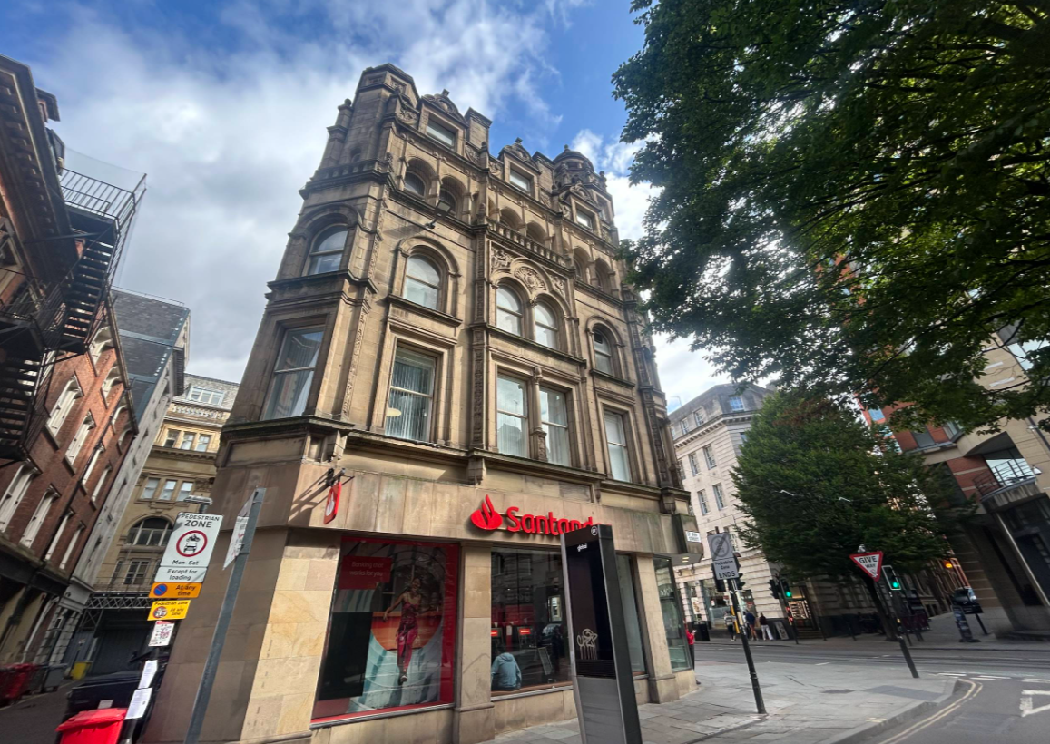

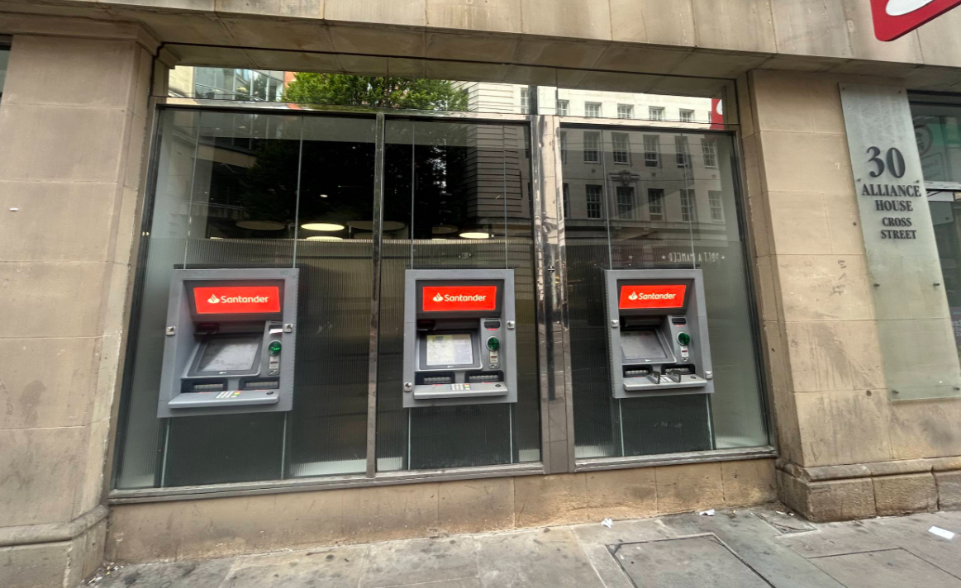

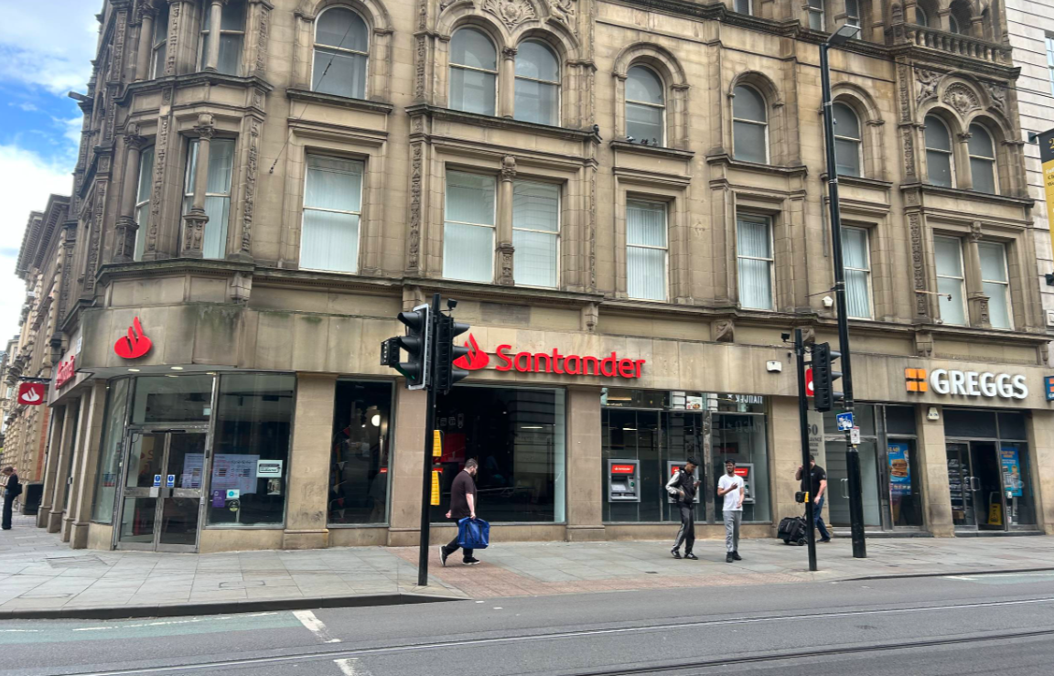

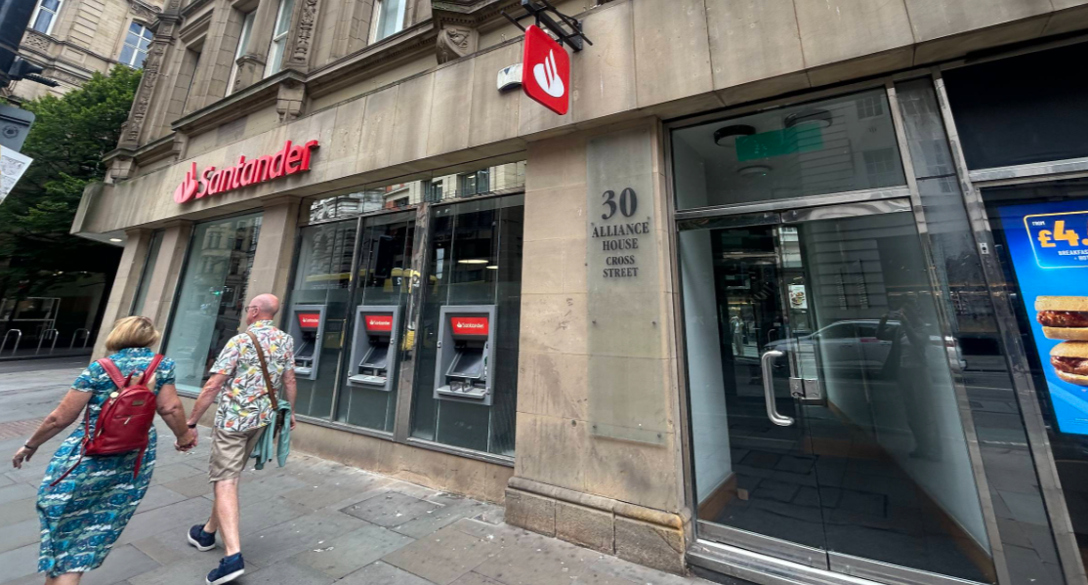

Description of development
Planning permission is sought for the installation of three external ATMs in replacement of existing ATMs and the installation of a roof plant.

The ATMs would be installed on the east elevation of Alliance House and would measure approximately 2m in length and 1.4m in width and therefore would be slightly larger than the existing ATMs. They would be located at 1.5m above ground floor level.

The proposed louvers would be located in the internal lightwell of the first and second floor the proposed materials to be used would be plastic coloured to be white.

This application has been submitted in relation to a Listed Building Consent, ref- PLA-2026-000703 and an Advertisement Consent, ref- PLA-2026-000710.

The cumulative works are to support a shared working space on the first and second floor and to improve facilities such as the staff rooms, bathrooms and office meeting rooms.

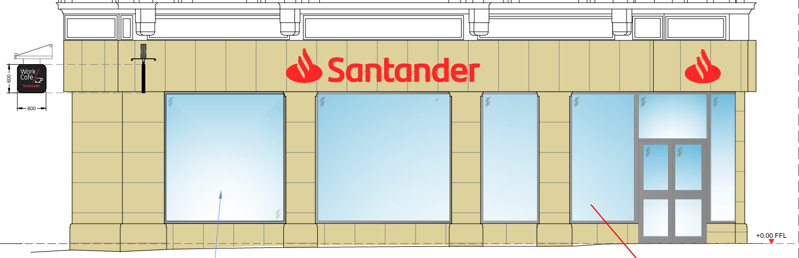
St Anne’s St Elevation

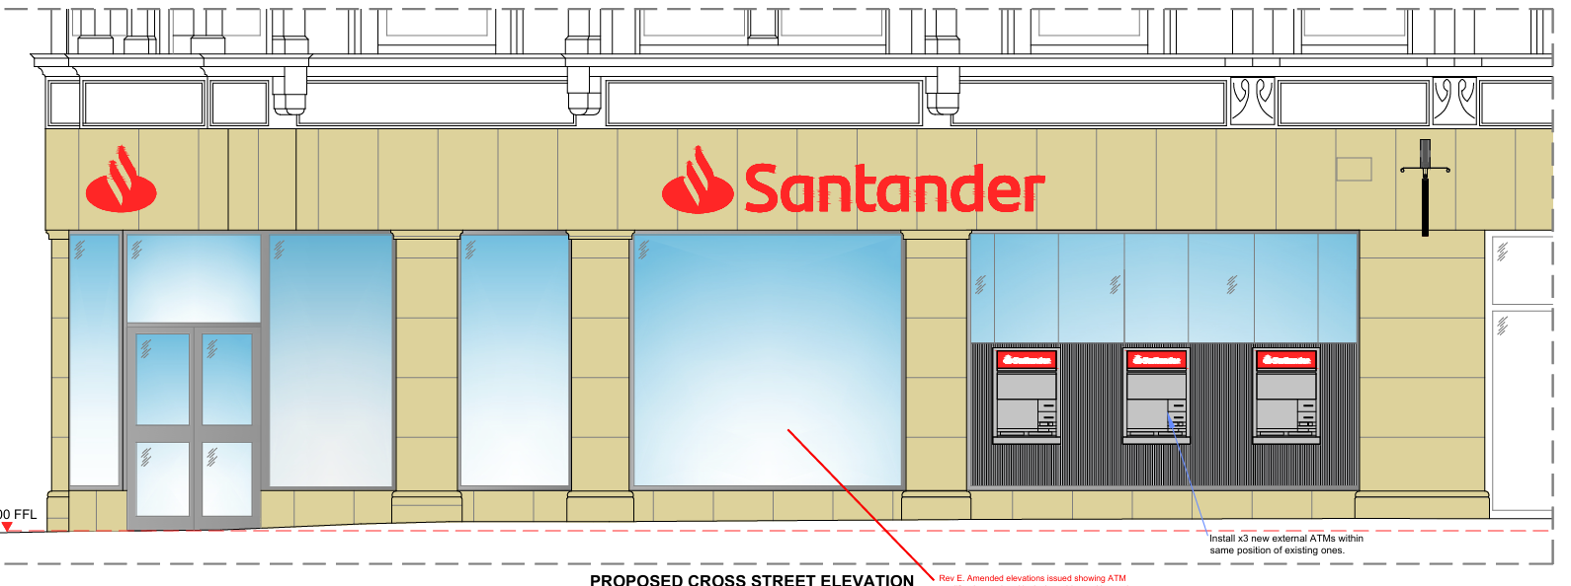
Proposed ATMs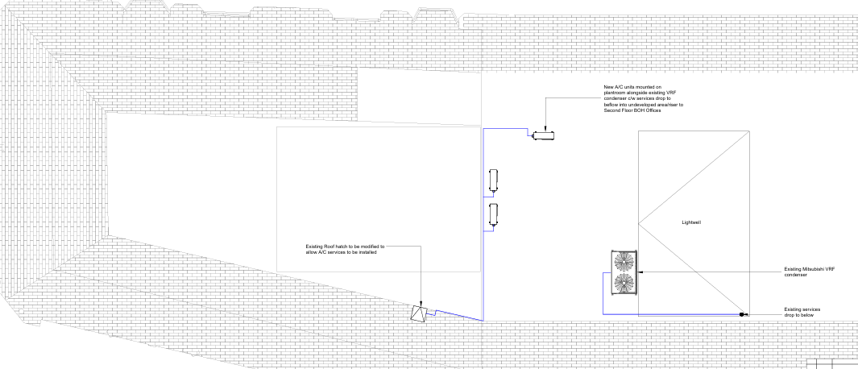
Proposed roof plants
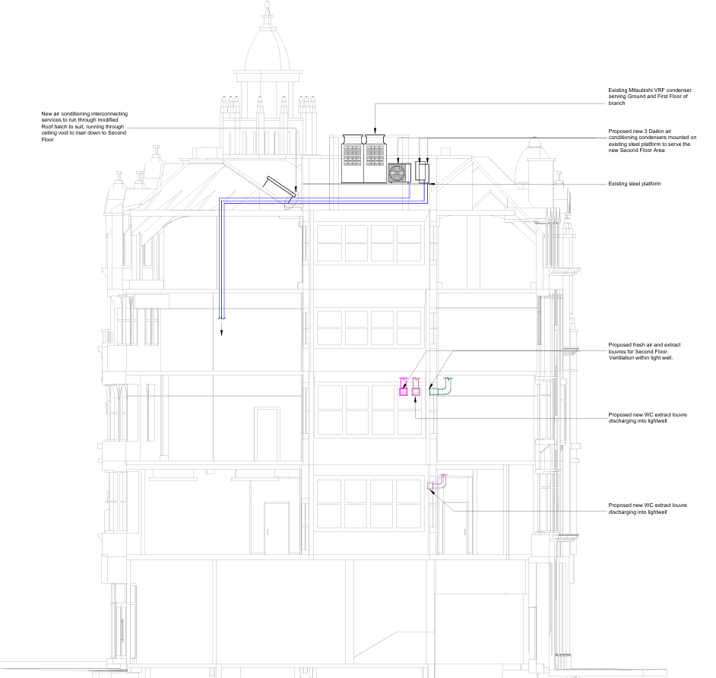
Proposed Roof Plant and air inlet and outlet points

Consultation, Notification and Publicity Responses

Consultations

MCC Highway Services- No objections to the proposal but have recommended an informative to be attached.

Environmental Health- No objections to the proposal but have recommended a condition to be attached to control any noise from the roof plant.

Greater Manchester Police- No objections to the proposal but have recommended standard measures to be incorporated that have been attached as a condition.

Notifications and publicity

Neighbouring properties have been notified of the proposed development; no representations have been received.

Relevant policies
The following policies are considered relevant in the consideration of this application:

Places for Everyone- A long term plan of nine Greater Manchester districts for jobs, new homes and sustainable growth, it has been published by the GMCA on behalf of the nine districts (Bolton, Bury, Rochdale, Oldham, Tameside, Stockport, Manchester, Trafford, Salford, Wigan) and took into effect and become part of the statutory development plan on March 21, 2024.

-Policy JP-P1: Sustainable Places
-Policy JP-P2: Heritage
-Policy JP-Strat2: City Centre

Unitary Development Plan (UDP)- The UDP has been superseded by the Core Strategy Development Plan, but certain policies are still considered of relevance:

-Policy DC19- Listed Buildings
-Policy DC18- Conservation Areas

The Manchester Core Strategy- Development Plan Document 2012- 2027 (The Core Strategy) was adopted by the City Council on the 11th of July 2012, it is a key document for the local plan which provides a framework that planning applications are assessed against.

Policy DM1- Development Management
Policy SP1- Spatial Principles
Policy EN1- Design Principles and Strategic Character Areas
Policy EN3- Heritage
Policy CC9: Design and Heritage

The National Planning Policy Framework (August 2026)- The Government’s new national planning policies and how they are to be implemented through local authorities.

Achieving sustainable development

Policy S3- Presumption in favour of sustainable development

Achieving well-designed places

Policy DP3- Key principles for well-designed places
Policy DP4- The design process

Other Legislative Requirements Planning (Listed Buildings and Conservation Areas) Act 1990

Section 66 – For development which affects a listed building or its setting, the local planning authority shall have special regard to the desirability of preserving the building or its setting.

Section 72- Special attention shall be paid to the desirability of preserving or enhancing the character of appearance of that area.

Assessment

Principle
The replacement of the ATMs, are supported in principle as they are a useful amenity that is frequently used by members of the public. The installation of the roof plant and the air inlet and outlet points are also accepted in principle considering it facilitates ventilation and the operation of the working spaces at first and second floor level. However, consideration must be given to the proposals siting and visual amenity, noise, highway safety and crime and safety.

Siting & Visual Amenity
Considering the existing ATMs at the applicant site on Cross Street, the proposed ATMs would not significantly impact the visual amenity of the building and surrounding area. The existing windows and panelling would be retained, and the total amount of ATMs would remain the same. Given the small increase in size, the replacement ATMs would not be out of character with the surrounding commercial character of the applicant site and street, and considering the precedent set by the existing ATMs, is considered acceptable.

The proposed air inlet and outlet points located on the first and second floor would be located in the buildings internal lightwell. Four ventilation points are proposed in total, which would be concealed and would not be visible from any public spaces. Each inlet and outlet point would be fixed into the glazing. The insertion of the louvres would provide ventilation to the first and second floor and therefore support the continued use of these floors.

The proposed three roof plants are not considered to be visible from the street scene and therefore is concealed from public view within the roof form. The addition of the plants are not considered to significantly alter the roof form or impact on the existing roof form of neighbouring buildings. The current roof features existing plants that support the use of the building and the addition of the proposed would be acceptable considering that it would not be visible from the public view.

Overall, the scheme is not considered to significantly impact the visual amenity of the building and surrounding area, especially considering the proposed louvres and roof plants would not be visible from the public view. Therefore, the development is considered to be in accordance with Policy DM1 and SP1 of the Core Strategy, Policy JP-P1 and Policy JP-Strat2 of the Places for Everyone Joint Development Document, and Policy S3 and DP3 of the National Planning Policy Framework (August 2026).

Impact on the Listed Building and the Conservation Area

The ATM equipment would be located in a Grade II listed building. The building significance is derived from its ornate façade. The application site is also located in the St Anns conservation area. The significance of the conservation area is derived from its collection of buildings which represent the commercial heart of the city centre.

The inclusion of modern ATM equipment into the shop frontage would cause harm. The shop front is clearly a modern addition, and ATMs have been a feature of the ground floor unit since the occupation of the bank. The insertion of the louvres are also considered to cause harm, however as they are located in the internal lightwell, they would not be visible from the street scene or from public view and therefore is considered acceptable.

In line with policy HE6 of the NPPF, harm should be outweighed by the public benefits. The occupation of the unit remains a priority on such a key route in the city centre. The ATM equipment is key to the banks high street offer and the long term occupation of the listed building. The public benefits in this regard outweigh the low level of harm.

Noise
Environmental Health Officers have recommended a condition regarding the noise levels of the proposed roof plant in order to manage the background noise levels around the site. This will ensure that the roof plant and any possible noise would be monitored so as to comply with Policy DM1 of the Core Strategy.

Highway Safety
Considering that Highway Officers are satisfied with the proposed, the ATMs are not considered to cause any harm to pedestrians or vehicle movements along Cross Street. The street is sufficiently wide to accommodate future users and queuing. Given this, the proposal is considered to be in accordance with Policy DM1 of the Core Strategy for the City of Manchester.

Crime and Safety
Further measures have been recommended by Greater Manchester Police to protect future users of the site and reduce the risk of crime, the measures are as follows,

-The area around the ATMs should be lit to an adequate and uniform level, so as not to allow any areas of pooling/shadowing.
-The proposed ATMs should be covered by a CCTV system that should view the area and the users of the ATMs, but not the ATM keypads themselves.
-The ATMs themselves should be securely anchored, alarmed and should include a banknote degradation system or similar – in-line with ATM Security Working Group Guidelines.
-Defensible space ground markings (e.g. 1sqm. painted area, change in surface texture, metal studs within paving etc.) should be employed and maintained at the front of the ATMs to indicate that only one user at a time may enter the space.

Other than implementing these features, Greater Manchester Police have no objections to the proposal. The agent has confirmed the intent to implement the aforementioned measures, and this will be conditioned, attached to this report and the decision notice.

Other Legislative Requirements

Equality Act 2010
Section 149 (Public Sector Equality Duty) of the Equality Act 2010 requires due regard to the need to: Eliminate unlawful discrimination, harassment and victimisation and other conduct prohibited by the Act and; Advance equality of opportunity between persons who share a protected characteristic and persons who do not share it. The Equality Duty does not impose a legal requirement to conduct an Equality Impact Assessment. Compliance with the Equality Duty involves consciously thinking about the aims of the Equality Duty as part of the process of decision-making.

Human Rights Act 1998 considerations
This application needs to be considered against the provisions of the Human Rights Act 1998. Under Article 6, the applicants (and those third parties, including local residents, who have made representations) have a right to a fair hearing and to this end the local planning authority must give full consideration to their comments.

Protocol 1 Article 1, and Article 8 where appropriate, confer(s) a right of respect for a person’s home, other land and business assets. In taking account of all material considerations, including Council policy as set out in the Core Strategy and saved polices of the Unitary Development Plan, the Director of Planning, Building Control & Licensing has concluded that some rights conferred by these articles on the applicant(s)/objector(s)/resident(s) and other occupiers and owners of nearby land that might be affected may be interfered with but that that interference is in accordance with the law and justified by being in the public interest and on the basis of the planning merits of the development proposal. She believes that any restriction on these rights posed by the recommendation given is proportionate to the wider benefits of and that such a decision falls within the margin of discretion afforded to the Council under the Town and Country Planning Acts.

Conclusion
Given the above issues, it is considered that the proposal is acceptable in terms of its principle, visual amenity, noise, highway safety, and crime and safety as it broadly complies with the saved Policy DC19 and DC18 of the Unitary Development Plan for the City of Manchester, Policies DM1, SP1, EN1, EN3, CC9 and EC3 of the Manchester Core Strategy and Chapter 8, 12 and 16 of the National Planning Policy Framework and Policies JP-P1, JP-P2 and JP-Strat2 of the Places for Everyone Joint Development plan document.

Article 35 Declaration: Officers have worked with the applicant in a positive and proactive manner based on seeking solutions to problems arising in relation to dealing with the planning application. No significant problems have arisen during the consideration of this application, and the application has been determined in a timely manner, in accordance with the policies with the development plan.

Recommendation: APPROVE

Conditions attached to this decision

- Time
The development must have begun no later than the expiration of three years beginning with the date of permission. Required to be imposed pursuant to Section 91 of the Town and Country Planning Act of 1990.

Reason - Required to be imposed pursuant to Section 91 of the Town and Country Planning Act of 1990.

2) Specified Plans

The development hereby approved shall be carried out in accordance with the following documents:

Proposed St Ann’s Street Elevation, ref- Manchester 34CS-SI-EL-EX-PR, received by the City Council as LPA on the 11 September 2026.
Proposed Cross Street Elevation, ref- Manchester 34CS-FR-EL-EX-PR, received by the City Council as the LPA on the 11 September 2026.
Proposed Rear Elevation, ref- C27049-05, received by the City Council as the LPA on the 30 September 2026.
Proposed First Floor plan, ref- Man-CS-HVAC-02, received by the City Council as the LPA on the 30 September 2026
Proposed Second Floor plan, ref- Man-CS-HVAC-03, received by the City Council as the LPA on the 30 September 2026.
Proposed Ground Floor plan, ref- Man-CS-HVAC-01, received by the City Council as the LPA on the 24 July 2026.
Proposed Roof Cross Section, ref- C27049-06, received by the City Council as the LPA on the 30 September 2026.
Location plan, ref- PP-15084431v1, received by the City Council as the LPA on the 15 July 2026.
Proposed roof plan, ref- C27049-04, received by the City Council as the LPA on the 15 July 2026.

Reason- to ensure that the development is carried out in accordance with the approved plans, pursuant to saved policy DC1 of the Unitary Development Plan for the City of Manchester and policies SP1 and DM1 of the Manchester Core Strategy.

- Security
The following security measures shall be completed within two months of the installation of the ATM and shall be retained for the duration of the use of the building:

- The area around the ATM shall be lit to an adequate and uniform level, so not to allow any areas of pooling/ shadowing.
- Defensible space ground markings (e.g. 1sqm. Surrounded by metal studs or change in surface texture within paving) shall be employed- The proposed ATM shall be covered by a CCTV system that shall view the areas and users of the ATM, but not the ATM keypad itself.
- The ATM itself shall be securely anchored, alarmed and shall include a banknote degradation system or similar -in-line with ATM Security Working Group Guidelines.
- Servicing shall be carried out within a secure area inside the host building or members of the public shall be excluded from the premises while servicing activities are carried out.
- Any yellow lines painted on the pavement shall be removed.

Evidence of the completion of these works shall be submitted to and approved in writing by the City Council as local planning authority within four months of the date that this application was approved.

Reason- To reduce the risk of crime pursuant to policies SP1 and DM1 of the Core Strategy and to reflect the guidance contained in the National Planning Policy Framework.

- External Plant

- The operation of the rooftop plant hereby approved shall be carried out in accordance with the approved technical note ‘A2501 TN01 Plant Noise Emissions Assessment’ dated 30th July 2026., received by the Local Planning Authority on 31 July 2026.
- Prior to the first operation of the rooftop plant hereby approved, a verification report, which will include post-completion testing, shall be submitted to and be approved in writing by the Local Planning Authority to validate that the rooftop plant achieve a rating level of 5dB (LAeq) below the typical background (LA90) level at the nearest noise sensitive location.
- In the event of non-conformity with a rating level of 5dB (LAeq) below the typical background (LA90) level at the nearest noise sensitive location, then any measures/changes required to achieve conformity shall be carried out. Any required measures/changes and verification shall continue until conformity has been achieved and agreed in writing by the Local Planning Authority, before operation of the rooftop plant hereby approved can commence.

Reason - To minimise the impact of the development and to prevent a general increase in pre-existing background noise levels around the site. Pursuant to policies SP1 and DM1 of the Core Strategy and saved policy DC26 of the UDP.

Informatives

- The applicant is required to discuss and agree any requirements for licensing, hoarding / scaffolding, skips and temporary access points (Section 50) with MCC's Highways Licensing Team via Email to: highwaylicences@manchester.gov.uk.

- The applicant is required to discuss and agree any requirements for temporary pedestrian and traffic management with MCC’s Event and Traffic Management Team via Email to highwaynetworkmanagement@manchester.gov.uk.

