

Planning

Delegated Officer Report

Summary of application details
Application reference: | PLA-2026-001325
Application type: | Full planning permission
Proposal: | Erection of 1no. outbuilding for use as gym and siting of 1no. storage container for use as storage, ancillary to existing building.
Site address: | Watkin Centre Claverton Road Manchester M23 9TT
Ward(s): | Baguley
Date application valid: | 17 August 2026
Applicant name: | Mr Nicholas Ledger
Agent (if any): | Mrs Rebecca Booth
Case officer: | Joshua Lee
Recommendation: | Approve
Date of recommendation: | 05/10/2026

Description of site, building and/or area
The proposal relates to a three storey detached Education Facility (Class F1). The site features car parking and play areas.
The site is bounded to the north, south and west by other office and commercial operations, with several other commercial, training, office and employment uses in the wider area.
Wythenshawe Hospital is sited to the immediate east of the application site. The site sits within the Roundthorn industrial estate area and is a location that contains a variety of industrial and commercial uses that require locations away from residential areas.

Description of development
Erection of 1no. outbuilding for use as gym and siting of 1no. storage container for use as storage, ancillary to existing building.

Outbuilding
The proposed outbuilding is located to the North western boundary and measures 9650mm x 2800mm and is 2700mm high. The outbuilding is finished in cedar wood cladding with UPVC glazing and fascia boards. The outbuilding would be used as a gym for ancillary use of the school.

Storage container
The proposed storage contained is located to the north western boundary and measures 3070mm x 2438mm and is 2591mm high. The container is a standard metal shipping container for use as storage in association with the school.
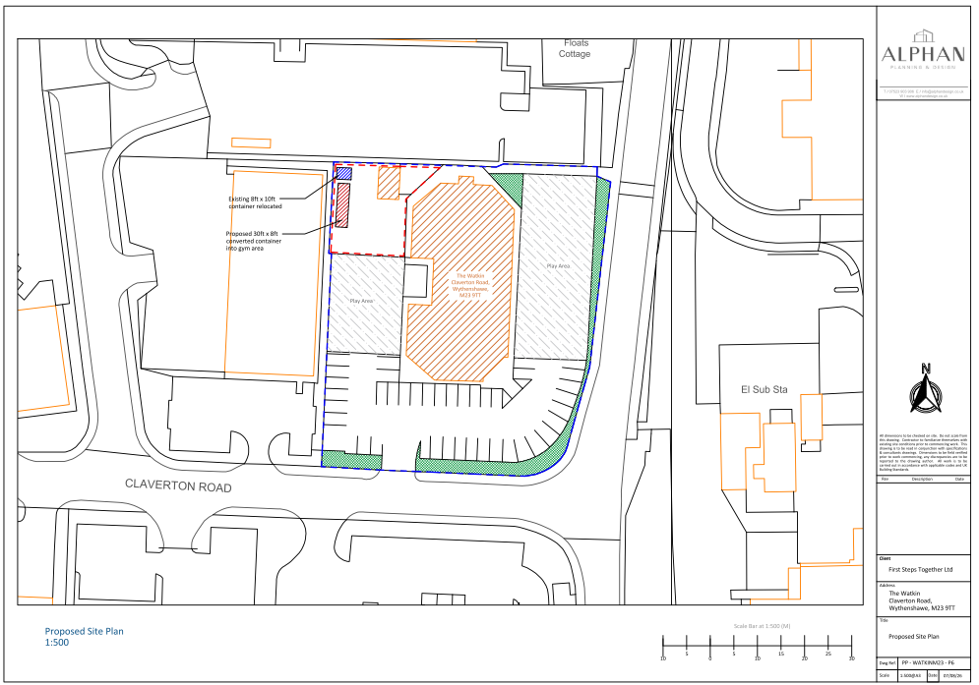
Figure 1. Proposed site plan

Relevant planning history

Planning Application - 142958/FO/2025
Change of use of Mulberry House from Class E (Offices) to Education Facility (Class F1)
Approve – 01/08/2025

Consultation, notification and publicity responses

Consultations

Highway Services
The Highway Authority has reviewed the proposal and raises no in-principle highway objections, subject to further clarification on several matters. It notes that the site is served by existing adopted highways and is reasonably accessible by sustainable transport, with regular bus services available within walking distance.

The Highway Authority requested confirmation and the applicant confirmed that:
- The proposed gym will be used solely by students and will not be available to external users.
- The existing vehicular access arrangements will remain unchanged.
- No existing parking spaces will be lost as a result of the siting of the two containers.
- The proposed development will not adversely affect existing servicing arrangements at the site.
The Highway Authority also advised that a Construction Management Plan should be secured prior to commencement, covering construction traffic, contractor parking, site set-up and management of construction activities. Following that advice, the applicant confirmed that the gym building and storage container had been installed, with the substantive delivery and construction activity completed. The remaining works are limited to electrical fit-out and decorating, to be undertaken outside normal school hours, with welfare facilities available within the main building. As the construction phase to which the requested controls principally relate has already taken place, a pre-commencement Construction Management Plan condition would no longer serve a practical planning purpose. Relevant informatives relating to highway licences and temporary traffic management remain appropriate where applicable.

Environmental Health
Environmental Health raises no objection to the proposal, subject to the operating hours of the gym being restricted. Having regard to the small scale of the proposed gym and the nature of the surrounding area, it is considered that a specific noise control condition would be unnecessarily onerous. Restricting the hours of use would provide appropriate control over noise associated with the gym.

Notifications and publicity

Neighbour letters
No responses received.

Relevant policies
In accordance with Section 38(6) of the Planning and Compulsory Purchase Act 2004, planning applications must be determined in accordance with the statutory development plan unless material considerations indicate otherwise.
For Manchester, the development plan comprises:
- The Manchester Core Strategy (2012 to 2027);
- Saved policies of the Manchester Unitary Development Plan (UDP); and
- The Places for Everyone Joint Development Plan Document (2022 to 2039).
These documents are considered up to date and are afforded significant weight in the determination of planning applications. Relevant Supplementary Planning Documents (SPDs) and other adopted guidance may also be material considerations.
The National Planning Policy Framework sets out the government’s policies for plan-making and for making decisions on development proposals in England. It is a material consideration of critical importance in both contexts.
Where relevant, the Council is required to give special regard to the desirability of preserving listed buildings and their settings, and special attention to the desirability of preserving or enhancing the character or appearance of conservation areas, in accordance with the Planning (Listed Buildings and Conservation Areas) Act 1990.
The policies and guidance referred to below are considered the most relevant to the scale, nature and location of the proposed development.
- The Manchester Core Strategy Development Plan Document 2012-2027
  - Development Management and Planning Obligations
    - DM 1 - Development Management
  - Objective 1 - Spatial Principles
    - SP 1 - Spatial Principles (Partially replaced by PfE Policy JP-S 1)
  - Objective 2 - Economy and the City Centre
    - EC 1 - Employment and Economic Growth in Manchester
    - EC 2 – Existing Employment Space
    - EC 10 – Wythenshawe
  - Objective 6 Environment
    - EN 1 - Design Principles and Strategic Character Areas
    - EN 19 – Waste
- Guide to development in Manchester - supplementary planning document and planning guidance, April 2007
- Extant Unitary Development Plan (UDP) –
  - Citywide Development Control Policies
    - DC26 - Development and Noise
  - Area 16 – West Wythenshawe
    - WW2 – Economic Development
- Places for Everyone Plan Joint Development Plan Document 2022-2039-
  - Strategy
    - JP-Strat9: Southern Areas
  - Sustainable and Resilient Places
    - JP-S1: Sustainable Development
  - Places for Jobs
    - JP-J1: Supporting Long-Term Economic Growth
    - JP-J2: Employment Sites and Premises
  - Places for People
    - JP-P1 Sustainable Places
    - JP-P5: Education, Skills and Knowledge
- National Planning Policy Framework – August 2026 - National Development Management Policies (NDMPs)
  - Procedural Policies
    - Chapter 3 – Decision-making policies
      - DM1: Preparing development proposals
      - DM2: Information requirements
      - DM3: Determining development proposals
      - DM6: Use of planning conditions and obligations
      - DM7: Relationship with other regulatory regimes
      - DM10: Removal of national permitted development rights
  - Sustainable Development
    - Chapter 4 - Achieving sustainable development
      - S3: Presumption in favour of sustainable development
      - S4: Principle of development within settlements
  - Delivering homes and supporting growth
    - Chapter 7 - Building a strong, effective economy
      - E2: Meeting the need for business land and premises
  - Creating high quality, sustainable places
    - Chapter 12 - Making effective use of land
      - L2: Making effective use of land
    - Chapter 14 - Achieving well-designed places
      - DP3: Key principles for well-designed places
      - DP4: The design process

Assessment

Principle of Development
The application seeks permission for the erection of an ancillary gym building and the siting of a storage container within the grounds of an established educational facility (Use Class F1). The proposed development would support the ongoing operation of the school by providing additional indoor recreational facilities and storage space for equipment associated with the educational use of the site. The proposals are therefore ancillary to, and functionally related to, the lawful use of the premises as an education facility.
The application site is located within an established commercial and institutional area comprising a mix of employment, training, educational and healthcare uses. The development would not result in the loss of employment floorspace, prejudice the operation of neighbouring businesses or undermine the economic function of the wider Roundthorn area. Instead, it would support the continued operation of an existing educational use, consistent with Policies EC1, EC10 and EN1 of the Core Strategy, Policies JP-J1, JP-J2 and JP-P5 of Places for Everyone, and Policies S4 and E2 of the NPPF.
In addition, Part 7, Class M of the Town and Country Planning (General Permitted Development) (England) Order 2015 grants permitted development rights for certain operational development at schools, including the erection of school buildings subject to specified limitations and conditions. Whilst the proposal has been assessed on its own planning merits, the existence of these permitted development rights is a material consideration which lends support to the principle of providing additional facilities associated with an educational establishment.
It is noted that planning permission 142958/FO/2025 for the change of use of the premises to an educational facility was granted on a personal basis and is restricted to occupation by First Steps Together. The proposed gym building and storage container are ancillary to the currently authorised use and would support its day-to-day operation.
Accordingly, the proposed development is considered acceptable in principle, subject to an assessment of its detailed design and impacts.

Appropriate siting, layout, scale, form, massing, materials, and detail
The proposed gym building and storage container would be located within the north-western part of the site adjacent to existing boundary treatments and areas of hardstanding. Both structures are modest in scale relative to the size of the application site and the main school building.
The gym building would be finished in cedar cladding with UPVC glazing and fascia boards. The scale, appearance and material palette are considered appropriate for an ancillary structure within a commercial and institutional setting. The storage container would be utilitarian in appearance, however it would be viewed in the context of an established employment area containing a variety of commercial and operational buildings where such structures are not uncommon.
Given their limited scale, siting and relationship to the existing building, the proposed structures would not appear visually prominent or incongruous within the site. The development is therefore considered to comply with Core Strategy Policies DM1 and EN1 and Policy DP3 of the NPPF

Impact on the surrounding areas in terms of the design, scale and appearance of the proposed development. Development should have regard to the character of the surrounding area.
The site is located within the Roundthorn industrial estate area and is surrounded by a mix of commercial, educational, healthcare and employment uses. The proposed development would be read within this context and would not appear out of character with the prevailing form of development in the locality.
Due to the position of the structures within the site, together with their modest scale and limited visibility from public vantage points, they would not adversely affect the character or appearance of the surrounding area. The development is therefore considered acceptable in design and townscape terms.

Effects on amenity

Privacy
The proposal does not introduce any windows or openings that would result in overlooking of neighbouring premises. Given the commercial nature of the surrounding area and separation distances involved, there would be no adverse impact upon privacy.

Light
The gym building and storage container are both single-storey structures of limited height. Owing to their scale, siting and distance from neighbouring buildings, they would not result in any material loss of daylight or sunlight to surrounding occupiers.

Noise
The proposed gym would be used ancillary to the operation of the existing educational facility and would not operate as an independent commercial leisure facility. The building is modest in scale and the site lies within the Roundthorn industrial estate, where surrounding uses are predominantly commercial, employment, educational and healthcare in nature.
Environmental Health has considered the proposal and raises no objection, subject to the operating hours of the gym being restricted. The applicant has applied for 0800 – 17:00 Monday to Friday and this has been conditioned. Given the small scale of the gym, its ancillary nature and the surrounding context, it is not considered necessary or proportionate to impose a more restrictive noise condition. Subject to the recommended hours condition, the proposal would not be expected to give rise to unacceptable noise or disturbance and would accord with Policy DC26 of the Unitary Development Plan and Policy DM1 of the Core Strategy.

Road Safety and Traffic Generation
The development comprises ancillary facilities serving an existing educational use and would not significantly increase staffing levels, visitor numbers or vehicle movements beyond those associated with the authorised use of the site. The Highway Authority raises no in-principle objection, and the applicant has confirmed that the gym would be for students only, the existing vehicular access would remain unchanged, no parking spaces would be lost and existing servicing arrangements would be unaffected. The applicant has subsequently confirmed that the structures have already been installed and that the substantive delivery and construction activity has been completed, with only limited electrical fit-out and decorating works remaining. In these circumstances, requiring a pre-commencement Construction Management Plan would no longer serve a practical planning purpose and would not be necessary to make the development acceptable. The proposal would therefore not give rise to an unacceptable impact on highway safety or the operation of the local highway network.

Accessibility: buildings and neighbourhoods fully accessible to disabled people, access to new development by sustainable transport modes.
The proposal does not materially alter existing access arrangements to the site. The development would provide ancillary accommodation associated with the existing use and would continue to benefit from the accessibility arrangements already serving the school. The site remains accessible by a range of sustainable transport modes, including walking, cycling and public transport.

Design for Health
The proposed gym would provide recreational and fitness facilities for users of the school and would support health and wellbeing outcomes. The proposal is therefore considered consistent with the objectives of creating healthy and sustainable communities.

Adequacy of internal accommodation and external amenity space.
The proposal provides additional ancillary floorspace and storage facilities to support the operation of the educational use. Sufficient outdoor space would remain available within the site to accommodate existing activities.

Refuse storage and collection.
The proposal would not materially alter existing refuse storage or collection arrangements. The storage container would provide additional capacity for equipment storage and would not prejudice waste management operations within the site.

Vehicular access and car parking
The proposal would not alter the existing vehicular access arrangements to the site. Existing parking provision would be retained, and the development is not expected to generate a material increase in parking demand.

Green Infrastructure including open space, both public and private
The proposal would be accommodated within an existing developed site and would not result in the loss of significant green infrastructure or open space. Adequate outdoor areas would remain available following development.

Flood risk and drainage
The proposal comprises relatively small-scale ancillary structures within an existing developed site. The development would utilise existing drainage arrangements and is not considered likely to increase flood risk either on-site or elsewhere. The proposal is therefore acceptable in flood risk and drainage terms.

Other Legislative Requirements

Equality Act 2010
Section 149 (Public Sector Equality Duty) of the Equality Act 2010 requires due regard to the need to: Eliminate unlawful discrimination, harassment and victimisation and other conduct prohibited by the Act and; Advance equality of opportunity between persons who share a protected characteristic and persons who do not share it. The Equality Duty does not impose a legal requirement to conduct an Equality Impact Assessment. Compliance with the Equality Duty involves consciously thinking about the aims of the Equality Duty as part of the process of decision-making.

Human Rights Act 1998 considerations
This application needs to be considered against the provisions of the Human Rights Act 1998. Under Article 6, the applicants (and those third parties, including local residents, who have made representations) have a right to a fair hearing and to this end the local planning authority must give full consideration to their comments.
Protocol 1 Article 1, and Article 8 where appropriate, confer(s) a right of respect for a person’s home, other land and business assets. In taking account of all material considerations, including Council policy as set out in the Core Strategy and saved polices of the Unitary Development Plan, the Director of Planning, Building Control & Licensing has concluded that some rights conferred by these articles on the applicant(s)/objector(s)/resident(s) and other occupiers and owners of nearby land that might be affected may be interfered with but that that interference is in accordance with the law and justified by being in the public interest and on the basis of the planning merits of the development proposal. She believes that any restriction on these rights posed by the recommendation given is proportionate to the wider benefits of and that such a decision falls within the margin of discretion afforded to the Council under the Town and Country Planning Acts.

Conclusion
The proposed gym building and storage container would provide ancillary facilities supporting the operation of the established educational use. Having regard to their siting, scale and appearance, and subject to conditions including restriction of the hours of use of the gym, the development would not adversely affect the character of the area, neighbouring amenity, highway safety or other material planning considerations. Although a Construction Management Plan was initially requested, the substantive construction and delivery activity has now been completed and only limited fit-out works remain. A pre-commencement condition would therefore no longer be necessary or serve a practical planning purpose. The proposal accords with the relevant policies of the Development Plan and planning permission should be approved subject to appropriate conditions.

Recommendation: Approve

Article 35 Declaration
Officers have worked with the applicant in a positive and proactive manner based on seeking solutions to problems arising in relation to dealing with the planning application. The proposal is considered to be acceptable and therefore determined within a timely manner.

Conditions to be attached to decision for approval

3-year time limit
The development must be begun not later than three years beginning with the date of this permission.
Reason - Required to be imposed by Section 91 of the Town and Country Planning Act 1990 (as amended).

Specified plans
The development hereby approved shall be carried out in accordance with the following drawings and documents:
  - PP - WATKINM23 - P1 - Location Plan & Block Plan, received 12 August 2026
  - PP - WATKINM23 - P6 Rev A - Site Plan (Existing and Proposed), received 12 August 2026
  - PP - WATKINM23 - P7 Rev A - Proposed Outbuilding, received 12 August 2026
  - PP - WATKINM23 - P8 - Container Details, received 17 August 2026
Reason - To ensure that the development is carried out in accordance with the approved plans, pursuant to policies DM 1, SP 1 and EN 1 of the Core Strategy and JP-P1 & of Places for Everyone.

Materials as approved on plan
The materials used in the external surfaces of the development hereby approved shall be those as specified on approved plan/drawing refs:
  - PP - WATKINM23 - P7 Rev A - Proposed Outbuilding, received 12 August 2026
  - PP - WATKINM23 - P8 - Container Details, received 17 August 2026

Reason - In order to ensure a satisfactory appearance in the interests of visual amenity in accordance with policies SP1 and DM1 of the Core Strategy and the requirements of the National Planning Policy Framework.

Ancillary Use Restriction
The gym building and storage container hereby approved shall be used only for purposes ancillary to the lawful use of the site and shall not be occupied, used, let or operated as a separate planning unit.
Reason - To ensure that the development remains ancillary to the principal use of the site pursuant to policies DM 1, SP 1 and EN 1 of the Core Strategy and JP-P1 & of Places for Everyone.

Hours of use
The gym building hereby approved shall only be used:
  - Monday – Friday: 0800 – 1700
The gym shall not be used outside these hours.
Reason: In the interests of the amenity of surrounding occupiers and to minimise the potential for noise and disturbance, pursuant to Policy DM1 of the Manchester Core Strategy and saved Policy DC26 of the Unitary Development Plan.

Informative(s)

Highway licences / approvals
The applicant is advised that any works affecting the adopted highway, including temporary occupation of the highway or the placement of skips, plant, materials or equipment, may require separate consent from the Highway Authority. The applicant should contact Manchester City Council's Highway Services before undertaking any such works.

Temporary traffic management
Any temporary traffic management measures required in connection with the remaining works should be agreed with the Highway Authority before they are implemented. Nothing associated with the works should obstruct the safe and convenient movement of pedestrians, cyclists or other highway users.

Construction hours / considerate working
The applicant is advised that any remaining fit-out or installation works should be undertaken in a considerate manner and at reasonable hours so as to minimise disturbance to neighbouring occupiers. Any activities giving rise to noise, dust or other disturbance remain subject to separate environmental health legislation.

