

Planning

Delegated Officer Report

Summary of application details
Application reference: | PLA-2026-001039
Application type: | Householder planning permission
Proposal: | Erection of single-storey rear detached outbuilding.
Site address: | 117 College Road Manchester M16 0AB
Ward(s): | Whalley Range
Date application valid: | 25 August 2026
Applicant name: | Mr Philip Davies
Agent (if any): | Mr Jamie Wildgoose
Case officer: | Joshua Lee
Recommendation: | Approve
Date of recommendation: | 30/09/2026

Description of site, building and/or area
The proposal relates to a two storey semi detached dwellinghouse on the corner of College Road and Park Drive. The property features a garden to front side and rear with hardstanding to the front for off street vehicle parking.
The property is in a mostly residential part of the Whalley Range ward of Manchester and within the Whalley Range Conservation Area.

Description of development
Erection of single-storey rear detached outbuilding
The proposed outbuilding sits at the rear boundary and measures 8340W x 5072D and has a flat roof height of 3045mm. The outbuilding is finished in walnut and cedar coloured slatted composite cladding with dark UPVC windows facing the house and bifold doors facing Park Drive. Recessed lighting is featured.
The outbuilding is proposed to be used as an incidental garden room.
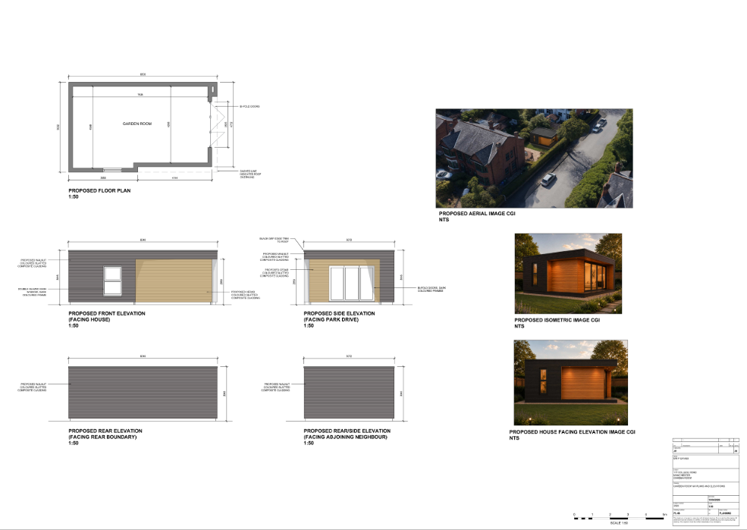
Figure 1. Proposed outbuilding

Relevant planning history

Planning Application - 105852/FH/2014/S1
Creation of driveway to front of property following partial demolition of front boundary wall, installation of block paving to front and raised decking to rear and closure of Park Drive vehicular access involving erection of infill boundary wall
Approve - 2014-07-30

Consultation, notification and publicity responses

Consultations

Flood Risk Management
No comment to make but recommended an informative on Property Flood Resilience (PFR) measures.

Notifications and publicity

Neighbour letters and site notice
No responses received.

Whalley Range Forum
No response received.

Relevant policies
In accordance with Section 38(6) of the Planning and Compulsory Purchase Act 2004, planning applications must be determined in accordance with the statutory development plan unless material considerations indicate otherwise.
For Manchester, the development plan comprises:
- The Manchester Core Strategy (2012 to 2027);
- Saved policies of the Manchester Unitary Development Plan (UDP); and
- The Places for Everyone Joint Development Plan Document (2022 to 2039).
These documents are considered up to date and are afforded significant weight in the determination of planning applications. Relevant Supplementary Planning Documents (SPDs) and other adopted guidance may also be material considerations.
The National Planning Policy Framework sets out the government’s policies for plan-making and for making decisions on development proposals in England. It is a material consideration of critical importance in both contexts.
Where relevant, the Council is required to give special regard to the desirability of preserving listed buildings and their settings, and special attention to the desirability of preserving or enhancing the character or appearance of conservation areas, in accordance with the Planning (Listed Buildings and Conservation Areas) Act 1990.
The policies and guidance referred to below are considered the most relevant to the scale, nature and location of the proposed development.
- The Manchester Core Strategy Development Plan Document 2012-2027
  - Development Management and Planning Obligations
    - DM 1 - Development Management
  - Objective 1 - Spatial Principles
    - SP 1 - Spatial Principles (Partially replaced by PfE Policy JP-S 1)
  - Objective 6 Environment
    - EN 1 - Design Principles and Strategic Character Areas
    - EN 3 – Heritage (Deletions replaced with PfE Policy JP-P2)
    - EN 14 – Flood Risk (partially replaced by PfE Policy JP-S 4)
    - EN 19 – Waste
- Guide to development in Manchester - supplementary planning document and planning guidance, April 2007
- Extant Unitary Development Plan (UDP) –
  - Citywide Development Control Policies
    - DC1 - Residential extensions
    - DC18 - Conservation Areas
    - DC26 - Development and Noise
- Places for Everyone Plan Joint Development Plan Document 2022-2039-
  - Strategy
    - JP-Strat9: Southern Areas
  - Sustainable and Resilient Places
    - JP-S1: Sustainable Development
    - JP-S4: Flood Risk and the Water Environment
  - Places for People
    - JP-P1 Sustainable Places
    - JP-P2: Heritage
- National Planning Policy Framework – August 2026 - National Development Management Policies (NDMPs)
  - Procedural Policies
    - Chapter 3 – Decision-making policies
      - DM1: Preparing development proposals
      - DM2: Information requirements
      - DM3: Determining development proposals
      - DM6: Use of planning conditions and obligations
      - DM7: Relationship with other regulatory regimes
      - DM10: Removal of national permitted development rights
  - Sustainable Development
    - Chapter 4 - Achieving sustainable development
      - S3: Presumption in favour of sustainable development
      - S4: Principle of development within settlements
  - Creating high quality, sustainable places
    - Chapter 12 - Making effective use of land
      - L2: Making effective use of land
    - Chapter 14 - Achieving well-designed places
      - DP3: Key principles for well-designed places
      - DP4: The design process
  - Conserving and enhancing the environment
    - Chapter 18 - Managing flood risk and coastal change
      - F4: Assessing flood risk for decision-making
      - F7: Ensuring development is safe from flooding
    - Chapter 20 - Conserving and enhancing the historic environment
      - HE4: Securing the conservation of heritage assets
      - HE5: Assessing effects on heritage assets
      - HE9: Conservation areas

Assessment

Principle of Development
The proposal seeks planning permission for the erection of a detached single-storey outbuilding within the rear garden of an existing dwellinghouse. The proposed structure would be used as an incidental garden room to the occupation of the host dwelling.
The site is located within an established residential area where domestic outbuildings are a common feature. Subject to consideration of its effects on visual amenity, neighbouring amenity and heritage assets, there is no objection in principle to the development. The proposal is therefore considered acceptable in principle and accords with Policy DM1 of the Manchester Core Strategy and relevant provisions of the NPPF.
It is also noted that Schedule 2, Part 1, Class E of the Town and Country Planning (General Permitted Development) (England) Order 2015 (as amended) grants planning permission for certain buildings incidental to the enjoyment of a dwellinghouse, subject to limitations and conditions. Whilst the current proposal exceeds the height limitations for permitted development due to its position adjacent to the boundary, the fallback position is nevertheless a material consideration. A substantial outbuilding could be erected within the rear garden without the need for planning permission if constructed in accordance with the provisions of Class E. The existence of this fallback position attracts weight in favour of the proposal and further supports the conclusion that the principle of a detached incidental garden building at this site is acceptable.
Accordingly, the principle of the development is considered acceptable, subject to the detailed assessment set out below.

Appropriate siting, layout, scale, form, massing, materials, and detail
The proposed outbuilding would be located at the rear of the garden adjacent to the rear boundary. It would measure approximately 8.34m in width by 5.07m in depth and would have a flat roof with an overall height of approximately 3.05m. The structure would be finished in walnut and cedar-effect composite cladding with dark-framed windows and doors.
Whilst larger than some domestic garden buildings, the outbuilding would remain single-storey in form and would be clearly subordinate to the host dwelling by virtue of its height, scale and ancillary function. The flat roof design assists in reducing its visual bulk, whilst the choice of timber effect cladding and muted colouring would enable it to sit comfortably within the garden setting.
Given its rear garden location and relationship with the existing dwelling, the proposal would not appear overbearing or incongruous within the plot and is considered to represent an appropriate form of development.

Impact on the surrounding areas in terms of the design, scale and appearance of the proposed development. Development should have regard to the character of the surrounding area.
The proposed outbuilding would be located to the rear of the host dwelling within a generous garden plot and would be largely screened from public view by the existing dwelling, boundary treatments and established vegetation. Whilst limited views would be available from Park Drive, the structure would be experienced primarily within its private garden setting.
The outbuilding would be single storey in scale with a flat roof form and, although substantial in footprint, would remain subordinate to the host dwelling. The use of walnut and cedar-effect composite cladding, together with dark-framed glazing, would provide a high-quality contemporary appearance appropriate to its ancillary function.
The site is situated within an area characterised by spacious residential plots, detached and semi-detached dwellings, and generous garden areas. Whilst the proposal would introduce additional built form within the rear garden, it would retain a significant proportion of the existing outdoor space and would not appear unduly prominent, dominant or incongruous within the wider street scene. Detached garden buildings and incidental domestic structures are also a feature of many larger residential plots, notably in the rear neighbouring garden, and the proposal would be read as a typical ancillary addition to the property.
Taking these factors into account, the proposal is considered to respect the prevailing character and appearance of the surrounding area. While the development gives rise to a limited degree of heritage harm to the significance of the Whalley Range Conservation Area, as discussed separately below, its design, scale, siting and appearance are otherwise acceptable and accord with Policies DM1 and EN1 of the Manchester Core Strategy

Effects on amenity

Privacy
The proposed outbuilding includes glazed doors and windows at ground floor level only. These openings would primarily provide views within the applicant's own garden and are not considered to result in unacceptable overlooking of neighbouring properties beyond what would normally be expected within a residential environment.
Given the single-storey nature of the development and absence of elevated viewing points, the proposal would not have a materially harmful impact on neighbouring privacy.

Light
The proposed outbuilding would be single-storey with a flat roof and would be located a considerable distance from neighbouring dwellings. Whilst it would be positioned close to the rear boundary, its limited height and scale would avoid any significant loss of daylight or sunlight to neighbouring occupiers.
The proposal would not therefore result in unacceptable overshadowing or loss of outlook.

Noise
The outbuilding is proposed as an incidental garden room associated with the residential use of the property. No commercial use, separate residential occupation or other intensive use is proposed. Furthermore, a condition is recommended requiring the outbuilding to be used only for purposes incidental to the enjoyment of the dwellinghouse and preventing its use as a separate unit of accommodation. This would ensure that activities associated with the building remain consistent with those typically expected within a residential curtilage.
Accordingly, the proposal would not be expected to generate noise levels beyond those ordinarily associated with a dwellinghouse and would not result in unacceptable impacts on the living conditions of neighbouring occupiers.

Road Safety and Traffic Generation
The proposal would be used incidental to the dwellinghouse and is not expected to generate any additional vehicle trips of significance. There would therefore be no adverse effects on highway safety or traffic conditions.

Accessibility: buildings and neighbourhoods fully accessible to disabled people, access to new development by sustainable transport modes.
The proposal relates to a detached garden room within the domestic curtilage of an existing dwelling and would not alter means of access to the site. The development would not create any additional accessibility issues and would continue to benefit from the site's existing access arrangements and sustainable transport connections.

Adequacy of internal accommodation and external amenity space.
The proposed outbuilding would provide additional ancillary accommodation for the occupants of the dwelling while retaining a substantial rear garden area. Adequate private amenity space would remain available following completion of the development and the proposal would not result in an overdevelopment of the site.

Refuse storage and collection.
The proposal would have no material effect on existing refuse storage or collection arrangements at the property. Existing facilities would continue to be used.

Vehicular access and car parking
The proposal would not alter existing access arrangements or parking provision at the site. Sufficient off-street parking would remain available and no highway concerns are raised.

Effects relating to biodiversity, landscape, archaeological or built heritage

Built heritage
The site lies within the Whalley Range Conservation Area, a designated heritage asset. In accordance with Section 72(1) of the Planning (Listed Buildings and Conservation Areas) Act 1990, special attention must be paid to the desirability of preserving or enhancing the character or appearance of the conservation area. The significance of the conservation area derives not only from its substantial Victorian and Edwardian buildings, but also from its spacious plots, mature landscaping, generous garden settings and the strong relationship between built form and open green spaces. These features make an important contribution to its special character and appearance.
The proposed outbuilding would be located within the rear garden of the host dwelling and would measure approximately 8.34m in width by 5.07m in depth with a flat roof height of approximately 3.05m. Whilst largely screened by existing boundary treatments, vegetation and the host dwelling, it would nevertheless introduce a substantial area of built development into a garden setting that contributes positively to the significance of the conservation area.
The proposal would not result in the loss of historic fabric, mature trees, important boundary treatments or other heritage features. However, by reducing the extent of open garden space and introducing a relatively large ancillary structure, the development would erode, to a limited degree, the spacious landscaped qualities that are identified as an important component of the conservation area's significance. Furthermore, whilst contemporary design is not inherently inappropriate within a conservation area, the flat roof form and composite cladding do not reflect the prevailing roofscape and traditional material palette that characterise much of the area.
Taking these factors into account, it is considered that the proposal would result in harm to the significance of the Whalley Range Conservation Area. The harm is limited in extent and at the lower end of the harm spectrum, having regard to the rear garden location of the building, its ancillary nature, the degree of screening and the absence of impacts on historic fabric, mature trees or other key heritage features. This harm is carried forward to the planning balance below.

Green Infrastructure including open space, both public and private
The proposal would result in the loss of a limited area of existing shrubbery within the rear garden in order to facilitate the construction of the outbuilding. However, the vegetation to be removed is not protected by a Tree Preservation Order, does not form part of any designated landscape feature and is not considered to make a significant contribution to the wider green infrastructure network.
Notwithstanding this limited vegetation loss, a substantial amount of private garden space would remain within the site following completion of the development. The proposal would not affect any public open space, protected trees or other significant green infrastructure assets. On balance, the impact on green infrastructure and private amenity space is considered acceptable and the proposal raises no objection in this regard

Flood risk and drainage
The proposal relates to a small-scale domestic outbuilding within the curtilage of an existing dwelling. The development would utilise existing site drainage arrangements and is not considered likely to increase flood risk either on the site or elsewhere.
The proposal is therefore acceptable in terms of flood risk and drainage.

Other Legislative Requirements

Equality Act 2010
Section 149 (Public Sector Equality Duty) of the Equality Act 2010 requires due regard to the need to: Eliminate unlawful discrimination, harassment and victimisation and other conduct prohibited by the Act and; Advance equality of opportunity between persons who share a protected characteristic and persons who do not share it. The Equality Duty does not impose a legal requirement to conduct an Equality Impact Assessment. Compliance with the Equality Duty involves consciously thinking about the aims of the Equality Duty as part of the process of decision-making.

Human Rights Act 1998 considerations
This application needs to be considered against the provisions of the Human Rights Act 1998. Under Article 6, the applicants (and those third parties, including local residents, who have made representations) have a right to a fair hearing and to this end the local planning authority must give full consideration to their comments.
Protocol 1 Article 1, and Article 8 where appropriate, confer(s) a right of respect for a person’s home, other land and business assets. In taking account of all material considerations, including Council policy as set out in the Core Strategy and saved polices of the Unitary Development Plan, the Director of Planning, Building Control & Licensing has concluded that some rights conferred by these articles on the applicant(s)/objector(s)/resident(s) and other occupiers and owners of nearby land that might be affected may be interfered with but that that interference is in accordance with the law and justified by being in the public interest and on the basis of the planning merits of the development proposal. She believes that any restriction on these rights posed by the recommendation given is proportionate to the wider benefits of and that such a decision falls within the margin of discretion afforded to the Council under the Town and Country Planning Acts.

Planning balance & Conclusion
The proposed development would provide additional ancillary accommodation for the occupants of the dwellinghouse and is acceptable in principle. The proposal would not result in unacceptable impacts on neighbouring residential amenity, highway safety, flood risk, drainage, accessibility or refuse arrangements. These matters weigh in favour of the development.
The proposal would result in harm to the significance of the Whalley Range Conservation Area through the introduction of a substantial outbuilding within a garden setting that contributes to the area's spacious and verdant character. Considerable importance and weight is attached to this harm.
However, moderate weight is afforded to the fallback position available under Schedule 2, Part 1, Class E of the Town and Country Planning (General Permitted Development) (England) Order 2015 (as amended). Given the size of the plot, there is a realistic prospect that a substantial detached outbuilding could be erected within the rear garden under permitted development rights without the need for express planning permission. Whilst the current proposal exceeds what could potentially be achieved under permitted development in certain respects, particularly in relation to its height adjacent to the boundary, the overall scale, footprint, function, materiality, and visual presence of the building are broadly comparable to a realistic fallback position. As such, the presence of a sizeable ancillary outbuilding within this part of the garden is a form of development that could reasonably occur in any event. This materially reduces the weight that can be attributed to the identified heritage harm.
Significant weight is also afforded to the absence of any unacceptable impacts in respect of neighbouring amenity, highway safety, drainage, flood risk or any other material planning consideration.
Taking all material considerations into account, the Council considers that the identified heritage harm is not of sufficient magnitude to justify refusing planning permission in this case. The overall planning balance therefore weighs in favour of the proposal. The development is considered acceptable when assessed against the development plan taken as a whole, and there are no material considerations that indicate planning permission should be withheld. Accordingly, the application is recommended for approval.

Recommendation: Approve

Article 35 Declaration
Officers have worked with the applicant in a positive and proactive manner based on seeking solutions to problems arising in relation to dealing with the planning application. The proposal is considered to be acceptable and therefore determined within a timely manner.

Conditions to be attached to decision for approval

3-year time limit
The development must be begun not later than three years beginning with the date of this permission.
Reason - Required to be imposed by Section 91 of the Town and Country Planning Act 1990 (as amended).

Specified plans
The development hereby approved shall be carried out in accordance with the following drawings and documents:
  - Location Plan (Drawing PL-01), received 16 July 2026.
  - Proposed Site Plan (Drawing PL-04), received 16 July 2026.
  - Proposed Street View Elevations (Drawing PL-05), received 16 July 2026.
  - Garden Room Proposed Plans and Elevations (Drawing PL-06), received 16 July 2026.
  - Heritage Statement Revision P01, received 24 August 2026.
Reason - To ensure that the development is carried out in accordance with the approved plans, pursuant to policies DM 1, SP 1 and EN 1 of the Core Strategy and JP-P1 & of Places for Everyone.

Materials as approved on plan
The materials used in the external surfaces of the development hereby approved shall be those as specified on approved plan/drawing:
  - Garden Room Proposed Plans and Elevations (Drawing PL-06), received 16 July 2026.

Reason - In order to ensure a satisfactory appearance in the interests of visual amenity in accordance with policies SP1 and DM1 of the Core Strategy and the requirements of the National Planning Policy Framework.

Incidental Use
The outbuilding hereby approved shall be used only for purposes incidental to the enjoyment of the dwellinghouse known as 117 College Road and shall not be used as a separate unit of accommodation, for any primary living accommodation, or for any business or commercial purpose.
Reason - To ensure that the outbuilding remains ancillary to the host dwelling and to safeguard the amenities of neighbouring occupiers, in accordance with Policies DM1 and EN1 of the Manchester Core Strategy and the National Planning Policy Framework.

Informative(s)

Property Flood Resilience (PFR) measures
The applicant is advised to incorporate Property Flood Resilience (PFR) measures to a minimum of 150mm above the surface water flood level or a minimum of 600mm above the fluvial flood level.

