

Planning

Delegated Officer Report

Summary of application details
Application reference: | PLA-2026-001484
Application type: | Consent to display an advertisement
Proposal: | Installation of replacement internally illuminated and non-illuminated signage
Site address: | KFC Unit 1 Monarch Leisure Park Lloyd Road Manchester M19 2RF
Ward(s): | Levenshulme
Date application valid: | 28 August 2026
Applicant name: | Robert Smith
Agent (if any): | Mrs Rachel Skinner
Case officer: | Joshua Lee
Recommendation: | Approve
Date of recommendation: | 29/09/2026

Description of site, building and/or area
The proposal relates to and existing Class E restaurant (KFC) located on the corner of Lloyd Road and and Wellington Road North.
The site is within a mixed commercial/residential area of the Levenshulme ward of Manchester close to the boundary with Stockport MBC. The immediate locality is predominantly retail and commercial frontages with a McDonalds restaurant directly adjacent. The site is located with Flood Zone 2 and 3 and intersects the Environment Agency’s Main River Consultation Area for the Black Brook.

Description of development
Installation of replacement internally illuminated and non-illuminated signage.
Internally illuminated signage would have a maximum of 200cd/m2 illuminance
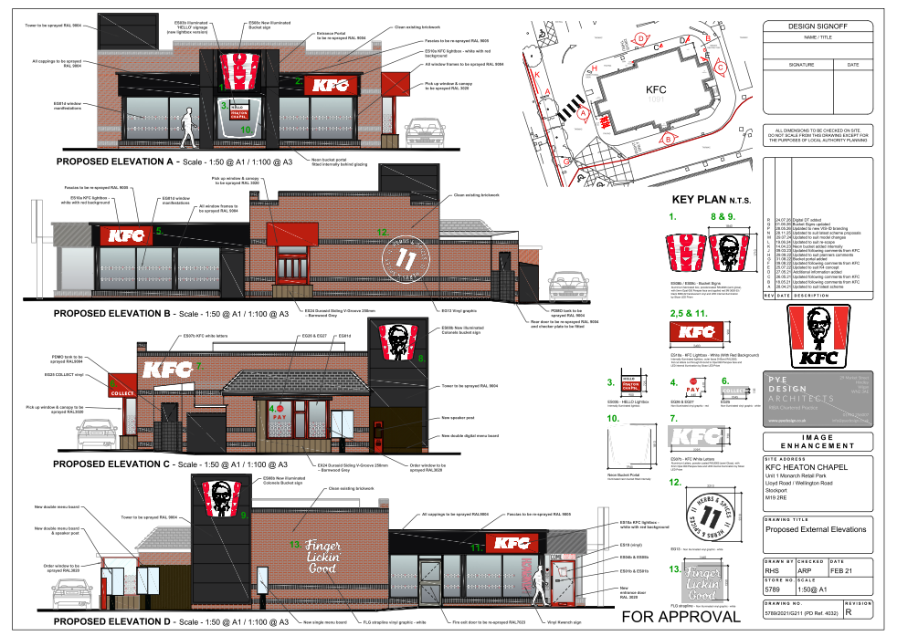
Figure 1. Proposed signage
1. Internally illuminated '3xKFC' Bucket Sign
2. Internally Illuminated KFC Lightbox
3. Internally illuminated HELLO Lightbox fitted internally
4. Non-illuminated vinyl PAY letters & arrow
5. Internally Illuminated KFC Lightbox
6. Non-illuminated vinyl COLLECT letters
7. Internally Illuminated 'KFC' letters
8. Internally illuminated Colonel's Bucket Sign
9. Internally illuminated Colonel's Bucket Sign
10. Illuminated neon bucket portal fitted internally
11. Internally Illuminated KFC Lightbox
12. Non-illuminated vinyl '11 HERBS & SPICES' graphic
13. Non-illuminated 'FLG Strapline' graphic
A. Re-skin existing internally illuminated Totem sign
B. New signage panel to existing height restrictor
C. New single digital menu board
D. New double digital menu board
E. New double digital menu board
F. New non-illuminated artwork to existing directional sign
G. New non-illuminated artwork to existing directional sign
H. New non-illuminated artwork to existing directional sign
J. New non-illuminated barrier sign
K. New non-illuminated barrier sign

Relevant planning history
Recent Planning History
- 2022
  - 134934/AO/2022: Approved advertisement consent for various illuminated and non-illuminated signage, menu boards, directional signage and replacement panels to the existing totem sign. Approved 31 October 2022.
  - 134933/FO/2022: Approved external alterations including new cladding, delivery driver collection window and canopy to packing area. Approved 21 October 2022.
- 2021
  - 130708/FO/2021: Approved refurbishment of the drive-through restaurant, elevational alterations, delivery driver collection window, pedestrian railings and updated branding including a new 8m totem sign. Approved 12 August 2021.
  - 130709/AO/2021: Approved illuminated and non-illuminated branding signage. Approved 5 August 2021.

Operational Changes
- 120838/JO/2018: Approved variation of condition to extend restaurant opening hours to 06:00 to midnight, seven days a week. Approved 8 November 2018.
- Similar applications seeking extended opening hours in 2012 and 2013 were refused.

Earlier Alterations and Signage
Between 2006 and 2012, several permissions were granted for:
- Building refurbishments and external alterations.
- Reconfiguration of parking and landscaping.
- Replacement cladding and roof alterations.
- Various advertisement consents for fascia signs, totem signs and other site signage.

Original Development
- 051170/FO/CENTL2/96: Approved in June 1997 for the erection of two restaurants, one with a drive-through facility, with associated car parking. This established the restaurant use on the site.
- 060457/FO/NORTH2/00: Approved in January 2001 for the erection of a replacement single-storey drive-through restaurant following demolition of the existing building. A duplicate application was later withdrawn.

Consultation, notification and publicity responses

Consultations

Highway Services
No objection. Highways have reviewed the proposal and note that the signage is not located on, nor projects over, the adopted highway, therefore a Projection Over Licence is not required. The proposed maximum luminance of 200 cd/m² is considered acceptable and in line with guidance from the Institution of Lighting Professionals. Highways are satisfied that adequate headroom clearance is provided and raise no concerns regarding highway safety. The applicant is advised to liaise with the Council's Highways Licensing Team regarding any construction or fit-out activities that may affect the highway, including any requirements for hoarding, scaffolding, skips, utility connections, or temporary traffic management arrangements.

Environmental Health
No objection. The illuminated signage should be installed in accordance with the illuminance level (200cd/m2) as stated in the application form.

Stockport Metropolitan Borough Council
No comments received.

Notifications and publicity

Neighbour letters
No comments received.

Relevant policies
This application has been assessed under the Town and Country Planning (Control of Advertisements) (England) Regulations 2007. Under Regulation 3, the Council can only consider the impact of the proposal on amenity and public safety.

In accordance with Section 38(6) of the Planning and Compulsory Purchase Act 2004, planning applications must be determined in accordance with the statutory development plan unless material considerations indicate otherwise.
For Manchester, the development plan comprises:
- The Manchester Core Strategy (2012 to 2027);
- Saved policies of the Manchester Unitary Development Plan (UDP); and
- The Places for Everyone Joint Development Plan Document (2022 to 2039).
These documents are considered up to date and are afforded significant weight in the determination of planning applications. Relevant Supplementary Planning Documents (SPDs) and other adopted guidance may also be material considerations.
The National Planning Policy Framework sets out the government’s policies for plan-making and for making decisions on development proposals in England. It is a material consideration of critical importance in both contexts.
Where relevant, the Council is required to give special regard to the desirability of preserving listed buildings and their settings, and special attention to the desirability of preserving or enhancing the character or appearance of conservation areas, in accordance with the Planning (Listed Buildings and Conservation Areas) Act 1990.
The policies and guidance referred to below are considered the most relevant to the scale, nature and location of the proposed development.
- The Manchester Core Strategy Development Plan Document 2012-2027
  - Development Management and Planning Obligations
    - DM 1 - Development Management
  - Objective 1 - Spatial Principles
    - SP 1 - Spatial Principles (Partially replaced by PfE Policy JP-S 1)
  - Objective 2 - Economy and the City Centre
    - EC 1 - Employment and Economic Growth in Manchester
    - EC 2 – Existing Employment Space
    - EC 9 – South Manchester
  - Objective 6 Environment
    - EN 1 - Design Principles and Strategic Character Areas
- Guide to development in Manchester - supplementary planning document and planning guidance, April 2007
- Shopfront and signage design guide
- Extant Unitary Development Plan (UDP) –
  - Citywide Development Control Policies
    - DC10 - Food and Drink uses
    - DC14 - Shop fronts and related signs
    - DC15 - Advertisements, hoardings and posters
- Places for Everyone Plan Joint Development Plan Document 2022-2039-
  - Strategy
    - JP-Strat9: Southern Areas
  - Sustainable and Resilient Places
    - JP-S1: Sustainable Development
    - JP-S4: Flood Risk and the Water Environment
  - Places for Jobs
    - JP-J1: Supporting Long-Term Economic Growth
    - JP-J2: Employment Sites and Premises
  - Places for People
    - JP-P1 Sustainable Places
- National Planning Policy Framework – August 2026 - National Development Management Policies (NDMPs)
  - Procedural Policies
    - Chapter 3 – Decision-making policies
      - DM1: Preparing development proposals
      - DM2: Information requirements
      - DM3: Determining development proposals
      - DM6: Use of planning conditions and obligations
      - DM7: Relationship with other regulatory regimes
  - Sustainable Development
    - Chapter 4 - Achieving sustainable development
      - S3: Presumption in favour of sustainable development
      - S4: Principle of development within settlements
  - Delivering homes and supporting growth
    - Chapter 7 - Building a strong, effective economy
      - E2: Meeting the need for business land and premises
  - Creating high quality, sustainable places
    - Chapter 14 - Achieving well-designed places
      - DP3: Key principles for well-designed places
      - DP4: The design process
    - Chapter 15 - Promoting sustainable transport
      - TR6: Assessing transport impacts
  - Conserving and enhancing the environment
    - Chapter 18 - Managing flood risk and coastal change
      - F4: Assessing flood risk for decision-making
      - F6: Development in areas at risk of flooding from rivers or the sea
      - F7: Ensuring development is safe from flooding
- Town and Country Planning (Control of Advertisements) Regulation 2007 –
  - Section 3 - Powers to be exercised in the interests of amenity and public safety

Assessment

Principle of development
Advertisement consent applications must be assessed having regard only to amenity and public safety considerations. The proposed advertisements relate to an established commercial restaurant and consist primarily of replacement illuminated and non-illuminated signage reflecting the operator's current branding. The principle of displaying advertisements at the site is acceptable, subject to detailed consideration of amenity and public safety below.

Factors relevant to amenity include the general characteristics of the locality, including the presence of any feature of historic, architectural, cultural or similar interest
The site occupies a prominent position within Monarch Leisure Park in an established commercial environment characterised by restaurants, retail units, customer parking areas and associated signage. The site is not located within a Conservation Area and there are no nearby heritage assets whose significance would be affected.
The proposals comprise replacement fascia signs, vinyl graphics, directional signage, menu boards and updated panels to existing signage structures. The scale, design and positioning of the advertisements are appropriate to the host building and reflect the character of the surrounding commercial area.
Illuminated signs would have a maximum luminance of 200cd/m², comparable with existing advertisements and appropriate within this commercial setting. Given the separation from nearby residential properties, the proposals would not result in unacceptable visual intrusion or light spill.
The site is located within Flood Zones 2 and 3; however, the proposal comprises replacement signage only and would not affect flood storage, flood flows or flood risk elsewhere.
The advertisements would preserve visual amenity and accord with the requirements of Regulation 3 of the Advertisement Regulations, Core Strategy policies DM1 and EN1, and UDP policies DC14 and DC15.

Factors relevant to public safety

The safety of persons using any highway, railway, waterway, dock, harbour or aerodrome (civil or military)
Highway Services have raised no objection to the proposal. The advertisements would be located on the building and within the site curtilage and would not project over the adopted highway. The proposed luminance level of 200 cd/m² is considered acceptable and accords with industry guidance. Highway Services are satisfied that adequate headroom clearance would be maintained and confirm that a Projection Over Licence is not required.
The proposed illumination levels are modest and are not considered likely to distract motorists or otherwise prejudice highway safety. The digital menu boards are positioned for customers within the drive-through lane and would not be directed towards passing traffic.
Accordingly, the proposal would not endanger highway users or raise wider public safety concerns.

Whether the display of the advertisement in question is likely to obscure, or hinder the ready interpretation of, any traffic sign, railway signal or aid to navigation by water or air;
The advertisements would be contained within the restaurant site and would not obscure, compete with or hinder the interpretation of any traffic signs, signals or other highway infrastructure. The signage utilises standard corporate branding that is readily distinguishable from statutory traffic signage.
The proposal would not interfere with the visibility or interpretation of navigational or traffic management measures and is acceptable in this regard.

Whether the display of the advertisement in question is likely to hinder the operation of any device used for the purpose of security or surveillance or for measuring the speed of any vehicle.
There is no evidence to suggest that the proposed advertisements would interfere with CCTV equipment, security systems or speed-monitoring devices. The signage would be attached to existing structures or the building itself and would not obstruct relevant sightlines.
The proposal is therefore acceptable in respect of this aspect of public safety.

Other Legislative Requirements

Equality Act 2010
Section 149 (Public Sector Equality Duty) of the Equality Act 2010 requires due regard to the need to: Eliminate unlawful discrimination, harassment and victimisation and other conduct prohibited by the Act and; Advance equality of opportunity between persons who share a protected characteristic and persons who do not share it. The Equality Duty does not impose a legal requirement to conduct an Equality Impact Assessment. Compliance with the Equality Duty involves consciously thinking about the aims of the Equality Duty as part of the process of decision-making.

Human Rights Act 1998 considerations
This application needs to be considered against the provisions of the Human Rights Act 1998. Under Article 6, the applicants (and those third parties, including local residents, who have made representations) have a right to a fair hearing and to this end the local planning authority must give full consideration to their comments.
Protocol 1 Article 1, and Article 8 where appropriate, confer(s) a right of respect for a person’s home, other land and business assets. In taking account of all material considerations, including Council policy as set out in the Core Strategy and saved polices of the Unitary Development Plan, the Director of Planning, Building Control & Licensing has concluded that some rights conferred by these articles on the applicant(s)/objector(s)/resident(s) and other occupiers and owners of nearby land that might be affected may be interfered with but that that interference is in accordance with the law and justified by being in the public interest and on the basis of the planning merits of the development proposal. She believes that any restriction on these rights posed by the recommendation given is proportionate to the wider benefits of and that such a decision falls within the margin of discretion afforded to the Council under the Town and Country Planning Acts.

Planning balance & Conclusion
Advertisement consent may only be determined with regard to amenity and public safety. The proposed advertisements are appropriately designed and proportioned for the host building and commercial surroundings and would not result in harm to visual amenity. Highway Services have raised no objection and are satisfied that the advertisements would not prejudice highway safety. The signage would not interfere with traffic signs, the interpretation of highway infrastructure, or surveillance equipment. The proposal therefore complies with the Town and Country Planning (Control of Advertisements) (England) Regulations 2007 and approval is recommended.

Recommendation: Approve

Conditions to be attached to decision for approval

Advertisement mandatory condition
  - No advertisement is to be displayed without the permission of the owner of the site or any other person with an interest in the site entitled to grant permission.
  - No advertisement shall be sited or displayed so as to:
- endanger persons using any highway, railway, waterway, dock, harbour or aerodrome (civil or military);
- obscure, or hinder the ready interpretation of, any traffic sign, railway signal or aid to navigation by water or air; or
- hinder the operation of any device used for the purpose of security or surveillance or for measuring the speed of any vehicle.
  - Any advertisement displayed, and any site used for the display of advertisements, shall be maintained in a condition that does not impair the visual amenity of the site.
  - Any structure or hoarding erected or used principally for the purpose of displaying
advertisements shall be maintained in a condition that does not endanger the public.
  - Where an advertisement is required under these Regulations to be removed, the site shall be left in a condition that does not endanger the public or impair visual amenity.
Reason - In the interests of pedestrian and highway safety, pursuant to Policy DM 1, SP 1 and EN 1 of the Manchester Core Strategy (2012) and The Town and Country Planning (Control of Advertisements) Regulation 2007.

Specified plans
The development hereby approved shall be carried out in accordance with the following drawings and documents:
  - Drawing - Existing & Proposed 17 Feb 2026 149-PLA-2007 ELEVATIONS AND LOCATION PLAN
Reason - To ensure that the development is carried out in accordance with the approved plans, pursuant to Policy DM 1, SP 1 and EN 1 of the Manchester Core Strategy (2012) and The Town and Country Planning (Control of Advertisements) Regulation 2007.

Luminance
In the hours of darkness, the advertisement display luminance shall be no greater than 300cd/m2 in accordance with the recommended maximum night time luminance value set out in Table 10.4 within the Institution of Lighting Professionals - Professional Lighting Guide (PLG 05) 'Brightness of Illuminated Advertisements including Digital Displays' (or its equivalent in a replacement guide) in cd/m2.
Reason: In the interests of amenity, public safety pursuant to Policy DM 1, SP 1 and EN 1 of the Manchester Core Strategy (2012) and The Town and Country Planning (Control of Advertisements) Regulation 2007.

Informative(s)

Highway licences and traffic management
The applicant is advised that any works associated with the installation of the advertisements that affect the public highway may require separate consent from the Council. Requirements for licences relating to hoarding, scaffolding, skips, utility connections or other activities affecting the highway should be agreed with the Council's Highways Licensing Team at highwaylicences@manchester.gov.uk. Any temporary pedestrian or traffic management arrangements should be agreed with the Council's Event and Traffic Management Team at highwaynetworkmanagement@manchester.gov.uk prior to works commencing.

