

Planning

Delegated Officer Report

Summary of application details
Application reference: | PLA-2026-001345
Application type: | Removal/variation of conditions
Proposal: | Variation of Condition 2 (Specified Plans) attached to planning permission PLA-2026-000467 to allow amendments to projection of single storey rear extension
Site address: | 7 Cranage Road Manchester M19 3LG
Ward(s): | Levenshulme
Date application valid: | 13 August 2026
Applicant name: | Mrs Sahar Hashmat
Agent (if any): | Mr Muhammad Dabeer Rana
Case officer: | Katie Raw
Recommendation: | Approve
Date of recommendation: | 23 September 2026

Description of site, building and/or area
The current application relates to 7 Cranage Road within the south Manchester ward of Levenshulme. The application site relates to a two storey, semi-detached, red brick dwellinghouse characterised by a staggered primary building line with roof overhang, with the front door sited to the side of the property. At the time of the site visit for the host application PLA-2026-000467, the front amenity space consisted of paving for off street parking and the rear of the site was characterised by areas of hard and soft landscaping. The rear building line consists of a recessed element, with ground floor window recessed, and the property benefits from a single storey rear outrigger. A shed is located against the existing rear outrigger.

The plot is irregular in shape. The property sits at the head of Cranage Road to the east.

The surrounding area is residential in nature.

Description of development
The current application seeks variation of condition 2 (Specified Plans) attached to planning permission PLA-2026-000467 to allow amendments to projection of single storey rear extension.

The parent application PLA-2026-000467 approved consent for erection of single storey side, part single, part two storey rear extension & front porch, approved 20 July 2026.

Through the current application, the applicant wishes to increase the projection of the approved single storey rear extension. A 4 metre extension from the end of the lounge was previously approved (2.5 metres from the rear elevation). Now the applicant seeks permission for a 5.5 metre extension from the end of the lounge (4 metres from the rear building line of the host dwelling (see Figure 1)).
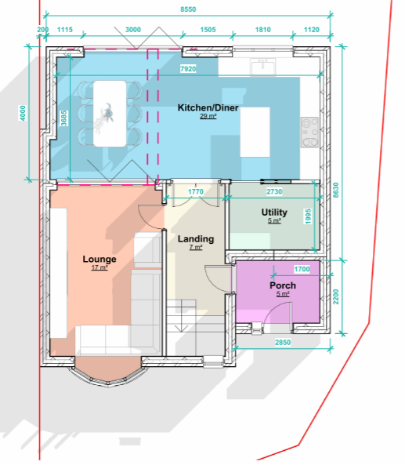
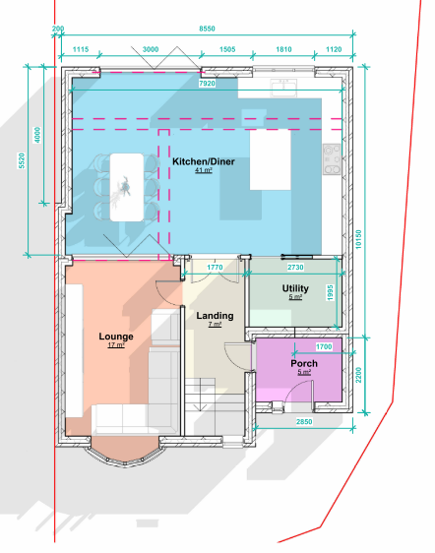

Figure 1, Left hand image: ground floor plan approved under PLA-2026-000467, right hand image: proposed ground floor plan

Relevant planning history
Parent application: PLA-2026-000467- Erection of single storey side, part single, part two storey rear extension & front porch.
Approved 20 July 2026.

Consultation, notification and publicity responses

Consultations
No consultees were required for this application.

Notifications and publicity
No neighbour comments were received during the course of the application.

Relevant policies
The National Planning Policy Framework (August 2026)

The document sets out the Government's Planning Policies for England and how these are
expected to be applied.

The purpose of the planning system is to contribute to the achievement of sustainable development, by managing the use and development of land in the long-term public interest.

Achieving sustainable development means that the planning system has three overarching objectives in providing for the homes, commercial development, facilities and infrastructure which society needs. These objectives are interdependent and need to be pursued in mutually supportive ways (so that opportunities can be taken to secure net gains across all three):
a) an economic objective
b) a social objective and
c) an environmental objective.

The following specific policies are considered to be particularly relevant to the proposed
development:
Chapter 3- Decision-making policies- The objective of the policies in this chapter is to ensure that development proposals are informed by appropriate information and decided in a way which is proportionate, timely and effective. This chapter provides a set of general decision-making policies which should be read with the rest of the thematic policies in the other chapters.
>Policy DM3: Determining development proposals
>Policy DM6: Use of planning conditions and obligations

Chapter 4- Achieving sustainable development- The objective of the policies in this chapter is to meet development needs through sustainable patterns of development, including by maximising the potential for growth on suitable land within settlements, enabling development which will support the rural economy, rural communities and the provision of infrastructure, and limiting development away from settlements to help safeguard the intrinsic character and beauty of the countryside.
>Policy S3: Presumption in favour of sustainable development

Chapter 14 - Achieving well-designed places- The objective of the policies in this chapter is to promote high quality, healthy, inclusive and sustainable places, through setting clear expectations about design outcomes and the use of relevant tools and processes.
-Policy DP3: Key principles for well-designed places
-Policy DP4: The design process

The Manchester Core Strategy Development Plan Document 2012-2027 ("the Core Strategy")
was adopted by the City Council on 11th July 2012, updated March 2024 following adoption of Places for Everyone Joint Development Plan

The Core Strategy is the key document in Manchester's Local Development Framework. It
replaces significant elements of the Unitary Development Plan (UDP) as the document that sets
out the long term strategic planning policies for Manchester's future development. Of relevance
are:
Policy DM1 (Development Management);
Policy SP1 (Spatial Principles) (partially superseded by PfE);
Policy EN1 (Design Principles and Strategic Character Areas).

Unitary Development Plan Saved Policies

Large elements of the UDP have been superseded by the Core Strategy. The following saved
policies are of relevance in the consideration of this application:

DC1. Residential Extensions
DC1.1 states that in determining planning applications for extensions to residential properties,
the Council will have regard to:
a. The general character of the property;
b. The effect upon the amenity of the neighbouring occupiers;
c. The desirability of enabling people to adapt their houses in appropriate ways to meet
changing household needs;
d. The overall appearance of the proposal in the a street scene;
e. The effect of the loss of any on-site car parking.

DC1.2 states that extensions to residential properties will be allowed subject to compliance with
other relevant policies of the Plan and the following criteria:
a. They are not excessively large or bulky (for example resulting in structures which are not
subservient to original houses or project out too far in front of original buildings);
b. They do not create undue loss of sunlight, daylight or privacy;
c. They are not out of character with the style of development in the area or the surrounding
scene by virtue of design, use of materials or construction details.
d. they would not result in the loss of off-street car-parking, in a situation where there is so
severe an existing on-street parking problem that unacceptable additional pressures would be
created.

DC1.3 Notwithstanding the generality of the above policies, the Council will not normally
approve:
a. rearward extensions greater than 3.65m (12 ft) in length;
b. 2-storey extensions with a flat roof, particularly those which would be visible from the public
highway;
c. 2-storey extensions to terraced properties which occupy the full width of the house;
d. flat roofed extensions to bungalows;
e. extensions which conflict with the Council's guidelines on privacy distances (which are
published as supplementary guidance).

DC1.4 In considering proposals for 2-storey side extensions, the Council will have regard to the
general guidance above and also to supplementary guidance to be issued. In particular, the
Council will seek to ensure that:
a. the development potential of the gap between detached and semi-detached houses is capable of being shared equally by the owners or occupiers of the two properties concerned;
b. the actual or potential result of building the extension will not be the creation of a terracing
effect, where this would be unsympathetic to the character of the street as a whole;
c. the actual or potential result of building the extension will not be the creation of a very narrow
gap between the properties, or any other unsatisfactory visual relationships between elements of the buildings involved.
As a guide, and without prejudice to the generality of this policy, the Council will normally permit
2-storey house extensions which, when built, would leave a minimum of 1.52m (5 ft) between the side wall and the common boundary, and which meet the other requirements of this policy.
Proposals which cannot meet these requirements will be judged on their merits, but with weight
being given to (a) and (c) above.

Guide to Development in Manchester Supplementary Planning Document and Planning
Guidance, Adopted April 2007.

The Guide aims to help to develop and enhance a unique and positive sense of place within
Manchester and its neighbourhoods. The guidance is grouped under seven key principles
recognised by CABE as being those urban design characteristics which create successful
places. These are: character and context, continuity and enclosure, ease of movement, quality
of the public realm, diversity, legibility, and adaptability. It advises that high quality design is a
vital attribute of successful neighbourhoods.

Manchester Residential Quality Guidance (2017)

This guidance provides clear direction on what is required to deliver sustainable neighbourhoods of choice where people will want to live and also raise the quality of life across Manchester.

Places for Everyone (2022-2039)

Places for Everyone is a long-term plan of nine Greater Manchester districts for jobs, new
homes, and sustainable growth. It has been published by the GMCA on behalf of the nine
districts and took effect and became part of the statutory development plan on March 21, 2024.
The Plan and its policies are now a material planning consideration in the determination of
planning applications. The Plan and its policies must therefore be given full weight in the
planning balance.

The following policies are relevant:
JP- S1- Sustainable development.

Assessment
Principle of Development

The current application seeks variation of condition 2 (Specified Plans) attached to planning permission PLA-2026-000467 to allow amendments to projection of single storey rear extension. Through the current application, the applicant wishes to increase the projection of the approved single storey rear extension. A 4 metre extension from the end of the lounge was previously approved (2.5 metres from the rear elevation). Now the applicant seeks permission for a 5.5 metre extension from the end of the lounge (4 metres from the rear building line of the host dwelling (see Figure 1)). The principle of development has already been approved under host permission PLA-2026-000467 and so this assessment considers only the proposed amendment to the scheme. Such amendment will now be discussed.

Residential Amenity

The adjoining property, no.5 Cranage Road, benefits from a single storey rear extension which extends close to the common boundary. As a result of the increased projection, the extension would extend approximately 1.8 metres beyond the neighbour’s rear building line. The roof form would be designed so that the bulk is pulled off the common boundary and is sited at the point furthest from the boundary, with a height of approximately 2.8 metres at such point. Given the limited projection beyond the neighbour’s rear building line and the attempts to mitigate bulk, the proposal would not give rise to significant overbearing implications. Although the applicant property sits due south of the neighbour, given this element is single storey, any loss of light from this element alone is not considered to be severe, and the built form at first floor level which would be more likely to impact sunlight has already been assessed as acceptable and approved at the site. As the proposal is single storey level only, no adverse privacy implications would be caused as a result of the proposal.

The increased projection at ground floor level would result in a larger extension that maybe perceived by the neighbour to the south- no.36 Cranage Road. Although the projection would increase, the proximity of the extension to the shared boundary to the south would not differ and so any impact is not considered to be significant. The extension would sit close to the side amenity space of no.36 and not the more sensitive space to the rear, so any sense of overbearing or loss of light would not be considered severe. There would not be any alterations to windows and door positions that would give rise to harm to such neighbour.
Although the proposed extension would come closer to the rear boundary of the site with properties along Ravenoak Avenue, the proposal would be single storey and so there would not be any adverse implications in respect of residential amenity.

Visual Amenity

The roof form of the single storey rear extension would be sloped to reduce the height of the proposal against the common boundary with the adjoining neighbour, and along the southern elevation of the proposal. Given the form of the roof to reduce the amount of bulk and massing, the proposal would not give rise to visual harm to surrounding properties.

The rear extension would change from an extension with the same projection at ground and first floor level to a staggered rear building line- with the first floor rear extension set back from the rear building line at ground floor level. Such built form is commonplace within residential extensions and so does not give rise to any visual harm.

Siting, Scale, Massing and Resultant Appearance

A 4 metre extension from the end of the lounge was previously approved (2.5 metres from the rear elevation). Now the applicant seeks permission for a 5.5 metre extension from the end of the lounge (4 metres from the rear building line of the host dwelling (see Figure 1)).

During the course of negotiations for PLA-2026-000467 the initial scheme had a projection of 6 metres, and a reduction was sought and shown on revised plans. The LPA did not specify an acceptable projection at ground floor level and were happy with the 2.5 metre extension beyond the rear building line presented on the revised plans. The applicant has realised that this would result in a marginal increase beyond the rear building line of the existing outrigger and that development at ground floor level would not be worthwhile.

In the case of the current submission, a 4 metre projection is shown from the rear building line of the site. Whilst this would exceed the maximum rearward projection as specified under policy DC1.3 of the UDP (of 3.65 metres), the Larger Homes Extension route would allow extensions of up to 6 metres for terraced and semi-detached properties. The 4 metres proposed marginally exceeds the 3.65 metre policy and given any harm to the immediate neighbour is limited by the neighbour’s existing development, the increased projection is considered acceptable in respect of siting and scale, and it is considered the scheme can be introduced to the site without giving rise to residential and visual harm.

Other Legislative Requirements

Equality Act 2010
Section 149 (Public Sector Equality Duty) of the Equality Act 2010 requires due regard to the need to: Eliminate unlawful discrimination, harassment and victimisation and other conduct prohibited by the Act and; Advance equality of opportunity between persons who share a protected characteristic and persons who do not share it. The Equality Duty does not impose a legal requirement to conduct an Equality Impact Assessment. Compliance with the Equality Duty involves consciously thinking about the aims of the Equality Duty as part of the process of decision-making.

Human Rights Act 1998 considerations
This application needs to be considered against the provisions of the Human Rights Act 1998. Under Article 6, the applicants (and those third parties, including local residents, who have made representations) have a right to a fair hearing and to this end the local planning authority must give full consideration to their comments.

Protocol 1 Article 1, and Article 8 where appropriate, confer(s) a right of respect for a person’s home, other land and business assets. In taking account of all material considerations, including Council policy as set out in the Core Strategy and saved polices of the Unitary Development Plan, the Director of Planning, Building Control & Licensing has concluded that some rights conferred by these articles on the applicant(s)/objector(s)/resident(s) and other occupiers and owners of nearby land that might be affected may be interfered with but that that interference is in accordance with the law and justified by being in the public interest and on the basis of the planning merits of the development proposal. She believes that any restriction on these rights posed by the recommendation given is proportionate to the wider benefits of and that such a decision falls within the margin of discretion afforded to the Council under the Town and Country Planning Acts.

Article 35 Declaration
The proposal was assessed with regards to policies outlined in the National Planning Policy Framework, Unitary Development Plan Saved Policies, Local Development Framework Core Strategy Development Plan and other material considerations. In this instance officers have worked with the applicant in a positive and proactive manner and appropriate conditions have been attached to the approval granted.

Recommendation: Approve

