

Planning

Delegated Officer Report

Summary of application details
Application reference: | OTH-2026-001585
Application type: | Non-Material Amendment
Proposal: | Non-material amendment to Planning Permission 145125/FO/2026 for relocation of door on the rear East elevation moved to the South, replacement of door to the front South elevation with glazing, replacement of central door on front West elevation with Bi-fold type door arrangement, omission of single door on South elevation to Hale Top and replacement with solid wall with tiled finish.
Site address: | 10, 12 & 14 Hale Top Manchester M22 5RN
Ward(s): | Woodhouse Park
Date application valid: | 08 September 2026
Applicant name: | Muse Places and Manchester City Council
Agent (if any): | Asteer Planning LLP
Case officer: | Katie Raw
Recommendation: | Approve
Date of recommendation: | 23 September 2026

Description of site, building and/or area
The current application relates to 10, 12 & 14 Hale Top within the south Manchester ward of
Woodhouse Park. The application site relates to three units on Hale Top characterised by a
canopy above, and an adjacent corner unit that has been opened up due to the demolition of
the Peacocks Building (see planning history for further details). The 3 units appear to relate to
class E uses, although only 1 unit appeared to be trading at the time of the site visit.

The applicant site sits within the Wythenshawe Town Centre, characterised by commercial
premises, tram stop, medical practice, Asda and local Council Offices.

The applicant site sits within the Wythenshawe Masterplan area.

Description of development
The current application seeks non-material amendment to Planning Permission 145125/FO/2026 for relocation of door on the rear East elevation moved to the South, replacement of door to the front South elevation with glazing, replacement of central door on front West elevation with Bi-fold type door arrangement, omission of single door on South elevation to Hale Top and replacement with solid wall with tiled finish.

The scheme of 145125/FO/2026 received planning approval for external alterations, including external lighting, installation of 2no. wall mounted heat pumps and ductwork to northern elevation, and associated works, approved 1 April 2026.

The works are required as part of the Wythenshawe regeneration scheme. The site has been
identified as a future Food Hub, adjacent to the proposed new Civic Square. The proposed
works would enable the premise to operate in the way proposed.

Further relevant planning history
OTH-2026-001587- Discharge of Condition 4 (Materials) attached to Planning Permission 145125/FO/2026.
Currently pending consideration.

OTH-2026-000795- Discharge of Condition 3 (construction management plan) from planning approval 145125/FO/2026.
Approved 17 August 2026.

EIASCO/25/010- Plots 3.1, 2.2 & 2.1 Wythenshawe Town Regeneration Proposals- Request for
Scoping opinion under Part 4, Regulation 15 of The Town and Country Planning (Environmental
Impact Assessment) Regulations 2017 (as amended).
Scoping Opinion Issued 10 November 2025.

The current application has come forwards due to the demolition of the previous Peacocks
building immediately to the west of the application site:
142088/DEM/2025- 36 The Birtles- Demolition of former Peacocks clothing store.
Approved 6 March 2025.

Subsequent CDN application:
CDN/25/0903- 36 The Birtles- Discharge of Conditions 2 (Hours of Demolition) attached to
planning permission 142088/DEM/2025.
Approved 25 November 2025.

120655/FO/2018- 10 Hale Top- Installation of new shop front.
Approved 21 August 2018.

117166/AO/2017- 10 Hale Top- Installation of a five internally-illuminated fascia signs and one
internally-illuminated projecting sign.
Approved 20 September 2017.

Further planning history exists for the units prior to 2012.

Other planning history relating to the regeneration of Wythenshawe:
142287/VO/2025- Former Co-Operative Building The Birtles- CITY COUNCIL DEVELOPMENT
Change of use of first and second floor to from Use Class E (Commercial, Business and
Service) to F1 (Community Hub) together with associated elevational alterations.
Approved 13 June 2025.

Consultation, notification and publicity responses

Consultations
N/A.

Notifications and publicity
N/A.

Relevant policies
The National Planning Policy Framework (NPPF) (August 2026)

The document sets out the Government's Planning Policies for England and how these are
expected to be applied.

The purpose of the planning system is to contribute to the achievement of sustainable development, by managing the use and development of land in the long-term public interest.

Achieving sustainable development means that the planning system has three overarching objectives in providing for the homes, commercial development, facilities and infrastructure which society needs. These objectives are interdependent and need to be pursued in mutually supportive ways (so that opportunities can be taken to secure net gains across all three):
a) an economic objective
b) a social objective and
c) an environmental objective.

The following specific chapters and policies are considered to be particularly relevant to the proposed
development:
Chapter 3- Decision-making policies- The objective of the policies in this chapter is to ensure that development proposals are informed by appropriate information and decided in a way which is proportionate, timely and effective. This chapter provides a set of general decision-making policies which should be read with the rest of the thematic policies in the other chapters.
>Policy DM3: Determining development proposals
>Policy DM6: Use of planning conditions and obligations

Chapter 4- Achieving sustainable development- The objective of the policies in this chapter is to meet development needs through sustainable patterns of development, including by maximising the potential for growth on suitable land within settlements, enabling development which will support the rural economy, rural communities and the provision of infrastructure, and limiting development away from settlements to help safeguard the intrinsic character and beauty of the countryside.
>Policy S3: Presumption in favour of sustainable development

Chapter 7- Building a strong, effective economy- The objective of the policies in this chapter is to enable businesses to invest, expand and adapt in a way that reflects the opportunities, challenges and characteristics of different areas, and supports long-term economic growth both locally and nationally.
-Policy E2: Meeting the need for business land and premises

Chapter 8- Ensuring the vitality of town centres- The objective of the policies in this chapter is to promote the long-term vitality and viability of town centres by prioritising them as locations for main town centre uses and allowing them to adapt to changing community and business needs, in a way which reflects their locally distinctive roles and opportunities. For the purpose of this chapter ‘town centres’ includes city, town, district and local centres as defined in the glossary at Annex B.
-Policy TC2: Development in town centres

Chapter 14 - Achieving well-designed places- The objective of the policies in this chapter is to promote high quality, healthy, inclusive and sustainable places, through setting clear expectations about design outcomes and the use of relevant tools and processes.
-Policy DP3: Key principles for well-designed places

Places for Everyone

Places for Everyone is a long-term plan of nine Greater Manchester districts for jobs, new
homes, and sustainable growth. It has been published by the GMCA on behalf of the nine
districts and took effect and became part of the statutory development plan on March 21, 2024.
The Plan and its policies are now a material planning consideration in the determination of
planning applications. The Plan and its policies must therefore be given full weight in the
planning balance.

The following policies are of relevance:
JP- S1- Sustainable development
JP-J2- Employment Sites and Premises
JP-P1- Sustainable Places
JP-C8- Transport Requirements for New Development
JP-Strat9- Southern Areas.

The Manchester Core Strategy Development Plan Document 2012-2027 ("the Core Strategy")
was adopted by the City Council on 11th July 2012. Updated March 2024 following adoption of
Places for Everyone Joint Development Plan

The Core Strategy is the key document in Manchester's Local Development Framework. It
replaces significant elements of the Unitary Development Plan (UDP) as the document that sets
out the long term strategic planning policies for Manchester's future development. Of relevance
are:
Policy DM1 (Development Management);
Policy SP1 (Spatial Principles) (partially superseded by PfE);
Policy EN1 (Design Principles and Strategic Character Areas);
Policy EC1 (Employment and Economic Growth in Manchester) (partially superseded by PfE);
Policy EC2 (Existing Employment Centre);
Policy EC10 (Wythenshawe);
Policy C1 (Centre Hierarchy);
Policy C 7 (Wythenshawe District Centres - Baguley (West Wythenshawe), Northenden and
Wythenshawe Town Centre);
Policy C 10 (Leisure and the Evening Economy);
Policy T1 (Sustainable Transport) (partially superseded by PfE);
Policy T2 (Accessible Areas of Opportunity and Need).

Unitary Development Plan Saved Policies (1995)

Large elements of the UDP have been superseded by the Core Strategy. The following saved
policies are of relevance in the consideration of this application:

DC10. Food and Drink Uses
DC10.1 In determining planning applications for developments involving the sale of food or drink
for consumption on the premises, or for hot food to be consumed off the premises (whether or
not other activities, such as a nightclub, are included), the Council will have regard to:
a. the general location of the proposed development, including any reference to the area in
other policies in the Plan;
b. the effect on the amenity of neighbouring residents;
c. the availability of safe and convenient arrangements for car parking and servicing;
d. ease of access for all, including disabled people; and
e. the storage and collection of refuse and litter.
DC10.2 The Council will normally accept the principle of developments of this kind in the City
Centre, industrial and commercial areas, in shopping centres and, at ground level, in local
shopping parades of more than 8 shops or offices.
DC10.3 Development will not normally be permitted where:
a. it is proposed outside the general locations mentioned above, or
b. there is a house or flat on the ground floor next to the proposed business, or only separated
from it by a narrow street or alleyway.
DC10.4 Where, having regard to the preceding policies, the Council considers the proposed
development to be acceptable in principle, conditions may be imposed in order to protect the
amenity of nearby residents. These conditions may, amongst other things, include limitations on
the hours of opening, and the need to deal satisfactorily with noise, fumes, smells, the storage
of refuse and the collection of litter.

DC14. Shop fronts and Related Signs
This policy applies to all retail premises and to other commercial premises which have similar
physical characteristics e.g. betting shops, banks, building society offices, opticians premises
etc.
DC14.1 In determining applications relating to these premises for shop fronts, security grilles,
advertisement signs, canopies and awnings, the Council will seek to ensure that proposals are
in keeping with the character of the building and adjoining buildings, of adjoining shopfronts,
where appropriate, and of the area within which the premises are located.
DC14.2 Shopfronts should allow full access for people whose mobility is impaired. The only
exceptions which the Council will normally permit are where the cost is unreasonably high or
where there are particularly difficult physical constraints, or where the architectural character of
a listed building would be damaged.
DC14.3 Externally mounted security grilles or shutters will not normally be permitted if they are
of solid construction.
DC14.4 In cases where externally mounted security grilles or shutters are considered
acceptable, the boxes housing the grille or shutter should wherever possible be located behind
the fascia.

DC26. Noise and Development
DC26.1 states the Council intends to use the development control process to reduce the impact
of noise on people living and working in, or visiting, the City. In giving effect to this intention, the
Council will consider both:
a. the effect of new development proposals which are likely to be generators of noise; and
b. the implications of new development being exposed to existing noise sources which are
effectively outside planning control.
DC26.2 states new noise sensitive developments (including large scale changes of use of
existing land or buildings) such as housing, schools, hospitals, or similar activities, will be
permitted subject to their not being in locations which would expose them to high noise levels
from existing uses or operations, unless the effects of the noise can realistically be reduced. In
giving effect to this policy, the council will take account both of noise exposure at the time of
receiving a planning application and of any increase that may reasonably be expected in the
foreseeable future.
DC26.4 states where the council believes that an existing noise source might result in an
adverse impact upon a proposed new development, or where a new proposal might generate
potentially unacceptable levels of noise, it will in either case require the applicant to provide an
assessment of the likely impact and of the measures he proposes to deal satisfactorily with it.
Such measures might include the following
a) engineering solutions, including reduction of noise at source, improving sound insulation of
sensitive buildings or screening by purpose-built barriers
b) layout solutions, including consideration of the distance between the source of the noise and
the buildings or land affected by it and screening by natural barriers or other buildings or
noncritical rooms within a building; and
c) administrative steps, including limiting the operating times of the noise source, restricting
activities allowed on the site or specifying an acceptable noise limit.
Any or all these factors will be considered appropriate for inclusion in conditions on any
planning permission
DC26.5 states the council will control noise levels by requiring, where necessary, high levels of
noise insulation in new development as well as noise barriers where this is appropriate.

Guide to Development in Manchester Supplementary Planning Document and Planning
Guidance, Adopted April 2007

The Guide aims to help to develop and enhance a unique and positive sense of place within
Manchester and its neighbourhoods. The guidance is grouped under seven key principles
recognised by CABE as being those urban design characteristics which create successful
places. These are: character and context, continuity and enclosure, ease of movement, quality
of the public realm, diversity, legibility, and adaptability. It advises that high quality design is a
vital attribute of successful neighbourhoods.

Wythenshawe Town Centre Development Framework

Endorsed by the City Council, it outlines a major regeneration initiative aimed at transforming
the area over the next 10–15 years. One of the highlights is the transformation of the Civic
Centre, with the provision of a food hub being a key part of that transformation.

Manchester City Council Shopfront and Signage Design Guide (2024)

Manchester City Council Shopfront and Signage Design Guide (2024) is supplementary
guidance which is to be considered material consideration in the determination of applications
including shop front alterations and/or signage. This document sets out best practice for
shopfronts and signage design across the City in order to promote positive change in the
context of its urban environment. High-quality and well considered shopfronts and
advertisements should therefore be an aspiration for all involved in the commission, design and
installation of shopfronts. This guide does not set out to prescribe specific shopfront design
across the city but seeks to set out the principles and standards of design, in order to inform the
design process and decision making.

Assessment
Principle of Amendment

Through the current application, consent is sought for non-material amendment to planning permission 145125/FO/2026 for relocation of door on the rear East elevation moved to the South, replacement of door to the front South elevation with glazing, replacement of central door on front West elevation with Bi-fold type door arrangement, omission of single door on South elevation to Hale Top and replacement with solid wall with tiled finish. Following the approval of the original planning application an operator has now been selected
to operate the scheme. The operator has reviewed the design and requested small scale changes to enhance the workability of the Food Hall. The changes reflect minor elevational amendments largely relating to the location and arrangement of doors. The changes would have a marginal impact on the overall design and appearance of the site and would be considered non-material changes. In addition, it would not alter the character or appearance of the building or site, nor would it significantly affect the relationship of the development to its context.

Siting, Scale, Design and Appearance

The amendments proposed would comprise of the following:
• Slight relocation of door on the rear (East) elevation moved to the south.
• Replacement of door to the front (South) elevation with glazing.
• Replacement of central door on front (West) elevation with Bi-fold type door arrangement.
• Omission of single door on south elevation to Hale Top and replacement with solid wall
with tiled finish (see Figure 1).

The amendments would allow better access in and out of the building for the benefit of the proposed user and would allow multiple entrance points in and out of the building. The proposed amendments would follow the same form of design in respect of stallrisers, glazing patterns and framing and tiled walls seen across the scheme, and so would be in keeping with the rest of the scheme. An approved set of double patio doors within the western/main entrance of the use would be amended for sliding doors. Whilst the sliding doors would be different to those other double doors along the elevation, it would still be consistent with the other door openings in respect of stallrisers, glazing length and framing and so would not give rise to concern.

As such, the proposal would be considered pursuant to Core Strategy policies SP1 and EN1 and provisions within the NPPF, in respect of design.

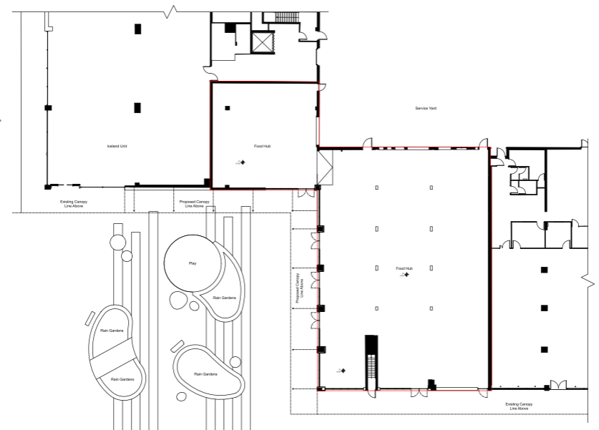
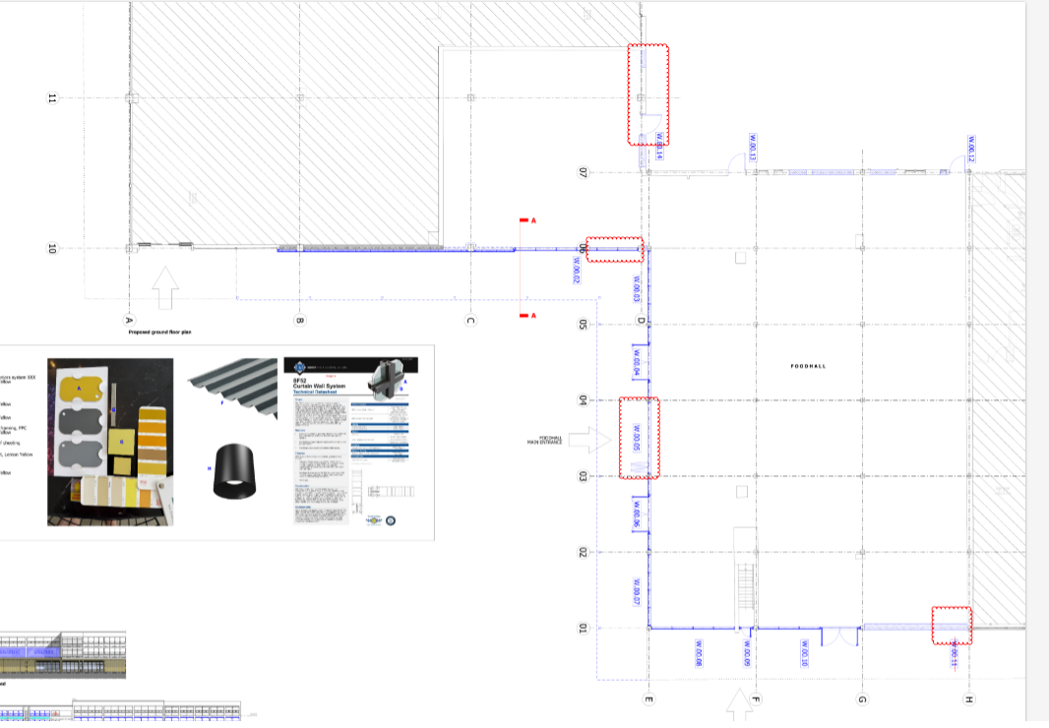

Figure 1. Top image approved floor plan under 145125/FO/2026; bottom image proposed ground floor plan under consideration.

Visual Amenity

The elevational alterations would be visible from the proposed civic square sited immediately to the west of the applicant site. Given the amendments would still follow the existing pattern of development across the proposed shop fronts and given the final materials and colouration of such development would be confirmed and agreed by the current OTH-2026-001587 application pending consideration, such alterations are not considered to give rise in respect of visual harm.

Residential Amenity

As existing, the site is a commercial led development and so there would not be any immediate
residential neighbours to be impacted by the proposal. However, it is noted that with the
regeneration, new residential uses may be introduced to the wider area. Notwithstanding this, given the nature of the amendments proposed (elevational alterations), no harm would be caused in respect of residential amenity.

Overall, the amendments would not have an adverse impact upon residential amenity and so be pursuant to Core Strategy policies SP1 and DM1 and provisions within the NPPF.

Conclusion- Non-Material Change

Following an assessment of the details submitted, I can confirm that the proposed amendment is considered to be of a non-material nature and is considered to be acceptable to the City Council as the Local Planning Authority. The City Council is satisfied that the proposed
change would have no material impact upon the character of the development or in terms of visual/residential amenity.

Other Legislative Requirements

Equality Act 2010
Section 149 (Public Sector Equality Duty) of the Equality Act 2010 requires due regard to the need to: Eliminate unlawful discrimination, harassment and victimisation and other conduct prohibited by the Act and; Advance equality of opportunity between persons who share a protected characteristic and persons who do not share it. The Equality Duty does not impose a legal requirement to conduct an Equality Impact Assessment. Compliance with the Equality Duty involves consciously thinking about the aims of the Equality Duty as part of the process of decision-making.

Human Rights Act 1998 considerations
This application needs to be considered against the provisions of the Human Rights Act 1998. Under Article 6, the applicants (and those third parties, including local residents, who have made representations) have a right to a fair hearing and to this end the local planning authority must give full consideration to their comments.

Protocol 1 Article 1, and Article 8 where appropriate, confer(s) a right of respect for a person’s home, other land and business assets. In taking account of all material considerations, including Council policy as set out in the Core Strategy and saved polices of the Unitary Development Plan, the Director of Planning, Building Control & Licensing has concluded that some rights conferred by these articles on the applicant(s)/objector(s)/resident(s) and other occupiers and owners of nearby land that might be affected may be interfered with but that that interference is in accordance with the law and justified by being in the public interest and on the basis of the planning merits of the development proposal. She believes that any restriction on these rights posed by the recommendation given is proportionate to the wider benefits of and that such a decision falls within the margin of discretion afforded to the Council under the Town and Country Planning Acts.

Article 35 Declaration
N/A.

Recommendation: Approve

