

Planning

Delegated Officer Report

Summary of application details
Application reference: | PLA-2026-000092
Application type: | Full planning permission
Proposal: | Installation of external plant equipment and cage with removable access gate.
Site address: | 132-134 Burton Road, Manchester M20 1JQ
Ward(s): | Didsbury West
Date application valid: | 04 June 2026
Applicant name: | Mr Ben Train
Agent (if any): | Ms V Priyanka
Case officer: | Joshua Lee
Recommendation: | Refuse
Date of recommendation: | 23/09/2026

Description of site, building and/or area
The proposal is related to a three-storey property on Burton Road. The property features a Tesco Express Convenience store to the ground floor (to which this application directly relates) and residential accommodation to first and second. The property features hardstanding to the rear for off street vehicle parking.
The property is in a mixed commercial/residential part of the Didsbury West ward as part of the Burton Road local centre and within the Albert Park Conservation Area. Directly adjacent to the property is an Electricity North West substation.

Description of development
The applicant is proposing the Installation of external plant equipment and cage with removable access gate.
The proposed development comprises:
• Installation of a horizontal 4-fan remote gas cooler unit;
• Installation of an associated protective cage with removable access gate; and
• Ancillary works necessary for operation and maintenance.

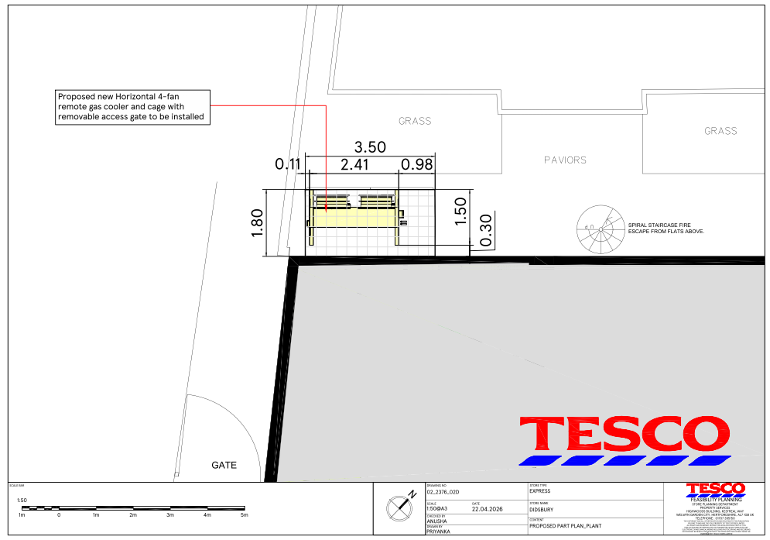
Figure 1. Proposed site plan

Relevant Planning History

Consultation, notification and publicity responses

Consultations

Manchester City Council Environmental Health
Initial comments raised concerns that the submitted noise assessment had not adequately assessed the impact of the proposed plant equipment on the nearest residential properties on Leopold Avenue, which have direct line of sight to the equipment. Environmental Health requested additional acoustic information and recommended a condition requiring noise mitigation measures and post-installation verification testing.
Following the submission of further acoustic information, Environmental Health confirmed that the applicant had satisfactorily demonstrated that the proposed equipment would comply with Manchester City Council's noise criteria for external plant and equipment. No objection is therefore raised, subject to a condition requiring the submission of a validation report to confirm that the installed equipment operates in accordance with the approved noise assessment and meets the required noise limits.

Manchester City Council Flood Risk Management
No objection to the proposal.

Manchester City Council Arboriculture Team
The Arboricultural Team advised that, due to the proposal's proximity to an off-site tree, an Arboricultural Impact Assessment (AIA) and Arboricultural Method Statement (AMS) were required to assess potential impacts and identify appropriate tree protection measures. The Tree Officer confirmed that this information should be submitted prior to determination, as without it the impact of the development on the neighbouring tree could not be adequately assessed. Despite multiple requests and extensions of time, the applicant has not provided the requested information. As a result, the Arboricultural Team maintains that the proposal cannot be supported in its current form.

Greater Manchester Police
Greater Manchester Police were consulted on this application and advised that as much as is reasonably possible, the proposed cage is designed to deterring climbing/reaching the upper floor residential windows above it.

Electricity North West
Electricity North West were consulted due to the proximity of a substation however no response was received.

Notifications and publicity
No responses were received.

Relevant policies
In accordance with Section 38(6) of the Planning and Compulsory Purchase Act 2004, planning applications must be determined in accordance with the statutory development plan unless material considerations indicate otherwise.
For Manchester, the development plan comprises:
• The Manchester Core Strategy (2012 to 2027);
• Saved policies of the Manchester Unitary Development Plan (UDP); and
• The Places for Everyone Joint Development Plan Document (2022 to 2039).
These documents are considered up to date and are afforded significant weight in the determination of planning applications. Relevant Supplementary Planning Documents (SPDs) and other adopted guidance may also be material considerations.
The National Planning Policy Framework sets out the government’s policies for plan-making and for making decisions on development proposals in England. It is a material consideration of critical importance in both contexts.
Where relevant, the Council is required to give special regard to the desirability of preserving listed buildings and their settings, and special attention to the desirability of preserving or enhancing the character or appearance of conservation areas, in accordance with the Planning (Listed Buildings and Conservation Areas) Act 1990.
The policies and guidance referred to below are considered the most relevant to the scale, nature and location of the proposed development.
- The Manchester Core Strategy Development Plan Document 2012-2027
  - Development Management and Planning Obligations
    - DM 1 - Development Management
  - Objective 1 - Spatial Principles
    - SP 1 - Spatial Principles (Partially replaced by PfE Policy JP-S 1)
  - Objective 2 - Economy and the City Centre
    - EC 1 - Employment and Economic Growth in Manchester
    - EC 9 – South Manchester
  - Objective 4 – Centres
    - C 1 – Centre Hierarchy
    - C 8 – Local Centres
  - Objective 6 Environment
    - EN 1 - Design Principles and Strategic Character Areas
    - EN 3 – Heritage (Deletions replaced with PfE Policy JP-P2)
    - EN 14 – Flood Risk (partially replaced by PfE Policy JP-S 4)
    - EN 16 - Air Quality (partially replaced by PfE Policy JP-S 5)
- Guide to development in Manchester - supplementary planning document and planning guidance, April 2007
- Extant Unitary Development Plan (UDP) –
  - Citywide Development Control Policies
    - DC18 - Conservation Areas
    - DC26 - Development and Noise
- Places for Everyone Plan Joint Development Plan Document 2022-2039-
  - Strategy
    - JP-Strat9: Southern Areas
  - Sustainable and Resilient Places
    - JP-S1: Sustainable Development
    - JP-S2: Carbon and Energy
    - JP-S4: Flood Risk and the Water Environment
  - Places for Jobs
    - JP-J1: Supporting Long-Term Economic Growth
    - JP-J2: Employment Sites and Premises
  - Places for People
    - JP-P1 Sustainable Places
    - JP-P2: Heritage
- National Planning Policy Framework – August 2026 - National Development Management Policies (NDMPs)
  - Procedural Policies
    - Chapter 3 – Decision-making policies
      - DM1: Preparing development proposals
      - DM2: Information requirements
      - DM3: Determining development proposals
      - DM6: Use of planning conditions and obligations
      - DM7: Relationship with other regulatory regimes
      - DM8: Unauthorised development and enforcement
      - DM10: Removal of national permitted development rights
  - Sustainable Development
    - Chapter 4 - Achieving sustainable development
      - S3: Presumption in favour of sustainable development
      - S4: Principle of development within settlements
    - Chapter 5 - Meeting the challenge of climate change
      - CC2: Mitigation of climate change
      - CC3: Adaptation to climate change
  - Delivering homes and supporting growth
    - Chapter 7 - Building a strong, effective economy
      - E2: Meeting the need for business land and premises
  - Creating high quality, sustainable places
    - Chapter 12 - Making effective use of land
      - L2: Making effective use of land
    - Chapter 14 - Achieving well-designed places
      - DP3: Key principles for well-designed places
      - DP4: The design process
  - Conserving and enhancing the environment
    - Chapter 18 - Managing flood risk and coastal change
      - F4: Assessing flood risk for decision-making
      - F7: Ensuring development is safe from flooding
    - Chapter 19 - Conserving and enhancing the natural environment
      - N2: Improving the natural environment
      - N3: Trees in new development
    - Chapter 20 - Conserving and enhancing the historic environment
      - HE4: Securing the conservation of heritage assets
      - HE9: Conservation areas

Assessment

Principle of Development
The application seeks planning permission for the installation of external plant equipment and an associated protective cage to serve the existing Tesco Express convenience store at ground floor level. The equipment is required to support the continued operation of the established retail unit within Burton Road Local Centre.
The site forms part of a designated local centre where policies seek to support the vitality and viability of existing commercial uses. Core Strategy Policies C1, C8, EC1 and EC9 support proposals that assist the ongoing operation of businesses and employment-generating uses. Likewise, Places for Everyone Policies JP-J1 and JP-J2 support development that maintains and enhances existing employment premises.
The proposed plant equipment is ancillary to the lawful retail use of the premises and would not result in a change of use, loss of commercial floorspace, or a significant intensification of activity. The proposal would support the continued operation of an established retail business within the local centre and is therefore considered acceptable in principle.
The site is located within the Albert Park Conservation Area and therefore regard must also be had to the statutory duty under Section 72 of the Planning (Listed Buildings and Conservation Areas) Act 1990 to pay special attention to the desirability of preserving or enhancing the character or appearance of the conservation area. Whilst this matter is considered in greater detail below, the installation of external plant equipment is not unacceptable in principle within a conservation area, subject to its design, siting and impact being acceptable.
The development is therefore considered acceptable in principle subject to an assessment of its design, heritage, amenity and environmental impacts.

Appropriate siting, layout, scale, form, massing, materials, and detail
The proposal relates to external plant equipment positioned to the rear/ancillary area of the host building. Given its functional nature, the equipment has been sited to minimise its visibility from Burton Road and to limit its prominence within the street scene.
The overall scale and massing of the unit, including the surrounding cage, is modest and typical of plant associated with retail uses. It would appear as a secondary and subservient addition to the host building and would not compete with the primary elevations or architectural features of the property.
The use of a protective cage is considered necessary for operational and safety purposes. Subject to appropriate finishing (for example, a dark, recessive colour), the structure would not appear unduly visually intrusive.

Impact on the surrounding areas in terms of the design, scale and appearance of the proposed development. Development should have regard to the character of the surrounding area.
The site lies within a mixed-use local centre where a degree of servicing and plant equipment is expected. The surrounding context includes commercial units, associated servicing arrangements, and infrastructure, including the adjacent substation.
Given the limited visibility of the plant equipment from public vantage points, together with its siting to the rear, the proposal would not harm the character or appearance of the wider area.
The development would therefore preserve the overall visual amenity of the area and comply with policies DM1 and EN1 of the Core Strategy.

Effects on amenity

Noise
The principal planning consideration is the potential impact of noise arising from the operation of the proposed plant equipment on nearby residential occupiers.
A Noise Impact Assessment (KR08048 (Didsbury Express) Noise Impact Assessment v1.1, received 27 April 2026) was submitted in support of the application. Following a review of the assessment, Environmental Health raised concerns that the original information had not adequately considered the nearest residential properties on Leopold Avenue, which benefit from direct line of sight to the proposed equipment.
In response, the applicant submitted further acoustic information by email on 20 August 2026. The additional information provided further clarification regarding the predicted noise emissions and proposed mitigation measures.
Following consideration of the revised information, Environmental Health confirmed that the applicant had satisfactorily demonstrated that the proposed equipment would achieve Manchester City Council's noise criteria for external plant and equipment and raised no objection to the proposal.
Given the specialist advice received and the submitted acoustic evidence, it is considered that any potential impact on neighbouring residential amenity can be appropriately mitigated through compliance with the submitted acoustic information. A condition requiring post-installation verification testing and confirmation that the approved noise limits have been achieved is recommended.
Subject to this condition, the proposal would not result in unacceptable harm to the living conditions of neighbouring occupiers and is considered compliant with Core Strategy Policies DM1 and SP1 and saved UDP Policy DC26.

Accessibility: buildings and neighbourhoods fully accessible to disabled people, access to new development by sustainable transport modes.
The proposal relates solely to plant installation and does not alter access arrangements to the building for customers or residents.
The site remains within a highly accessible local centre location, well served by public transport, in accordance with Core Strategy policy DM1.

Community safety and crime prevention.
The proposed lockable protective cage around the plant equipment would help prevent unauthorised access and improve site safety. The development would not introduce features that would increase opportunities for crime, disorder or anti-social behaviour. Greater Manchester Police (GMP) noted that, insofar as reasonably practicable, the design of the cage should deter climbing and reduce the potential for access to the residential windows on the upper floor above. As such, the proposal is considered acceptable in community safety and crime prevention terms.

Refuse storage and collection.
The proposal does not alter existing refuse arrangements for the site. Waste associated with the use would continue to be managed through existing arrangements.

Vehicular access and car parking
The proposal does not alter existing access, servicing, or parking arrangements. It would not result in any increased traffic generation or impact on highway safety.

Effects relating to biodiversity, landscape, archaeological or built heritage

Built heritage
The site lies within the Albert Park Conservation Area. Under the Planning (Listed Buildings and Conservation Areas) Act 1990, the Council must have special regard to preserving or enhancing the character or appearance of the conservation area.
The proposed plant equipment would be sited in a discreet location with limited visibility from public views. Its scale and functional appearance mean it would not detract from the key characteristics of the conservation area.
Any harm identified would be at most less than substantial and would be outweighed by the benefits of supporting the continued operation of an established local retail use, in line with the NPPF.
The proposal is therefore considered to comply with Core Strategy policy EN3 and Places for Everyone policy JP-P2.

Green Infrastructure including open space, both public and private
The proposal is located within the Albert Park Conservation Area and in close proximity to an off-site tree. Trees within conservation areas are afforded additional protection, reflecting their important contribution to the character and appearance of the conservation area. The Council's Arboricultural Officer advised that an Arboricultural Impact Assessment (AIA) and Arboricultural Method Statement (AMS) were required to assess the likely impacts of the development and installation works on the adjacent tree and to identify any necessary protection measures. The Arboricultural Team confirmed that this information should be submitted prior to determination and has maintained its objection in the absence of the requested submissions.
Despite requests for further information and extensions of time, the applicant has failed to provide the required arboricultural information. Consequently, the Local Planning Authority is unable to adequately assess the likely effects of the development on the adjacent tree, including any impacts upon its root protection area and whether appropriate protection measures could be secured during construction and installation works.
Trees make a significant contribution to visual amenity, biodiversity, climate resilience and, in this instance, the character and appearance of the Albert Park Conservation Area. In the absence of sufficient arboricultural information, the Local Planning Authority cannot be satisfied that the development would not adversely affect the adjacent tree or that appropriate protection measures could be secured. It has therefore not been demonstrated that the proposal would safeguard an existing tree which contributes to the significance of the conservation area. The proposal consequently conflicts with Core Strategy Policy EN1, Places for Everyone Policy JP-P1, National Development Management Policy N3 and the statutory duty under Section 72 of the Planning (Listed Buildings and Conservation Areas) Act 1990.

Flood risk and drainage.
The proposal is minor in scale and would not result in a significant increase in impermeable surfacing or alterations to the existing drainage arrangements. Whilst parts of the site are identified as being at medium risk of surface water flooding, the development would utilise the existing drainage infrastructure and is not expected to increase flood risk either within the site or elsewhere. The proposal is therefore considered acceptable in flood risk and drainage terms.
The Council's Flood Risk Management team advised that the culverted Chorlton Brook Tributary (Hough Ends) is located in close proximity to the site, approximately 54 metres to the east. Given the limited nature of the works, no objection was raised. However, Flood Risk Management requested that an informative be attached to any approval advising the applicant and contractors to remain vigilant during any excavation works and to take appropriate safety precautions should any unexpected underground watercourse-related features be encountered.

Existing or proposed hazardous installations.

Electricity North West substation
The adjacent Electricity North West substation is noted. The proposal would not interfere with its operation, and no objections have been raised by the operator.

Other Legislative Requirements

Equality Act 2010
Section 149 (Public Sector Equality Duty) of the Equality Act 2010 requires due regard to the need to: Eliminate unlawful discrimination, harassment and victimisation and other conduct prohibited by the Act and; Advance equality of opportunity between persons who share a protected characteristic and persons who do not share it. The Equality Duty does not impose a legal requirement to conduct an Equality Impact Assessment. Compliance with the Equality Duty involves consciously thinking about the aims of the Equality Duty as part of the process of decision-making.

Human Rights Act 1998 considerations
This application needs to be considered against the provisions of the Human Rights Act 1998. Under Article 6, the applicants (and those third parties, including local residents, who have made representations) have a right to a fair hearing and to this end the local planning authority must give full consideration to their comments.
Protocol 1 Article 1, and Article 8 where appropriate, confer(s) a right of respect for a person’s home, other land and business assets. In taking account of all material considerations, including Council policy as set out in the Core Strategy and saved polices of the Unitary Development Plan, the Director of Planning, Building Control & Licensing has concluded that some rights conferred by these articles on the applicant(s)/objector(s)/resident(s) and other occupiers and owners of nearby land that might be affected may be interfered with but that that interference is in accordance with the law and justified by being in the public interest and on the basis of the planning merits of the development proposal. She believes that any restriction on these rights posed by the recommendation given is proportionate to the wider benefits of and that such a decision falls within the margin of discretion afforded to the Council under the Town and Country Planning Acts.

Planning balance & Conclusion
The proposal would support the continued operation of an established retail unit within Burton Road Local Centre and would provide replacement plant equipment necessary for the functioning of the existing Tesco Express store. The proposal is also considered acceptable in terms of noise, residential amenity, flood risk, highway safety and the character and appearance of the conservation area. Environmental Health has confirmed that the submitted acoustic information demonstrates compliance with the Council's noise criteria and raises no objection subject to conditions.
However, the application site lies within the Albert Park Conservation Area and adjacent to a tree which contributes to the character, appearance and environmental quality of the area. The Council's Arboricultural Officer advised that an Arboricultural Impact Assessment and Arboricultural Method Statement were required to enable a full assessment of the proposal's impact on the adjacent tree and to identify any necessary tree protection measures. Despite requests for further information and extensions of time, the applicant has failed to provide the requested arboricultural information. The Arboricultural Team therefore maintains its objection to the proposal.
In the absence of this information, the Local Planning Authority cannot be satisfied that the development and associated installation works would not result in harm to a protected tree, nor that appropriate mitigation and protection measures could be secured. Given the site's location within a conservation area, where trees are afforded additional protection and make an important contribution to local character and appearance, this uncertainty attracts significant weight.
Whilst the operational and economic benefits of the proposal are acknowledged, limited weight is attached to these benefits given the relatively modest scale of the development. By contrast, substantial weight is attached to the failure to provide sufficient information to demonstrate that the adjacent tree, which contributes to the character and appearance of the Albert Park Conservation Area, would be appropriately safeguarded. The proposal therefore conflicts with Core Strategy Policy EN1, Places for Everyone Policy JP-P1, National Development Management Policy N3 and the statutory duty under Section 72 of the Planning (Listed Buildings and Conservation Areas) Act 1990. Accordingly, the application is recommended for refusal.

Recommendation: REFUSE

Article 35 Declaration
In accordance with Article 35 of the Town and Country Planning (Development Management Procedure) (England) Order 2015, the Local Planning Authority has worked with the applicant in a positive and proactive manner. Following consultation with the Council's Arboricultural Officer, the applicant was advised that an Arboricultural Impact Assessment and Arboricultural Method Statement were required to enable a full assessment of the proposal's impact on an adjacent tree within the Albert Park Conservation Area. The applicant was afforded opportunities to submit the requested information, including extensions of time to do so. However, the necessary information was not provided. In the absence of sufficient information to demonstrate that the development would not adversely affect the adjacent tree, the Local Planning Authority has been unable to conclude that the proposal complies with the relevant development plan policies and planning permission has therefore been refused

Reason(s) for refusal

Insufficient Arboricultural Information and Impact on Conservation Area
The applicant has failed to provide an Arboricultural Impact Assessment and Arboricultural Method Statement, despite these being requested by the Local Planning Authority's Arboricultural Officer. In the absence of this information, the Local Planning Authority is unable to adequately assess the impact of the proposed development on a neighbouring tree, including any effects on its root protection area and the suitability of measures necessary to safeguard the tree during construction and operation of the development. The tree is located within the Albert Park Conservation Area, where trees make an important contribution to local character and are afforded additional protection.
Consequently, insufficient information has been submitted to demonstrate that the proposal would safeguard an existing tree which contributes to the character and appearance of the Albert Park Conservation Area. The proposal is therefore contrary to Policy EN1 of the Manchester Core Strategy, Policy JP-P1 of Places for Everyone, National Development Management Policy N3.

