

Planning

Delegated Officer Report

Summary of application details
Application reference: | PLA-2026-000866
Application type: | Householder planning permission
Proposal: | Retention of single-storey rear extension and installation of window to side elevation of dwellinghouse.
Site address: | 6 Allan Roberts Close Manchester M9 8AL
Ward(s): | Harpurhey
Date application valid: | 03 August 2026
Applicant name: | Ms Daniella Onalaja
Agent (if any): | Mr Dean King
Case officer: | Katie Raw
Recommendation: | Refuse
Date of recommendation: | 22 September 2026

Description of site, building and/or area
The application site relates to 6 Allan Roberts Close within the north Manchester ward of Harpurhey. The application site relates to a semi-detached, two storey multi-colour brick dwellinghouse with elements of cream/ yellow render and brown timber patterns at the first floor level of all elevations. At the time of the site visit, the property benefitted from a wooden shed sited to the side of the property, and the rear extension subject to this application. Amenity space to the front of the property takes the form of an off street driveway to the side and front of the property, and the rear amenity space consists of a garden.

The surrounding area is residential in nature and the applicant site sits within a housing estate approved in 1990 (planning ref: 036222), properties further to east are older in age.

Description of development
The current application seeks planning permission for retention of single-storey rear extension and installation of window to side elevation of dwellinghouse.

The agent was advised the plans submitted were inaccurate, and on 8 September 2026 the agent confirmed it was the intention of the client to retain the structure with small, proposed changes in door location. The agent provided two sets of revised drawings in attempt to produce accurate plans; however the subsequent submissions were still inaccurate and did not reflect the intention of the applicant. The application is assessed on the basis of the initial plans submitted for consideration, received by the Local Planning Authority on 1 July 2026 and 24 July 2026.

Relevant planning history
140215/PDE/2024- Prior notification of proposed larger home extension projecting 4.3m to the rear, with a maximum height of 3.7m and a height at eaves of 2.5m.
Granted 11 July 2024.

Approval for the development of the wider estate:
036222- Land off Andrew Road, Sidney Road- Erection of 43 houses and 4 bungalows.
Approved 21 June 1990.

Consultation, notification and publicity responses

Consultations
Environmental Health

Having reviewed the above application, Environmental Health note that the retrospective extension appears to have been constructed directly on a historic landfill site categorised as having a 'Moderate' risk potential for landfill gas migration.

Further comments 24 August 2026:
Environmental Health accepted that no gas protection measures were required for the properties as per the development of the estate. With respect to other issues of potential ground contamination, the dwelling has been in residential use for approximately 35 years and, based on the information currently available, Environmental Health have not identified evidence of an existing contamination issue associated with the property. On that basis, no further comments were made, and no conditions were suggested to be attached to any approval granted.

Notifications and publicity
An objection was received from the neighbour notification process. The neighbour details neighbour disputes with the position of the boundary and extent of works. The neighbour requests the plans are examined for their accuracy in relation to works on the site. The neighbour requests the work is amended so the extension sits only within the applicant’s site edged red.

Relevant policies
The National Planning Policy Framework (August 2026)

The document sets out the Government's Planning Policies for England and how these are
expected to be applied.

The purpose of the planning system is to contribute to the achievement of sustainable development, by managing the use and development of land in the long-term public interest.

Achieving sustainable development means that the planning system has three overarching objectives in providing for the homes, commercial development, facilities and infrastructure which society needs. These objectives are interdependent and need to be pursued in mutually supportive ways (so that opportunities can be taken to secure net gains across all three):
a) an economic objective
b) a social objective and
c) an environmental objective.

The following specific policies are considered to be particularly relevant to the proposed
development:
Chapter 3- The objective of the policies in this chapter is to ensure that development proposals are informed by appropriate information and decided in a way which is proportionate, timely and effective. This chapter provides a set of general decision-making policies which should be read with the rest of the thematic policies in the other chapters.
>Policy DM3: Determining development proposals
>Policy DM6: Use of planning conditions and obligations
>Policy DM8: Unauthorised development and enforcement
“1. Where there has been unauthorised development and local planning authorities are considering whether enforcement action is expedient, they should take account of their local enforcement plan, the impact of the breach of planning control, and the extent to which the breach would otherwise be acceptable.
2.In cases of unauthorised development where consideration is being given to an application for retrospective planning permission (or through an enforcement appeal, whether to grant planning permission in respect of a breach of planning control), if it is concluded based on evidence that the unauthorised development was intentional, that fact should be given substantial weight in considering whether to grant planning permission”.

Chapter 4- Achieving sustainable development- The objective of the policies in this chapter is to meet development needs through sustainable patterns of development, including by maximising the potential for growth on suitable land within settlements, enabling development which will support the rural economy, rural communities and the provision of infrastructure, and limiting development away from settlements to help safeguard the intrinsic character and beauty of the countryside.
>Policy S3: Presumption in favour of sustainable development

Chapter 14 - Achieving well-designed places- The objective of the policies in this chapter is to promote high quality, healthy, inclusive and sustainable places, through setting clear expectations about design outcomes and the use of relevant tools and processes.
-Policy DP3: Key principles for well-designed places
-Policy DP4: The design process

The Manchester Core Strategy Development Plan Document 2012-2027 ("the Core Strategy")
was adopted by the City Council on 11th July 2012. Updated March 2024 following adoption of
Places for Everyone Joint Development Plan.

The Core Strategy is the key document in Manchester's Local Development Framework. It
replaces significant elements of the Unitary Development Plan (UDP) as the document that sets
out the long term strategic planning policies for Manchester's future development. Of relevance
are:
Policy DM1 (Development Management),
Policy SP1 (Spatial Principles) (Deletions replaced by PfE Policy JP-S1)
Policy EN1 (Design Principles and Strategic Character Areas).

Unitary Development Plan Saved Policies (1995)

Large elements of the UDP have been superseded by the Core Strategy. The following saved
policies are of relevance in the consideration of this application:

Policy DC1 Residential extensions
DC1.1 states that in determining planning applications for extensions to residential properties,
the Council will have regard to:
a. The general character of the property;
b. The effect upon the amenity of the neighbouring occupiers;
c. The desirability of enabling people to adapt their houses in appropriate ways to meet
changing household needs;
d. The overall appearance of the proposal in the a street scene;
e. The effect of the loss of any on-site car parking.

DC1.2 states that extensions to residential properties will be allowed subject to compliance with
other relevant policies of the Plan and the following criteria:
a. They are not excessively large or bulky (for example resulting in structures which are not
subservient to original houses or project out too far in front of original buildings);
b. They do not create undue loss of sunlight, daylight or privacy;
c. They are not out of character with the style of development in the area or the surrounding
scene by virtue of design, use of materials or construction details.
d. they would not result in the loss of off-street car-parking, in a situation where there is so
severe an existing on-street parking problem that unacceptable additional pressures would be
created.

DC1.3 Notwithstanding the generality of the above policies, the Council will not normally
approve:
a. rearward extensions greater than 3.65m (12 ft) in length;
b. 2-storey extensions with a flat roof, particularly those which would be visible from the public
highway;
c. 2-storey extensions to terraced properties which occupy the full width of the house;
d. flat roofed extensions to bungalows;
e. extensions which conflict with the Council's guidelines on privacy distances (which are
published as supplementary guidance).

Guide to Development in Manchester Supplementary Planning Document and Planning
Guidance, Adopted April 2007.

The Guide aims to help to develop and enhance a unique and positive sense of place within
Manchester and its neighbourhoods. The guidance is grouped under seven key principles
recognised by CABE as being those urban design characteristics which create successful
places. These are: character and context, continuity and enclosure, ease of movement, quality
of the public realm, diversity, legibility, and adaptability. It advises that high quality design is a
vital attribute of successful neighbourhoods.

Places for Everyone (2022-2039)

Places for Everyone is a long-term plan of nine Greater Manchester districts for jobs, new
homes, and sustainable growth. It has been published by the GMCA on behalf of the nine
districts and took effect and became part of the statutory development plan on March 21, 2024.
The Plan and its policies are now a material planning consideration in the determination of
planning applications. The Plan and its policies must therefore be given full weight in the
planning balance.

The following policies are relevant:
JP- S1- Sustainable development.

Assessment
Principle of Development

- The current application seeks planning permission for retention of single-storey rear extension and installation of window to side elevation of dwellinghouse. This application has been submitted as the applicant has not implemented the previous Larger Homes permitted development scheme as per the approved plans (see planning ref: 140215/PDE/2024). Whilst there are small variations between the two sets of plans in respect of window positioning, the main difference between the two is that the current scheme encroaches on the neighbour’s land by approximately 200mm, albeit the floor plan submitted does not accurately reflect the extent of the encroachment onto the neighbour’s land (see Figure 1 and 2). Certificate B has been signed as part of the application with notice no.1 served on the adjoining neighbour.

As per national development policy DM8 ‘Unauthorised development and enforcement’ “if it is concluded based on evidence that the unauthorised development was intentional, that fact should be given substantial weight in considering whether to grant planning permission”. In the case of this site, the application seeks to retain the existing development on the site. Whilst permission has been granted for a single storey rear extension under the Larger Homes Route, the scheme has not been implemented as per the plans. The applicant has previously interacted with the planning system, although has not implemented the scheme correctly. There has not been any involvement on the site by colleagues within the Planning Enforcement Team. The LPA understand that the boundary dispute between the neighbours is being pursued using necessary civil procedures. In the case of the application, the LPA consider the development is intentional, as it deviates from the plans and results in works extending beyond the applicant’s land and so, such factor should be given significant weight. However, as any resultant harm in relation to residential and visual amenity or design is not considered significant, as the main issue arising from the proposal relates to a civil matter, the intentional breach alone would not constitute a reason for refusal.

Notwithstanding this, the plans submitted for consideration are inaccurate and conflict with the principles set out under the Town and Country Planning (Development Management Procedure) (England) Order 2015 (as amended). Such considerations will now be discussed in turn.
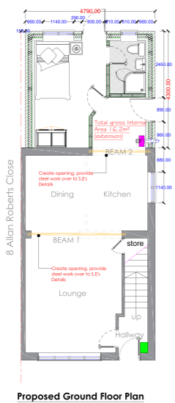
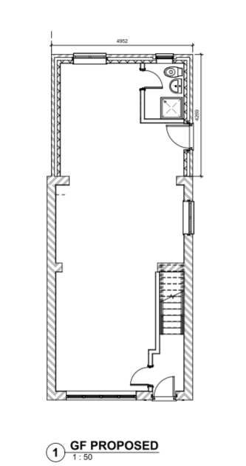

Figure 1. Left hand image, floor plan approved under 140215/PDE/2024, right hand image, floor plan proposed for retention.

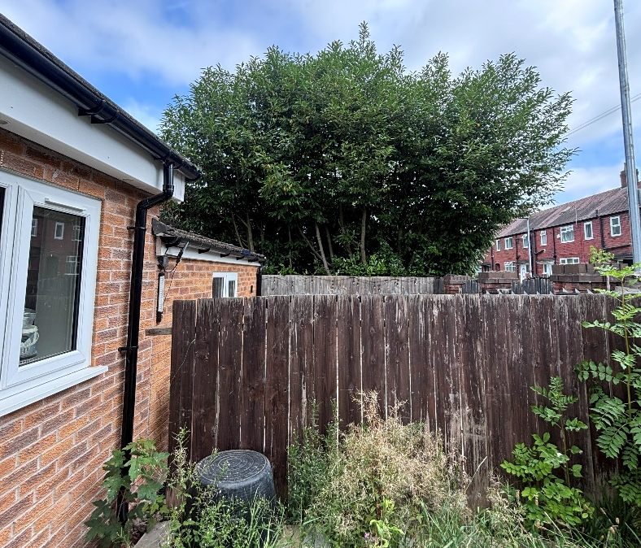

Figure 2. On site photos showing encroachment of extension beyond shared boundary (extension extending further northwards beyond the timber fence/ shared boundary)

Inaccurate Submission

The Town and Country Planning (Development Management Procedure) (England) Order 2015 (as amended) provides general requirements for the submission of planning applications and states that “an application for planning must….be accompanied by…. 7(1c)(ii) any other plans, drawings and information necessary to describe the development which is the subject of the application”. In addition, national decision making policy DP4 states “The local planning authority should… b. Ensure that relevant planning conditions refer to clear and accurate plans and drawings which provide visual clarity about the design of the development, including the approved use of materials where appropriate”.

With this in mind, it is considered that the information submitted under this application fails to meet the requirements set out in this Order and the NPPF. The following inaccuracies have been found, although such list is not exhaustive:

6 Allan Roberts Close has a gable roof form, with a ridge height continuous along the roof; however both the existing and proposed elevation plans show the property has a dual pitched roof. The plans are not reflective of the applicant property on any of the submitted elevations provided within the initial submission (see Figure 3 and 4).

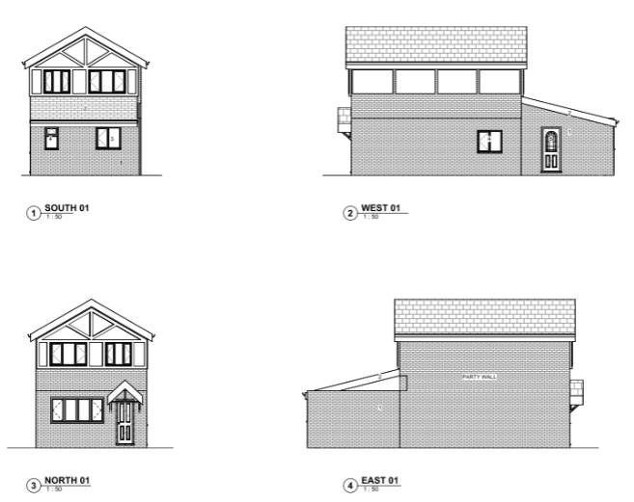
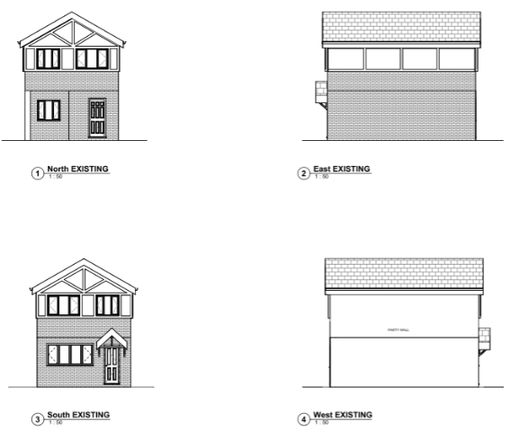

Figure 3. Left hand image existing elevations, right hand image proposed elevations (extension to be retained with some amendments to window and door arrangements)
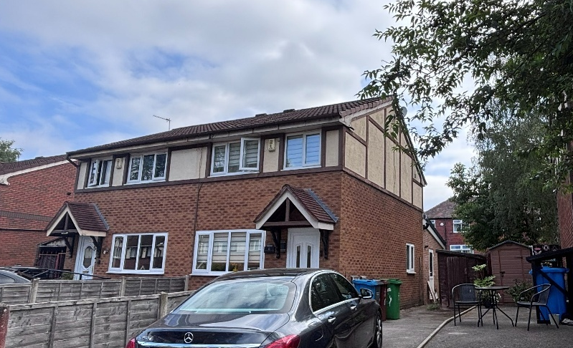
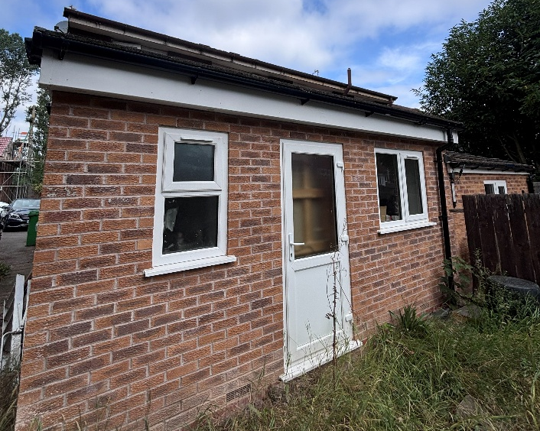

Figure 4. Existing property and development seen on site

The agent confirmed it is the intention of the applicant to retain the works seen on site, with some small alterations to the windows and doors. This explains why the window arrangement on the proposed rear elevation does not match the window and door arrangement as seen on site (see Figures 3 and 4). The floor plans and elevations suggest development sits wholly within the applicant’s site edged red, when analysing the indicated boundary line on the plan. This is not the case as seen on site (see Figure 1, 2, 3 and 4), and as per the ongoing civil disputes.

Therefore, given the quality and accuracy of the submitted information, and the uncertainty of exactly what development the applicant is seeking to retain on the site, the City Council is unable to support this application, as it conflicts with the principles set out under the Town and Country Planning (Development Management Procedure) (England) Order 2015 (as amended), and provisions within the NPPF.

Siting, Scale, Design and Appearance

It is noted the extension and its dimensions are incorrectly drawn in respect to the extension and its relationship with the common boundary with the adjoining property, no.8 Allan Roberts Close. The dimensions of the proposal according to the plans show the extension with dimensions of Height: 3.7 x Length: 4.3 x Width: 5 metres. The previously approved extension under 140215/PDE/2024 had dimensions of Height: 3.7 x Length: 4.3 x Width: 4.8 metres. As such, the main difference relates to the width, and the LPA are confident the width extends beyond the common boundary and encroaches onto the neighbour’s land. Given the projection is the same as that previously approved, no concern is raised in respect of the scale of the proposal. As the width and the encroachment of the development onto the neighbour’s land is a civil matter, and given the current proposal is not considered to give rise to harm in respect of residential amenity (see section below), the siting and scale of the proposal does not constitute a reason for refusal in its own right.

In addition, the window within the side elevation of the main dwellinghouse could be achieved through permitted development rights and has already been granted through the previous 140215/PDE/2024 application.

Residential Amenity

The proposed development keys into the neighbour’s existing extension with both neighbours having the same rear building line. As such, the extension does not give rise to an overbearing feature to the detriment of the adjoining neighbour given the extension would not extend beyond the established building line. Given this, no adverse loss of light/ overshadowing implications would occur. As the extension is single storey, there would not be any adverse privacy implications caused from the proposed arrangement of windows along the rear elevation.

If an acceptable scheme were submitted as a subsequent planning application, a condition would be attached to any approval granted to ensure any bathroom window is obscure glazed to protect the privacy of the applicant and passersby.

The rear extension would not extend beyond the existing side wall of the host property and so an approximate 2.6 metre gap is retained between the extension and the shared boundary with no.4 Allan Roberts Close. Given such gap and the high boundary treatment separating the common boundary, the extension is not considered to give rise to any overbearing implications. As the applicant site sits due north, the proposal would not give rise to any loss of light implications. The application also requests consent for the window to the inserted in the side elevation of the main dwelling, facing in the direction of no.4 Allan Roberts Close. Such window was granted consent through 140215/PDE/2024. Given the window would not come any closer to the shared boundary than the existing side wall and given a shed currently blocks views onto the neighbour’s land, any adverse privacy implications would not be considered severe.

Visual Amenity

Although the rear extension is visible from Sidney Road, the extension is largely hidden from view to the immediate neighbours. The resultant materials are considered acceptable in respect of matching the host dwelling, and the brickwork used matches that brickwork within the neighbour’s rear extension giving a consistent appearance along the rear elevation of the pair of semi-detached properties. As such, the proposal is not considered to give rise to visual harm.

Conclusion

In this instance, although the development on site deviates from the scheme approved under 140215/PDE/2024 and there are civil disputes ongoing in relation to the encroachment of the extension onto the neighbour’s land, the development on site is considered acceptable in respect of visual and residential amenity, design and siting and scale as planning considerations. However, the plans submitted are wholly inaccurate which leads to uncertainty as to the applicant’s intentions on the site.

It is therefore considered that the proposed development conflicts with the principles set out under the Town and Country Planning (Development Management Procedure) (England) Order 2015 (as amended), policies SP1 and DM1 of the Manchester Core Strategy and saved policy
DC1 of the Unitary Development Plan for the City of Manchester, and provisions within
the NPPF.

It is noted that if a subsequent application is submitted and approved from a planning perspective, such civil matters would remain until separably resolved.

Other Legislative Requirements

Equality Act 2010
Section 149 (Public Sector Equality Duty) of the Equality Act 2010 requires due regard to the need to: Eliminate unlawful discrimination, harassment and victimisation and other conduct prohibited by the Act and; Advance equality of opportunity between persons who share a protected characteristic and persons who do not share it. The Equality Duty does not impose a legal requirement to conduct an Equality Impact Assessment. Compliance with the Equality Duty involves consciously thinking about the aims of the Equality Duty as part of the process of decision-making.

Human Rights Act 1998 considerations
This application needs to be considered against the provisions of the Human Rights Act 1998. Under Article 6, the applicants (and those third parties, including local residents, who have made representations) have a right to a fair hearing and to this end the local planning authority must give full consideration to their comments.

Protocol 1 Article 1, and Article 8 where appropriate, confer(s) a right of respect for a person’s home, other land and business assets. In taking account of all material considerations, including Council policy as set out in the Core Strategy and saved polices of the Unitary Development Plan, the Director of Planning, Building Control & Licensing has concluded that some rights conferred by these articles on the applicant(s)/objector(s)/resident(s) and other occupiers and owners of nearby land that might be affected may be interfered with but that that interference is in accordance with the law and justified by being in the public interest and on the basis of the planning merits of the development proposal. She believes that any restriction on these rights posed by the recommendation given is proportionate to the wider benefits of and that such a decision falls within the margin of discretion afforded to the Council under the Town and Country Planning Acts.

Article 35 Declaration

The proposal was assessed with regards to policies outlined in the National Planning
Policy Framework, Unitary Development Plan Saved Policies, Local Development
Framework Core Strategy Development Plan and other material considerations. In this
instance officers have worked with the applicant in a proactive manner but the revised plans were inaccurate and could not be accepted as revised plans. As such, the application is progressed in a timely manner.

Recommendation: Refuse

