

Planning

Delegated Officer Report

Summary of application details
Application reference: | PLA-2026-000688
Application type: | Householder planning permission
Proposal: | Erection of single-storey extension to rear and side of property.
Site address: | 185 Oswald Road Manchester M21 9AZ
Ward(s): | Chorlton
Date application valid: | 25 June 2026
Applicant name: | Mr James Balderstone
Agent (if any): | Mr Philip Lambert
Case officer: | Ellie Knowles
Recommendation: | Approve
Date of recommendation: | 18 September 2026

Description of site/building/area

The application relates to a two-storey Victorian semi-detached class C3 dwellinghouse on Oswald Road in Chorlton. The property is built from red brick with white render detailing and black roof tiles. The property features a front porch canopy, hardstanding for vehicle parking to the front and a garden to the rear.

Oswald Road is a residential street within the Chorlton Ward of Manchester. The area is predominantly residential comprising of 2 storey semi-detached and terraced residential houses with St Hilda’s Primary School at the northern end of the road.

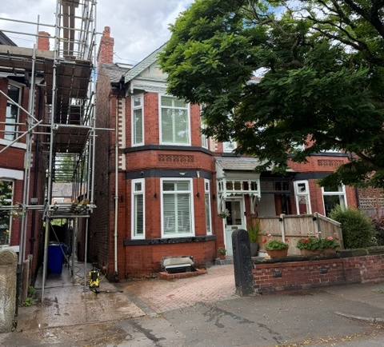

Listed building: Not applicable

Conservation area: Not applicable

Tree Preservation Order: Not applicable

Description of development

The applicant is seeking permission for the erection of a single-storey extension to rear and side of property to form additional living accommodation.
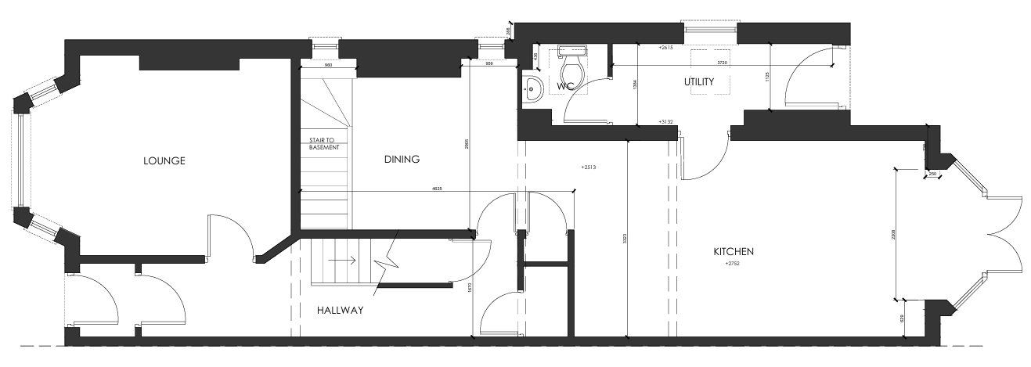
Figure 1: Existing Ground Floor Plan
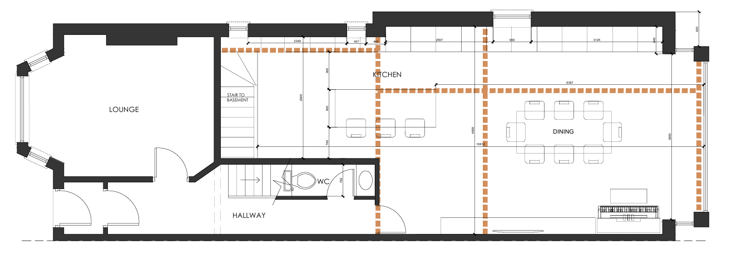
Figure 2: Proposed Ground Floor Plan

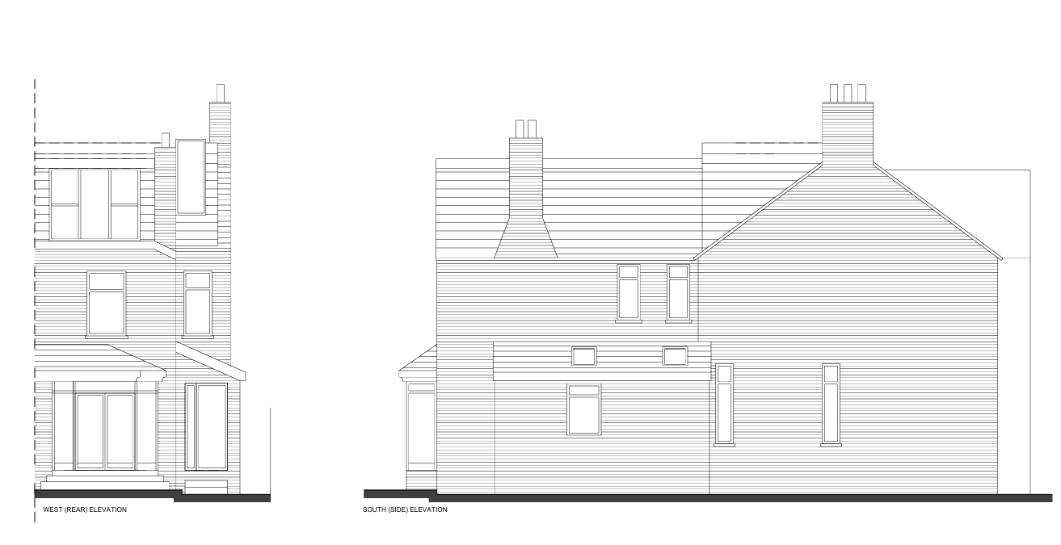
Figure 3: Existing Elevations

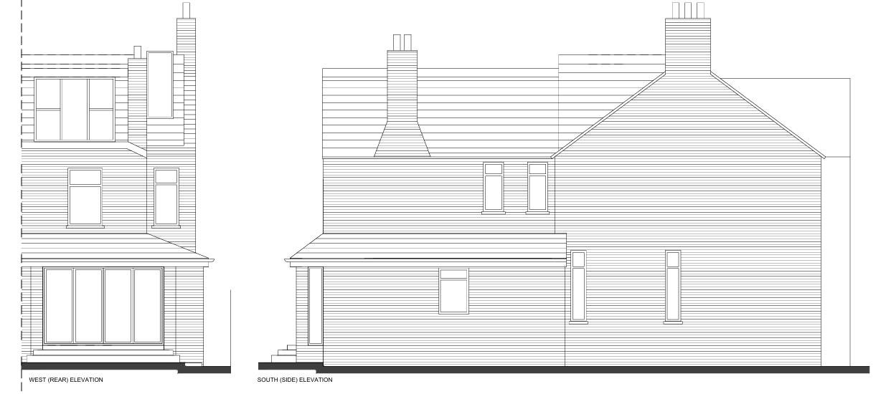
Figure 4: Proposed Elevations

Consultations & Notification Responses

Local responses
None

Consultee responses
None

Relevant Planning History

At the application site –

140216/FH/2024 – Erection of single storey side/rear extension including demolition of existing rear bay window. Approved 29.07.2024. Not Implemented.

096552/FH/2011/S1 – Erection of single storey side extension to form additional living accommodation. Approved 29.07.2011. Implemented.

History of negotiations

No negotiations were entered into with the agent, given that the scheme was considered policy compliant.

Policy

Places for Everyone (2022-2039) – Places for Everyone is a long-term plan of nine Greater Manchester districts for jobs, new homes, and sustainable growth. It has been published by the GMCA on behalf of the nine districts and took effect and became part of the statutory development plan on March 21, 2024.

The PfE Plan and its policies are now a material planning consideration in the determination of planning applications. The PfE Plan and its policies must therefore be given full weight in the planning balance.

Manchester Core Strategy Development Plan Document (2012-2027) - The Core Strategy was adopted on the 11 July 2012 and replaces a large number of policies in Manchester’s Unitary Development Plan. Parts of the policies have been superseded by the Places for Everyone Plan.

The Unitary Development Plan (UDP) for the City of Manchester (1995) - The Unitary Development Plan for the City of Manchester was adopted in 1995 and has largely been replaced with the policies contained within the Core Strategy. However, there are a number of policies that are extant.

The relevant Places for Everyone policies for this application are as follows:

JP-S1 – Sustainable Development
JP-P1 – Sustainable Places

The relevant Core Strategy policies for this application are as follows:

DM 1 – Development Management
SP 1 – Spatial Principles (partially superseded by PfE)
EN 1 – Design Principles and Strategic Character Areas
EN 19 – Waste

The relevant saved UDP policies for this application are:

DC1 – Residential Extensions

The relevant supplementary planning guidance documents for this application are:
- The Guide to Development in Manchester SPD

A relevant material consideration is also:
- Manchester Residential Quality Guidance March 2017 (Manchester’s Emerging Space Standards)

National Planning Policy Framework

The Draft National Planning Policy Framework (August 2026) - The National Planning Policy Framework (NPPF) sets out the Government’s planning policies for England and how these should be applied.

Planning law requires that applications for planning permission be determined in accordance with the development plan, unless material considerations indicate otherwise. The national decision-making policies in this Framework are a material consideration in making these decisions and should be read alongside the policies in the development plan.

The Local Planning Authority consider the following NPPF policies relevant to this proposal.

DM3: Determining development proposals
S3: Presumption in favour of sustainable development
L4: Residential extensions
DP3: Key principles for well-designed places

Issues

Principle of development:

The principle of erecting a single storey side rear extension to provide additional living accommodation for a family dwellinghouse is acceptable given that many individuals prefer to extend and alter their homes to meet changing household needs rather than move. However, consideration must be given to the proposal’s siting, scale and massing, appearance and impact upon visual amenity, residential amenity, waste storage, and parking.

Impact on visual amenity and the streetscene:

The proposed side and rear extension would create a single storey wraparound element around the existing two storey outrigger. It would sit flush with the existing single storey side extension and project 803mm rearwards from the rear elevation of the outrigger. The extension would accommodate a hipped roof. The proposal would be maintain the inset from the shared side boundary with no.183 Oswald Road. The current existing bay window would be removed to facilitate the rear extension.

The proposed side and rear single storey extensions would be built of brickwork to match the existing dwellinghouse. The submitted plans indicate that 1.no side window would be retained within the ground floor elevation (proposed to serve a kitchen), 2.no vertical windows proposed to the rear extension side elevations and bi fold doors in the rear elevation.

The overall siting, scale, and massing of the proposal is considered to be acceptable on balance, as the development is understood as being subservient to the host dwellinghouse in terms of their dimensions, would avoid resulting in ‘excessively large or bulky’ additions to the property, and would not cause undue harm to the residential amenity of neighbouring occupiers in terms of introducing overbearing features into the area. Sufficient private outdoor amenity space would also be retained to the rear.

The proposal is considered relatively standard in terms of its design and scale for developments of this type and would be in-keeping with the existing precedent of residential extensions in this locale. Sited at the side and rear of the property, the extensions would be partially visible within the street scene and public realm

The design and appearance of the proposed developments therefore accords with Core Strategy policies DM1 and SP1 as well as chapter 12 of the NPPF as their impact upon visual amenity is considered to be minor.

Impact on residential amenity:

On the basis, that the proposed side and rear extension would be single storey with a side projection and hipped roof height to match the existing side extension, inset from the shared boundaries and a modest rearward projection of 803mm from the existing outrigger rear building line, it is considered that the proposal should not cause significant issues associated with overshadowing, loss of light, or loss of outlook, nor should it introduce an overbearing presence into the area.

Fenestration proposed to the rear elevation would not give rise to any indue overlooking and loss of privacy of neighbouring occupiers.

With regards to the retention of a ground floor window to the side elevation, facing the boundary with no.183, this window would serve a new kitchen (formerly Utility room). On balance this window is considered acceptable to retain, giving that it would not create any greater impact than existing.

Similarly, the proposed side windows to the modest rear extension would give a similar impact to the bay window (to be demolished), therefore are considered acceptable on balance. Furthermore, this fenestration pattern was granted recent consent under ref: 140216/FH/2024.

The proposal therefore accords with saved policy DC1 of the Unitary Development Plan for the City of Manchester and policies DM1 and SP1 of the Manchester Core Strategy.

Impact on Highway Safety:

The proposed development would not interfere with the existing parking provision on street, as such is considered acceptable in this regard.

Waste:

The current waste storage arrangements would be unaffected by the proposal.

Conclusion:

Given the above issues, it is considered that the proposal is acceptable in terms of its principle, siting, scale and massing, appearance, impact upon visual and residential amenity, waste storage and parking as it broadly complies with saved policies DC1 of the UDP, policies DM1 and SP1 of the Core Strategy, policy JP-P1 and JP-P2 of the Places for Everyone joint development plan document and chapter 12 of the NPPF.

Other Legislative Requirements

Equality Act 2010
Section 149 (Public Sector Equality Duty) of the Equality Act 2010 requires due regard to the need to: Eliminate unlawful discrimination, harassment and victimisation and other conduct prohibited by the Act and; Advance equality of opportunity between persons who share a protected characteristic and persons who do not share it. The Equality Duty does not impose a legal requirement to conduct an Equality Impact Assessment. Compliance with the Equality Duty involves consciously thinking about the aims of the Equality Duty as part of the process of decision-making.

Human Rights Act 1998 considerations
This application needs to be considered against the provisions of the Human Rights Act 1998. Under Article 6, the applicants (and those third parties, including local residents, who have made representations) have a right to a fair hearing and to this end the local planning authority must give full consideration to their comments.

Protocol 1 Article 1, and Article 8 where appropriate, confer(s) a right of respect for a person’s home, other land and business assets. In taking account of all material considerations, including Council policy as set out in the Core Strategy and saved polices of the Unitary Development Plan, the Director of Planning, Building Control & Licensing has concluded that some rights conferred by these articles on the applicant(s)/objector(s)/resident(s) and other occupiers and owners of nearby land that might be affected may be interfered with but that that interference is in accordance with the law and justified by being in the public interest and on the basis of the planning merits of the development proposal. She believes that any restriction on these rights posed by the recommendation given is proportionate to the wider benefits of and that such a decision falls within the margin of discretion afforded to the Council under the Town and Country Planning Acts.

Recommendation: Approve

Article 35 Declaration

Officers have worked with the applicant/agent in a positive and proactive manner based on seeking solutions to problems arising in relation to dealing with the planning application. In this instance, no negotiations were necessary but appropriate conditions have been attached to the end of this report. The scheme is considered to be in accordance with the guidance contained within saved policy DC1 of the Manchester Unitary Development Plan and to policies SP1 and DM1 of the Core Strategy.

Condition(s) to be attached to decision for approval

- 3 Year Time Limit
The development must be begun not later than the expiration of three years beginning with the date of this permission.

Reason - Required to be imposed pursuant to Section 91 of the Town and Country Planning Act 1990.

- Specified drawings and documents
The development hereby approved shall be carried out in accordance with the documents labelled:

- 'Proposed Basement and Ground Floor Plans', numbered '01-03 REV D', stamped as received by the City Council as Local Planning Authority on the 15/06/2026.
- 'Proposed Elevations', numbered '01-05 REV B', stamped as received by the City Council as Local Planning Authority on the 25/06/2026.

Reason - To ensure the development is carried out in accordance with the approved plans, pursuant to Policies SP1 and DM1 of the Core Strategy.

- Matching materials
The materials to be used on the external surfaces of the extension hereby permitted shall match those of the existing dwellinghouse in type, size, colour and texture.

Reason - To ensure the appearance of the building to be extended is not adversely affected by the materials to be used in the construction of the extension, pursuant to saved policies DC1.1 and DC1.2 of the Unitary Development Plan for the City of Manchester and policy DM1 of the Manchester Core Strategy.

- Additional glazing restriction
Notwithstanding the provisions of the Town and Country Planning (General Permitted Development) (Amendment) Order 2015, (or any order revoking and re-enacting that Order with or without modification), no additional glazing, windows, or doors, other than those shown on the approved plans, shall be inserted at the property unless Planning Permission is specifically granted.

Reason - In the interests of the amenities of the occupiers of the neighbouring residences, pursuant to policy DM 1 of the Core Strategy for the City of Manchester and saved policy DC1 of the Unitary Development Plan.

