

Planning

Delegated Officer Report

Summary of application details
Application reference: | PLA-2026-001041
Application type: | Householder planning permission
Proposal: | Installation of rear dormer and associated elevational alterations.
Site address: | 3 Mayfair Park Manchester M20 2JW
Ward(s): | Didsbury West
Date application valid: | 18 August 2026
Applicant name: | Mr Kami Zargar
Agent (if any): | Mr Matthew McNulty
Case officer: | Joshua Lee
Recommendation: | Approve
Date of recommendation: | 16/09/2026

Description of site, building and/or area
The proposal relates to a 4 bed two-storey detached dwellinghouse with a double garage on Mayfair Park.
The property is located on the edge of residential development within the Didsbury West ward of Manchester. The property sits close to the River Mersey, within the Mersey River Valley and within Flood Zone 3 and High Surface Water Flood Risk. The curtilage of the site also intersects the Manchester Green Belt.

Description of development
Installation of rear dormer and associated elevational alterations.

Rear dormer
The proposed dormer runs 15800mm across the main rear roof slope (leaving gaps to the eaves) and is finished in black and grey timber cladding with aluminium windows.

Elevational alterations
Other alterations include the addition of timber cladding detail on main fascias.

Relevant planning history
Reference | Proposal | Decision | Decision Date
060803/FH/SOUTH2/00 | Extension at lower garden level to form new entrance and family room with WC and store | Approved | 22 Dec 2000
019735 | Alterations and extensions to dwellinghouse to form games room and exercise room | Approved | 12 Jul 1983
018158 | Erection of a two-storey dwellinghouse with a double garage on vacant land | Approved | 3 Nov 1982
F14474 | Erection of a 3 bedroom bungalow with a garage. | Approved | 4 Nov 1980
F09540 | RESERVED MATTERS Erection of two detached dwellinghouses arising out of the Outline Planning Permission (Ref. F06864) granted on 5.10.77 | Approved | 7 Mar 1979
F03943 | Erection of 2 one and two-storey houses with double garages. | Approved | 2 Aug 1976
F06864 | Erection of six dwellings. | Approved | 5 Oct 1997

Consultation, notification and publicity responses

Consultations

Flood Risk Management
No response received.

Notifications and publicity

Neighbour letters
1no comment received objecting to the proposed development.
The objection relates solely to residential amenity, specifically perceived overlooking and loss of privacy arising from proposed side-facing windows at first-floor level. The commenter seeks either refusal or privacy mitigation through amended window design.

Negotiations
Issues were identified during the consultation and assessment process which required positive and proactive discussions with the applicant.
Following a site visit, it was considered that the proposed dormer windows would effectively function as first-floor windows and would have a similar relationship to the neighbouring property as conventional side-facing windows. As a result, concerns were raised regarding the potential for overlooking and loss of privacy to adjacent occupiers.
To address these concerns, the applicant was requested to amend the proposal so that the windows within the dormer would be fitted with obscure glazing. Given that these windows primarily serve a bathroom and other secondary accommodation, this amendment was not considered unduly onerous and would help to mitigate any potential overlooking impacts while allowing the development to proceed.

Updated proposed development
The updated scheme introduces obscuration to the proposed dormer windows.
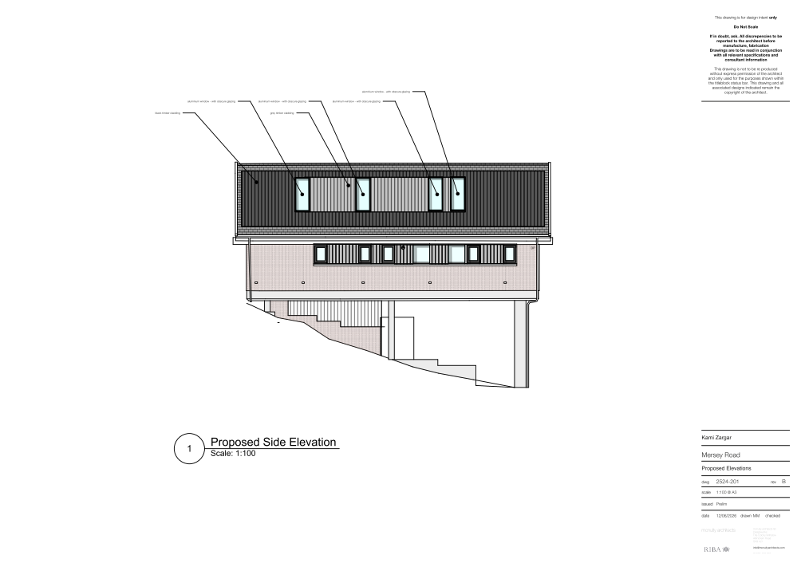
Figure 1. Proposed development

Consultation, notification & publicity responses to updated description of development
Not required due to positive addition to amenity

Relevant policies
In accordance with Section 38(6) of the Planning and Compulsory Purchase Act 2004, planning applications must be determined in accordance with the statutory development plan unless material considerations indicate otherwise.
For Manchester, the development plan comprises:
- The Manchester Core Strategy (2012 to 2027);
- Saved policies of the Manchester Unitary Development Plan (UDP); and
- The Places for Everyone Joint Development Plan Document (2022 to 2039).
These documents are considered up to date and are afforded significant weight in the determination of planning applications. Relevant Supplementary Planning Documents (SPDs) and other adopted guidance may also be material considerations.
The National Planning Policy Framework sets out the government’s policies for plan-making and for making decisions on development proposals in England. It is a material consideration of critical importance in both contexts.
Where relevant, the Council is required to give special regard to the desirability of preserving listed buildings and their settings, and special attention to the desirability of preserving or enhancing the character or appearance of conservation areas, in accordance with the Planning (Listed Buildings and Conservation Areas) Act 1990.
The policies and guidance referred to below are considered the most relevant to the scale, nature and location of the proposed development.
- The Manchester Core Strategy Development Plan Document 2012-2027
  - Development Management and Planning Obligations
    - DM 1 - Development Management
  - Objective 1 - Spatial Principles
    - SP 1 - Spatial Principles (Partially replaced by PfE Policy JP-S 1)
  - Objective 6 Environment
    - EN 1 - Design Principles and Strategic Character Areas
    - EN 13 – Green Belt
    - EN 14 – Flood Risk (partially replaced by PfE Policy JP-S 4)
    - EN 19 – Waste
- Guide to development in Manchester - supplementary planning document and planning guidance, April 2007
- Extant Unitary Development Plan (UDP) –
  - Citywide Development Control Policies
    - DC1 - Residential extensions
    - DC26 - Development and Noise
  - Environmental Improvement and Protection
    - E3.4 - Safe and attractive major linear recreational open spaces
  - Area 15 – Didsbury
    - DB25 - Woodland areas between Westmorland Road, Didsbury and Palatine Road; Fielden Park, West Didsbury – Protection and improvement of important woodland.
- Places for Everyone Plan Joint Development Plan Document 2022-2039-
  - Strategy
    - JP-Strat9: Southern Areas
  - Sustainable and Resilient Places
    - JP-S1: Sustainable Development
    - JP-S4: Flood Risk and the Water Environment
  - Greener Places
    - JP-G9: The Green Belt
  - Places for People
    - JP-P1 Sustainable Places
- National Planning Policy Framework – August 2026 - National Development Management Policies (NDMPs)
  - Procedural Policies
    - Chapter 3 – Decision-making policies
      - DM1: Preparing development proposals
      - DM2: Information requirements
      - DM3: Determining development proposals
      - DM6: Use of planning conditions and obligations
      - DM7: Relationship with other regulatory regimes
  - Sustainable Development
    - Chapter 4 - Achieving sustainable development
      - S3: Presumption in favour of sustainable development
      - S4: Principle of development within settlements
  - Creating high quality, sustainable places
    - Chapter 12 - Making effective use of land
      - L2: Making effective use of land
      - L3: Achieving appropriate densities
    - Chapter 13 - Protecting Green Belt land
      - GB6: Control of development in the Green Belt
      - GB7: Development which is not inappropriate in the Green Belt
    - Chapter 14 - Achieving well-designed places
      - DP3: Key principles for well-designed places
      - DP4: The design process
  - Conserving and enhancing the environment
    - Chapter 18 - Managing flood risk and coastal change
      - F4: Assessing flood risk for decision-making
      - F6: Development in areas at risk of flooding from rivers or the sea
      - F7: Ensuring development is safe from flooding
      - F8: Sustainable drainage systems and watercourses

Assessment

Principle of Development
The proposal seeks to alter and extend an existing dwellinghouse within an established residential area. Whilst the Council acknowledges the need for additional living accommodation, development should not result in unacceptable harm to the character of the area, neighbouring amenity or environmental assets.
The application site lies within the Mersey River Valley, identified under UDP Policy E3.4 as a major linear recreational open space. The policy seeks to protect the recreational, landscape and environmental value of river corridors and associated green infrastructure. The proposed development comprises a modest roof alteration to an existing dwellinghouse and would not result in any loss of open space, vegetation, public access, or harm to the landscape character and function of the River Valley. The proposal is therefore considered to accord with the objectives of Policy E3.4.
Policy SP1 of the Manchester Core Strategy promotes development that responds appropriately to its context, protects environmental assets and contributes positively to sustainable neighbourhoods. As the proposal relates to alterations to an existing dwelling within its established residential curtilage and would not prejudice the recreational, environmental or landscape value of the Mersey River Valley, it is considered to accord with Policy SP1.
The site is also located within the Manchester Green Belt. NPPF Policies GB6 and GB7 identify forms of development that are not inappropriate within the Green Belt. The proposal comprises alterations to an existing dwellinghouse and, having regard to its scale and form, would not result in a disproportionate increase in the size of the original building. It therefore falls within a category of development that is not inappropriate in Green Belt terms.
Accordingly, the principle of the development is considered acceptable, subject to the detailed assessment set out below

Appropriate siting, layout, scale, form, massing, materials, and detail
The proposed rear dormer addition is designed to remain subservient to the host dwelling, sitting entirely within the existing rear roof slope. The proposed timber cladding to both dormer and existing elevations reflects the wider material palette found on the building and the surrounding area and would not result in harm to the character or appearance of the existing building.
The greatest potential impact would be on No. 2 Mayfair Park due to the close relationship between the properties. However, the proposed dormer would sit entirely within the main roof slope and would not project beyond the existing building lines. As such, its impact on the property's outlook and the perceived massing of the dwelling is considered acceptable.
The impact on other neighbouring properties would be further reduced by the separation distances involved and the presence of mature, landscaped boundaries and vegetation.
Due to its size, position and relationship with neighbouring properties, the proposal would not appear overbearing or unduly dominant, nor would it result in any unacceptable impact on residential amenity.

Impact on the surrounding areas in terms of the design, scale and appearance of the proposed development. Development should have regard to the character of the surrounding area.
Only minimal views of the main proposed works are capable of being seen from the street. Given the position of the extension and the limited massing, together with the use of proposed materials, the character of the street would not be unduly affected.
The proposal is similar in size and scale to other buildings nearby and would not therefore disrupt the area's existing features.

Effects on amenity

Privacy
The proposed dormer introduces additional windows at roof level which, due to the site's relationship with the neighbouring property at No. 2 Mayfair Park, have the potential to create overlooking impacts similar to those associated with conventional first-floor side-facing windows.
Following discussions with the applicant, the proposed dormer windows have been amended to incorporate obscure glazing. These windows primarily serve a bathroom and other secondary accommodation and are therefore capable of being permanently obscured without materially affecting the usability of the internal accommodation.
Subject to a condition securing the retention of the obscure glazing and limiting the insertion of new openings, the proposal would not result in any unacceptable loss of privacy or overlooking to neighbouring occupiers

Light
Given the dormer is entirely within the existing roof slope the impact on local light would be acceptable and give rise to little more harm than the existing roof layout.

Noise
The proposed extension is not expected to generate any noise beyond what would be reasonably expected of a residential dwelling.

Accessibility: buildings and neighbourhoods fully accessible to disabled people, access to new development by sustainable transport modes.
The proposal does not change how people can get in and out of the building and would not present further accessibility issues into the property.

Adequacy of internal accommodation and external amenity space.
The proposal adds space inside the property with minimal effect to the outdoor area and maintains a good level of external amenity space post development.

Refuse storage and collection.
The proposal itself has little impact on waste from the site. It uses the current domestic storage and collection methods on site and maintains external access to the rear of the property.

Vehicular access and car parking
The proposal doesn't change how vehicles access and park at the property.

Green Infrastructure including open space, both public and private
The dwelling benefits from a garden beyond the siting of the proposed development and maintains a good amount of private green space post development.

Flood risk and drainage
The application site is located within an area identified as being at risk of flooding. However, the proposal is limited to the construction of a rear dormer extension and associated alterations to the existing dwellinghouse. The development would not increase the building footprint, create additional areas of hardstanding, or result in any material changes to existing surface water drainage arrangements.
Given the nature, scale and location of the works, it is considered that the proposal would have a negligible impact on flood risk and drainage. The development would not increase the risk of flooding on the application site or elsewhere. No objections or comments were received from the Lead Local Flood Authority, and there are no flood risk or drainage concerns that would warrant refusal of the application.

Other Legislative Requirements

Equality Act 2010
Section 149 (Public Sector Equality Duty) of the Equality Act 2010 requires due regard to the need to: Eliminate unlawful discrimination, harassment and victimisation and other conduct prohibited by the Act and; Advance equality of opportunity between persons who share a protected characteristic and persons who do not share it. The Equality Duty does not impose a legal requirement to conduct an Equality Impact Assessment. Compliance with the Equality Duty involves consciously thinking about the aims of the Equality Duty as part of the process of decision-making.

Human Rights Act 1998 considerations
This application needs to be considered against the provisions of the Human Rights Act 1998. Under Article 6, the applicants (and those third parties, including local residents, who have made representations) have a right to a fair hearing and to this end the local planning authority must give full consideration to their comments.
Protocol 1 Article 1, and Article 8 where appropriate, confer(s) a right of respect for a person’s home, other land and business assets. In taking account of all material considerations, including Council policy as set out in the Core Strategy and saved polices of the Unitary Development Plan, the Director of Planning, Building Control & Licensing has concluded that some rights conferred by these articles on the applicant(s)/objector(s)/resident(s) and other occupiers and owners of nearby land that might be affected may be interfered with but that that interference is in accordance with the law and justified by being in the public interest and on the basis of the planning merits of the development proposal. She believes that any restriction on these rights posed by the recommendation given is proportionate to the wider benefits of and that such a decision falls within the margin of discretion afforded to the Council under the Town and Country Planning Acts.

Planning balance & Conclusion
The proposed rear dormer and associated elevational alterations represent a modest and well-designed addition to the existing dwelling that would preserve the character and appearance of both the host property and the wider area. Subject to the recommended conditions securing the retention of obscure glazing and limiting the insertion of new openings, the development would not result in unacceptable impacts on neighbouring residential amenity in terms of privacy, outlook, light or noise. The proposal would not harm the openness of the Green Belt, the recreational or environmental value of the Mersey River Valley, or increase flood risk. Having regard to the development plan as a whole, including relevant policies of the Manchester Core Strategy, Places for Everyone, the saved UDP policies and the National Planning Policy Framework, the benefits of the proposal outweigh any limited impacts identified. The proposal is therefore considered to constitute sustainable development and planning permission should be approved.

Recommendation: Approve

Article 35 Declaration
Officers have worked with the applicant in a positive and proactive manner based on seeking solutions to problems arising in relation to dealing with the planning application. The proposal is considered to be acceptable and therefore determined within a timely manner.

Conditions to be attached to decision for approval

3-year time limit
The development must be begun not later than three years beginning with the date of this permission.
Reason - Required to be imposed by Section 91 of the Town and Country Planning Act 1990 (as amended).

Specified plans
The development hereby approved shall be carried out in accordance with the following drawings and documents:
- 2524-1001 Location Plan, received 16 July 2026
- 2524-1002 Site Plan, received 16 July 2026
- 2524-101 Proposed Ground Floor Plan, received 16 July 2026
- 2524-102 Proposed First Floor Plan, received 16 July 2026
- 2524-201 Rev B Proposed Side Elevation, received 4 September 2026
- 2524-202 Proposed Side Elevation, received 16 July 2026
- 2524-203 Proposed Front Elevation, received 16 July 2026
- 2524-204 Proposed Rear Elevation, received 16 July 2026
Reason - To ensure that the development is carried out in accordance with the approved plans, pursuant to policies DM 1, SP 1 and EN 1 of the Core Strategy and JP-P1 & of Places for Everyone.

Materials as approved on plan
The materials used in the external surfaces of the development hereby approved shall be those as specified on approved plan/drawing refs:
- 2524-201 Rev B Proposed Side Elevation, received 4 September 2026
- 2524-202 Proposed Side Elevation, received 16 July 2026
- 2524-203 Proposed Front Elevation, received 16 July 2026
- 2524-204 Proposed Rear Elevation, received 16 July 2026

Reason - In order to ensure a satisfactory appearance in the interests of visual amenity in accordance with policies SP1 and DM1 of the Core Strategy and the requirements of the National Planning Policy Framework.

OBSCURE GLAZING AND TOP OPENING WINDOW – NEW DWELLING/EXTENSION TO DWELLING
The windows in the dormer extension hereby approved shall be obscure glazed to a specification of no less than level 5 of the Pilkington Glass Scale or such other alternative equivalent and shall be retained as such thereafter. Any parts of the window that can be opened must be more than 1.7 metres above the floor of the room in which the window is installed.

Reason - In order to protect the amenity of neighbouring residents and in accordance with policies SP1 and DM1 of the Core Strategy.

EXTENSIONS – PD RIGHTS REMOVED FOR NEW OPENINGS
Notwithstanding the provisions of Schedule 2, Part 1 of the Town and Country Planning (General Permitted Development) Order 2015 (as amended) (or any order revoking and re-enacting that Order with or without modification), no additional windows, doors or other openings shall be inserted in the dormer extension hereby approved, without planning permission being granted by the Local Planning Authority.

Reason - In the interests of residential amenity, pursuant to policies DM1 and SP1 of the Manchester Core Strategy.

