

Planning

Delegated Officer Report

Summary of application details
Application reference: | PLA-2026-000651
Application type: | Householder planning permission
Proposal: | Erection of single-storey rear extension, first-floor side and rear extension together with roof alterations and extensions.
Site address: | 328 Wilbraham Road Manchester M21 0UX
Ward(s): | Chorlton Park
Date application valid: | 24 June 2026
Applicant name: | Mr Muhammad Saddique
Agent (if any): | Holborow & Ormesher
Case officer: | Joshua Lee
Recommendation: | Approve
Date of recommendation: | 15 Sept 2026

Description of site, building and/or area
The proposal is related to a two-storey detached dwellinghouse on Wilbraham Road. The property features an existing part single, part two storey side extension, single storey rear extension and further single store conservatory extension along with a front porch extension and front canopy. The property features hardstanding to front and side (for off street vehicle parking) and garden to the rear with a detached garage shared with No 330.
The property is in a mostly residential part of the Chorlton Park ward. To the rear boundary is the Main Road Football Club and St Bedes College Sports Ground. The property is in a medium risk surface water risk area.

Description of development
The applicant is proposing the erection of single-storey rear extension, first-floor side and rear extension together with roof alterations and extensions.

Single-storey rear extension
The proposed single storey rear extension projects 3655mm from the two storey rear extension, replacing the existing conservatory. The single storey rear extension is finished in matching brick with a flat roof featuring a roof lantern skylight and glazing to the rear.

First-floor side and rear extension
The first floor side and rear extension projects 3200mm from the existing rear elevation of the original dwelling and existing side extension to meet the rear of the existing ground floor rear extension. The extension spans the full 10540mm across the existing rear elevation (including extension). The extension is finished in brick to match with new rear facing glazing.

Roof alterations and extensions
The proposed roof alterations included the replacement of the existing roof with a new truncated hip roof across the full original and extended dwelling. The new roof features gable dormer features on front and rear elevations and roof lights to the side elevations.
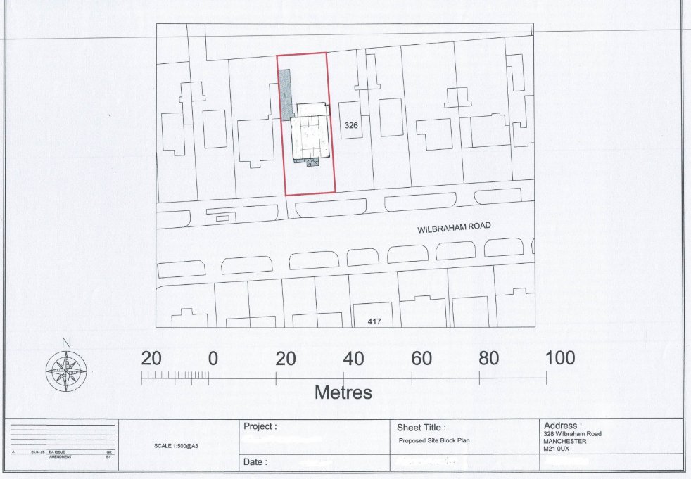
Figure 1. Proposed site plan

Relevant planning history

Lawful development: Proposed - 142391/LP/2025
Enlargement of existing dwellinghouse through the erection of a single storey rear extension.
Refuse
2025-05-30
The previous refusal related solely to whether the proposed extension constituted permitted development under the relevant provisions of the GPDO. The decision did not assess the proposal against development plan policies or consider the planning merits of the development. Consequently, it carries limited weight in the determination of the current application.

Consultation, notification and publicity responses

Consultations

Manchester City Council Flood Risk Management
The LLFA had no objections but advised the LPA to consult United Utilities due to a public sewer onsite.

United Utilities
No response received.

Notifications and publicity
No responses received.

Negotiations
During the consideration of the application, concerns were raised regarding the design, scale and visual impact of the proposed extensions, particularly the effect of the front extension on the character and appearance of the host dwelling and wider street scene.
The applicant was initially requested to clarify the extent of retained and proposed built form to establish whether the proposal constituted an extension or a replacement dwelling. Following receipt of further information and a site visit, concerns were subsequently raised regarding the introduction of prominent front-facing gables, which were considered to create excessive massing and result in a visually dominant feature that would be out of keeping with the prevailing hipped-roof character of the row. The applicant was advised to revise the scheme by removing the front gables and adopting a more traditional hipped roof form.
Amended plans were submitted; however, further concerns remained regarding the prominence of the front extension, its impact on the subservient appearance of the proposals, and the extent to which it projected forward of the neighbouring property. The applicant was advised to further reduce the visual impact of the frontage and was directed to a recently approved neighbouring scheme at 334 Wilbraham Road (Ref. 137140/FO/2023) as an example of how a substantial extension could be achieved whilst retaining the existing roof form and reducing perceived bulk.
Following continued discussions and the submission of revised plans, amendments were made to the front extension design, including revisions to the roof form and massing. The final amended scheme was considered to satisfactorily address the Council's concerns regarding prominence, scale and subservience, resulting in a form of development that is acceptable in design terms.
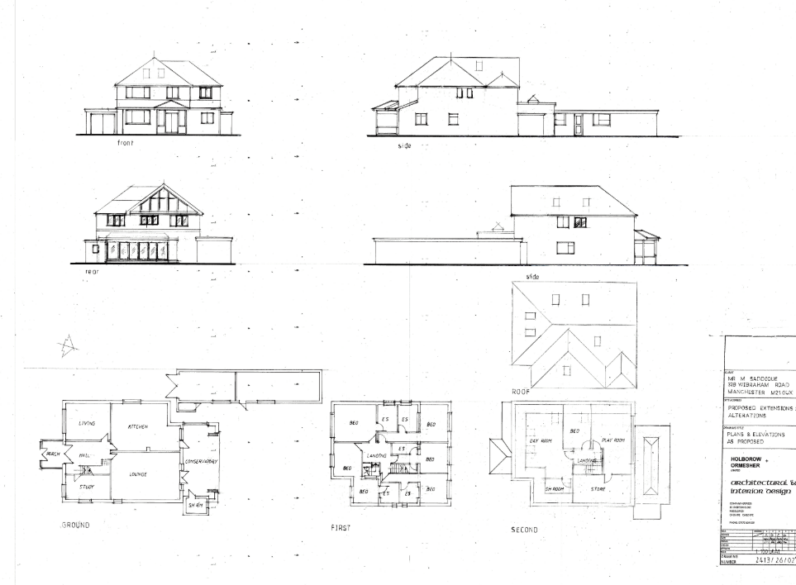
Figure 2. Updated plans (REV D)

Relevant policies
In accordance with Section 38(6) of the Planning and Compulsory Purchase Act 2004, decisions on planning applications must be made in line with the statutory development plan, unless material considerations indicate otherwise.

For Manchester, the development plan comprises:

- The Core Strategy (2012–2027)
- Saved policies of the Unitary Development Plan (UDP)
- The Places for Everyone Joint Development Plan Document (2022–2039)

These documents are considered up to date and carry substantial weight in decision-making. Supplementary Planning Documents (SPDs) and other local guidance may also be relevant.

National planning policy, including the National Planning Policy Framework (NPPF), is a material consideration and provides overarching guidance.

The Government has published a consultation draft of the NPPF, intended to improve housebuilding rates through a clearer, more predictable and faster policy basis for decision and plan making. While this draft is not yet adopted, it is a material consideration.

Where applicable, the Council must give special regard to preserving the character of conservation areas and the setting of listed buildings, in line with statutory duties under the Planning (Listed Buildings and Conservation Areas) Act 1990.

The policies referenced in this report are those considered most relevant to the nature, scale and location of the proposed development as follows:

- The Manchester Core Strategy Development Plan Document 2012-2027
  - Development Management and Planning Obligations
    - DM 1 - Development Management
  - Objective 1 - Spatial Principles
    - SP 1 - Spatial Principles (Partially replaced by PfE Policy JP-S 1)
  - Objective 6 Environment
    - EN 1 - Design Principles and Strategic Character Areas
    - EN 14 – Flood Risk (partially replaced by PfE Policy JP-S 4)
    - EN 19 – Waste
- Guide to development in Manchester - supplementary planning document and planning guidance, April 2007
- Extant Unitary Development Plan (UDP) –
  - Citywide Development Control Policies
    - DC1 - Residential extensions
    - DC26 - Development and Noise
- Places for Everyone Plan Joint Development Plan Document 2022-2039-
  - Strategy
    - JP-Strat9: Southern Areas
  - Sustainable and Resilient Places
    - JP-S1: Sustainable Development
    - JP-S4: Flood Risk and the Water Environment
  - Places for People
    - JP-P1 Sustainable Places
- National Planning Policy Framework (NPPF) December 2024–
  - Section 2 - Achieving sustainable development
  - Section 4 – Decision-making
  - Section 11 – Making effective use of land
  - Section 12 – Achieving well-designed places
  - Section 14 - Meeting the challenge of climate change, flooding and coastal change
- National Planning Policy Framework Draft for Consultation December 2025 - National decision-making policies
  - Chapter 3 – Decision-making policies
    - DM1: Preparing development proposals
    - DM2: Information requirements
    - DM3: Determining development proposals
    - DM6: Use of planning conditions and obligations
    - DM7: Relationship with other regulatory regimes
  - Chapter 4 - Achieving sustainable development
    - S3: Presumption in favour of sustainable development
    - S4: Principle of development within settlements
  - Chapter 12 - Making effective use of land
    - L4: Residential extensions
  - Chapter 14 - Achieving well-designed places
    - DP3: Key principles for well-designed places
    - DP4: The Design process
  - Chapter 18 - Managing flood risk and coastal change
    - F4: Assessing flood risk for decision-making
    - F7: Ensuring development is safe from flooding

Assessment

Principle of development
Many people prefer to extend their existing homes rather than move, and the planning system needs to accommodate this demand for more living space, while at the same time ensuring that the amenities of neighbours are protected, and that the overall character of the surrounding area is not harmed. The Council is not generally in favour of dealing with this issue by laying down firm rules about home extensions with each case looked at on its individual merits, having regard to a range of criteria.
In this case the principle of the development is acceptable.
As stated in Policy DM 1 of the Manchester Core Strategy, all development should have regard to the following specific issues:

Appropriate siting, layout, scale, form, massing, materials, and detail
The proposed extensions have been designed to reflect the character and appearance of the existing dwelling through the use of matching brickwork, roof tiles and window fenestration. The design approach ensures that the additions integrate well with the existing property and maintain a coherent overall appearance.
Whilst substantial in scale, the proposal is read as part of the existing extended dwelling and, following the removal of the front gables and retention of the front roofline, would not appear visually dominant or incongruous within the street scene. The extensions are located predominantly to the rear and adopt a roof form, scale and material palette that are consistent with the host property (notably a truncated hip roof which maintains the existing roof height), ensuring the development does not appear incongruous or overly dominant.
The revised scheme has been designed so that the altered roof form would maintain the existing ridge height and retain the hipped appearance of the dwelling when viewed from the public realm. Whilst the extension would significantly increase the amount of accommodation provided, the development would continue to be read as an extension to the existing dwellinghouse rather than a replacement dwelling. The proposal would therefore remain proportionate to the host property and would not appear unduly prominent within the street scene

Impact on No. 330
The proposed first-floor extensions would not project beyond the existing elevations of the dwelling and would maintain the existing separation distance of approximately 3 metres from the shared boundary with No. 330. As such, the development would not result in any unacceptable impact in terms of outlook, overbearing effect or loss of light.
The proposed ground-floor extension would replace an existing conservatory and is not considered to result in any greater impact on neighbouring amenity than the existing structure.

Impact on No. 326
The proposed first-floor side extension would not project beyond the footprint of the existing side extension, with the first-floor element positioned directly above the existing ground-floor structure. A separation distance of approximately 1 metre to the boundary would be maintained.
Given the relationship with the adjoining property, the retained boundary distance and the fact that the proposal reflects an established relationship between Nos. 330 and 332, the extension is not considered to result in harmful massing or an unacceptable overbearing impact, especially when considering the hipped roof form to this side. Furthermore, the proposed ground-floor extension would replace an existing conservatory and would be viewed in the context of the existing two-storey built form adjacent to No. 328.
Overall, by virtue of its scale, siting and relationship with neighbouring properties, the proposal would not appear over-dominant, overbearing or unacceptably harmful to the residential amenity of adjoining occupiers.
Impact on the surrounding areas in terms of the design, scale and appearance of the proposed development. Development should have regard to the character of the surrounding area.
Whilst limited views of the rear extensions would be available from the public realm, the roof alterations and front-facing elements would be visible from Wilbraham Road. The amended scheme has removed the previously proposed prominent front-facing gables and instead retains a roof form that reflects the established character of neighbouring properties. As a result, the development would sit comfortably within the streetscene and would not appear visually dominant or incongruous.
The proposal is comparable to a number of extended properties within the locality, including the approved and implemented extension at No. 330 Wilbraham Road. The development would therefore reflect the established pattern of household extensions within the area and would preserve the character and appearance of the surrounding residential environment.

Effects on amenity

Privacy
The proposed development includes new window openings within the front and rear elevations. These would be positioned in locations broadly comparable to existing windows and would not result in any material increase in overlooking or loss of privacy to neighbouring occupiers. The rear of the site also benefits from a relatively open aspect, further reducing the potential for adverse amenity impacts.
The proposal includes new first-floor side-facing windows which, by virtue of their orientation, could give rise to overlooking. To mitigate this, a condition is recommended requiring these windows to be obscure glazed and retained as such thereafter. Subject to this condition, the development would not result in an unacceptable loss of privacy.
Whilst the proposed openings are acceptable, additional windows or openings inserted under permitted development rights could result in increased overlooking of neighbouring properties. Given the relationship with adjoining residential occupiers, it is considered necessary to remove permitted development rights for the insertion of further windows and openings within the approved extension. This will ensure that any future alterations with the potential to affect residential amenity remain subject to planning control.
The proposed rooflights are positioned such that they would not afford direct views into neighbouring habitable room windows or private garden areas and are therefore not considered to give rise to unacceptable overlooking or privacy impacts.

Light
The proposed first-floor extension would be constructed above an existing side extension and would not project beyond the established building lines of the dwelling. Given its siting, separation distances to neighbouring properties and the existing relationship between the surrounding dwellings, the proposal is not considered to result in a significant loss of daylight or sunlight to neighbouring habitable room windows or private garden areas.
The proposed single-storey rear extension would replace an existing conservatory and, by virtue of its scale and position, would not result in any materially greater impact on light to neighbouring occupiers than the existing built form.

Noise
The proposed extension is not expected to generate any noise beyond what would be reasonably expected of a residential dwelling.

Accessibility: buildings and neighbourhoods fully accessible to disabled people, access to new development by sustainable transport modes.
The proposal does not change how people can get in and out of the building.

Adequacy of internal accommodation and external amenity space.
The proposal adds space inside the property with minimal effect to the outdoor area and maintains a good level of external amenity space post development.

Refuse storage and collection.
The proposal itself has little impact on waste from the site. It uses the current storage and collection methods on site and maintains external access to the rear of the property.

Vehicular access and car parking
The proposal doesn't change how vehicles access and park at the property.

Green Infrastructure including open space, both public and private
The dwelling benefits from a garden beyond the siting of the proposed development and maintains a good amount of private green space post development.

Flood risk and drainage.
The Flood Risk Management Team raise no objection. United Utilities were consulted regarding the presence of a public sewer but no response was received within the consultation period. Given the scale and nature of the proposal, this does not justify withholding planning permission.

Other Legislative Requirements

Equality Act 2010
Section 149 (Public Sector Equality Duty) of the Equality Act 2010 requires due regard to the need to: Eliminate unlawful discrimination, harassment and victimisation and other conduct prohibited by the Act and; Advance equality of opportunity between persons who share a protected characteristic and persons who do not share it. The Equality Duty does not impose a legal requirement to conduct an Equality Impact Assessment. Compliance with the Equality Duty involves consciously thinking about the aims of the Equality Duty as part of the process of decision-making.

Human Rights Act 1998 considerations
This application needs to be considered against the provisions of the Human Rights Act 1998. Under Article 6, the applicants (and those third parties, including local residents, who have made representations) have a right to a fair hearing and to this end the local planning authority must give full consideration to their comments.
Protocol 1 Article 1, and Article 8 where appropriate, confer(s) a right of respect for a person’s home, other land and business assets. In taking account of all material considerations, including Council policy as set out in the Core Strategy and saved polices of the Unitary Development Plan, the Director of Planning, Building Control & Licensing has concluded that some rights conferred by these articles on the applicant(s)/objector(s)/resident(s) and other occupiers and owners of nearby land that might be affected may be interfered with but that that interference is in accordance with the law and justified by being in the public interest and on the basis of the planning merits of the development proposal. She believes that any restriction on these rights posed by the recommendation given is proportionate to the wider benefits of and that such a decision falls within the margin of discretion afforded to the Council under the Town and Country Planning Acts.

Planning balance & Conclusion
The proposed development represents a substantial but acceptable extension to the existing dwelling which, following amendments secured through negotiation, has been revised to address concerns regarding design, massing and visual prominence. The final scheme is considered to respect the character and appearance of both the host property and the wider street scene whilst maintaining acceptable living conditions for neighbouring occupiers. The development would not result in unacceptable impacts on neighbouring residential amenity in terms of outlook, privacy, light or overbearing impact, subject to the recommended conditions. The proposal therefore accords with Policies DM1 and EN1 of the Manchester Core Strategy, Policy DC1 of the UDP, Policy JP-P1 of Places for Everyone and the relevant design objectives of the National Planning Policy Framework. Accordingly, the application is recommended for approval, subject to conditions.

Recommendation: Approve

Article 35 Declaration
Officers have worked with the applicant in a positive and proactive manner based on seeking solutions to problems arising in relation to dealing with the planning application. There were minor changes required to meet the requirements for approval and the officer and applicant worked together to find an amicable solution.

Conditions to be attached to decision for approval

3-year time limit
The development must be begun not later than three years beginning with the date of this permission.
Reason - Required to be imposed by Section 91 of the Town and Country Planning Act 1990 (as amended).

Specified plans
The development hereby approved shall be carried out in accordance with the following drawings and documents:
  - 328 Wilbraham Rd - Location Plan, Version V1, received 25 May 2026.
  - 328 Wilbraham Rd - Site Plan as Proposed .REV A.pdf, Proposed Site Block Plan, Revision A, received 14 September 2026.
  - 328 Wilbraham Rd - 26 02D.pdf, Proposed Plans and Elevations, Drawing No. 26 02 D, received 14 September 2026.
Reason - To ensure that the development is carried out in accordance with the approved plans, pursuant to policies DM 1, SP 1 and EN 1 of the Core Strategy and JP-P1 & of Places for Everyone.

Materials to match
The materials used in the external surfaces of the development hereby approved shall be similar in appearance to the existing building in terms of type, size, colour and texture.
Reason - In order to ensure a satisfactory appearance in the interests of visual amenity in accordance with policies SP1 and DM1 of the Core Strategy and the requirements of the National Planning Policy Framework.

OBSCURE GLAZING AND TOP OPENING WINDOW – NEW DWELLING/EXTENSION TO DWELLING
The window(s) in the first floor of the side elevations of the development hereby approved shall be obscure glazed to a specification of no less than level 5 of the Pilkington Glass Scale or such other alternative equivalent and shall be retained as such thereafter. Any parts of the window that can be opened must be more than 1.7 metres above the floor of the room in which the window is installed.
Reason - In order to protect the amenity of neighbouring residents and in accordance with policies SP1 and DM1 of the Core Strategy.

EXTENSIONS – PD RIGHTS REMOVED FOR NEW OPENINGS
Notwithstanding the provisions of Schedule 2, Part 1 of the Town and Country Planning (General Permitted Development) Order 2015 (as amended) (or any order revoking and re-enacting that Order with or without modification), no additional windows, doors or other openings shall be inserted in the development hereby approved, without planning permission being granted by the Local Planning Authority.
Reason - In the interests of residential amenity, pursuant to policies DM1 and SP1 of the Manchester Core Strategy.

Flat roof restriction
The flat roof of the extension shall not be used for any other purpose other than as a means of escape in emergency or for maintenance of the building.
Reason - To safeguard the amenities of the adjoining premises for overlooking or perceived overlooking and in accordance with policies SP1 and DM1 of the Core Strategy and JP-S1 and JP-P1 of Places for Everyone.

Informative(s)

Property Flood Resilience (PFR) measures
The applicant is advised to incorporate Property Flood Resilience (PFR) measures to a minimum of 150mm above the surface water flood level or a minimum of 600mm above the fluvial flood level.

