

Planning

Delegated Officer Report

Summary of application details
Application reference: | PLA-2026-001243
Application type: | Householder planning permission
Proposal: | Erection of two-storey part single, part two-storey rear extension following demolition of conservatory.
Site address: | 39 Northcote Avenue Manchester M22 9AJ
Ward(s): | Sharston
Date application valid: | 05 August 2026
Applicant name: | Mr Michael Garrick
Agent (if any): | Mr Stelios Kattou
Case officer: | Joshua Lee
Recommendation: | Approve
Date of recommendation: | 04/09/2026

Description of site, building and/or area
The proposal relates to a two-storey detached dwelling, built circa 2004, constructed of red brick with a pitched tiled roof. The property benefits from a front driveway along with existing rear conservatory extension and garden to the rear.
The property is in a mostly residential part of the Sharston ward of Manchester.

Description of development
Erection of two-storey rear extension following demolition of conservatory.
The proposed two storey rear extension projects 3000mm from the existing rear elevation and spans 8000mm across the full rear width of the property. The extension is finished in brick to match with a hipped tiled roof to match and glazing to the rear.
The existing rear conservatory would be demolished to make way for the proposed extension.
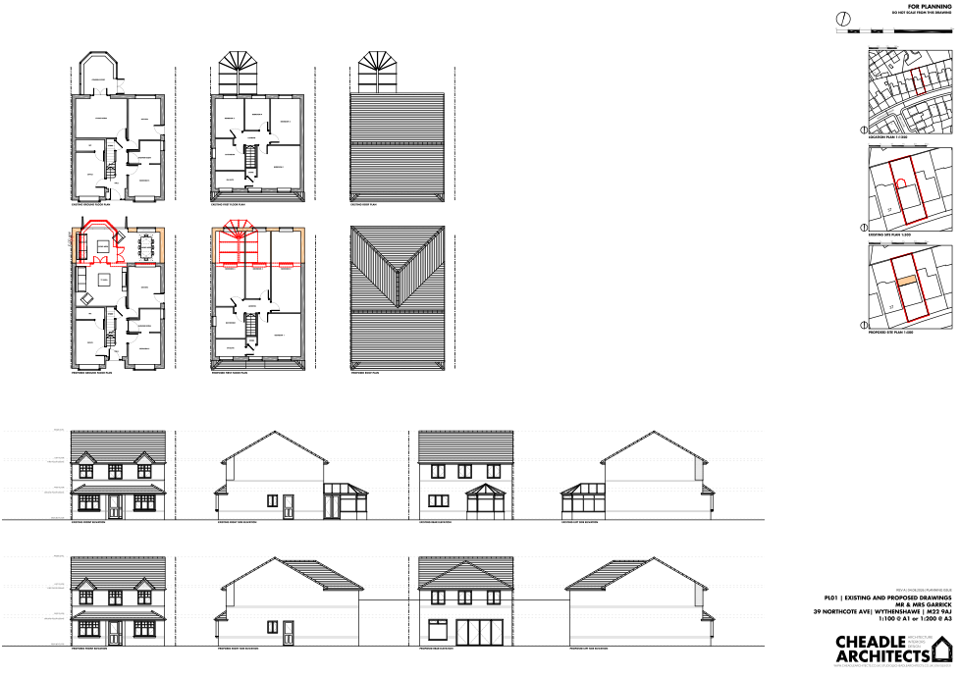
Figure 1. Proposed plans and elevations

Relevant planning history
074600/FH/2005/S2 - Erection of conservatory to rear to form additional living accommodation. Approved 8 March 2005.
073894/FH/2004/S2 - Erection of rear conservatory. Refused 10 January 2005.
067149/FO/SOUTH2/03 - Erection of 6 four-storey apartment blocks (96 apartments) and 190 two and three-storey dwellinghouses with associated landscaping and parking. Approved 22 May 2003.

Consultation, notification and publicity responses

Notifications and publicity

Neighbour letters
No responses received.

Negotiations
Following concerns raised during the assessment process regarding the impact of the proposed two-storey rear extension on the occupiers of No. 37 Northcote Avenue, discussions were undertaken with the applicant's agent to explore potential amendments to the scheme.
The original proposal involved a two-storey rear extension extending close to the shared boundary with No. 37. Having undertaken a site visit and assessed the relationship between the properties, concerns were raised that the scale, massing and proximity of the first-floor element could result in an overbearing form of development and have an unacceptable impact on the outlook and residential amenity of the neighbouring occupiers.
In response, revised plans were submitted which introduced a 1.5 metre setback of the first-floor rear extension from the boundary shared with No. 37. This amendment significantly reduces the perceived bulk of the extension when viewed from the neighbouring property and creates a greater degree of separation between the development and the adjoining occupier.
Officers consider that the revised design materially improves the relationship with No. 37 by reducing the dominance of the first-floor addition and mitigating concerns regarding overbearing impact. The amendment also results in a more proportionate form of development that better respects the amenity of neighbouring occupiers whilst still allowing for the extension of the dwelling.
As such, the submitted revisions are considered to have satisfactorily addressed the concerns raised during the application process in respect of neighbouring residential amenity.
The description of development has been updated to read ‘Erection of part single, part two-storey rear extension following demolition of conservatory to provide additional living accommodation.
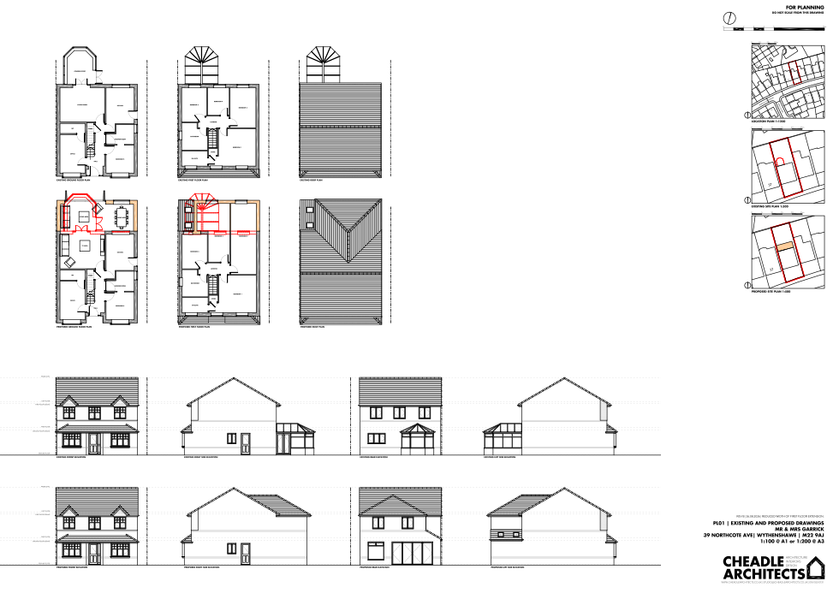
Figure 2. Updated Plans

Relevant policies
In accordance with Section 38(6) of the Planning and Compulsory Purchase Act 2004, decisions on planning applications must be made in line with the statutory development plan, unless material considerations indicate otherwise.

For Manchester, the development plan comprises:

- The Core Strategy (2012–2027)
- Saved policies of the Unitary Development Plan (UDP)
- The Places for Everyone Joint Development Plan Document (2022–2039)

These documents are considered up to date and carry substantial weight in decision-making. Supplementary Planning Documents (SPDs) and other local guidance may also be relevant.

National planning policy, including the National Planning Policy Framework (NPPF), is a material consideration and provides overarching guidance.

The Government has published a consultation draft of the NPPF, intended to improve housebuilding rates through a clearer, more predictable and faster policy basis for decision and plan making. While this draft is not yet adopted, it is a material consideration.

Where applicable, the Council must give special regard to preserving the character of conservation areas and the setting of listed buildings, in line with statutory duties under the Planning (Listed Buildings and Conservation Areas) Act 1990.

The policies referenced in this report are those considered most relevant to the nature, scale and location of the proposed development as follows:

- The Manchester Core Strategy Development Plan Document 2012-2027
  - Development Management and Planning Obligations
    - DM 1 - Development Management
  - Objective 1 - Spatial Principles
    - SP 1 - Spatial Principles (Partially replaced by PfE Policy JP-S 1)
  - Objective 6 Environment
    - EN 1 - Design Principles and Strategic Character Areas
    - EN 19 – Waste
- Guide to development in Manchester - supplementary planning document and planning guidance, April 2007
- Extant Unitary Development Plan (UDP) –
  - Citywide Development Control Policies
    - DC1 - Residential extensions
    - DC26 - Development and Noise
- Places for Everyone Plan Joint Development Plan Document 2022-2039-
  - Strategy
    - JP-Strat9: Southern Areas
  - Sustainable and Resilient Places
    - JP-S1: Sustainable Development
  - Places for People
    - JP-P1 Sustainable Places
- National Planning Policy Framework (NPPF) December 2024–
  - Section 2 - Achieving sustainable development
  - Section 4 – Decision-making
  - Section 11 – Making effective use of land
  - Section 12 – Achieving well-designed places
- National Planning Policy Framework Draft for Consultation December 2025 - National decision-making policies
  - Chapter 3 – Decision-making policies
    - DM1: Preparing development proposals
    - DM2: Information requirements
    - DM3: Determining development proposals
    - DM6: Use of planning conditions and obligations
    - DM7: Relationship with other regulatory regimes
  - Chapter 4 - Achieving sustainable development
    - S3: Presumption in favour of sustainable development
    - S4: Principle of development within settlements
  - Chapter 12 - Making effective use of land
    - L4: Residential extensions
  - Chapter 14 - Achieving well-designed places
    - DP3: Key principles for well-designed places
    - DP4: The Design process

Assessment

Principle of development
Many people prefer to extend their existing homes rather than move, and the planning system needs to accommodate this demand for more living space, while at the same time ensuring that the amenities of neighbours are protected, and that the overall character of the surrounding area is not harmed. The Council is not generally in favour of dealing with this issue by laying down firm rules about home extensions with each case looked at on its individual merits, having regard to a range of criteria.
In this case the principle of the development is acceptable.
As stated in Policy DM 1 of the Manchester Core Strategy, all development should have regard to the following specific issues:

Appropriate siting, layout, scale, form, massing, materials, and detail
The proposed development comprises a two-storey rear extension extending approximately 3.0 metres beyond the existing rear elevation across the width of the dwelling and sitting within the existing side elevations.
The extension would be constructed using materials to match the existing dwelling, including brickwork, roof tiles and window detailing. The hipped roof design reflects the form and appearance of the host property and assists in integrating the extension into the existing building.
Following amendments during the application process, the first-floor element has been set in from the shared boundary with No. 37 Northcote Avenue by approximately 1.5 metres. This significantly reduces the perceived scale and dominance of the extension when viewed from the neighbouring property and improves the relationship between the two dwellings. It is also noted that No. 37 benefits from an existing single-storey rear extension along the shared boundary, which assists in mitigating the impact of the proposal on the ground-floor rear outlook from that property.
With regard to No. 41 Northcote Avenue, the impact is reduced by the retention of the separation to the shared boundary, the slight stagger in the building lines between the properties and the presence of an existing rear conservatory extension at No. 41. These factors reduce the prominence of the proposed extension when viewed from the neighbouring property and ensure that it would not appear unduly dominant or overbearing.
Taking into account its scale, design, materials and relationship with neighbouring properties, the proposal is considered to represent an acceptable form of development.
Impact on the surrounding areas in terms of the design, scale and appearance of the proposed development. Development should have regard to the character of the surrounding area.
Negligible views of the main proposed works are capable of being seen from the street. Given the position of the extension together with the use of proposed materials, the character of the street would not be unduly affected.
The proposal is similar in size and scale to other buildings nearby and would not therefore disrupt the area's existing features.

Effects on amenity

Privacy
The proposal includes new ground-floor glazing and bifold doors within the rear elevation. These openings would serve private garden areas and replace existing rear-facing glazing associated with the conservatory. As such, no materially greater overlooking would arise.
First-floor windows are limited to those serving habitable rooms facing the applicant's own rear garden. No side-facing first-floor windows are proposed. The proposal would therefore not give rise to unacceptable overlooking or loss of privacy for neighbouring occupiers.
New rooflights are to be inserted into the part ground floor rear, however given their angle there would be little impact to privacy.
To ensure this is maintained it is appropriate and proportionate to attach a condition to the decision limiting the insertion of additional openings within the development.

Light
The extension projects a relatively modest distance beyond the existing rear elevation. Following the reduction in the scale of the first-floor element adjacent to No. 37, officers are satisfied that the proposal would not result in a significant loss of daylight or sunlight to neighbouring habitable room windows or private garden areas.
The extension would not create unacceptable overshadowing and the impact on neighbouring residential amenity is considered acceptable.

Noise
The proposed extension is not expected to generate any noise beyond what would be reasonably expected of a residential dwelling.

Accessibility: buildings and neighbourhoods fully accessible to disabled people, access to new development by sustainable transport modes.
The proposal does not change how people can get in and out of the building.

Adequacy of internal accommodation and external amenity space.
The proposal adds space inside the property with minimal effect to the outdoor area and maintains a good level of external amenity space post development.

Refuse storage and collection.
The proposal itself has little impact on waste from the site. It uses the current storage and collection methods on site and maintains external access to the rear of the property.

Vehicular access and car parking
The proposal doesn't change how vehicles access and park at the property.

Green Infrastructure including open space, both public and private
The dwelling benefits from a garden beyond the siting of the proposed development and maintains a good amount of private green space post development.

Flood risk and drainage.
The site is not located in a flood risk area and therefore does not require a flood statement or assessment.
The proposal has a negligible impact on drainage using the existing drainage on site.

Other Legislative Requirements

Equality Act 2010
Section 149 (Public Sector Equality Duty) of the Equality Act 2010 requires due regard to the need to: Eliminate unlawful discrimination, harassment and victimisation and other conduct prohibited by the Act and; Advance equality of opportunity between persons who share a protected characteristic and persons who do not share it. The Equality Duty does not impose a legal requirement to conduct an Equality Impact Assessment. Compliance with the Equality Duty involves consciously thinking about the aims of the Equality Duty as part of the process of decision-making.

Human Rights Act 1998 considerations
This application needs to be considered against the provisions of the Human Rights Act 1998. Under Article 6, the applicants (and those third parties, including local residents, who have made representations) have a right to a fair hearing and to this end the local planning authority must give full consideration to their comments.
Protocol 1 Article 1, and Article 8 where appropriate, confer(s) a right of respect for a person’s home, other land and business assets. In taking account of all material considerations, including Council policy as set out in the Core Strategy and saved polices of the Unitary Development Plan, the Director of Planning, Building Control & Licensing has concluded that some rights conferred by these articles on the applicant(s)/objector(s)/resident(s) and other occupiers and owners of nearby land that might be affected may be interfered with but that that interference is in accordance with the law and justified by being in the public interest and on the basis of the planning merits of the development proposal. She believes that any restriction on these rights posed by the recommendation given is proportionate to the wider benefits of and that such a decision falls within the margin of discretion afforded to the Council under the Town and Country Planning Acts.

Planning balance & Conclusion
The proposed two-storey rear extension represents an acceptable form of residential development that would provide additional living accommodation whilst maintaining the character and appearance of the host dwelling and surrounding area. Following amendments secured during the application process, including the setback of the first-floor element from the boundary with No. 37 Northcote Avenue, the proposal has satisfactorily addressed concerns regarding dominance and impact on neighbouring amenity. The development would not result in unacceptable harm to privacy, outlook, daylight, parking provision, landscaping or other material planning considerations. The proposal accords with the relevant policies of the Manchester Core Strategy, saved UDP policies, the Places for Everyone Plan and the National Planning Policy Framework. Having regard to the development plan as a whole and all other material considerations, there are no adverse impacts that would significantly and demonstrably outweigh the benefits of the proposal. Planning permission should therefore be approved, subject to the attached conditions

Recommendation: Approve

Article 35 Declaration
Officers have worked with the applicant in a positive and proactive manner based on seeking solutions to problems arising in relation to dealing with the planning application. There were minor changes required to meet the requirements for approval and the officer and applicant worked together to find an amicable solution.

Conditions to be attached to decision for approval

3-year time limit
The development must be begun not later than three years beginning with the date of this permission.
Reason - Required to be imposed by Section 91 of the Town and Country Planning Act 1990 (as amended).

Specified plans
The development hereby approved shall be carried out in accordance with the following drawings and documents:
  - PL01_39 NORTHCOTE AVENUE_Existing and Proposed Drawings_RevB.pdf - Existing & Proposed Plans and Elevations - PL01 B - 28 Aug 2026
Reason - To ensure that the development is carried out in accordance with the approved plans, pursuant to policies DM 1, SP 1 and EN 1 of the Core Strategy and JP-P1 & of Places for Everyone.

Materials to match
The materials used in the external surfaces of the development hereby approved shall be similar in appearance to the existing building in terms of type, size, colour and texture.
Reason - In order to ensure a satisfactory appearance in the interests of visual amenity in accordance with policies SP1 and DM1 of the Core Strategy and the requirements of the National Planning Policy Framework.

EXTENSIONS – PD RIGHTS REMOVED FOR NEW OPENINGS
Notwithstanding the provisions of Schedule 2, Part 1 of the Town and Country Planning (General Permitted Development) Order 2015 (as amended) (or any order revoking and re-enacting that Order with or without modification), no additional windows, doors or other openings shall be inserted in the development hereby approved, without planning permission being granted by the Local Planning Authority.
Reason - In the interests of residential amenity, pursuant to policies DM1 and SP1 of the Manchester Core Strategy.

