Highways Query’s

Initial Construction Management Plan

Project: Whitworth Street West – Fusion PBSA development
Date: 21st April 2026
Revision: 1

Contents

  - Introduction

  - Statement of intent and overall control strategy
  - Existing development site
  - Summary of new works proposed.
  - Considerate contractors Scheme

  - Overview- Nuisance mitigation measures

  - Health and safety
  - Minimising disruption to ongoing use of adjacent buildings
  - Construction noise and vibration
  - Dust and Mud
  - Fire protection
  - Light pollution
  - Ground and watercourse pollution.
  - Trees and existing hedge rows
  - Site Housekeeping
  - Waste management proposals.
  - Liaison with community.
  - Site hours

  - Construction Logistics and Construction Process

  - Traffic management, Construction Logistics, and Construction Methodology

    - 3rd Party Consultation
    - Site vehicle access restrictions
    - Offsite storage
    - Tower cranes
    - Site establishment, enabling works and vibration monitoring.
    - Site commencement
    - Pilling and sub-structure works
    - Core
    - Floor construction
    - Double high-speed hoists
    - Site welfare and office accommodation
    - Unitised curtain walling
    - Lift installation
    - Apartment fit out.

Appendices

- Initial project logistics plans

  - Introduction

  - Statement of intent and overall control strategy

Domis are committed to maintaining a dynamic and robust integrated management system. This will ensure that we deliver everything we do in a safe sustainable manner and to a high standard which meets or exceeds our customer’s expectations.

We are committed to achieving excellence through:

- Preparing and implementing programmes and systems to benefit the integrated management system to ensure that it is continually improved and remains effective.

- Establishing and setting objectives and targets and closely monitoring their implementation.

- Empowering our people and our supply chain to be proactive in suggesting improvements to the processes, procedures and related documentation.

- Developing and training our people in both quality management and delivery.

- Engaging with our people on all matters to improve and embed learning across the business.

- Providing sufficient resources to enable this policy to function effectively and to ensure that this policy is regularly reviewed and communicated to all employees, our supply chain and stakeholders.

- Complying with applicable regulatory, customer and other requirements.

- Conducting regular internal audits and management reviews.

- Seeking feedback on performance from stakeholders, our supply chain and employees.

- Implementing mechanisms which encourage the identification of best practice and drive innovation.

- Generating commitment amongst all employees and our supply chain to provide the service, delivery and workmanship required by our customers.

Domis’s policy will be delivered by generating a culture which actively encourages exemplary management practices and insuring the real involvement and participation of all our people, our supply chain and stakeholders.

  - Existing development site

The current site is located on Whitworth Street West and is located adjacent to the City Inn Road Inn and Cameron Street.
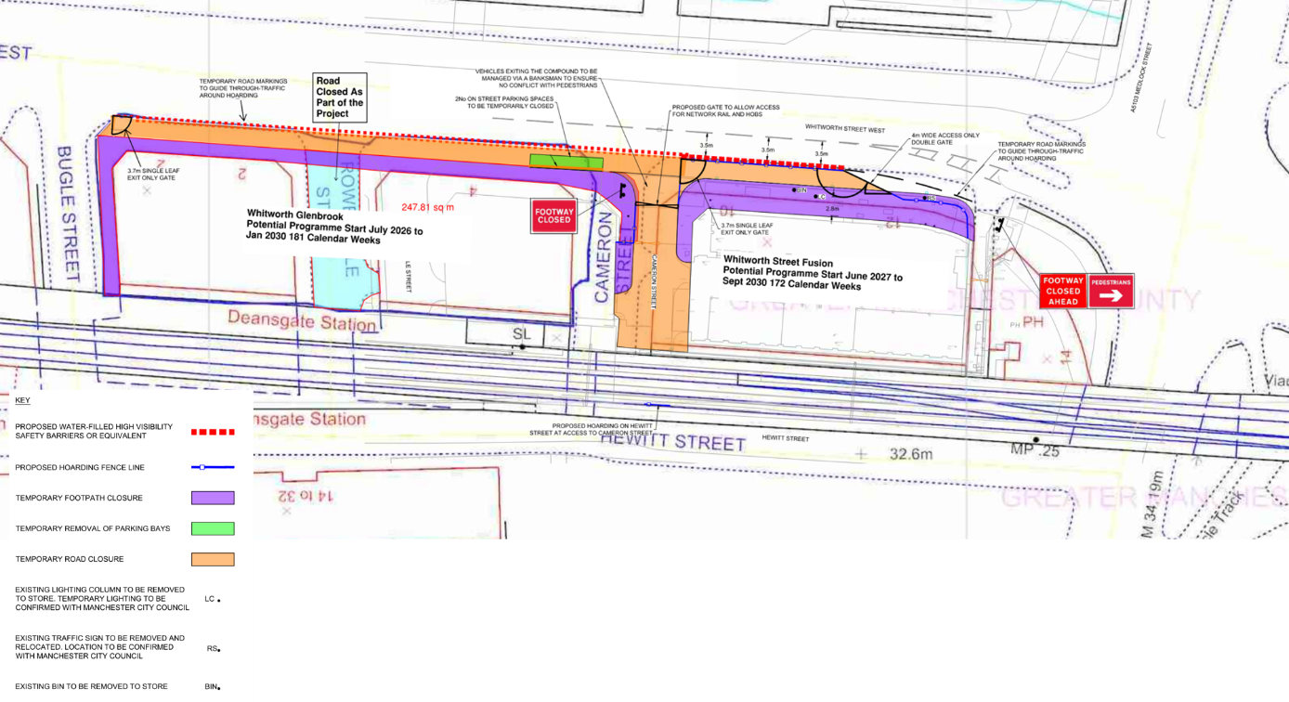

  - Summary of new works proposed

The project involves the construction of a 38 storey purpose built student accommodation tower with associated incoming utilities, plant rooms and servicing areas, resident’s reception with lounges and other amenity space.

  - Overview- Nuisance mitigation measures.

  - Health and safety

The risks associated with each identified hazard and their specific management controls are recorded on the Overall Project Risk Assessment form held in the Construction Phase Health & Safety Plan.
Control measures are generally; activity risk assessments, point of work risk assessments, method statements, inspection and test plan and permits. Information from the assessment is issued to subcontractors to identify the control documents required before starting the work. Records of the preparation, approval, receipt, issue and communication of all risk assessments, method statements and permits are maintained on file.

  - Minimising disruption to ongoing use of adjacent buildings

The continuity of existing site operations will be at the heart of all our planning and delivery of the project. We will use the following hierarchy:
- Protect and maintain all existing adjacent buildings operations and services
- Protect and maintain all existing highway and footpath operations and services contained within
- Management strategy for working adjacent to the Network Rail asset, as further defined below.
- Use construction methods that are appropriate when working close to site users and staff
- Plan and communicate on the above basis.
- Deliver, monitor and control activities.

We will continue to develop our plans in more detail as we move through to the next stage ensuring that, at any one point in time, all site users can continue to access the site unimpaired, that all site ME&P services remain live, that deliveries and visitors can access necessary areas, and that site fire escape and muster points are protected.
Clear and safe dividing lines between site and construction operations will be created and adapted to suit controlled changes.

- Construction noise and vibration

Consideration will be given to noise and vibration at the pre-construction stage for all the various activities involved with delivering the buildings, we will take specialist contractor advice to ensure we minimise excessive noise and vibration, and as such we have identified the noisiest activities which are as follows: -

    - Continuous Flight Auger Piling
    - Bulk Excavation
    - Arch interventions
    - Concrete Structure

The following table illustrates expected levels of noise from the various types of machinery to be used on this project: -

Plant Type | BS 5228 Reference | Sound Pressure Level  Leq (dBA) at 10m
Tower crane | C4.49 | 77
Passenger/goods hoists | C4.62 | 66
Cutters, drills, and small tools | C3.35 | 65
Pulveriser on Excavator | C1.4 | 76
Folk lift truck | C4.55 | 70
Lorries and vans | - | 73
Mobile crane | C4.46 | 67
Mobile lorry mounted concrete pump | C4.30 | 79
Poker vibrator | C4.33 | 78
Ready mixed concrete lorry | C4.21 | 77
Concrete splitters/saws | C1.6 | 83
Scaffolding and hydraulic access platforms | C4.58 | 63
Tipper lorries | C2.32 | 74
Flatbed articulated vehicle | - | 73
Large rigid lorries | - | 75
Track mounted piling rigs | C3.15 | 82
Water pumps | C2.45 | 65

In order to minimise the effect these activities will have on our adjacent neighbours and the general public; we will undertake a series of mitigation procedures coupled with a scheme of noise and vibration monitoring.

Noise and vibration mitigation to be undertaken on site:

The following steps will be carried out to minimise noise on site within Best Practicable Means (BPM), as defined in Section 72 of the Control of Pollution Act 1974 and Section 10 of BS 5228 part 1):

- We will use methods, machinery, and equipment that will have a lower vibration level impact.
- We deploy machines and equipment that has been recently serviced and will be
routinely serviced during the project to minimise the amount of noise and vibration from those machines and equipment.
- Attitude of operatives to the making of noise to be addressed, to have an understanding that work activities have an effect on those around not just operatives but residents and the public. This will be achieved though toolbox talks and daily activity briefings.
- Use cast in Halfen brackets for the cladding in lieu of post drilling into concrete.
- Screens surrounding the concrete slabs and proprietary formwork wrapping the stair and lift core to minimise noise break out from concreting activities
- Acoustic screens used to shield metal pipe cutting or concrete cutting activities on site.
- Cutting stations for cutting metal wall studs will be in suitably acoustically sheltered locations.
- Electric forklifts and pallet trucks in lieu of diesel forklifts where available from the Domis fleet of electric plant.
- All site operatives will be inducted on the potential impact on the surrounding community of site activities. This should cover principles of BPM pertaining to all site activities, highlight any particularly sensitive or high impact activities and precautions to be taken.
- No shouting.
- Stereos will not be permitted on site.
- All contractors/sub-contractors will demonstrate and undertake best working practices to avoid exceeding noise or vibration limits which have been agreed with Manchester City Council control limits.
- Sub-contractors shall highlight in their method statement and/or risk assessment any activities that will create significant noise and vibration levels. Sub-contractors will demonstrate how they will mitigate/ manage the emissions.
- All plant and equipment will be switched off when not in use, or where this is not practicable, throttled down to a minimum.
- Wherever practicable, all plant and equipment should be powered by mains electricity in preference to locally powered sources such as diesel generators.
- All compressors and generators shall be models fitted with properly lined and sealed acoustic covers or enclosures which remain closed when in use.
- Noisy plant or equipment should be sited as far away as possible from noise sensitive buildings. Wherever practicable, the use of barriers in the form of acoustic barriers or enclosures will be employed.
- All vehicles, plant and machinery used during operations shall be fitted with effective exhaust silencers and all parts of the machinery, plants and vehicles will be maintained in good working order and repair in accordance with the manufacturer’s recommendations.
- Screening from existing features will be maximised or the use of full or partial enclosures will be employed for fixed plant. Fixed or semi-static plant will be located and orientated away from noise sensitive receptors where feasible to do so.
- Identification and use of low noise and vibration techniques. Where construction plant which is known to generate significant levels of noise and vibration then it will be used with consideration, and the construction process closely monitored to minimise noise and vibration impacts on and off the site.
- Vibratory compaction equipment will be used in a mode which minimises the incident vibration at nearby residential and other sensitive properties. Consideration will be given to engaging concentric weights only when running at speed to avoid run up, run down resonances, the use of smaller equipment, or turning off the mechanical vibration on vibratory rollers and undertaking more passes for areas where there is a particular risk that disruption may occur at neighboring properties.
- Noisy works will be controlled utilising the hierarchy of risk control and measured using noise monitoring equipment to ensure safe levels are not compromised and noisy work hours are not breached. In all noisy work cases substitution of equipment for machines or processes which reduce the noise levels to acceptable levels and therefore minimise the impact on both site personnel and the general public. Where this is not possible, engineering controls will be employed utilising such control measures as baffles and ‘noise screens.
- And at all times refer to the noise from building sites webpage for further information/guidance and also IAQM/EPUK Construction Guidance on controlling emissions. [Currently January 2024, Version 2.2] ** (For city centre major developments).

Monitoring and control of noise and vibration

The critical construction activities have been identified, as follows: -

    - Sectional Flight Auger Piling
    - Bulk Excavation
    - Concrete Structure

We would propose to carry out week-long environmental noise and vibration monitoring at the beginning of each of these phases of work at the site boundary nearest to the identified sensitive receptors.

The monitoring will capture hourly dB LAeq noise levels and PPV (mm/s) vibration levels continuously throughout the week.

At the end of each survey, the results will be quickly analysed and the risks of exceedance of the pre-agreed noise/vibration limits shall be evaluated.

1. If the verified survey deems that activities fall comfortably below the pre-agreed limits, risks of adverse impact would be deemed low, and the works would continue without the need for continuous monitoring. Occasional sample (spot check) noise and vibration level measurements may be taken periodically throughout the remainder of the identified period of works. These sample measurements will be carried out by the project’s independent acoustic consultant, Jameson Acoustics, with visiting days chosen by them at random.

2. If the verification survey deems that activities are below the pre-agreed limits, but only by a margin that may suggest that, on certain days/times, the limits could be reached or exceeded, then a second verification survey will be conducted for another week. If after this week, the levels remain consistently below the limits with a reasonable margin, then works would continue without the need for continuous monitoring. However, occasional sample (spot check) noise and vibration level measurements may be taken throughout the remainder of the identified period of works.

3. If the verification survey deems that activities have reached or exceeded the pre-agreed limits, then continuous noise and vibration monitoring station shall be installed.

In the event of scenario 3 occurring, noise and vibration levels will be monitored onsite 24/7 via a live online monitoring system.

The monitor will transfer data via cellular connection to Jameson Acoustics on a daily basis, and in addition real-time alarms will be sent via email and/or SMS to the project manager and construction manager.

Locations of monitoring equipment will be stationed where there is a suitable power supply, accessible mounting point and where the equipment can be maintained and be safe and secure for the project duration.

*Noise trigger levels Noise trigger levels will be set at the following (based on the guidance in BS5228-1, E.3.2 at the nearest dwelling:

• 75 dB(A) Leq (10 h) Monday to Friday working day (07:30-18:00)
• 75 dB(A) Leq (5 h) Saturday working day (08:00 – 14:00)
• 65 dB(A) Leq (3.5 h) Saturday working day (13:00 – 16:30)

Noise triggers may be adjusted according to the mounting locations as it may not be practical or reasonably possible to mount the noise monitor onto the receptor’s façade. If noise measurements are to be taken at the site boundary, the noise limits will be recalculated according to account for the noise reduction over distance to the receptor’s façade from the site boundary. We can confirm that suitable mounting locations can be achieved at the site boundary.

The monitors will have a trigger level set for working 1 hour periods, above which an alert will be sent by text and/or email to the allocated site contacts.

The 1-hour alert is intended to inform the construction management of potential issues onsite. The intent is that measures can be taken to reduce the noise activities such that working period average is not breached.

Following receipt of an alert, the response procedure will be followed as soon as is reasonably practical.

The Project Manager / Frame Project Manager will be informed of the breach and the following action will be taken;

We will review the monitoring results to:
• Cease all works likely to be causing any potential noise or vibration.
• Determine the activities / plant that is responsible for the exceedances.
• Ascertain if there are any practicable means of reducing the measured levels including alternative working techniques.
• Determine whether this reduction can be practically employed and if so, the measures will be implemented.

The site team will regularly review monitoring records to review the effectiveness of the noise management activities onsite.

Class 1 sound level meters will be used in compliance with relevant British Standards (Noise and Vibration).

Vibration will be monitored by real-time, cellular connected vibration monitors and will measure and conform to the standard BS5228-2 which provides guidance on monitoring vibration on construction and open sites.

Limits in the document are based on measuring vibration at the receptor, at the base of the building on the outer wall.

Vibration affecting occupied buildings shall not exceed levels that are likely to give rise to damage to the building or discomfort to the occupants of the building. It will normally be appropriate to set limits in terms of Peak Particle Velocity (PPV), in accordance with BS 5228-2.

Vibration monitoring will be carried out during each of the key work phases (critical construction activities listed above). Vibration monitors will upload data every 24 hours or at the point of exceedance, where the Project Acoustician will be available to view, analyse and issue to site contacts. Waveform & frequency data can be collected by the monitor where required.

Please see Section 2.11 for details of our complaints procedure.

The at-risk noise and vibration receptors?

We have identified that we have a series of neighbours that may be potentially impacted by our works on site. We have addressed this in part by contacting these parties and will include them in the first of our quarterly updates that includes information about our works, our contact details for the site team and our out of hours contact customer service centre.

As part of this review, we have determined that our closest (and thus at most risk) receptors are as detailed in the below site plan. As such, we are proposing these as the receptor locations. These will be positioned at the three nearest locations in relation to where we believe our noise generation locations will occur.

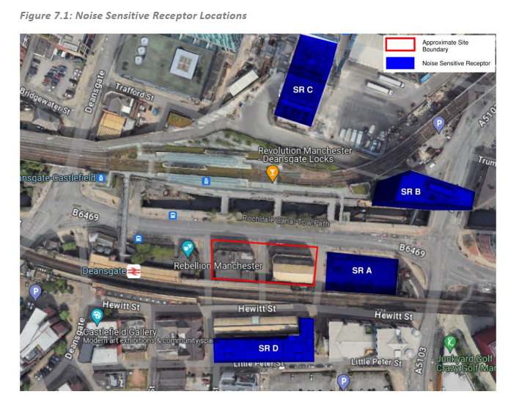
NSR C
NSR B
NSR A

- Dust and Mud

Good practice measures will be adopted at the WSW development to control the generation and dispersion of dust such that significant impacts on all permanent and transient stakeholders is minimised.

The hierarchy for mitigation will be:

- Prevention
- Suppression
- Containment

The following section provides detail on the Generic Mitigation to be incorporated into the Proposed Development:

- Communication

Develop and implement a stakeholder communications plant that includes community engagement before work commences on site.

Display the name and contact details of person(s) accountable for air quality and dust issues on the site boundary. This may be the environment manager/engineer or the site manager.

Display the head or regional office contact information.

- Planning

Develop and implement a Dust Management Plan (DMP), which may include measures to control other emissions, approved by the Local Authority. The level of detail will depend on the risk and should include as a minimum the measures recommended in this table.

- Site Management

Record all dust and air quality complaints, identify cause(s), take appropriate measures to reduce emissions in a timely manner, and record the measures taken.

Make the complaints log available to the local authority when asked.

Record any exceptional incidents that cause dust and/or emissions, either on- or off- site, and the action taken to resolve the situation in the log book.

- Monitoring

Undertake daily on-site and off-site inspection, where receptors (including roads) are nearby, to monitor dust, record inspection results, and make the log available to the local authority when asked. This should include regular dust soiling checks of surfaces such as street furniture, cars and window sills within 100m of the site boundary, with cleaning provided if necessary.

Carry out regular site inspections to monitor compliance with the DMP, record inspection results, and make an inspection log available to the local authority when asked.

Increase the frequency of site inspections by the person accountable for air quality and dust issues on site when activities with a high potential to produce dust are being carried out and during prolonged dry or windy conditions.

Agree dust deposition, dust flux, or real-time PM10 continuous monitoring locations with the Local Authority. Where possible commence baseline monitoring at least three months before work commences on site or, if at a large site, before work on a phase commences. Further guidance is provided by IAQM on monitoring during demolition, earthworks and construction.

- Preparing and Maintaining the Site

Plan site layout so that machinery and dust causing activities are located away from receptors, as far as is possible.

Erect solid screens or barriers around dusty activities or the site boundary that are at least as high as any stockpiles on site.

Fully enclose site for specific operations where there is a high potential for dust production and the site is active for an extensive period.

Avoid site run-off of water or mud.

Keep site fencing, barriers and scaffolding clean using wet methods.

Remove materials that have potential to produce dust from site as soon as possible, unless being re-used on site. If they are being re-used onsite cover as described below.

Cover, seed or fence stockpiles to prevent wind whipping.

- Operating Vehicle/Vehicle Movements

Ensure all vehicles are well maintained and switch off engines when stationary – no idling vehicles.

Avoid the use of diesel- or petrol-powered generators and use mains electricity or battery powered equipment where practicable.

Impose and signpost a maximum speed-limit of 15 mph on surfaced and 10 mph on unsurfaced haul roads and work areas (if long haul routes are required these speeds may be increased with suitable additional control measures provided, subject to the approval of the nominated undertaker and with the agreement of the local authority, where appropriate).

Produce a Construction Logistics Plan to manage the sustainable delivery of goods and materials.

Use of ultra-low Sulphur diesel in all non-road mobile machinery where available.

Where possible all Non-Road Mobile Machinery (NRMM) used for the purpose of construction or demolition works should meet Stage IV of EU directive 97/68/EC, and Stage IIIA.

- Operations

Only use cutting, grinding or sawing equipment fitted or in conjunction with suitable dust suppression techniques such as water sprays or local extraction, e.g. suitable local exhaust ventilation systems.

Ensure an adequate water supply on the site for effective dust/particulate matter suppression/mitigation, using non-potable water where possible and appropriate.

Use enclosed chutes and conveyors and covered skips.

Minimise drop heights from conveyors, loading shovels, hoppers and other loading or handling equipment and use fin water sprays on such equipment wherever appropriate.

Ensure equipment is readily available on site to clean any dry spillages, and clean up spillages as soon as reasonably practicable after the event using wet cleaning methods.

- Waste Management

Avoid bonfires and burning of waste materials.

The following section provides detail on the Activity Specific Mitigation to be Incorporated into the Proposed Development:

- Demolition

Soft strip inside buildings before demolition (retaining walls and windows in the rest of the building where possible, to provide a screen against dust).

Ensure effective water suppression is used during demolition operations. Handheld sprays are more effective than hoses attached to equipment as the water can be directed to where it is needed. In addition, high volume water suppression systems, manually controlled, can produce fine water droplets that effectively bring the dust particles to the ground.

Avoid explosive blasting, using appropriate manual or mechanical alternatives.

Bag and remove any biological debris or damp down such material before demolition.

- Earthworks

Only remove the cover in small areas during work and not all at once.

- Construction

Avoid scabbling (roughening of concrete surfaces) if possible.

Ensure sand and other aggregates are stored in bunded areas and are not allowed to dry out, unless this is required for a particular process, in which case ensure that appropriate additional control measures are in place.

Ensure bulk cement and other fine powder materials are delivered in enclosed tankers and stored in silos with suitable emission control systems to prevent escape of material and overfilling during delivery.

For small supplies of fine powder materials, ensure bags are sealed after use and stored appropriately to prevent dust.

- Track out

Use water-assisted dust sweeper(s) on the access and local roads, to remove, as necessary, any material tracked out of the site. This may require the sweeper to be continuously in use.

Avoid dry sweeping of large areas.

Ensure vehicles entering and leaving sites are covered to prevent the escape of materials during transport.

Inspect on-site haul routes for integrity and instigate necessary repairs to the surface as soon as reasonably practicable.

Record all inspections of haul routes and any subsequent action in a site logbook.

Install hard surface haul routes, which are regularly damped down with fixed or mobile sprinkler systems, or mobile water bowsers and regularly cleaned.

Implement a wheel washing system for routine use (with rumble grids to dislodge accumulated dust and mud prior to leaving the site where reasonably practicable).

Ensure there is an adequate area of hard surfaced road between the wheel wash facility and the site exit, wherever site size and layout permits.

Access gates to be located at least 10m from receptors where possible.

All construction activities will be subject to the production of a detailed method statement and risk assessment by specialist subcontractors, these will include the measures being proposed for eliminating, reducing or controlling dust and any proposals for monitoring where deemed necessary.

These method statements are subject to approval by the Domis Construction Operations Team and our Safety Advisor and agreement will need to be reached prior to any work being carried out.

  - Fire protection

On contract commencement the Project Manager will appoint a competent person to act as Fire Safety Coordinator to control fire evacuation and muster checks.
The Project Manager and the Fire Safety Coordinator will conduct a fire assessment to determine all potential fire hazards, the employees and other site users at risk and the fire safety arrangements. This will be recorded on the Fire Assessment and Arrangements Form.
Following completion of the Fire Assessment and Arrangements an action plan will be produced by the Project Manager and Fire Safety Coordinator to ensure all potential hazards are eliminated and all fire safety controls are in place prior to taking occupancy.

The Project Manager and Fire Safety Coordinator will ensure the content of the completed Fire Assessment and Arrangements is added to the Contract Management Plan.
The Project Manager will ensure the fire arrangements form part of the induction process and that all individuals are aware of the fire evacuation process. The Project Manager will ensure a drawing showing site / office layout and firefighting arrangements is displayed at strategic locations. A Fire Notice is available to record this.
The Project Manager will nominate and arrange training for Fire Wardens. Consideration must be given to cover holiday and illness absences. The names of the Fire Wardens will be communicated. A Fire Notice is available to record these. The Fire Wardens will attend the relevant training, ensuring they fully understand the content and their overall responsibility.
The Fire Safety Coordinator will establish a Fire Safety Inspection Record for each location for each calendar year. This will be used to record Weekly Checks, Emergency Evacuation Drills and Annual Equipment Checks.
The Fire Safety Coordinator (or his nominee) will undertake weekly checks on Fire Extinguishers; Fire Escape Routes; Fire Signs; Fire Alarms and Fire Brigade Access. This will be recorded on the Fire Safety Inspection Record
The Fire Safety Coordinator will undertake practice emergency evacuations at approximately six-monthly intervals for locations where there is a static workforce, for locations where there is a high turnover of staff this frequency will be increased. During the emergency evacuation the Fire Wardens will adequately perform their duties and feedback any issues to the Fire Safety Coordinator.

Where the alarm goes off for an unknown reason, but it becomes apparent there is not an emergency situation the alarm should be allowed to continue, and the building evacuated to prevent confusion in the evacuation and treated thereafter as a practice drill. The Fire Safety Coordinator will record the details on the Emergency Evacuation Record and the Fire Safety Inspection Record. Where actions have been identified these will be transferred to the Fire Assessment and Arrangements Form.

The Fire Safety Coordinator will ensure all firefighting equipment is tested on an annual

basis by a competent person. These will be recorded on the Fire Safety Inspection Form. The Fire Assessment and Arrangements will be reviewed on an annual basis or after any event which may affect its content, such as alteration or substantial changes in occupancy.

  - Light pollution

Site lighting will be carefully considered to ensure the required level of safety and security is achieved without causing excessive nuisance to neighbours. Floodlights will be located to provide the necessary site illumination, and the lamp-heads will be specified to minimise overspill and directed to shine onto site. All tower cranes will have air-craft warning lights fixed to the upper part of the crane and jib.

  - Ground and watercourse pollution

Method statements for the works will be devised to take account of contamination risk and the effective management of that risk:
- All materials / processes will be handled / undertaken strictly in accordance with the suppliers / manufacturer’s recommendations
- All bulk solid, granular, liquid materials will only be stored on site in (limited) quantities necessary to meet the requirements of the construction process
- All liquid materials will be stored in suitable containers, adequately bunded to comply with Health, Safety and Environmental legislation / recommendations
- Sensitive areas will be subjected to specific protection regimes
- Spillage reaction / clean-up plans will be in place to be undertaken by a trained squad of personnel
- Specialist cleaning equipment will be placed in key locations around site to minimise any spillage should it occur
- All waste materials will be controlled / sorted into the appropriate waste containers on site prior to removal by an authorised / licensed waste carrier
- Interceptors will be used to remove solids etc. from any site discharges, which may, with the agreement of the Local Authority be made into the surface water drainage system

  - Trees and existing hedge rows
This section is not applicable due to the fact that there are no hedgerows or trees on site.

  - Site Housekeeping

Throughout the project we will encourage and enforce an excellent housekeeping regime. A strategy will be developed and incorporated into the Site Rules which will be sent to suppliers and supply chain partners alike. The strategy will also form an essential part of the supply chain / suppliers pre-order interview.
We will ensure that all operatives engaged on the works are familiar with the work in progress, skilled at their task, aware of their duties and responsibilities to others and knowledgeable of the Site Rules. All persons working on site will attend the site safety induction and commit to the site rules.

  - Waste management proposals

We will operate a site wide waste segregation removal procedure. Recycling areas will be located on the service yard level and ground floor of the site. Waste wheelie bins will be situated in designated areas which will be filled by the subcontractors and taken by them to the recycling areas.
Waste reports will be created on a monthly basis which will detail the quantity, type and percentage of waste being produced, with the percentage of recycling achieved.
Waste control will be reviewed with the contractors during the procurement process to minimise packaging on deliveries and encourage removal of their own waste such as plasterboard, pallets, paint pots and cable drums.
The specialist contractors will work with the design team during the design stages to find the most efficient and economical solutions in reducing waste during the construction phase. In addition, the strategy for maximising the levels of works through prefabrication off site will further reduce waste generation.

  - Liaison with community.

We will keep our neighbours well informed before and during the construction phase through various means: A member of the Domis team will be designated as the Project Community Liaison Manager responsible as a single-point contact to ensure good neighbour relations. A regular residents’ meeting will be established at a frequency agreed with the residents to bring them up to speed with project progress and key elements of the work. It also provides an open discussion for residents to voice concern or highlight issues.

Newsletters will be widely distributed to identify completed works and focus on forthcoming activities to give neighbours early notice of such works. Information displays in prominent locations will contain various project-specific information.
A 24-hour emergency contact number will be established to allow concerns to be raised, these will be actively dealt with by the Domis Project Community Liaison Manager until the issue is resolved.
Emergency contact display
A clearly visible contact board will be displayed at the site hoarding/entrance, at the site office and within the site induction area, showing the 24-hour emergency contact number, the Domis out-of-hours customer service centre number, the name and direct contact details of the Site Manager and the Project Community Liaison Manager, and the postal/email address for written enquiries or complaints. The board will be kept up to date throughout the project and reissued immediately if any of the named contact’s change.
Site Manager contact details
The Site Manager (or their appointed deputy in their absence) is the first point of contact for day-to-day site management, health and safety, and operational queries from neighbours, statutory authorities and members of the public, and will be named on the site hoarding contact board together with a direct mobile telephone number. The Site Manager's contact details will also be issued to Manchester City Council, Network Rail, Project Four Safety and immediate neighbouring occupiers as part of the pre-commencement notification process and will be reissued promptly in the event of any change of personnel.

Role | Name | Contact Number | Email
Site Manager | TBC | TBC | TBC
Deputy/Assistant Site Manager | TBC | TBC | TBC
Out-of-Hours / Emergency Contact | TBC | 24hr number - TBC | TBC
Emergency Services (Fire/Police/Ambulance) | N/A | 999 / 101 (non-emergency) | N/A

  - Site hours

Working hours will be in line with the LA planning requirements. These are anticipated to be 07.30 – 18.00 Mondays to Fridays and 08.00 – 14.00 Saturdays. No work on Sundays or Bank holidays.

Additional working hours will be required for activities such as;

- Tower crane erection and dismantle.
- Power floating to concrete slabs.
- Large volume concrete pours.

  - Construction Logistics and Construction Processes

This section contains statements and plans for traffic management and construction logistics for the works. Statements and plans to cover the following;

  - Traffic management, Construction Logistics and Construction Methodology

    - 3rd Party Consultation
We will consult with and have consulted with various 3rd parties over the construction of the development, these include;
Manchester City Council (MCC) –Ben Phillips Event and Specialist Co- for Manchester City Centre Piccadilly and Deansgate wards.
Manchester City Council

We have developed a site layout that is based on the minimal interference with transport network, a copy of the same is attached, which is in keeping with the previously agreed TM plans for the previously commenced Viadux 2 development.

Wider Manchester City Centre Issues

There is a large amount of construction work going on in the city centre and the roads around the site will be subject to road closures and diversions over the course of the project. We will require a 4-day partial road closure for the erection and removal of TC1, and TC2

    - Site Vehicle access restrictions

The site will operate a strict vehicle one-way access regime, with only one vehicle being allowed into site at any time, the rest will be held off site and called in to site when the space is available. No vehicle holding will be allowed in the adjacent streets. Parking for site staff and operatives will not be allowed on site and they will have to use the existing public car parking in the city and through the use of public transport. There are a number of public car parks in close proximity of the site such as the Great Northern Warehouse, Little Peter St. Q-Park at First St. and the train and tram networks are all within walking distance, e.g. Deansgate, Manchester Oxford Rd.

    - Site set-up plan
The plan below is a dedicated Site Set-Up Plan that has been prepared and showing the extent of the site hoarding line, pedestrian and vehicle access/egress points, the wheel wash and rumble grid location, welfare and office accommodation, materials storage and laydown areas, tower crane base positions and exclusion zones, hoist locations, contractor and delivery holding areas, fire assembly points and the location of the site security and traffic marshals.
The Site Set-Up Plan is displayed at the site entrance and within the site induction area, and copies are issued to Manchester City Council, Project Four Safety and the design team for information and comment prior to implementation.

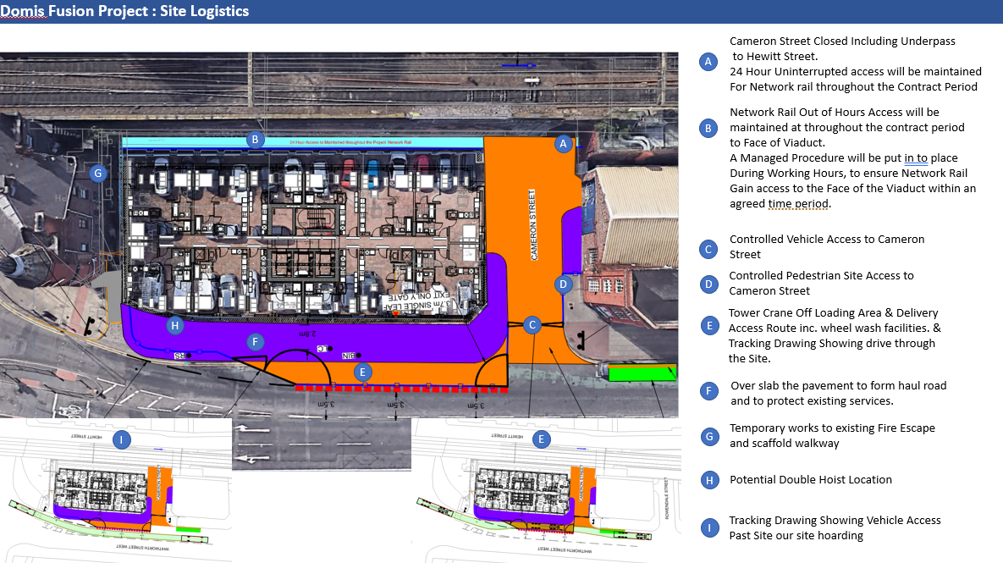

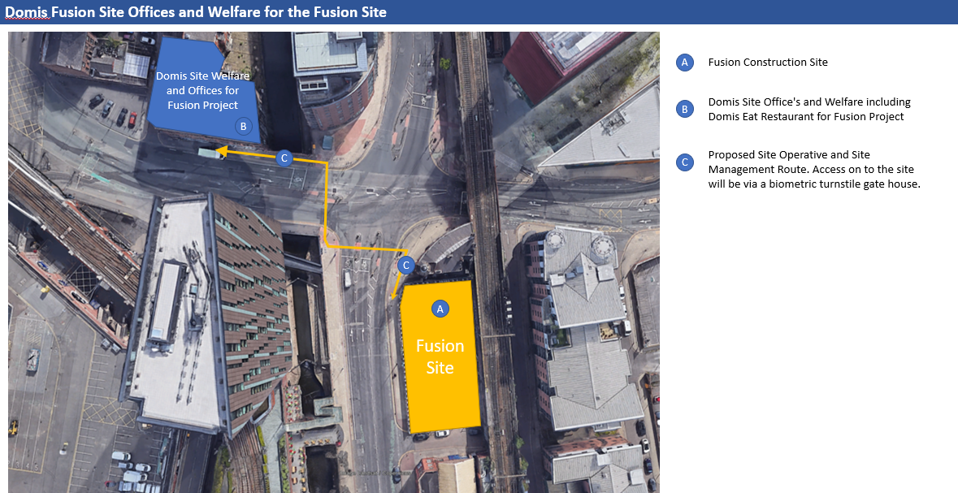

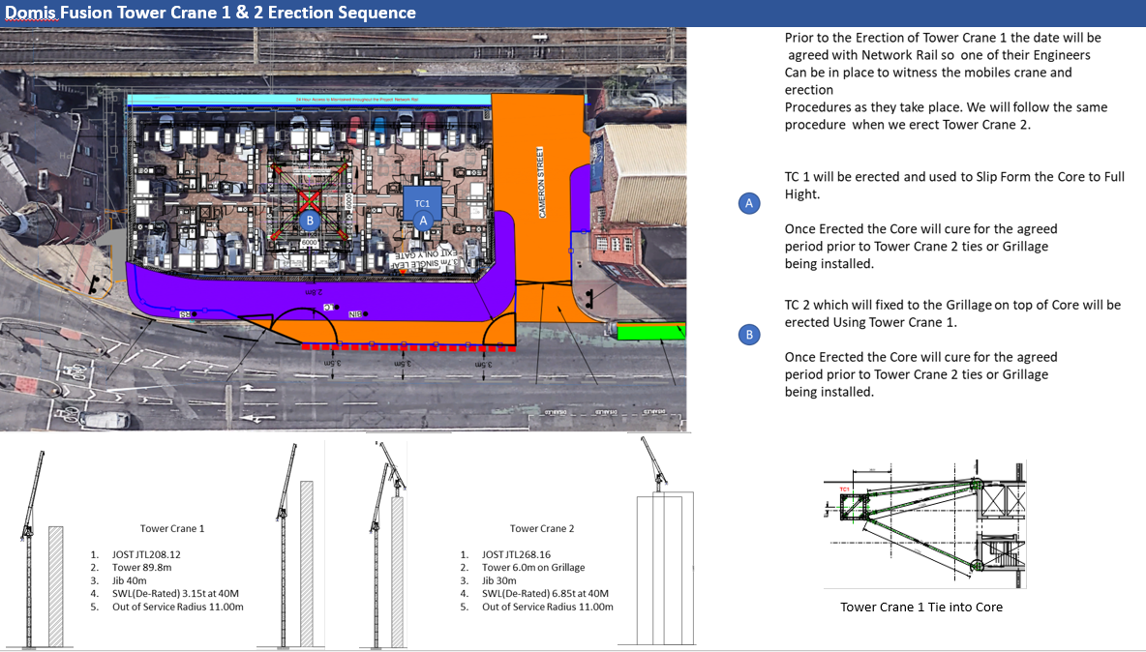

    - Construction phasing and vehicle trip generation
Vehicle movements to and from the site will vary significantly by construction phase, and the logistics strategy has been developed to minimise peak trip generation and to spread deliveries outside of the network's peak hours wherever practicable. Indicative phase-by-phase vehicle movement generation is summarised below and will be refined and reissued as a live Construction Traffic Management Plan as subcontractor and supply chain programmes are finalised.

Wagons Required for 2 - 4 Whitworth Street
Tasks | Wk. No | Wk. No | Duration Days | Total Wagons | Average Wagons Per Day
Piling
Piling Arisings | 1 | 7 | 30 | 90 | 4
Piling Concrete | 1 | 7 | 30 | 184 | 8
Sub-Structures
Spoil removed from site | 7 | 10 | 15 | 252 | 25
Foundations Rebar, Concrete & Formwork | 9 | 16 | 35 | 345 | 7
Drainage Works | 14 | 18 | 20 | 8 | 0.3
Main Concrete Frame
Concrete Frame Rebar, Concrete & Formwork | 20 | 113 | 465 | 2373 | 5
Envelope
Unitised Glazing | 53 | 139 | 430 | 213 | 1
Internal Works
Apartment Build and Internal Works | 42 | 160 | 590 | 3312 | 6

Details of any significant import or export of materials, earthworks, demolition arisings, or any abnormal loads.

- We are currently taking possession of the site upon completion of the Demolition and the grubbing up of existing foundations and the piling mat laid.
- There is a large amount of construction work going on in the city centre and the roads around the site will be subject to road closures and diversions over the course of the project. We will require a 4-day partial road closure for the erection and removal of TC1, and TC2

The proposed construction access arrangements and preferred routing of construction traffic to and from the Strategic Road Network (SRN)

  - We have highlighted below our preferred routes to site which is depended on the suppliers and which depots they utilise but in General.
  - Concrete Wagons from Trafford Park
  - Rebar from Liverpool
  - Excavated Materials off Site
  - Internal Works from Domis Warehouse (Off Site Storage) at Wigan.

Key Delivery Route Map

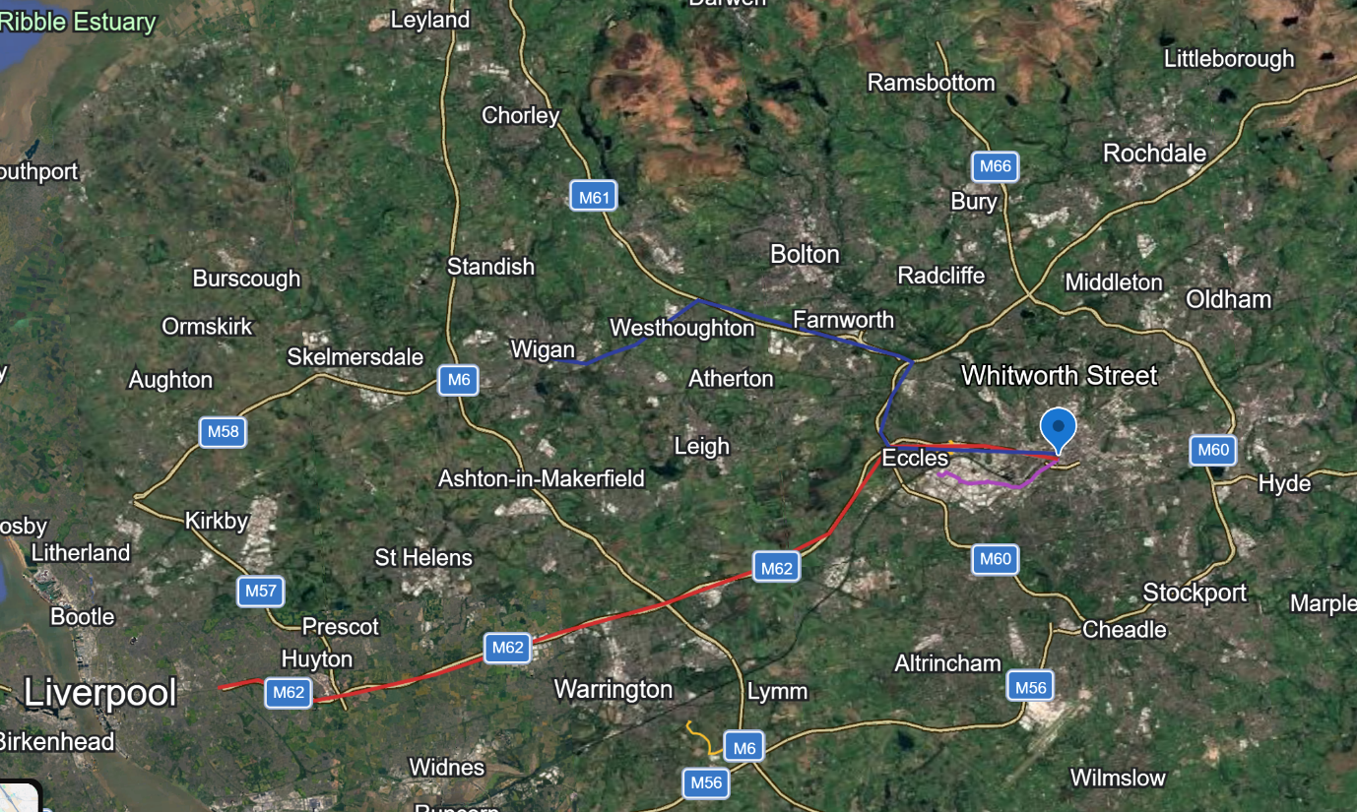

Red Proposed Location of the Rebar Supplier Liverpool (Maximum 5 HGV per week)
Purple Proposed Location of the Concrete Plant Trafford Park
Blue Location of Domis Off Site Storage Warehouse Wigan

Any measures proposed to manage deliveries, contractor parking and the impacts of construction traffic

The site will operate a strict vehicle one-way access regime, with only one vehicle being allowed into site at any time, the rest will be held off site and called in to site when the space is available. No vehicle holding will be allowed in the adjacent streets. Parking for site staff and operatives will not be allowed on site, and they will have to use the existing public car parking in the city and through the use of public transport. There are a number of public car parks in close proximity of the site such as the Great Northern Warehouse, Little Peter St. Q-Park at First St. and the train and tram networks are all within walking distance, e.g. Deansgate, Manchester Oxford Rd.

Where a phase requires an abnormal or high-volume delivery (piling rig, tower crane erection, large precast or structural steel elements), this will be identified in advance in a specific lift/delivery plan and communicated to Manchester City Council and Project Four Safety, with vehicle movements scheduled outside of the AM and PM network peaks (07:30-09:30 and 16:30-18:30) wherever practicable.
    - Construction traffic routing and swept-path assessment
A designated construction traffic route will be agreed with Manchester City Council and Transport for Greater Manchester prior to works commencing, directing all HGVs to and from the site via the primary road network in preference to residential streets, and avoiding routes past schools during opening and closing times where an alternative route exists.
Swept path analysis has been undertaken for the largest anticipated vehicles (articulated low-loaders for piling plant and tower crane sections, and standard 8-wheel rigid concrete/delivery vehicles) to confirm that the proposed site access, turning and egress manoeuvres can be achieved safely within the available highway width without encroachment onto opposing traffic lanes, footways or the adjacent Network Rail boundary. The swept path drawings are included within Appendix A and will be updated if the site access arrangement changes at any phase.
A banksman/traffic marshal will control all vehicle movements in and out of the site, and a one-in-one-out vehicle holding regime will continue to be operated as set out in the Site Vehicle Access Restrictions section above, so that no vehicle queues or waits on the public highway.
    - Traffic Regulation Order (TRO) impacts
A number of temporary Traffic Regulation Orders will be required to facilitate the works, principally to support: the erection and dismantling of TC1 and TC2 (temporary partial road closure, anticipated 4 days per crane); footway/carriageway closures associated with the site hoarding line and any temporary pedestrian diversion; and any oversailing of the highway during crane operation, which will be the subject of a separate Oversailing Licence from Manchester City Council.
Applications for the necessary TROs will be submitted to Manchester City Council's Highways team in line with their standard notice periods (generally a minimum of 12 weeks for a full TRO and shorter timescales for a Temporary Traffic Regulation Order/road closure, to be confirmed with MCC on a case-by-case basis). Statutory notices and press notices will be published as required, and affected businesses, residents and Network Rail will be notified directly by the Project Community Liaison Manager in advance of any closure taking effect.
Where a TRO or road closure affects bus routes, cycle routes or on-street parking, Domis will liaise with the relevant operator/authority (including Transport for Greater Manchester where applicable) to agree temporary diversions or suspensions and to ensure these are clearly signed in advance.
    - Traffic management for all users
The Traffic Management Plan has been developed to protect the safety and convenience of all users of the surrounding highway network, not solely vehicular traffic, in line with the principles of inclusive design and the Highway Code hierarchy of road users. The following measures will be implemented and maintained for the duration of the works:
- Continuous, clearly signed and adequately lit pedestrian routes will be always maintained around the site boundary, with temporary footway widths meeting the minimum standards required by Manchester City Council (generally a minimum of 1.5m clear width, increased where pedestrian flows are higher).
- Dedicated, segregated crossing points will be provided and marshalled wherever a pedestrian route crosses a vehicle access/egress point, with banksmen deployed during all vehicle movements.
- Existing cycle routes and cycle parking in the vicinity of the site will be maintained or provided with a clearly signed temporary diversion where the route is directly affected by the works, in consultation with Manchester City Council's cycling and walking team.
- Signage will be provided in accordance with Chapter 8 of the Traffic Signs Manual and will include advance warning signs, pedestrian diversion signage and, where required, tactile paving and audible/visual crossing aids to support users with visual or mobility impairments.
- Public transport stops and access to the adjacent Network Rail assets will be protected and kept open and accessible throughout the works, with any temporary stop relocation agreed in advance with the relevant operator.
- All banksmen and traffic marshals will hold a valid New Roads and Street Works Act (NRSWA) or equivalent traffic management qualification, and a Traffic Management Plan drawing will be displayed at the site entrance and within the induction area.
    - Contractor and site staff parking
In line with the strategy set out under Site Vehicle Access Restrictions, no parking for site staff, operatives or subcontractors will be permitted on site, on the surrounding highway, or in the adjacent streets. All personnel will be required to travel to site by public transport, or to use one of the existing public/commercial car parks within walking distance of the site (including the Great Northern Warehouse, Little Peter Street and Q-Park First Street car parks), the cost and availability of which will be confirmed to the workforce as part of the site induction.
A Workforce Travel Plan will be promoted through site inductions and toolbox talks, encouraging car-sharing, cycling and use of the adjacent tram (Deansgate-Castlefield) and rail (Manchester Oxford Road) stations, both within a short walking distance of the site. Secure, covered cycle parking will be provided within the site compound for operatives who cycle to site.
A small, marshalled holding area within the site boundary will be retained for essential operational vehicles only (small tools/plant deliveries and site management vehicles), strictly on a controlled, non-permanent basis and subject to the one-in-one-out access regime; this is not available for general staff parking.
    - Street furniture protection and mitigation
A condition survey of existing street furniture, signage, lighting columns, bollards, cycle stands, trees in tree pits, and public realm finishes within the zone of influence of the works will be carried out prior to commencement, with photographic records taken and shared with Manchester City Council's Highways and Public Realm teams.
Where street furniture falls within or immediately adjacent to the site hoarding line, working area or a vehicle swept path, it will be protected in situ using proprietary padded/timber protection or, where this is not practicable, temporarily removed, stored securely off site and reinstated to its original location and specification on completion of the relevant phase of works, subject to the agreement of Manchester City Council. Any item that is damaged as a result of the works will be repaired or replaced like-for-like at Domis's cost, and recorded on the dust/site inspection log referenced in Section 3.5.
Hoarding and any temporary signage erected within the highway will be positioned so as not to obstruct sightlines to existing traffic signals, street signage or pedestrian crossing points, and will be reviewed periodically with Manchester City Council to confirm continued compliance.
    - Utility connection coordination
Domis will appoint a dedicated utilities coordinator to manage the design, application and delivery of all new incoming utility connections (electricity, gas, water, telecoms and district heating where applicable) in liaison with the relevant statutory undertakers, and to coordinate the sequencing of any diversion of existing apparatus located within the site boundary or the adjacent highway.
Prior to any excavation, existing utility records (including those held by National Grid, United Utilities, statutory telecoms providers and Manchester City Council) will be obtained and a utility survey (including trial holes/CAT and Genny scanning where required) will be carried out to confirm the position and depth of live apparatus. Excavations in the vicinity of live services will be carried out in accordance with HSG47 'Avoiding Danger from Underground Services'.
Where a new connection or diversion requires excavation within the public highway, the relevant NRSWA street works notice will be submitted to Manchester City Council within the statutory notice period, and works will be programmed, where possible, to coincide with other planned excavations to minimise the number of separate highway openings and the associated disruption to traffic and pedestrians.
A programme of utility connection dates will be maintained and shared with the project team and Manchester City Council, with any outage affecting neighbouring buildings or the public highway communicated in advance through the Project Community Liaison Manager.
    - Highway dilapidation survey
A pre-commencement highway (and where relevant, footway and adjacent structure) dilapidation survey will be carried out jointly with Manchester City Council, or by an independent specialist on Domis's behalf, covering the full extent of the highway within the anticipated construction traffic route and the immediate site frontage. The survey will record the condition of carriageway and footway surfacing, kerb lines, drainage gullies, street furniture and any existing defects by way of a photographic and written schedule of condition, agreed and signed off with Manchester City Council prior to works commencing.
The dilapidation survey will be repeated at practical completion (or at the end of the heavy construction traffic phase, whichever is earlier) to identify any deterioration attributable to the works. Any damage identified will be made good to the reasonable satisfaction of Manchester City Council, and a bond or other financial security may be provided in accordance with the Council's requirements for construction of traffic routes.
    - Wheel washing and dust suppression at site exit
A wheel washing facility with rumble grid will be installed at the site exit, sized to suit the anticipated vehicle fleet, and will be used by every vehicle leaving the site to remove mud and debris from wheels and chassis before entering the public highway, in accordance with the Dust and Mud mitigation hierarchy set out in Section 3.5.
A hard-surfaced run-off area of adequate length will be maintained between the wheel wash and the site exit to allow vehicles to drain before joining the highway, and a road sweeper will be retained on a scheduled and as-required basis to clear any residual material tracked onto the surrounding carriageway. Daily inspections of the site exit and adjacent highway will be recorded in the site logbook, with any track out incident and the remedial action taken also recorded and made available to Manchester City Council on request.
The wheel wash and rumble grid location is shown on the Site Set-Up Plan in Appendix A, and its position will be reviewed at each phase change to ensure it remains the last point of vehicle movement before the public highway.
    - Falling object controls - proximity to the elevated Mancunian Way
The site's proximity to the elevated Mancunian Way (A57(M)) and other adjacent highway and rail infrastructure require specific controls to prevent any risk of materials, debris or tools falling from height and affecting road users, pedestrians or Network Rail assets below or adjacent to the works.
- A falling object risk assessment will be prepared and reviewed at each phase of the work, identifying activities at height adjacent to the elevated highway and rail boundary and the specific controls required.
- Full-height edge protection, brick guards and debris netting/sheeting will be installed and maintained on all elevations facing the Mancunian Way and Network Rail boundary for the duration of works at height, and inspected on a scheduled basis as part of the weekly scaffold/edge protection inspection regime.
- Where practicable, loading and unloading activities involving crane lifts over or adjacent to the highway will be programmed outside of peak traffic periods, and exclusion zones will be established and marshalled on the ground beneath any lifting operation.
- Tool lanyards, toe boards and enclosed/braked material hoists will be used for work at height in this zone, and loose materials will not be stored within the edge protection zone facing the highway.
- A permit-to-work system will apply to any activity with the potential to generate a falling object risk to the highway, requiring sign-off from the Project Manager and CDM/Principal Contractor's health and safety advisor before work commences.
- Where any oversailing of the Mancunian Way by a tower crane jib is required, this will be the subject of a specific method statement, lift plan and licence/consent from the relevant highway authority (including National Highways where the elevated structure falls under their remit), with a full exclusion zone and banksman control in place for the duration of the oversailing lift.
These controls are in addition to, and will be read alongside, the general Fire Protection, Health and Safety and Site Housekeeping measures set out elsewhere in this Plan.

    - Tower Cranes

We have developed our lifting strategy around a two-tower crane approach to the project, within the site boundaries.

TC 1 to construct the main core and floor plates until level 9-10 are complete and then TC2 will be installed and supported off the core, no oversailing will be required apart from a small amount on the Highways, which will be concluded with the requisite Oversailing license from MCC.
Road Closures and extended working hours will be required to rig and de-rig the cranes and this will be agreed with MCC once exact dates are known,
The tower crane arrangements have been developed in conjunction with the piling and structural engineers to confirm base loading, tie-in levels and jib radii, and are recorded in a dedicated Lifting Plan and Crane Erection/Dismantle Method Statement, which will be reviewed by an independent appointed person prior to each crane erection. Both cranes will be fitted with anti-collision systems, zone limiting devices to restrict slewing and load travel over the adjacent highway and Network Rail corridor wherever practicable, and anemometers linked to an automatic high-wind alarm/lock-out.
Where a lift cannot avoid passing over the public highway or Network Rail land, this will be planned as an exclusion zone lift: the relevant section of highway or footway will be temporarily closed and marshalled by trained banksmen, the lift will be programmed outside of peak traffic periods wherever possible, and Manchester City Council/Network Rail will be given advance notice in line with the consultation arrangements set out in Section 3.2.1.
Daily pre-use inspections and statutory thorough examinations (in accordance with LOLER) will be carried out and recorded for both cranes, and radio communication protocols between crane operators, banksmen and the site management team will be confirmed as part of the site induction.

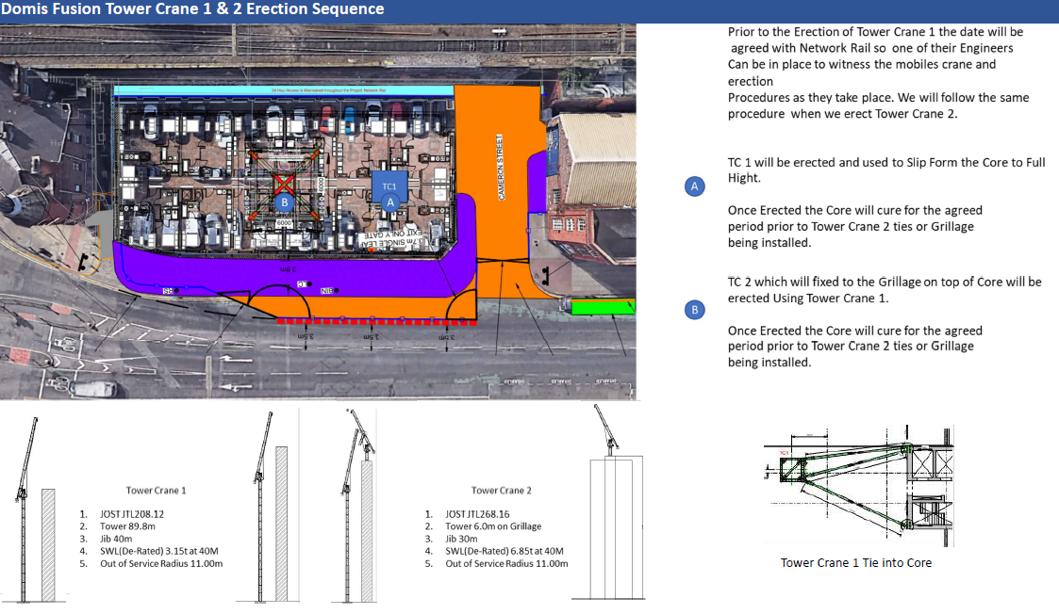

Establishment and Enabling Works

Piling mat will be completed prior to the main works commence, all necessary method statements and Networks Rail approvals will be arranged, and a draft method statement is provided as appendix 2. Vibration monitoring equipment will be installed as agreed with the Engineer and Network Rail.
The main site establishment and accommodation is located within Lock 90 building on Albion Street which is also used for all site accommodation requirements.

Working Adjacent to Railway Operational Land
At the right point after the planning process is being worked through, we will work with Network Rail Asset Protection Manager with support from our CEM (Construction Engineering Manager). relevant applications forms A-C will be processed to enable commencement of the enabling works.
Final draft submission of nomination and form applications will be submitted no later than 20 working days prior to commencement. All applications will be completed in advance of this deadline. Works will not commence on site until formal approval is received from Network Rail.
All works will be carried out in accordance with NR/L2/RSE/02009 Module 02 – The Management and review of Engineering Deliverables. Domis will appoint a single member of the team as CEM who will be responsible for submissions and monitoring/control of operations on site in accordance with Network rail requirements.
Clear 24-hour access will be maintained to Network Rail assets.

Any work required that could potentially impact Network Rail infrastructure will be submitted to Network Rail with RAMS for review a minimum of 20 working days before the work is due to commence.

General Methodology section

3.1.5 The general sequence of the works is as follows;

Phase 1– Piling and Sub-structures and temporary works
Phase 2 – Construction of Main core and structure
Phase 3 – façade installation.
Phase 4- Internal fit out and site commissioning

    - Site Commencement

The development will be serviced from pre-existing office and welfare accommodation which is located on Albion Street.
    - Piling and substructure Works

The piling rig and concrete agitator will be delivered and operate within the site boundary, working on the pile mat.
When the piling works have been completed, we will commence excavation of the Ground floor pile assisted raft as well as install the cast in drainage runs.
Drainage runs outside of the main raft bases will be cast as the first activity to allow them to be backfilled for storage and transport movement purposes.
When the ground floor slab has been cast, we will begin setting up for the columns and core.
    - Slip Formed Core.

We will erect the core. During the pre- construction period we will design and procure the equipment, ensuring that the structural stability of the core is maintained in its temporary condition. The rig will be fully encapsulated to ensure that no materials fall out or blow off the structure.
As the core progresses, we will install the pre-cast stairs to gain permanent access up the building. A hoist will be progressively installed to feed personnel and light materials to the top of the construction work face.
    - Floor Construction

Work will commence on the construction of the main floor construction.
When the structure is up to finished level, we will then use the Tower Crane to install lift in to place the Building Maintenance Unit (BMU).
    - Double high-speed hoists.

Two high speed passenger and goods hoists will be utilised.
3.1.12 Unitised Curtain Walling

The unitised curtain walling will commence when the structure is sufficiently advanced.

A team will work ahead of the installation, fitting brackets to line and level into the halfen channels cast into the floor slab.
We will load out the curtain walling frames using the main hoists that will be distributed on to each floor plate or via crane onto loading platforms at floor level. The facade will be installed using the method of positioning the individual curtain walling panels on a sliding table, connecting on to the overhead floor crane and pushing the units out over the floor edge, turning the panels and connecting them to the lower floor, whilst securing them using the overhead fixing bracket. The process will be repeated until the whole elevation is complete.

For the larger end glass panels, we will need to utilise the Tower Crane to lift them in to position.

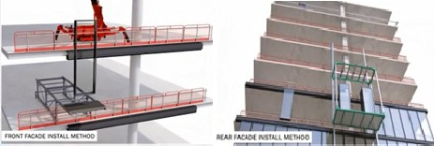

We will design the Unitised Curtain Walling system so that we can leave out the bay where the hoists need to access the building. The intention is to strip out the landing bridges when the floor has been sufficiently loaded out and substantially complete, then infill the unitised windows and panels on that floor, to allow the final fit out of the last unit.
    - Lift Installation

When we have completed the core structure and have sufficiently advanced the core area floor slabs, we will commence with the installation of the passenger lifts. Owing to access restrictions and handling of materials we will fit out each lift shaft, before commencing the next and so on. By completing the lifts early, we will get beneficial use of the lifts progressively.

    - Fit Out
When we have a fully watertight floor, we will complete the high-level corridor services, including any temporary electrics, power and lighting.
The first fix will commence with the metal stud walls, one side of plasterboard and the noggin brackets that carry the electrical back boxes as well as any structural supports required for door frames, kitchen units etc.
The completed first side boarded apartment will be handed over to the Mechanical and Electrical contractor for their first fix works to all services as well as ventilation and ductwork, electrical, comms and control wiring, sprinkler pipework and all pipework including all testing prior to handing back for second side boarding and ceiling works. The student rooms will be plastered, and mist coated when dry. The walls will be snagged and repaired where necessary ahead of 2nd fix joinery, kitchen installation and final decorations. Final fix electrical and lighting will be followed by floor finishes, builders clean and commissioning of services. The team will instigate an inspection and snagging process with the client team to clear all defects before final sparkle clean and lock up of the completed apartment.
As the accommodation is completed, we will finish the corridor fit out, including lift architraves etc. and protect any finished surfaces necessary. From completion of the apartments, we will instigate an inspection process to ensure the integrity of the apartments up until overall final project practical completion.

Appendix A Project logistic plans

END OF DOCUMENT

