

Planning

Delegated Officer Report

Summary of application details
Application reference: | PLA-2026-000934
Application type: | Householder planning permission
Proposal: | Erection of two-storey side extension and single-storey rear extension for additional living accommodation
Site address: | 31 Austin Drive Manchester M20 6EB
Ward(s): | Didsbury East
Date application valid: | 05 August 2026
Applicant name: | Mr Sean McKenna

Agent (if any):
Case officer: | Joshua Lee
Recommendation: | Approve
Date of recommendation: | 01/09/2026

Description of site, building and/or area
The proposal relates to a two storey semidetached dwellinghouse on Austin Drive. The property sits on a angled plot with a garden to the rear and hardstanding to the front for off street vehicle parking.
The property is in a mostly residential part of the Didsbury East ward of Manchester.

Description of development

Erection of two-storey side extension and single-storey rear extension for additional living accommodation

Two storey side extension
The proposed side extension projects 1465mm and, at ground floor runs 8980mm (from a 1m set back to the principal elevation) and at first floor runs 7180mm. The extension follows the angled boundary (maintaining a 1m gap to the boundary) to sit 3225mm wide at the rear of the extension. The extension is finished in matching brick with a gable end tiled roof into the main roofline. The projecting first floor rear also finishes in a gable with new glazing to the rear and ground floor side.

Single-storey rear extension
The proposed rear extension projects 3000mm from the existing rear elevation and spans 9625mm across the original dwelling and proposed side extension to meet the side elevation of the proposed side extension. The single storey extension is finished in matching brick with a flat roof with larger latern rooflight and glazing to the rear.
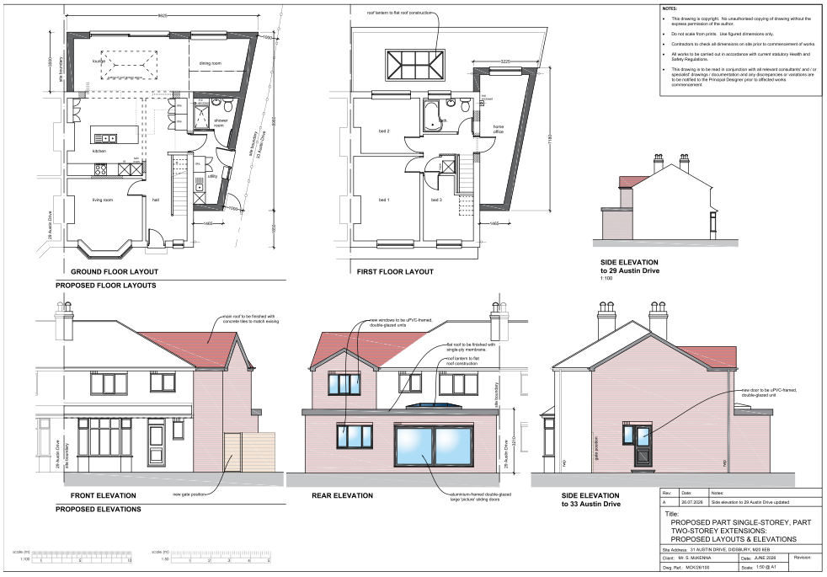
Figure 1. Proposed plans as submitted

Relevant planning history
There is no planning history at the address.

Consultation, notification and publicity responses

Notifications and publicity

Neighbour letters
No responses received.

Negotiations
Issues were identified during the consultation process that required discussions with the applicant in a positive and proactive manner. As a result of these negotiations, the applicant amended the proposal by replacing the proposed gable ends with hip ends to better reflect the design of the existing dwelling.
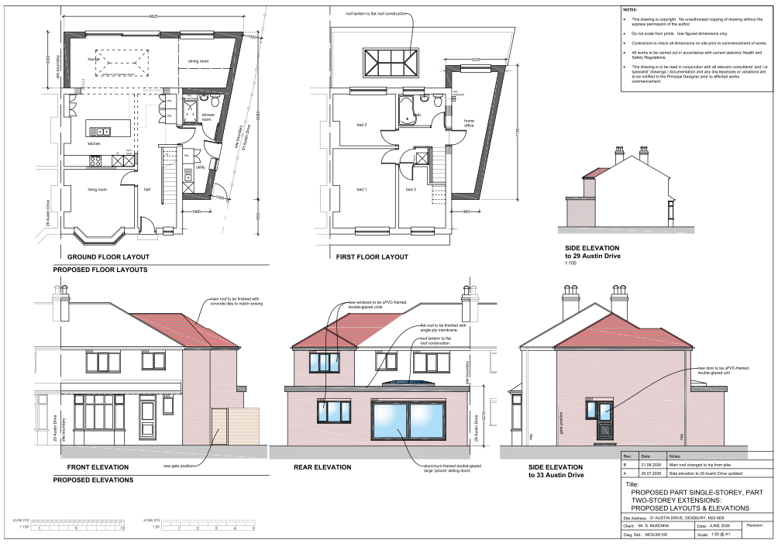
Figure 2. Updated proposed plans

Consultation, notification & publicity responses to updated description of development
Not required due to minor design amendment resulting in a reduction in massing.

Relevant policies
In accordance with Section 38(6) of the Planning and Compulsory Purchase Act 2004, planning applications must be determined in accordance with the statutory development plan unless material considerations indicate otherwise.
For Manchester, the development plan comprises:
- The Manchester Core Strategy (2012 to 2027);
- Saved policies of the Manchester Unitary Development Plan (UDP); and
- The Places for Everyone Joint Development Plan Document (2022 to 2039).
These documents are considered up to date and are afforded significant weight in the determination of planning applications. Relevant Supplementary Planning Documents (SPDs) and other adopted guidance may also be material considerations.
The National Planning Policy Framework sets out the government’s policies for plan-making and for making decisions on development proposals in England. It is a material consideration of critical importance in both contexts.
Where relevant, the Council is required to give special regard to the desirability of preserving listed buildings and their settings, and special attention to the desirability of preserving or enhancing the character or appearance of conservation areas, in accordance with the Planning (Listed Buildings and Conservation Areas) Act 1990.
The policies and guidance referred to below are considered the most relevant to the scale, nature and location of the proposed development.

- The Manchester Core Strategy Development Plan Document 2012-2027
  - Development Management and Planning Obligations
    - DM 1 - Development Management
  - Objective 1 - Spatial Principles
    - SP 1 - Spatial Principles (Partially replaced by PfE Policy JP-S 1)
  - Objective 6 Environment
    - EN 1 - Design Principles and Strategic Character Areas
    - EN 19 – Waste
- Guide to development in Manchester - supplementary planning document and planning guidance, April 2007
- Extant Unitary Development Plan (UDP) –
  - Citywide Development Control Policies
    - DC1 - Residential extensions
    - DC26 - Development and Noise
- Places for Everyone Plan Joint Development Plan Document 2022-2039-
  - Strategy
    - JP-Strat9: Southern Areas
  - Sustainable and Resilient Places
    - JP-S1: Sustainable Development
  - Places for People
    - JP-P1 Sustainable Places
- National Planning Policy Framework – August 2026 - National Development Management Policies (NDMPs)
  - Procedural Policies
    - Chapter 3 – Decision-making policies
      - DM1: Preparing development proposals
      - DM2: Information requirements
      - DM3: Determining development proposals
      - DM6: Use of planning conditions and obligations
      - DM7: Relationship with other regulatory regimes
  - Sustainable Development
    - Chapter 4 - Achieving sustainable development
      - S3: Presumption in favour of sustainable development
      - S4: Principle of development within settlements
    - Chapter 5 - Meeting the challenge of climate change
      - CC2: Mitigation of climate change
      - CC3: Adaptation to climate change
  - Creating high quality, sustainable places
    - Chapter 12 - Making effective use of land
      - L2: Making effective use of land
      - L3: Achieving appropriate densities
    - Chapter 14 - Achieving well-designed places
      - DP3: Key principles for well-designed places
      - DP4: The design process

Assessment

Principle of development
The proposal seeks to extend and alter an existing dwellinghouse within an established residential area. Whilst the Council acknowledges the need for additional living accommodation, development must not result in harm to the character of the area or the amenity of neighbouring occupiers.
The application site is located within a settlement where the National Planning Policy Framework states that development proposals should generally be approved unless their adverse effects would substantially outweigh the benefits. Policy DM1 of the Manchester Core Strategy similarly supports development where it responds appropriately to its context and does not result in unacceptable impacts.
Accordingly, the principle of the development is considered acceptable, subject to the detailed assessment set out below.

Appropriate siting, layout, scale, form, massing, materials, and detail
The proposed extensions have been designed to remain subordinate to the host dwelling. The two-storey side extension is set back from the principal elevation by approximately 1m and incorporates a lowered roofline that sits below the ridge height of the existing dwelling. Following negotiations with the applicant, the originally proposed gable ends have been replaced with hipped roof forms, reducing the overall bulk and massing of the development. These amendments ensure the extension remains visually subservient and avoids creating a terracing effect within the street scene (with a 1m set back and 1m gap to the boundary).
The proposed materials, including matching brickwork, roof tiles and window openings, would closely reflect those used on the existing dwelling and would result in a cohesive appearance. As such, the proposal would integrate satisfactorily with the host property and surrounding residential character.
In respect of neighbouring amenity, the principal property affected by the development is No. 33 Austin Drive. Whilst the proposed two-storey side extension would be positioned adjacent to the shared boundary, No. 33 benefits from substantial existing side and rear extensions. As a result, the relationship between the properties is already characterised by an extended built form and the proposal would be viewed within that context. The proposed extension projects only a modest distance from the existing side elevation and incorporates a hipped roof design which reduces its perceived scale and bulk. Having regard to the existing pattern of development and the relationship between the properties, the proposal would not appear unduly dominant or result in an unacceptable sense of enclosure for the occupiers of No. 33.
The single-storey rear extension projects 3m beyond the existing rear elevation and is of a scale commonly found in residential extensions. Owing to its limited height and projection, it would not result in an overbearing relationship with adjoining occupiers and would not have an unacceptable effect on outlook from neighbouring properties. Properties to the rear are separated from the application property by substantial garden distances and would not be adversely affected by the proposal.
Overall, the siting, scale and massing of the proposed development are considered acceptable
Impact on the surrounding areas in terms of the design, scale and appearance of the proposed development. Development should have regard to the character of the surrounding area.
The majority of the proposed development would be located to the side and rear of the dwelling and would therefore have limited visibility from the public realm. Where visible, the extensions would appear proportionate to the host property and would not appear visually intrusive.
The proposal would not harm the established character and appearance of Austin Drive or the wider residential area. It is considered that the scale, design and appearance of the extensions would be consistent with that expected within a suburban residential setting and would comply with relevant design policies.

Effects on amenity

Privacy
The proposed rear-facing windows and bifold doors would serve habitable accommodation and provide views over the application site's rear garden in a manner comparable to the existing arrangement. Whilst views towards neighbouring gardens would be possible, this is characteristic of the existing residential environment and would not result in a materially harmful level of overlooking. The proposed roof lantern within the flat roof of the single-storey rear extension is designed to admit light from above and would not facilitate direct views towards neighbouring properties.
Notwithstanding the above, in the interests of safeguarding the privacy of neighbouring occupiers, it is considered reasonable to remove permitted development rights for the insertion of additional windows or other openings in the extension. This would ensure that any future alterations with the potential to create overlooking can be properly assessed by the Local Planning Authority. Subject to such a condition, the proposal would maintain an acceptable level of privacy for neighbouring residents

Light
The proposed side extension would be located adjacent to the applicant's side boundary and would project beyond the rear elevation. Given the orientation of the site, the modest width of the extension and the relationship with neighbouring properties, the development would not result in a significant loss of daylight or sunlight to neighbouring habitable room windows or private garden areas especially given No33s existing extensions.
Similarly, the single-storey rear extension has a limited projection and height and would not create an unacceptable impact on neighbouring amenity through overshadowing. Overall, the proposal would comply with Policy DC1 in respect of light and outlook.

Noise
The proposed extension is not expected to generate any noise beyond what would be reasonably expected of a residential dwelling.

Accessibility: buildings and neighbourhoods fully accessible to disabled people, access to new development by sustainable transport modes.
The proposal does not materially alter access arrangements to the dwellinghouse. The development would continue to provide an acceptable level of accessibility for occupiers and visitors.

Adequacy of internal accommodation and external amenity space.
The proposal would provide additional living accommodation for the occupants of the dwellinghouse. Whilst part of the rear garden would be occupied by the extension, a substantial and usable private garden area would remain. The proposal would therefore maintain an appropriate balance between indoor and outdoor living space

Refuse storage and collection.
The proposal would not significantly alter existing refuse storage and collection arrangements. Adequate provision for the storage and collection of household waste would remain available within the site (maintaining external rear access) and waste collection arrangements would not be adversely affected.

Vehicular access and car parking
The proposal would not alter the existing vehicular access arrangements. Sufficient off-street parking would remain available within the site following completion of the development and no concerns are raised in relation to parking provision or highway safety

Green Infrastructure including open space, both public and private
Although a small portion of the rear garden would be developed, the site would retain a substantial area of private green space. The proposal would not affect public open space or wider green infrastructure networks

Flood risk and drainage.
The site is located within an established residential area and the scale of development proposed is modest. The proposal is not considered to create any significant flood risk concerns and surface water would continue to be managed through existing drainage arrangements. The proposal is therefore acceptable in drainage and flood risk terms.

Other Legislative Requirements

Equality Act 2010
Section 149 (Public Sector Equality Duty) of the Equality Act 2010 requires due regard to the need to: Eliminate unlawful discrimination, harassment and victimisation and other conduct prohibited by the Act and; Advance equality of opportunity between persons who share a protected characteristic and persons who do not share it. The Equality Duty does not impose a legal requirement to conduct an Equality Impact Assessment. Compliance with the Equality Duty involves consciously thinking about the aims of the Equality Duty as part of the process of decision-making.

Human Rights Act 1998 considerations
This application needs to be considered against the provisions of the Human Rights Act 1998. Under Article 6, the applicants (and those third parties, including local residents, who have made representations) have a right to a fair hearing and to this end the local planning authority must give full consideration to their comments.
Protocol 1 Article 1, and Article 8 where appropriate, confer(s) a right of respect for a person’s home, other land and business assets. In taking account of all material considerations, including Council policy as set out in the Core Strategy and saved polices of the Unitary Development Plan, the Director of Planning, Building Control & Licensing has concluded that some rights conferred by these articles on the applicant(s)/objector(s)/resident(s) and other occupiers and owners of nearby land that might be affected may be interfered with but that that interference is in accordance with the law and justified by being in the public interest and on the basis of the planning merits of the development proposal. She believes that any restriction on these rights posed by the recommendation given is proportionate to the wider benefits of and that such a decision falls within the margin of discretion afforded to the Council under the Town and Country Planning Acts.

Planning Balance & Conclusion
The proposed two-storey side extension and single-storey rear extension would provide additional living accommodation for the occupiers of the dwellinghouse and represent an appropriate and sustainable form of development within an established residential area. Following amendments secured through the application process, the design, scale, massing and appearance of the extensions are considered subordinate to the host dwelling and sympathetic to the character of the surrounding area. The proposal would not result in unacceptable harm to the amenity of neighbouring occupiers in terms of outlook, light, privacy or overbearing impact, and adequate external amenity space, parking provision and refuse arrangements would be retained. The development accords with Policies DM1, EN1 and SP1 of the Manchester Core Strategy, Policy DC1 of the UDP, the relevant policies of Places for Everyone, and the design objectives of the National Planning Policy Framework. No material considerations have been identified that would outweigh this policy support. Accordingly, the application is recommended for approval, subject to the conditions set out below.

Recommendation: Approve

Article 35 Declaration
Officers have worked with the applicant in a positive and proactive manner based on seeking solutions to problems arising in relation to dealing with the planning application. There were minor changes required to meet the requirements for approval and the officer and applicant worked together to find an amicable solution.

Conditions to be attached to decision for approval

3-year time limit
The development must be begun not later than three years beginning with the date of this permission.
Reason - Required to be imposed by Section 91 of the Town and Country Planning Act 1990 (as amended).

Specified plans
The development hereby approved shall be carried out in accordance with the following drawings and documents:
  - LocationPlan.pdf - Location Plan - V1 - 7 Jul 2026#
  - MCK-26-100-B_scheme-proposal.pdf – Plan - PROPOSED LAYOUTS & ELEVATIONS - MCK-26-100-B - 24 Aug 2026
Reason - To ensure that the development is carried out in accordance with the approved plans, pursuant to policies DM 1, SP 1 and EN 1 of the Core Strategy and JP-P1 & of Places for Everyone.

Materials to match
The materials used in the external surfaces of the development hereby approved shall be similar in appearance to the existing building in terms of type, size, colour and texture.
Reason - In order to ensure a satisfactory appearance in the interests of visual amenity in accordance with policies SP1 and DM1 of the Core Strategy and the requirements of the National Planning Policy Framework.

EXTENSIONS – PD RIGHTS REMOVED FOR NEW OPENINGS
Notwithstanding the provisions of Schedule 2, Part 1 of the Town and Country Planning (General Permitted Development) Order 2015 (as amended) (or any order revoking and re-enacting that Order with or without modification), no [additional] windows, doors or other openings shall be inserted in the development hereby approved, without planning permission being granted by the Local Planning Authority.
Reason - In the interests of residential amenity, pursuant to policies DM1 and SP1 of the Manchester Core Strategy

