

Planning

Delegated Officer Report

Summary of application details
Application reference: | PLA-2026-001016
Application type: | Householder planning permission
Proposal: | Erection of two-storey side, part single part two storey rear extension and front porch to provide additional living accommodation
Site address: | 149 MANCHESTER ROAD MANCHESTER M16 0FE
Ward(s): | Chorlton
Date application valid: | 03 August 2026
Applicant name: | Mr Ashfaq Ishaq

Agent (if any):
Case officer: | Joshua Lee
Recommendation: | Approve
Date of recommendation: | 15/09/2026

Description of site, building and/or area
The proposal relates to a two storey semi detached dwellinghouse on Manchester Road. The property features an existing single storey rear extension. The side and rear curtilage is entirely paved with parking to the front and side with a small front garden.
The property is in a mostly residential part of the Chorlton ward of Manchester. A 3 storey block of flats sits on the south west boundary.

Description of development

Erection of two-storey side, part single part two storey rear extension and front porch to provide additional living accommodation

Two storey side and rear
The two storey side and rear extension projects 2000mm from the existing side elevation (retaining a 700mm gap to the boundary) and runs 6900mm from a set back of 5300mm from the principal elevation to sit 3500mm beyond the existing rear elevation. It spans 5150mm across the rear retaining a 3380mm gap to the shared boundary. The two storey side extension is finished in matching brick with hipped tile roof to match.

Part single storey rear
The single storey part of the rear extension project 2250mm beyond the two storey section to meet the rear elevation of the existing rear extension and spans 1860mm to meet the existing rear extension. The extension is finished with a sloping roof to match.
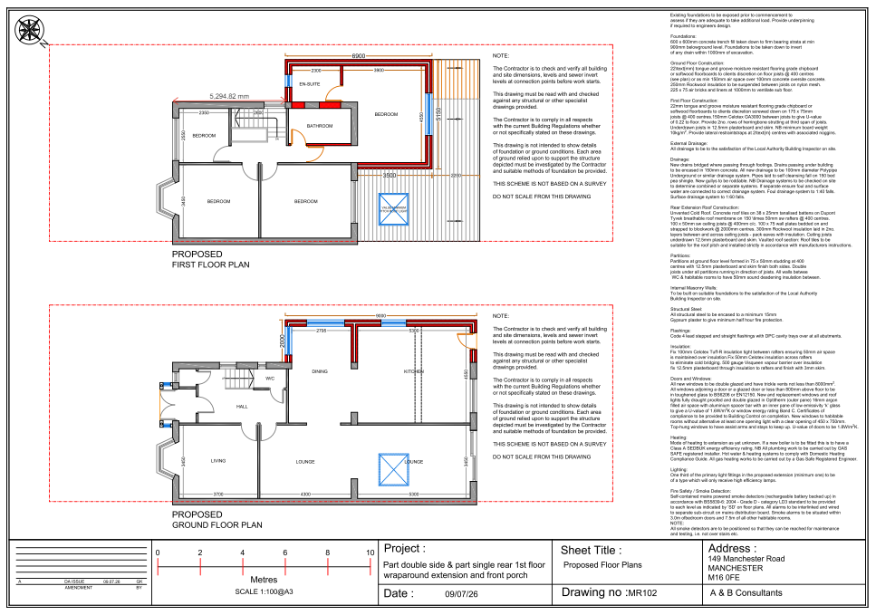
Figure 1. Proposed floor plan

Relevant planning history

Planning Application - 075187/FH/2005/S1
Retrospective Application erection of a single storey rear extension to form additional living accommodation
Refused - 2005-05-17
Appeal dismissed – 2006-05-19
A retrospective planning application for the erection of a single-storey rear extension was refused on 17 May 2005, and a subsequent appeal was dismissed on 19 May 2006.
It is acknowledged that the existing rear extension does not benefit from planning permission. However, as the extension has been in place for more than 10 years without enforcement action being taken, it is considered to be immune from enforcement and is therefore lawful through the passage of time. Accordingly, the existing rear extension is treated as an established lawful feature of the property.

Consultation, notification and publicity responses

Notifications and publicity

Neighbour letters
No responses received.

Relevant policies
In accordance with Section 38(6) of the Planning and Compulsory Purchase Act 2004, planning applications must be determined in accordance with the statutory development plan unless material considerations indicate otherwise.
For Manchester, the development plan comprises:
- The Manchester Core Strategy (2012 to 2027);
- Saved policies of the Manchester Unitary Development Plan (UDP); and
- The Places for Everyone Joint Development Plan Document (2022 to 2039).
These documents are considered up to date and are afforded significant weight in the determination of planning applications. Relevant Supplementary Planning Documents (SPDs) and other adopted guidance may also be material considerations.
The National Planning Policy Framework sets out the government’s policies for plan-making and for making decisions on development proposals in England. It is a material consideration of critical importance in both contexts.
Where relevant, the Council is required to give special regard to the desirability of preserving listed buildings and their settings, and special attention to the desirability of preserving or enhancing the character or appearance of conservation areas, in accordance with the Planning (Listed Buildings and Conservation Areas) Act 1990.
The policies and guidance referred to below are considered the most relevant to the scale, nature and location of the proposed development.
- The Manchester Core Strategy Development Plan Document 2012-2027
  - Development Management and Planning Obligations
    - DM 1 - Development Management
  - Objective 1 - Spatial Principles
    - SP 1 - Spatial Principles (Partially replaced by PfE Policy JP-S 1)
  - Objective 6 Environment
    - EN 1 - Design Principles and Strategic Character Areas
    - EN 19 – Waste
- Guide to development in Manchester - supplementary planning document and planning guidance, April 2007
- Extant Unitary Development Plan (UDP) –
  - Citywide Development Control Policies
    - DC1 - Residential extensions
    - DC26 - Development and Noise
- Places for Everyone Plan Joint Development Plan Document 2022-2039-
  - Strategy
    - JP-Strat9: Southern Areas
  - Sustainable and Resilient Places
    - JP-S1: Sustainable Development
  - Places for People
    - JP-P1 Sustainable Places
- National Planning Policy Framework – August 2026 - National Development Management Policies (NDMPs)
  - Procedural Policies
    - Chapter 3 – Decision-making policies
      - DM1: Preparing development proposals
      - DM2: Information requirements
      - DM3: Determining development proposals
      - DM6: Use of planning conditions and obligations
      - DM7: Relationship with other regulatory regimes
      - DM10: Removal of national permitted development rights
  - Sustainable Development
    - Chapter 4 - Achieving sustainable development
      - S3: Presumption in favour of sustainable development
      - S4: Principle of development within settlements
  - Creating high quality, sustainable places
    - Chapter 12 - Making effective use of land
      - L2: Making effective use of land
    - Chapter 14 - Achieving well-designed places
      - DP3: Key principles for well-designed places
      - DP4: The design process

Assessment

Principle of development
Many people prefer to extend their existing homes rather than move, and the planning system needs to accommodate this demand for more living space, while at the same time ensuring that the amenities of neighbours are protected, and that the overall character of the surrounding area is not harmed. The Council is not generally in favour of dealing with this issue by laying down firm rules about home extensions with each case looked at on its individual merits, having regard to a range of criteria.
In this case the principle of the development is acceptable.
As stated in Policy DM 1 of the Manchester Core Strategy, all development should have regard to the following specific issues:

Appropriate siting, layout, scale, form, massing, materials, and detail
The proposal comprises a part two-storey side extension, part two-storey rear extension, part single-storey rear extension and front porch. The submitted plans indicate that the extensions would be constructed using materials to match the existing dwelling, including matching brickwork, roof tiles and window detailing.
The two-storey side extension would be set back from the principal elevation and would incorporate a lower ridge height than the host dwelling. These measures ensure that the extension remains subordinate to the original dwelling and clearly identifiable as an addition.
In terms of neighbouring properties, the proposal would have a limited visual impact on No. 151 Manchester Road. The two-storey side extension is located on the opposite side of the host dwelling from the shared boundary with No. 151 and would therefore not materially alter the relationship between the two properties when viewed from the street or adjoining garden areas. Whilst the rear extension elements would increase the scale of built development to the rear, they are considered proportionate additions and would not appear unduly dominant when viewed from No. 151.
To the south-west, the proposed side extension would be visible from the neighbouring three-storey block of flats located beyond the access drive. Whilst the development would reduce the existing gap to the side boundary and increase the overall massing of the dwelling, the extension would be viewed in the context of a significantly larger residential building. Given the scale of the flats and the separation provided by the access road, the proposal is not considered to result in an unacceptably dominant or overbearing relationship.
The rear extension elements would also be separated from No. 21 Crimsworth Avenue by substantial rear garden distances.
Consequently, whilst there would be some increase in built form, the proposal would not appear unduly dominant or visually intrusive when viewed from that property.
Impact on the surrounding areas in terms of the design, scale and appearance of the proposed development. Development should have regard to the character of the surrounding area.
The surrounding area is characterised by a mix of semi-detached dwellings and larger residential buildings. The proposed extensions would utilise matching materials and adopt a form that remains subordinate to the host dwelling. As such, the proposal would integrate satisfactorily with the surrounding built environment and would preserve the character and appearance of the area.

Effects on amenity

Privacy
The proposal would introduce additional first-floor windows serving bedrooms and bathrooms. The first-floor openings appear on similar elevations to existing. Ground floor windows facing into exisitng boundary treatments and similar to existing side facing windows, Given the location and separation from neighbouring residential properties, the proposal is not considered to give rise to unacceptable overlooking or loss of privacy. To ensure that this remains the case a condition has been attached removing the PD rights for the insertion of new openings.

Light
The proposed extensions would not result in significant losses of daylight, sunlight or outlook to neighbouring occupiers. The nearest adjacent building is a three-storey block of flats located beyond the access drive to the south-west of the site. Given the scale of that building and the separation provided by the access drive, the proposed extensions would not appear unduly overbearing or result in unacceptable overshadowing. The proposal is therefore considered acceptable in terms of its impact on residential amenity.

Noise
The proposed extension is not expected to generate any noise beyond what would be reasonably expected of a residential dwelling.

Accessibility: buildings and neighbourhoods fully accessible to disabled people, access to new development by sustainable transport modes.
The proposal would retain the existing residential use and access arrangements. Whilst a new front porch is proposed, this would not materially affect accessibility to the dwelling.

Adequacy of internal accommodation and external amenity space.
The proposed extensions would significantly increase the amount of internal floorspace available to occupants through enlarged living accommodation and additional bedroom space. Despite the increase in footprint, a substantial area of private outdoor amenity space would remain within the side and rear curtilage. The proposal therefore provides an acceptable standard of internal accommodation and external amenity space

Refuse storage and collection.
The proposal would not materially alter existing waste collection arrangements. Adequate space remains within the curtilage for the storage and presentation of refuse and recycling bins, and the development would not prejudice refuse collection services

Vehicular access and car parking
The proposal would not alter the existing vehicular access to the site. Given the size of the plot and existing hardstanding areas, adequate off-street parking provision would remain available following completion of the development. The proposal is therefore acceptable in parking and highway terms

Green Infrastructure including open space, both public and private
The proposal has no impact on green infrastructure.

Flood risk and drainage.
The proposal is a householder extension to an existing dwelling and would utilise existing drainage arrangements. Given the scale and nature of the development, no unacceptable flood risk or drainage concerns are identified.

Other Legislative Requirements

Equality Act 2010
Section 149 (Public Sector Equality Duty) of the Equality Act 2010 requires due regard to the need to: Eliminate unlawful discrimination, harassment and victimisation and other conduct prohibited by the Act and; Advance equality of opportunity between persons who share a protected characteristic and persons who do not share it. The Equality Duty does not impose a legal requirement to conduct an Equality Impact Assessment. Compliance with the Equality Duty involves consciously thinking about the aims of the Equality Duty as part of the process of decision-making.

Human Rights Act 1998 considerations
This application needs to be considered against the provisions of the Human Rights Act 1998. Under Article 6, the applicants (and those third parties, including local residents, who have made representations) have a right to a fair hearing and to this end the local planning authority must give full consideration to their comments.
Protocol 1 Article 1, and Article 8 where appropriate, confer(s) a right of respect for a person’s home, other land and business assets. In taking account of all material considerations, including Council policy as set out in the Core Strategy and saved polices of the Unitary Development Plan, the Director of Planning, Building Control & Licensing has concluded that some rights conferred by these articles on the applicant(s)/objector(s)/resident(s) and other occupiers and owners of nearby land that might be affected may be interfered with but that that interference is in accordance with the law and justified by being in the public interest and on the basis of the planning merits of the development proposal. She believes that any restriction on these rights posed by the recommendation given is proportionate to the wider benefits of and that such a decision falls within the margin of discretion afforded to the Council under the Town and Country Planning Acts.

Conclusion
The proposed part two-storey side extension, part two-storey and part single-storey rear extensions and front porch are considered to be of an appropriate scale, design and appearance that would remain subordinate to the host dwelling and integrate satisfactorily with the surrounding area. The development would not result in unacceptable harm to the amenities of neighbouring occupiers, including No. 151 Manchester Road, the neighbouring three-storey block of flats or No. 21 Crimsworth Avenue, by reason of overlooking, loss of light, outlook or overbearing impact. Adequate private amenity space and off-street parking would remain available, and no other material planning considerations have been identified that would weigh against the proposal. The development is therefore considered to comply with Policies DM1 and EN1 of the Manchester Core Strategy and Policy DC1 of the Unitary Development Plan and is recommended for approval subject to conditions.

Recommendation: Approve

Article 35 Declaration
Officers have worked with the applicant in a positive and proactive manner based on seeking solutions to problems arising in relation to dealing with the planning application. The proposal is considered to be acceptable and therefore determined within a timely manner.

Conditions to be attached to decision for approval

3-year time limit
The development must be begun not later than three years beginning with the date of this permission.
Reason - Required to be imposed by Section 91 of the Town and Country Planning Act 1990 (as amended).

Specified plans
The development hereby approved shall be carried out in accordance with the following drawings and documents:
  - MR102 – Proposed Floor Plans (received 14 July 2026)
  - MR103 – Existing & Proposed Roof Plans (received 14 July 2026)
  - MR105 – Proposed Elevations – (received 15 Sept 2026)
  - Proposed Site Block Plan (received 14 July 2026)
  - Location Plan (received 14 July 2026)
Reason - To ensure that the development is carried out in accordance with the approved plans, pursuant to policies DM 1, SP 1 and EN 1 of the Core Strategy and JP-P1 & of Places for Everyone.

Materials to match
The materials used in the external surfaces of the development hereby approved shall be similar in appearance to the existing building in terms of type, size, colour and texture.
Reason - In order to ensure a satisfactory appearance in the interests of visual amenity in accordance with policies SP1 and DM1 of the Core Strategy and the requirements of the National Planning Policy Framework.

EXTENSIONS – PD RIGHTS REMOVED FOR NEW OPENINGS
Notwithstanding the provisions of Schedule 2, Part 1 of the Town and Country Planning (General Permitted Development) Order 2015 (as amended) (or any order revoking and re-enacting that Order with or without modification), no additional windows, doors or other openings shall be inserted in the the development hereby approved, without planning permission being granted by the Local Planning Authority.
Reason - In the interests of residential amenity, pursuant to policies DM1 and SP1 of the Manchester Core Strategy.

