

Planning

Delegated Officer Report

Summary of application details
Application reference: | PLA-2026-001148
Application type: | Full planning permission
Proposal: | Installation of louvered pergola.
Site address: | 420 Wilbraham Road Manchester M21 0AS
Ward(s): | Chorlton
Date application valid: | 27 July 2026
Applicant name: | Mr Naima Begum
Agent (if any): | Mr Hassan Naqvi
Case officer: | Holly Wright
Recommendation: | Refuse
Date of recommendation: | 15 September 2026

Description of site, building and/or area
The application site comprises a single-storey commercial unit within the Chorlton District Centre, located in the Chorlton ward of Manchester. The building is characterised by glazed shopfronts to its southern and eastern elevations, with fascia signage above, retractable canopies/awnings, and a flat roof. An unenclosed outdoor seating area is situated within the forecourt of the premises at the junction of Wilbraham Road and Albany Road.

The surrounding area is predominantly commercial in character, containing a wide range of retail, food and drink, and other town centre uses. Residential properties are also present in the vicinity, including dwellings located to the north and south of the site, as well as residential accommodation on the upper floors of several nearby commercial premises.

The site is not a listed building and does not lie within a designated conservation area.

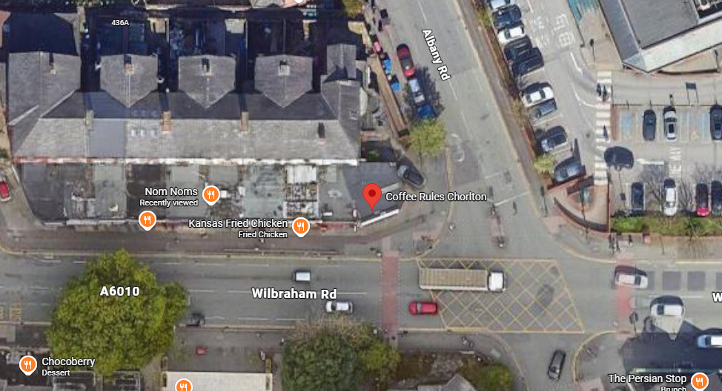

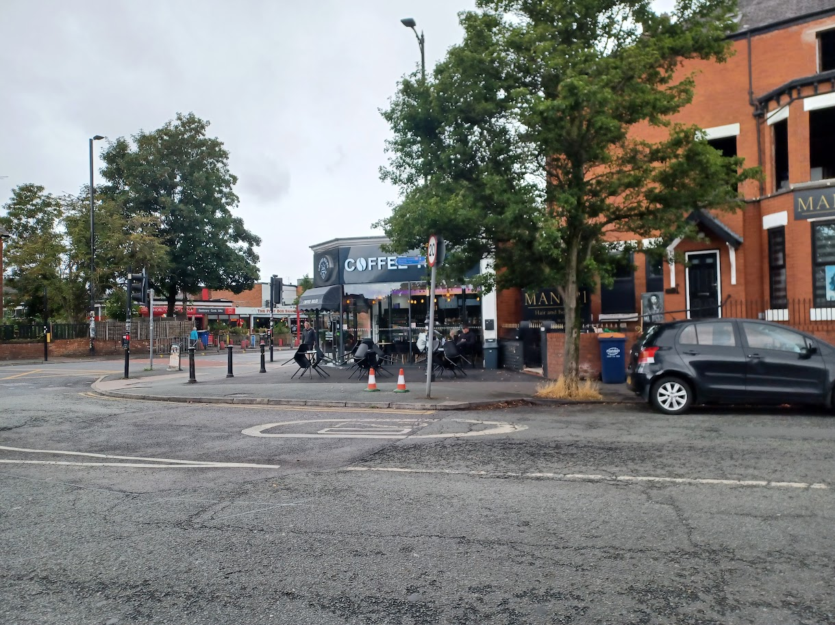

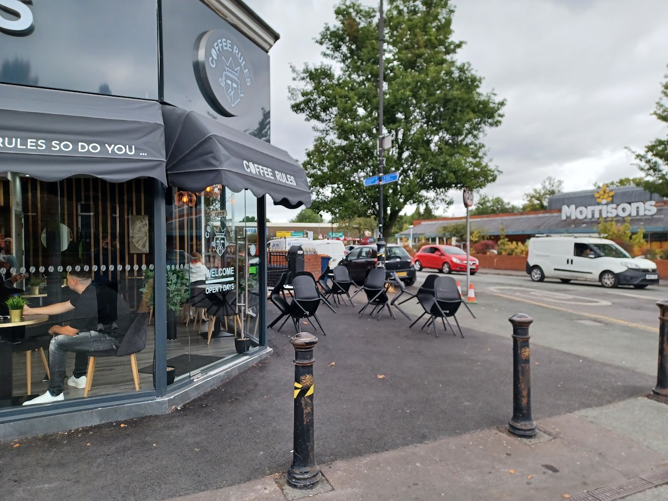

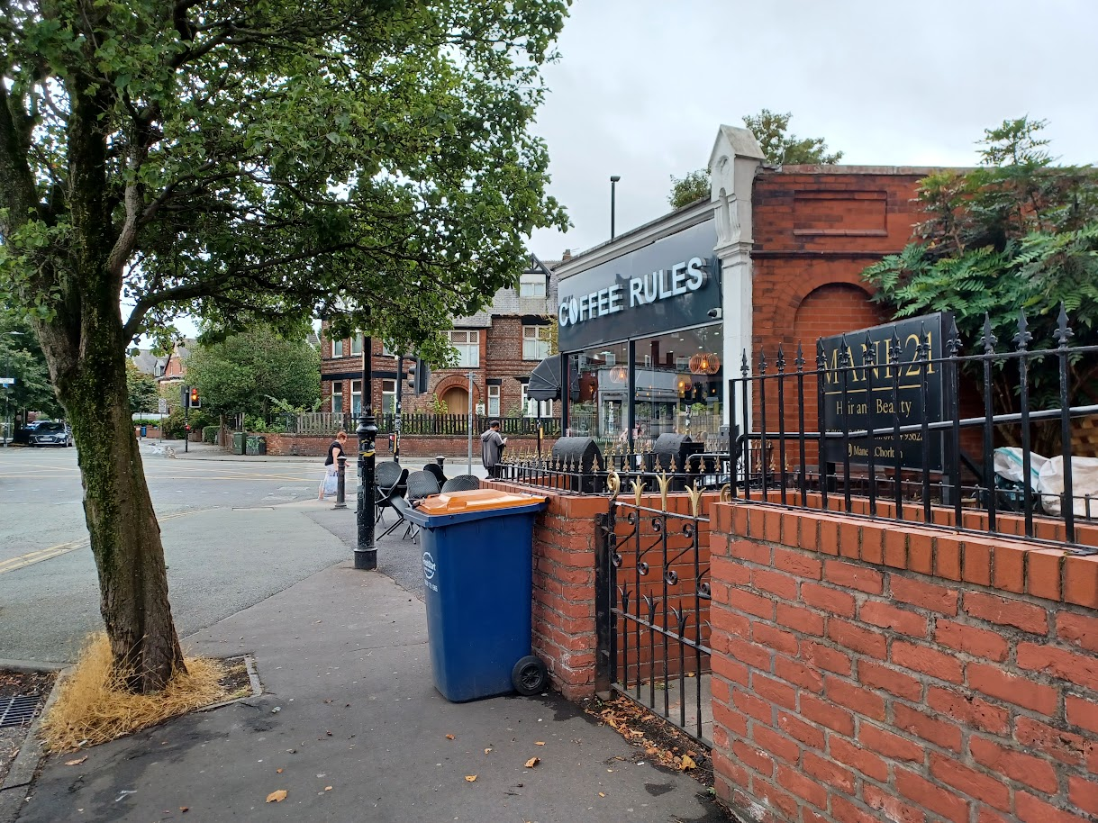

Description of development
The applicant is seeking planning permission for the installation of a louvered pergola.

Relevant planning history
Planning Application - 145534/FO/2026 - Installation of shop front and formation of external seating area – Under consideration.

Planning Application - 145535/AO/2026 - Advertisement consent for the display of 3no. internally illuminated signs – Under consideration.

Consultation, notification and publicity responses
Local residents – no representations received.

Chorlton Civic Society objected to the proposal on the basis that the proposed structure would be out of keeping with the design of the main building and with the character of the surrounding area. It would also adversely affect sight lines on the corner.

MCC’s Highways Services made the following comments:

- Proposed pergola appears to be located on private forecourt within the site red-line boundary.
- Proposed plans also demonstrate a seating area with associated planters beneath the pergola.
- *Clarification is sought on the following and should be shown on an updated dimensioned plan:
  - Retained footway width adjacent to the proposed pergola including the pinch-point
  - Set-back distance from the back of the pergola to the back of the footway
  - Headroom clearance for the proposed pergola
- Highways have concerns that access to the adjacent 420a Wilbraham Road is to be obstructed by the pergola and seating area – Further clarification is sought.
- All furniture should be stored internally within the premises outside of operational hours. This is considered appropriate in preventing unnecessary obstruction of the adjacent highway.
Following clarification on the above matters, MCC’s Highways Services indicated:

- The proposed pergola headroom clearance of 2.96m is considered acceptable in principle.
- The proposed retained footway widths, ranging between 2.03m and 7.56m, are considered acceptable in principle.
- Highways' previous concerns regarding the potential obstruction of access to the adjacent property at 420A Wilbraham Road have now been satisfactorily addressed.

Relevant policies
Unitary Development Plan (UDP) – The UDP has been superseded by the Core Strategy Development Plan, but certain policies are still considered of relevance:
- Policy DC22 – Footpath Protection

The Manchester Core Strategy – Development Plan Document 2012-2027 (“the Core Strategy”) was adopted by the City Council on the 11th of July 2012:
- Policy DM1 – Development Management
- Policy SP1 – Spatial Principles

Places for Everyone - is a long-term plan of nine Greater Manchester districts for jobs, new homes, and sustainable growth. It has been published by the GMCA on behalf of the nine districts and took effect and became part of the statutory development plan on March 21, 2024.
- Policy JP-P1 – Sustainable Places

National Planning Policy Framework (NPPF, 2026)
- Chapter 14 – Achieving Well-Designed Places
- Policy DP3: Key principles for well-designed places

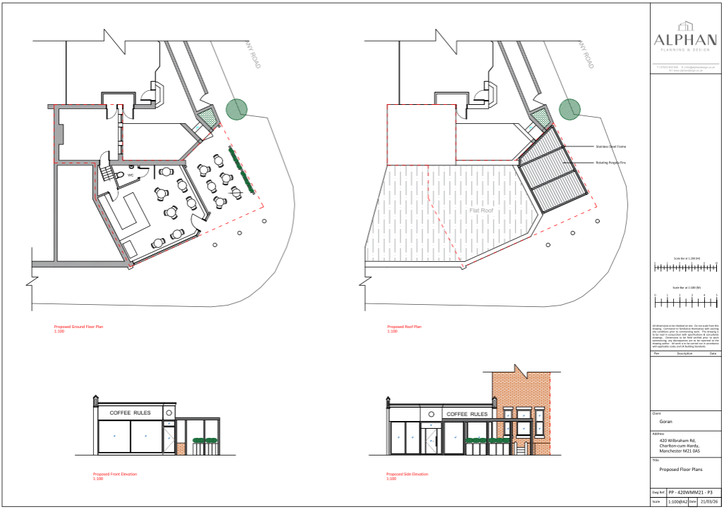
Submitted proposed plans and elevations

Assessment

Principle – Section 38(6) of the Planning and Compulsory Purchase Act 2004 and paragraph 3 of chapter 1 (introduction) of the National Planning Policy Framework (2026) require that
decisions must be made in accordance with the development plan, unless material
considerations indicate otherwise.

In the case of this application, the principle of the proposal is considered unacceptable and
cannot be supported as it conflicts with the development plan policies and associated guidance
listed in the preceding section.

It is considered that the proposal would occupy a prominent position within the forecourt of the premises at the junction of Wilbraham Road and Albany Road. By reason of its scale, form and highly visible siting, the structure would appear as an incongruous and visually intrusive addition that would fail to integrate appropriately with both the application property and the wider street scene. The proposal would significantly reduce the openness of this corner site and introduce an overly prominent feature that would create visual clutter and detract from the character and appearance of the area. The proposal would therefore fail to achieve the high standard of design required for new development and would not respond positively to the local character and sense of place of the surrounding area.

On this basis, the proposal is considered to conflict with policies DM1 and SP1 of the Manchester Core Strategy, policy JP-P1 of Places for Everyone, and chapter 14 and policy DP3 of the National Planning Policy Framework (2026), all of which seek to secure high-quality, well-designed development that is sympathetic to local character, enhances the quality of the built environment, and contributes positively to the identity and attractiveness of places.

Appearance and visual amenity – the proposed pergola would be positioned within the forecourt of the application premises, adjacent to the junction of Wilbraham Road and Albany Road. It would measure to approximately 4m in width, 6.2m in length, and 3m in height. A clearance of approximately 2m would be maintained between the structure and the edge of the pavement at its northernmost point, with a wider setback of approximately 3.1m retained at the southeastern corner. The pergola would comprise a powder-coated black stainless steel frame with a flat roof incorporating rotating louvred fins. The submitted plans indicate that six tables would be situated beneath the structure, with planters positioned along its eastern edge.
Given its siting within a prominent corner location at a busy junction within the District Centre, the proposed pergola would be highly visible from the surrounding public realm and from a range of vantage points along both Wilbraham Road and Albany Road. The existing forecourt presently provides a relatively open setting which contributes positively to the character and appearance of the site and wider street scene. By maintaining an absence of built form in front of the application property, the existing forecourt area provides clear and unobstructed views across the corner plot and provides a sense of visual relief within an otherwise developed street frontage, thus contributing to a sense of space and openness at this key junction.
Whilst the pergola would be open-sided in design, it would nevertheless introduce a substantial and permanent built structure into an area currently characterised by openness. By spanning a significant proportion of the forecourt and incorporating a roof structure, associated seating and planters, the proposal would visually occupy and enclose much of the available open space. The proposal would therefore erode the sense of openness currently experienced at the site, interrupt established views across the corner frontage and result in a noticeably more enclosed and urbanised appearance.
On this basis, it is considered that the pergola, by reason of its scale, form and prominent siting, would appear as a visually intrusive and incongruous addition to the application property. The structure would become a dominant feature within the street scene and would diminish the contribution that the open forecourt currently makes to the spatial character of the junction. The cumulative presence of the pergola, tables and planters would create an ad hoc and cluttered appearance, reducing visual permeability across the site and detracting from the openness that presently helps soften the relationship between the building and surrounding public realm.
Further to this, the proposal would not appear as a well-integrated or sympathetic addition to the application property. Instead, it would read as a standalone structure of a utilitarian appearance, lacking any meaningful relationship with the architectural character of the host premises or the wider street scene. Its prominent visibility from multiple directions would further exacerbate the degree of visual harm caused.
Overall, the proposal would result in the loss of an important area of openness and visual relief on this prominent corner plot. It would introduce an incongruous and overly dominant feature that would detract from the character and appearance of the surrounding area and fail to respond positively to its context. The proposal is therefore considered to conflict with policies DM1 and SP1 of the Manchester Core Strategy, policy JP-P1 of Places for Everyone, and the requirements of the National Planning Policy Framework (2026), which seek to secure high-quality development that is well integrated with its surroundings and contributes positively to local character and sense of place.
Residential amenity – given that the proposed pergola would be single storey in scale and positioned at a considerable distance from the nearest residential properties, it is not considered that it would give rise to significant harmful impacts in terms of overshadowing, loss of daylight, sunlight, or outlook.
In respect of noise and disturbance, the proposal is not considered to result in undue harm to residential amenity as the application site already benefits from an outdoor seating area in this location, and the proposed pergola would primarily provide weather protection of this space, rather than intensify the use of the site. As such, significant additional noise impacts are not anticipated beyond those associated with the existing use of the space.
Waste storage – the waste storage and management arrangements would be unaffected by the proposal.
Parking – the current parking arrangements would be unaffected by the proposal.
Pedestrian and highways implications – the proposed pergola would be located within the existing forecourt of the premises and would retain a minimum footway width of at least 2m on all sides. MCC’s Highways Services made no objection to these arrangements.
Conclusion – overall, it is considered that the proposal would occupy a prominent position within the forecourt of the premises at the junction of Wilbraham Road and Albany Road. By virtue of its scale, form and highly visible siting, the structure would appear as an incongruous and visually intrusive addition that would fail to integrate satisfactorily with either the host building or the wider street scene. The proposal would significantly reduce the openness of this corner site and introduce an overly prominent feature that would create visual clutter and detract from the character and appearance of the area.

The proposal would therefore fail to achieve the high standard of design required for new development and would not respond positively to its context. As a result, it would cause unacceptable harm to the visual amenity of the surrounding area and would not contribute positively to the creation of an attractive and successful place.

On this basis, the proposal is considered to conflict with policies DM1 and SP1 of the Manchester Core Strategy, policy JP-P1 of Places for Everyone, and chapter 14 and policy DP3 of the National Planning Policy Framework (2026), all of which seek to secure high-quality, well-designed development that is sympathetic to local character, enhances the quality of the built environment, and contributes positively to the identity and attractiveness of places.

The agent of the application notified of the LPA’s intent to refuse the proposal.

Other Legislative Requirements

Equality Act 2010
Section 149 (Public Sector Equality Duty) of the Equality Act 2010 requires due regard to the need to: Eliminate unlawful discrimination, harassment and victimisation and other conduct prohibited by the Act and; Advance equality of opportunity between persons who share a protected characteristic and persons who do not share it. The Equality Duty does not impose a legal requirement to conduct an Equality Impact Assessment. Compliance with the Equality Duty involves consciously thinking about the aims of the Equality Duty as part of the process of decision-making.

Human Rights Act 1998 considerations
This application needs to be considered against the provisions of the Human Rights Act 1998. Under Article 6, the applicants (and those third parties, including local residents, who have made representations) have a right to a fair hearing and to this end the local planning authority must give full consideration to their comments.

Protocol 1 Article 1, and Article 8 where appropriate, confer(s) a right of respect for a person’s home, other land and business assets. In taking account of all material considerations, including Council policy as set out in the Core Strategy and saved polices of the Unitary Development Plan, the Director of Planning, Building Control & Licensing has concluded that some rights conferred by these articles on the applicant(s)/objector(s)/resident(s) and other occupiers and owners of nearby land that might be affected may be interfered with but that that interference is in accordance with the law and justified by being in the public interest and on the basis of the planning merits of the development proposal. She believes that any restriction on these rights posed by the recommendation given is proportionate to the wider benefits of and that such a decision falls within the margin of discretion afforded to the Council under the Town and Country Planning Acts.

Recommendation: Refuse

Article 35 Statement:

The proposal would not improve the social and environmental conditions of the area, nor does it
comply with the development plan and therefore does not comprise sustainable development.
There are no conditions which could reasonably have been imposed, which would have made
the development acceptable, and it is therefore not possible to approve the application.

Condition(s) to be attached to decision for approval OR Reasons for recommendation to refuse

1) The proposed pergola, by reason of its scale, form and prominent siting within the forecourt of the premises at the junction of Wilbraham Road and Albany Road, would appear as an incongruous, visually intrusive and ad-hoc addition within the street scene. The proposal would erode the openness of this prominent corner site, introduce visual clutter, and fail to integrate satisfactorily with both the application property and the character and appearance of the surrounding area. As such, the proposal would represent a poor-quality form of development that would fail to respond positively to its context and would cause unacceptable harm to the visual amenity of the surrounding area. The proposal is therefore contrary to policies DM1 and SP1 of the Manchester Core Strategy, policy JP-P1 of Places for Everyone, and the National Planning Policy Framework (2026).

