

Planning

Delegated Officer Report

Summary of application details
Application reference: | PLA-2026-000419
Application type: | Householder planning permission
Proposal: | Erection of single-storey outbuilding in rear garden.
Site address: | 134 Mauldeth Road Manchester M14 6SQ
Ward(s): | Withington
Date application valid: | 20 May 2026
Applicant name: | Ms Nasreen Afzal
Agent (if any): | Mr Niamat Ali
Case officer: | Jake Walther
Recommendation: | Approve
Date of recommendation: | 16/09/2026

Description of site, building and/or area
The property that is subject of this planning application is a two-storey detached property finished in red brick. It has already been extended to the rear with a part single part two storey rear extension. The area is mixed use, consisting of residential dwellings and a commercial parade to the east.

Description of development
The applicant is seeking permission for the erection of a single storey outbuilding to be used as storage.

Consultation, notification and publicity responses

Consultations
N/A

Notifications and publicity
Neighbours – No comments received.

Negotiations
Following initial assessment of the submitted plans, concerns were raised regarding the proposed monopitch roof. The roof would have reached a maximum height of approximately 4.04m along the rear boundary and, given its relationship with the neighbouring property at No. 20 Weld Road, was considered likely to appear overly dominant and result in an unacceptable sense of enclosure.

In response to these concerns, the applicant was invited to amend the scheme. Revised plans were subsequently submitted replacing the monopitch roof with a dual-pitched roof form incorporating eaves at approximately 2.61m to both the front and rear elevations. This amendment reduces the perceived bulk and massing of the outbuilding and addresses the identified amenity concerns.

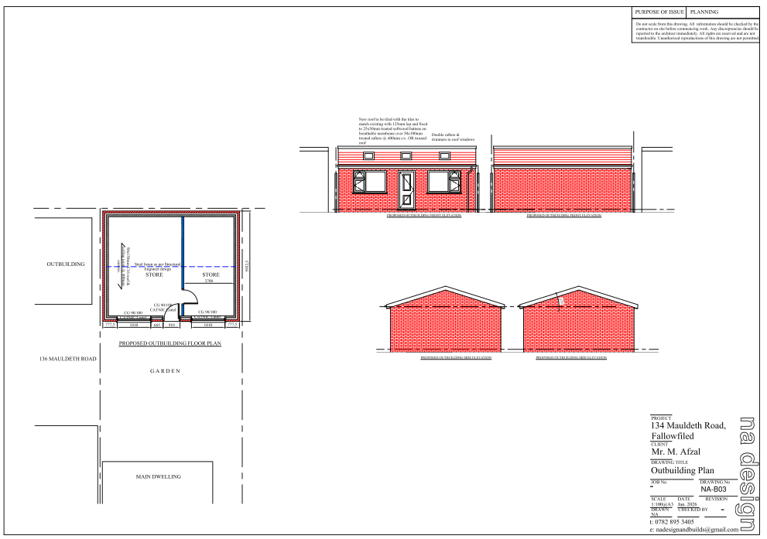
Figure 1. Updated plans

Relevant policies
The Manchester Core Strategy Development Plan Document 2012-2027 –
The City Council adopted the core strategy on July 11, 2012. It is the key document in the Manchester Local Plan. The plan determines how Manchester will grow and forms the framework that planning applications are assessed against. We consider the following Core Strategy Policies relevant to this proposal.
- Policy DM1 – Development Management
- Policy SP1 – Spatial Principles
- Policy EN1 – Design Principles and Strategic Character Areas
- Policy EN19 – Waste

Extant Unitary Development Plan (UDP)
The Core Strategy replaced much of the UDP, but some UDP Development Control policies are extant (remain). The following extant policy is still considered relevant to this proposal.
- DC1 - Residential Extensions

Places for Everyone
Places for Everyone (2022-2039) – Places for Everyone is a long-term plan of nine Greater Manchester districts for jobs, new homes, and sustainable growth. It has been published by the GMCA on behalf of the nine districts and took effect and became part of the statutory development plan on March 21, 2024.
The following policies are relevant:
- JP-S1- Sustainable development

The National Planning Policy Framework August 2026
Updated in August 2026, the National Planning Policy Framework sets out the government’s policies for plan making and for making decisions on development proposals in England. The following policies from the NPPF are considered relevant to this application:
Chapter 3 – Decision-making policies
- DM1: Preparing development proposals
Chapter 4 – Achieving Sustainable Development
- S3: Presumption in favour of sustainable development
Chapter 14 – Achieving well-designed places
- DP4: The Design Process

Assessment
Principle
The submitted application is for the erection of a detached outbuilding to provide storage. This is considered acceptable in principle as many people prefer to alter or extend homes, rather than move, to meet changing needs. However, consideration must be given to the proposal's appearance, impact on the visual amenity of the area and impact on the neighbouring properties' residential amenity.

In this instance the principle of the proposal is considered acceptable, and it is not believed that there are any factors of sufficient weight in amenity terms that would warrant refusal of the application. The proposed outbuilding is deemed to accord with saved policy DC1 of the UDP and policies DM1 and SP1 of the Manchester Core Strategy.

Sitting, Scale and Mass
The proposed outbuilding would measure approximately 7.40m by 5.95m and would feature a dual-pitched roof with eaves at approximately 2.61m and a maximum ridge height of approximately 4.04m. During the course of the application, amended plans were submitted replacing the originally proposed monopitch roof with a dual-pitched roof form in order to reduce the perceived bulk and massing of the development when viewed from neighbouring properties.

It is noted that whilst the ridge height exceeds the maximum height permitted for an outbuilding located within 2m of a boundary under permitted development rights, the exceedance is limited. The proposal is therefore only marginally larger in scale than a building that could otherwise be constructed without the need for planning permission.

It is also noted that a comparable outbuilding has previously been approved and constructed at the neighbouring property, No. 136 Mauldeth Road, which contributes to the established pattern of development within the locality.

The outbuilding would occupy a relatively modest proportion of the rear garden and would not result in overdevelopment of the site. Having regard to its scale, siting and design, together with the permitted development fallback position, the proposal is considered acceptable and would accord with saved Policy DC1 of the UDP and Policies DM1, SP1 and EN1 of the Core Strategy.

Residential Amenity
The proposed outbuilding would be positioned at the rear of the garden alongside existing outbuildings within neighbouring properties. Owing to its single-storey scale, dual-pitched roof design, separation distances and the generous depth of the rear gardens in this location, the development is not considered likely to result in any unacceptable loss of daylight, sunlight or outlook to neighbouring occupiers.

The building would contain windows and doors only on the elevation facing the host dwelling, with the side and rear elevations remaining largely blank. In these circumstances, and having regard to the existing relationship between neighbouring properties and outbuildings, the proposal would not give rise to undue overlooking or loss of privacy.

To ensure the impact to amenity is maintained, conditions have been adding limiting the insertion of further openings in the proposed outbuilding and restricting the use to incidental to the main dwellinghouse.

Overall, the proposal is considered to maintain acceptable living conditions for neighbouring occupiers and therefore accords with saved Policy DC1 of the UDP and Policies DM1 and SP1 of the Core Strategy.

Visual Amenity
The outbuilding would be constructed in red brick with a tiled dual-pitched roof and white uPVC windows and doors. The form, scale and appearance of the structure are typical of domestic outbuildings and are considered appropriate within the context of the site and surrounding residential area.

The development would be located within the rear garden and would not be readily visible from the public highway. Consequently, it would have a limited impact on the wider street scene. Furthermore, the revised dual-pitched roof design assists in reducing the visual bulk of the building when viewed from adjoining properties.

The proposal is therefore considered to comply with Policies DM1, SP1 and EN1 of the Core Strategy and the design objectives of the National Planning Policy Framework

Conclusion
The proposed detached outbuilding is acceptable in principle and would provide ancillary storage accommodation associated with the occupation of the dwellinghouse. Following amendments secured through the application process, the revised dual-pitched roof design ensures that the development would not appear unduly dominant or overbearing when viewed from neighbouring properties.

The proposal would have an acceptable impact on visual amenity and residential amenity and would not result in harm sufficient to warrant refusal. Accordingly, the development is considered to comply with saved Policy DC1 of the UDP, Policies DM1, SP1, EN1 and EN19 of the Core Strategy, Policy JP-S1 of Places for Everyone and the relevant provisions of the National Planning Policy Framework. The application is therefore recommended for approval.

Other Legislative Requirements

Equality Act 2010
Section 149 (Public Sector Equality Duty) of the Equality Act 2010 requires due regard to the need to: Eliminate unlawful discrimination, harassment and victimisation and other conduct prohibited by the Act and; Advance equality of opportunity between persons who share a protected characteristic and persons who do not share it. The Equality Duty does not impose a legal requirement to conduct an Equality Impact Assessment. Compliance with the Equality Duty involves consciously thinking about the aims of the Equality Duty as part of the process of decision-making.

Human Rights Act 1998 considerations
This application needs to be considered against the provisions of the Human Rights Act 1998. Under Article 6, the applicants (and those third parties, including local residents, who have made representations) have a right to a fair hearing and to this end the local planning authority must give full consideration to their comments.

Protocol 1 Article 1, and Article 8 where appropriate, confer(s) a right of respect for a person’s home, other land and business assets. In taking account of all material considerations, including Council policy as set out in the Core Strategy and saved polices of the Unitary Development Plan, the Director of Planning, Building Control & Licensing has concluded that some rights conferred by these articles on the applicant(s)/objector(s)/resident(s) and other occupiers and owners of nearby land that might be affected may be interfered with but that that interference is in accordance with the law and justified by being in the public interest and on the basis of the planning merits of the development proposal. She believes that any restriction on these rights posed by the recommendation given is proportionate to the wider benefits of and that such a decision falls within the margin of discretion afforded to the Council under the Town and Country Planning Acts.

Article 35 Direction
Officers have worked with the applicant in a positive and proactive manner based on seeking solutions to problems arising in relation to dealing with the planning application. No significant problems have arisen during the consideration of this application and the application has been determined in a timely manner, in accordance with the policies with the Development Plan.

Recommendation: Approve

Conditions:
- 3-year time limit:
The development must be begun not later than the expiration of three years beginning with the date of this permission.

Reason - Required to be imposed pursuant to Section 91 of the Town and Country Planning Act 1990.

- Specified plans:
The development hereby approved shall be carried out in accordance with the following drawings and documents:
  - 134 mauldeth rd outbuilding planREVISED1.pdf (Drawing No. NA-B03), received 15 September 2026;
  - LocationPlan.pdf, received 20 May 2026.

Reason - To ensure that the development is carried out in accordance with the approved plans, pursuant to policies DM1, SP1 and EN1 of the Core Strategy.

- Specified materials:
The materials used in the external surfaces of the development hereby approved shall be those as specified on approved plans/drawings ref.
a. 134 mauldeth rd outbuilding planREVISED1.pdf (Drawing No. NA-B03), received 15 September 2026;

Reason - In order to ensure a satisfactory appearance in the interests of visual amenity in accordance with policies SP1 and DM1 of the Core Strategy and the requirements of the National Planning Policy Framework.

- Additional glazing restriction:
Notwithstanding the provisions of the Town and Country Planning (General Permitted Development) (Amendment) Order 2015, (or any order revoking and re-enacting that Order with or without modification), no additional glazing, windows, or doors, other than those shown on the approved plans, shall be inserted at the property unless Planning Permission is specifically granted.

Reason - In the interests of the amenities of the occupiers of the neighbouring residences, pursuant to policy DM 1 of the Core Strategy for the City of Manchester and saved policy DC1 of the Unitary Development Plan.

- Incidental Use:
The outbuilding hereby approved shall be used only for purposes incidental to the enjoyment of the dwellinghouse known as 134 Mauldeth Road and shall not be used as a separate unit of accommodation, for any commercial purpose, or for any other independent use.

Reason - In the interests of residential amenity pursuant to policy SP1 and DM1 of the Core Strategy for the City of Manchester.

