TRAVEL PLAN

New Youth Centre
306A Yew Tree Road
Old Moat
Manchester
M20 3GF

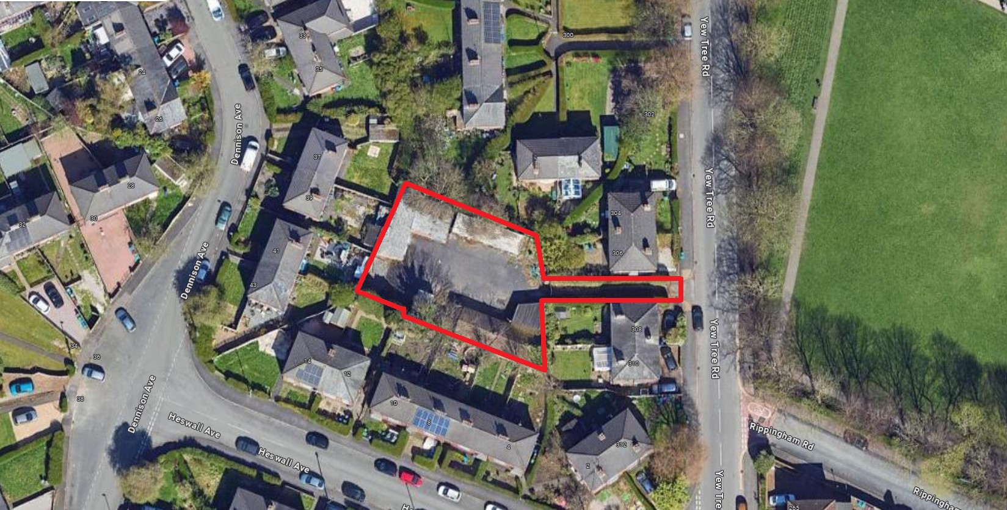

Extract from the Planning Decision Notice: 142985/VO/2025 Condition 10

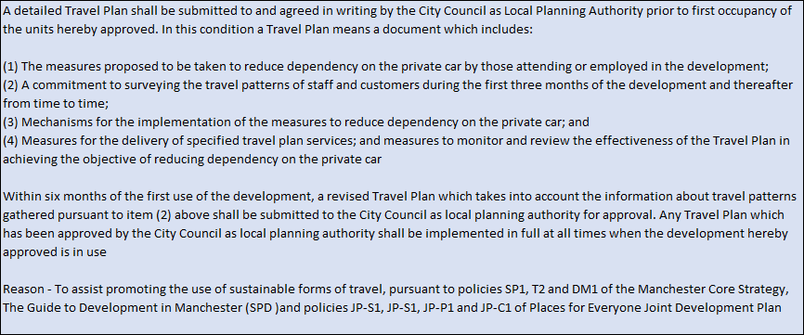

Revision Sheet

Version | Date | Changes
1.0 | 28/07/2026 | First Issue
2.0
3.0
4.0
5.0

Approval

Version | Author |  | Reviewed / Authorised
Version | By | Date | By | Date
1.0 | Patch Barber | 28/06/26
2.0
3.0
4.0
5.0

Table of Contents:

- Project Description

- Project Address

- Project Team

- Planning Condition Notice and Response

- Project Description
This new facility is part of the national programme known as Youth Investment Fund supported by the Department of Media, Culture and Sport. One of 28 nationally and 6 in the city of Manchester the facility is provided primarily as a youth centre with added value community usage.

OMYOP has applied to establish a new facility on the site previously known as ‘The Depot’ in Old Moat. The facility is a small indoor modular modern method of construction (MMC), building with activity space, toilets, storage and utilities. This MMC building has low running costs and is as environmentally friendly as possible, it is fully accessible with some storage and landscaping for a variety of uses.
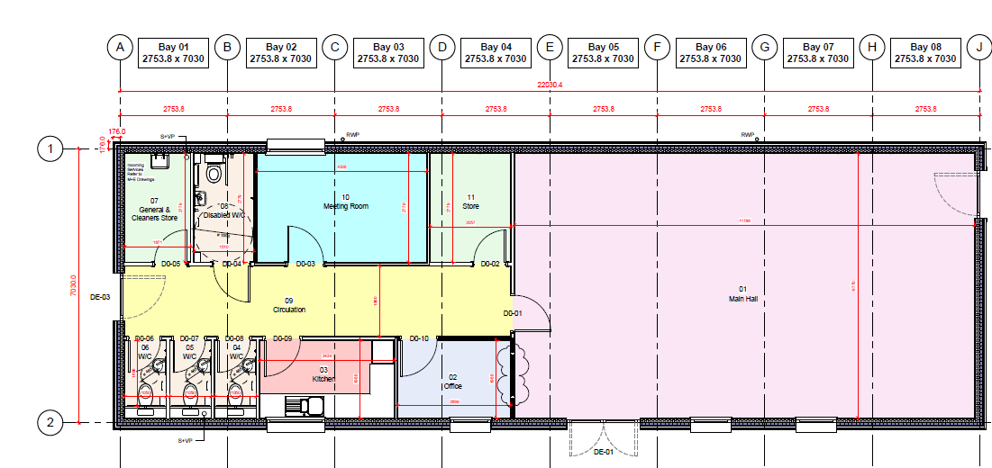

- Project Address
The Depot, 306A Yew Tree Road, Old Moat, Manchester, M20 3GF.

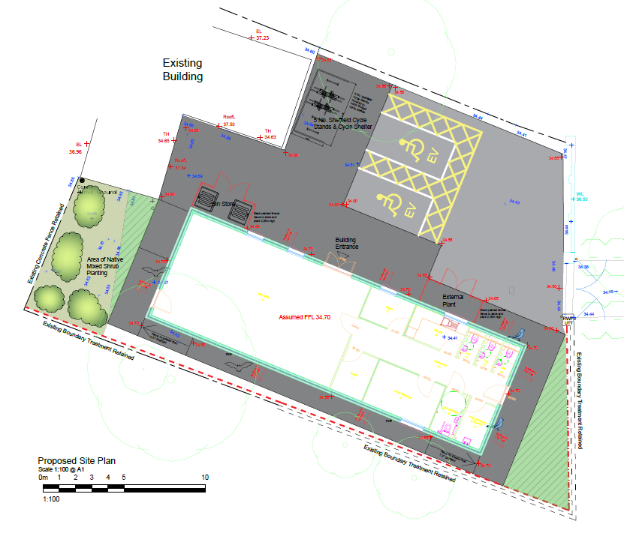
- Project Team

a) Client | 306A Yew Tree Road (The Depot) / Old Moat Outreach Youth Project (OMYOP)  306A Yew Tree Road, M20 3GF  Manchester  Tel: 07803272945  Email: elizabeth.harding@ymail.com
b) Project management / cost consultant | Turner and Townsend  Low Hall, Calverley Lance, Horsforth, Leeds, LS18 4GH  Tel: 07586 845 599  Email: Mark.Wheatley@turntown.co.uk
c) Principal designer / CDM | P and HS Architects  The Old Station, Station Road, Stokesley  Tel: 01642 712684  Email: I.Webster@pandhs.co.uk
d) Contractors / architect | Premier Module Limited  Catfoss Lane, Brandesburton, Driffield, East Yorkshire, YO25 8EJ  Tel: 01964 545001  Email: richard.keeting@premiermodular.co.uk

- Planning Condition Notice and Response

A detailed Travel Plan shall be submitted to and agreed in writing by the City Council as Local Planning Authority prior to first occupancy of the units hereby approved. In this condition a Travel Plan means a document which includes:

- The measures proposed to be taken to reduce dependency on the private car by those attending or employed in the development;

This Travel Plan sets out measures to reduce car dependency and promote sustainable travel for a new youth centre in Old Moat. It supports:

- Improved access for young people
- Reduced congestion, emissions, and parking demand
- Healthier and more independent travel behaviours

The travel plan aims to:
- Minimise single-occupancy car trips
- Increase walking, cycling, and public transport use
- Ensure safe, inclusive access for all young people
- Embed sustainable travel habits early in life
- Reduce environmental impact and congestion

The centre is a youth and community facility that will be operated by Old Moat Youth Outreach Project (OMYOP), a community youth organisation that focuses on supporting young people. The centre will be known as The Depot and will focus on the supporting young people from the areas of Old Moat and Withington.

The aims of OMYOP

- To educate young people and provide facilities for recreation and leisure time occupation.

- The advancement of education and the relief of poverty.

- To promote the relief of those young people who are affected by addiction to alcohol or drugs of any kind by providing advice, support and information.

- To preserve and protect the good health of young peoples by the provision of advice and information on health-related issues.

- The relief of poverty.

Based on the existing work of OMYOP and the service users currently engaged by the project it is anticipated that the young people attending The Depot will primarily be from the local area – the ward of Old Moat with some attendance from the neighbouring ward of Withington.

The centre has a capacity of up to 100 attendees subject to activity type and room layout. Most activities will be limited to 30-40 attendees for weekly youth clubs, drop-ins and holiday activity clubs. Based on travel patterns at similar sized neighbourhood youth centres we anticipate that attendees aged 13+ will travel independently to The Depot by walking or cycling. Younger attendees (such as for holiday clubs) are more likely to be accompanied by parents and also primarily walk to the centre with some utilising public transport or private vehicles.
The target audience for services are local families, children and young people who live close to the centre.

Centre users will be encouraged to travel on foot or bicycles. The operator anticipates (based on current service usage) that 80% of users will travel sustainably and make use of the bike racks at the centre.

- A commitment to surveying the travel patterns of staff and customers during the first three months of the development and thereafter from time to time;

OMYOP has a staff and volunteer team who all live locally or close to Old Moat. A private vehicle is used by the project for the transportation of youth project resources and their detached/outreach youth team, but daily travel is via public transport, walking or cycling by project staff and volunteers

- The Old Moat ward is approximately 4.3 miles south of the city centre. The ward has good public transport links:

- Easy access to multiple bus routes from Yew Tree, Mauldeth, Wilmslow and Princess Roads. Mauldeth, Wilmslow and Princess Roads are approximately between 2 and 10 minutes to walk to and offer easy access to the city centre and surrounding areas.

- All bus routes are run by Beeline Services and run approximately every 4 to 10 minutes depending on which route is favoured.

OMYOP is committed to monitoring service provision including attendance at services, service user details and monitoring of travel.

Service users will be required to complete a registration form including their address and postcode.

At each service session a register will be completed. This register will include the name, postcode and method of transport. Regular reviews of this data will be compiled and reported as part of the narrative report to MCC funders (The Youth, Play and Participation Service).

- Mechanisms for the implementation of the measures to reduce dependency on the private car; and

Based on the results of the initial 3-month transport survey the project will develop an action plan to promote active travel for staff, volunteers and service users.

This will include measures such as:

- Cycling promotion events
- Bike repair workshops
- Promotional campaigns for active travel
- Discourage car use for dropping off

Staff / volunteer information:

- Induction packs
- Promotional campaigns
- Access to schemes such as bike purchasing

The travel plan and active travel promotion activities will be reviewed on an annual basis and reported to the funder.

- Measures for the delivery of specified travel plan services; and measures to monitor and review the effectiveness of the Travel Plan in achieving the objective of reducing dependency on the private car

The travel plan will be based on the findings of the initial survey following the first 3 months of opening of the facility. As a new facility we can only estimate the numbers of car users.

The travel plan will establish annual targets for the promotion of active travel and reduction in private car usage based on the initial survey.

The travel plan will include an annual review of travel by conducting a time limited survey (e.g a travel survey for four weeks to assess any changes in patterns of travel).

For example, if we identify that 30% of users attend each month by private car we would undertake a variety of activities such as bicycle use promotion and bicycle maintenance, independent travel training, campaigns etc. We’ll also to set a target of private car usage by 10% of users.

Within six months of the first use of the development, a revised Travel Plan which takes into account the information about travel patterns gathered pursuant to item (2) above shall be submitted to the City Council as local planning authority for approval. Any Travel Plan which has been approved by the City Council as local planning authority shall be implemented in full at all times when the development hereby approved is in use

The travel plan will be produced within 6 months of occupation (based on the first 3 months travel survey) and will set targets for improvement for the subsequent 12-month period.
Survey results (annually) and travel plans and updates will be retained and available for review.

Reason - To assist promoting the use of sustainable forms of travel, pursuant to policies SP1, T2 and DM1 of the Manchester Core Strategy, The Guide to Development in Manchester (SPD )and policies JP-S1, JP-S1, JP-P1 and JP-C1 of Places for Everyone Joint Development Plan

